 | - TPS activity on building Data Warehouse/Data Mart

Name of Student | Hardik Prajapati | Roll No. | 9152
Sign here to indicate that you have read all relevant material provided /available on Moodle while performing and writing this experiment |  | Sign:

Late Submission Details (if any)
Reason(s) of late submission | Date of practical performance | Date of practical submission

References used
1 | Name and author of reference book(s) with page nos.
2 | Name and roll nos. of the peers whose help you have taken (if any)

1. | Course, Subject & Experiment Details

Course & Branch | T.E. (ECS) | Estimated Time | 02 Hours Per Week
Current Semester | Semester VI | Subject Name | DWM
Chapter No. & Unit | 1.5 | Chapter Title | -
Experiment Type | Design | Subject Code | ECL 603

2. | Aim & Objective of activity
- To understand the concepts of different types of dimensional modeling
3. | Expected Outcome of activity
- To construct the schema for data warehouse using dimension modeling concept
4. | Outcome of think and share activity

- Design the data warehouse for a wholesale furniture manufacturing company. The data warehouse has to allow analyzing company’s situation at least with respect to Furniture, Customer and Time. More ever the company needs to analyze The Furniture with respect to its type, category and material. The customers with respect to their special location, by at least considering cities, regions and states. The company is interested in learning the quantity, income and discount of its sales. Justify your design.
  - Draw a star schema for the above data warehouse
  - Draw a snowflake schema for the above data warehouse.

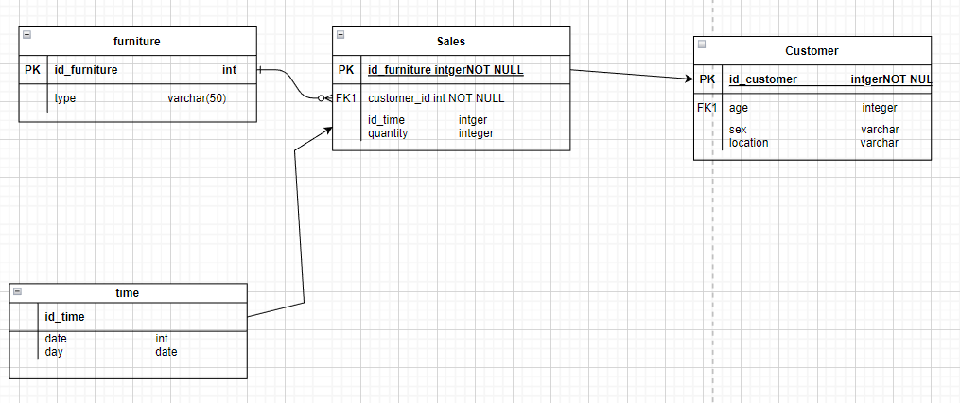

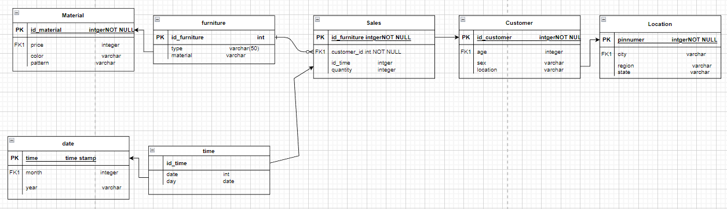

6. | Conclusions & Inferences

7. | Post Lab exercise

- Write an SQL query to “find list of total fee collected by each doctor in 2004” assuming the data is stored in a relational database with the schema fee (day, month, year, doctor, hospital, patient, count, charge).
- Justify your approach to deal with large dimension tables for the problem selected.
- Justify the use of junk dimension and surrogate key for the problem selected.
- Compare dimension table and fact table
- Compare star schema and snowflake schema

******************

