 | - To perform regression and apply Apriori algorithm on the given dataset using Weka

Name of Student | Hardik Prajapati | Roll No. | 9152
Sign here to indicate that you have read all relevant material provided /available on Moodle while performing and writing this experiment |  | Sign:

Late Submission Details (if any)
Reason(s) of late submission | Date of practical performance | Date of practical submission

References used
1 | Name and author of reference book(s) with page nos.
2 | Name and roll nos. of the peers whose help you have taken (if any)

Rubrics for assessment of Experiment:
Indicator | Poor | Average | Good
Timeliness  Maintains Experiment deadline (3) | Experiment not done (0) | One or More than One week late (1-2) | Maintains deadline (3)
Completeness and neatness  Complete all parts of Experiment (3) | N/A | < 80% complete (1-2) | 100% complete (3)
Originality  Extent of plagiarism (2) | Copied it from someone else (0) | At least try to implement but could not succeed (1) | Implemented (2)
Knowledge  In depth knowledge of the Experiment (2) | Unable to answer any questions (0) | Unable to answer few questions (1) | Able to answer all questions (2)

Assessment Marks:
Timeliness
Completeness and neatness
Originality
Knowledge
Total

Signature of Teacher with date

1. | Course, Subject & Experiment Details

Course & Branch | T.E. (ECS) | Estimated Time | 02 Hours Per Week
Current Semester | Semester V | Subject Name | DWM
Chapter No. & Unit | 4, 5 | Chapter Title | Association rule, classification
Experiment Type | Software Performance | Subject Code | ECC 604

2. | Aim & Objective of Experiment
- Understand different types of regression models
- Construct association rules for the given data set
3. | Expected Outcome of Experiment
- Apply linear and non-linear regression principals on the given data set
- Apply Apriori algorithm on the given data set and construct the association rules
4. | Theory and procedure of the experiment

Solve Exercise 1, 2, 3 and 4 from the following document:
https://drive.google.com/file/d/1V3ew96GNHd1ay4ba_Bhed9dOJV1Kvvmy/view?usp=share_link

4. | Output

Attach the screenshots of output above exercises and comment on the result of each exercise

Exercise 1:

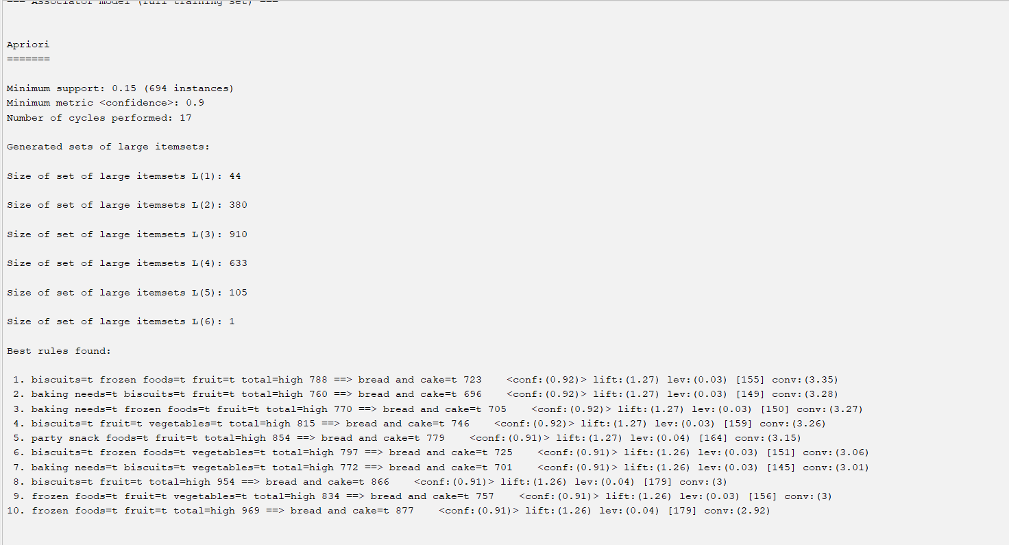

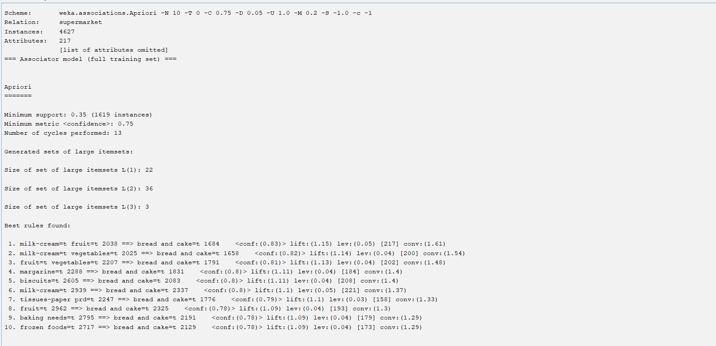

Exercise 2:

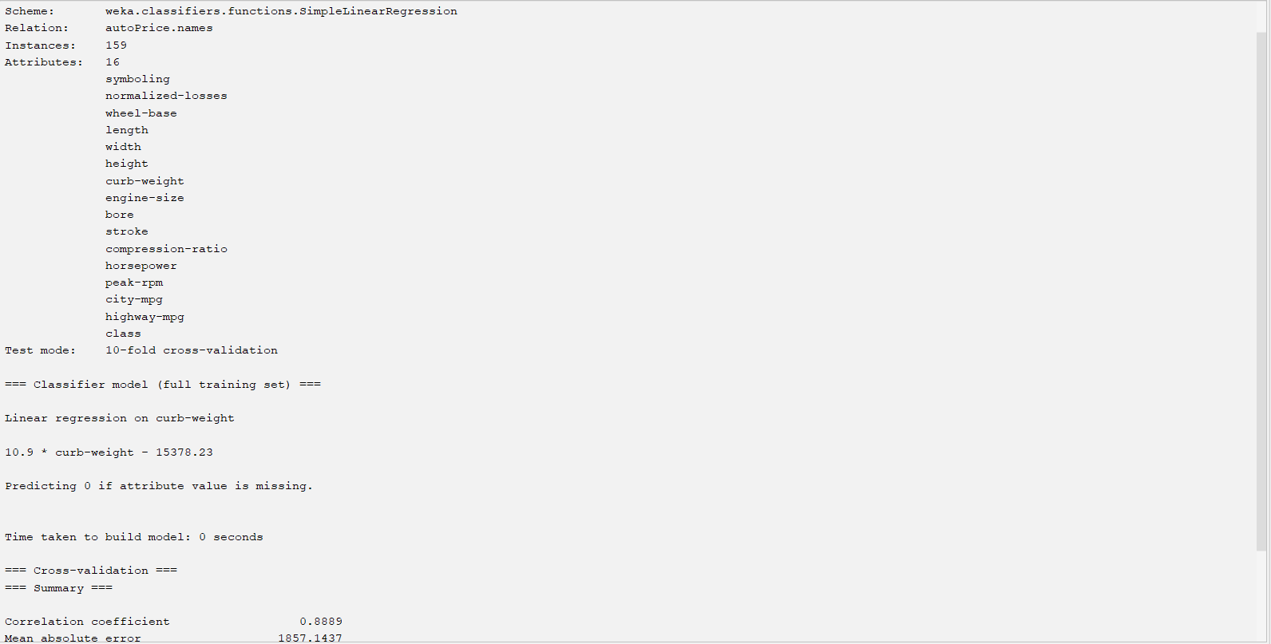

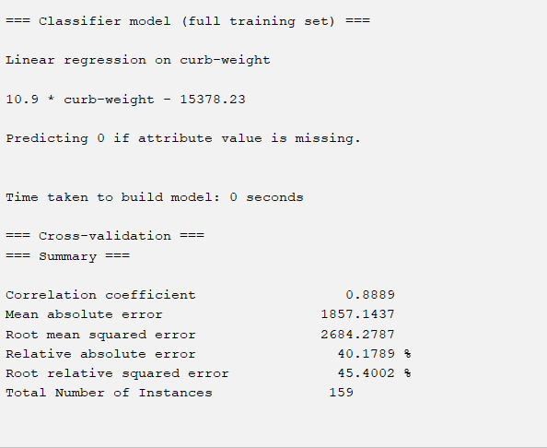

c.)

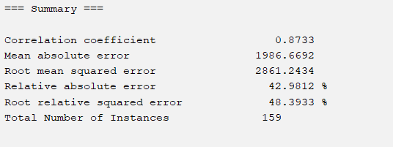

Exercise 3:

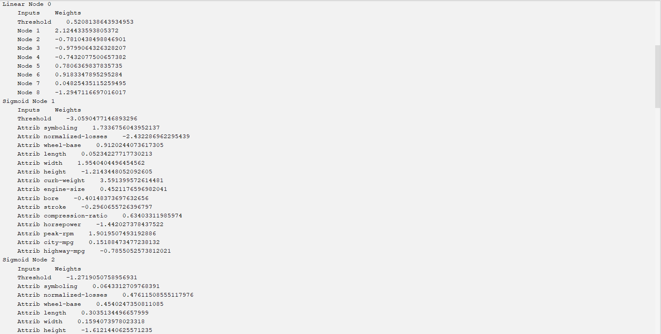

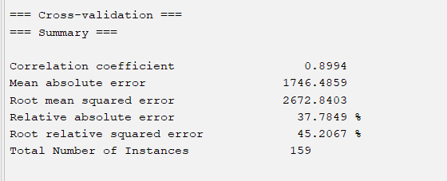

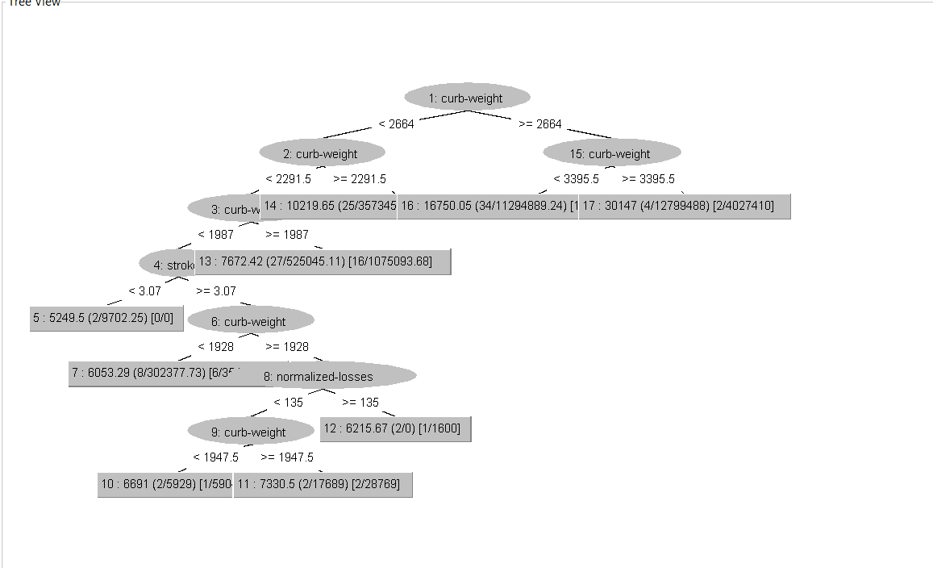

Exercise 4:

Linear Regression

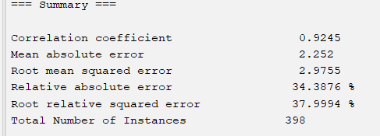

Perceptron Model:

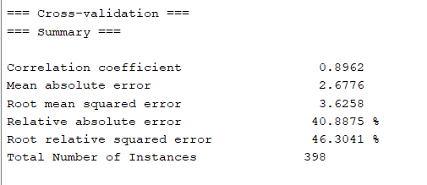

REP Tree:

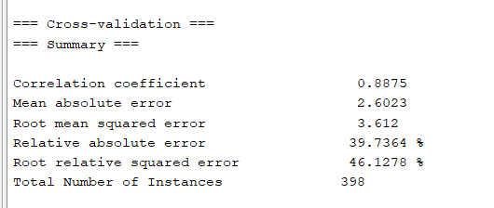

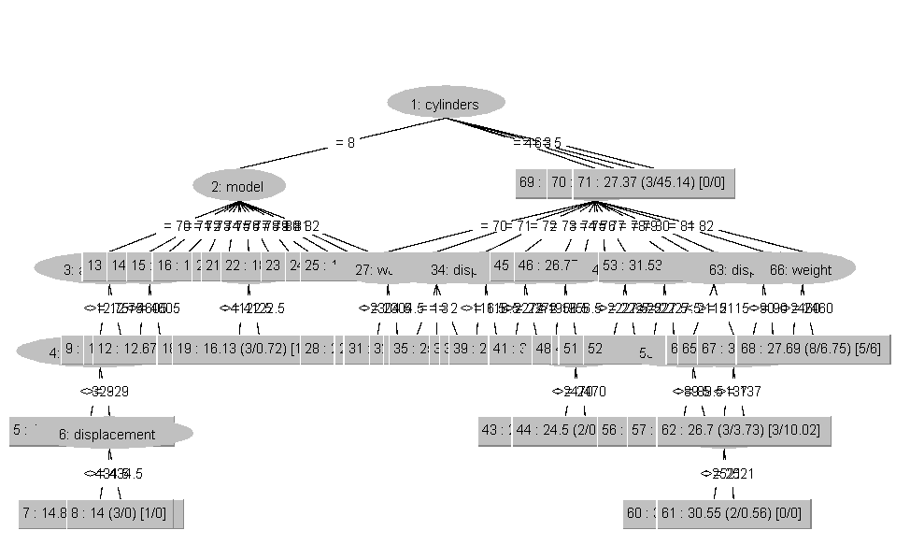

5. | Conclusions & Inferences

From this experiment, we have learnt how to use the Weka Functions for Perceptron Model and various other features present in the Weka application

6. | Post Lab exercise

- Describe multilayer perceptron in detail
- Describe mean absolute error

******************

