 | - To Implement Regression Analysis

Name of Student | Hardik Prajapati | Roll No. | 9152
Sign here to indicate that you have read all relevant material provided /available on Moodle while performing and writing this experiment |  | Sign:

Late Submission Details (if any)
Reason(s) of late submission | Date of practical performance | Date of practical submission

References used
1 | Name and author of reference book(s) with page nos.
2 | Name and roll nos. of the peers whose help you have taken (if any)

Rubrics for assessment of Experiment:
Indicator | Poor | Average | Good
Timeliness  Maintains Experiment deadline (3) | Experiment not done (0) | One or More than One week late (1-2) | Maintains deadline (3)
Completeness and neatness  Complete all parts of Experiment (3) | N/A | < 80% complete (1-2) | 100% complete (3)
Originality  Extent of plagiarism (2) | Copied it from someone else (0) | At least try to implement but could not succeed (1) | Implemented (2)
Knowledge  In depth knowledge of the Experiment (2) | Unable to answer any questions (0) | Unable to answer few questions (1) | Able to answer all questions (2)

Assessment Marks:
Timeliness
Completeness and neatness
Originality
Knowledge
Total

Signature of Teacher with date:

1. | Course, Subject & Experiment Details

Course & Branch | T.E. (ECS) | Estimated Time | 02 Hours Per Week
Current Semester | Semester V | Subject Name | DWM
Chapter No. & Unit | 3 | Chapter Title | Linear regression
Experiment Type | Software Performance | Subject Code | ECC 604

2. | Aim & Objective of Experiment
- Understand linear regression
3. | Expected Outcome of Experiment
- Demonstrate classifications, prediction, etc. on datasets using open source tools
4. | Code of the experiment

Batch – C
- Dataset for Simple regression:
https://drive.google.com/file/d/1w-1sFOO9OomxmDEQWTtxkQEd1av2DH5k/view?usp=share_link
Predict the salary based on years of experience. Predict the salary for the years of experience = 12.5

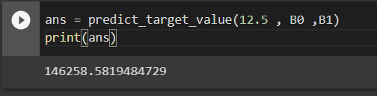

- Verify your result mathematically and using sklearn library of Python

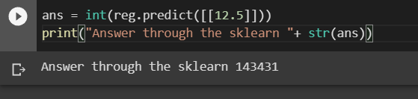

- Dataset for multiple regression:
https://drive.google.com/file/d/148rf83veuB1pfcM71t748A-yNFn4U7jK/view?usp=share_link

Predict the housing price given area = 3500 and bedrooms = 3
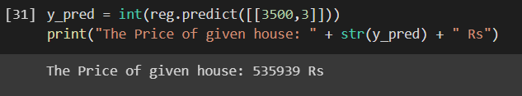

Code:
from google.colab import files
uploaded = files.upload()
import numpy as np
import pandas as pd

df = pd.read_csv('Salary_Data_2_variables.csv')

df.duplicated().sum()
df.isnull().sum()

df.head(10)

x = df['YearsExperience'].values
y = df['Salary'].values

x_mean = x.mean()
x_mean
y_mean = y.mean()
y_mean

df['x-x^2'] = (df['YearsExperience'] - x_mean )*(df['YearsExperience'] - x_mean )

x_var = df['x-x^2'].sum()/len(df['x-x^2'])

df['x-x_mean'] = df['YearsExperience'] - x_mean
df['y-y_mean'] = df['Salary'] - y_mean

df['(x-x_mean)*(y-y_mean)'] = df['x-x_mean']*df['y-y_mean']

co_var_x_y = (df['(x-x_mean)(y-y_mean)'].sum()) / (len(df['(x-x_mean)(y-y_mean)']) - 1)

co_var_x_y

B1 = co_var_x_y / x_var

B0 = y_mean - ( B1*x_mean)

def predict_target_value(x, b0, b1):
"""
Calculating the target (y) value using the input x and the coefficients b0, b1
:param x:
:param b0:
:param b1:
:return:
"""
return b0 + b1 * x

ans = predict_target_value(12.5 , B0 ,B1)
print(ans)

"""*MULTIPLE LINEAR REGRESSION*"""

from google.colab import files
uploaded = files.upload()
import numpy as np
import pandas as pd

df = pd.read_csv('Housing_Data_3_variables.csv')

df.head()

y = df['house_price'].values
x = df.drop(['house_price'],axis=1).values

from sklearn.model_selection import train_test_split
x_train, x_test, y_train, y_test = train_test_split( x, y, test_size=0.33, random_state=69)

from sklearn import linear_model
reg = linear_model.LinearRegression()
reg.fit(x_train,y_train)

x_test
y_pred = int(reg.predict([[3500,3]]))
print("The Price of given house: " + str(y_pred) + " Rs")
y_pred

5. | Conclusions & Inferences

Learnt the regression techniques for multiple variables.
6. | Post Lab exercise

- Plot the graph of the data using python. Show the regression line on the graph.
Write the code for the graph and attach the screenshot of the graph.
Write your roll no on graph.
