 | - Demonstrate working of different programming constructs

Name of Student |  | Roll No.

Late Submission Details (if any)
Reason(s) of late submission | Date of practical performance | Date of practical submission

Rubrics for assessment of Experiment:
Indicator | Poor | Average | Good
Timeliness  Maintains Experiment deadline (3) | Experiment not done (0) | One or More than One week late (1-2) | Maintains deadline (3)
Completeness and neatness  Complete all parts of Experiment (3) | N/A | < 80% complete (1-2) | 100% complete (3)
Originality  Extent of plagiarism (2) | Copied it from someone else (0) | At least try to implement but could not succeed (1) | Implemented (2)
Knowledge  In depth knowledge of the Experiment (2) | Unable to answer any questions (0) | Unable to answer few questions (1) | Able to answer all questions (2)

Assessment Marks:
Timeliness
Completeness and neatness
Originality
Knowledge
Total (Out of 10)

Signature of Teacher with date:

1. | Course, Subject & Experiment Details

Course & Branch | T.E. (ECS) | Estimated Time | 02 Hours Per Week
Current Semester | Semester V | Subject Name | STQA
Chapter No. & Unit | 1 | Chapter Title | Introduction
Experiment Type | Use of Programming Constructs | Subject Code | ECCDO501

2. | Aim & Objective of Experiment
- To demonstrate use of different programming constructs like loops and conditional statements in C Programming

4. | Questions

2 /*
*Note: Kindly attach screen shot of outputs for programming questions
What is the output of the following Program?
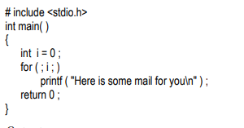
What is the output of the following Program?
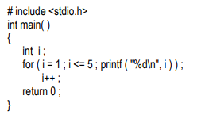
What is the output of the following Program?
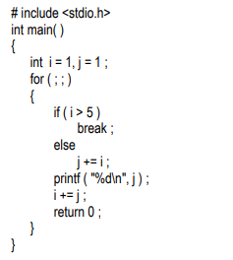
What is the output of the following program?

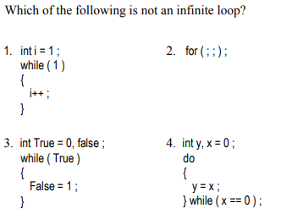
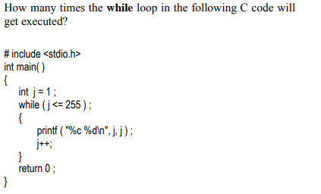
What is the output of the following program?
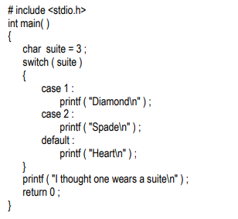
What is the output of the following program?
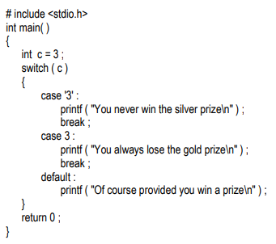
What is the output of the following program?
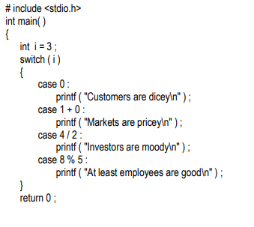
}
What is the output of the following program?
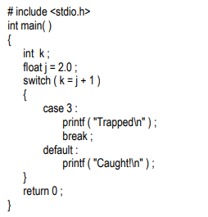
What is the output of the following program?
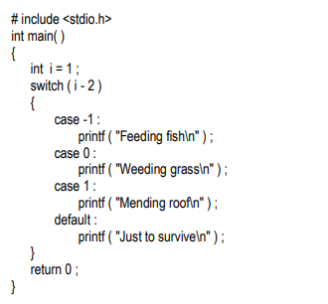
Given a string S consisting of alphabets and digits, find the frequency of each digit in the given string.
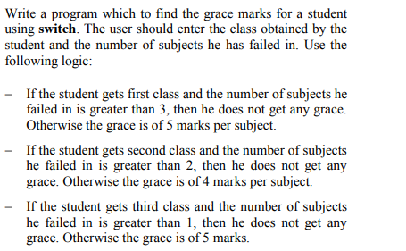
Write a program to fill the entire screen with a smiling face
