Launch to http://newtours.demoaut.com
Phase 1: New User Registration
Click on Register link
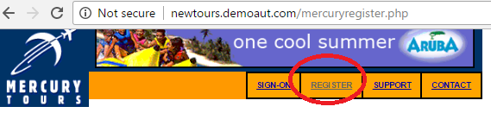
Fill the User Registration form using the information furnished in the Assignment.xml
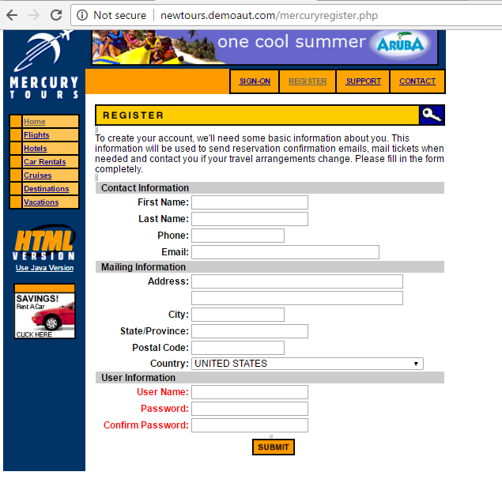

Phase 2:
Make sure that able to login with new username and password and verify that Flight Details
Section displayed.

