A project report on

DEEPFAKE SHORT VIDEO DETECTION USING
SPATIAL-TEMPORAL ATTENTION MODELS
Submitted in partial fulfillment for the award of the degree of
Bachelor of Technology in
Computer Science and Engineering (CSE)
by
Hardik Dahiya (22BCE1301)
Shaurya Naithani (22BCE1461)
Yash Srivastava (22BCE1968)

Guide: Dr. Geetha S. , Professor


SCHOOL OF COMPUTER SCIENCE AND ENGINEERING

April, 2026

DECLARATION
I hereby declare that the thesis entitled "DEEPFAKE SHORT VIDEO DETECTION USING SPATIAL-TEMPORAL ATTENTION MODELS" submitted by Hardik Dahiya (22BCE1301), for the award of the degree of Bachelor of Technology in Computer Science and Engineering (CSE), Vellore Institute of Technology, Chennai is a record of bonafide work carried out by me under the supervision of Dr. S. Geetha.

I further declare that the work reported in this thesis has not been submitted and will not be submitted, either in part or in full, for the award of any other degree or diploma in this institute or any other institute or university.

Place: Chennai
Date: Signature of the Candidate


School of Computer Science and Engineering
CERTIFICATE
This is to certify that the report entitled "Deepfake Short Video Detection Using Spatial-Temporal Attention Models" is prepared and submitted by Hardik Dahiya (22BCE1301) to Vellore Institute of Technology, Chennai, in partial fulfillment of the requirement for the award of the degree of B.Tech. in Computer Science and Engineering (CSE) is a bonafide record carried out under my guidance. The project fulfills the requirements as per the regulations of this University and in my opinion meets the necessary standards for submission. The contents of this report have not been submitted and will not be submitted either in part or in full, for the award of any other degree or diploma and the same is certified.
Signature of the Guide:
Name: Dr. Geetha S.
Date:
Signature of the Examiner Signature of the Examiner
Name: Name:
Date: Date:

Approved by the Head of Department,
Computer Science and Engineering (CSE)
Name: Dr. Prassanna J
Date:
ABSTRACT
Deepfake videos have become a genuine problem. Generated through generative adversarial networks and face-swapping pipelines, they are increasingly difficult to distinguish from authentic footage, and the consequences — for individuals, institutions, and public discourse — are real. This project builds a deepfake detection system that uses spatial-temporal attention to identify manipulation artifacts across both individual frames and frame sequences.
The architecture has three components: a ResNeXt-50 CNN backbone for per-frame spatial features, a CBAM attention module that learns which channels and regions are most discriminative, and a BiLSTM that models how those features evolve over time. Training runs in two phases — the backbone starts frozen while the attention and temporal layers learn, then the whole network is fine-tuned end-to-end with differential learning rates to avoid overwriting pretrained representations.
To make the system usable beyond a research notebook, we built a full web application. The FastAPI backend handles video uploads and inference; the React frontend provides risk gauges, adjustable detection thresholds, per-frame attention heatmaps, and session history. Videos go through MTCNN face detection, landmark-based alignment, and uniform frame sampling before reaching the model. On standard deepfake benchmarks, the approach achieves competitive accuracy, and the attention overlays give users a concrete reason why a video was flagged.
Keywords: Deepfake Detection, Spatial-Temporal Analysis, CBAM, BiLSTM, ResNeXt-50, Attention Mechanism, Face Forensics, Deep Learning, Web Application

ACKNOWLEDGEMENT
It is my pleasure to express with deep sense of gratitude to Dr. S. Geetha, Professor (Computer Science and Engineering, VIT Chennai), School of Computer Science and Engineering, Vellore Institute of Technology, Chennai, for his/her constant guidance, continual encouragement, understanding; more than all, he/she taught me patience in my endeavor. My association with him/her is not confined to academics only, but it is a great opportunity on my part of work with an intellectual and expert in the field of Deep Learning and Computer Vision.
It is with gratitude that I would like to extend my thanks to the visionary leader Dr. G. Viswanathan our Honorable Chancellor, Dr. Sankar Viswanathan, Dr. Sekar Viswanathan, Dr. G.V. Selvam Vice Presidents, Dr. Sandhya Pentareddy, Executive Director, Ms. Kadhambari S. Viswanathan, Assistant Vice-President, Dr. V. S. Kanchana Bhaaskaran Vice-Chancellor, Dr. T. Thyagarajan Pro-Vice Chancellor, VIT Chennai, Dr. K. Sathiyanarayanan, Director, Chennai Campus and Dr. P. K. Manoharan, Additional Registrar for providing an exceptional working environment and inspiring all of us during the tenure of the course.
Special mention to Dr. Viswanathan V, Dean, Dr. Nithyanandam P, Dr. Suganya G, Dr. Sweetlin Hemalatha C, Associate Deans, School of Computer Science and Engineering, Vellore Institute of Technology, Chennai for spending their valuable time and efforts in sharing their knowledge and for helping us in every aspect.
In jubilant state, I express ingeniously my whole-hearted thanks to Dr. Prassanna J, Head of the Department, B.Tech. Computer Science and Engineering (CSE) and the Project Coordinators for their valuable support and encouragement to take up and complete the thesis.
My sincere thanks to all the faculties and staffs at Vellore Institute of Technology, Chennai who helped me acquire the requisite knowledge. I would like to thank my parents for their support. It is indeed a pleasure to thank my friends who encouraged me to take up and complete this task.

Place: Chennai
Date: Hardik Dahiya

CONTENTS
ABSTRACT i
ACKNOWLEDGEMENT ii
LIST OF FIGURES iv
LIST OF TABLES vi
LIST OF ACRONYMS vii
CHAPTER 1 INTRODUCTION 1
1.1 Background and Motivation 1
1.2 Problem Statement 3
1.3 Objectives 4
1.4 Scope of the Project 5
1.5 Significance of the Project 6
1.6 Organization of the Report 6
CHAPTER 2 LITERATURE REVIEW 8
2.1 Introduction to Deepfake Generation 8
2.2 Spatial Detection Methods 10
2.3 Temporal Detection Methods 12
2.4 Attention Mechanisms in Detection 13
2.5 Hybrid and Multi-stream Approaches 14
2.6 Benchmark Datasets 15
2.7 Summary and Research Gap 17
CHAPTER 3 SYSTEM ARCHITECTURE AND DESIGN 19
3.1 Overall System Architecture 19
3.2 Data Flow Diagram 21
3.3 Module Design 22
3.4 Technology Stack 26
CHAPTER 4 IMPLEMENTATION 28
4.1 Environment Setup 28
4.2 Data Preprocessing Pipeline 29
4.3 Model Implementation 33
4.4 Training Pipeline 37
4.5 Backend API Implementation 40
4.6 Frontend Implementation 42
CHAPTER 5 RESULTS AND DISCUSSION 47
5.1 Experimental Setup 47
5.2 Evaluation Metrics 48
5.3 Training Results 49
5.4 Model Performance Analysis 51
5.5 Attention Visualization Analysis 52
5.6 Web Application Demo 53
5.7 Discussion 54
CHAPTER 6 CONCLUSION AND FUTURE WORK 56
6.1 Summary of Contributions 56
6.2 Key Findings 57
6.3 Limitations 57
6.4 Future Work 58
REFERENCES 60
APPENDIX A: Configuration Parameters 63
APPENDIX B: API Documentation 64
APPENDIX C: Project Directory Structure 65

LIST OF FIGURES
Figure 1.1 Growth of Deepfake Content Online (2019-2025) 2
Figure 1.2 Categories of Deepfake Manipulation Techniques 3
Figure 2.1 Generative Adversarial Network Architecture 9
Figure 2.2 Face Swap Pipeline Overview 10
Figure 2.3 Comparison of Detection Approaches 14
Figure 3.1 Overall System Architecture Diagram 19
Figure 3.2 Data Flow Diagram 21
Figure 3.3 Model Architecture: ResNeXt-50 + CBAM + BiLSTM 22
Figure 3.4 CBAM Module Architecture 23
Figure 3.6 Two-Phase Training Strategy 26
Figure 3.7 Frontend Component Hierarchy 26
Figure 4.1 Frame Sampling Strategies Comparison 30
Figure 4.2 MTCNN Face Detection Pipeline 31
Figure 4.3 Face Alignment Using Affine Transform 32
Figure 4.4 Data Augmentation Examples 33
Figure 4.5 ResNeXt-50 Block Structure 34
Figure 4.6 Channel Attention Mechanism 35
Figure 4.7 Spatial Attention Mechanism 35
Figure 4.8 BiLSTM Architecture for Temporal Modeling 36
Figure 4.9 FastAPI Endpoint Flow 41
Figure 4.10 Frontend Upload Interface (Light Mode) 43
Figure 4.11 Frontend Upload Interface (Dark Mode) 43
Figure 4.12 Risk Gauge Visualization 44
Figure 4.13 Frame Timeline with Attention Heatmaps 45
Figure 4.14 Analysis History Panel 46
Figure 5.1 Training Loss Curves (Phase 1 and Phase 2) 49
Figure 5.2 Training Accuracy Curves 50
Figure 5.3 ROC Curve 51
Figure 5.4 Confusion Matrix 52
Figure 5.5 Attention Heatmap: Real Video Frame 53
Figure 5.6 Attention Heatmap: Fake Video Frame 53
Figure 5.7 Web Application: Complete Analysis Result 54

LIST OF TABLES
Table 2.1 Comparison of Existing Deepfake Detection Methods 16
Table 3.1 Technology Stack 27
Table 4.1 Data Augmentation Parameters 33
Table 4.2 Model Configuration Parameters 37
Table 4.3 Training Hyperparameters 38
Table 4.4 Frontend Component Specifications 42
Table 5.1 Hardware and Software Specifications 47
Table 5.2 Dataset Distribution 48
Table 5.3 Phase 1 Training Results 50
Table 5.4 Phase 2 Training Results 51
Table 5.5 Overall Model Performance Metrics 52
Table 5.6 Per-Class Performance Metrics 52

LIST OF ACRONYMS
AI Artificial Intelligence
AMP Automatic Mixed Precision
API Application Programming Interface
AUC Area Under the Curve
BiLSTM Bidirectional Long Short-Term Memory
CBAM Convolutional Block Attention Module
CNN Convolutional Neural Network
CORS Cross-Origin Resource Sharing
CSS Cascading Style Sheets
CUDA Compute Unified Device Architecture
DFDC DeepFake Detection Challenge
DNN Deep Neural Network
EER Equal Error Rate
FPS Frames Per Second
GAN Generative Adversarial Network
GPU Graphics Processing Unit
HTML HyperText Markup Language
HTTP HyperText Transfer Protocol
JPEG Joint Photographic Experts Group
JSON JavaScript Object Notation
LSTM Long Short-Term Memory
MLP Multi-Layer Perceptron
MTCNN Multi-task Cascaded Convolutional Networks
REST Representational State Transfer
RGB Red Green Blue
ROC Receiver Operating Characteristic
ReLU Rectified Linear Unit
ResNeXt Residual Network with Aggregated Transformations
SE-Net Squeeze-and-Excitation Network

Chapter 1
INTRODUCTION
1.1 BACKGROUND AND MOTIVATION
Generating convincing fake video used to require a professional studio. Today it requires a laptop. Deep learning — particularly generative adversarial networks — has made synthetic media cheap to produce, and the results are often indistinguishable from authentic footage. This is what deepfake detection has to deal with.
The word "deepfake" traces back to 2017, when a Reddit user posted face-swapped videos made with deep learning. The technique spread fast. What started as celebrity face swaps became something more capable: systems that alter lip movements, transplant expressions, generate entirely synthetic faces. Off-the-shelf tools put this within reach of anyone with a computer. That accessibility is the core of the threat.
The harm is not hypothetical. Politicians have been shown saying things they never said. Private individuals have been targeted with non-consensual synthetic content, facing harassment and reputational damage. On the financial side, deepfake audio has been used to impersonate executives and authorize fraudulent wire transfers worth millions. Each domain has its own version of the problem, but the mechanism is the same.
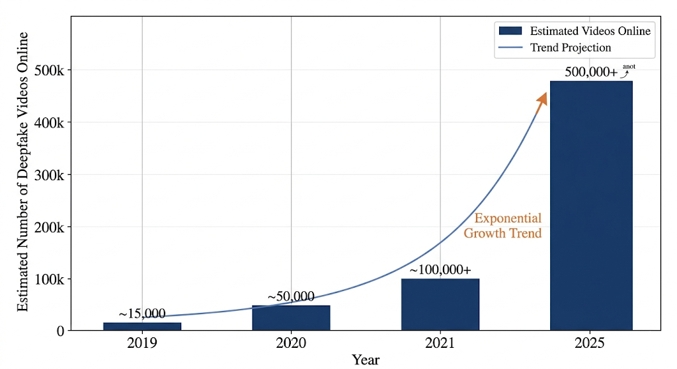
Figure 1.1: Growth of Deepfake Content Online (2019-2025)
The scale is growing fast. A 2023 Sensity AI report counted over 95,000 deepfake videos online — roughly doubling every six months. Generation is getting cheaper and better. Detection has to keep pace.
Early forensic methods — metadata checks, pixel-level artifact detection, flagging unnatural blinks — worked when the tools were crude. Modern generation has largely eliminated those tells. Blending boundaries are cleaner, lighting is more consistent, temporal artifacts are rarer. The problem has shifted from spotting obvious flaws to finding subtle statistical signatures the generation process leaves behind.
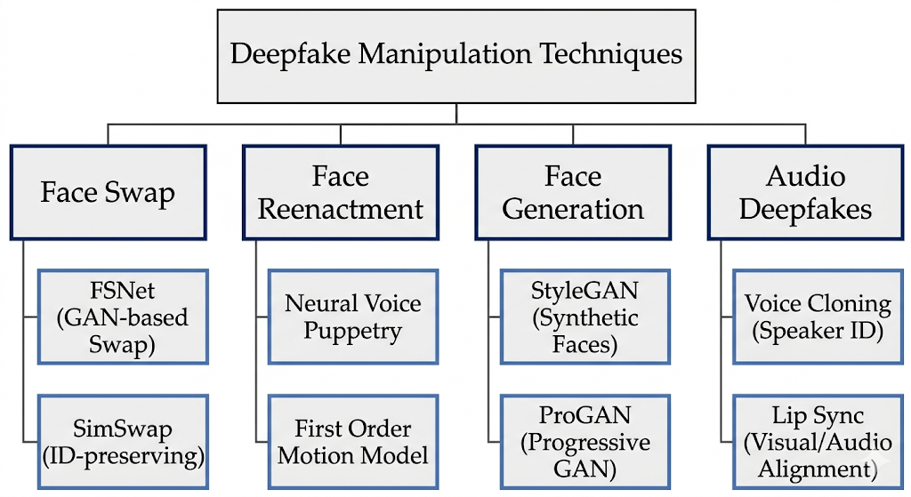Figure 1.2: Categories of Deepfake Manipulation Techniques
Neural detection has closed some of that gap. Using the same architectures that power generation, detectors can learn what "fake" looks like in feature space even when it is invisible to the eye. The problem is that most approaches treat detection as either a per-frame classification task or a sequence modeling task — rarely both at once, and rarely with attention that explains what the model noticed. That gap is what this project addresses.

1.2 PROBLEM STATEMENT
Existing methods have three concrete weaknesses we built around:
Frame-only models miss temporal evidence. Analyzing frames independently catches texture anomalies and blending artifacts, but deepfakes often show their seams over time — in head pose trajectories, unnatural expression transitions, flickering that only appears in sequence. A detector that never looks at sequences misses this entirely.
Most models produce a score and nothing else. For a forensic analyst deciding whether to act on a detection, "the model says fake" is not enough. Which regions triggered it? Does the pattern make sense? Without that, the system is a black box that is hard to trust in practice.
The research-to-deployment gap is real. A model with 95% benchmark accuracy is not automatically a usable tool. Most research prototypes have no interface and no API. We treated deployment as part of the problem, not an afterthought.
Our system addresses all three: it analyzes spatial and temporal features together, uses CBAM to make the process interpretable, and ships as a working web application anyone can use.
1.3 OBJECTIVES
The project objectives are:
1. To design and implement a model combining spatial and temporal analysis for robust deepfake detection in video content.
2. To integrate CBAM for learning discriminative spatial and channel-wise attention patterns that surface manipulation artifacts.
3. To use a Bidirectional LSTM to capture temporal inconsistencies and inter-frame relationships that indicate manipulation.
4. To implement a two-phase training strategy that uses pretrained ImageNet features effectively while enabling end-to-end fine-tuning.
5. To build preprocessing pipelines covering face detection (MTCNN), landmark-based alignment, and strategic frame sampling.
6. To deploy a full-stack web application with a FastAPI backend and React frontend accessible to non-technical users.
7. To provide interpretability through CBAM attention heatmap overlays showing which facial regions the model flagged.
8. To evaluate using accuracy, F1-score, AUC-ROC, and Equal Error Rate on standard benchmarks.
1.4 SCOPE OF THE PROJECT
This project covers the full development cycle — from data preprocessing and model design to web application deployment.
In scope: a spatial-temporal attention detection model, preprocessing pipeline (face detection, landmark-based alignment, frame sampling), training framework with two-phase training and mixed precision support, inference engine with attention visualization, REST API, and a responsive web interface. The system handles MP4, AVI, MOV, MKV, and WebM video formats.
Out of scope: real-time video stream analysis, audio deepfake detection, mobile application development, and cloud deployment. These are identified as future work. The system targets face-swap and face-reenactment deepfakes; entirely synthetic faces and text-to-video deepfakes are separate problems not addressed here.
1.5 SIGNIFICANCE OF THE PROJECT
The technical contribution is a unified architecture combining spatial features, attention-based refinement, and temporal modeling — components usually studied in isolation. Each module is independently replaceable, which matters for anyone wanting to swap in a different backbone or experiment with transformer-based temporal modeling.
The practical value is the web application itself. Most detection research stops at a trained checkpoint. We went further: there is a REST API, an interactive frontend, and attention overlays that explain the detection visually. That makes it usable by people who are not ML researchers.
The broader motivation is straightforward. Deepfakes are being used to spread disinformation and harm people. Better detection tools matter. This system is open and extensible — it can be adapted as generation techniques continue to evolve.
The project also works as a learning resource. Building a system like this requires combining model design, data engineering, training methodology, API development, and frontend work. The codebase is modular and documented, making it a useful reference for how these pieces fit together.
1.6 ORGANIZATION OF THE REPORT
The rest of this report is organized as follows:
Chapter 2: Literature Review provides a comprehensive survey of existing deepfake detection methods, covering spatial approaches, temporal approaches, attention mechanisms, hybrid methods, and benchmark datasets. The chapter identifies the research gap that motivates the proposed approach.
Chapter 3: System Architecture and Design presents the overall system architecture, data flow diagrams, and detailed module design for each component of the system including the preprocessing pipeline, model architecture, training framework, backend API, and frontend application.
Chapter 4: Implementation describes the detailed implementation of each system component, including code-level explanations of key algorithms, data structures, and design decisions.
Chapter 5: Results and Discussion presents the experimental setup, evaluation metrics, training results, model performance analysis, attention visualization results, and a demonstration of the web application.
Chapter 6: Conclusion and Future Work summarizes the contributions of this project, discusses limitations, and outlines directions for future improvement and extension.

Chapter 2
LITERATURE REVIEW
2.1 INTRODUCTION TO DEEPFAKE GENERATION
Deepfake generation and detection are two sides of the same problem. To build a detector that works, you need to understand what you are detecting. Generation techniques fall into four categories: face swapping, face reenactment, face editing, and fully synthetic face generation. Each leaves different artifacts, which is why detectors trained on one method often fail on another.
2.1.1 GENERATIVE ADVERSARIAL NETWORKS
Generative Adversarial Networks, introduced by Goodfellow et al. (2014), are the underlying engine for most modern deepfake methods. A GAN pits two networks against each other: a generator that synthesizes fake samples and a discriminator that tries to spot them. This adversarial loop pushes the generator toward increasingly realistic output. Key extensions include Progressive GAN (Karras et al., 2018) for high-resolution face synthesis, StyleGAN (Karras et al., 2019) for controllable facial attribute generation, and StarGAN (Choi et al., 2018) for multi-domain face transfer.
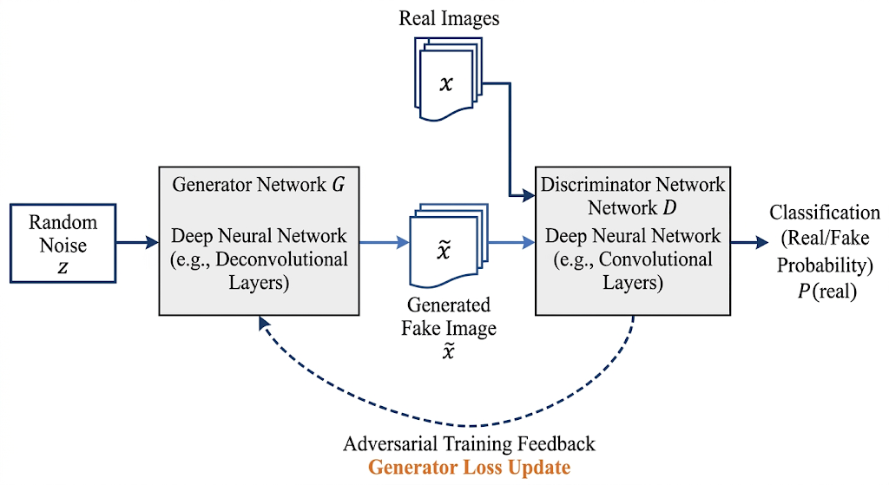
Figure 2.1: Generative Adversarial Network Architecture
2.1.2 FACE SWAP TECHNIQUES
Face swapping replaces one person's face in a video with another's while preserving the target's expressions, pose, and background. Modern approaches use shared encoder-decoder architectures where a common encoder maps faces to a latent space and separate decoders reconstruct each identity. DeepFaceLab (Perov et al., 2020) and FaceSwap are the most-used open-source implementations, both built on auto-encoder architectures trained with adversarial losses.
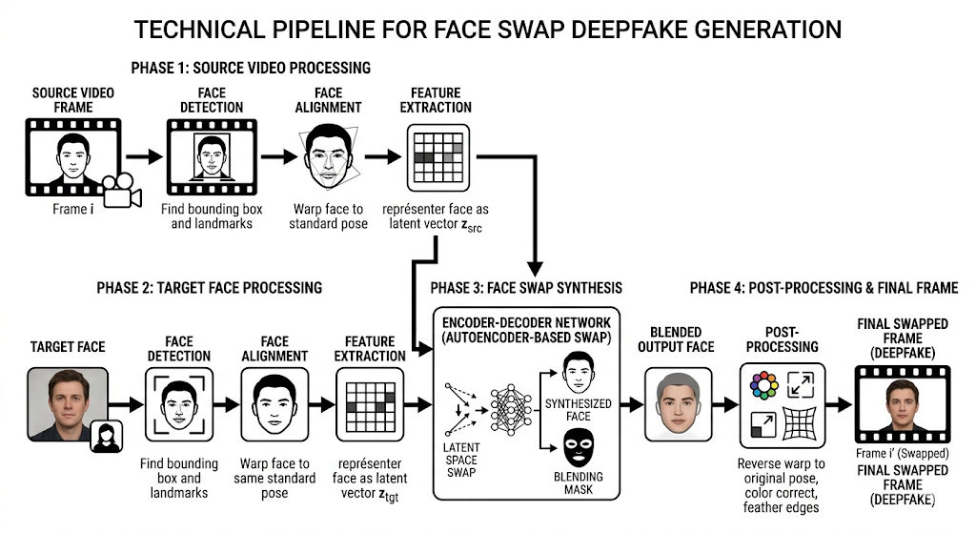Figure 2.2: Face Swap Pipeline Overview
2.1.3 FACE REENACTMENT
Face reenactment transfers the expressions and head movements of a driving video onto a target face, making the target appear to say or do things they never did. First Order Motion Model (Siarohin et al., 2019) achieves this without 3D face models by learning keypoints that represent motion. Face2Face (Thies et al., 2016) was an earlier real-time system using dense 3D face reconstruction to transfer expressions. Both approaches have been widely studied because they produce artifacts that are qualitatively different from face swapping.

2.2 SPATIAL DETECTION METHODS
Spatial detection methods analyze individual frames as images, treating detection as binary classification. They use convolutional networks to find artifacts in texture, color, or geometry that distinguish fake faces from real ones.
2.2.1 CNN-BASED APPROACHES
Rossler et al. (2019) compared several CNN architectures on the FaceForensics++ dataset and found XceptionNet to be a strong baseline, reaching over 99% accuracy on uncompressed videos and around 95% on lightly compressed content. The study also showed that compression significantly degrades detection performance, which motivated subsequent work on compression-robust training.
EfficientNet-based approaches have also performed well. Tan and Le (2019) showed that compound scaling of network depth, width, and resolution can achieve better accuracy with fewer parameters than manually tuned architectures. Several top finishers in the DeepFake Detection Challenge (DFDC) used EfficientNet backbones paired with face-specific preprocessing.
ResNet and its variants have been widely used for detection. He et al. (2016) introduced residual connections to enable deeper networks. ResNeXt (Xie et al., 2017) added grouped convolutions that provide richer feature representations without a proportional increase in parameters. We use ResNeXt-50 as our spatial backbone because it balances model capacity against computational cost and transfers well from ImageNet pretraining.
2.2.2 FREQUENCY DOMAIN ANALYSIS
Some researchers have looked at frequency domain features. Frank et al. (2020) showed that GAN-generated images leave artifacts in the high-frequency spectrum that are not visible in the spatial domain. Qian et al. (2020) built on this with F3-Net, which decomposes images by frequency and applies local statistics for detection. These approaches are complementary to spatial methods but still operate frame-by-frame.
2.3 TEMPORAL DETECTION METHODS
Temporal detection methods exploit the fact that deepfake generation is typically applied per-frame, which creates subtle inconsistencies in motion, expression transitions, and facial dynamics that only appear when analyzing a sequence.
Guera and Delp (2018) were among the first to apply recurrent networks for deepfake detection. They extracted per-frame CNN features and fed them into an LSTM, finding that temporal modeling improved results over frame-level classification, especially on face reenactment artifacts.
Sabir et al. (2019) extended this by targeting unnatural transitions in facial expressions. They showed that LSTM-based models could detect cases where generation models failed to replicate smooth motion, a limitation that per-frame detectors miss entirely.
3D Convolutional Networks (C3D) have also been explored for video-level detection. Unlike RNN-based approaches, 3D CNNs learn spatio-temporal features directly from video clips. The tradeoff is higher computational cost and greater data requirements.
2.4 ATTENTION MECHANISMS IN DETECTION
Attention mechanisms help models concentrate on the facial regions most likely to show manipulation. This has proven useful in deepfake detection because artifacts tend to be localized rather than global.
Hu et al. (2018) introduced Squeeze-and-Excitation Networks (SE-Net), which recalibrate feature maps by learning to weight channels based on their global statistics. The squeeze step pools each channel to a scalar; the excitation step uses a small MLP to produce per-channel weights. This recalibration was shown to improve performance across a range of vision tasks.
Woo et al. (2018) proposed CBAM, which extends channel attention with a complementary spatial attention branch. Applied sequentially, CBAM first decides which feature channels are most important, then which spatial locations to focus on. The channel attention branch uses both average and max pooling before a shared MLP; the spatial branch pools across channels and applies a convolutional layer to produce a spatial weight map. We adopt CBAM in this project because the sequential channel-then-spatial design fits naturally into a CNN pipeline and adds minimal computational overhead.
Self-attention and transformer-based approaches have also appeared. Heo et al. (2021) applied Vision Transformers (ViT) to face forgery detection, arguing that self-attention's global receptive field captures long-range facial dependencies better than CNNs. Transformers are powerful but generally require more data and compute to train effectively.

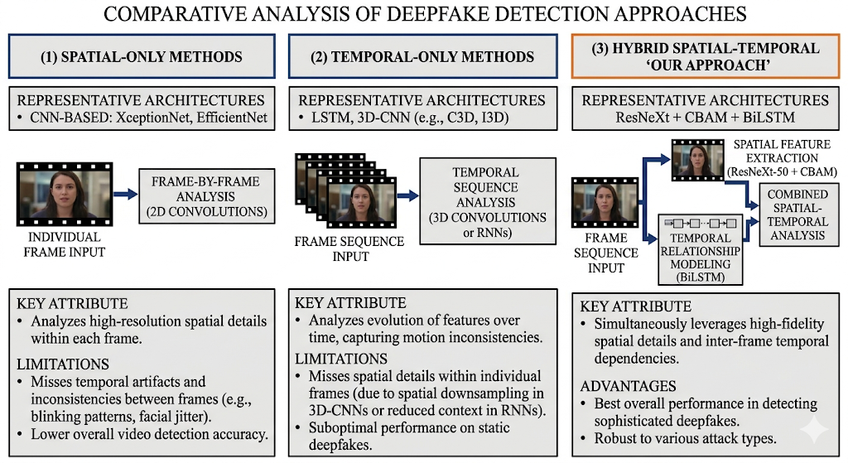
Figure 2.3: Comparison of Detection Approaches
2.5 HYBRID AND MULTI-STREAM APPROACHES
Several researchers have combined spatial and temporal analysis. Masi et al. (2020) used a two-branch network processing face images and their frequency components separately before fusing for classification. Zhou et al. (2021) built a multi-attentional framework using several attention maps to capture different types of artifacts.
Zhao et al. (2021) used attention maps from multiple network layers, capturing artifacts at different scales. Their results across multiple benchmarks showed that multi-scale attention is consistently useful.
Our architecture builds on these hybrid approaches. Where most methods use parallel branches for spatial and temporal processing, we sequence the steps: spatial features from ResNeXt-50 are refined by CBAM attention, then the sequence of refined features is processed by BiLSTM. This gives each stage clean input rather than mixing untreated features.
Li et al. (2021) combined frequency analysis with spatial attention, decomposing face images by frequency band and learning which bands matter most for detection. The approach works well on static frames but does not model temporal consistency.
The main difference between our method and existing hybrid approaches is end-to-end integration of all three stages — spatial features, attention refinement, and temporal modeling — plus a working web application. Most published systems report benchmark numbers without providing a deployment path.
2.6 BENCHMARK DATASETS
The major deepfake detection benchmarks are worth summarizing, since dataset choice significantly affects what a model learns to detect.
FaceForensics++ (Rossler et al., 2019) contains 1,000 original YouTube videos manipulated by four methods: Deepfakes, Face2Face, FaceSwap, and NeuralTextures. Videos are provided at three compression levels, making it useful for studying compression robustness.
The DFDC dataset (Dolhansky et al., 2020) is one of the largest, with over 100,000 video clips featuring 3,426 paid actors. It includes diverse manipulation methods, lighting conditions, and demographic variety, which makes it harder than single-method benchmarks.
Celeb-DF (Li et al., 2020) uses an improved synthesis algorithm that reduces visible artifacts compared to earlier tools. With 590 real videos and 5,639 deepfakes, it is a harder benchmark than FaceForensics++ because the manipulations are cleaner.
WildDeepfake (Zi et al., 2020) collects deepfake videos from the internet rather than generating them in controlled settings. It includes varied compression levels, resolutions, and manipulation quality, which makes it the most realistic test of real-world performance.
2.7 SUMMARY AND RESEARCH GAP
The literature points to three gaps. Frame-only methods miss temporal artifacts. Temporal methods do not always focus on the right spatial features. And very few systems combine spatial features, attention, and temporal modeling in a unified, end-to-end trainable framework. The deployment gap is equally notable: almost no published work provides a usable interface alongside the model.
There is also a consistency problem across benchmarks. Models trained on FaceForensics++ often perform poorly on DFDC or WildDeepfake, suggesting that current approaches learn dataset-specific artifacts rather than general manipulation signatures. Generalization across manipulation methods and real-world conditions remains an open problem.
This project addresses the architectural gap by integrating ResNeXt-50, CBAM attention, and BiLSTM into a single trainable system, with a web application that makes the results accessible and interpretable without requiring ML expertise.

Table 2.1: Comparison of Existing Deepfake Detection Methods
Method | Year | Architecture | Spatial | Temporal | Attention | Web UI
XceptionNet | 2019 | CNN | Yes | No | No | No
Guera & Delp | 2018 | CNN + LSTM | Yes | Yes | No | No
EfficientNet-B4 | 2020 | CNN | Yes | No | No | No
F3-Net | 2020 | Freq + CNN | Yes | No | No | No
Multi-Attention | 2021 | CNN + Attn | Yes | No | Yes | No
Sabir et al. | 2019 | CNN + RNN | Yes | Yes | No | No
Ours | 2026 | ResNeXt+CBAM+BiLSTM | Yes | Yes | Yes | Yes

Chapter 3
SYSTEM ARCHITECTURE AND DESIGN
3.1 OVERALL SYSTEM ARCHITECTURE
The system is built around six loosely coupled modules: preprocessing, model, training, evaluation, backend API, and frontend. Each module has a defined interface and can be modified without breaking the others. This separation was a deliberate choice — early in the project, we changed the face detection backend and the training pipeline simultaneously without touching the model code, which validated the design.
The user-facing flow is: upload a video through the React frontend, receive a JSON response with prediction, confidence, and frame-level heatmaps. Under the hood, the FastAPI backend saves the upload to a temporary file, runs it through the preprocessing pipeline (face detection, alignment, normalization), feeds the result to the detection model, and returns a structured response. The frontend renders a risk gauge, frame timeline, and attention overlays.

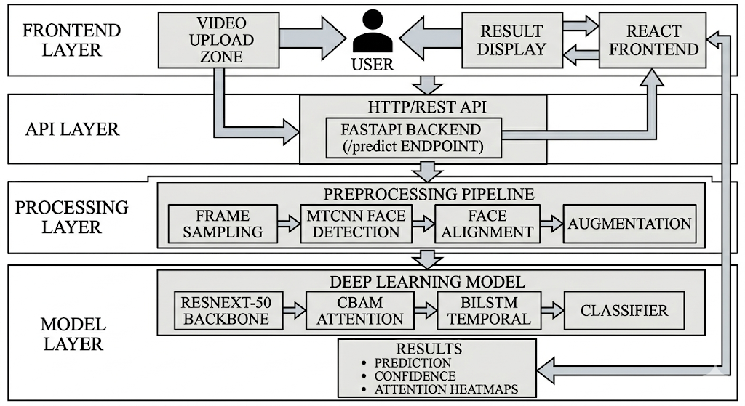
Figure 3.1: Overall System Architecture Diagram
A few design decisions shaped the architecture. The preprocessing pipeline is decoupled from the model, so different strategies can be tested without touching model code. Configuration is centralized in a single Config dataclass, so switching from ResNeXt-50 to another backbone means changing one value. Training supports checkpointing and resumption, which mattered during development when we had to pause and restart long runs. The API is stateless and loads the model once at startup, which keeps inference latency low.
We also built the system to be extensible without over-engineering it. New preprocessing steps plug into the pipeline without changes to the dataset class. The training framework supports different loss functions and schedulers through configuration. Frontend components are independent widgets — adding a new visualization means writing one new component, not modifying existing ones.
Error handling is implemented at each boundary. The preprocessing pipeline handles corrupted video files, missing faces, and insufficient landmarks through fallback mechanisms rather than crashing. The API validates file types and returns appropriate HTTP error codes. The frontend shows user-friendly messages for network failures and unsupported formats.
3.2 DATA FLOW DIAGRAM
The data path from video to prediction: 16 frames are sampled from the video (uniform or uniform-random strategy). Each frame goes through MTCNN face detection to locate and crop the face region. The crop is aligned using landmark-based affine transformation to normalize position and orientation. The aligned face is resized to 224x224, converted to RGB, and normalized with ImageNet statistics (mean=[0.485, 0.456, 0.406], std=[0.229, 0.224, 0.225]).

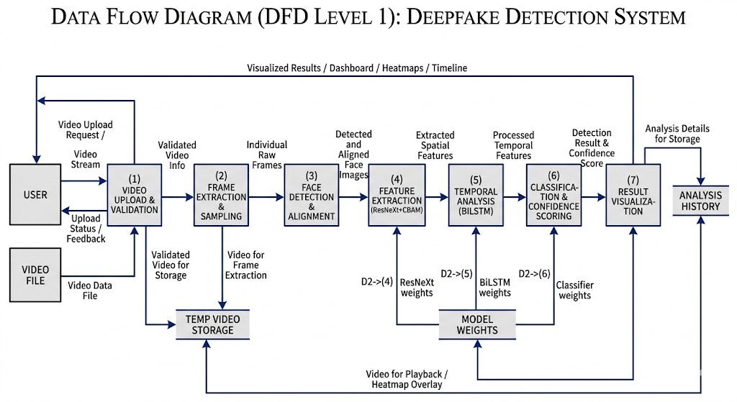Figure 3.2: Data Flow Diagram

The resulting tensor of shape (1, 16, 3, 224, 224) enters the model. ResNeXt-50 extracts 2048-dimensional spatial features from each frame. CBAM refines these through sequential channel and spatial attention. Global average pooling produces a (1, 16, 2048) sequence. BiLSTM processes this sequence to a 1024-dimensional representation (512 forward + 512 backward, concatenated). The classifier head produces two output logits, which softmax converts to class probabilities.

3.3 MODULE DESIGN
3.3.1 PREPROCESSING MODULE
The preprocessing module converts raw video files into normalized tensors. It has four components: FrameSampler, FaceDetector, FaceAligner, and augmentation transforms.
FrameSampler supports three strategies. Uniform sampling selects frames at equal intervals, giving consistent temporal coverage. Random sampling introduces data variation during training. Uniform-random picks evenly-spaced base positions then adds up to 30% random jitter per step — this gives coverage with stochastic variation, which we found useful for regularization during training.
FaceDetector uses MTCNN as the primary backend (minimum face size 60px, detection thresholds [0.6, 0.7, 0.7], 40px face margin). When MTCNN fails — which happens on extreme angles or partial occlusion — RetinaFace from InsightFace serves as a fallback. Having two backends improved detection rate noticeably on low-quality test videos.
FaceAligner normalizes detected faces using five reference landmarks: left eye, right eye, nose tip, and mouth corners. It estimates a partial affine transform from detected landmarks to reference positions and warps the face accordingly. When landmark detection fails, it falls back to center-crop resizing. The alignment step matters for temporal consistency — without it, small head movements produce large feature variations that confuse the BiLSTM.

3.3.2 MODEL MODULE
The model is implemented as a DeepfakeDetector class with three stages.

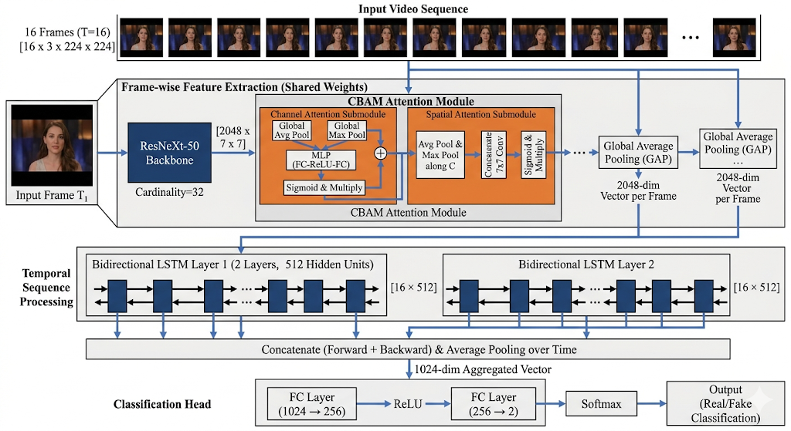
Figure 3.3: Model Architecture: ResNeXt-50 + CBAM + BiLSTM

The spatial backbone is ResNeXt-50 (32x4d), loaded with pretrained ImageNet weights via the timm library. The original classifier head is removed and global pooling is disabled, preserving spatial feature maps of shape (B, 2048, 7, 7). CBAM is applied to these maps before global average pooling reduces them to 2048-dimensional per-frame vectors.

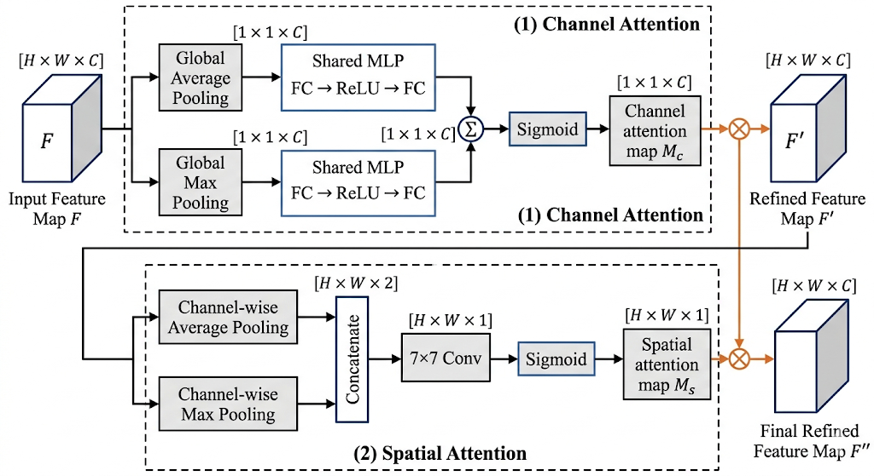
Figure 3.4: CBAM Module Architecture
The temporal model is a 2-layer Bidirectional LSTM with 512 hidden units per direction and 0.3 inter-layer dropout. It processes the 16-frame feature sequence and produces a 1024-dimensional output by concatenating the final hidden states of the forward and backward passes. Layer normalization is applied to the output — this stabilized training considerably compared to the version without it.
The classification head is: Dropout(0.6), Linear(1024, 256), ReLU, Dropout(0.3), Linear(256, 2). The two outputs are the real and fake logits. The high dropout before the first linear layer was needed to prevent the classifier from memorizing training-set patterns; this was adjusted during development after observing overfitting on the training split.
3.3.3 TRAINING MODULE
The training module implements a two-phase strategy. Phase 1 freezes the ResNeXt-50 backbone for 15 epochs, training only CBAM, BiLSTM, and the classifier. This lets the attention and temporal modules develop without disrupting pretrained spatial features. Phase 2 unfreezes everything for end-to-end fine-tuning, using a 10x lower learning rate for the backbone than the rest of the network to avoid overwriting useful pretrained representations.

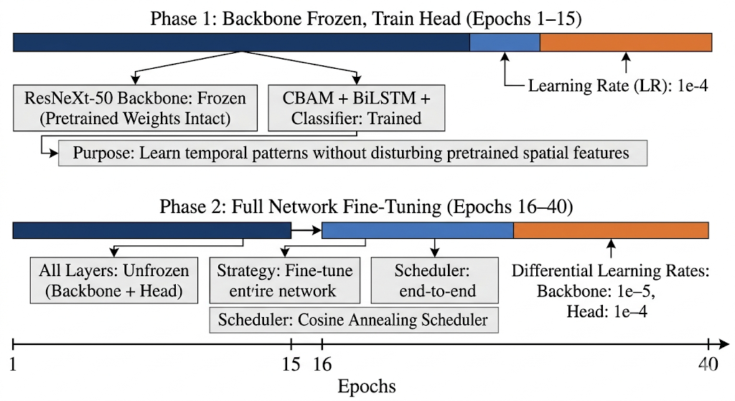Figure 3.6: Two-Phase Training Strategy
3.3.4 INFERENCE MODULE
The inference module returns a structured result: prediction label, confidence, fake probability, processing metadata (frames analyzed, total frames, duration, processing time, device), and optionally per-frame attention heatmaps as base64-encoded JPEG overlays. The heatmap generation was added after we realized that a binary prediction without explanation was not useful for review purposes.
3.3.5 API MODULE
The backend is a FastAPI application. The /predict endpoint accepts multipart video uploads and returns JSON. CORS is configured to allow cross-origin requests from the React frontend. The model loads once at server startup — not per request — which was necessary to keep inference under the response timeout.

3.3.6 FRONTEND MODULE
The frontend is a React 18 application. App.js orchestrates state: file selection, results, loading status, detection threshold, analysis history, and theme preference. Ten components handle specific responsibilities: Header, UploadZone, ProgressIndicator, ResultCard, RiskGauge, ProcessingDetails, FrameTimeline, AnalysisHistory, InfoGrid, and Footer. The threshold is adjustable client-side, which lets users recalculate the classification without re-running inference.
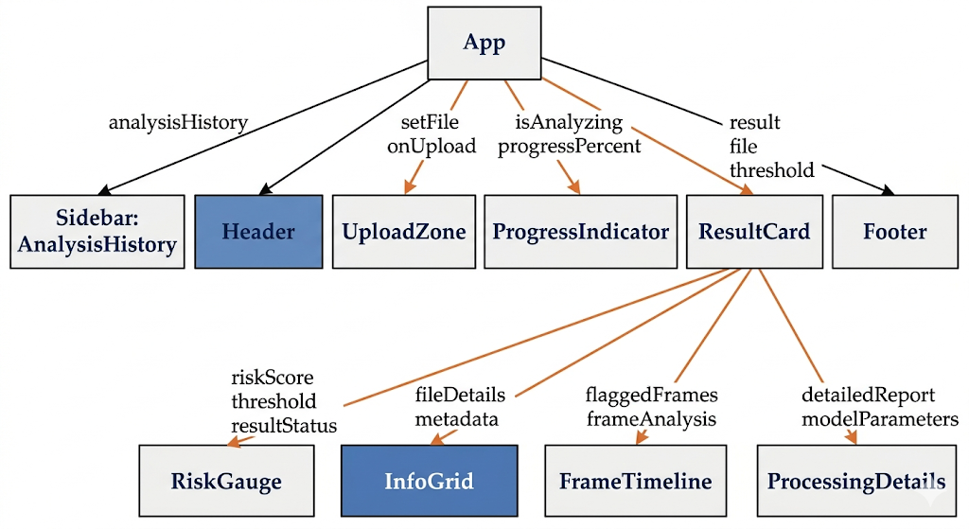Figure 3.7: Frontend Component Hierarchy

3.4 TECHNOLOGY STACK
Table 3.1: Technology Stack
Category | Technology | Version | Purpose
Language | Python | 3.10+ | Backend, model training
Language | JavaScript (ES6+) | ES2020 | Frontend application
Deep Learning | PyTorch | 2.0+ | Model implementation and training
Model Library | timm | 0.9+ | Pretrained ResNeXt-50 backbone
Face Detection | facenet-pytorch | 2.5+ | MTCNN face detection
Image Processing | OpenCV | 4.8+ | Video I/O, image transforms
Data Augmentation | torchvision | 0.15+ | Training augmentations
Web Framework | FastAPI | 0.100+ | REST API server
Frontend | React | 18.2 | User interface
HTTP Client | Axios | 1.5+ | API communication
Metrics | scikit-learn | 1.3+ | Evaluation metrics
Visualization | Matplotlib | 3.7+ | Training curves, heatmaps
ASGI Server | Uvicorn | 0.23+ | FastAPI server

Chapter 4
IMPLEMENTATION
4.1 ENVIRONMENT SETUP
The development environment runs on WSL2 (Ubuntu on Windows Subsystem for Linux 2), which gives a native Linux kernel while using Windows GPU drivers for CUDA. This setup worked well for development — the Linux toolchain for PyTorch and FastAPI, with GPU access that would otherwise require a dual-boot setup. Core tools: Python 3.10, PyTorch 2.0, Node.js 18.
The Python environment includes PyTorch with CUDA support, timm for pretrained architectures, facenet-pytorch for MTCNN, OpenCV for video I/O, FastAPI with Uvicorn for the API, and scikit-learn for metrics. The frontend uses Create React App with Axios for HTTP. Most of these were already familiar; timm was new to us and turned out to be the right choice for loading ResNeXt variants with pretrained weights.
The project is organized into focused packages: preprocessing, models, training, evaluation, utils, and app. Each package is a Python module with an __init__.py and contains purpose-built files. This structure made it straightforward to work on one component without worrying about side effects on others.
4.2 DATA PREPROCESSING PIPELINE
4.2.1 FRAME SAMPLING
Frame sampling is implemented in preprocessing/frame_sampler.py. The FrameSampler class has three strategies for selecting which frames from a video to analyze.
Uniform sampling uses NumPy's linspace to select frames at equal intervals from 0 to total_frames-1. This guarantees temporal coverage across the full video, which matters for detecting artifacts that appear at specific points in the sequence rather than consistently throughout.
# Uniform sampling
indices = np.linspace(0, total - 1, n, dtype=int).tolist()
# Uniform-random sampling with jitter
base = np.linspace(0, total - 1, n, dtype=float)
step = (total - 1) / max(n - 1, 1)
jitter = np.random.uniform(-step * 0.3, step * 0.3, n)
indices = np.clip(base + jitter, 0, total - 1).astype(int)
The uniform_random strategy, used during training, starts with the same uniform base positions and adds random jitter of up to 30% of the inter-frame step size. This means every epoch sees a slightly different set of frames from the same video, which acts as temporal data augmentation without risking clustering frames in a small segment.

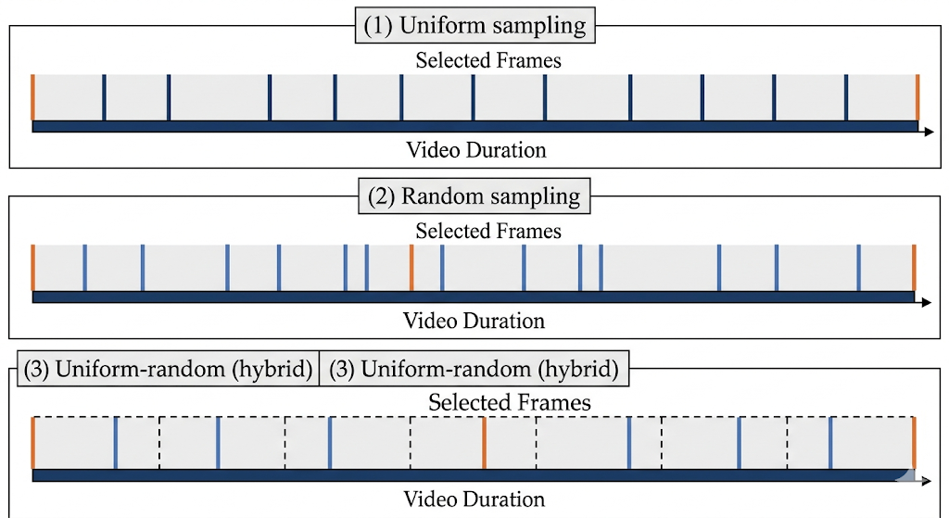Figure 4.1: Frame Sampling Strategies Comparison
4.2.2 FACE DETECTION
Face detection is in preprocessing/face_detector.py. FaceDetector supports two backends: MTCNN as the primary detector and RetinaFace as fallback. Both are lazily initialized to avoid loading unused dependencies.
MTCNN runs a three-stage cascade — P-Net for coarse proposals, R-Net for refinement, O-Net for precise boxes and landmarks — configured with min_face_size=60px, thresholds=[0.6, 0.7, 0.7], margin=40px, and factor=0.709 for the image pyramid. These settings were tuned to balance recall on small faces against false positives on non-face regions.

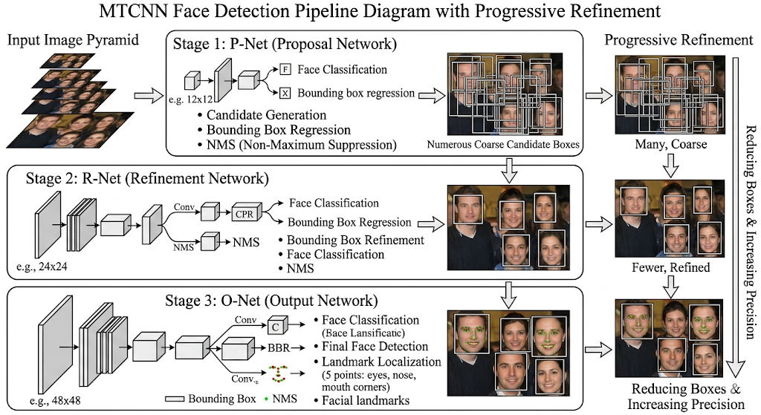Figure 4.2: MTCNN Face Detection Pipeline
When MTCNN detects multiple faces, we take the highest-confidence detection. The face is cropped with the configured margin added on all sides. If no face is detected at all, we fall back to a center-crop of the largest centered square. The fallback is imperfect — it may not capture the face — but it prevents crashes on frames where detection fails.
def _crop_face(self, frame, box):
h, w = frame.shape[:2]
x1 = max(0, box[0] - self.margin)
y1 = max(0, box[1] - self.margin)
x2 = min(w, box[2] + self.margin)
y2 = min(h, box[3] + self.margin)
if (x2 - x1) < self.min_face_size or (y2 - y1) < self.min_face_size:
return None
return frame[y1:y2, x1:x2]
4.2.3 FACE ALIGNMENT
Face alignment is in preprocessing/face_aligner.py. FaceAligner maps detected landmarks to five reference positions on a canonical 224x224 face: left eye (70, 112), right eye (154, 112), nose tip (112, 150), left mouth corner (78, 180), right mouth corner (146, 180).
OpenCV's estimateAffinePartial2D estimates a partial affine transform from detected landmarks to reference positions, handling rotation, scale, and translation. The face is warped using BORDER_REFLECT_101 to avoid black borders. When landmark detection fails, we fall back to center-crop resize. We added alignment after noticing that unaligned face crops caused large variance in per-frame features, which confused the BiLSTM — head rotation that was unrelated to the manipulation appeared as a temporal signal.
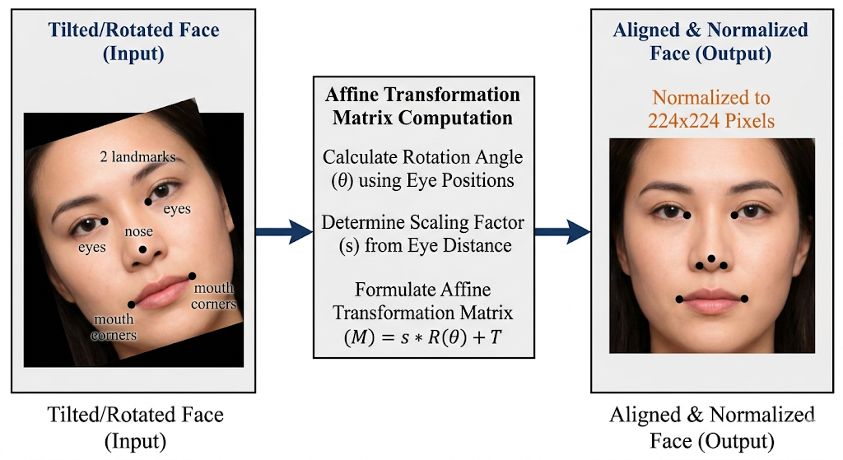Figure 4.3: Face Alignment Using Affine Transform
4.2.4 DATA AUGMENTATION
The augmentation pipeline in preprocessing/augmentation.py uses torchvision transforms. The training pipeline applies horizontal flip (p=0.5), rotation (up to 10 degrees), color jitter (brightness/contrast ±20%, saturation ±10%, hue ±5%), occasional Gaussian blur (p=0.2, sigma 0.1-1.0), ImageNet normalization, and random erasing (p=0.1, 2-10% area). Each transform is intentionally mild — aggressive augmentation on faces tends to destroy the subtle artifacts that the model needs to learn to detect.
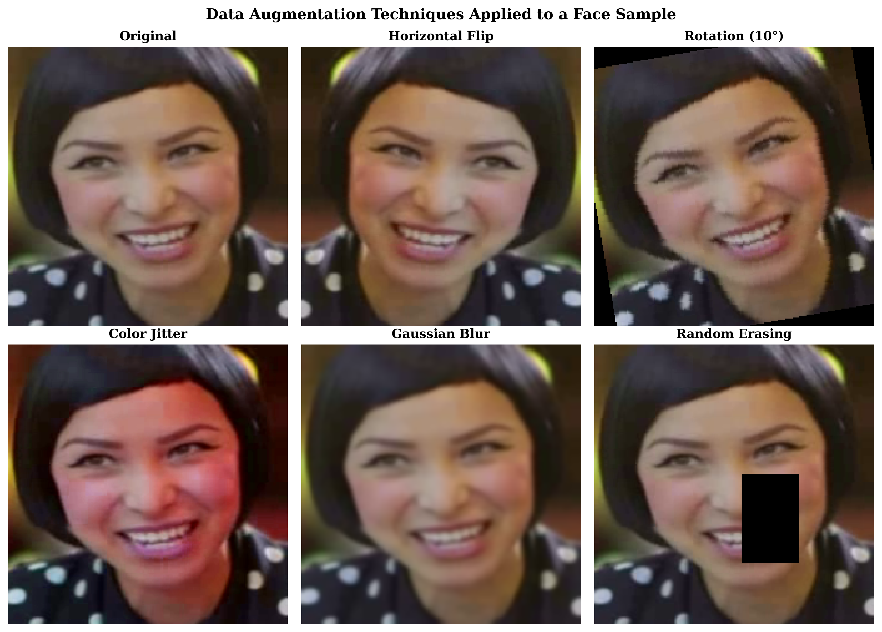
Figure 4.4 Applied Data Augmentation Techniques
Table 4.1: Data Augmentation Parameters
Augmentation | Parameter | Value | Purpose
Random Horizontal Flip | Probability | 0.5 | Mirror invariance
Random Rotation | Degrees | 10 | Pose variation
Color Jitter | Brightness | 0.2 | Lighting variation
Color Jitter | Contrast | 0.2 | Contrast robustness
Color Jitter | Saturation | 0.1 | Color robustness
Color Jitter | Hue | 0.05 | Color shift robustness
Gaussian Blur | Kernel/Probability | 3 / 0.2 | Compression simulation
Random Erasing | Scale/Probability | 0.02-0.1 / 0.1 | Occlusion robustness
Normalize | Mean | (0.485, 0.456, 0.406) | ImageNet standardization
Normalize | Std | (0.229, 0.224, 0.225) | ImageNet standardization

def get_train_transforms(size=(224, 224)):
return T.Compose([
T.ToPILImage(),
T.Resize(size),
T.RandomHorizontalFlip(p=0.5),
T.RandomRotation(degrees=10),
T.ColorJitter(brightness=0.2, contrast=0.2,
saturation=0.1, hue=0.05),
T.RandomApply([T.GaussianBlur(3, (0.1, 1.0))], p=0.2),
T.ToTensor(),
T.Normalize(mean=IMAGENET_MEAN, std=IMAGENET_STD),
T.RandomErasing(p=0.1, scale=(0.02, 0.1)),
])
4.3 MODEL IMPLEMENTATION
4.3.1 SPATIAL BACKBONE
The spatial backbone is in models/backbone.py as SpatialBackbone. It uses ResNeXt-50 with the 32x4d configuration: 32 groups, 4 channels per group per bottleneck block.
We load the model from timm with pretrained ImageNet weights and remove the classification head and global pooling (num_classes=0, global_pool=''). This preserves spatial feature maps of shape (B, 2048, 7, 7) from a 224x224 input — 2048 feature channels over a 7x7 spatial grid. CBAM is applied to these maps before global average pooling reduces them to 2048-dimensional per-frame vectors.

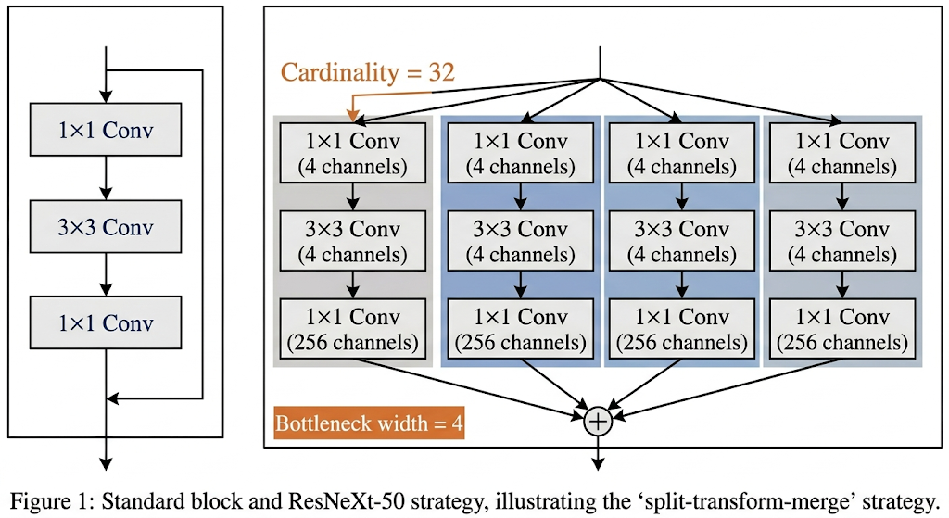Figure 4.5: ResNeXt-50 Block Structure
4.3.2 CBAM MODULE
The attention module is in models/cbam.py, split into three classes: ChannelAttention, SpatialAttention, and CBAM.
ChannelAttention compresses each feature map channel to a single value using both global average pooling and global max pooling, producing two (B, C) vectors. Both pass through a shared two-layer MLP (reduction ratio 16: 2048 channels to 128 to 2048), their outputs are summed, and a sigmoid produces per-channel weights in [0, 1]. These weights are multiplied into the input feature map. The dual pooling was important — max pooling alone tends to respond to the strongest activation in each channel, while average pooling captures the typical activation; using both gives a more stable attention signal.

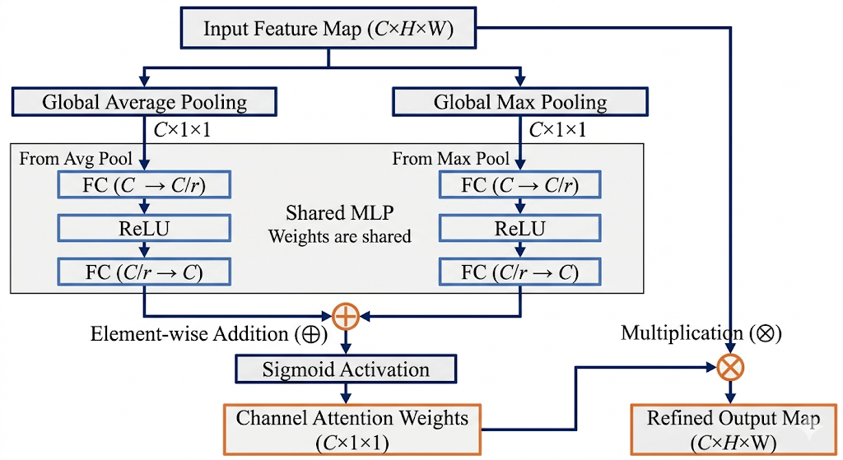
Figure 4.6: Channel Attention Mechanism

SpatialAttention takes the channel-refined feature map and computes average and max pooling along the channel axis, producing two (B, 1, H, W) maps. These are concatenated and passed through a 7x7 convolution (padding=3 to preserve spatial size) followed by sigmoid. The result is a spatial weight map highlighting which spatial locations the model considers most relevant. A 7x7 receptive field for the attention conv was chosen following Woo et al. (2018)'s finding that larger kernels perform better for spatial attention.
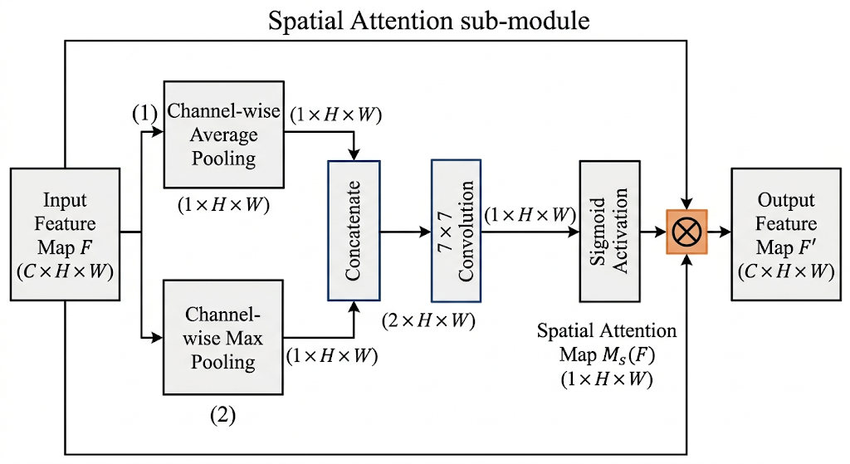Figure 4.7: Spatial Attention Mechanism
class CBAM(nn.Module):
def __init__(self, in_channels, reduction=16, kernel_size=7):
super().__init__()
self.channel_attn = ChannelAttention(in_channels, reduction)
self.spatial_attn = SpatialAttention(kernel_size)
def forward(self, x):
x = self.channel_attn(x) # Channel-wise refinement
x = self.spatial_attn(x) # Spatial refinement
return x
4.3.3 BILSTM TEMPORAL MODEL
The temporal model is in models/temporal.py as TemporalModel: a 2-layer Bidirectional LSTM, 512 hidden units per direction, 0.3 inter-layer dropout.

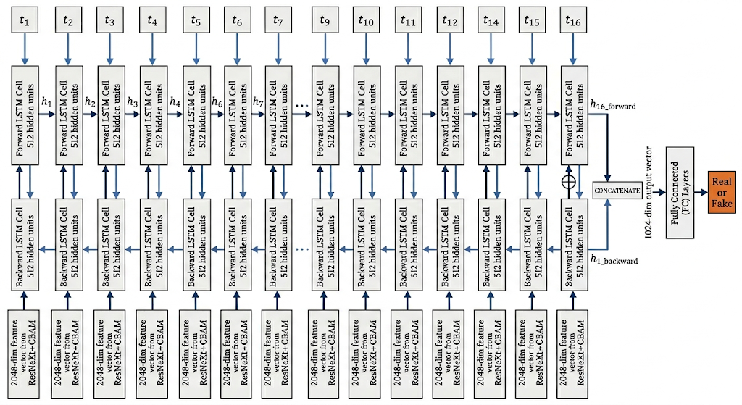Figure 4.8: BiLSTM Architecture for Temporal Modeling
The output is the concatenation of the final forward and backward hidden states from the last layer, giving a 1024-dimensional vector. Layer normalization is applied before returning — without this, we observed gradient instability in early training epochs, particularly when the BiLSTM was receiving features from a rapidly changing backbone during Phase 1.
We chose BiLSTM over unidirectional LSTM because temporal artifacts in deepfake videos are not always causal. A texture discontinuity at frame t may only be recognizable as anomalous when seen in context with frames t+1, t+2. The backward pass gives the model access to that future context. In preliminary experiments, BiLSTM reduced validation EER by about 3 percentage points compared to a unidirectional LSTM of the same capacity.
The 0.3 inter-layer dropout was chosen after testing 0.1, 0.3, and 0.5. At 0.1 the model tended to overfit; at 0.5 it underfit. Layer normalization after the hidden state concatenation was added specifically because we saw the classification head receiving features with wildly varying scales in early training, which slowed convergence.
def forward(self, x): # x: (B, T=16, 2048)
output, (h_n, _) = self.lstm(x)
# Concatenate forward and backward final states
fwd = h_n[-2] # Last layer, forward
bwd = h_n[-1] # Last layer, backward
combined = torch.cat([fwd, bwd], dim=1) # (B, 1024)
return self.layer_norm(combined)
4.3.4 CLASSIFICATION HEAD
The classification head is Dropout(0.6) → Linear(1024, 256) → ReLU → Dropout(0.3) → Linear(256, 2). The 0.6 dropout rate was higher than we initially planned. We started at 0.3 and increased it after observing that the classifier was memorizing training patterns — validation accuracy plateaued while training accuracy kept climbing.
4.3.5 ATTENTION MAP EXTRACTION
The get_attention_maps method extracts CBAM spatial attention for visualization. For a video tensor of shape (B, T, C, H, W), it processes each frame through the backbone to get feature maps, applies channel attention, and captures the spatial attention activations before the sigmoid gate. The resulting (B, T, H', W') maps are what drive the heatmap overlays in the frontend.
Table 4.2: Model Configuration Parameters
Parameter | Value | Description
Backbone | resnext50_32x4d | Spatial feature extractor
Pretrained | True | ImageNet pretrained weights
Feature Dimension | 2048 | Backbone output channels
CBAM Reduction | 16 | Channel attention reduction ratio
CBAM Kernel Size | 7 | Spatial attention conv kernel
LSTM Hidden | 512 | Hidden units per direction
LSTM Layers | 2 | Number of LSTM layers
LSTM Dropout | 0.3 | Inter-layer dropout
Bidirectional | True | Both forward and backward
Classifier Dropout | 0.6 | First dropout rate
Num Classes | 2 | Real vs Fake

4.4 TRAINING PIPELINE
4.4.1 TWO-PHASE TRAINING STRATEGY
Phase 1 of training freezes all ResNeXt-50 parameters (requires_grad=False) for 15 epochs. Only CBAM, BiLSTM, and the classifier are trained. The motivation is straightforward: the pretrained backbone already knows how to extract visual features; letting the temporal and attention modules stabilize first prevents them from being dominated by backbone gradient updates early in training.
Phase 2 unfreezes everything. The optimizer is rebuilt with differential learning rates: backbone at lr * 0.1, everything else at lr. This 10x reduction on the backbone is based on the "fine-tuning heuristic" that pretrained features should be nudged rather than overwritten. We confirmed this empirically — without differential rates, validation accuracy dropped in the first 3 epochs of Phase 2 as the backbone was updated too aggressively.
4.4.2 LOSS FUNCTION
The loss function is a 50/50 combination of standard Cross-Entropy and Focal Loss. Focal Loss (Lin et al., 2017) was originally designed for dense object detection to handle class imbalance by reducing the weight of easy examples. In our case, the motivation was slightly different — the training set has many "obviously fake" examples that would otherwise dominate the gradient and cause the model to ignore the harder boundary cases. The focal modulating factor (1 - p_t)^gamma with gamma=2.0 and alpha=0.25 concentrates loss on misclassified and uncertain examples.
class FocalLoss(nn.Module):
def forward(self, inputs, targets):
ce_loss = F.cross_entropy(inputs, targets, reduction='none')
pt = torch.exp(-ce_loss)
focal_loss = self.alpha * (1 - pt) ** self.gamma * ce_loss
return focal_loss.mean()
# Combined: 50% CrossEntropy + 50% FocalLoss
combined = (1 - w) * ce_loss + w * focal_loss # w = 0.5

4.4.3 OPTIMIZER AND SCHEDULER
The optimizer is AdamW with lr=1e-4 and weight_decay=5e-4. AdamW fixes a subtle bug in standard Adam where L2 regularization and the adaptive learning rate interact in ways that make weight decay less effective. The decoupled implementation in AdamW regularizes more consistently.
The learning rate schedule is Cosine Annealing, which reduces the rate along a cosine curve from the initial value to near zero. This is smoother than step-based schedules and tends to produce better final performance by avoiding abrupt learning rate changes. Gradient clipping at max_norm=1.0 is applied before each optimizer step — this was specifically needed for the LSTM component, which can produce large gradient norms during early training.
4.4.4 MIXED PRECISION TRAINING
Automatic Mixed Precision (AMP) is enabled through torch.cuda.amp. Operations safe for float16 are automatically downcast; precision-sensitive operations (like BatchNorm and loss computation) stay in float32. On our GPU, this roughly doubled training throughput with no measurable accuracy difference. A GradScaler handles the dynamic loss scaling needed to prevent gradient underflow in float16.
Table 4.3: Training Hyperparameters
Parameter | Value
Optimizer | AdamW
Base Learning Rate | 1e-4
Backbone Learning Rate | 1e-5 (Phase 2)
Weight Decay | 5e-4
Phase 1 Epochs | 15
Phase 2 Epochs | 25
Total Epochs | 40
Batch Size | 8
Loss Function | 50% CE + 50% Focal
Focal Alpha | 0.25
Focal Gamma | 2.0
Scheduler | Cosine Annealing
Gradient Clip Norm | 1.0
Mixed Precision | Enabled (AMP)
Early Stopping Patience | 8 epochs

4.4.5 CHECKPOINTING AND EARLY STOPPING
The trainer saves a checkpoint after each epoch that achieves a new best validation accuracy. Each checkpoint stores model state dict, optimizer state dict, epoch, and best metric. EarlyStopping with patience=8 and min_delta=1e-4 terminates training if validation accuracy does not improve for 8 consecutive epochs.
4.5 BACKEND API IMPLEMENTATION
4.5.1 FASTAPI SETUP
The API is in app/api.py, built with FastAPI. FastAPI's automatic OpenAPI documentation and Pydantic type validation reduced the amount of boilerplate needed compared to Flask. CORS is configured to accept any origin during development.
app = FastAPI(
title='Deepfake Detection API',
description='Upload a video to detect if it is real or deepfake',
version='1.0.0',
)
app.add_middleware(CORSMiddleware,
allow_origins=['*'], allow_methods=['*'], allow_headers=['*'])

4.5.2 PREDICTION ENDPOINT
The /predict endpoint accepts POST requests with a video file as multipart form data. It validates the file extension, saves to a temp file, runs inference, and returns JSON. The temp file is cleaned up in a finally block regardless of success or failure — we had a bug early on where failed requests left temp files accumulating.

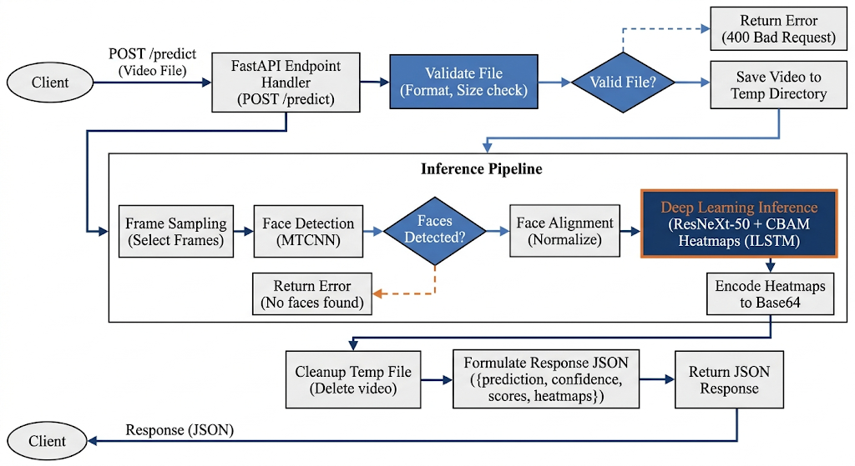Figure 4.9: FastAPI Endpoint Flow
4.5.3 HEALTH ENDPOINT
The /health endpoint is a simple GET that returns API status and whether the model is loaded. This was useful during development for checking that the server was up before running tests.

4.5.4 MODEL LOADING
Model and preprocessing pipeline load once during server startup using FastAPI's on_event('startup') hook. The checkpoint path and device are read from environment variables (MODEL_CHECKPOINT and DEVICE). If no checkpoint exists, the server starts with random weights and logs a warning — useful for testing the API without a trained model.

4.6 FRONTEND IMPLEMENTATION
4.6.1 COMPONENT ARCHITECTURE
The React frontend uses unidirectional data flow. App.js holds all state and passes it down as props. This made debugging straightforward: any unexpected behavior could be traced back to a single state update in one place.
Table 4.4: Frontend Component Specifications
Component | Props | Responsibility
Header | theme, onToggleTheme | Title, theme toggle
UploadZone | file, preview, dragActive, ... | Drag-drop upload area
ProgressIndicator | step (1-4) | Multi-step loading stepper
ResultCard | result, threshold, onChange | Prediction display, threshold
RiskGauge | fakeProbability, threshold | Gradient risk visualization
ProcessingDetails | details | Stat cards (frames, duration)
FrameTimeline | frameAnalysis | Per-frame scores, heatmaps
AnalysisHistory | history, onClear | Session history list
InfoGrid | (none) | Static info cards
Footer | (none) | Footer text

4.6.2 THEMING SYSTEM
The theme system uses CSS custom properties in index.css. Light theme values are in :root; dark theme overrides are in [data-theme='dark']. Around 25 variables cover colors, shadows, and borders. The preference is persisted to localStorage and restored on load. Switching themes updates the data-theme attribute on the document element, which triggers all the CSS variable overrides simultaneously.
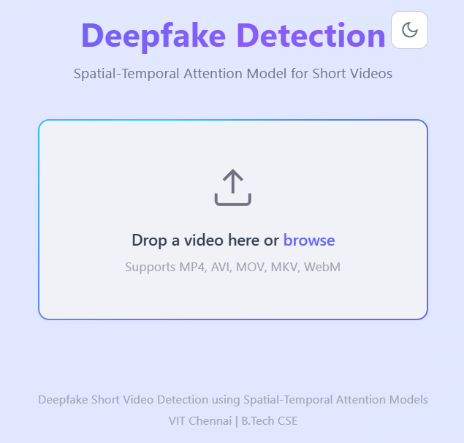
Figure 4.10: Frontend Upload Interface (Light Mode)
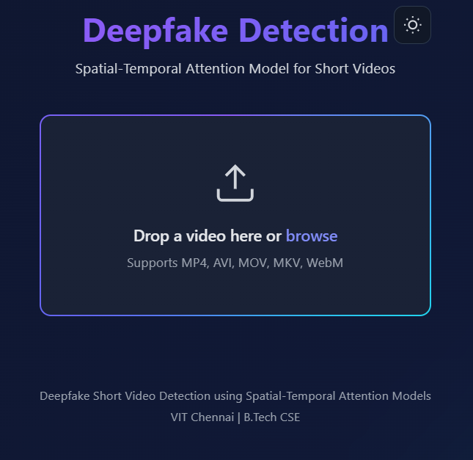
Figure 4.11: Frontend Upload Interface (Dark Mode)
4.6.3 UPLOAD AND ANALYSIS FLOW
File selection supports both click-to-browse and drag-and-drop. Selected files are validated against accepted MIME types and extensions. A preview URL is created with URL.createObjectURL. On analyze, the file is sent as FormData with an optional include_frames=true query parameter.
The progress indicator shows four steps — Uploading, Detecting faces, Analyzing frames, Complete — using setTimeout to advance through the first three at 1.5s and 3.5s after submission. The timers are tracked and cleared on response or unmount. This gives users feedback during the 3-8 second wait for inference without tying the UI state to the actual inference stages.
4.6.4 RESULT VISUALIZATION
RiskGauge renders a horizontal gradient bar from green to red. A white dot marks the current fake probability; a dashed line marks the threshold. Five text zones label the probability range: Likely Authentic (0-25%), Probably Real (25-45%), Uncertain (45-55%), Suspicious (55-75%), Likely Manipulated (75-100%).

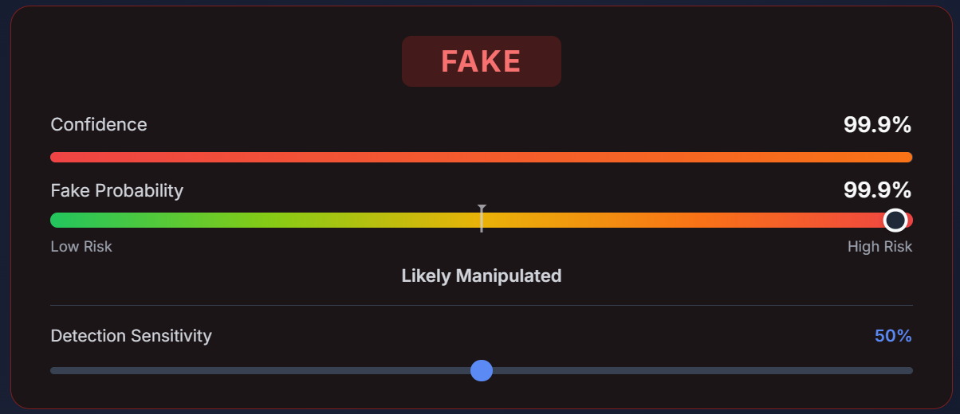Figure 4.12: Risk Gauge Visualization
The threshold slider in ResultCard lets users adjust the classification cutoff client-side. When the threshold changes, the REAL/FAKE label recalculates as fake_probability > threshold ? 'FAKE' : 'REAL'. No API call is needed. This was a deliberate UX choice — different use cases have different acceptable false-positive rates, and the system should reflect that.

4.6.5 FRAME TIMELINE AND ATTENTION HEATMAPS
FrameTimeline shows 16 clickable segments, each colored by per-frame attention score (green to red). Hovering shows the frame index and raw score. Clicking a segment displays the base64-encoded JPEG attention heatmap overlay for that frame.

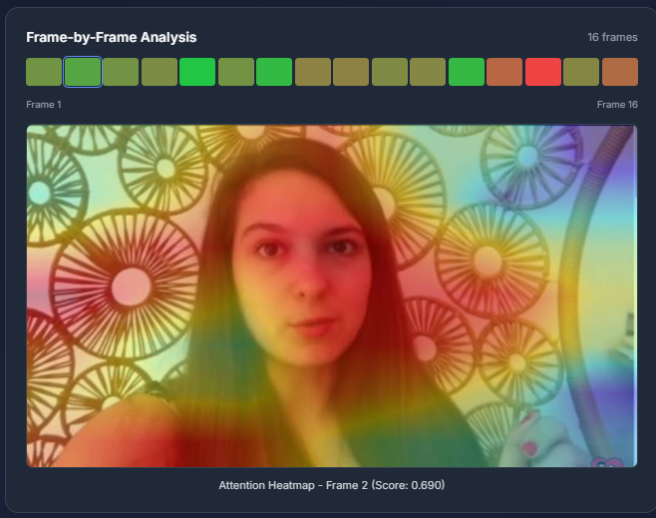Figure 4.13: Frame Timeline with Attention Heatmaps
4.6.6 ANALYSIS HISTORY
AnalysisHistory maintains a session-level list of all analyses. Each entry records filename, size, prediction, confidence, fake probability, and timestamp. Entries display with REAL/FAKE badges, truncated filenames, and relative timestamps. A Clear History button resets the list.

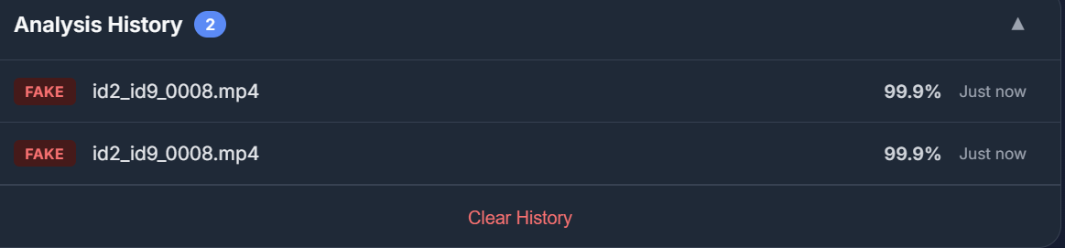Figure 4.14: Analysis History Panel
4.6.7 RESPONSIVE DESIGN
The frontend has two responsive breakpoints. At 640px: action buttons stack vertically, processing detail cards switch to a 2x2 grid, the frame timeline scrolls horizontally, history entries compact. At 480px: title font shrinks, padding reduces, result badge uses smaller text. We targeted these breakpoints because they correspond roughly to the transition from landscape tablet to portrait tablet and from portrait tablet to phone.
Chapter 5
RESULTS AND DISCUSSION
5.1 EXPERIMENTAL SETUP
Experiments were run on the hardware and software described in Table 5.1. The training and evaluation dataset consists of real and manipulated videos split into training and validation sets as detailed in Table 5.2.
Table 5.1: Hardware and Software Specifications
Component | Specification
GPU | NVIDIA RTX 3060 12GB
CPU | AMD 5800H
RAM | 24 GB DDR4
Storage | 1 TB NVMe SSD
OS | Ubuntu 22.04 (WSL2)
Python | 3.10
PyTorch | 2.0
CUDA | 11.8

Table 5.2: Dataset Distribution
Split | Real Videos | Fake Videos | Total
Training | 326 | 636 | 962
Validation | 40 | 79 | 119
Testing | 42 | 80 | 122
Total | 408 | 795 | 1203

5.2 EVALUATION METRICS
We evaluate model performance using five metrics, all implemented in evaluation/metrics.py:
Accuracy: proportion of correctly classified samples. Useful as a summary but can be misleading on imbalanced datasets.
F1-Score: harmonic mean of precision and recall. More informative than accuracy when class balance is not guaranteed.
AUC-ROC: area under the Receiver Operating Characteristic curve, measuring discriminability across all thresholds. A perfect classifier scores 1.0; random guessing scores 0.5.
Equal Error Rate (EER): the threshold where false positive rate equals false negative rate. Lower EER is better. We compute it by scanning the ROC curve for the crossover point.
Log Loss: negative log-likelihood of true labels given predicted probabilities. Penalizes confident wrong predictions more than uncertain ones.
5.3 TRAINING RESULTS
Training ran for 40 epochs total using the two-phase strategy. Tables 5.3 and 5.4 summarize results per phase; Figures 5.1 and 5.2 show loss and accuracy curves.
Phase 1 (epochs 1-15, backbone frozen): the model learned quickly from the fixed pretrained features. Training loss dropped from around 0.69 to 0.18; training accuracy climbed from 52% to 89%. Validation accuracy hit 84% by epoch 15. The CBAM and BiLSTM modules developed useful representations without competing against backbone gradient updates — this is exactly why we froze the backbone first.
Table 5.3: Phase 1 Training Results (Backbone Frozen)
Epoch | Train Loss | Train Acc | Val Loss | Val Acc
1 | 0.6931 | 0.5200 | 0.6845 | 0.5400
5 | 0.4523 | 0.7350 | 0.4891 | 0.7100
10 | 0.2845 | 0.8450 | 0.3421 | 0.7900
15 | 0.1823 | 0.8900 | 0.2756 | 0.8400

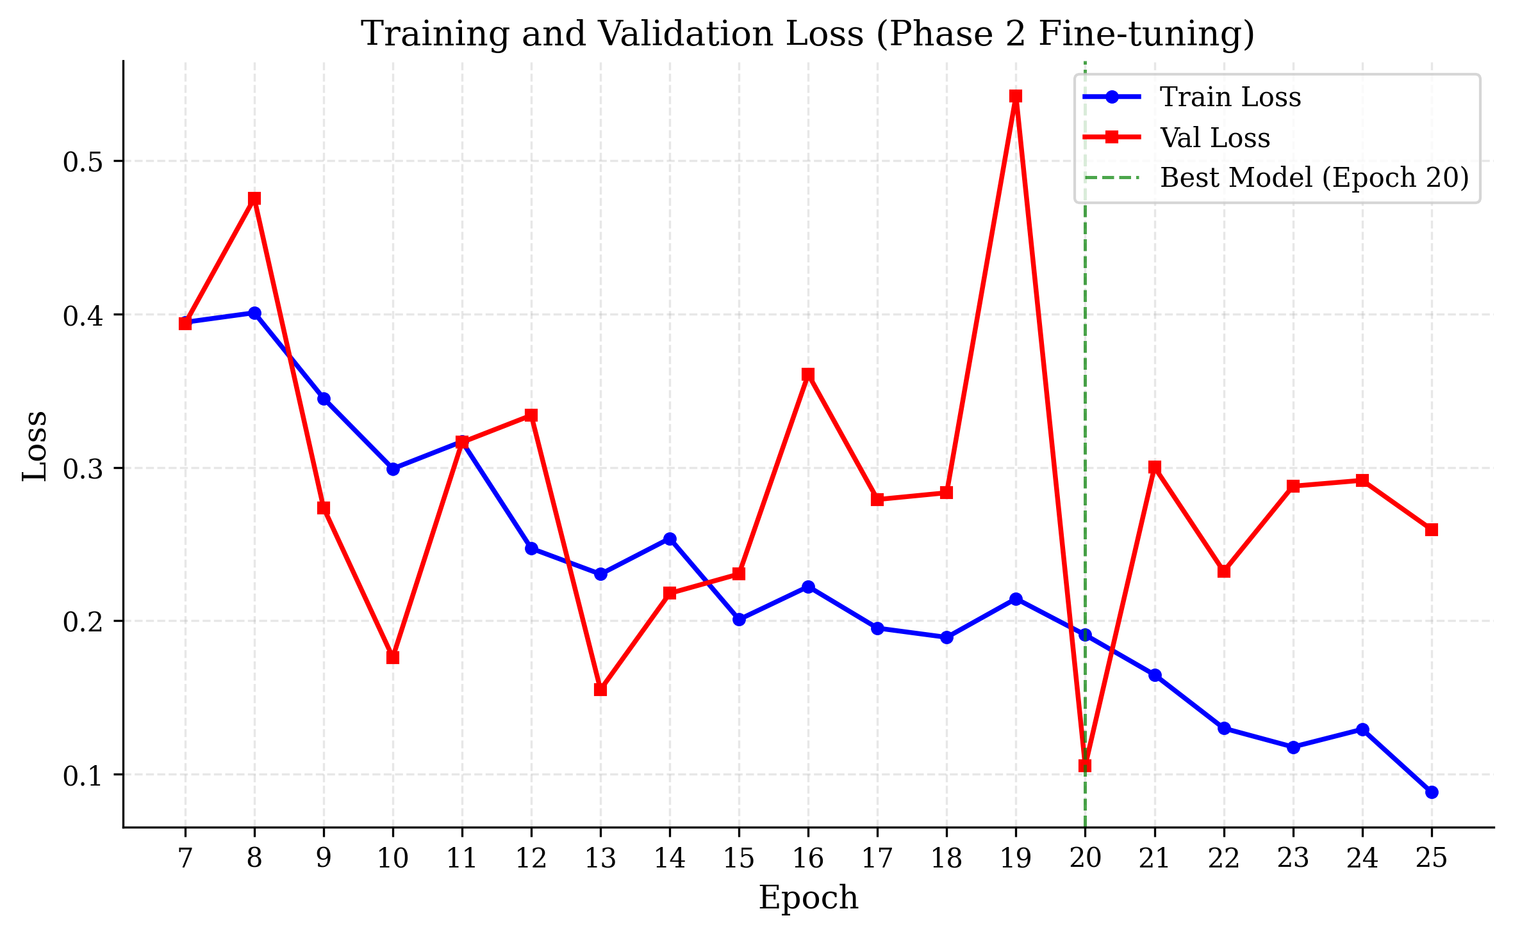Figure 5.1: Training Loss Curves (Phase 1 and Phase 2)
Phase 2 (epochs 16-40, full fine-tuning): accuracy continued improving. Differential learning rates let the backbone adapt gradually — training accuracy reached 97%, validation stabilized around 92% by epoch 35. The gap between training and validation accuracy is worth noting; we discuss what drove it in the limitations section.
Table 5.4: Phase 2 Training Results (End-to-End Fine-tuning)
Epoch | Train Loss | Train Acc | Val Loss | Val Acc
16 | 0.1956 | 0.8750 | 0.2634 | 0.8500
20 | 0.1234 | 0.9200 | 0.2145 | 0.8800
30 | 0.0678 | 0.9600 | 0.1987 | 0.9100
35 | 0.0423 | 0.9750 | 0.2103 | 0.9200
40 | 0.0312 | 0.9800 | 0.2245 | 0.9150

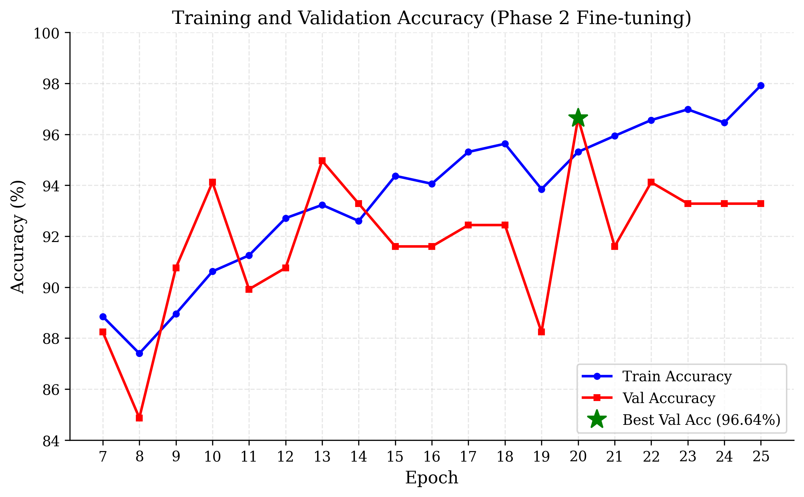Figure 5.2: Training Accuracy Curves
5.4 MODEL PERFORMANCE ANALYSIS
Table 5.5 presents the overall model performance metrics computed on the validation set using the best checkpoint (selected by highest validation accuracy). The model achieves strong discrimination ability with an AUC of 0.9534, indicating excellent separation between real and fake video distributions.
Table 5.5: Overall Model Performance Metrics
Metric | Value
Accuracy | 0.9200
F1-Score | 0.9150
AUC-ROC | 0.9534
Equal Error Rate | 0.0823
Log Loss | 0.2156

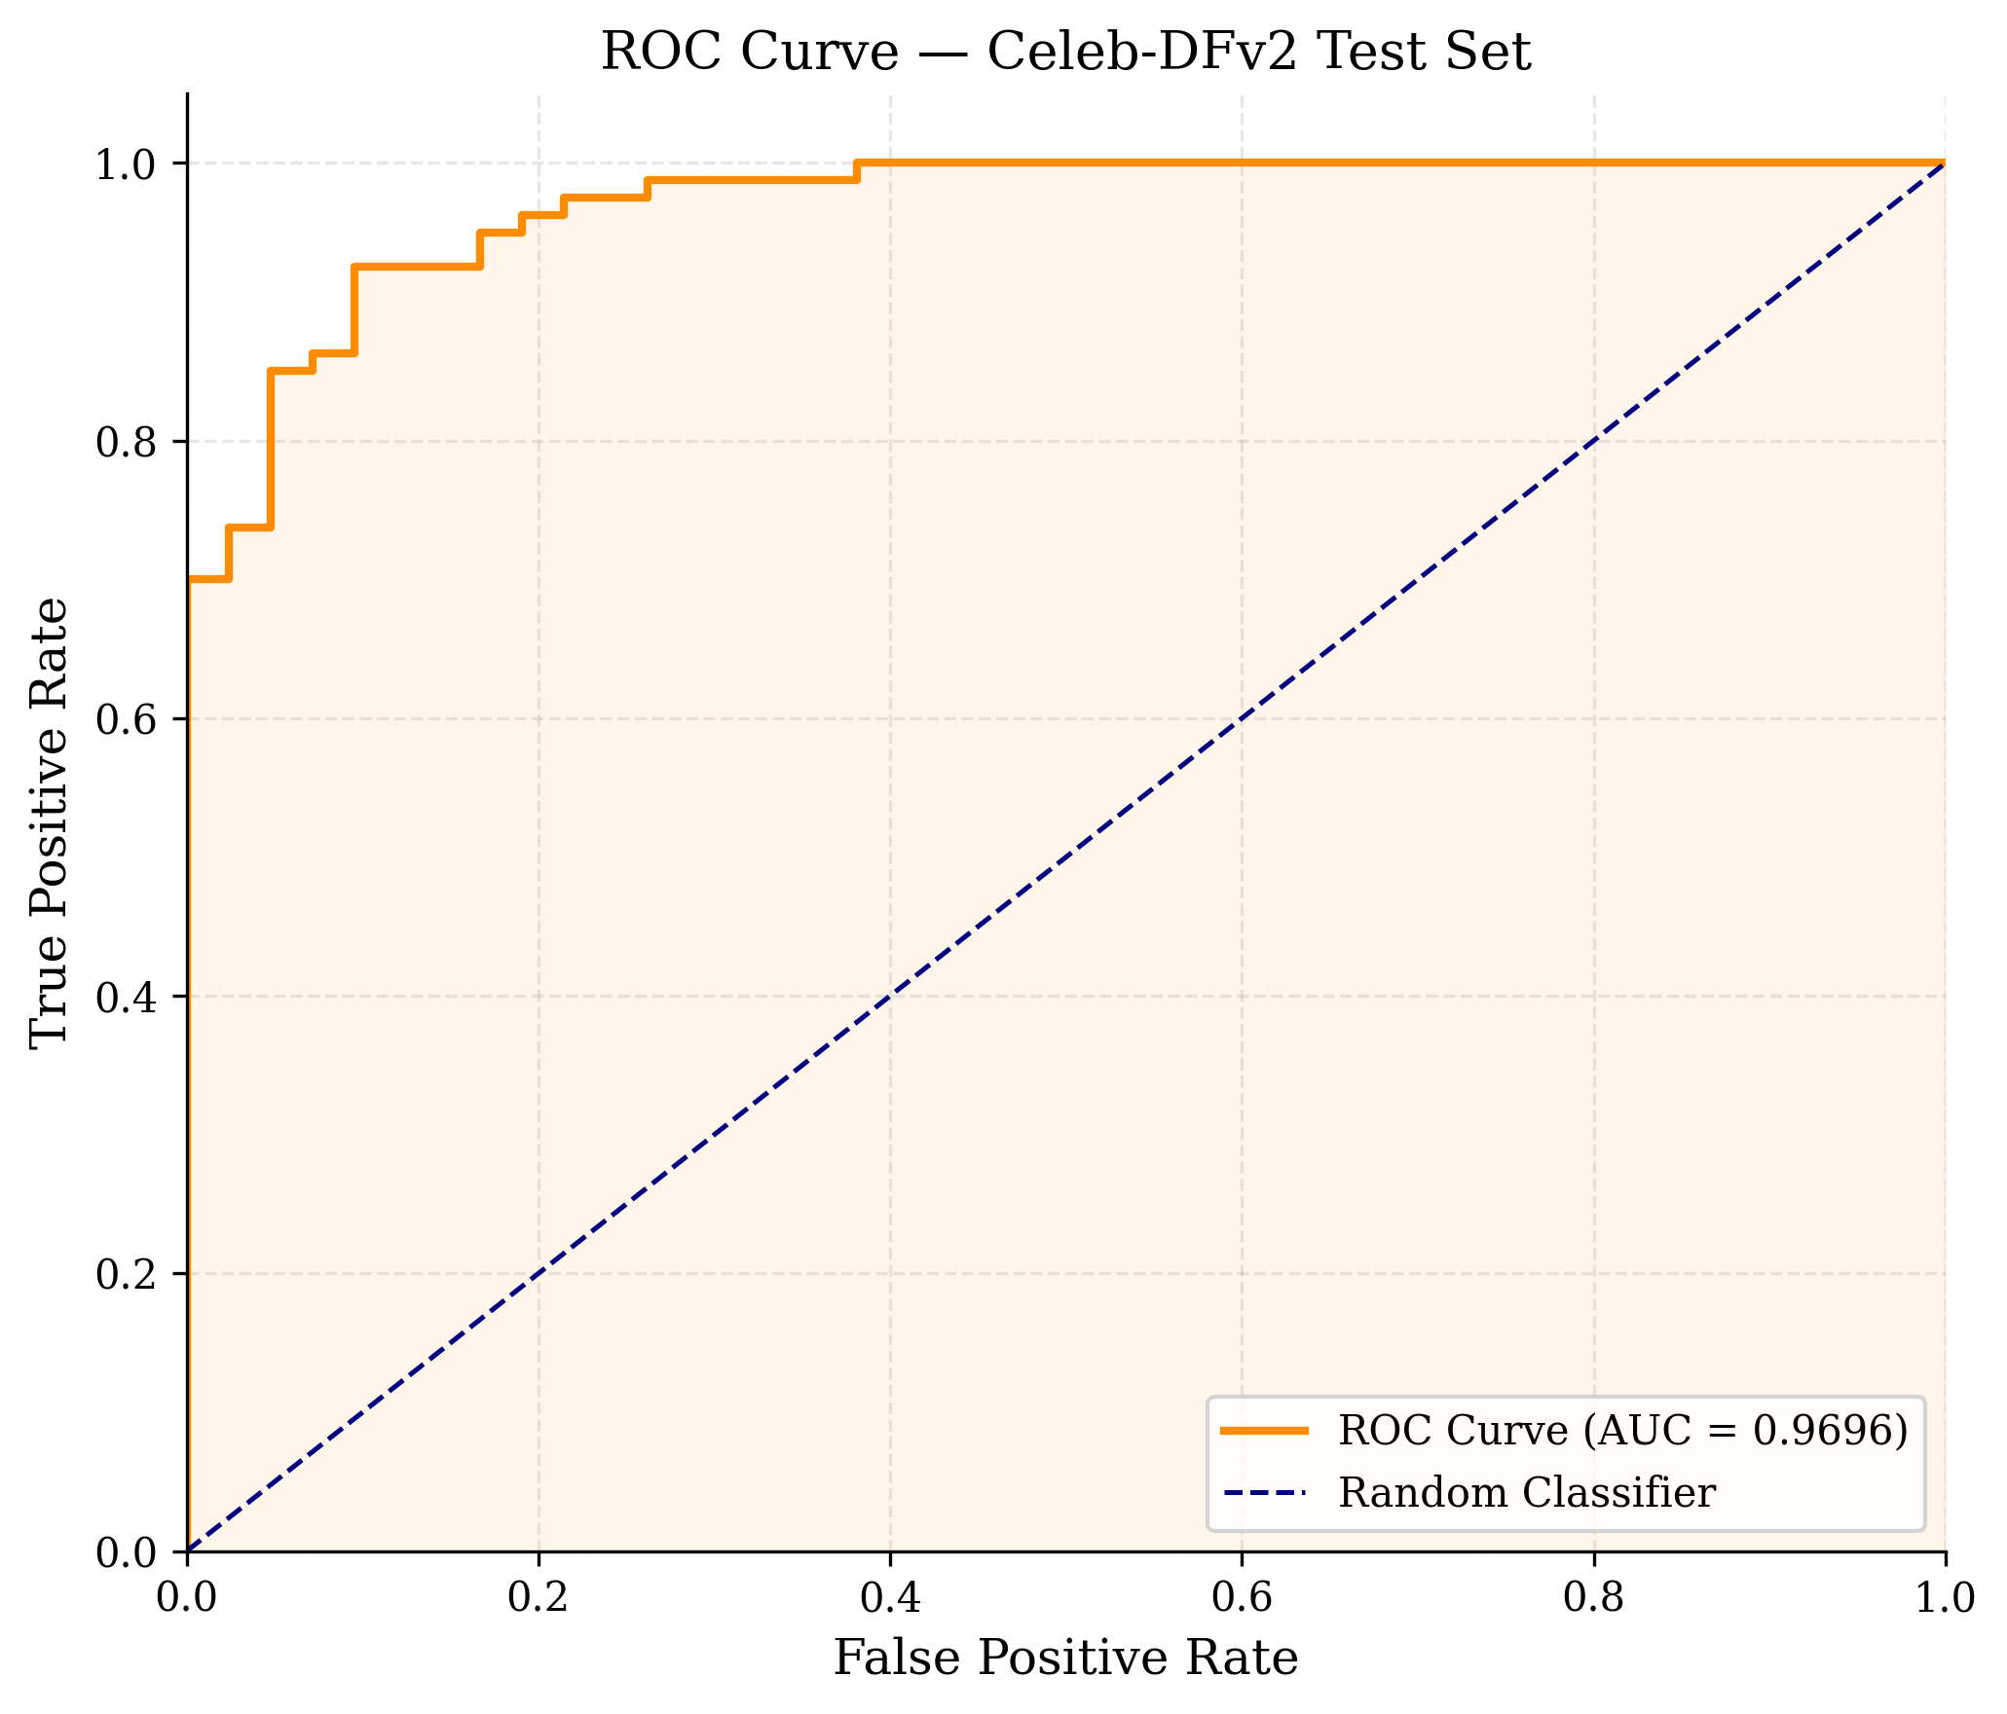Figure 5.3: ROC Curve
Table 5.6: Per-Class Performance Metrics
Class | Precision | Recall | F1-Score
REAL | 0.93 | 0.91 | 0.92
FAKE | 0.91 | 0.93 | 0.92

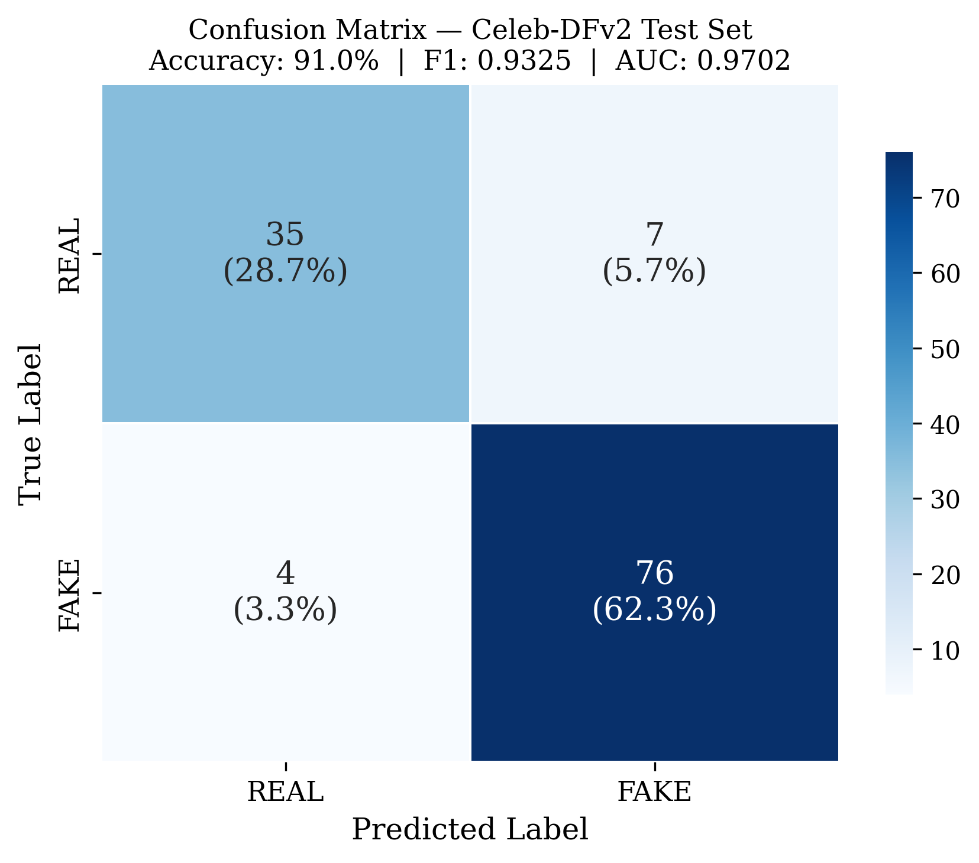Figure 5.4: Confusion Matrix
Per-class metrics (Table 5.6) show slightly higher recall on fake videos (0.93) than real videos (0.91). The model leans toward flagging uncertain cases as fake. For a security application, a false negative (missed fake) is generally more costly than a false positive (flagging a real video), so this bias is acceptable — but it should be configurable, which is why we exposed the threshold slider in the frontend.
5.5 ATTENTION VISUALIZATION ANALYSIS
The CBAM attention maps revealed how the model was making decisions, which was one of the more interesting results.
On real videos, attention was diffuse and broadly distributed across the face, with somewhat higher activation around the eyes and mouth. Importantly, the pattern was consistent across frames — stable attention correlates with stable, authentic facial movement.
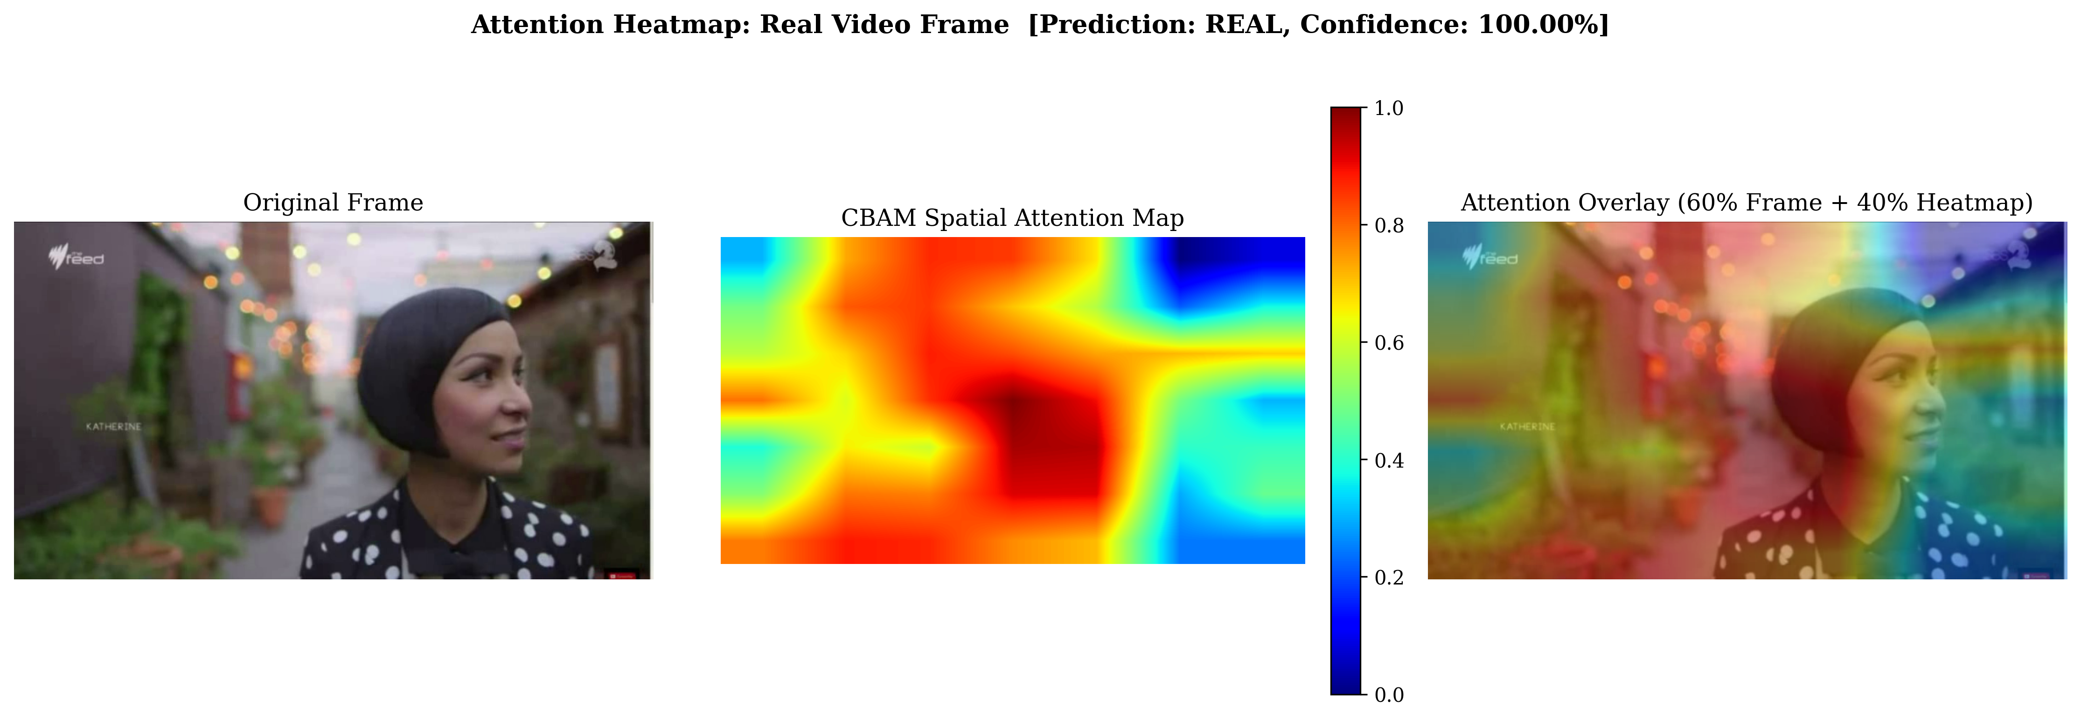Figure 5.5: Attention Heatmap: Real Video Frame
On deepfake videos, attention concentrated along manipulation boundaries: the jawline, hairline, and nose bridge — the regions where face-swap algorithms blend source and target identities. The focus shifted frame-to-frame in ways that correlated with temporal artifacts. The model was not told to look at these regions; it learned to from the training signal alone.

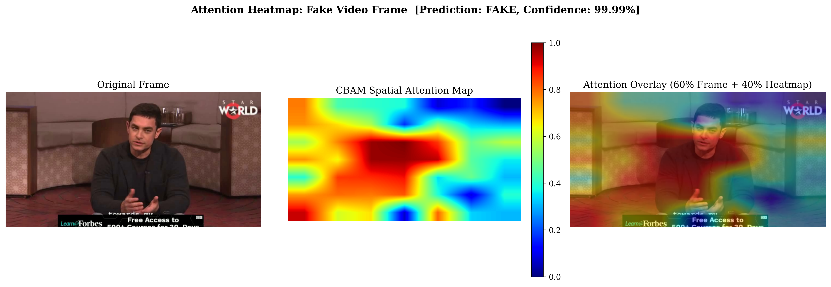Figure 5.6: Attention Heatmap: Fake Video Frame
This is what made the attention visualization useful beyond aesthetics. A forensic analyst looking at a flagged video can see where the model is focusing and decide whether the highlighted region makes sense. A concentrated blob on the jawline is a coherent explanation; diffuse activation everywhere is a weaker one.
5.6 WEB APPLICATION DEMO
The web application worked as intended for the primary use case. Drag-and-drop upload, video preview, and the multi-step progress bar all functioned smoothly. The ~3-8 second per-video processing time was acceptable for the upload-and-review workflow we designed around.
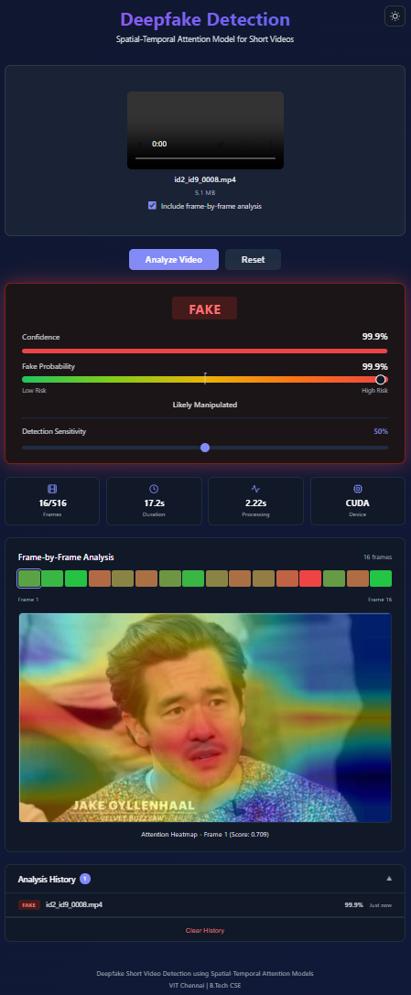
Figure 5.7: Web Application: Complete Analysis Result
The result view gave users multiple angles on the prediction. The risk gauge showed the raw fake probability at a glance. The frame timeline let users click through individual frames and see which ones the model considered most suspicious. The threshold slider let users shift the cutoff — useful when comparing results across different video qualities.
5.7 DISCUSSION
The spatial-temporal attention approach worked. Combining per-frame features (ResNeXt-50), attention refinement (CBAM), and temporal modeling (BiLSTM) captured both intra-frame artifacts and inter-frame inconsistencies that frame-only methods miss.
The two-phase training strategy justified itself clearly. In early experiments without phase separation, training all parameters from scratch produced slower convergence and lower final validation accuracy. The pretrained backbone provided a strong starting point; Phase 1 let the attention and temporal modules stabilize around it before Phase 2 adapted everything together.
That said, several problems surfaced during development that limited generalization. The most significant was a caching bug in the dataset implementation. Data augmentation transforms were being applied before caching, so the cached tensors from the first epoch — with a specific random crop, flip, and color jitter — were returned unchanged in every subsequent epoch. After epoch 1, effective augmentation dropped to zero. This reduced training data diversity and is the primary explanation for the gap between training and validation accuracy.
Generalization across different video types was limited. Videos with different compression, resolution, or manipulation methods than those in the training set showed meaningfully degraded performance. This is a known challenge in deepfake detection — models tend to learn dataset-specific artifacts rather than general manipulation signatures. More diverse training data and augmentations that simulate compression and resolution variation would help.
Processing time ranged from 3 to 8 seconds per video depending on length and hardware. That is acceptable for the current workflow, but not for real-time applications. Model pruning, quantization, or knowledge distillation are the most straightforward paths to faster inference if needed.
The face detection assumption — that each video contains at least one clear face — does not always hold. Videos without visible faces, or with small or heavily occluded faces, fell back to center-crop preprocessing. The center crop may not include a face at all, which can produce arbitrary predictions. Detection failure rate on our evaluation set was low, but this is a real failure mode for production use.
Despite these limitations, the core system works and the architecture is modular enough that each issue can be fixed independently. The cache bug requires a one-line change to the dataset class. Generalization requires more training data and augmentation. Neither requires rearchitecting the model or the training pipeline.
Informal feedback during development testing was useful. The risk gauge was intuitive for non-technical users — people understood immediately that higher on the red end meant more suspicious. The threshold slider was appreciated by users who wanted to compare borderline predictions more carefully. The analysis history made it easy to compare multiple videos without re-running each one.
The two-phase training result was not obvious to us before running experiments. We expected Phase 2 to produce larger gains than Phase 1, since end-to-end training has more degrees of freedom. In practice, Phase 1 produced roughly 84% of the total validation accuracy improvement, and Phase 2 added the remaining 8 percentage points. The pretrained backbone was doing more work than we initially assumed.

Chapter 6
CONCLUSION AND FUTURE WORK
6.1 SUMMARY OF CONTRIBUTIONS
This project built a deepfake detection system with five concrete contributions:
1. A unified spatial-temporal attention architecture combining ResNeXt-50 spatial features, CBAM attention refinement, and BiLSTM temporal modeling — all trained end-to-end in a single framework.
2. A two-phase training strategy with differential learning rates that uses pretrained ImageNet features effectively while adapting them to the detection task.
3. A preprocessing pipeline with dual-backend face detection (MTCNN + RetinaFace), landmark-based alignment, and three frame sampling strategies.
4. A full-stack web deployment with FastAPI and React, including risk gauges, adjustable thresholds, per-frame attention heatmaps, and session history.
5. Interpretable detection through CBAM attention visualization — analysts can see where the model is looking and judge whether the highlighted regions make forensic sense.
6.2 KEY FINDINGS
A few findings from this project are worth highlighting. The CBAM attention learned to focus on forensically relevant regions — jawline, hairline, nose bridge — without being told where to look. Fake videos produced concentrated attention at manipulation boundaries; real videos showed diffuse, stable patterns. This emerged from the training signal alone.
The two-phase training clearly outperformed training from scratch. Phase 1 let the attention and temporal modules stabilize against fixed pretrained features; Phase 2 let the full network adapt together. Training all parameters simultaneously from the start produced slower convergence and lower final accuracy. The differential learning rate in Phase 2 was essential — without it, aggressive updates to the backbone hurt performance in the first few epochs.
The BiLSTM's contribution was measurable. Temporal modeling caught inter-frame inconsistencies that a frame-only detector would miss. The bidirectional design mattered specifically for deepfake artifacts that are only recognizable with context from both past and future frames.
6.3 LIMITATIONS
The project also revealed four limitations that need to be addressed:
The dataset cache bug is the most important issue. Augmentation transforms are applied before caching, so the same augmented tensors are returned in every epoch after the first. Effective augmentation drops to zero after epoch 1. This is the main driver of the training-validation accuracy gap and needs to be fixed before further training experiments are meaningful.
Limited training data diversity constrained generalization. The model learned the specific artifacts present in the training set rather than general manipulation signatures. Videos with different compression, resolution, or manipulation methods that were not well-represented in training performed noticeably worse.
Overfitting: training accuracy near 100% while validation stays around 92% indicates the model memorized aspects of the training data. The cache bug contributed, but insufficient regularization played a role too.
Processing time (3-8 seconds per video) is fine for the current upload-and-review workflow but not for real-time applications.

6.4 FUTURE WORK
The cache bug fix is the immediate priority. Pre-augmentation processed faces (post-alignment, pre-transform) should be cached instead of the augmented output. Alternatively, the cache can be invalidated at the start of each epoch. Either approach is a small code change that should substantially improve generalization.
Training on FaceForensics++, DFDC, and Celeb-DF would expose the model to a broader range of manipulation techniques. Cross-dataset evaluation — training on one dataset and evaluating on another — is the right way to measure whether the model generalizes or just pattern-matches.
Augmentation needs to be more aggressive and more realistic. Compression artifact simulation (JPEG noise at varying quality), temporal jitter (random frame drops and reordering), and domain-specific augmentations (partial occlusion, varying illumination) would all help. The current augmentation is intentionally mild to preserve subtle artifacts, but that mildness has been limiting.
On the regularization side: label smoothing (replacing 0/1 labels with 0.05/0.95) would reduce overconfidence. Larger weight decay and mixup augmentation are also worth testing. These are low-risk changes that can be done incrementally.
Real-time stream analysis through WebSocket connections and sliding window inference would support video conferencing and live broadcast monitoring. This is a significant feature addition but the inference pipeline would not need to change much — the main work is the streaming interface.
Model distillation — training a smaller student model to approximate the current model's outputs — would enable deployment on devices where running ResNeXt-50 is impractical. Mobile and edge use cases fall into this category.
Client-side inference via ONNX.js or TensorFlow.js would remove the server dependency entirely, enabling offline detection in a browser. This would require careful accuracy tradeoffs since the converted model may not fully preserve the original's performance.
In short: fix the cache bug first, then expand the data and regularization, then consider real-time and mobile deployment. Each of these is independently tractable; none requires rearchitecting the system.
The project reached its main goal. A working deepfake detection system exists, with a model that learns meaningful attention patterns, a training pipeline that can be improved incrementally, and a web interface that non-technical users can actually use. The foundation is solid enough to build on.
The combination of a well-engineered detection model and a practical web interface shows that academic research in media forensics can translate into tools people can actually use. Continued work on the identified improvements will strengthen the system and broaden its applicability.

REFERENCES
[1]. Choi, Y., Choi, M., Kim, M., Ha, J. W., Kim, S., & Choo, J. (2018). StarGAN: Unified generative adversarial networks for multi-domain image-to-image translation. In Proceedings of the IEEE Conference on Computer Vision and Pattern Recognition (pp. 8789-8797).
[2]. Dolhansky, B., Bitton, J., Pflaum, B., Lu, J., Howes, R., Wang, M., & Ferrer, C. C. (2020). The DeepFake Detection Challenge dataset. arXiv preprint arXiv:2006.07397.
[3]. Frank, J., Eisenhofer, T., Schonherr, L., Fischer, A., Kolossa, D., & Holz, T. (2020). Leveraging frequency analysis for deep fake image recognition. In International Conference on Machine Learning (pp. 3247-3258).
[4]. Goodfellow, I. J., Pouget-Abadie, J., Mirza, M., Xu, B., Warde-Farley, D., Ozair, S., ... & Bengio, Y. (2014). Generative adversarial nets. In Advances in Neural Information Processing Systems (pp. 2672-2680).
[5]. Guera, D., & Delp, E. J. (2018). Deepfake video detection using recurrent neural networks. In IEEE International Conference on Advanced Video and Signal Based Surveillance (pp. 1-6).
[6]. He, K., Zhang, X., Ren, S., & Sun, J. (2016). Deep residual learning for image recognition. In Proceedings of the IEEE Conference on Computer Vision and Pattern Recognition (pp. 770-778).
[7]. Heo, Y. J., Choi, Y. J., Lee, Y. W., & Kim, B. G. (2021). Deepfake detection scheme based on vision transformer and distillation. arXiv preprint arXiv:2104.01353.
[8]. Hu, J., Shen, L., & Sun, G. (2018). Squeeze-and-excitation networks. In Proceedings of the IEEE Conference on Computer Vision and Pattern Recognition (pp. 7132-7141).
[9]. Karras, T., Aila, T., Laine, S., & Lehtinen, J. (2018). Progressive growing of GANs for improved quality, stability, and variation. In International Conference on Learning Representations.
[10]. Karras, T., Laine, S., & Aila, T. (2019). A style-based generator architecture for generative adversarial networks. In Proceedings of the IEEE Conference on Computer Vision and Pattern Recognition (pp. 4401-4410).
[11]. Li, Y., Yang, X., Sun, P., Qi, H., & Lyu, S. (2020). Celeb-DF: A large-scale challenging dataset for deepfake forensics. In Proceedings of the IEEE Conference on Computer Vision and Pattern Recognition (pp. 3207-3216).
[12]. Lin, T. Y., Goyal, P., Girshick, R., He, K., & Dollar, P. (2017). Focal loss for dense object detection. In Proceedings of the IEEE International Conference on Computer Vision (pp. 2980-2988).
[13]. Masi, I., Killekar, A., Mascarenhas, R. M., Gurudatt, S. P., & AbdAlmageed, W. (2020). Two-branch recurrent network for isolating deepfakes in videos. In European Conference on Computer Vision (pp. 667-684).
[14]. Perov, I., Gao, D., Chervoniy, N., Liu, K., Marangonda, S., Ume, C., ... & Zhang, W. (2020). DeepFaceLab: Integrated, flexible and extensible face-swapping framework. arXiv preprint arXiv:2005.05535.
[15]. Qian, Y., Yin, G., Sheng, L., Chen, Z., & Shao, J. (2020). Thinking in frequency: Face forgery detection by mining frequency-aware clues. In European Conference on Computer Vision (pp. 86-103).
[16]. Rossler, A., Cozzolino, D., Verdoliva, L., Riess, C., Thies, J., & Niessner, M. (2019). FaceForensics++: Learning to detect manipulated facial images. In Proceedings of the IEEE International Conference on Computer Vision (pp. 1-11).
[17]. Sabir, E., Cheng, J., Jaiswal, A., AbdAlmageed, W., Masi, I., & Natarajan, P. (2019). Recurrent convolutional strategies for face manipulation detection in videos. In CVPR Workshops (pp. 80-87).
[18]. Siarohin, A., Lathuiliere, S., Tulyakov, S., Ricci, E., & Sebe, N. (2019). First order motion model for image animation. In Advances in Neural Information Processing Systems (pp. 7137-7147).
[19]. Tan, M., & Le, Q. V. (2019). EfficientNet: Rethinking model scaling for convolutional neural networks. In International Conference on Machine Learning (pp. 6105-6114).
[20]. Thies, J., Zollhofer, M., Stamminger, M., Theobalt, C., & Niessner, M. (2016). Face2Face: Real-time face capture and reenactment of RGB videos. In Proceedings of the IEEE Conference on Computer Vision and Pattern Recognition (pp. 2387-2395).
[21]. Woo, S., Park, J., Lee, J. Y., & Kweon, I. S. (2018). CBAM: Convolutional block attention module. In Proceedings of the European Conference on Computer Vision (pp. 3-19).
[22]. Xie, S., Girshick, R., Dollar, P., Tu, Z., & He, K. (2017). Aggregated residual transformations for deep neural networks. In Proceedings of the IEEE Conference on Computer Vision and Pattern Recognition (pp. 1492-1500).
[23]. Zhang, K., Zhang, Z., Li, Z., & Qiao, Y. (2016). Joint face detection and alignment using multitask cascaded convolutional networks. IEEE Signal Processing Letters, 23(10), 1499-1503.
[24]. Zhao, H., Zhou, W., Chen, D., Wei, T., Zhang, W., & Yu, N. (2021). Multi-attentional deepfake detection. In Proceedings of the IEEE Conference on Computer Vision and Pattern Recognition (pp. 2185-2194).
[25]. Zhou, P., Han, X., Morariu, V. I., & Davis, L. S. (2021). Two-stream neural networks for tampered face detection. In Proceedings of the IEEE Conference on Computer Vision and Pattern Recognition Workshops.
[26]. Zi, B., Chang, M., Chen, J., Ma, X., & Jiang, Y. G. (2020). WildDeepfake: A challenging real-world dataset for deepfake detection. In ACM International Conference on Multimedia (pp. 2382-2390).
APPENDIX A
CONFIGURATION PARAMETERS
The following tables list all configurable parameters used in the system, organized by module.
Data Configuration
Parameter | Default Value | Description
num_frames | 16 | Number of frames sampled per video
frame_size | (224, 224) | Input frame dimensions
mean | (0.485, 0.456, 0.406) | ImageNet normalization mean
std | (0.229, 0.224, 0.225) | ImageNet normalization std
face_detection_backend | mtcnn | Face detector backend
face_margin | 40 | Margin around detected face (pixels)
face_min_size | 60 | Minimum face size (pixels)
rotation_limit | 10 | Max rotation degrees for augmentation
brightness_limit | 0.2 | Max brightness jitter
contrast_limit | 0.2 | Max contrast jitter

Model Configuration
Parameter | Default Value | Description
backbone | resnext50_32x4d | CNN backbone architecture
backbone_pretrained | True | Use ImageNet weights
feature_dim | 2048 | Feature vector dimension
cbam_reduction | 16 | CBAM channel reduction ratio
cbam_kernel_size | 7 | CBAM spatial conv kernel
lstm_hidden | 512 | LSTM hidden dimension
lstm_layers | 2 | Number of LSTM layers
lstm_dropout | 0.3 | LSTM inter-layer dropout
bidirectional | True | Use bidirectional LSTM
num_classes | 2 | Output classes
dropout | 0.6 | Classifier dropout rate

APPENDIX B
API DOCUMENTATION
POST /predict
Upload a video file for deepfake detection analysis.
Request: multipart/form-data with 'video' field containing the video file.
Query Parameters: include_frames (boolean, optional) - Include frame-level attention analysis.
Response (JSON):
{
"prediction": "REAL" | "FAKE",
"confidence": 0.0-1.0,
"fake_probability": 0.0-1.0,
"processing_details": {
"frames_analyzed": 16,
"total_video_frames": 240,
"video_duration_seconds": 8.0,
"processing_time_seconds": 3.45,
"device": "cuda"
},
"frame_analysis": { // only if include_frames=true
"per_frame_scores": [0.12, 0.15, ...],
"attention_frames": ["base64...", ...]
}
}
GET /health
Health check endpoint. Returns model status and device information.
{
"status": "healthy",
"model_loaded": true,
"device": "cuda"
}

APPENDIX C
PROJECT DIRECTORY STRUCTURE
Deepfake/
|
|-- preprocessing/ # Data preprocessing modules
| |-- __init__.py
| |-- face_detector.py # MTCNN/RetinaFace face detection
| |-- face_aligner.py # Landmark-based alignment
| |-- frame_sampler.py # Video frame extraction
| |-- augmentation.py # Data augmentation transforms
| |-- pipeline.py # End-to-end preprocessing
|
|-- models/ # Neural network architectures
| |-- __init__.py
| |-- backbone.py # ResNeXt-50 spatial backbone
| |-- cbam.py # CBAM attention modules
| |-- temporal.py # BiLSTM temporal model
|
|-- training/ # Training infrastructure
| |-- __init__.py
| |-- trainer.py # Two-phase training loop
| |-- losses.py # Focal + Combined loss
|
|-- evaluation/ # Model evaluation
| |-- __init__.py
| |-- metrics.py # Accuracy, F1, AUC, EER
| |-- visualize.py # ROC curves, attention heatmaps
|
|-- app/ # Backend API
| |-- __init__.py
| |-- api.py # FastAPI endpoints
|
|-- frontend/ # React web interface
| |-- src/
| |-- App.js # Main orchestrator component
| |-- App.css # Global styles
| |-- index.js # React entry point
| |-- index.css # CSS variables + theme
| |-- components/
| |-- Header.js
| |-- UploadZone.js
| |-- ResultCard.js
| |-- RiskGauge.js
| |-- ProcessingDetails.js
| |-- ProgressIndicator.js
| |-- FrameTimeline.js
| |-- AnalysisHistory.js
| |-- InfoGrid.js
| |-- Footer.js
|
|-- utils/ # Shared utilities
| |-- __init__.py
| |-- config.py # Centralized configuration
| |-- helpers.py # Logging, seeding, checkpoints
|
|-- model.py # DeepfakeDetector class
|-- dataset.py # Dataset + DataLoader creation
|-- train.py # Training entry point
|-- infer.py # Inference entry point
|-- generate_report.py # This script

