LAB 2 | COMP 3123

Ques 1:  
const greeter = (myArray, counter) => {

    const greetText = 'Hello ';

    myArray.forEach(item => {

        console.log(greetText + item);

    });

};

greeter(['Randy Savage', 'Ric Flair', 'Hulk Hogan'], 3);

output:

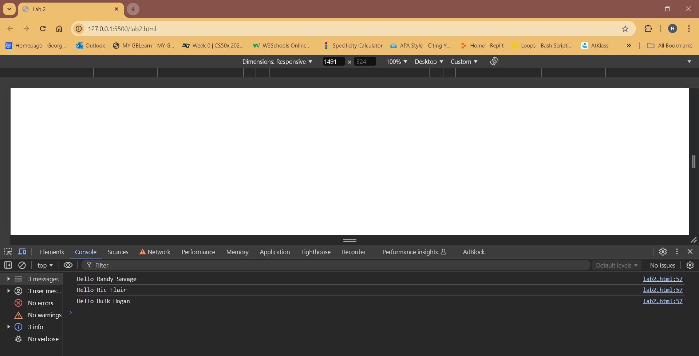

Ques 2:   
const capitalize = ([first, ...rest]) => {

    return first.toUpperCase() + rest.join('');

};

console.log(capitalize('fooBar'));

console.log(capitalize('nodeJs'));

output:  
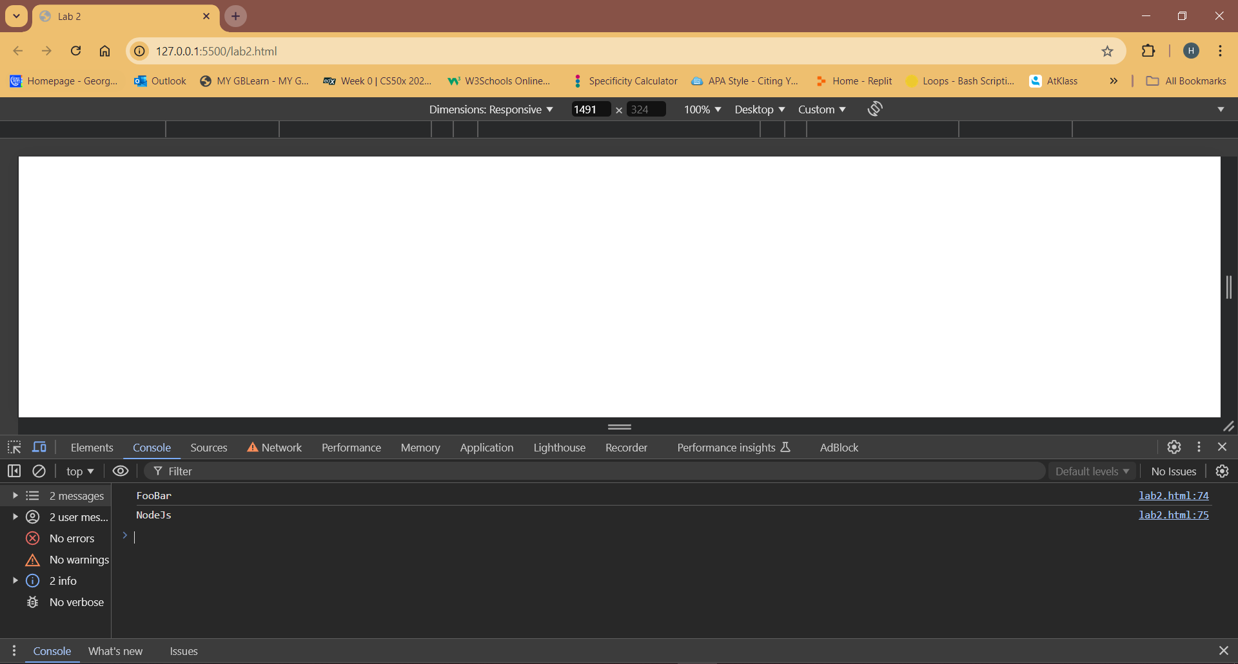

Ques 3:  
const colors = ['red','green','blue']

const capitalizedcolors = colors.map(color => capitalize(color))

console.log(capitalizedcolors)

output:  
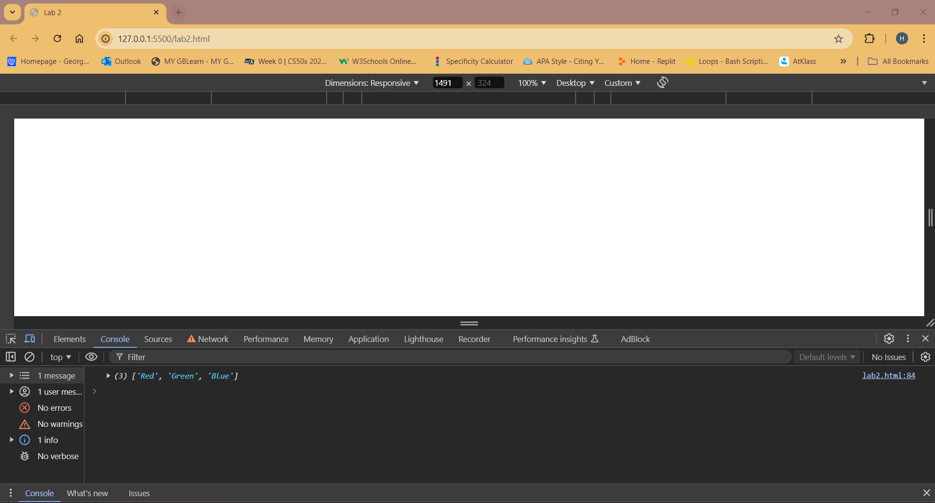  
  
Ques 4:  
var values = [1,60,34,30,20,5]

const filterLessthan20 = values.filter(value => value < 20)

console.log(filterLessthan20)

output:  
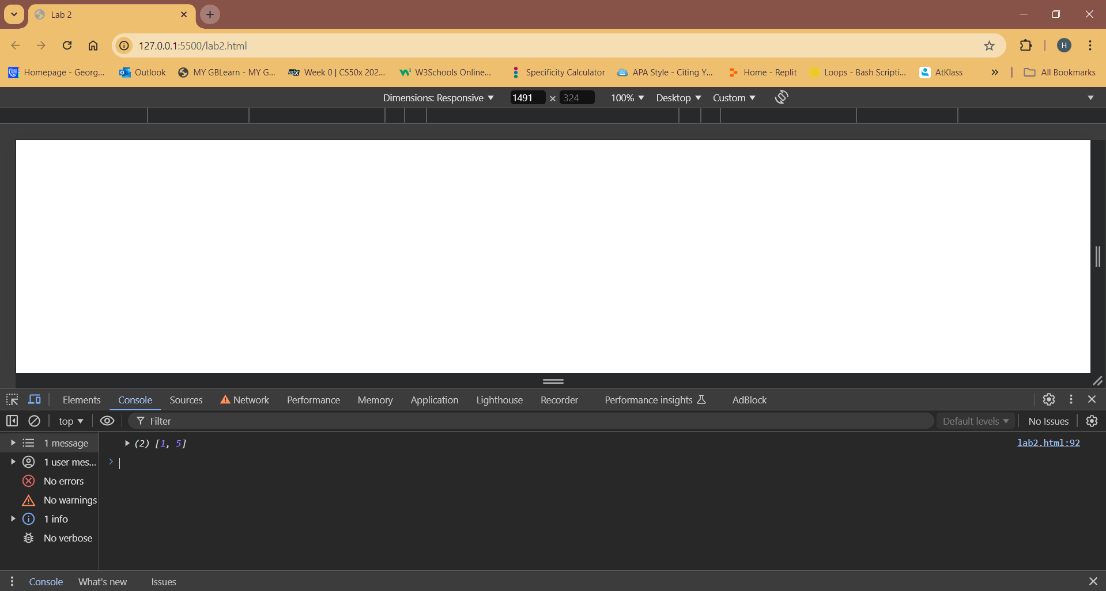  
  
Ques 5:  
var array = [1,2,3,4]

const sum = array.reduce((accumulator,currentValue)=>{

return accumulator + currentValue

},)

console.log("sum = " + sum)

const product = array.reduce((accumulator,currentValue)=>{

return accumulator \* currentValue

},)

console.log("product = " + product)

output:  
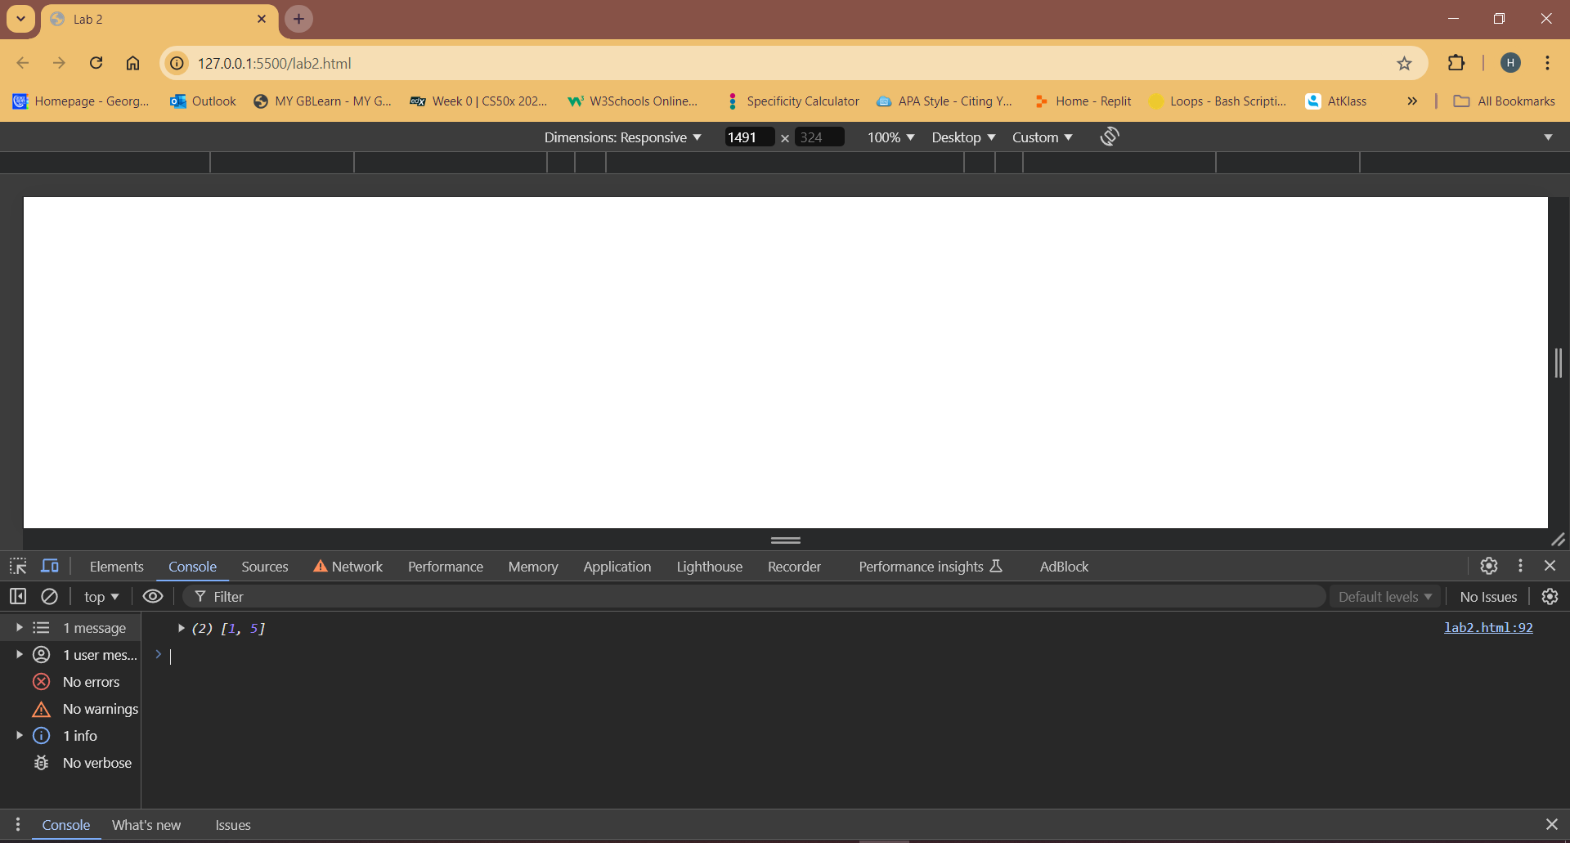  
  
Ques 6:  
class Car{

    constructor(model,year){

        this.model = model;

        this.year = year

    }

    info(){

        return `Model: ${this.model}, Year: ${this.year}`;

    }

}

class Sedan extends Car{

    constructor(model,year,balance){

        super(model,year);

        this.balance = balance;

    }

    info(){

        return `${super.info()},Balance: ${this.balance}`

    }

}

const car2 = new Car('Pontiac firebird',1976);

console.log(car2.info())

const sedan = new Sedan('Volvo SD',2018,30000)

console.log(sedan.info())

output:  
