[/employee](http://localhost:8081/employee)  
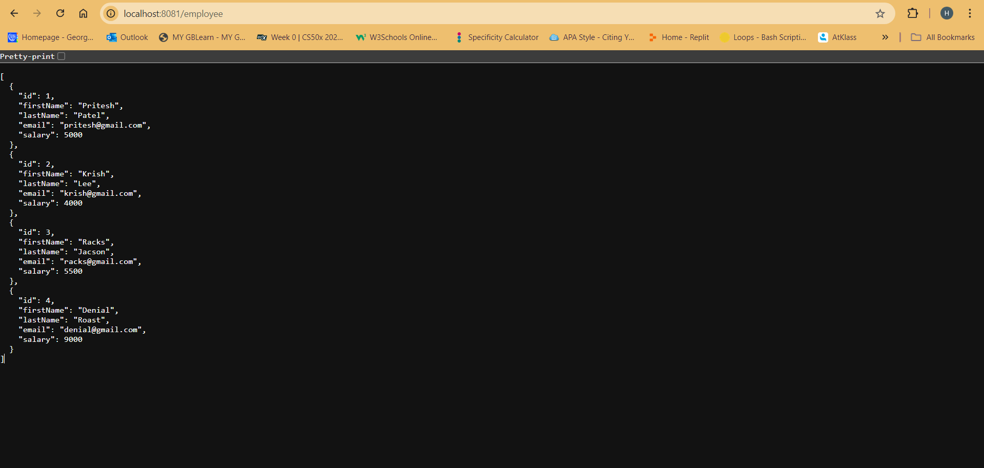

[/employee/names](http://localhost:8081/employee/names)  
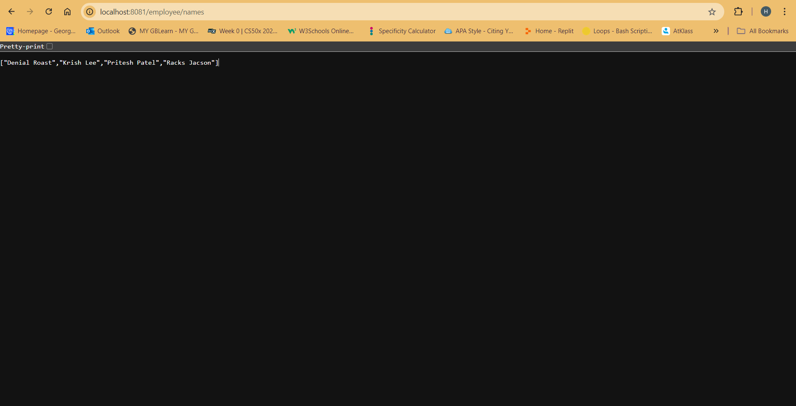

[/employee/totalsalary](http://localhost:8081/employee/totalsalary)  
