COMP3123|LAB_6

studentID:101410993  
Name: Hardik kumar

1.)sending a GET request to see if our app runs:

<http://localhost:8081> GET  
  
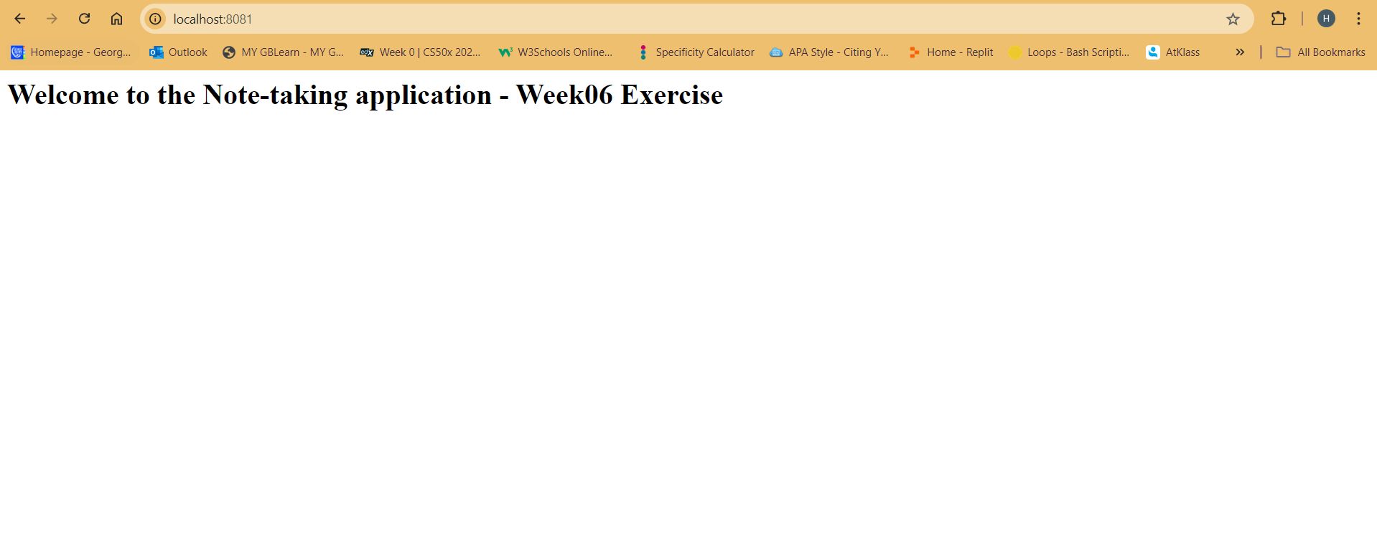

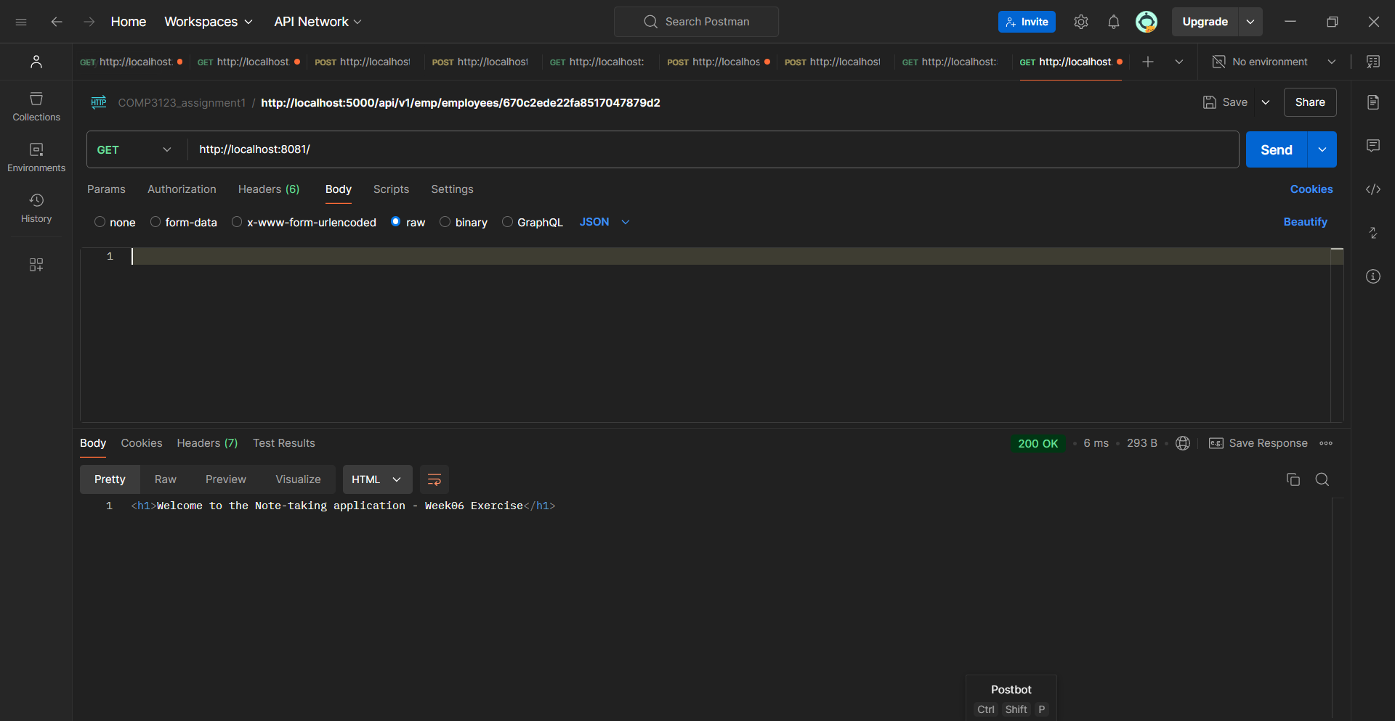

2.) Trying to create a sample note:  
<http://localhost:8081/notes> POST

Input:  
{

"title": "Sample Note",

"content": "This is a sample note content."

}

Ouput:  
