Comp3104

Lab 6

studentID: 101410993,

name: Hardik kumar

* Commands list  
  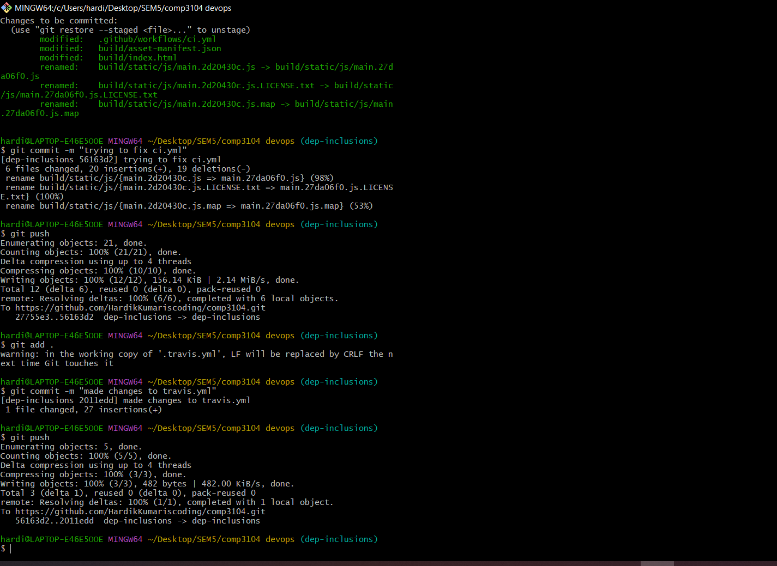
* Students page  
  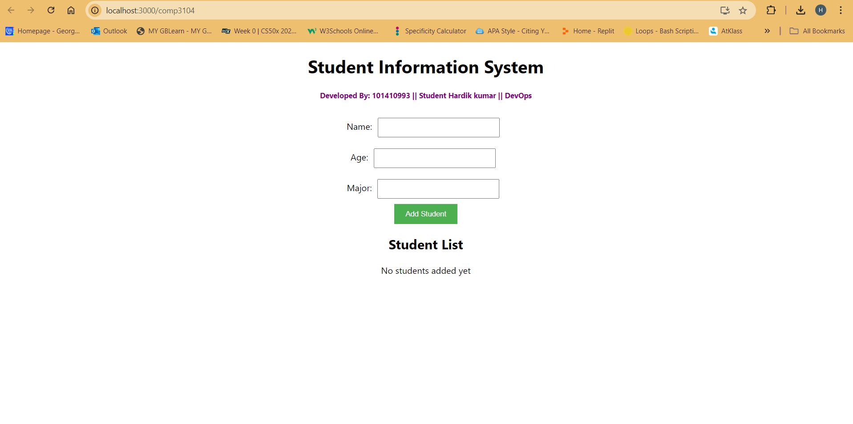
* Commit list

