DOCKER COMMANDS

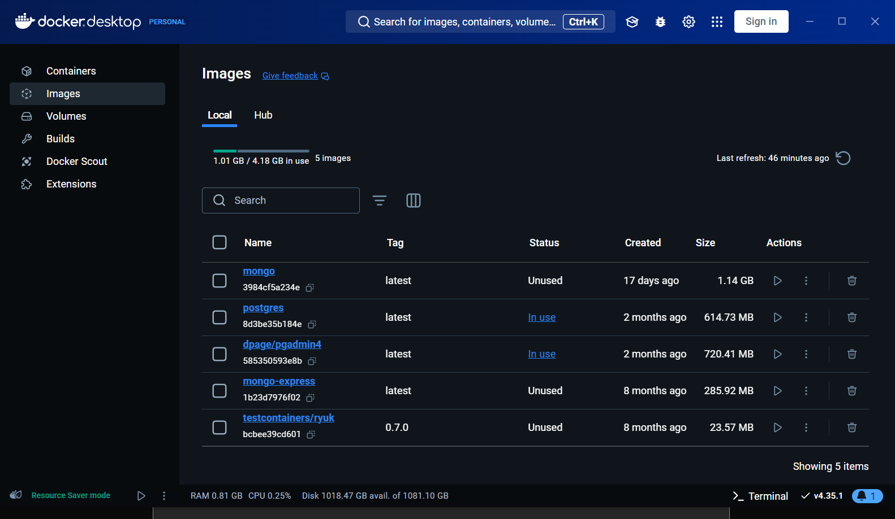

Docker –version   
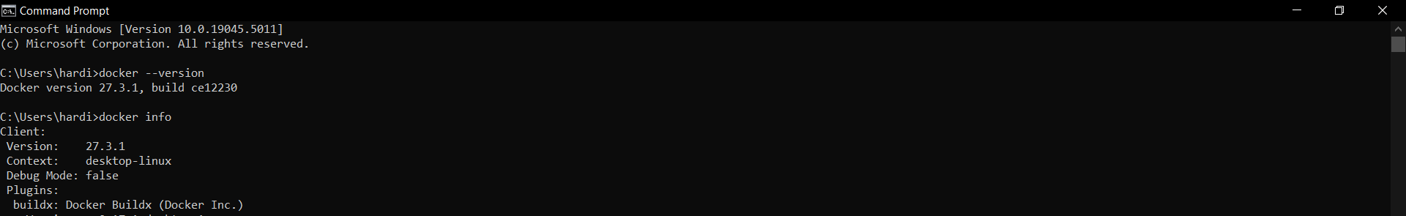

Docker info   
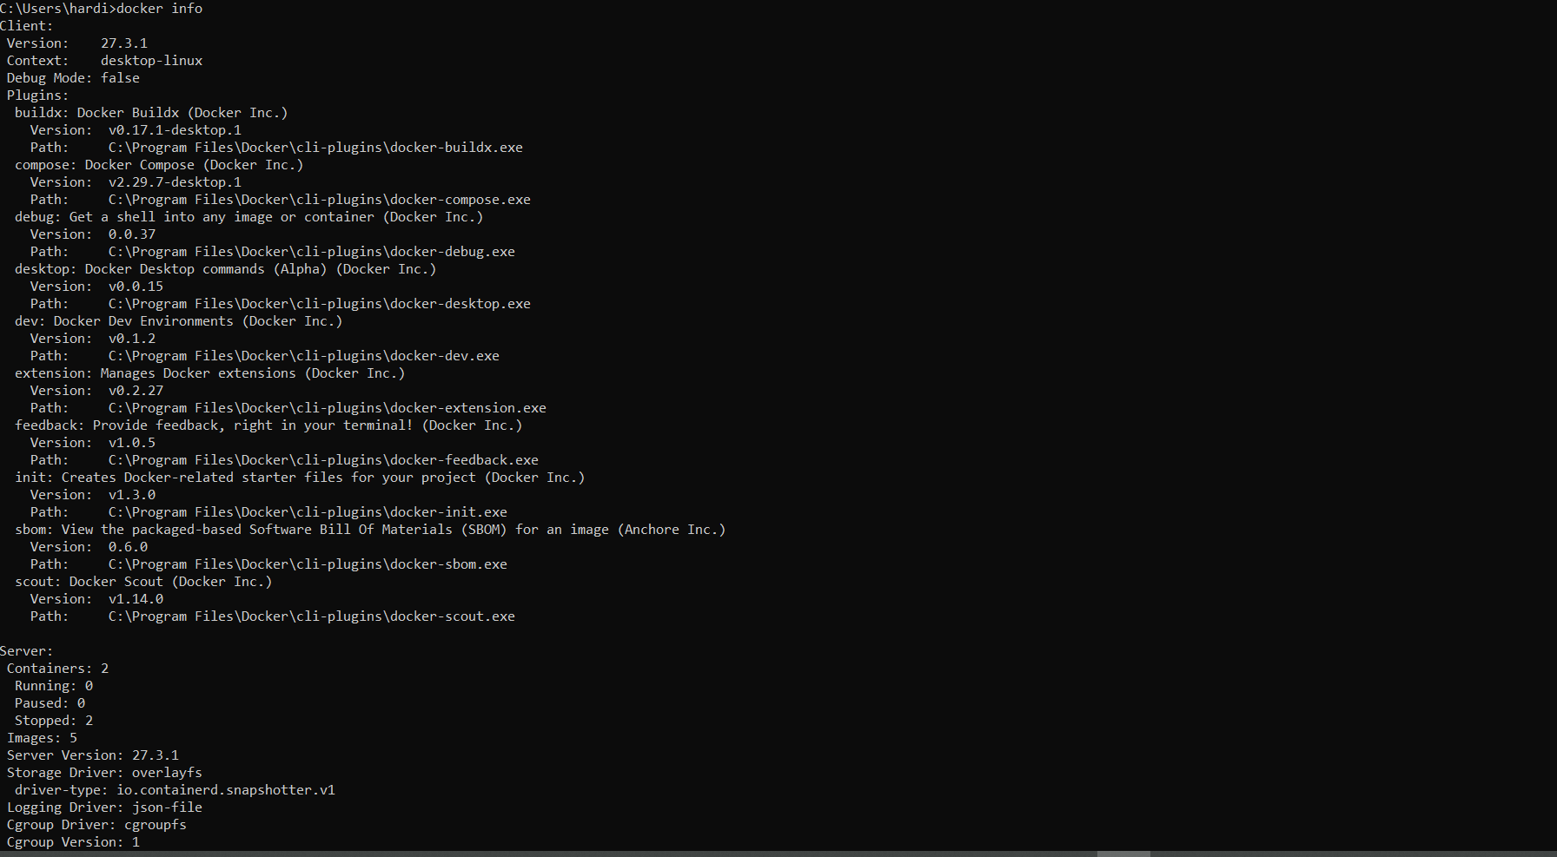

Docker run hello-world  
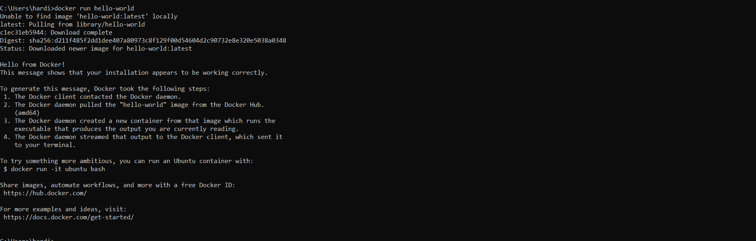

Docker images and docker ls -a  
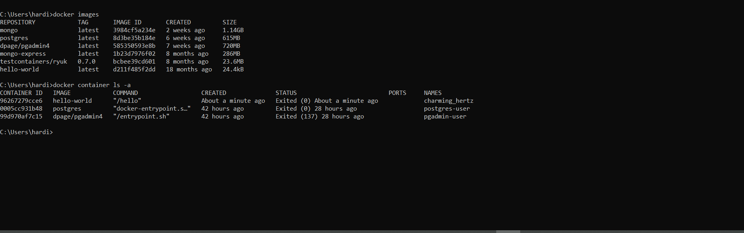

Docker rm {container ID or Name} (to remove the container)  
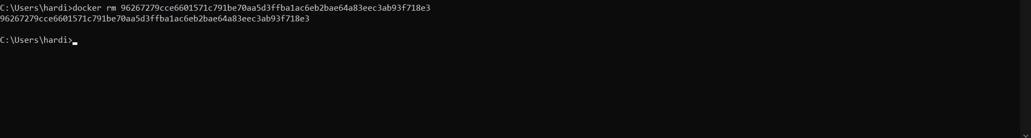  
  
Dodker rmi {image ID} (to remove the image)  
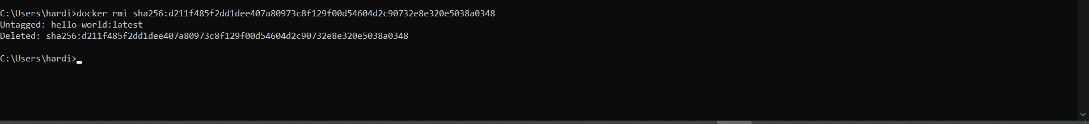

UBUNTU VM in AZURE

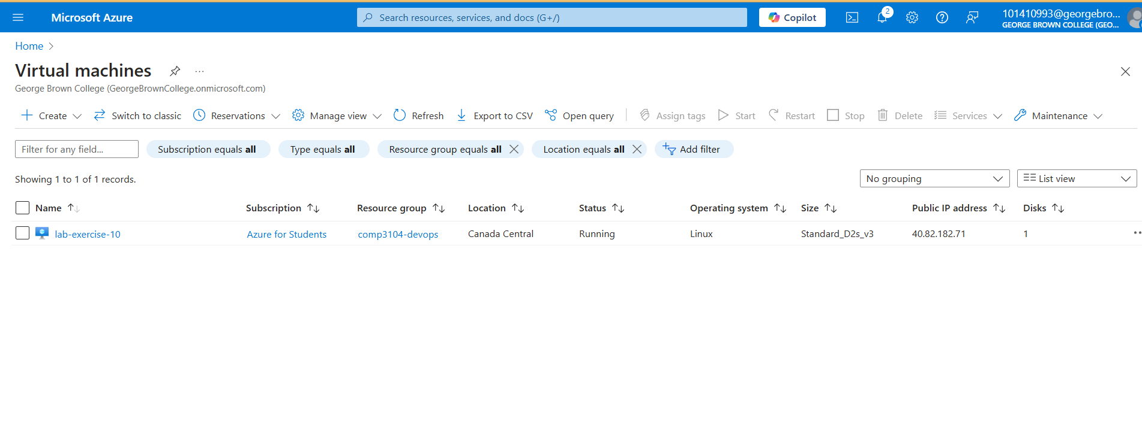

1. Logging in to our VM using the pem key

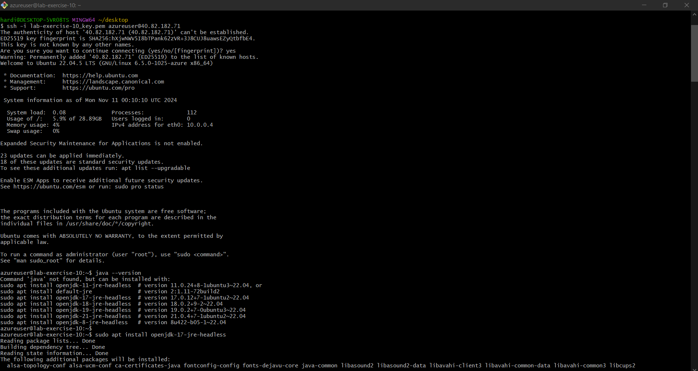

1. Installed java and checked java version on VM  
     
   