Comp-3104 | Devops

Week 7- Lab Exercise

NAME: HARDIK KUMAR

STUDENT ID: 101410993

Jenkins Dashboard

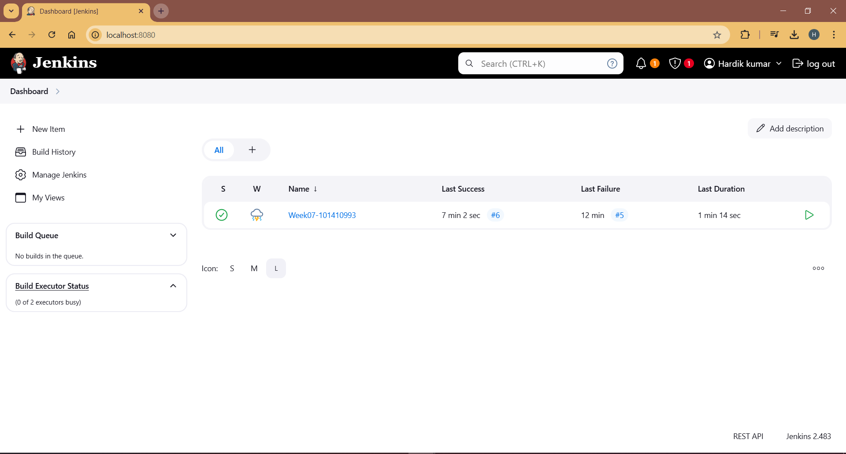

Configure Page on Jenkins

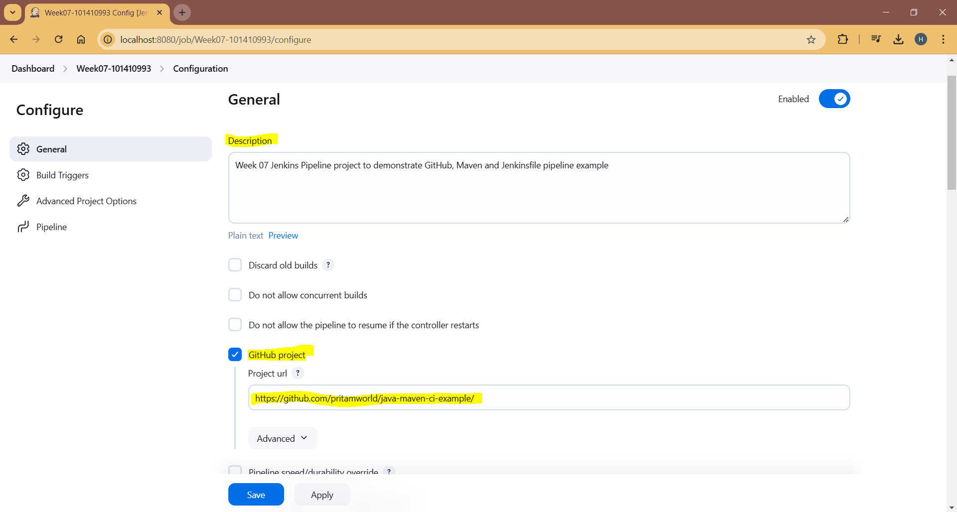

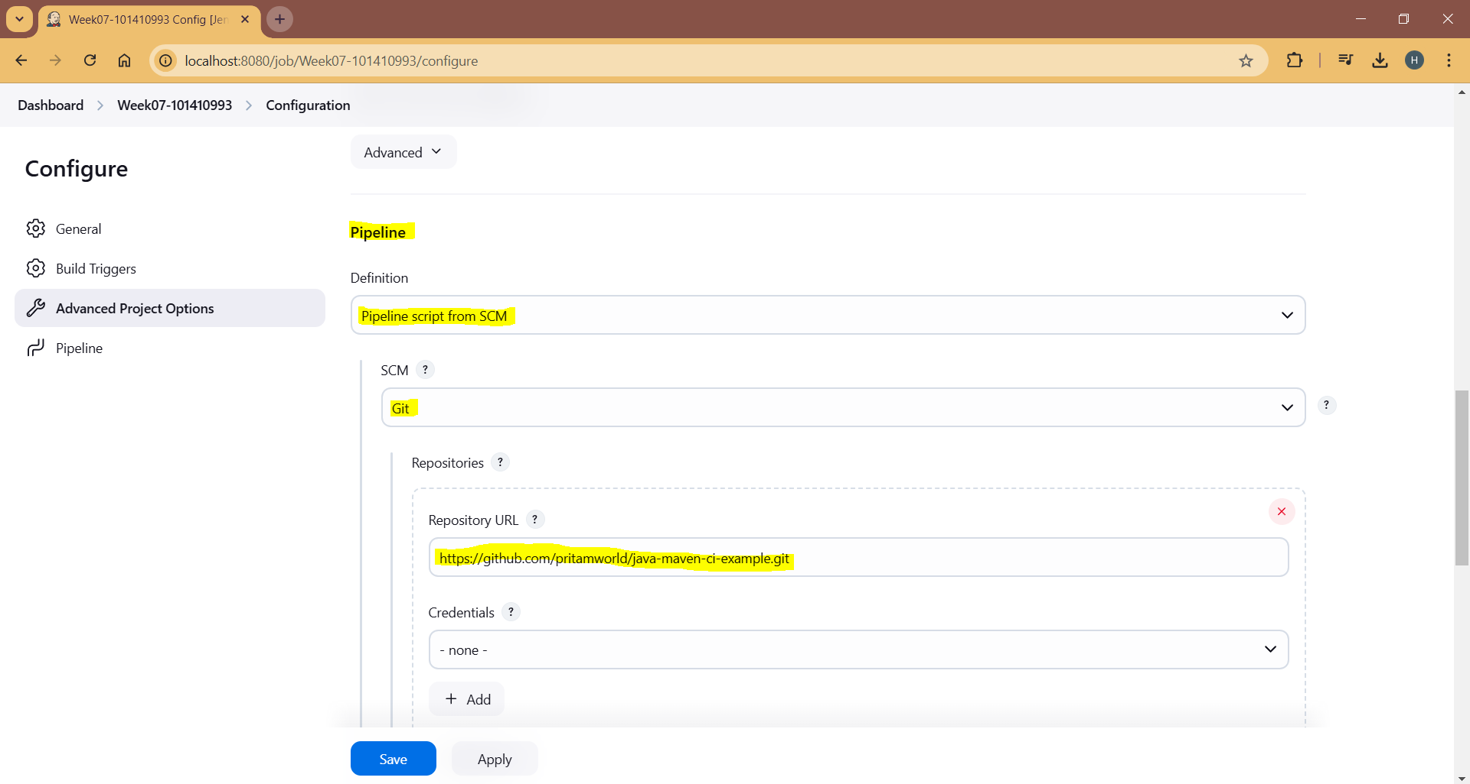

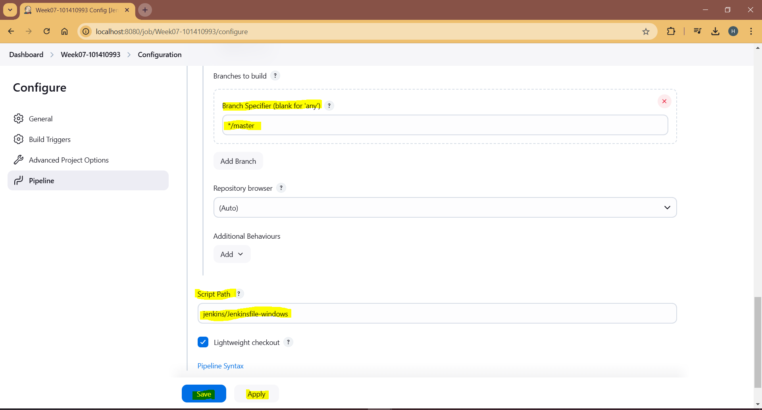

Jenkins Console

