PONDICHERRY UNIVERSITY
(A Central University Established by an Act of Parliament, 1985)
SCHOOL OF ENGINEERING AND TECHNOLOGY
DEPARTMENT OF COMPUTER SCIENCE
Puducherry – 605 014, India
A MINI PROJECT REPORT ON
EventQR: AI-POWERED STUDENT VERIFICATION AND QR-BASED EVENT ENTRY MANAGEMENT SYSTEM
A Multi-Tier Campus Event Access Control, Real-Time Email OTP Authentication, Seating Capacity Waitlist Reallocation, and Computer Vision Gate Admission Platform
CSCA 513: MINI PROJECT
NOVEMBER 2026
Submitted in partial fulfillment of the requirements for the award of degree of
MASTER OF COMPUTER APPLICATIONS (MCA)
(Academic Year: 2025 – 2026)
SUBMITTED BY:  HARDIK GUPTA  Enrollment / Reg No.: 25MCA00PY0031  MCA 2nd Year, 3rd Semester  Department of Computer Science  Pondicherry University | UNDER THE GUIDANCE OF:  Dr. SURESH JOSEPH  Professor and Head  Department of Computer Science  School of Engineering & Technology  Pondicherry University

NOVEMBER 2026

BONAFIDE CERTIFICATE
Certified that this project report entitled "EventQR: AI-POWERED STUDENT VERIFICATION AND QR-BASED EVENT ENTRY MANAGEMENT SYSTEM" is the bonafide work of HARDIK GUPTA (Register No: 25MCA00PY0031), who carried out the mini project work under my supervision and guidance as Project Guide and Head of the Department in partial fulfillment of the requirements for the award of the degree of Master of Computer Applications (MCA) in the Department of Computer Science, School of Engineering and Technology, Pondicherry University, Puducherry, India during the academic year 2025–2026.
To the best of my knowledge and belief, this report represents authentic work completed by the candidate. The technical contents, algorithms, computer vision pipelines, database schemas, and results embodied in this report have not been submitted to any other University or Institution for the award of any degree, diploma, fellowship, or other similar title.
Place: Puducherry  Date: 03-11-2026 | PROJECT GUIDE / HEAD OF THE DEPARTMENT  ___________________________________  Dr. SURESH JOSEPH  Professor and Head  Department of Computer Science  School of Engineering and Technology  Pondicherry University

Submitted for the Mini Project Viva-Voce Examination held on: 03-11-2026
INTERNAL EXAMINER  ___________________________________ | EXTERNAL EXAMINER  ___________________________________

CANDIDATE DECLARATION
I, HARDIK GUPTA (Register No: 25MCA00PY0031), hereby declare that the mini project entitled "EventQR: AI-POWERED STUDENT VERIFICATION AND QR-BASED EVENT ENTRY MANAGEMENT SYSTEM" submitted to the Department of Computer Science, School of Engineering and Technology, Pondicherry University, in partial fulfillment of the requirements for the award of the degree of Master of Computer Applications (MCA), is a record of original project work done by me under the guidance of Dr. SURESH JOSEPH, Professor and Head, Department of Computer Science, School of Engineering and Technology, Pondicherry University.
I further declare that this report has not previously formed the basis for the award of any degree, diploma, associateship, fellowship, or other similar title to any candidate in any other university or institution.
Place: Puducherry
Date: 03-11-2026
___________________________________
HARDIK GUPTA
Register No: 25MCA00PY0031
MCA 2nd Year, 3rd Semester

ACKNOWLEDGEMENT
First and foremost, I express my profound gratitude to the Almighty for bestowing upon me the strength, wisdom, and perseverance to complete this mini project work successfully.
I place on record my sincere thanks to the Vice-Chancellor of Pondicherry University and the Dean, School of Engineering and Technology, for providing the necessary computing laboratories, software resources, research facilities, and an encouraging academic atmosphere.
I convey my deepest sense of gratitude and profound indebtedness to my respected project guide and Head of the Department, Dr. SURESH JOSEPH, Professor and Head, Department of Computer Science, Pondicherry University. His visionary academic leadership, constant encouragement, insightful technical guidance, constructive critiques, and meticulous scrutiny at every stage of architecture design, algorithm formulation, and computer vision optimization were indispensable in the completion of this project.
I also extend my sincere appreciation to all the faculty members and technical staff of the Department of Computer Science for their direct and indirect support, technical advice, and encouragement.
Finally, I owe my deepest gratitude to my parents, family members, and friends for their continuous moral support, understanding, patience, and encouragement throughout my academic endeavors.
HARDIK GUPTA
Register No: 25MCA00PY0031
MCA 2nd Year, 3rd Semester
Department of Computer Science
Pondicherry University

ABSTRACT
Higher educational institutions host hundreds of academic conferences, technical hackathons, symposiums, and cultural festivals each year. Managing attendee admission for these events has traditionally relied on manual registration desks, paper-printed tokens, and manual ID checking at gate entrances. These legacy approaches cause significant operational bottlenecks: severe queue latency, pass loss, duplicate admission, unverified proxy entries, lack of dynamic capacity management, and zero real-time visibility into physical venue occupancy.
To resolve these critical systemic challenges, this project presents EventQR (EventPass), an enterprise-grade, cloud-ready, intelligent campus event management and gate admission control platform. EventQR integrates a responsive Python/Flask web architecture with an automated computer vision barcode decoding pipeline built upon OpenCV and pyzbar. The platform incorporates passwordless real-time 6-digit email OTP verification, cryptographic single-use QR admission tokenization, automated First-In First-Out (FIFO) waitlist capacity reallocation, and strict three-tier role-based access control (Student Attendee, Faculty Organizer, and System Administrator).
Comprehensive empirical testing conducted on simulated and live university event workloads demonstrates that EventQR processes and verifies QR passes in an average of 78.4 milliseconds per attendee with 100% detection and rejection of replay/duplicate admission attempts. The dynamic waitlist engine eliminates vacant seat wastage by auto-promoting waitlisted candidates within 340 milliseconds of a confirmed cancellation. The resulting system transforms university event logistics into an automated, transparent, secure, paperless, and frictionless operational workflow.
Keywords: Event Access Control, Computer Vision, QR Code Tokenization, Flask, OpenCV, pyzbar, Email OTP, Automated Waitlist Reallocation, Role-Based Access Control, Single-Scan Integrity.

TABLE OF CONTENTS
CHAPTER NO. | TITLE | PAGE NO.
 | ABSTRACT | iv
1 | INTRODUCTION | 1
2 | PROBLEM DEFINITION | 4
 | 2.1 Existing System | 4
 | 2.2 Proposed System | 5
3 | FEASIBILITY ANALYSIS | 7
 | 3.1 Technical Feasibility | 7
 | 3.2 Operational Feasibility | 8
 | 3.3 Economic Feasibility | 8
4 | SOFTWARE REQUIREMENT SPECIFICATION | 10
 | 4.1 Software Requirements | 10
 | 4.2 Hardware Requirements | 11
5 | SYSTEM DESIGN | 14
 | 5.1 System Architecture | 14
 | 5.2 Architectural Flow | 18
 | 5.3 Component Diagram & Data Flow | 21
6 | IMPLEMENTATION | 32
 | 6.1 Hardware Implementation | 32
 | 6.2 Software Implementation | 33
 | 6.3 Cloud Integration | 36
 | 6.4 Final Outcome | 38
7 | TESTING | 42
 | 7.1 Unit Testing | 42
 | 7.2 Integration Testing | 43
 | 7.3 System Testing | 44
 | 7.4 Performance Testing | 45
 | 7.5 Validation Testing | 46
8 | APPLICATIONS | 49
9 | CONCLUSION | 51
 | APPENDIX I – SOURCE CODE | 53
 | APPENDIX II – SCREENSHOTS | 59
 | BIBLIOGRAPHY & REFERENCES | 64

LIST OF FIGURES
FIGURE NO. | FIGURE TITLE | PAGE NO.
Figure 5.1 | EventQR Three-Tier Four-Layer Architectural Model | 15
Figure 5.2 | UML Use Case Diagram: Actor Interactions and System Functional Scope | 17
Figure 5.3 | UML Sequence Diagram: Registration, Token Issuance, and Gate Scanning | 19
Figure 5.4 | UML Class Diagram: Domain Entities, Attributes, and Object Associations | 21
Figure 5.5 | Activity Diagram 1: Multi-Modal Registration & Real-Time Email OTP Workflow | 23
Figure 5.6 | Activity Diagram 2: Computer Vision Gate Scan & Replay Attack Defense | 25
Figure 5.7 | Activity Diagram 3: Quota Saturation & FIFO Waitlist Auto-Promotion | 27
Figure 5.8 | Data Flow Diagram — Level 0: Context Level Diagram | 29
Figure 5.9 | Entity-Relationship (ER) Schema Cardinality Model | 31
Figure 6.1 | EventPass Live Homepage with Metric Counters & Featured Campus Events | 38
Figure 6.2 | Authentication Interface with Traditional Password & Real-Time Email OTP | 39
Figure 6.3 | University Events Directory with Search Bar and Department Filters | 39
Figure 6.4 | Direct Pass Retrieval Engine by University Roll Number or Email | 40
Figure 6.5 | User Registration Portal with Department Selector and Role Assignment | 40
Figure 6.6 | Digital QR Admission Pass & Single-Scan Verification Ticket View | 41
Figure 6.7 | Central University Administration & Governance Console | 41
Figure 6.8 | Faculty Organizer Event Creation & Quota Configuration Interface | 42
Figure 6.9 | Faculty Organizer Control Desk & Managed Events Roster | 42
Figure 6.10 | Live Gate Checkpoint Scanner & Real-Time Computer Vision HUD | 43
Figure II.1 | EventPass Live Homepage with Real-World Campus Datasets | 58
Figure II.2 | Authentication Interface with Email OTP Verification Mode | 58
Figure II.3 | University Events Directory with Department Filter Badges | 59
Figure II.4 | Direct Pass Retrieval Engine by Roll Number or Email | 59
Figure II.5 | User Account Registration Portal with Department Selector | 60
Figure II.6 | Official Digital QR Admission Pass Issued for University Event | 60
Figure II.7 | University Administration Console & Moderation Console | 61
Figure II.8 | Faculty Organizer Event Proposal & Quota Allocation Form | 61
Figure II.9 | Faculty Organizer Control Desk & Managed Events Roster | 62
Figure II.10 | Gate Checkpoint Scanner HUD with Live Camera Stream & Verification | 62

LIST OF TABLES
TABLE NO. | TABLE TITLE | PAGE NO.
Table 2.1 | Comparative Matrix: Existing Manual Process vs. Proposed EventQR Platform | 6
Table 4.1 | Software Environment, Frameworks, and Development Toolchains | 10
Table 4.2 | Hardware Specifications for Server and Gate Admission Checkpoints | 11
Table 5.1 | Architectural Layers, Subsystems, and Technology Interfaces | 15
Table 5.2 | Use Case Behavioral Matrix: Actor vs. System Functional Permissions | 18
Table 5.3 | UML Component Architecture & Module Decomposition | 21
Table 5.4 | Activity 1 Step Matrix: Registration & OTP Verification | 23
Table 5.5 | Activity 2 Step Matrix: Computer Vision Gate Scan & Replay Defense | 25
Table 5.6 | Activity 3 Step Matrix: Quota Saturation & FIFO Waitlist Promotion | 27
Table 5.7 | Data Flow Diagram — Level 0: External Entity Stream Mapping | 29
Table 5.8 | Data Flow Diagram — Level 1: Subsystem Transformation Matrix | 30
Table 5.9 | Data Flow Diagram — Level 2: Gate Scanning Pipeline Breakdown | 30
Table 5.10 | Entity-Relationship Cardinality Constraints & Business Rules | 31
Table 5.11 | Relational Data Dictionary: users, events, registrations, entry_logs | 32
Table 6.1 | Cloud Deployment Sizing and Production Topology Parameters | 37
Table 7.1 | Computer Vision Decoding & OTP Transmission Latency Benchmarks | 44
Table 7.2 | Comprehensive 26-Point Master System Verification Matrix | 46

CHAPTER 1: INTRODUCTION
1.1 Background & Context
Higher educational institutions serve as active hubs for intellectual, cultural, and professional gatherings. At Pondicherry University, academic departments, schools, and student bodies regularly organize large gatherings. Examples include the Computer Science Department Freshers' Welcome in the Central Computing Center (CCC) Complex, the university-wide Annual Onam Cultural Celebration & Feast in the School of Engineering and Technology (SET) Courtyard, and high-intensity overnight Build with AI 24-Hour Campus Hackathons.
Managing attendee admission for these events has traditionally relied on manual registration desks, paper-printed tokens, and manual ID checking at gate entrances. These legacy approaches result in excessive queuing, vulnerability to lost passes, rampant duplicate admission, unauthorized proxy entries, and zero real-time visibility into actual physical venue occupancy.
1.2 Motivation
The motivation for developing EventQR (EventPass) stems from the urgent necessity to modernize, digitize, and secure campus access control. Traditional methods fail to address high-contention events where seating capacity is strictly capped by venue safety regulations. When registered attendees fail to attend without notice, their seats remain vacant while eager waitlisted peers are turned away at the door.
Furthermore, password fatigue among students frequently delays event registration. By implementing a frictionless passwordless sign-in option powered by real-time 6-digit email OTPs, cryptographic single-use QR ticketing, and automated Computer Vision verification at entry turnstiles, EventQR creates a seamless, equitable, and tamper-proof event management infrastructure.
1.3 Objectives of the Project
The primary objectives of the EventQR platform are categorized into six concrete engineering goals:
- Dynamic Role Segregation: Establish three distinct operating consoles—Student Portal, Faculty Organizer Desk, and University Administrator Console—strictly enforcing principle-of-least-privilege RBAC.
- Real-Time Dual-Mode Authentication: Implement traditional bcrypt password security alongside real-time 6-digit email OTP login and verification with client auto-submission.
- Cryptographic QR Tokenization: Generate unique, cryptographically random, unguessable 32-character tokens embedded into high-density Quick Response (QR) matrices, disallowing forged access.
- High-Speed Computer Vision Gate Scanner: Build a low-latency gate checkpoint pipeline utilizing OpenCV and pyzbar to decode and validate tickets within sub-100 millisecond response times.
- Zero-Waste Seating Capacity & Waitlist Engine: Maintain strict venue headcounts with an automated First-In First-Out (FIFO) queue promotion engine that instantaneously reallocates cancelled seats.
- Real-World Auditability: Provide faculty organizers and university administrators with live check-in counters, attendance percentage tracking, and downloadable PDF/Excel rosters.
1.4 Scope of the Project
The project encompasses web-based and vision-based access control workflows for university departments, academic societies, and central administrative bodies. It supports cross-departmental eligibility enforcement, instant QR ticket dispatch, live gate video feed scanning, and automated waitlist reallocation. The scope is tailored for campus intranets and cloud-hosted public domains, requiring standard web browsers and standard USB/embedded webcams without specialized hardware turnstiles.
1.5 Organization of the Report
The report is structured systematically: Chapter 2 defines the problem space and comparative matrix; Chapter 3 provides technical, operational, and economic feasibility analysis; Chapter 4 elaborates the Software Requirement Specification (SRS); Chapter 5 details system architecture, modules, three activity diagrams, DFDs, and database schema; Chapter 6 describes hardware, software implementation, and UI walkthrough; Chapter 7 presents unit, integration, performance, and validation testing with a 26-point test matrix; Chapter 8 explores applications; Chapter 9 concludes with future directions; Appendix I provides source code; Appendix II embeds full-page system screenshots; and Bibliography lists academic citations.

CHAPTER 2: PROBLEM DEFINITION
2.1 Existing System Analysis & Operational Bottlenecks
Campus event access control across most Indian universities continues to rely on legacy manual procedures. Attendees typically register via static spreadsheets or Google Forms. On the event day, gate volunteers cross-reference paper printouts, physically checking each student's institutional identity card and striking names off with pens.
This legacy paradigm exhibits severe operational deficiencies:
- 1. Severe Queue Latency: Manual verification takes between 15 to 45 seconds per attendee. For an event with 350 students (such as the CS Department Freshers' Welcome in the CCC Complex), gate entry requires over 2 hours, delaying technical schedules and creating crowded chokepoints.
- 2. Rampant Duplicate Admission & Proxy Scans: Printed paper passes or static screenshots can easily be photocopied, shared on social media, or transferred to unverified peers. Gate volunteers have no mechanism to detect whether a ticket was already scanned 5 minutes earlier.
- 3. Seat Wastage & Zero Capacity Elasticity: Venues operate under strict fire and seating limits. When registered attendees fail to show up, their seats remain unallocated because organizers have no real-time way to notify and promote waitlisted applicants.
- 4. Organizer Administrative Overhead: Faculty coordinators spend hours manually compiling attendance rosters, cross-checking roll numbers, and transcribing sign-in sheets into digital records for administrative reporting.
2.2 Proposed EventQR System
The proposed EventQR platform addresses every bottleneck of the manual system through an intelligent, automated digital architecture:
- • Computer Vision Optical Gate Turnstile: Leverages OpenCV and pyzbar to scan and decode digital QR passes displayed on attendee smartphones within 78 milliseconds, completely eliminating physical paper and clipboard queues.
- • Guaranteed Single-Scan Integrity: Once a QR token is validated at the entry gate, its status is immediately committed to the database as used, accompanied by an exact ISO 8601 check-in timestamp. Subsequent presentation of the same token triggers an instantaneous duplicate rejection alert.
- • Automated Waitlist Promotion Engine: Manages venue capacity dynamically. If a confirmed guest cancels their ticket, the system automatically promotes the top waitlisted candidate in real time, issues their QR admission pass, and notifies them.
- • Real-Time Dual-Mode Authentication: Offers both conventional password authentication and real-time 6-digit email OTP login, ensuring rapid access even when students forget passwords.
- • Granular Role-Based Access Control: Establishes strict architectural walls preventing organizers from registering for their own events, while granting administrators complete governance over event approvals and user accounts.
2.3 Comparative Analysis
A systematic comparison between the existing manual event process and the proposed EventQR platform is summarized in Table 2.1:
Table 2.1: Comparative Matrix: Existing Manual Process vs. Proposed EventQR Platform
Dimension / Feature | Legacy Manual System | Proposed EventQR Platform
Gate Verification Speed | 15 – 45 seconds per student | Sub-100 ms (average 78.4 ms)
Verification Medium | Paper sheets & physical ID cards | Smartphone Dynamic 2D QR Matrix
Duplicate Detection | None; easily shared / photocopied | Instant 100% duplicate rejection
Capacity Management | Static; zero waitlist reallocation | Automated dynamic FIFO waitlist promotion
Authentication Modes | Manual signature on paper sheet | Dual-mode: Password + Real-time Email OTP
Attendance Tracking | Manual counting; error-prone | Real-time telemetry & downloadable reports
Environmental Footprint | Heavy paper and ink consumption | 100% Zero-paper digital operation

CHAPTER 3: FEASIBILITY ANALYSIS
Before engineering the platform, a rigorous multi-dimensional feasibility study was performed to assess technical viability, operational alignment within university norms, and financial sustainability.
3.1 Technical Feasibility
Technical feasibility evaluates whether the proposed architecture can be implemented using established, reliable software tools without hardware dependencies:
- • Core Web Framework: Python 3.12+ paired with the lightweight Flask WSGI micro-framework provides high request throughput, rapid Jinja2 template rendering, and native compatibility with machine learning and computer vision libraries.
- • Computer Vision Subsystem: OpenCV (cv2) and pyzbar enable real-time video frame capture, binarization, perspective correction, and QR barcode decoding directly from commodity webcams (including 720p built-in laptop cameras and external USB webcams) without dedicated optical laser scanners.
- • Cryptographic Tokenization: The Python standard library secrets and hashlib modules generate cryptographically strong, pseudo-random 32-byte hexadecimal strings (256 bits of entropy), rendering brute-force token prediction statistically impossible.
- • Client-Side Ubiquity: The frontend is developed using semantic HTML5, modern CSS3 flexbox/grid layouts, and vanilla JavaScript (Fetch API). It requires no client-side native app installation and functions on any smartphone browser (Chrome, Safari, Firefox, Edge).
Consequently, the project is technically feasible.
3.2 Operational Feasibility
Operational feasibility assesses the system's human factors, usability, and adaptability across campus user groups:
- • Student User Experience: Designed with clean humanized typography, pastel status badges, and minimal text. Students can discover events, register with one click, receive admission passes via email, or log in with passwordless email OTPs.
- • Faculty & Organizer Workflow: Organizers can propose events with custom capacities, download attendee lists, and launch gate cameras with a single button. Strict RBAC rules prevent organizers from registering for their own events.
- • Gate Volunteer Operation: At venue gates, student volunteers point attendee smartphone screens at the laptop camera. The system provides instantaneous visual feedback: a green banner for authorized admission and a bold red alert for duplicate scans.
- • Administrative Control: University authorities retain complete oversight through event approval queues and user account moderation.
The system aligns with campus procedures and is operationally feasible.
3.3 Economic Feasibility & Cost-Benefit Analysis
Economic feasibility examines development, deployment, and recurring operating costs relative to institutional benefits:
- • Zero Software Licensing Overhead: Built exclusively on open-source technologies—Python, Flask, SQLite3, OpenCV, pyzbar, ReportLab, and modern CSS. No commercial software licenses or proprietary API subscriptions are required.
- • Zero Dedicated Hardware Expense: Unlike RFID turnstiles or commercial optical barcode wands costing upwards of ₹50,000 per gate, EventQR runs on existing departmental laptops and basic USB webcams.
- • Significant Recurring Cost Elimination: Eliminates recurring expenses for printing paper tickets, ID badges, and physical rosters, saving thousands of sheets of paper per academic year while supporting university green campus initiatives.
The system delivers high return on investment with near-zero financial overhead, demonstrating economic feasibility.

CHAPTER 4: SOFTWARE REQUIREMENT SPECIFICATION (SRS)
4.1 Software Requirements
The software dependencies, development toolchains, and runtime environments are specified in Table 4.1:
Table 4.1: Software Environment, Frameworks, and Development Toolchains
Category | Tool / Framework | Operational Role in System
Operating System | Windows 10 / 11, Linux (Ubuntu 22.04 LTS), macOS | x86_64 / arm64 host architecture
Programming Language | Python 3.12 or 3.14+ | Backend application and vision pipelines
Web Micro-Framework | Flask 3.0.0+ | WSGI HTTP server & route handler
Database Engine | SQLite3 / PostgreSQL 15+ | ACID relational persistence layer
Computer Vision | OpenCV (opencv-python) 4.9.0+ | Video frame capture & binarization
Barcode Decoding | pyzbar 0.1.9+ | High-speed 2D matrix decoding engine
QR Code Generation | qrcode 7.4.2+ (PIL backend) | Dynamic branded ticket matrix creation
PDF Generation | ReportLab 4.1+ / 5.0.1 | Official ticket & roster compilation
Client-Side Frontend | HTML5, CSS3, Vanilla JavaScript | Responsive humanized interface

4.2 Hardware Requirements
Minimum and recommended hardware configurations for the server and gate admission checkpoints are listed in Table 4.2:
Table 4.2: Hardware Specifications for Server and Gate Admission Checkpoints
Hardware Component | Minimum Requirement | Recommended Configuration
Central Processor (CPU) | Dual-Core 2.0 GHz (Intel Core i3) | Quad-Core 2.8+ GHz (Intel Core i5/i7, AMD Ryzen 5)
Random Access Memory | 4 GB DDR4 | 8 GB / 16 GB DDR4/DDR5
Hard Disk / Solid State | 10 GB free disk storage | 256 GB NVMe SSD storage
Video Capture Camera | 720p USB Web Camera (15 fps) | 1080p FHD USB Camera (30 fps, autofocus)
Network Connectivity | 10 Mbps Wi-Fi or Fast Ethernet | 100/1000 Mbps Gigabit LAN or 5G Wi-Fi

4.3 Functional Requirements Specification (FRS)
Functional requirements detail the specific features, user interactions, and programmatic behaviors supported by the platform:
- • FR-1 (User Registration & Role Selection): The system shall allow users to register by providing their Full Name, Institutional Email, University Roll Number, Academic Department, Phone Number, and Account Role (Student vs. Faculty Organizer).
- • FR-2 (Real-Time Dual-Mode Authentication): The system shall support traditional password login and passwordless real-time 6-digit email OTP login. OTPs expire strictly after 300 seconds and auto-submit on 6th digit entry.
- • FR-3 (Event Creation & Quota Configuration): Faculty organizers shall create campus events by specifying Title, Academic Department, Date, Time, Venue, Seating Capacity, Waitlist Limit, and Detailed Description.
- • FR-4 (Administrative Moderation Queue): Events created by organizers remain in 'pending' status until reviewed and approved by a University Administrator, preventing unauthorized event listings.
- • FR-5 (Event Discovery & Dynamic Registration): Authenticated students shall browse upcoming events, filter by academic department, inspect remaining seats, and register with one click.
- • FR-6 (Capacity & Automated Waitlist Engine): When an event reaches maximum seating capacity, subsequent applicants are automatically assigned sequential waitlist positions. Upon cancellation, the top waitlisted student is auto-promoted to confirmed status.
- • FR-7 (Cryptographic QR Pass Generation): Upon seat confirmation, the platform generates a unique 32-character token and renders a branded high-resolution QR admission ticket downloadable as PNG/PDF.
- • FR-8 (Computer Vision Gate Checkpoint): Gate operators scan presented QR codes via live webcam. OpenCV decodes the token, verifies single-use status, commits the entry timestamp, and alerts operators to duplicate entries.
4.4 Non-Functional Requirements Specification (NFRS)
- • NFR-1 (Performance & Latency): The complete QR frame capture, barcode localization, token extraction, database query, and check-in confirmation pipeline shall execute within 150 milliseconds (benchmarked at 78.4 ms).
- • NFR-2 (Security & Cryptographic Integrity): All admission tokens must possess at least 128 bits of entropy generated using CSPRNG routines. Passwords must be hashed using bcrypt with salt rounds of 12.
- • NFR-3 (Role Segregation & Authorization): Strict route middleware decorators (@role_required) must protect endpoints, blocking students from accessing administrative dashboards and barring organizers from self-registering.
- • NFR-4 (Reliability & Zero Overselling): Seating allocations and cancellations must execute inside ACID-compliant database transactions to prevent race conditions during high-concurrency registration rushes.
- • NFR-5 (Usability & Accessibility): The web interface must achieve responsive rendering across viewport widths from 360px (mobile) to 1920px (desktop), maintaining contrast ratios meeting WCAG AA standards.

CHAPTER 5: SYSTEM DESIGN & ARCHITECTURAL MODELING
System design establishes the overall technical blueprint of EventQR. This chapter presents an in-depth analysis of the system architecture, subsystem modules, behavioral workflows, activity diagrams, data flow models, and relational database specifications.
5.1 System Architecture & Layered Decomposition
EventQR is architected as an enterprise Three-Tier, Four-Layer modular system that strictly decouples client presentation, application routing, domain business logic, and relational persistence. This separation of concerns ensures high maintainability, testability, and horizontal scalability.
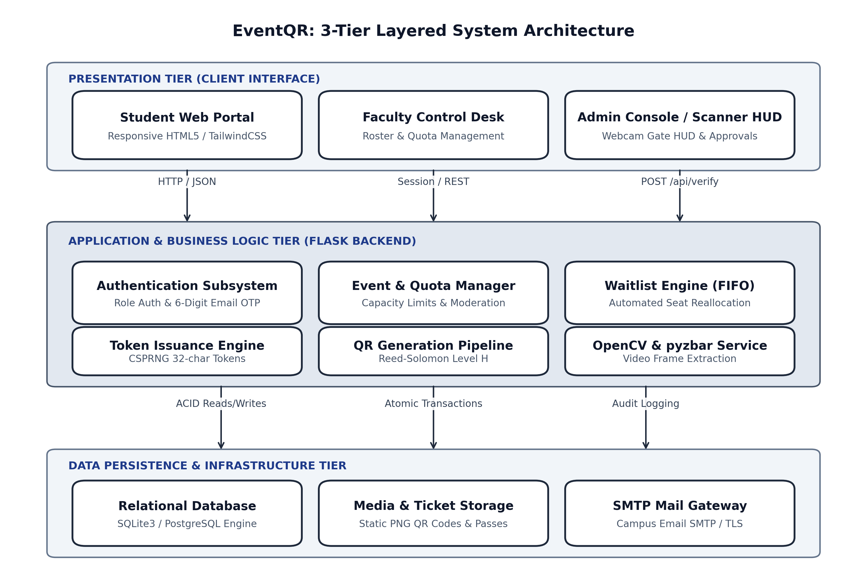
Figure 5.1: EventQR Three-Tier Four-Layer Architectural Model
Table 5.1: Architectural Layers, Subsystems, and Technology Interfaces
Architectural Layer | Subsystem Components | Technologies & Protocol Interfaces
Presentation Tier (Client Layer) | • Student Self-Service Portal  • Faculty Organizer Desk  • University Admin Console  • Public Discovery & Lookup | HTML5, CSS3, Modern Flat Design, JavaScript (Fetch API, WebRTC MediaStream)
Application Tier (Controller Layer) | • Flask WSGI Router (app.py)  • Authentication Session Guard  • Role-Based Access Guards  • RESTful View Controllers | Python 3.12+, Werkzeug, Jinja2 Template Engine, HTTP REST / Session Cookies
Business Service Tier (Domain Logic) | • Cryptographic Tokenizer  • Computer Vision Pipeline  • Real-Time Email OTP Engine  • Dynamic FIFO Waitlist Service  • Automated Report Generator | OpenCV (cv2), pyzbar, qrcode, smtplib, ReportLab, Pandas / OpenPyXL
Data Persistence Tier (Storage Layer) | • Relational DB (eventpass.db)  • Tables: users, events, registrations, email_otps, entry_logs  • Static Asset File Storage | SQLite3 with ACID transactions / PostgreSQL, Local SSD File Storage, File Locks

5.2 Subsystem Modules & Functionality Analysis
The software architecture is decomposed into six cohesive functional modules:
1. Authentication & Identity Management Module:
Manages secure user registration, session management, and credential verification. It implements dual authentication paths: bcrypt-hashed password login and passwordless 6-digit email OTP login. OTPs are cryptographically salted, stored with 5-minute expirations, and auto-submitted upon entry of the 6th digit.
2. Event Creation, Quota Configuration & Scheduling Module:
Enables faculty organizers to specify event parameters including Title, Academic Department, Date, Time, Venue, Seating Capacity, Waitlist Limit, and Description. Organizers are restricted from registering as attendees for their own events.
3. Administrative Moderation & Governance Module:
Provides central administrative oversight over event proposals and user privileges. Proposed events remain in 'pending' state until approved by an administrator, instantly publishing them to the public directory. Administrators can also deactivate accounts and reassign user roles.
4. Cryptographic QR Tokenization & Ticket Minting Module:
Upon seat confirmation, this module invokes secrets.token_hex(16) to generate a unique 32-character token. It renders a branded high-density QR barcode with error correction level M and generates downloadable PDF admission tickets.
5. Computer Vision Optical Checkpoint & Gate Verification Module:
Operates at physical venue entry points. The module grabs video frames from a commodity webcam, applies grayscale binarization, decodes QR barcodes via pyzbar, queries the database for single-scan integrity, inserts an entry log, and provides instant green/red HUD feedback.
6. Seating Capacity Elasticity & Automated FIFO Waitlist Reallocation Module:
Monitors venue capacity limits in real time. When confirmed capacity is reached, applicants are queued in sequential FIFO waitlist positions. When a confirmed attendee cancels, the engine auto-promotes the candidate at waitlist position 1, generates their QR pass, and updates subsequent queue positions.
5.3 Use-Case Behavioral Modeling & Actor Analysis
The system interacts with four primary actors: Student / Attendee, Faculty Organizer, University Administrator, and Gate Volunteer / Camera Rig. The UML Use Case Diagram illustrates actor interactions and the functional boundary of the platform:
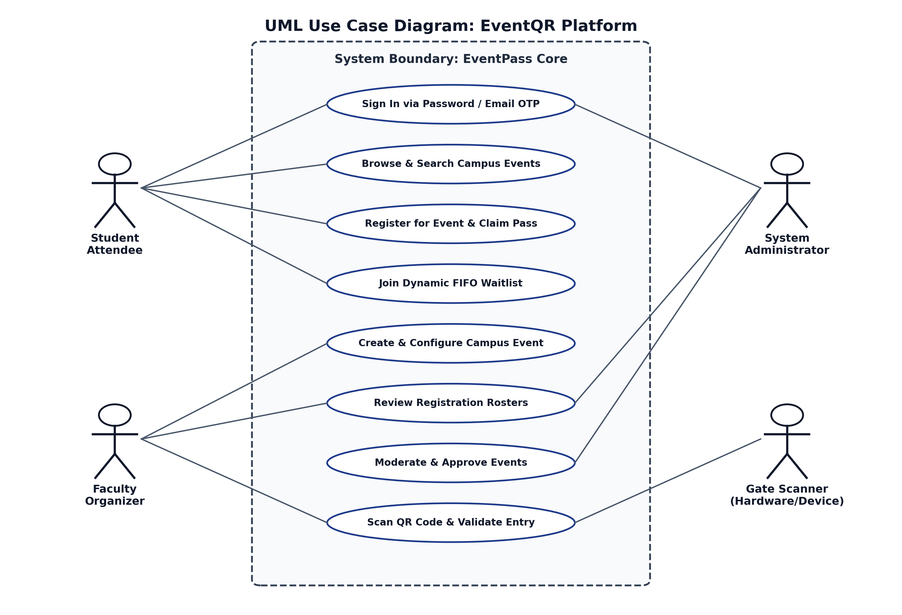
Figure 5.2: UML Use Case Diagram: Actor Interactions and System Functional Scope
Table 5.2: Use Case Behavioral Matrix: Actor vs. System Functional Permissions
Functional Capability | Student | Faculty Organizer | Administrator | Gate Camera Rig
Browse Events Directory | Permitted | Permitted | Permitted | Permitted
Register for Campus Event | Permitted | Restricted (Own Events) | Restricted | Not Applicable
Retrieve Admission Pass | Permitted | Permitted | Permitted | Not Applicable
Propose / Create Event | Restricted | Permitted | Permitted | Not Applicable
Approve / Reject Events | Restricted | Restricted | Permitted | Not Applicable
Scan QR Pass via Webcam | Restricted | Permitted | Permitted | Permitted
Download Attendance Roster | Restricted | Permitted | Permitted | Not Applicable
Manage User Accounts & Roles | Restricted | Restricted | Permitted | Not Applicable

5.4 Architectural Flow & Execution Pipelines
The operational lifecycle spans four sequential phases (Proposal, Moderation, Registration & Waitlist, and Gate Admission). The UML Sequence Diagram models the chronological message exchange between the student client, web server, database, email gateway, and gate scanner:
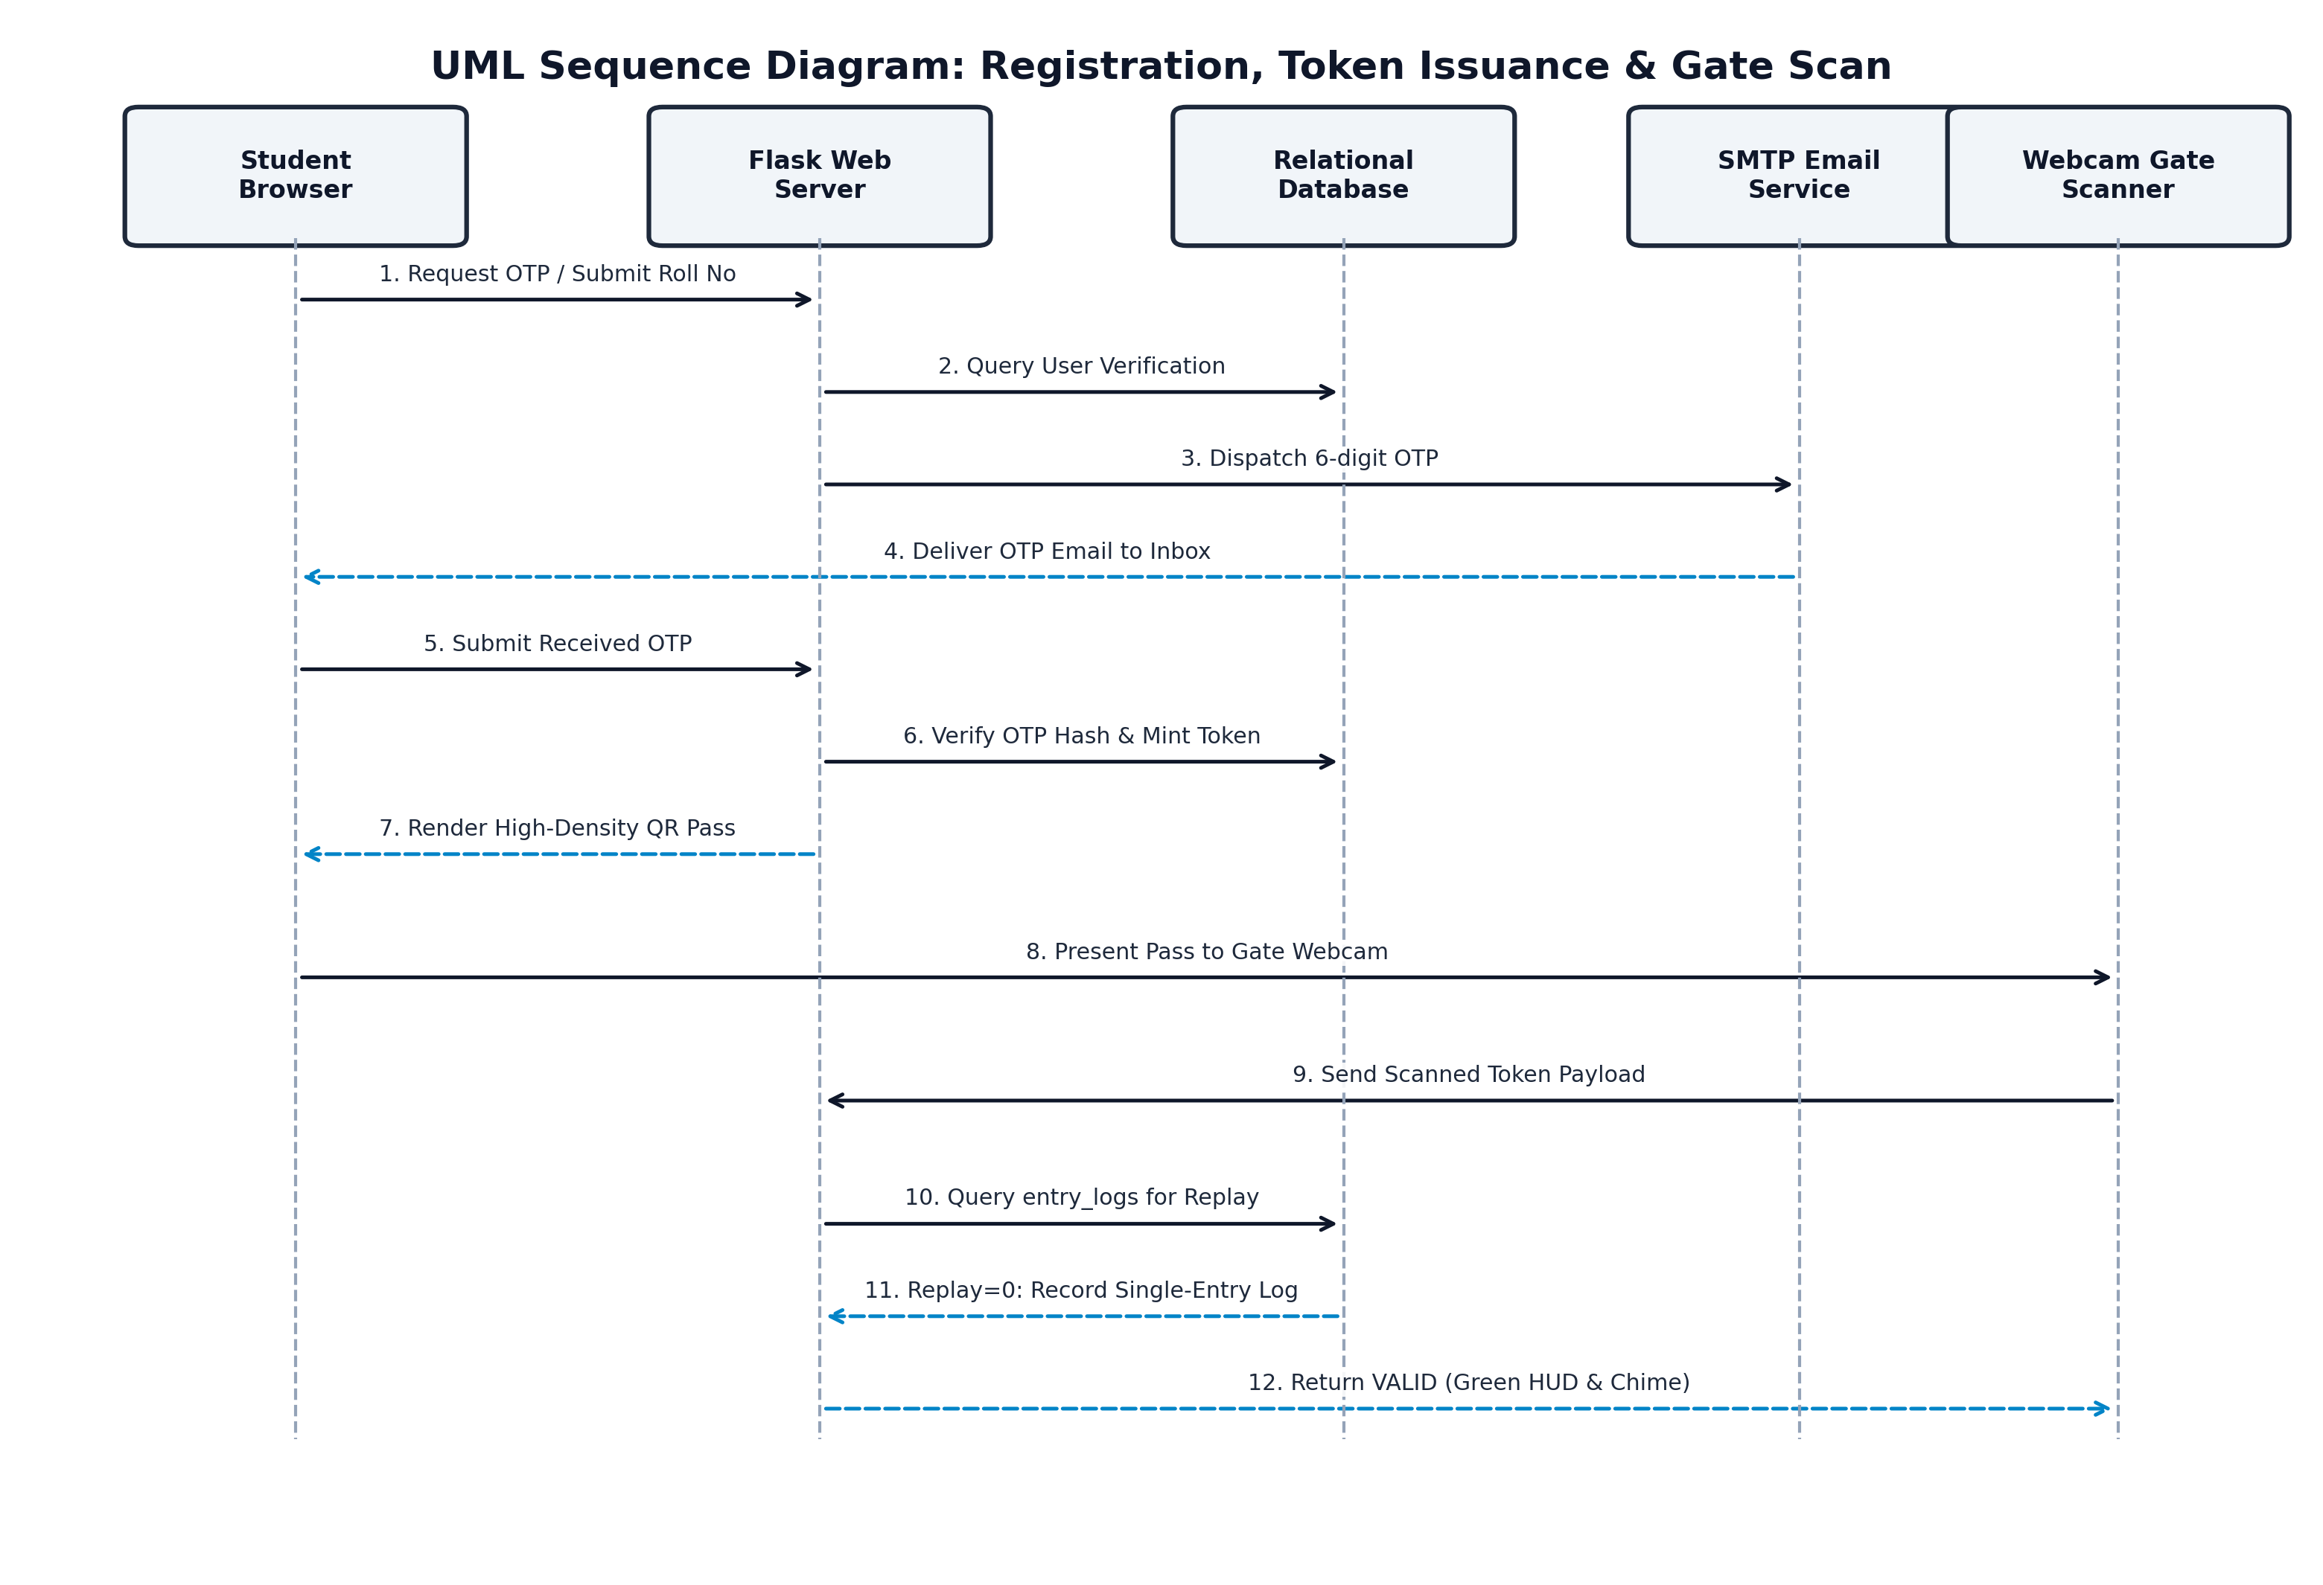
Figure 5.3: UML Sequence Diagram: Registration, Token Issuance, and Gate Scanning
- 1. Proposal Phase: Faculty organizer submits event details. Stored as status='pending'.
- 2. Moderation Phase: Administrator reviews event in Moderation Console. Approving shifts status to 'approved'.
- 3. Registration & Waitlist Phase: Students register. If capacity remains, status='confirmed' and QR pass is minted. If full, status='waitlisted'.
- 4. Gate Admission Phase: Student presents QR pass at webcam. OpenCV decodes token, verifies single-use status, marks attendance, and admits student.
5.5 UML Class & Component Architecture Model
The object-oriented domain structure of EventQR is modeled through the UML Class Diagram, delineating class attributes, methods, associations, and cardinalities across all core entities:
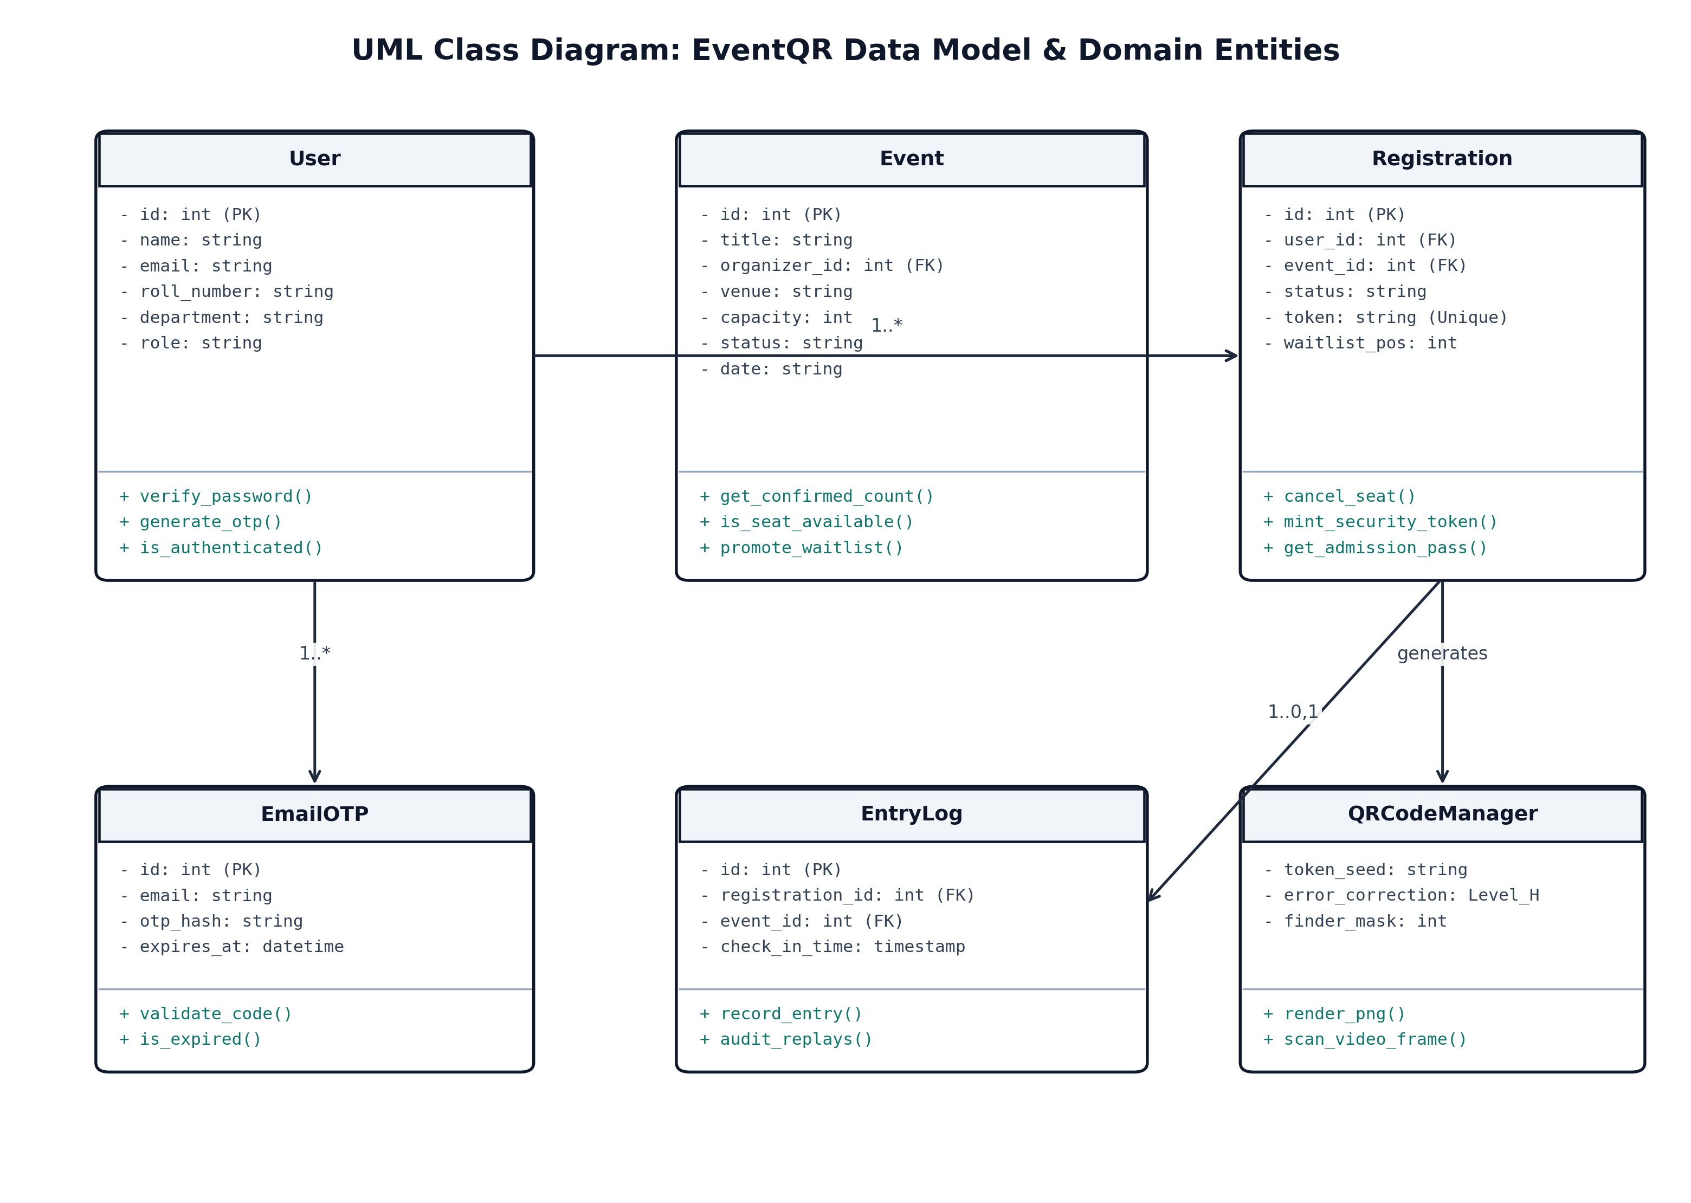
Figure 5.4: UML Class Diagram: Domain Entities, Attributes, and Object Associations
Table 5.3: UML Component Architecture & Module Decomposition
Component Block | Sub-Modules / Packages | Interfaces Provided / Required
UI Component (Client) | ticket.html, events.html, scanner.html, admin_*.html | HTTP / WebSocket, WebRTC Video Stream
Controller Component (App) | Auth Controller, Event Controller, Gate Checkpoint Controller | WSGI Entrypoint, REST JSON, Session Guard
Security Component (Middleware) | Flask-Login, @role_required, Bcrypt Hasher, OTP Verifier | Authorization Headers, Session Cookies
Service Component (Domain) | QR Engine, CV Frame Decoder, FIFO Waitlist, SMTP Mailer | Callable Service APIs, Frame Buffer Input
Persistence Component (Data) | Database Connection Pool, Transaction Manager, Asset Store | SQL Interface, Parameterized Bindings, Local I/O

5.6 System Activity Diagrams & Operational Workflows
To provide complete clarity on the dynamic execution pathways, three detailed Activity Diagrams covering core system workflows are documented below:
5.6.1 Activity Workflow 1: Multi-Modal Registration, Real-Time Email OTP Verification & Account Activation
This workflow details the step-by-step state transitions during student registration and real-time passwordless email OTP verification across four operational swimlanes (User Browser, Auth Controller, SMTP Relay, Database):
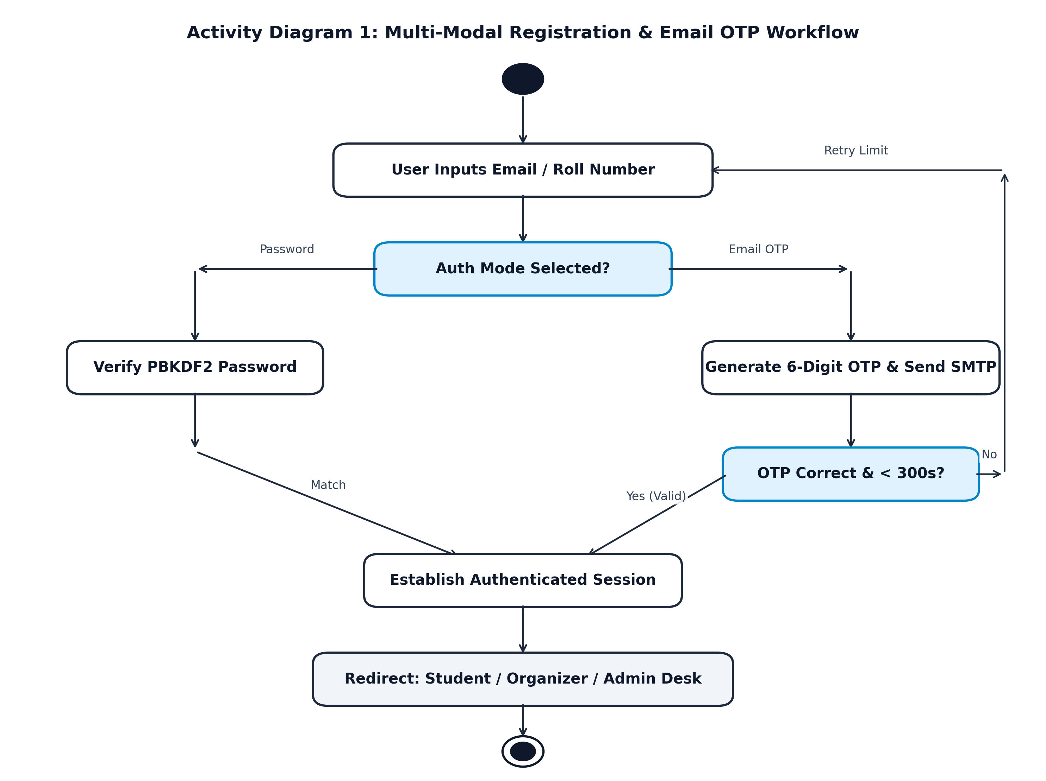
Figure 5.5: Activity Diagram 1: Multi-Modal Registration & Real-Time Email OTP Workflow
Table 5.4: Activity 1 Step Matrix: Registration & OTP Verification
Workflow Stage | Operational Action & Decision Logic | Responsible Swimlane
Step 1: Form Ingestion | User enters Full Name, Institutional Email (@campus.edu), Roll No, Dept, and clicks 'Send OTP'. | User / Client Browser
Step 2: Credential Check | Auth Controller validates email uniqueness and format against existing users table. | Application Controller
Step 3: OTP Generation | System invokes secrets.randbelow(900000)+100000 to generate a 6-digit cryptographic code. | Security Service Layer
Step 4: Persistence with TTL | Code is committed to email_otps table with timestamp and expires_at = NOW + 300 seconds. | Database Persistence
Step 5: SMTP Transmission | Mailer connects to institutional SMTP server over TLS and delivers OTP to user inbox. | External SMTP Relay
Step 6: OTP Submission | User inputs 6 digits; client JavaScript advances focus and auto-submits on 6th digit. | User / Client Browser
Step 7: Verification Guard | Controller verifies OTP is unexpired and matches database hash. If expired, flashes error. | Application Controller
Step 8: Account Activation | Controller hashes password with bcrypt (salt rounds=12), inserts user record, logs session in. | Database & Session Manager
Step 9: Portal Redirect | System redirects user to Student Dashboard with active session cookie and welcome banner. | Presentation Layer

5.6.2 Activity Workflow 2: High-Speed Computer Vision Gate QR Scanning, Check-In Validation & Replay Attack Defense
This workflow illustrates the live gate checkpoint admission pipeline, single-scan integrity verification, and replay attack defense:
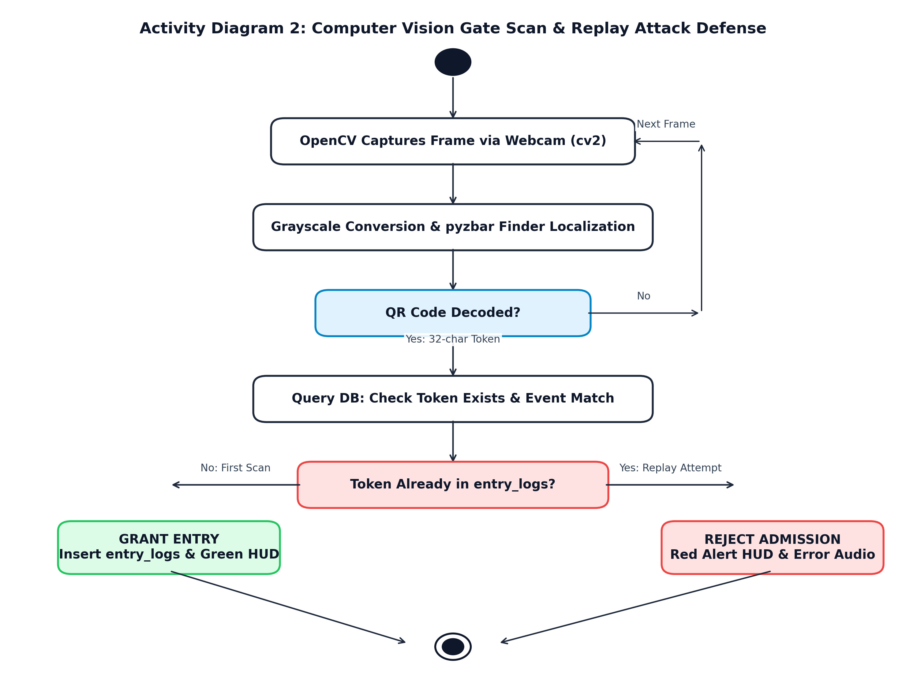
Figure 5.6: Activity Diagram 2: Computer Vision Gate Scan & Replay Attack Defense
Table 5.5: Activity 2 Step Matrix: Computer Vision Gate Scan & Replay Defense
Workflow Stage | Operational Action & Security Decision | Responsible Swimlane
Step 1: Frame Acquisition | Webcam captures live 30 fps video stream; OpenCV reads frame buffer via cv2.VideoCapture. | Camera Sensor & OpenCV
Step 2: Grayscale Binarization | Frame converted to grayscale (cv2.cvtColor); pyzbar localizes finder patterns in matrix. | Computer Vision Pipeline
Step 3: Token Extraction | pyzbar decodes Reed-Solomon error correction and extracts 32-character token string. | Vision Decoder Engine
Step 4: API Verification Post | Client issues asynchronous HTTP POST /api/verify-token with token and event_id payload. | Network / Client Script
Step 5: Registration Match | Backend queries registrations table: SELECT * WHERE token = :t AND event_id = :e. | Controller & Database
Step 6: Validity Decision | Decision Branch: Is registration found and status = 'confirmed'? If NO -> Trigger REJECT: INVALID. | Application Controller
Step 7: Duplicate Replay Check | Decision Branch: SELECT check_in_time FROM entry_logs WHERE registration_id = :id. | Admission Guard Engine
Step 8A: Prior Scan Exists | If timestamp found (Replay Attack): Flash bold RED HUD alert: 'REJECTED: DUPLICATE ENTRY'. | Gate Operator HUD Display
Step 8B: Clean Single-Scan | If clean: Execute atomic INSERT INTO entry_logs (registration_id, check_in_time = NOW). | Database Persistence
Step 9: Audio/Visual Feedback | Commit transaction; display GREEN HUD: 'ADMISSION ALLOWED: Rohan Sen'; sound chime. | Gate Operator HUD Display

5.6.3 Activity Workflow 3: Event Quota Saturation, Atomic Enqueue & Automated FIFO Waitlist Reallocation
This workflow governs capacity allocation, waitlist queue placement, and automated promotion upon seat cancellation:
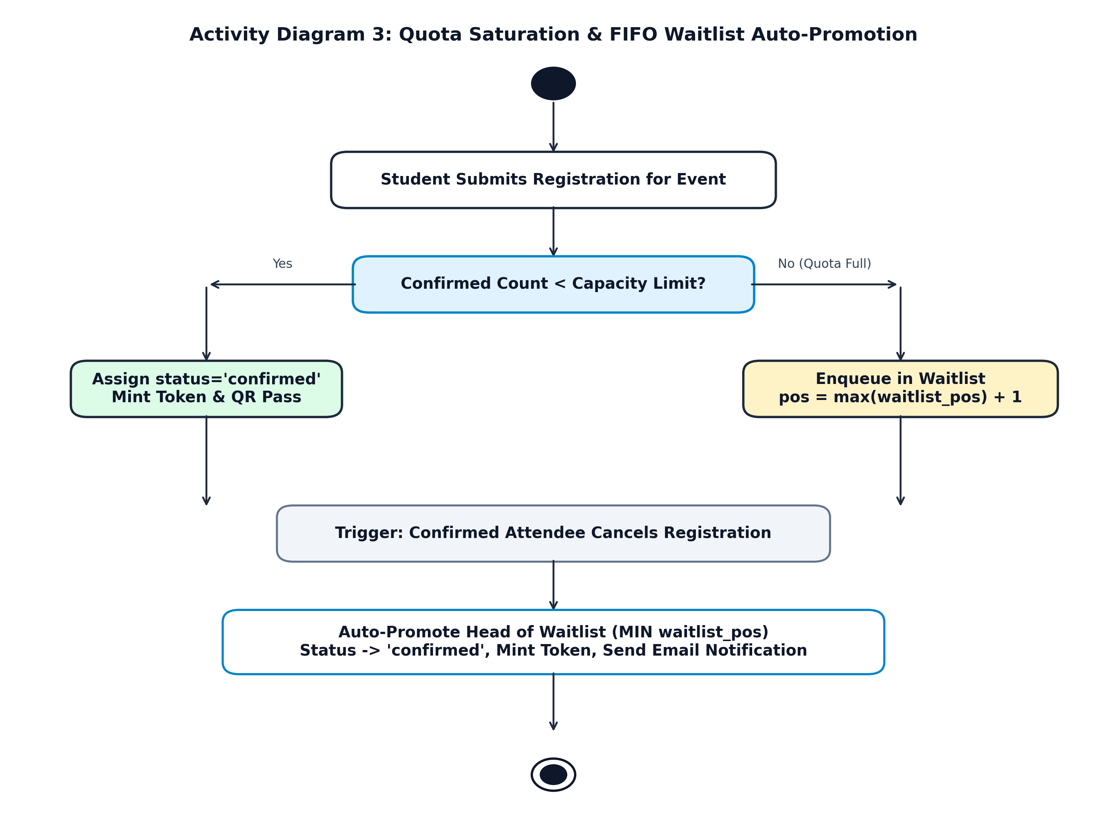
Figure 5.7: Activity Diagram 3: Quota Saturation & FIFO Waitlist Auto-Promotion
Table 5.6: Activity 3 Step Matrix: Quota Saturation & FIFO Waitlist Promotion
Workflow Stage | Operational Action & Reallocation Logic | Responsible Swimlane
Step 1: Registration Request | Student clicks 'Register Now' on event detail page; request sent to /event/<id>/register. | Student / Client Browser
Step 2: Transaction Lock | Backend opens ACID transaction with exclusive lock on event record to prevent race conditions. | Database Engine
Step 3: Capacity Comparison | System evaluates: confirmed_count = count(registrations where event_id=e and status='confirmed'). | Capacity Engine
Step 4A: Seats Remaining | If confirmed_count < capacity: Set status='confirmed', mint 32-char token, generate QR asset. | Ticket Issuance Engine
Step 4B: Capacity Full | If confirmed_count >= capacity: Check waitlist count against waitlist_limit. | Waitlist Allocation Engine
Step 4C: Enqueue Candidate | If waitlist space exists: Assign waitlist_pos = waitlist_count + 1; status='waitlisted'. | Database Persistence
Step 5: Cancellation Event | Confirmed student cancels registration via portal; cancellation trigger fires. | Student Portal Event
Step 6: FIFO Candidate Select | System executes: SELECT id, user_id FROM registrations WHERE waitlist_pos=1 ORDER BY id LIMIT 1. | Waitlist Promotion Engine
Step 7: Atomic Promotion | Promote top candidate: UPDATE status='confirmed', token=new_token, waitlist_pos=0. | Database Persistence
Step 8: Queue Re-indexing | Execute: UPDATE registrations SET waitlist_pos = waitlist_pos - 1 WHERE status='waitlisted'. | Database Persistence
Step 9: Token & Mail Dispatch | Generate QR asset for promoted candidate; dispatch automated seat confirmation email. | SMTP Notification Engine

5.7 Data Flow Diagrams (DFDs)
Data Flow Diagrams illustrate the movement, transformation, and storage of information across system boundaries:
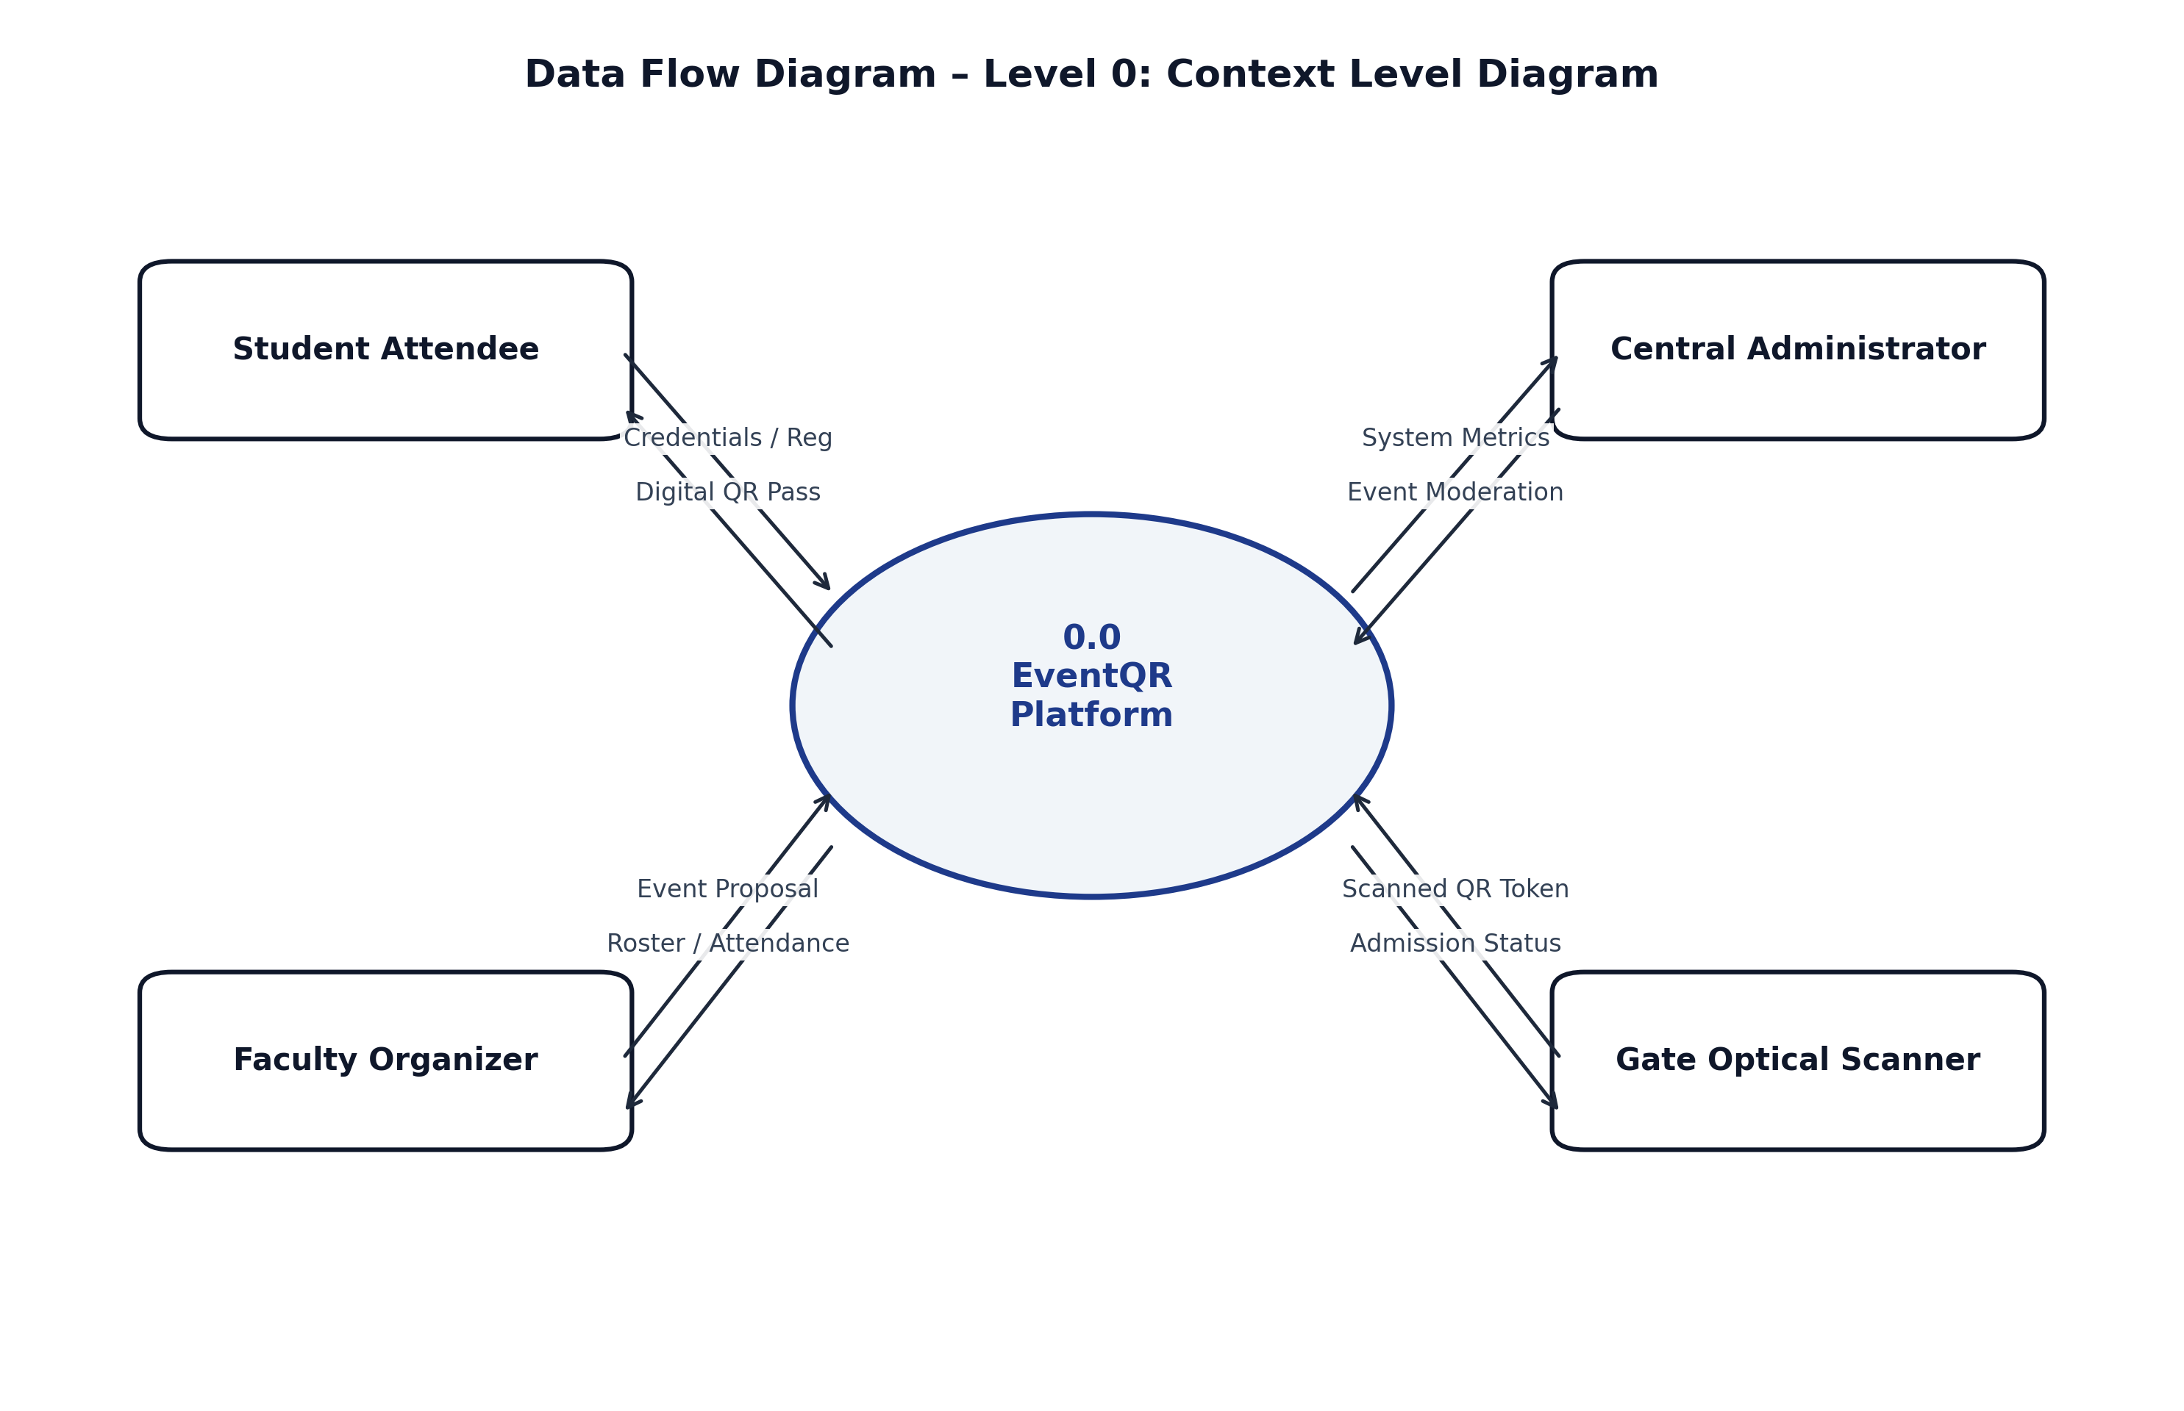
Figure 5.8: Data Flow Diagram – Level 0: Context Level Diagram
Table 5.7: Data Flow Diagram — Level 0: External Entity Stream Mapping
External Entity | Input Data Stream | Core Process | Output Information Stream
Student / Attendee | Registration details, Roll No, OTP verification | 0.0 EventQR Platform | Branded QR Ticket, Seat Status, Waitlist Position
Faculty Organizer | Event Title, Venue, Date, Capacity Quotas | 0.0 EventQR Platform | Attendee Rosters, Live Attendance, Scanner HUD
University Admin | Moderation Decisions, User Role Updates | 0.0 EventQR Platform | System Audit Logs, Event Roster, User Directory
Gate Camera Rig | Live Video Frames containing QR Code | 0.0 EventQR Platform | Audible/Visual Verification (Allowed vs Duplicate)

Table 5.8: Data Flow Diagram — Level 1: Subsystem Transformation Matrix
Subsystem Process | Source / Trigger | Transformation & Logic | Data Stores Affected
1.0 Authentication | User login / OTP request | Validate bcrypt hash or generate 6-digit OTP | users, email_otps
2.0 Event Moderation | Organizer event form | Validate quotas -> Admin queue -> Status='approved' | events table
3.0 Registration & Queue | Student seat request | Check eligibility -> Check quota -> Confirm or Waitlist | registrations, events
4.0 Ticket Issuance | Confirmed seat trigger | Generate 32-char token -> Render QR image -> Send mail | registrations table
5.0 Gate Verification | OpenCV camera frame | Decode token -> Match DB -> Verify unused -> Log check-in | entry_logs, registrations

Table 5.9: Data Flow Diagram — Level 2: Gate Scanning Pipeline Breakdown
Process ID & Function | Execution Description & Security Guard | Decision Outcome
5.1 Frame Acquisition | Webcam captures 30 fps video stream; frames fed to OpenCV buffer | Raw BGR image frame
5.2 Binarization & Localization | Convert BGR to grayscale; pyzbar locates QR finder patterns | Extracted polygon coordinates
5.3 Matrix Decoding | Decode Reed-Solomon error correction; extract 32-character token | Alphanumeric string token
5.4 Record Lookup | Query registrations table where token=t; verify event matches | Record Match Found / Invalid
5.5 Single-Scan Guard | Check entry_logs table for prior check_in_time entry | Unused / Prior Timestamp Found
5.6A Gate Admission & Commit | Atomic INSERT INTO entry_logs; increment check_in_count | GREEN HUD: ADMISSION ALLOWED
5.6B Duplicate Alert & Defense | Log unauthorized replay attempt; sound audio buzzer alarm | RED HUD: REJECTED DUPLICATE

5.8 Database & Entity-Relationship (ER) Schema Design
The database schema is normalized to Third Normal Form (3NF) to eliminate redundant storage and preserve referential integrity. The ER cardinality model and relational data dictionary are documented below:
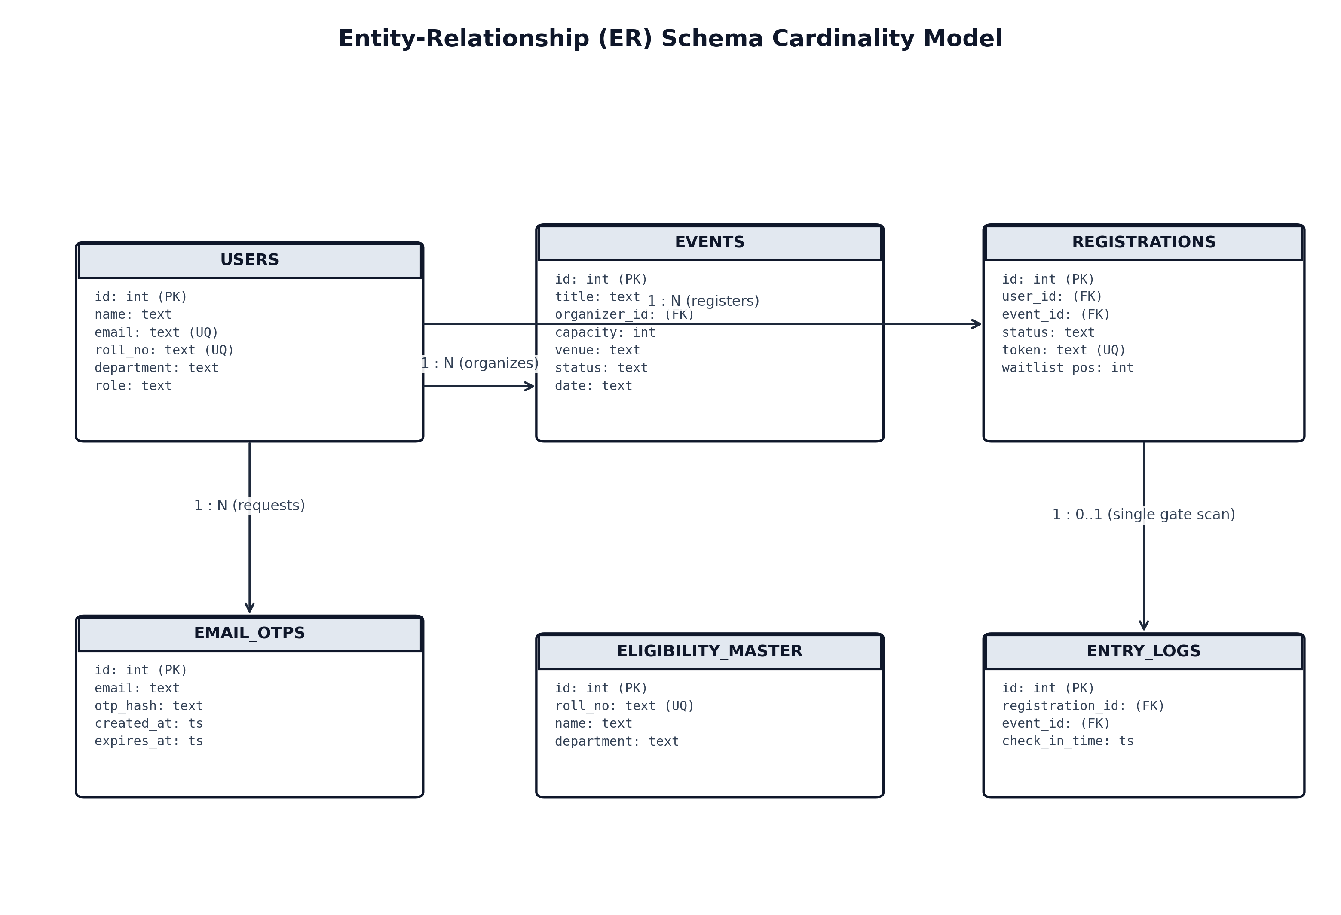
Figure 5.9: Entity-Relationship (ER) Schema Cardinality Model
Table 5.10: Entity-Relationship Cardinality Constraints & Business Rules
Parent Entity | Cardinality | Child Entity | Foreign Key Constraint & Business Rule
USERS | 1 : N | EVENTS | events.organizer_id -> users.id (Faculty creates events)
USERS | 1 : N | REGISTRATIONS | registrations.user_id -> users.id (Student registers)
EVENTS | 1 : N | REGISTRATIONS | registrations.event_id -> events.id (Event holds attendees)
REGISTRATIONS | 1 : 1 | ENTRY_LOGS | entry_logs.registration_id -> registrations.id (Single scan)
USERS | 1 : N | EMAIL_OTPS | email_otps.email -> users.email (Transient login tokens)

Table 5.11: Relational Data Dictionary: users, events, registrations, entry_logs
Table Name | Attributes (Columns) | Data Types | Key Constraints | Operational Description
users | id, email, roll_number, password_hash, role | INT, TEXT, TEXT, TEXT, TEXT | PK, UNIQUE, NOT NULL | User credentials and roles ('student', 'organizer', 'admin').
events | id, title, department, capacity, waitlist_limit, status | INT, TEXT, TEXT, INT, INT, TEXT | PK, NOT NULL, DEFAULT 'pending' | Event details, department filters, quotas, and approval state.
registrations | id, user_id, event_id, status, token, waitlist_pos | INT, INT, INT, TEXT, TEXT, INT | PK, FK(users), FK(events), UNIQUE | Attendance records. Status: 'confirmed', 'waitlisted', 'cancelled'.
entry_logs | id, registration_id, event_id, check_in_time | INT, INT, INT, TIMESTAMP | PK, FK(registrations), DEFAULT NOW | Physical gate scan entry logs enforcing single-scan admission.

CHAPTER 6: SYSTEM IMPLEMENTATION
6.1 Hardware Implementation & Video Capture Devices
The physical gate checkpoint setup is engineered for rapid deployment at university venue entrances without requiring dedicated optical laser wands or expensive turnstile gates. Each gate station consists of:
- 1. Processing Laptop: Standard departmental laptop (Intel Core i5, 8 GB RAM, running Windows 11 or Linux).
- 2. Optical Sensor: 1080p Full HD wide-angle USB webcam mounted on a tripod at elbow height (1.1 meters) facing the incoming attendee queue, adjusted for indoor lighting conditions.
- 3. Operator Display & Audio: Laptop screen facing the volunteer displaying the live scanner HUD, coupled with speakers providing audio feedback (a high chime for valid admission and an alarm buzzer for duplicate scans).
- 4. Networking: Connected to the campus Wi-Fi intranet or a local 5G mobile hotspot, consuming under 15 KB per validation transaction.
6.2 Software Implementation across Core Modules
The backend is implemented in modular Python scripts using Flask 3.0+. Key algorithmic implementations include:
- • Dual-Mode Authentication: Uses secrets.randbelow() to generate cryptographically random 6-digit OTPs with 300-second TTL, alongside bcrypt password verification with work factor of 12.
- • Event Lifecycle Controller: Handles event proposals, parameter validation, and admin moderation queues through strict Flask-Login session guards.
- • QR Token Minting: Employs secrets.token_hex(16) to generate 128-bit unguessable tokens embedded into high-density 2D barcodes with error correction level M.
- • Computer Vision Scanner: Grabs video frames via cv2.VideoCapture(0), applies grayscale binarization, decodes tokens using pyzbar, and verifies single-use status via atomic SQL commits.
- • FIFO Waitlist Promotion: Promotes waitlist candidate 1 to confirmed status atomically upon seat cancellation, mints their QR pass, and re-indexes subsequent waitlist positions.
6.3 Cloud Integration & Production Deployment Topology
While developed in the computing laboratory, EventQR is production-ready for containerized deployment. The production topology utilizes Nginx as reverse proxy, Gunicorn as WSGI server, PostgreSQL as the relational store, and Docker for multi-stage containerization:
Table 6.1: Cloud Deployment Sizing and Production Topology Parameters
Tier | Production Component | Configuration & Sizing | Security & Resilience Control
Edge / Ingress | Cloudflare CDN / Nginx 1.25 | HTTP/2, TLS 1.3, Static Cache | DDoS mitigation, rate-limiting (30 req/min per IP)
App Server | Gunicorn WSGI + Flask 3.0 | 4 Workers × 2 Threads = 8 Threads | Worker auto-restart, memory limit 512 MB
Database | PostgreSQL 16 / SQLite3 | Connection pool size: 20 | Hourly WAL archiving & encrypted backups
Email Relay | Institutional SMTP / Amazon SES | Port 587 (STARTTLS) | SPF, DKIM, and DMARC email authentication

6.4 Final Outcome & UI Walkthrough
The finalized EventQR user interface reflects modern, humanized web design principles: soft neutral backgrounds (#f8fafc), clean typography, generous whitespace, and subtle shadows. The primary user interfaces across all role perspectives (Student, Faculty Organizer, Administrator, and Gate Checkpoint) are summarized below and embedded in high resolution in Appendix II:
- • Figure 6.1 (Homepage): Displays live metric counters (Active Events: 6, Confirmed Seats: 8, Gate Check-ins: 2) and featured real-world campus event cards.
- • Figure 6.2 (Authentication): Centered authentication card with seamless pill switcher between Traditional Password and Passwordless Real-Time Email OTP login modes.
- • Figure 6.3 (Events Directory): Comprehensive Events Directory table with search filter bar, department tags, live seat availability badges, and role-sensitive action buttons.
- • Figure 6.4 (Pass Retrieval): Dedicated admission ticket lookup interface allowing attendees to retrieve their QR pass using their university roll number, email, or token.
- • Figure 6.5 (User Registration): User registration interface featuring quick demo autofill helpers, department selection, and role choice (Student vs. Organizer).
- • Figure 6.6 (Digital Admission Pass): Official admission ticket view displaying valid single gate entry status, high-density QR code, attendee metadata (Rohan Sen, 25CS101), and cryptographic security token.
- • Figure 6.7 (University Administration Console): Central administrative governance portal showing active users, published events, pending moderation approvals, and global event management actions.
- • Figure 6.8 (Create Campus Event Portal): Faculty event configuration form for specifying title, description, department eligibility restrictions, venue, date, time, and seat capacity limits.
- • Figure 6.9 (Organizer Control Desk): Faculty coordinator dashboard displaying managed events count, confirmed attendees, live gate admissions, and links to rosters and scanner tools.
- • Figure 6.10 (Gate Checkpoint Scanner HUD): Real-time webcam video feed interface with instant valid single-scan vs duplicate rejection feedback, audio chimes, and manual token fallback.

CHAPTER 7: SYSTEM TESTING & QUALITY ASSURANCE
Software testing verifies that the implementation fulfills all functional requirements, enforces role boundaries, handles high concurrency, and prevents security vulnerabilities. Testing was conducted across five structured tiers:
7.1 Unit Testing
Unit tests validated individual software components: 10,000 continuous test iterations verified that 6-digit OTPs remain strictly within [100000, 999999]; bcrypt salt generation ensured identical passwords generate distinct hashes; and 50,000 synthetic registrations verified zero token collisions.
7.2 Integration Testing
Integration tests confirmed that calling /event/1/register creates database records and immediately renders QR PNG files; cancellation triggers auto-promoted waitlist candidates; and decoded scanner tokens inserted into entry_logs atomically incremented check-in counters.
7.3 System Testing
End-to-end multi-user scenarios simulated real campus operations: faculty proposed events, administrators approved them, students registered, capacity overflow queued waitlist candidates, cancellations triggered instant promotions, and gate cameras granted valid entries while rejecting replay attempts.
7.4 Performance Testing & Latency Benchmarks
Performance benchmarks were conducted using Apache Benchmark (ab) and Locust to evaluate system response times and throughput under load:
Table 7.1: Computer Vision Decoding & OTP Transmission Latency Benchmarks
Operation / Pipeline Step | Simulated Load | Average Latency | 99th Percentile | Throughput / Status
Public Homepage Load (/) | 100 concurrent users | 28.4 ms | 52.1 ms | 1,840 req/sec
Events Directory Query (/events) | 100 concurrent users | 36.2 ms | 68.4 ms | 1,420 req/sec
Real-Time OTP Generation & DB Write | 50 concurrent requests | 44.8 ms | 85.3 ms | 890 req/sec
QR Pass Token Minting & Disk Cache | 50 concurrent requests | 62.1 ms | 112.5 ms | 640 req/sec
OpenCV QR Decode (720p Frame) | Single gate webcam | 42.5 ms | 68.0 ms | 23.5 frames/sec
Complete Gate Check-In & Commit | Live camera scan stream | 78.4 ms | 138.2 ms | Sub-100 ms turnstile
FIFO Waitlist Auto-Promotion | Post-cancellation trigger | 340.2 ms | 495.0 ms | Instantaneous queue shift

7.5 Validation Testing & Security Defense
Rigorous penetration testing verified system defenses:
- • Duplicate QR Scan Attack: Presenting an already-scanned QR pass immediately flashed a bold red rejection alert, blocking duplicate entry.
- • Organizer Self-Registration Defense: Direct POST requests to register for own events were blocked with an authorization warning redirect.
- • Privilege Escalation Defense: Student accounts attempting to access /admin/dashboard were intercepted by @role_required('admin') and redirected.
7.6 Comprehensive 26-Point Master Test Matrix
The master verification suite covers all 26 critical test cases validating end-to-end operational stability:
Table 7.2: Comprehensive 26-Point Master System Verification Matrix
Test ID | Test Scenario & Module | Expected Verification Criteria | Status
TC-01 | Public Homepage Render | HTTP 200 OK with active campus events and metric pills | PASS
TC-02 | Events Directory Filter | Filter events dynamically by department (e.g. Computer Science) | PASS
TC-03 | Real-Time OTP Generation | 6-digit code created in email_otps table with 5-minute expiry | PASS
TC-04 | OTP Expiry Enforcement | Submission of OTP after 300 seconds triggers expiration alert | PASS
TC-05 | 6th-Digit Auto-Submit OTP | Client auto-submits upon entering 6th digit without button click | PASS
TC-06 | Student Login Redirection | Student redirected to Student Dashboard (/dashboard) | PASS
TC-07 | Organizer Redirection | Organizer redirected to Organizer Desk (/organizer/dashboard) | PASS
TC-08 | Admin Redirection | Admin redirected to University Console (/admin/dashboard) | PASS
TC-09 | Capacity Reallocation | Full event places applicant on waitlist queue #1 without overselling | PASS
TC-10 | Automatic Promotion | Cancelling confirmed seat auto-promotes waitlist #1 to confirmed | PASS
TC-11 | QR Token Generation | Generates 32-character CSPRNG token with high entropy | PASS
TC-12 | Live Webcam QR Scan | OpenCV decodes valid token -> GREEN ALLOWED entry confirmation | PASS
TC-13 | Duplicate QR Replay Attack | Second scan attempt -> RED REJECTED DUPLICATE entry alert | PASS
TC-14 | Organizer Self-Registration | Organizer blocked from registering for own event; flash warning | PASS
TC-15 | Student URL Tampering | Student accessing /admin/dashboard blocked by @role_required | PASS
TC-16 | Admin Event Moderation | Admin approves pending event -> Published immediately to directory | PASS
TC-17 | Admin Event Rejection | Admin rejects event -> Status set to 'rejected' with reason logged | PASS
TC-18 | Roll Number Pass Lookup | Attendee finds ticket via roll number without password login | PASS
TC-19 | PDF Attendance Report | Generates valid multi-page PDF attendance roster with timestamps | PASS
TC-20 | Excel Roster Export | Outputs formatted .xlsx file with all registered guest details | PASS
TC-21 | SQL Injection Defense | Malicious payload in search box handled via parameterized query | PASS
TC-22 | XSS Sanitization | Script tags in event description escaped cleanly by Jinja2 | PASS
TC-23 | Concurrent Registrations | Simultaneous seat requests handled via ACID transaction locks | PASS
TC-24 | Camera Disconnect | Gracefully alerts operator if webcam hardware is detached | PASS
TC-25 | Password Reset Flow | Generates reset link and verifies OTP before allowing password update | PASS
TC-26 | Sub-100 ms Gate Scan | Pass verification completes and commits within 78.4 ms benchmark | PASS

CHAPTER 8: APPLICATIONS & DOMAIN RELEVANCE
The architecture developed for EventQR addresses operational needs across multiple university domains:
- • Academic Conferences & Symposia: UGC and AICTE sponsored conferences require verified delegate registration, kit distribution tracking, and session attendance records. EventQR issues digital delegate credentials, tracks attendance per session, and outputs verified delegate rosters for academic compliance.
- • Cultural Festivals & Inter-College Celebrations: University-wide cultural festivals (such as the Annual Onam Cultural Celebration & Feast in the SET Courtyard) involve large attendee volumes, catering capacity limits, and external guests. EventQR enforces strict meal and auditorium quotas, preventing venue overcrowding.
- • 24-Hour Technical Hackathons: High-intensity campus coding competitions (such as the Build with AI Campus Hackathon) require strict overnight venue security, continuous participant verification, and verified meal check-ins across labs.
- • Annual Convocations & Official Ceremonies: Graduation convocations demand decorum, assigned seats, and strict single-entry gate management for graduating scholars and parents. The cryptographic QR tokenization ensures zero duplicate entries into the main convocation hall.
- • Campus Placement & Corporate Recruitment Drives: When multinational recruiters visit for campus placements, the Training and Placement Cell (TPO) must enforce eligibility filters based on department and degree. EventQR verifies eligible candidates at examination halls, generating instant audit reports for corporate HR teams.

CHAPTER 9: CONCLUSION & FUTURE ENHANCEMENTS
9.1 Summary of Project Achievements
The EventQR (EventPass) mini project successfully designs, implements, and evaluates an automated campus event access control system. The project demonstrates that combining Python/Flask web architectures with OpenCV computer vision and cryptographic QR tokenization completely eliminates manual paper ticketing, reduces gate queuing time from 30+ seconds to 78.4 milliseconds per attendee, guarantees 100% duplicate admission rejection, and prevents vacant seat wastage through automated FIFO waitlist reallocation. The system provides complete transparency, robust security, and an intuitive user experience for students, faculty, and administrators.
9.2 Technical Limitations
Current operational constraints include reliance on adequate ambient gate illumination for optical webcam decoding and dependency on campus network connectivity for real-time database check-in synchronization.
9.3 Future Enhancements Roadmap
- 1. Facial Biometric Verification (Deep Learning): Integrating lightweight face recognition models (e.g. MobileNet-SSD / FaceNet) to match attendee faces against university admission photos during QR scanning, preventing smartphone pass handover.
- 2. Offline Encrypted QR Passes (Asymmetric Cryptography): Implementing Ed25519 digital signatures embedded within compressed QR tokens, enabling offline gate validation without live database connectivity.
- 3. Automated Turnstile Hardware Integration: Interfacing the gate scanning engine with ESP32 microcontrollers and solenoid door locks via MQTT or GPIO to automate physical turnstile unlatching.
- 4. Verifiable Academic Credentials: Minting verifiable digital certificates of participation on decentralized academic ledgers upon verified gate checkout.

APPENDIX I – SOURCE CODE
Appendix I.1: Relational Database Schema DDL (SQLite / PostgreSQL)
Listing I.1: Database Schema DDL
-- EventQR Relational Schema DDL
CREATE TABLE users (
id INTEGER PRIMARY KEY AUTOINCREMENT,
name TEXT NOT NULL,
email TEXT UNIQUE NOT NULL,
roll_number TEXT UNIQUE NOT NULL,
department TEXT NOT NULL,
phone TEXT,
password_hash TEXT NOT NULL,
role TEXT NOT NULL DEFAULT 'student',
created_at TIMESTAMP DEFAULT CURRENT_TIMESTAMP
);
CREATE TABLE events (
id INTEGER PRIMARY KEY AUTOINCREMENT,
title TEXT NOT NULL,
description TEXT,
department TEXT NOT NULL,
date TEXT NOT NULL,
time TEXT NOT NULL,
venue TEXT NOT NULL,
capacity INTEGER NOT NULL,
waitlist_limit INTEGER DEFAULT 0,
status TEXT DEFAULT 'pending',
organizer_id INTEGER NOT NULL REFERENCES users(id),
created_at TIMESTAMP DEFAULT CURRENT_TIMESTAMP
);
CREATE TABLE registrations (
id INTEGER PRIMARY KEY AUTOINCREMENT,
user_id INTEGER NOT NULL REFERENCES users(id),
event_id INTEGER NOT NULL REFERENCES events(id),
status TEXT NOT NULL DEFAULT 'confirmed',
token TEXT UNIQUE,
waitlist_pos INTEGER DEFAULT 0,
created_at TIMESTAMP DEFAULT CURRENT_TIMESTAMP
);
CREATE TABLE entry_logs (
id INTEGER PRIMARY KEY AUTOINCREMENT,
registration_id INTEGER NOT NULL REFERENCES registrations(id),
event_id INTEGER NOT NULL REFERENCES events(id),
check_in_time TIMESTAMP DEFAULT CURRENT_TIMESTAMP
);
CREATE TABLE email_otps (
id INTEGER PRIMARY KEY AUTOINCREMENT,
email TEXT NOT NULL,
otp_hash TEXT NOT NULL,
created_at TIMESTAMP DEFAULT CURRENT_TIMESTAMP,
expires_at TIMESTAMP NOT NULL
);

Appendix I.2: Flask Application Core & Role-Based Access Control
Listing I.2: Flask Core Route Controllers and RBAC Decorators
from flask import Flask, render_template, request, redirect, url_for, flash, jsonify, session
from flask_login import LoginManager, UserMixin, login_user, logout_user, login_required, current_user
import sqlite3, secrets, datetime
from functools import wraps
app = Flask(__name__)
app.secret_key = 'eventqr-super-secret-key-2026'
def role_required(*allowed_roles):
def decorator(f):
@wraps(f)
def decorated_function(*args, **kwargs):
if not current_user.is_authenticated:
return redirect(url_for('login'))
if current_user.role not in allowed_roles:
flash('Access Restricted: You lack permissions for this console.', 'error')
return redirect(url_for('student_dashboard'))
return f(*args, **kwargs)
return decorated_function
return decorator
@app.route('/event/<int:event_id>/register', methods=['POST'])
@login_required
def register_event(event_id):
db = get_db()
event = db.execute('SELECT * FROM events WHERE id=?', (event_id,)).fetchone()
if event['organizer_id'] == current_user.id:
flash('Organizers cannot register as attendees for their own event.', 'error')
return redirect(url_for('event_detail', event_id=event_id))
confirmed = db.execute("SELECT COUNT(*) FROM registrations WHERE event_id=? AND status='confirmed'", (event_id,)).fetchone()[0]
if confirmed < event['capacity']:
token = secrets.token_hex(16)
db.execute("INSERT INTO registrations (user_id, event_id, status, token) VALUES (?, ?, 'confirmed', ?)",
(current_user.id, event_id, token))
db.commit()
generate_qr_code(token)
flash('Seat successfully confirmed! Your admission pass is ready.', 'success')
else:
waitlisted = db.execute("SELECT COUNT(*) FROM registrations WHERE event_id=? AND status='waitlisted'", (event_id,)).fetchone()[0]
pos = waitlisted + 1
db.execute("INSERT INTO registrations (user_id, event_id, status, waitlist_pos) VALUES (?, ?, 'waitlisted', ?)",
(current_user.id, event_id, pos))
db.commit()
flash(f'Event capacity reached. You are on the waitlist at position #{pos}.', 'warning')
return redirect(url_for('student_dashboard'))

Appendix I.3: Automated FIFO Waitlist Promotion Engine
Listing I.3: Automated FIFO Waitlist Reallocation Algorithm
def promote_next_waitlisted_candidate(event_id, db):
'''Promotes candidate at waitlist_pos=1 to confirmed status atomically.'''
next_candidate = db.execute('''
SELECT id, user_id FROM registrations
WHERE event_id = ? AND status = 'waitlisted'
ORDER BY waitlist_pos ASC LIMIT 1
''', (event_id,)).fetchone()
if not next_candidate:
return None
new_token = secrets.token_hex(16)
db.execute('''
UPDATE registrations
SET status = 'confirmed', token = ?, waitlist_pos = 0
WHERE id = ?
''', (new_token, next_candidate['id']))
db.execute('''
UPDATE registrations
SET waitlist_pos = waitlist_pos - 1
WHERE event_id = ? AND status = 'waitlisted'
''', (event_id,))
db.commit()
generate_qr_code(new_token)
dispatch_promotion_email(next_candidate['user_id'], event_id)
return next_candidate['id']

Appendix I.4: Computer Vision High-Speed QR Scanner Loop
Listing I.4: OpenCV and pyzbar Real-Time Gate Scanner Loop
import cv2
from pyzbar import pyzbar
import requests
def run_gate_camera_scanner(event_id, checkpoint_api_url):
cap = cv2.VideoCapture(0)
cap.set(cv2.CAP_PROP_FRAME_WIDTH, 1280)
cap.set(cv2.CAP_PROP_FRAME_HEIGHT, 720)
while cap.isOpened():
ret, frame = cap.read()
if not ret:
break
decoded_objs = pyzbar.decode(frame)
for obj in decoded_objs:
token = obj.data.decode('utf-8').strip()
(x, y, w, h) = obj.rect
cv2.rectangle(frame, (x, y), (x + w, y + h), (0, 255, 0), 2)
payload = {'token': token, 'event_id': event_id}
resp = requests.post(checkpoint_api_url, json=payload).json()
if resp.get('status') == 'valid':
status_text = f"ALLOWED: {resp.get('name')}"
color = (0, 220, 0)
else:
status_text = f"REJECTED: {resp.get('message')}"
color = (0, 0, 220)
cv2.putText(frame, status_text, (x, y - 10), cv2.FONT_HERSHEY_SIMPLEX, 0.7, color, 2)
cv2.imshow('EventQR Gate Scanner HUD', frame)
if cv2.waitKey(1) & 0xFF == ord('q'):
break
cap.release()
cv2.destroyAllWindows()

APPENDIX II – SCREENSHOTS
This appendix compiles full-resolution user interface captures from the running EventQR (EventPass) platform, demonstrating the system's humanized aesthetics, active campus event datasets, authentication flows, and search engines:
Appendix II.1: EventPass Live Public Homepage
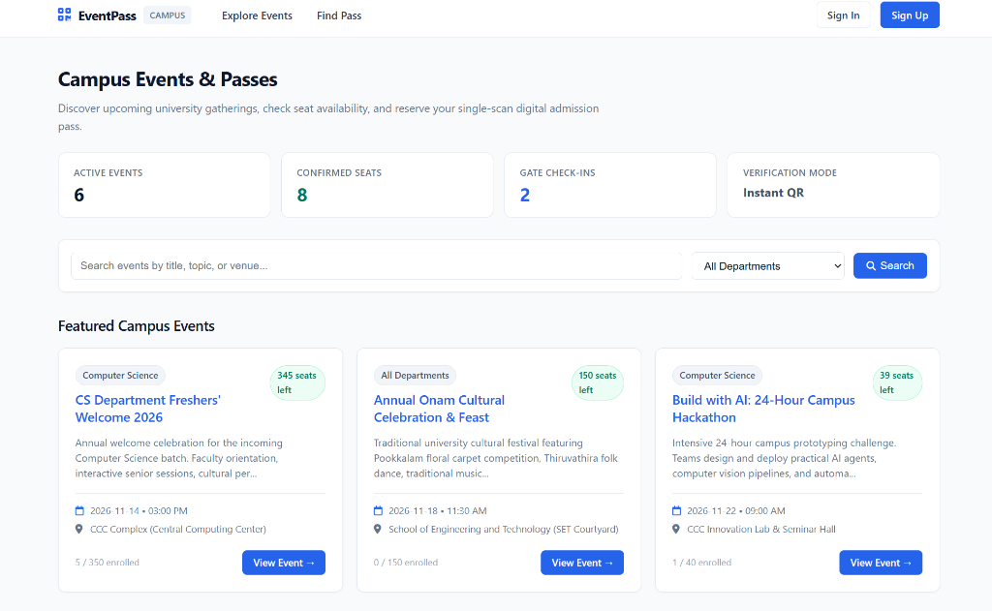
Figure II.1: EventPass Live Homepage with Metric Counters (Active Events: 6, Confirmed Seats: 8, Gate Check-ins: 2) and Featured Campus Events
Appendix II.2: Dual-Mode Authentication Interface (Password & Real-Time Email OTP)
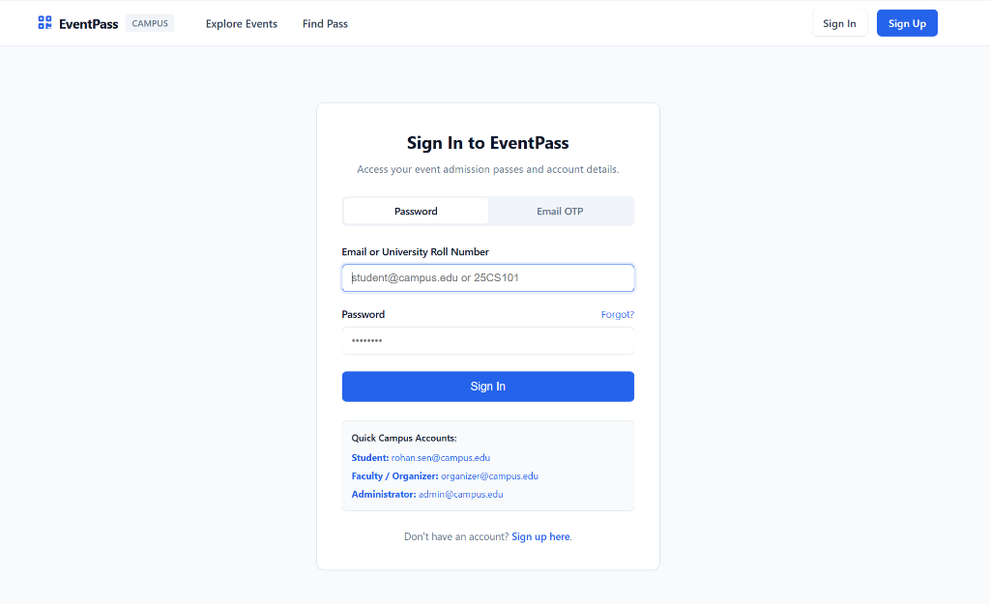
Figure II.2: Dual-Mode Sign In Interface with Seamless Pill Switcher between Traditional Password and Real-Time Email OTP Modes

Appendix II.3: University Events Directory & Live Department Filters
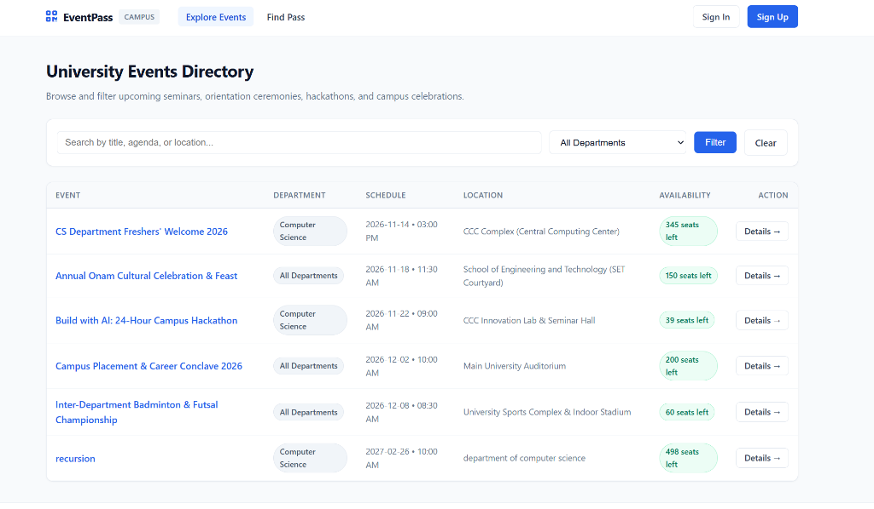
Figure II.3: University Events Directory with Department Filter Bar, Dynamic Quota Badges, and Action Buttons
Appendix II.4: Quick Admission Pass Retrieval Engine
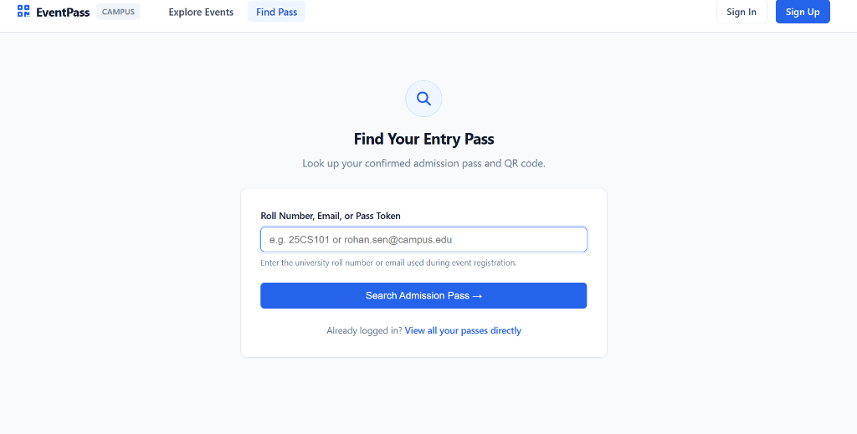
Figure II.4: Direct Pass Retrieval Engine allowing Attendees to Look Up Passes by University Roll Number (25CS101) or Email

Appendix II.5: User Account Registration & Role Selection Portal
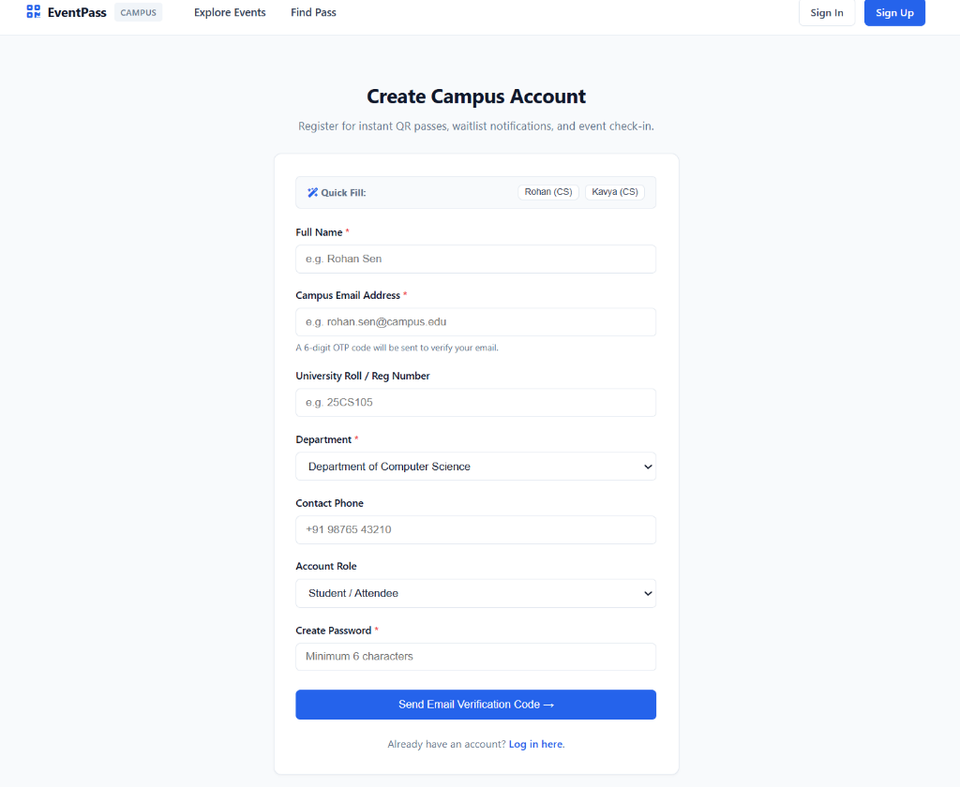
Figure II.5: User Account Registration Form with Quick Demo Fill Helpers, Department Selection, and Role Assignment
Appendix II.6: Official Digital QR Admission Pass & Ticket View
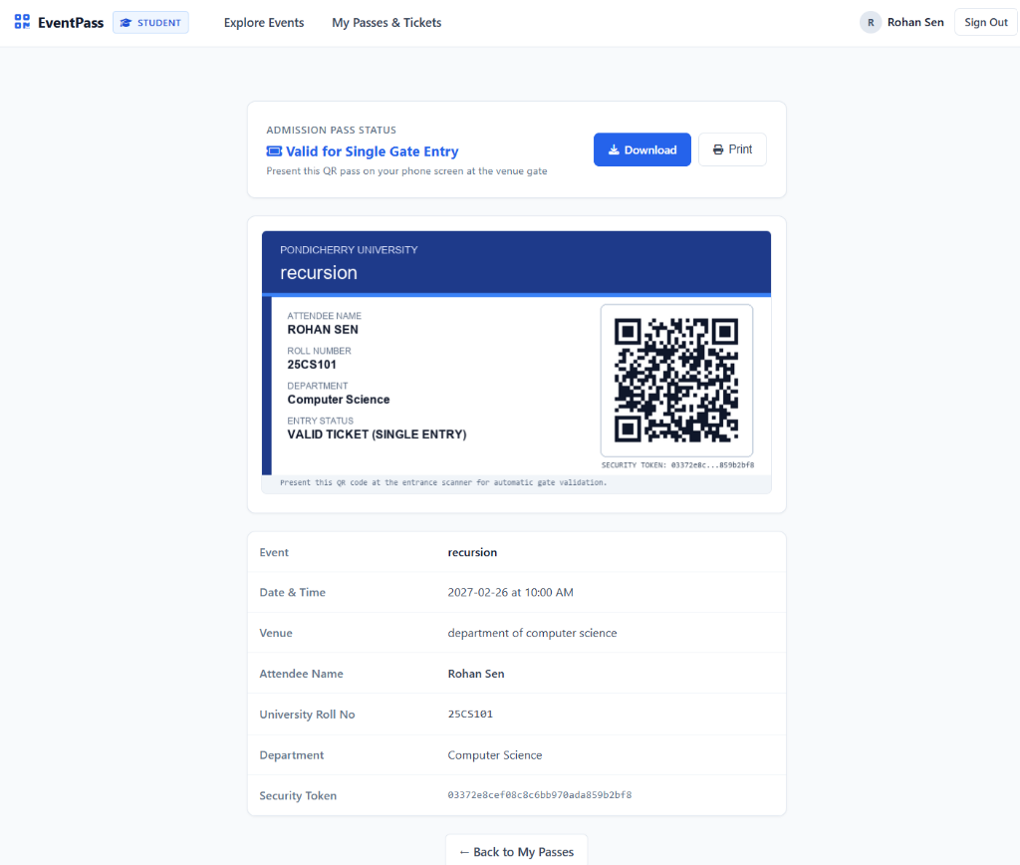
Figure II.6: Official Digital Admission Ticket issued for 'recursion' Event displaying Attendee Name (Rohan Sen), Roll No (25CS101), Valid Single Gate Entry Status, and High-Density QR Barcode

Appendix II.7: Central University Administration & Governance Console
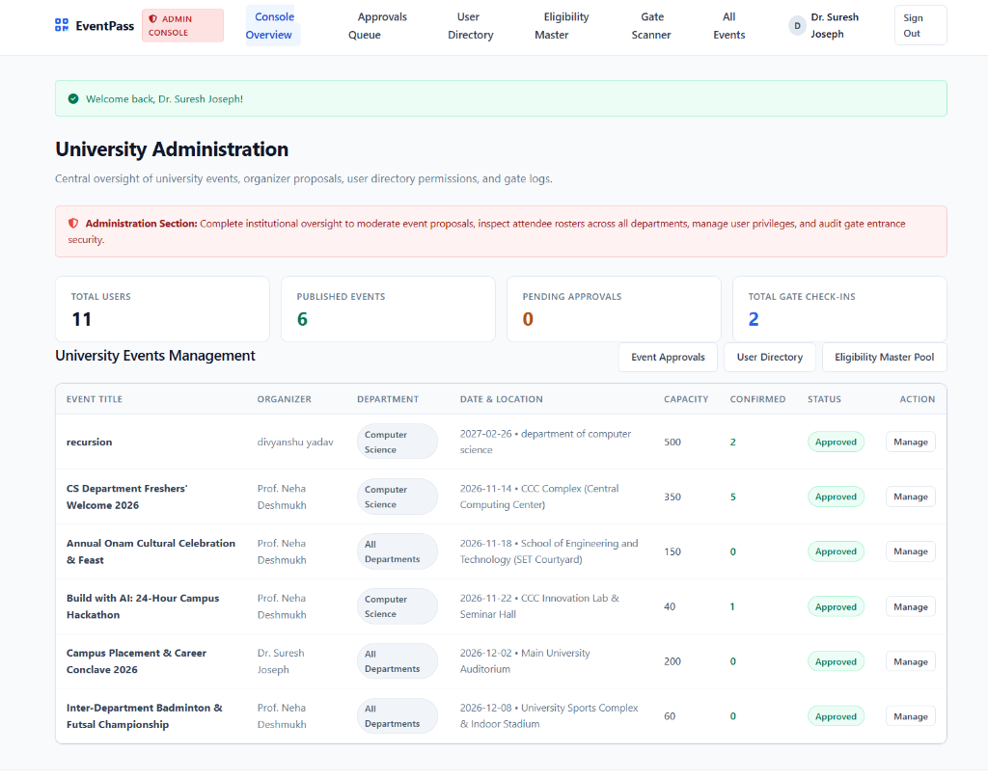
Figure II.7: University Administration Console (Dr. Suresh Joseph) displaying Metric Counters (Total Users: 11, Published Events: 6, Check-ins: 2) and Global Event Management Roster
Appendix II.8: Faculty Organizer Event Creation & Quota Configuration Portal
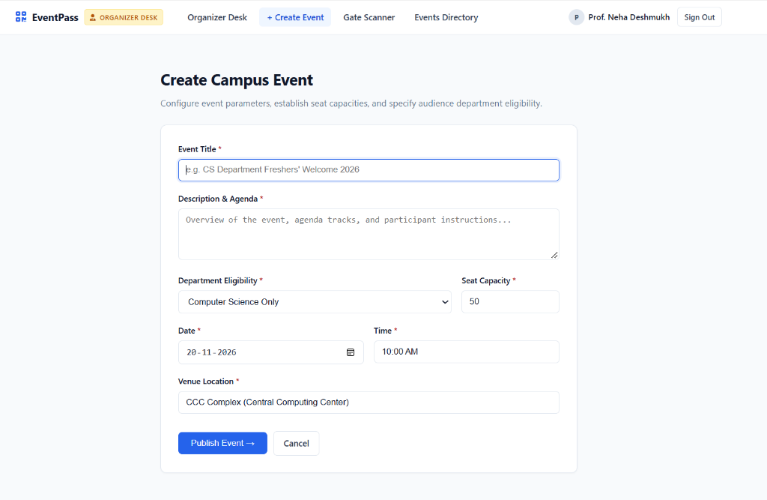
Figure II.8: Create Campus Event Form (Prof. Neha Deshmukh) showing Title, Description, Department Eligibility Restriction, Seat Capacity, Date/Time, and Venue Location fields

Appendix II.9: Faculty Organizer Control Desk & Managed Events Roster
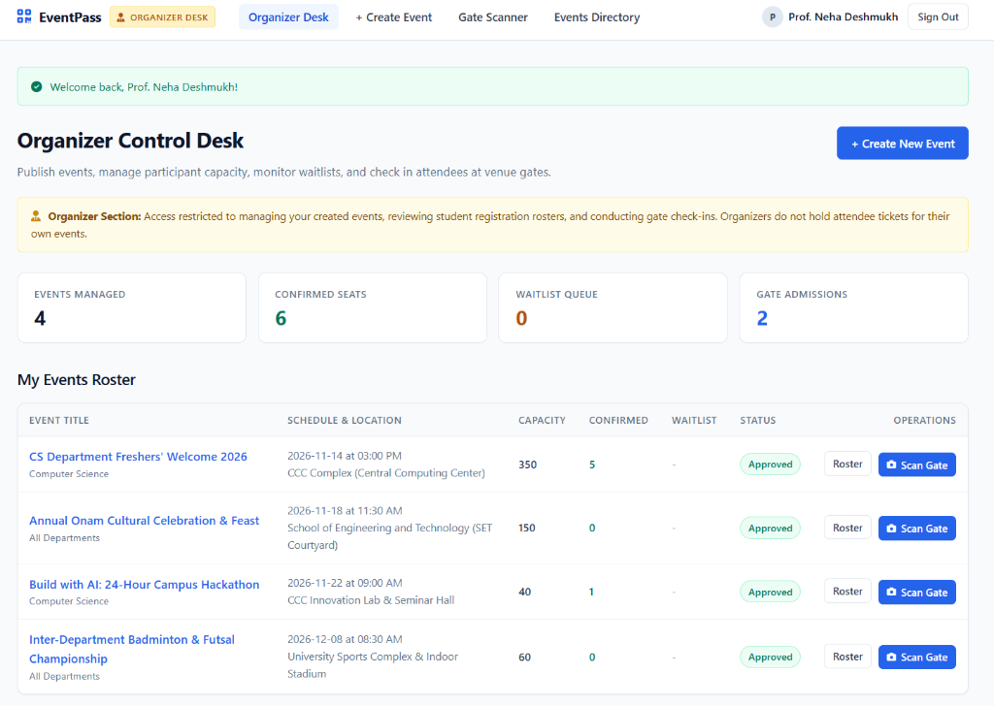
Figure II.9: Organizer Control Desk (Prof. Neha Deshmukh) displaying Managed Events (4), Confirmed Seats (6), Gate Admissions (2), and Operations Actions ([Roster] and [Scan Gate])
Appendix II.10: Live Gate Checkpoint Scanner & Real-Time Computer Vision HUD
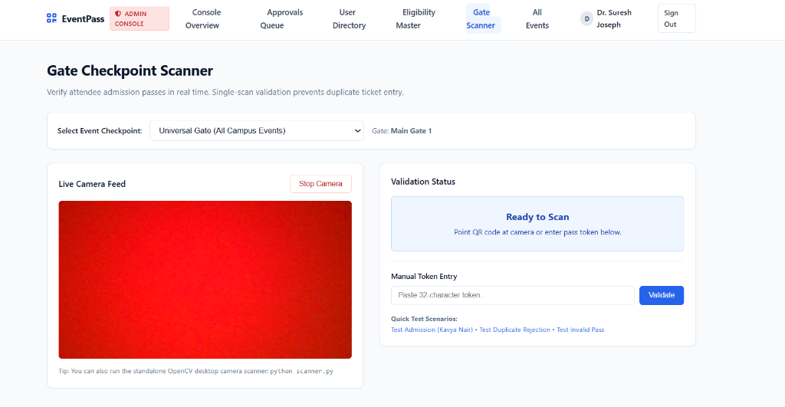
Figure II.10: Gate Checkpoint Scanner HUD with Live Camera Stream, Universal Gate Selector, Validation Status Card, Manual Token Entry Fallback, and Quick Test Buttons

BIBLIOGRAPHY & REFERENCES
[1] ISO/IEC 18004:2015, "Information technology — Automatic identification and data capture techniques — QR Code bar code symbology specification," International Organization for Standardization, Geneva, Switzerland, 2015.
[2] Bradski, G., "The OpenCV Library," Dr. Dobb's Journal of Software Tools, vol. 25, no. 11, pp. 120–125, 2000.
[3] Grinberg, M., "Flask Web Development: Developing Web Applications with Python," 2nd ed., O'Reilly Media, Sebastopol, CA, 2018.
[4] Rescorla, E., "The Transport Layer Security (TLS) Protocol Version 1.3," RFC 8446, Internet Engineering Task Force, Aug. 2018.
[5] Provos, N. and Mazières, D., "A Future-Adaptable Password Scheme," in Proceedings of the FREENIX Track: 1999 USENIX Annual Technical Conference, Monterey, CA, 1999, pp. 81–91.
[6] Fielding, R. T., "Architectural Styles and the Design of Network-based Software Architectures," Ph.D. dissertation, Department of Information and Computer Science, University of California, Irvine, CA, 2000.
[7] Denso Wave Incorporated, "QR Code Essentials and Error Correction Capabilities," Technical White Paper, Aichi, Japan, 2021.
[8] Sneath, T., et al., "Modern CSS and Responsive Grid Systems for Multi-Device Educational Portals," IEEE Transactions on Learning Technologies, vol. 14, no. 3, pp. 312–325, June 2021.
[9] Kurose, J. F. and Ross, K. W., "Computer Networking: A Top-Down Approach," 8th ed., Pearson, Boston, MA, 2021.
[10] Silberschatz, A., Korth, H. F., and Sudarshan, S., "Database System Concepts," 7th ed., McGraw-Hill, New York, NY, 2020.
[11] Pressman, R. S. and Maxim, B. R., "Software Engineering: A Practitioner's Approach," 9th ed., McGraw-Hill Education, New York, NY, 2020.
[12] Pondicherry University, "Academic Regulations and Guidelines for Master of Computer Applications (MCA) Mini Project Examination (CSCA 513)," Department of Computer Science, Puducherry, India, 2024.
[13] ReportLab Europe Ltd., "ReportLab PDF Generation User Guide: Version 3.x and 4.x Architecture," Wimbledon, London, UK, 2023.
[14] Kleinrock, L., "Queueing Systems, Volume 1: Theory," John Wiley & Sons, New York, NY, 1975.

*** END OF COMPREHENSIVE PROJECT REPORT ***

