A
Project Report
On..
E-Commerce Website(Wristwatches)

Developed By..
Hardik Parmar
Submitted to ..
Geetanjali College of computer science & commerce(BBA)
Saurashtra Univetsity
Rajkot
2026-27
Guided by..
Prof. Harsh Joshi
Acknowledgements
The success and final outcome of this project required a lot of guidence and assistance from many people and I am extremely privileged to have got this all along the completion of my project all that I have done due to such supervision and assistance and I would not forget to thank them.

I would like to thank my project coordinator and my faculty guide for his valuable guidance for the project and I would like to thank my project partnet who helped me through my entire project.
Preface

The purpose of this E-Commerce website is to improve the user experience and their awarenesses.

The E-Commerce Website project will be used to minimize the time and the resource by enhancing product purchasing technique and seamless experience.

While the resources which minimized are workforce,money and paper etc.

The website is user-friendly and will help the watch purchasers.
Index
Sr.  No. | Description | Page  No.
1 | Project Profile | 1
2 | Project Requirement | 2
3 | Technology Requirement | 2
4 | Data Flow diagram | 3
5 | ER diagram | 4
6 | Data Dictionaty | 5
7 | Screen Shots | 7
8 | Future Enhancements | 20
9 | Limitations of Project | 21
10 | Bibilography | 22

Project Profile
Project Title | E-Commerce Website(Wristwatches)
Objective | The E-commerce Website will provide user a better experience of purchasing the Wristwatches.
Hardware Requirements | Pentium 90 MHz or faster and 4GB RAM or higher
Software Requiremnts | Any Browser like Chrome
Front-End | React JS, TailwindCSS
Back-End | NodeJS, Express
Database | MongoDB
Others | Ms-word 2022

Project Requirement
- Hardware Requirement
Hardware Name | Hardware
Processor | Pentium or AMD
storage | 800MB or Higher
RAM | 4GB or Higher

Technology Requirements
- Software Requirements
No. | Software Used
1 | Google Chrome
2 | Windows OS (Windows 10/11)
3 | Visual Studio Code

Data Flow Diagram

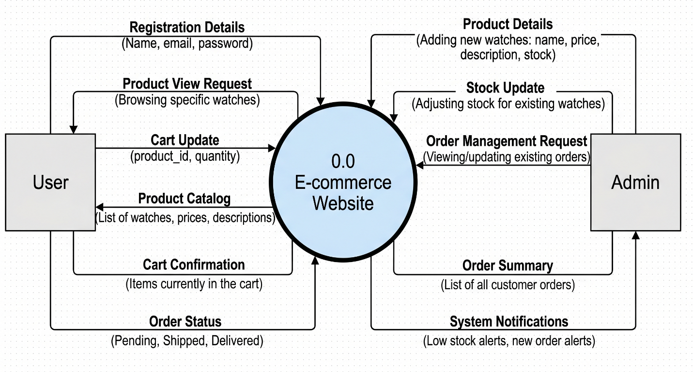
ER Diagram
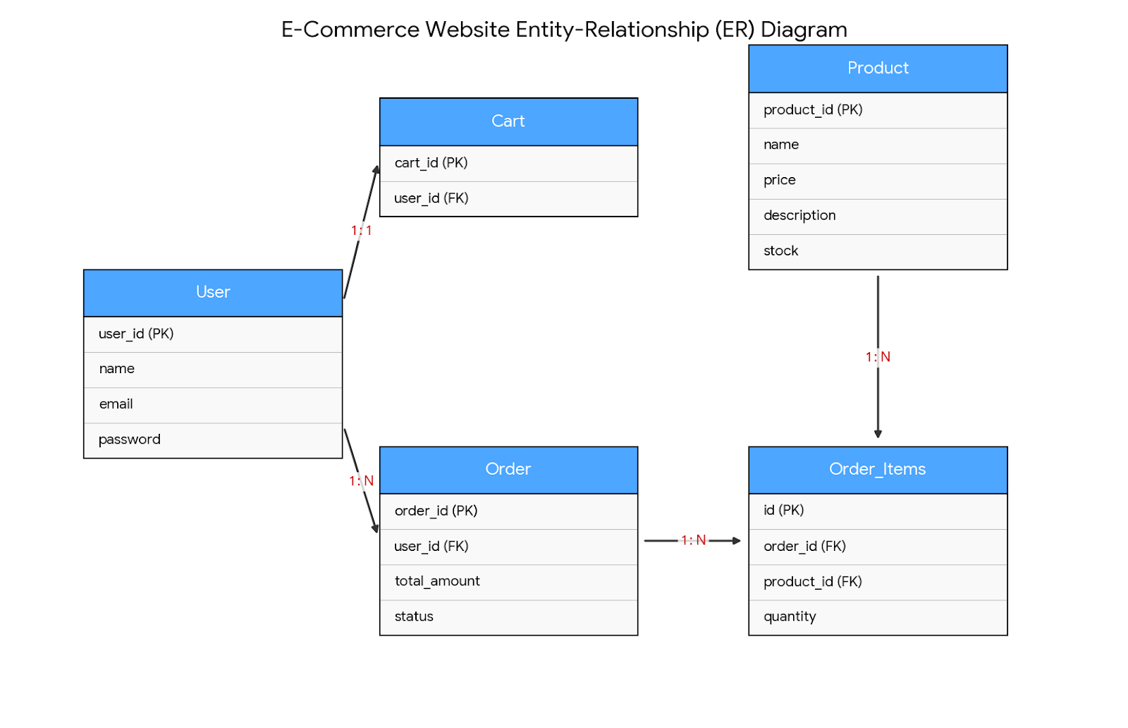

Data Dictionary
- User_table
Sr No. | Field Name | Data Type | Size | Constraints
1 | user_id | ObjectId | - | Primary Key
2 | name | Varchar | 255 | Not Null
3 | email | Varchar | 255 | Unique
4 | password | Varchar | 255 | Not Null

- Product_table
Sr no. | Field Name | Data  Type | Size | Constrains
1 | product_id | ObjectId | - | Primary Key
2 | name | Varchar | 255 | Not Null
3 | price | Decimal | - | Not Null
4 | description | Text | - | -
5 | stock | Int | - | Default

- Cart
Sr No. | Field Name | Data Type | Size | Constraints
1 | cart_id | ObjectId/Int | - | Primary Key
2 | user_id | ObjectId/Int | - | Foreign Key

- Order
Sr No. | Field Name | Data Type | Size | Constraints
1 | order_id | ObjectId | - | Primary Key
2 | user_id | ObjectId | - | Foreign Key
3 | total_amount | Decimal | - | Not Null
4 | status | Varchar | 50 | Pending/Delivered

Order_Items
Sr No. | Field Name | Data Ty pe | Size | Constraints
1 | id | ObjectId | - | Primary Key
2 | order_id | ObjectId | - | Foreign Key
3 | product_id | ObjectId | - | Foreign Key
4 | quantity | Int | - | Not Null

Screen Shots

- Admin Login Page

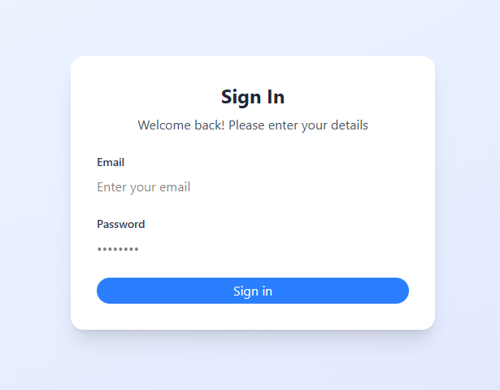

- In this page admin can enter the main page using correct username and password. It is an authentication for all admin.
- Admin panel

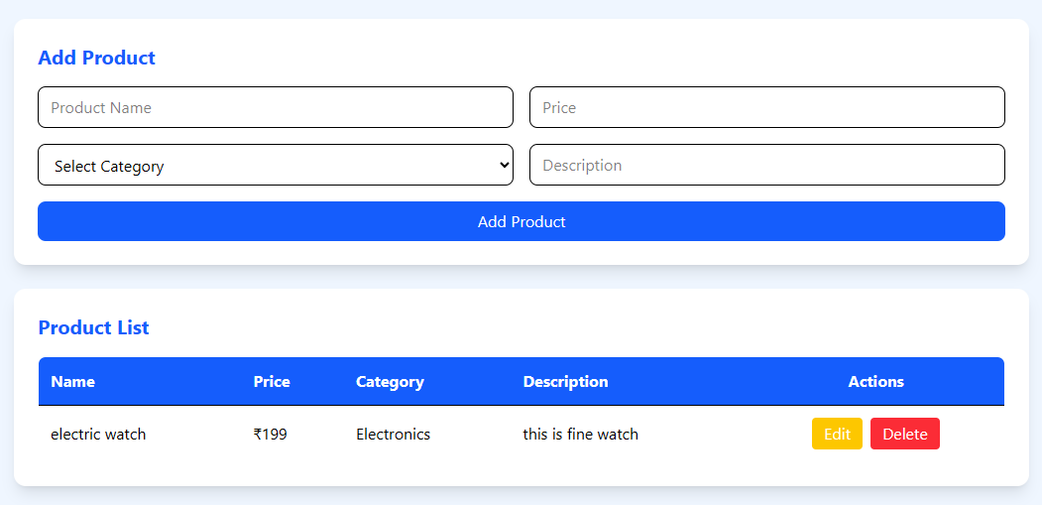

- This is the main dashboard of admin panel in this page admin can add product, user and also can view products and users.
- User detail page

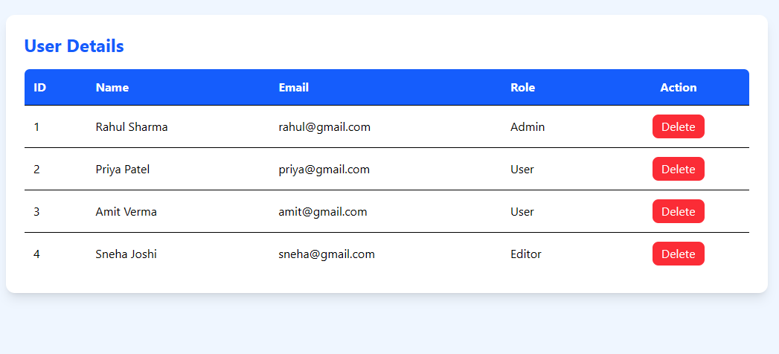

- In this page admin can add product. Admin needs to fullfill all the fields to add product.
- Home page

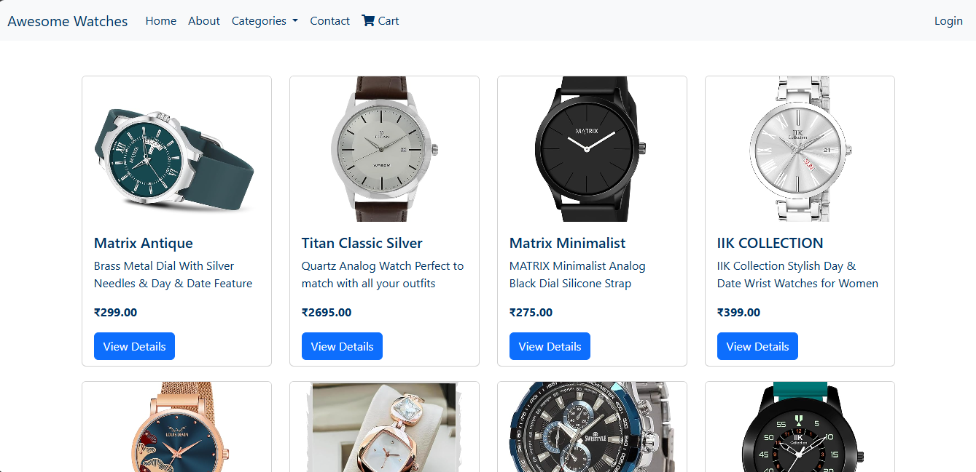

- This is the main home page of our website.
- You can see all products and the menu also can se the categories.
- About page
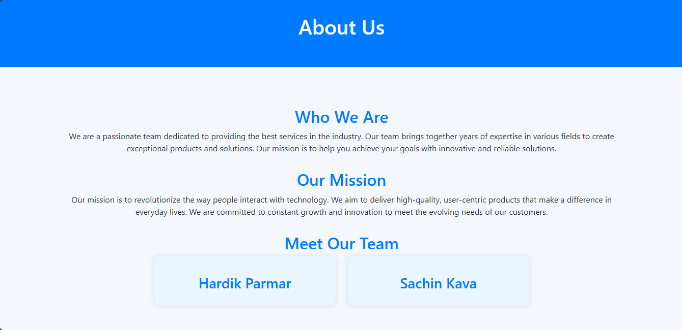

- This is the about page it contains the basic information about the website.
- Contact Page

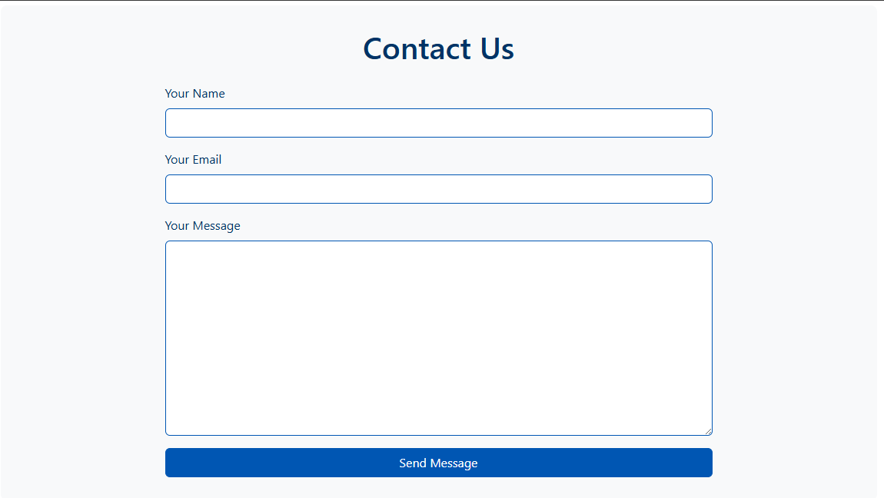

- This is the contact page it helps customer to contact with the site developers.

- Registration page

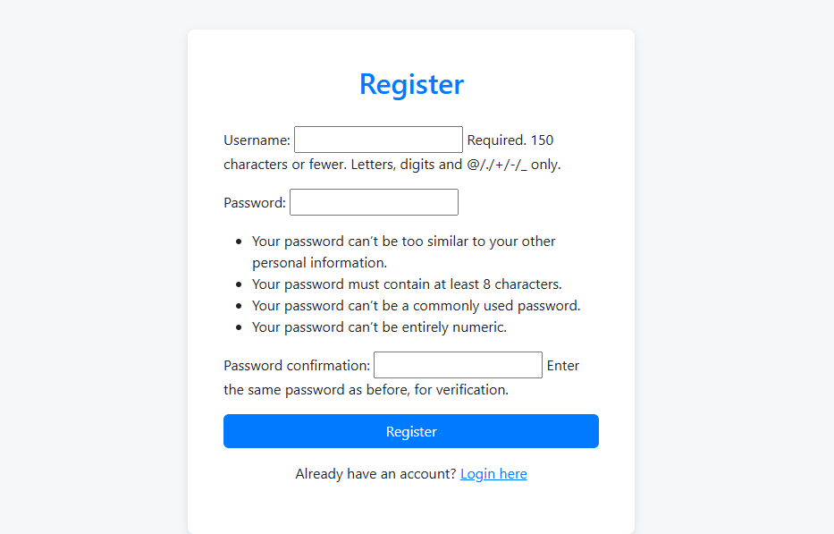

- This is the registration page where user can register themselves and then do the login into the site.

- User Login Page

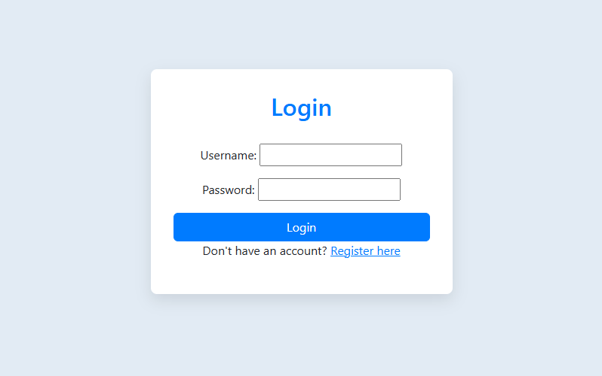

- This is the login page when user can simply enter the username and password and can login into the website.
- Also if user is not registered then user can simply just go to the registration page by clicking on the ‘register here’ link.

- Product Detail Page

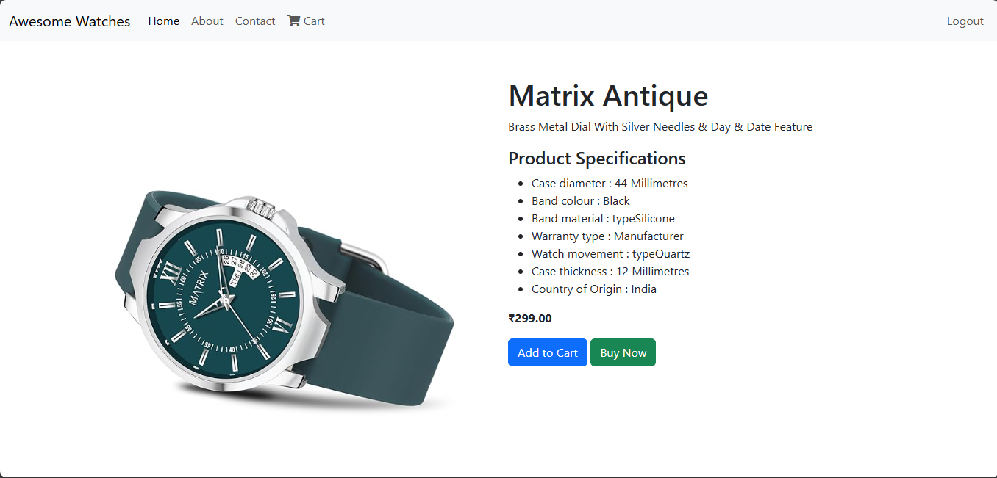

- This is the product detail page where user can see the details about the product and add to the cart if he/she wants.
- User also can go to purchase the product by simply clicking on the ‘Buy Now’ button.
- Cart Page

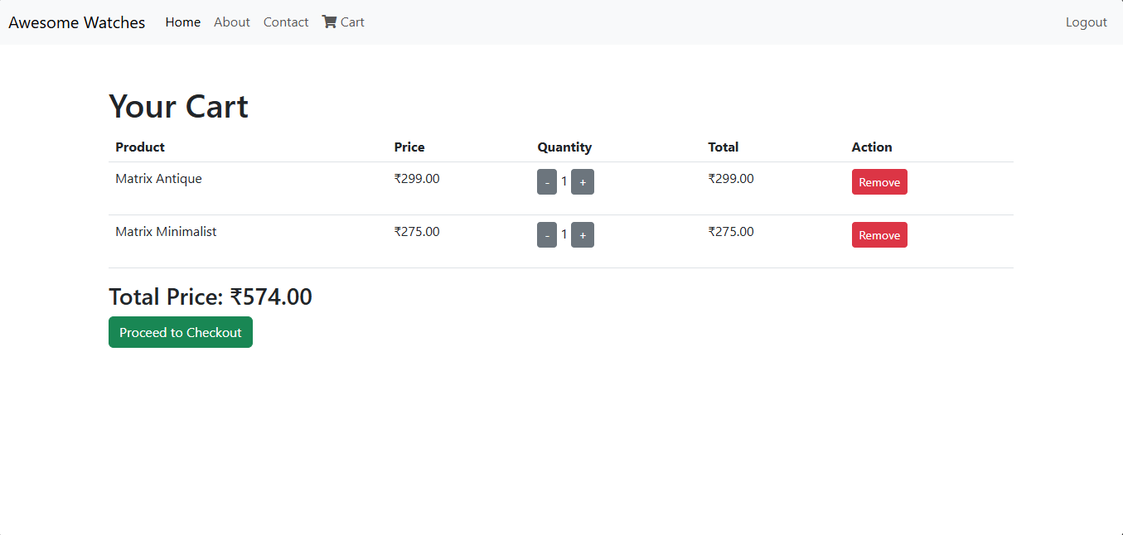

- This is the user cart page.
- User can only see the cart page if he/she is logged in.
- In this page user can see all the products and its quantity and price which user added to that cart.

- Checkout Page

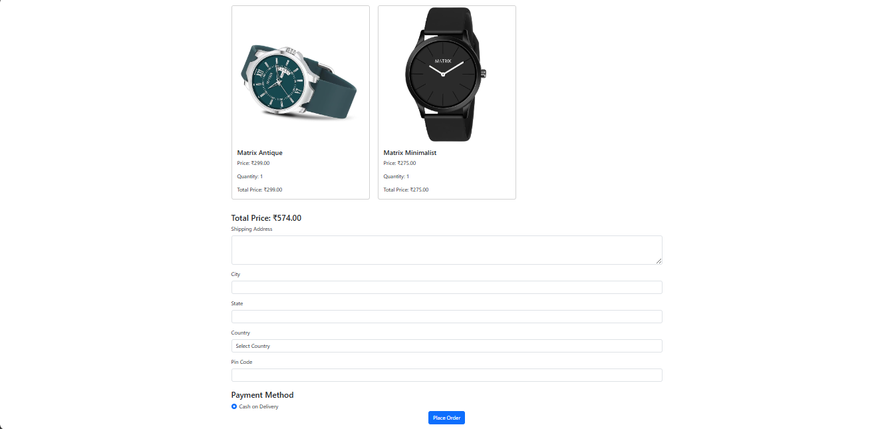

- This is the checkout page where user can enter the address where user wants its product to be delievered.
- Down there is the payment method which is only ‘cash on delievery’.

- Order Summary Page

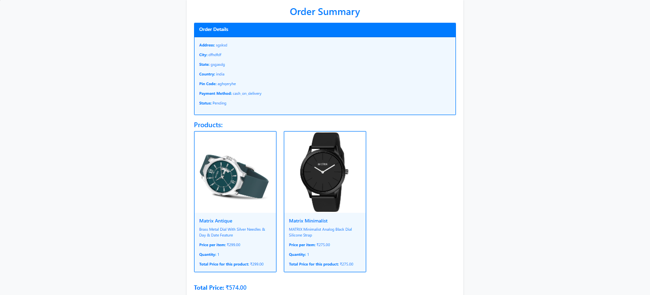

- This page is order summary page.
- In this page user can see the order’s all details and total price that has to be paid.
Future Enhancements

Our software “Library Management System” which provides complete information about Users like Student and admin.
We will add more content on them in future. In our web-based application right now, only Books and Users with their information available but in future we will add Online Lectures, Links, etc.
We will also provide more images in GUI related to our software in future. We will try to find out more about this topic and add in future. We will try to make this application more attractive so that visitor cannot get bored while using it.
Limitations
- User Limitations:
- Concurrent Users:
The system may struggle with performance if too many users access it simultaneously, leading to slow response times or crashes.
- User Authentication:
Limited user authentication methods may expose the system to unauthorized access.
- Functionality Limitations:
- Search Functionality:
Basic search capabilities may not support advanced queries, such as filtering by multiple criteria.
- Reporting:
Limited reporting features may restrict users from generating customized reports on user activity or inventory status.
Webliography
- https://www.w3schools.com/react-js/
- https://nodejs.org/
- https://react.dev/

