A
Project Report
On..
Library management system

Developed By..
Hardik Parmar
Submitted to ..
Geetanjali College of computer science & commerce(BBA)
Saurashtra Univetsity
Rajkot
2025-26
Guided by..
Prof. Mital goswami
Acknowledgements
The success and final outcome of this project required a lot of guidence and assistance from many people and I am extremely privileged to have got this all along the completion of my project all that I have done due to such supervision and assistance and I would not forget to thank them.

I would like to thank my project coordinator and my faculty guide for his valuable guidance for the project and I would like to thank my project partnet who helped me through my entire project.
Preface

The purpose of this library management system is to improve the user experience and their awarenesses.

The library management system Website project will be used to minimize the time and the resource by enhancing book renting and managing technique and seamless experience.

While the resources which minimized are workforce,money and paper etc.

Index
Sr.  No. | Description | Page  No.
1 | Project Profile | 1
2 | Project Requirement | 2
3 | Technology Requirement | 2
4 | Data Flow diagram | 3
5 | ER diagram | 4
6 | Data Dictionaty | 5
7 | Screen Shots | 7
8 | Future Enhancements | 20
9 | Limitations of Project | 21
10 | Bibilography | 22

Project Profile
Project Title | The library management system
Objective | The library management system will provide user a better experience of renting book and manage books.
Hardware Requirements | Pentium 90 MHz or faster and 2GB RAM or higher
Software Requiremnts | Php version 8+, MongoDB latest version
Front-End | HTML,CSS,JAVASCRIPT,php
Back-End | Php , MongoDB
Database | MongoDB
Others | Ms-word 2022

Project Requirement
- Hardware Requirement
Hardware Name | Hardware
Processor | Pentium or AMD
storage | 150MB or Higher
RAM | 2GB or Higher

Technology Requirements
- Software Requirements
No. | Software Used
1 | Php , MongoDB
2 | Windows OS (Windows 10/11)
3 | Visual Studio Code

Data Flow Diagram

Library Database
User
Administrator
Library
Management
system
(view the book) user register
Read and write
Book request
and return

ER Diagram
UserName
Author
Title

Manage
Books

Book_id

Database
relationship

User_id

User_collection
Users
Book_id

id

User_id
Password

Data Dictionary

- User/Admin Login
Sr no. | Field Name | Data  Type | Size | Constrains
1 | _id | ObjectId | - | -
2 | Username | Varchar | 255 | -
3 | Password | Varchar | 8 | -
4 | Role | String | 255 | -

- Books
Sr no. | Field Name | Data  Type | Size | Constrains
1 | Book_id | ObjectId | - | Primary Key, Foreign Key
2 | Title | Varchar | 255 | -
3 | Author | Varchar | 255 | -
4 | Year | Number | 255 | -
5 | Available | Boolean | - | -

- User_collection
Sr no. | Field Name | Data  Type | Size | Constrains
1 | Id | ObjectId | - | Primary Key
2 | User_id | ObjectId | - | Foreign Key
3 | Book_id | ObjectId | - | Foreign Key

Screen Shots

- Admin Login Page

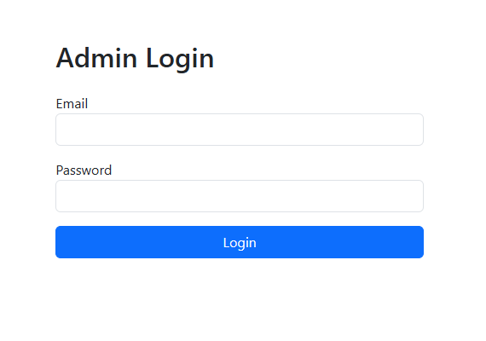

- In this page admin can enter the main page using correct username and password. It is an authentication for all admin.
- Admin panel

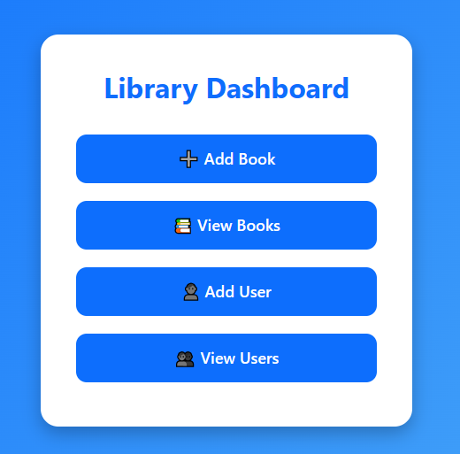

- This is the main dashboard of admin panel in this page admin can add book, user and also can view books and users.
- Add book page

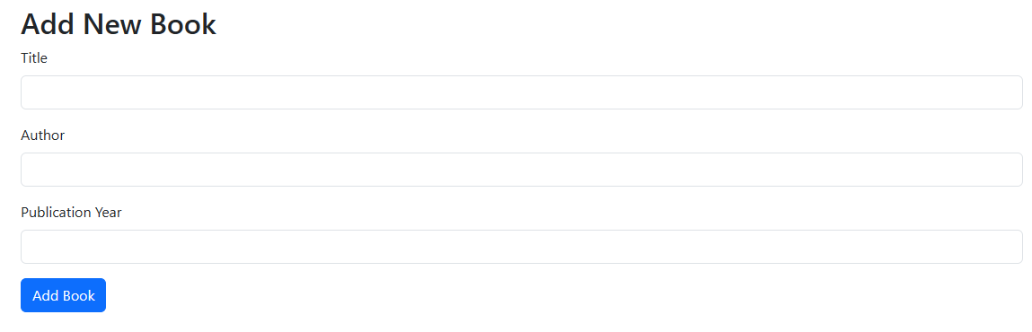

- In this page admin can add book. Admin needs to fullfill all the fields to add book.
- Add user page

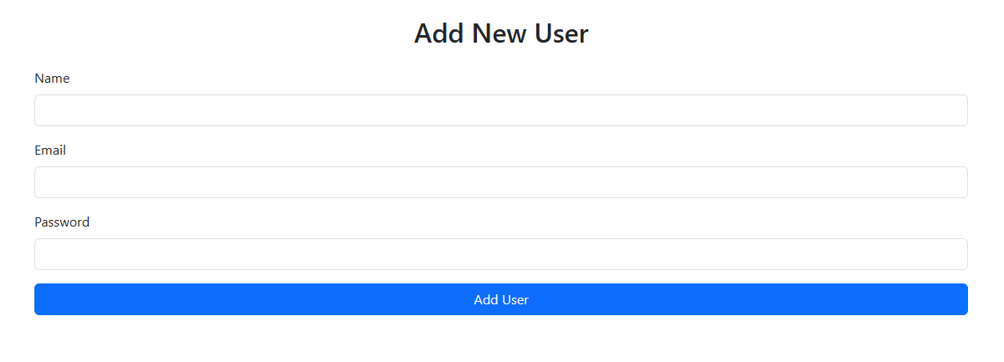

- In this page admin can add user.
- View Books

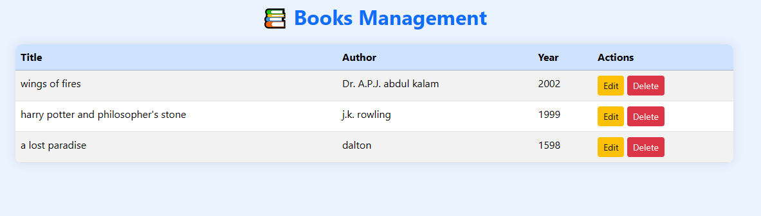

- in this page admin can view, update and delete books.

- View users

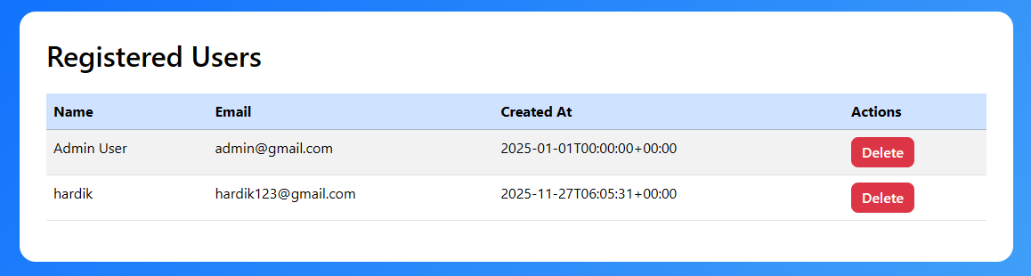

- In this page admin can view the current user and also can delete them.

- Home page

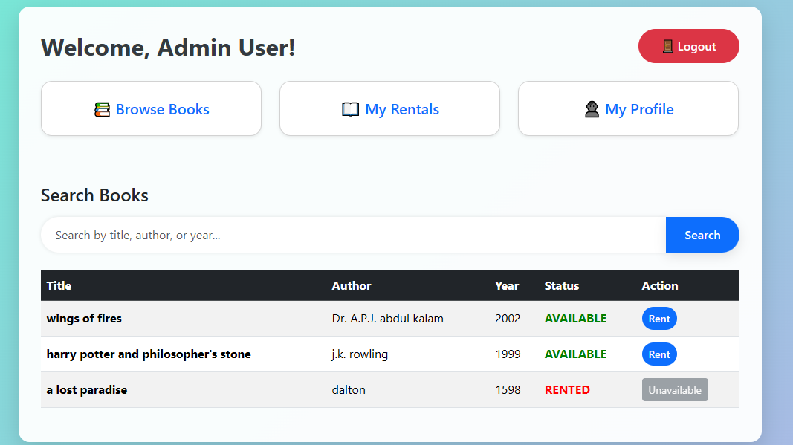

- This is the main home page of our website.
- You can see all books here and rent them.
- User Login Page

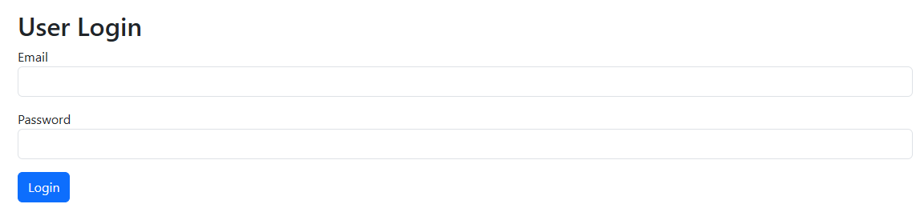

- This is the login page when user can simply enter the username and password and can login into the website.

- User Profile Page

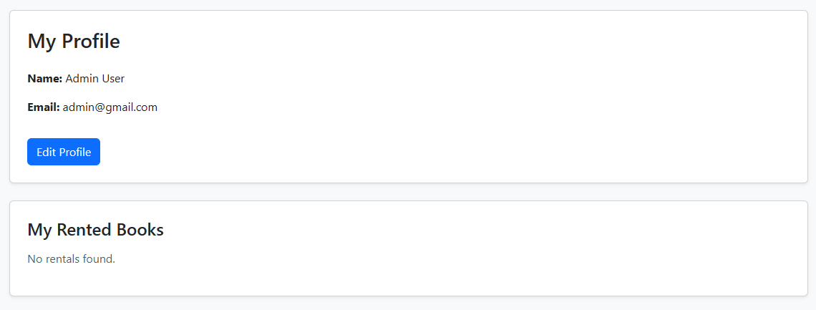
- In this page user can see his profile and change name and email address.

- User rental page

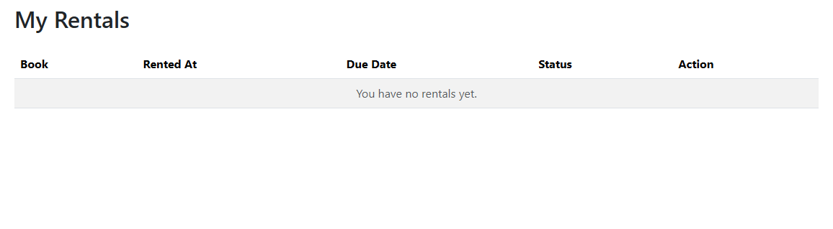

- In this page user can see his rental books and also sees the last date to submit the book.

- Rental confirmation page

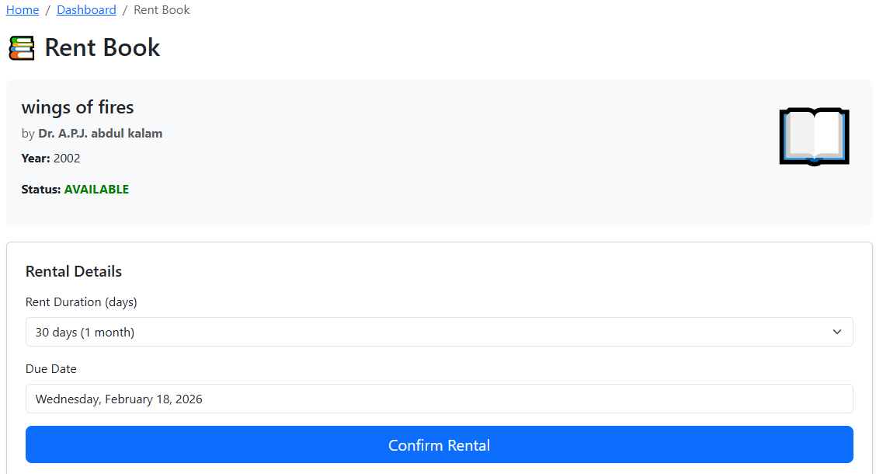

- This page is confirmational page for the book rent.
- Here you can set the duration of the rent.

Future Enhancements

Our software “Library Management System” which provides complete information about Users like Student and admin.
We will add more content on them in future. In our web-based application right now, only Books and Users with their information available but in future we will add Online Lectures, Links, etc.
We will also provide more images in GUI related to our software in future. We will try to find out more about this topic and add in future. We will try to make this application more attractive so that visitor cannot get bored while using it.
Limitations
- User Limitations:
- Concurrent Users:
The system may struggle with performance if too many users access it simultaneously, leading to slow response times or crashes.
- User Authentication:
Limited user authentication methods may expose the system to unauthorized access.
- Functionality Limitations:
- Search Functionality:
Basic search capabilities may not support advanced queries, such as filtering by multiple criteria.
- Reporting:
Limited reporting features may restrict users from generating customized reports on user activity or inventory status.
Bibliography
- https://www.w3schools.com/php/
- https://stackoverflow.com/questions/tagged/php
- https://www.javatpoint.com/mongodb

