A

Project Report

On..

**E-Commerce Website(HandWatches)**

Developed By..

Hardik Parmar

&

Sachin Kava

Submitted to ..

Geetanjali College of computer science & commerce(BBA)

Saurashtra Univetsity

Rajkot

2024-25

Guided by..

Prof. Pranav Trivedi

Acknowledgements

The success and final outcome of this project required a lot of guidence and assistance from many people and I am extremely privileged to have got this all along the completion of my project all that I have done due to such supervision and assistance and I would not forget to thank them.

I would like to thank my project coordinator and my faculty guide for his valuable guidance for the project and I would like to thank my project partnet who helped me through my entire project.

**Preface**

The purpose of this E-Commerce website is to improve the user experience and their awarenesses.

The E-Commerce Website project will be used to minimize the time and the resource by enhancing product purchasing technique and seamless experience.

While the resources which minimized are workforce,money and paper etc.

The website is user-friendly and will help the watch purchasers.

**Index**

|  |  |  |
| --- | --- | --- |
| **Sr.**  **No.** | **Description** | **Page**  **No.** |
| 1 | Project Profile | 1 |
| 2 | Project Requirement | 2 |
| 3 | Technology Requirement | 2 |
| 4 | Data Flow diagram | 3 |
| 5 | ER diagram | 4 |
| 6 | Data Dictionaty | 5 |
| 7 | Screen Shots | 7 |
| 8 | Future Enhancements | 20 |
| 9 | Limitations of Project | 21 |
| 10 | Bibilography | 22 |

**Project Profile**

|  |  |
| --- | --- |
| Project Title | E-Commerce Website(Handwatches) |
| Objective | The E-commerce Website will provide user a better experience of purchasing the handwatches. |
| Hardware Requirements | Pentium 90 MHz or faster and 1GB RAM or higher |
| Software Requiremnts | Python version 3.11.9 or higher,  Mysql |
| Front-End | Python Customtkinter,tkinter |
| Back-End | Python Mysql.connector |
| Database | Mysql |
| Others | Ms-word 2019 |

**Project Requirement**

* Hardware Requirement

|  |  |
| --- | --- |
| **Hardware Name** | **Hardware** |
| Processor | Pentium or AMD |
| storage | 150MB or Higher |
| RAM | 1GB or Higher |

**Technology Requirements**

* Software Requirements

|  |  |
| --- | --- |
| **No.** | **Software Used** |
| 1 | Python |
| 2 | Mysql (Laragon) |
| 3 | Windows OS (Windows 10/11) |
| 4 | Visual Studio Code |

**Data Flow Diagram**

Library Database

User

Administrator

(view the book) user register

Read and write

Book request

and return

**ER Diagram**

Manage

Admin

Books

Database

relationship

User_collection

Users

**Data Dictionary**

* **Reg_table**

|  |  |  |  |  |
| --- | --- | --- | --- | --- |
| **Sr no.** | **Field Name** | **Data**  **Type** | **Size** | **Constrain** |
| 1 | User_id | Int | 5 | Primary Key,Foreign Key |
| 2 | First_name | Varchar | 255 | - |
| 3 | Last_name | Varchar | 255 | - |
| 4 | Address | Varchar | 255 | - |
| 5 | Email | Varchar | 128 | - |
| 6 | Mobile_no | Varchar | 10 | - |
| 7 | Username | Varchar | 255 | - |
| 8 | Password | Varchar | 8 | - |

* **Admin Login**

|  |  |  |  |  |
| --- | --- | --- | --- | --- |
| **Sr no.** | **Field Name** | **Data**  **Type** | **Size** | **Constrains** |
| 1 | Username | Varchar | 255 | - |
| 2 | Password | Varchar | 8 | - |

* **Books**

|  |  |  |  |  |
| --- | --- | --- | --- | --- |
| **Sr no.** | **Field Name** | **Data**  **Type** | **Size** | **Constrains** |
| 1 | Book_id | Int | 5 | Primary Key, Foreign Key |
| 2 | Title | Varchar | 255 | - |
| 3 | Author | Varchar | 255 | - |
| 4 | Genre | Varchar | 255 | - |
| 5 | Available | Boolean | - | - |

* **User_collection**

|  |  |  |  |  |
| --- | --- | --- | --- | --- |
| **Sr no.** | **Field Name** | **Data**  **Type** | **Size** | **Constrains** |
| 1 | Id | Int | 5 | Primary Key |
| 2 | User_id | Int | 5 | Foreign Key |
| 3 | Book_id | Int | 5 | Foreign Key |

**Screen Shots**

* **Admin Login Page**

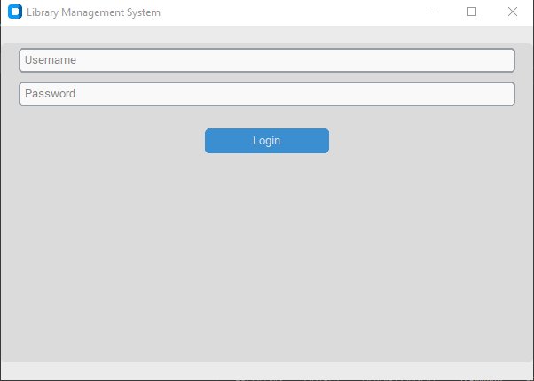

* In this page admin can enter the main page using correct username and password. It is an authentication for all admin.
* **Admin panel**

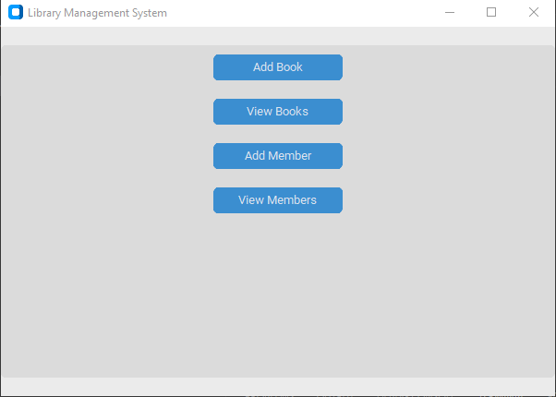

* This is the main dashboard of admin panel in this page admin can add book, member and also can view books and members.
* **Add book page**

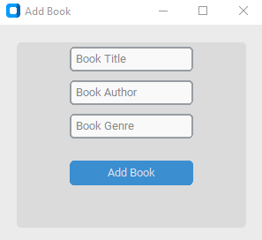

* In this page admin can add book. Admin needs to fullfill all the fields and he/she can add book.
* **View books page**

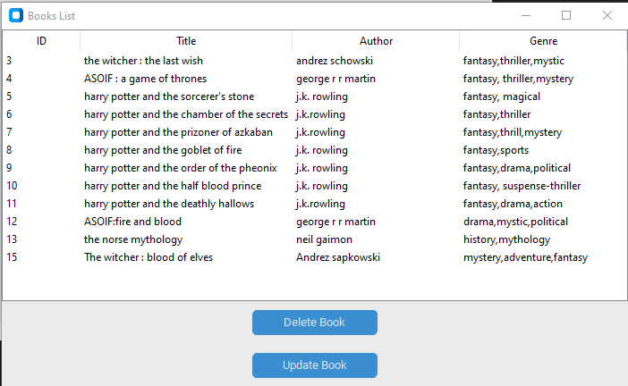

* In this page admin can view and manage all the books are available right now.
* Admin can also delete selected book and update the selected books in case of needs.
* **Update book Page**

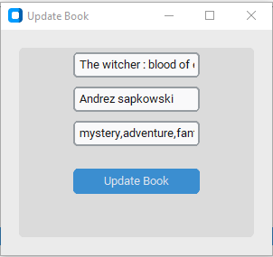

* In this page admin can update the book. Admin needs to do changes that he/she wants in the selected book.
* By simply clicking on the update button book will be updated.
* **Add Member Page**

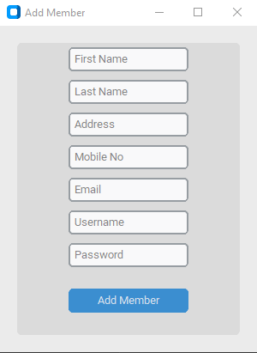

* In this page admin can add member by simply fill all the fields and click on the add member.
* All the fields must need to be filled.
* **View Members Page**

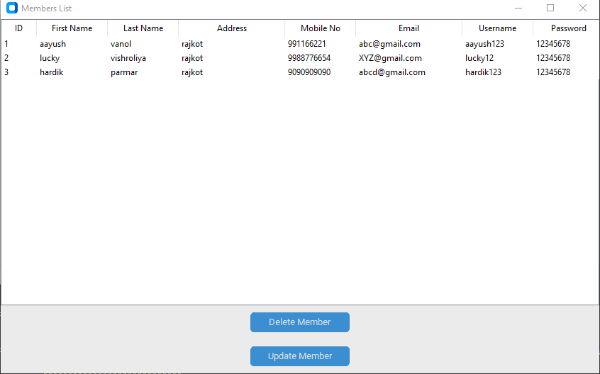

* In this page admin can view and manage all the members that are registered in the software.
* Admin can delete the selected member using the Delete Member button.
* Admin can also update the selected member using the Update member button.
* **Update member Page**

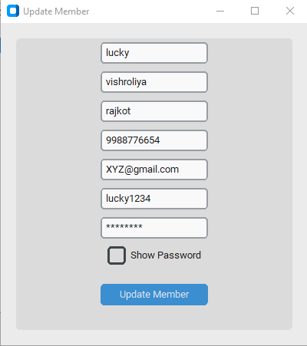

* In this page admin can update the member. Admin needs to do changes that he/she wants in the selected member.
* By simply clicking on the update button, member will be updated.
* **User Login Page**

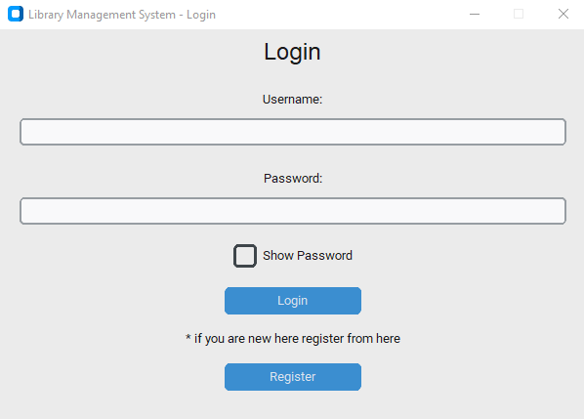

* In this page user can login into the software by filling correct username and password.
* If user visit this page first time user can register himself by simply clicking on the Register button.
* **Registration Page**

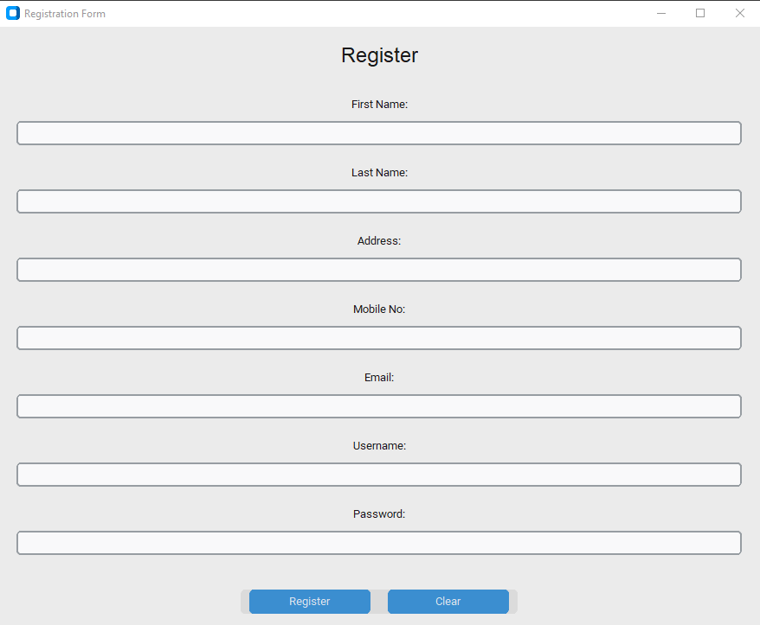

* In this page user can register himself by filling form above given.
* Thus, all the form fields must needed to be fulfilled by user otherwise user can’t register.
* **User main-screen Page**

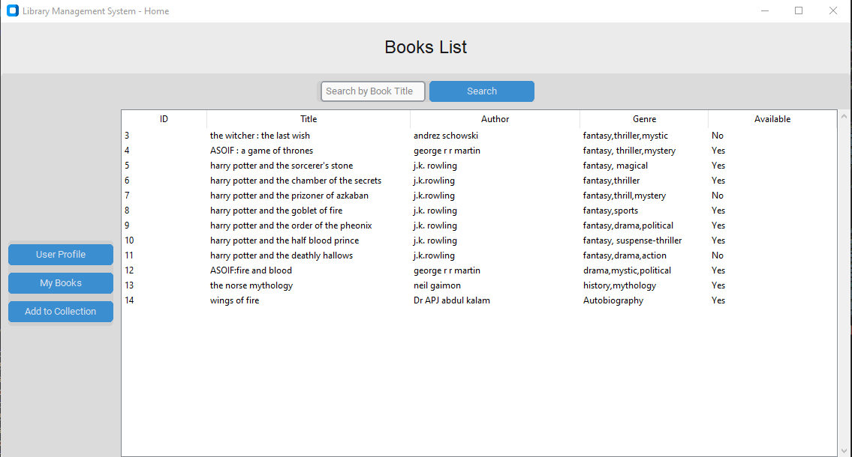

* This is the user main-screen page.
* In this screen user can see all the books that are in the software user can also search the book he needs.
* User can simply select book and click the button ‘Add to collection’ and the book will be in his account.
* **User book Page**

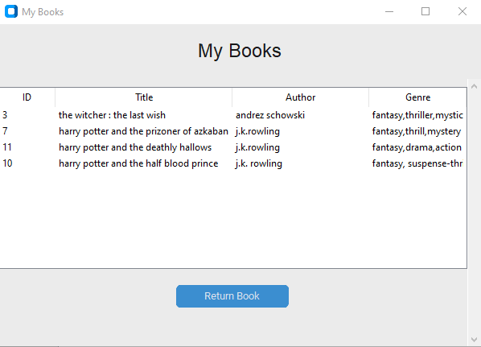

* In this page User can see his collected books.
* User can return book by clicking on the return book button.
* **User Profile Page**

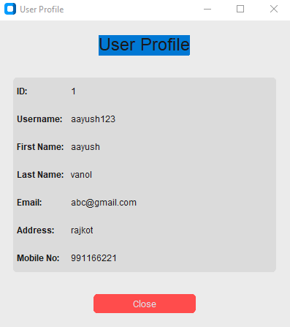

* In this page user can simply see his/her profile.

**Future Enhancements**

Our software “Library Management System” which provides complete information about Users like Student and admin.

We will add more content on them in future. In our web-based application right now, only Books and Users with their information available but in future we will add Online Lectures, Links, etc.

We will also provide more images in GUI related to our software in future. We will try to find out more about this topic and add in future. We will try to make this application more attractive so that visitor cannot get bored while using it.

**Limitations**

* **User Limitations**:
* **Concurrent Users**:

The system may struggle with performance if too many users access it simultaneously, leading to slow response times or crashes.

* **User Authentication**:

Limited user authentication methods may expose the system to unauthorized access.

* **Functionality Limitations**:
* **Search Functionality**:

Basic search capabilities may not support advanced queries, such as filtering by multiple criteria.

* **Reporting**:

Limited reporting features may restrict users from generating customized reports on user activity or inventory status.

**Bibliography**

* <https://www.w3schools.com/python/>
* <https://stackoverflow.com/questions/tagged/python>