

Faculty of Computer Applications & Information Technology

Integrated Master of Computer Applications [iMSc.IT]
Programme
Semester VIII Project Report for
221601801 CROSS PLATFORM MOBILE APP DEVELOPMENT
“Bus Pass Management App”

Submitted by:

Group No.:
Hardik Sanjaybhai Parmar – 202201619010054
Dhairy Pradipbhai Makadia – 202201619010152

GLS UNIVERSITY
Faculty of Computer Applications & IT iMSc.IT Programme
Ahmedabad

CERTIFICATE

This is to certify that
- Hardik Sanjaybhai Parmar
- Dhairy Pradipbhai Makadia

Students of Semester- VIII iMSc.IT , FCAIT, GLS University have successfully completed the Project of 221601801 CROSS PLATFORM MOBILE APP DEVELOPMENT “Bus Pass Management App” as a fulfillment of the study of Semester-V, Integrated Master of Computer Applications [iMSc.IT]

Date of Submission:
Project Guide - Name & Sign

TABLE OF CONTENTS
1. Introduction
2. System Architecture
3. Screenshots – User Side
4. Screenshots – Admin Side

1. INTRODUCTION
I. Project Objective
The Bus Pass Management System is a cross-platform mobile application developed using Flutter. The main objective of this project is to digitize the process of issuing, managing, and verifying bus passes.
The system replaces traditional manual processes with a digital platform, improving efficiency, reducing paperwork, and enhancing user convenience.
II. Purpose
The purpose of this system is to modernize public transportation services by providing:
- Digital bus passes
- Online application system
- QR-based verification
- Family pass management
- Real-time pass tracking

This system reduces waiting time and ensures a smooth and secure experience for users and administrators.
III. Modules
1. User Authentication Module
- User registration and login
- Secure authentication using JWT
- Password encryption
- Forgot and reset password functionality
2. Individual Pass Module
- Select source and destination
- Dynamic fare calculation
- Choose pass type (Monthly, Quarterly, etc.)
- Submit pass request
3. Family Pass Module
- Add multiple family members
- Manage dependent accounts
- Purchase passes for family
- Generate multiple passes
4. Dashboard Module
- View all passes
- Categorization (Active, Pending, Expired)
- Display QR codes
- Pass details overview
5. Admin Module
- Approve or reject passes
- Manage users
- View system data
6. Verification Module
- QR code scanning
- Manual verification using code
- Real-time validation

2. SYSTEM ARCHITECTURE
I. Technology Stack

Component | Technology
Frontend | Flutter
Backend | Node.js (Express)
Database | MongoDB
Authentication | JSON Web Token (JWT)
API Client | Dio
State Management | Riverpod

II. Project Structure
Frontend Structure
- lib/core
- lib/models
- lib/screens
- lib/providers
Backend Structure
- models
- controllers
- routes
- middleware
III. Database Models
User Model
- Name
- Email
- Phone Number
- Password
- Date of Birth
Bus Pass Model
- Pass Type
- Source
- Destination
- Price
- Status
- QR Code
- Verification Code
IV. API Endpoints
User APIs
- Register User
- Login User
- Forgot Password
- Reset Password
Pass APIs
- Buy Individual Pass
- Buy Family Pass
- Get All Passes
- Verify Pass
Admin APIs
- Approve/Reject Pass
- Manage Users

3. SCREENSHOTS – USER SIDE
I. Login Screen

This screen allows users to log into the system using their registered email and password. It includes validation for incorrect inputs and displays appropriate error messages.
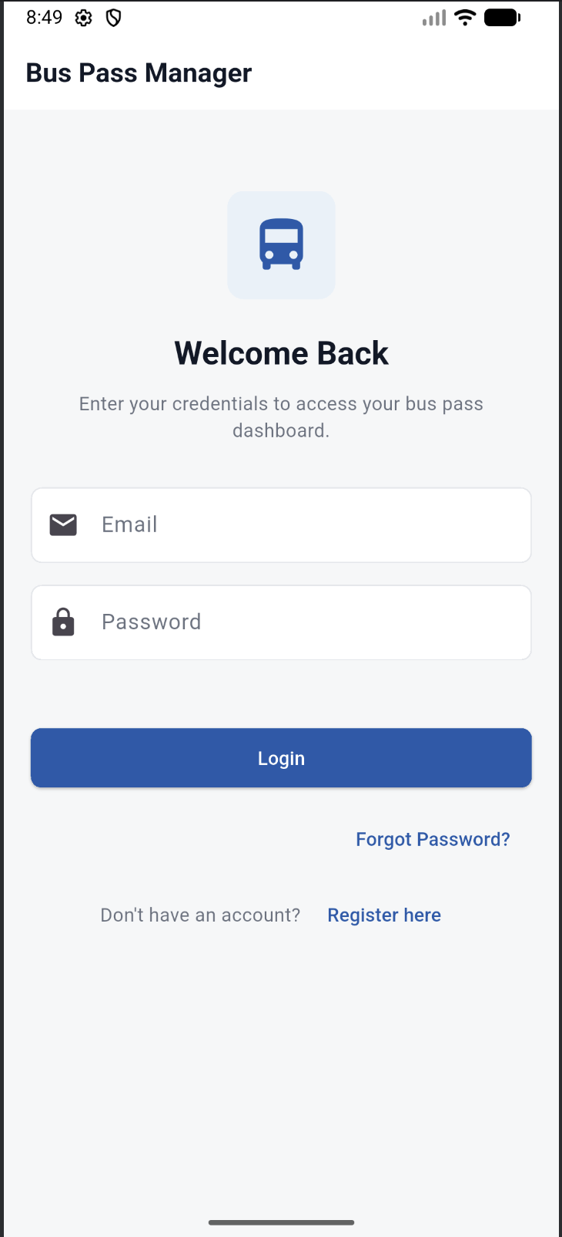

II. Registration Screen

Users can create a new account by entering personal details such as name, email, phone number, and password. The system validates all inputs before submission.
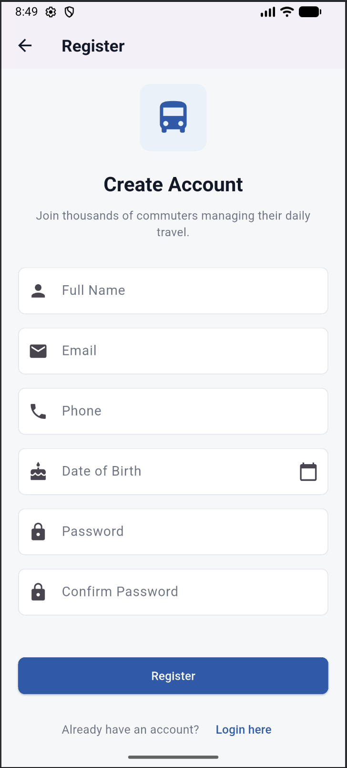

III. Dashboard Screen

Displays all bus passes categorized as active, pending, or expired. Users can view pass details and access QR codes from this screen.
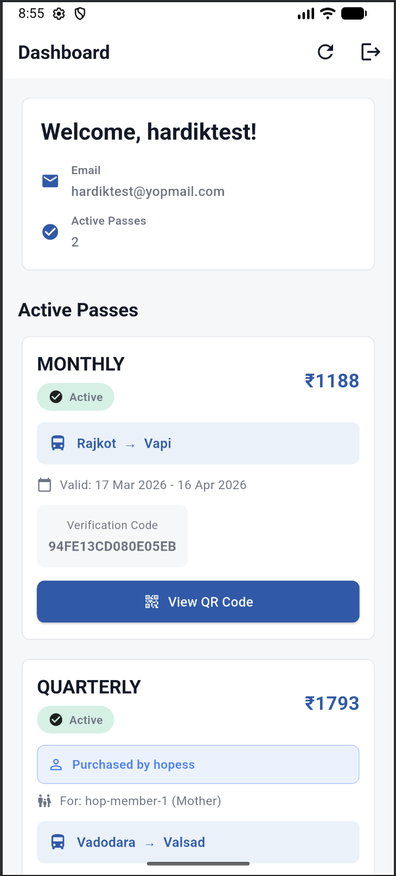
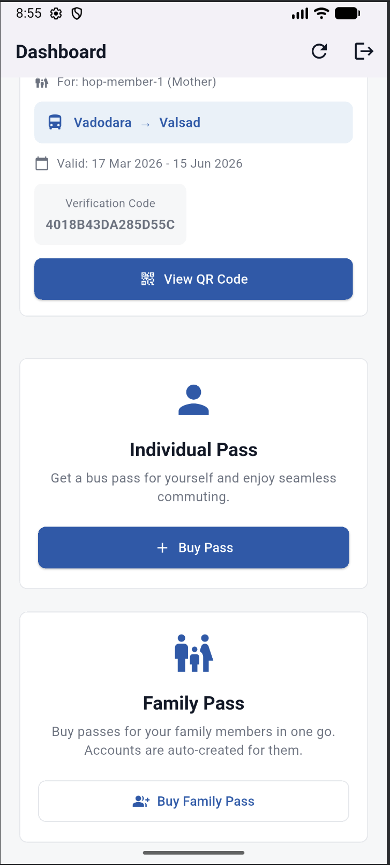
IV. Buy Pass Screen

Allows users to select source and destination, choose pass type, and calculate fare dynamically before purchasing a pass.

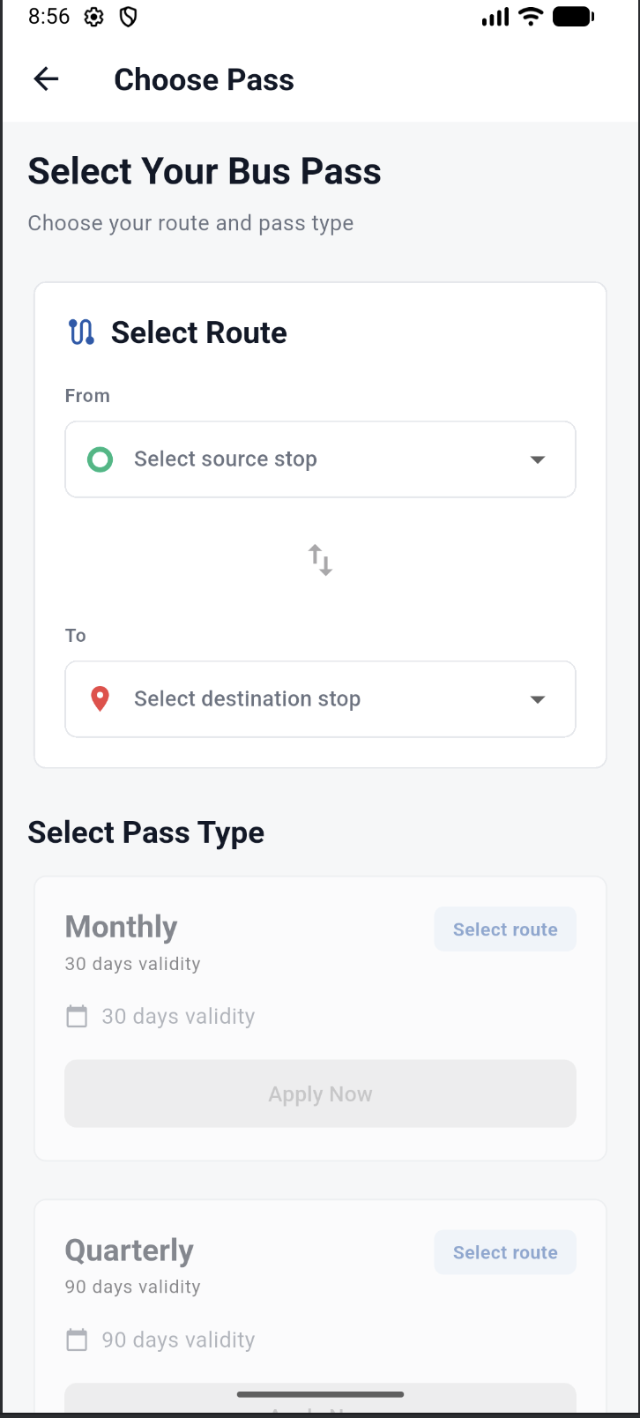
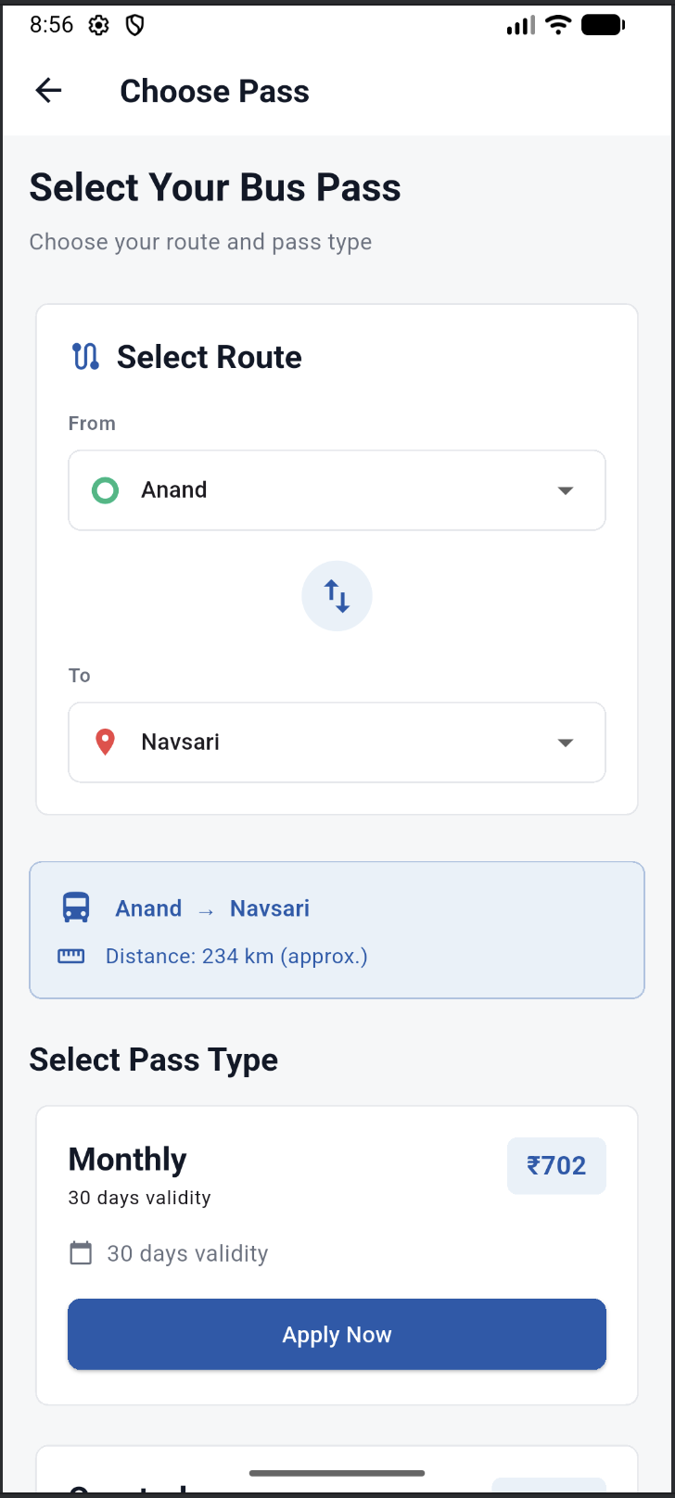
V. Family Pass Screen

Users can add multiple family members and purchase bus passes for them. The system supports batch processing of passes.
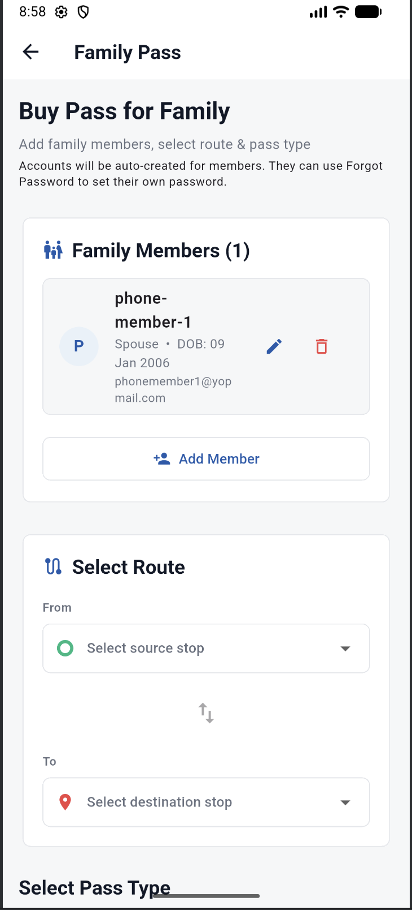

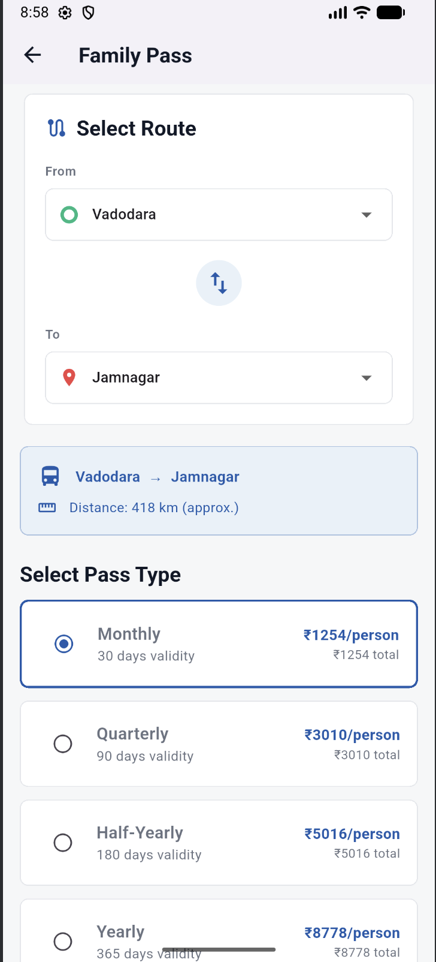
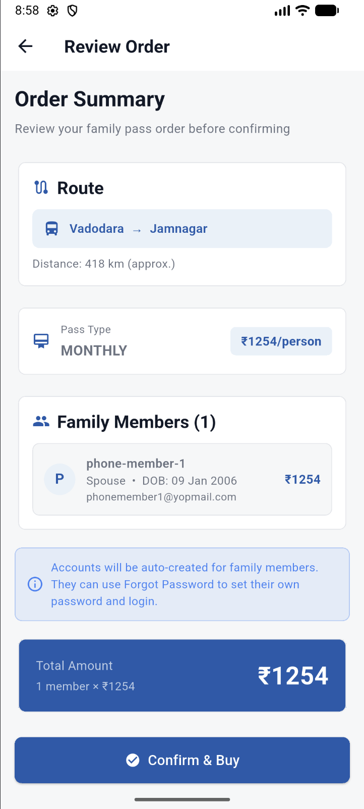
VI. Pass Detail Screen

Displays detailed information about a selected pass, including QR code, validity, and travel route.
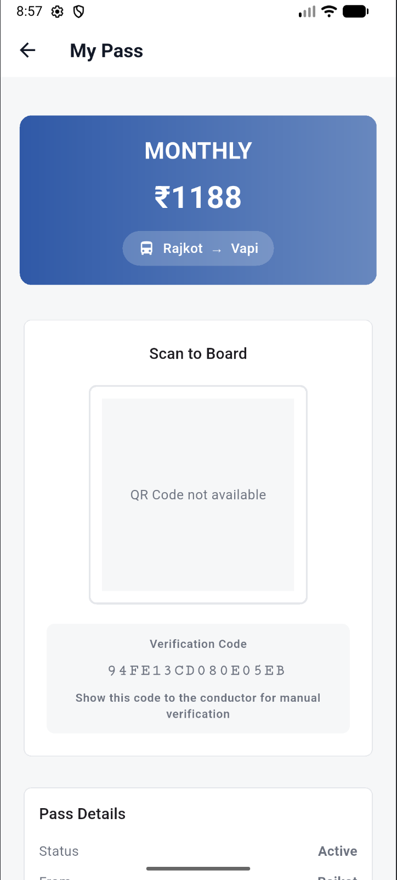

VII. Forgot Password Screen

Allows users to request a password reset by entering their registered email address.

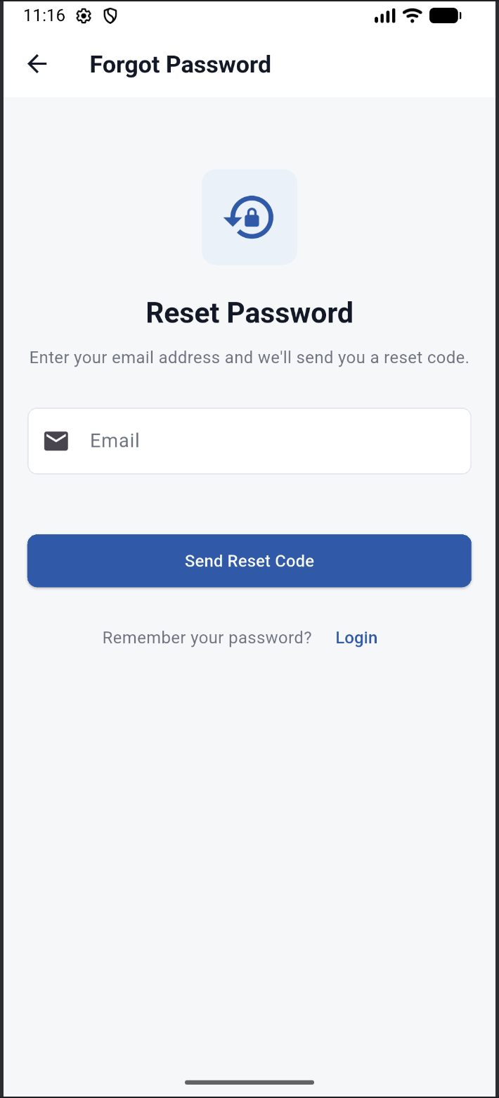

VIII. Reset Password Screen

Users can set a new password securely after verifying their identity.

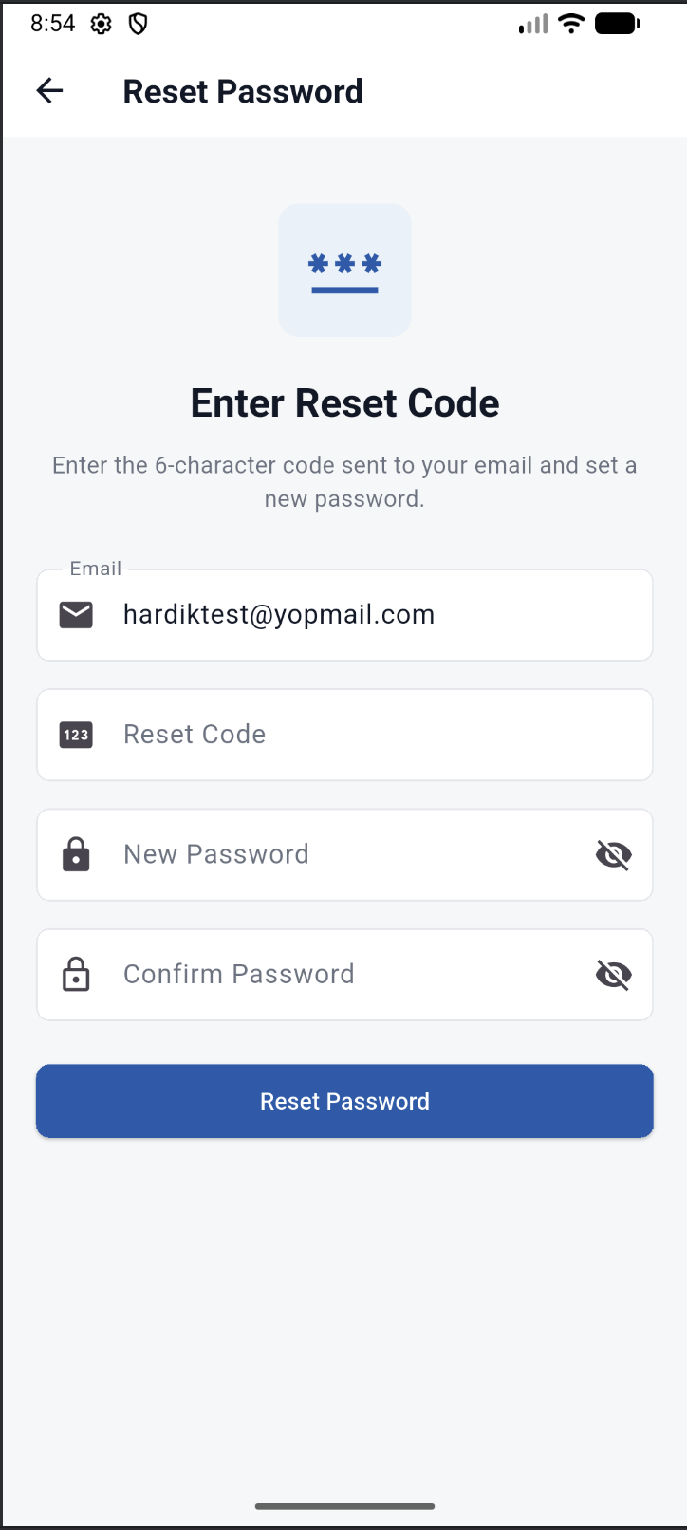

4. SCREENSHOTS – ADMIN SIDE
I. Admin Login Screen

Allows administrators to log into the system securely.

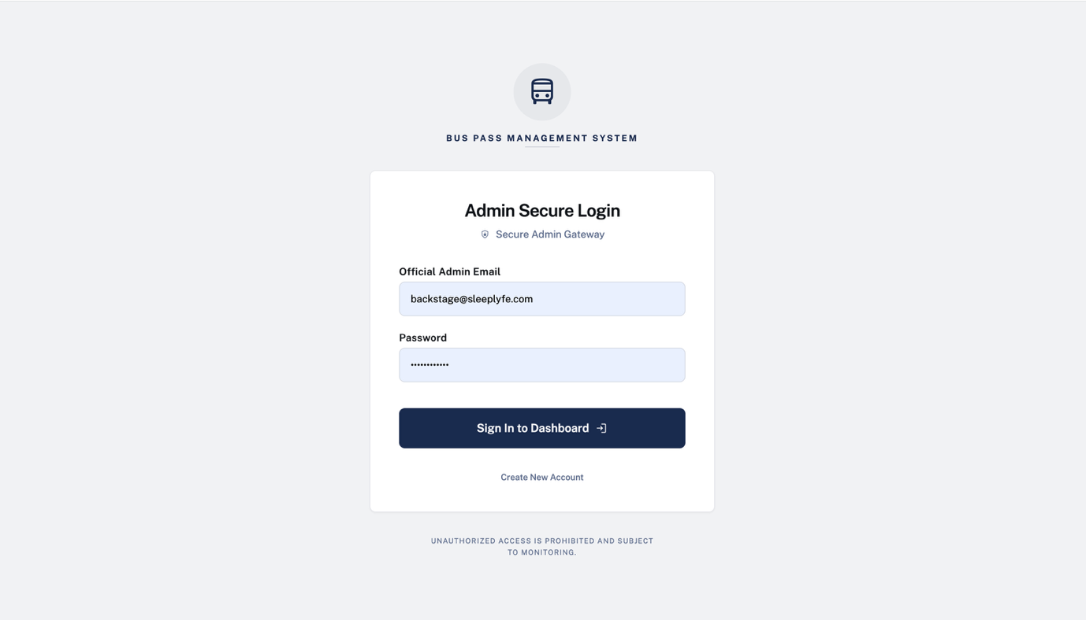
II. Pass Management Screen

Admins can view all pass requests and approve or reject them based on verification.

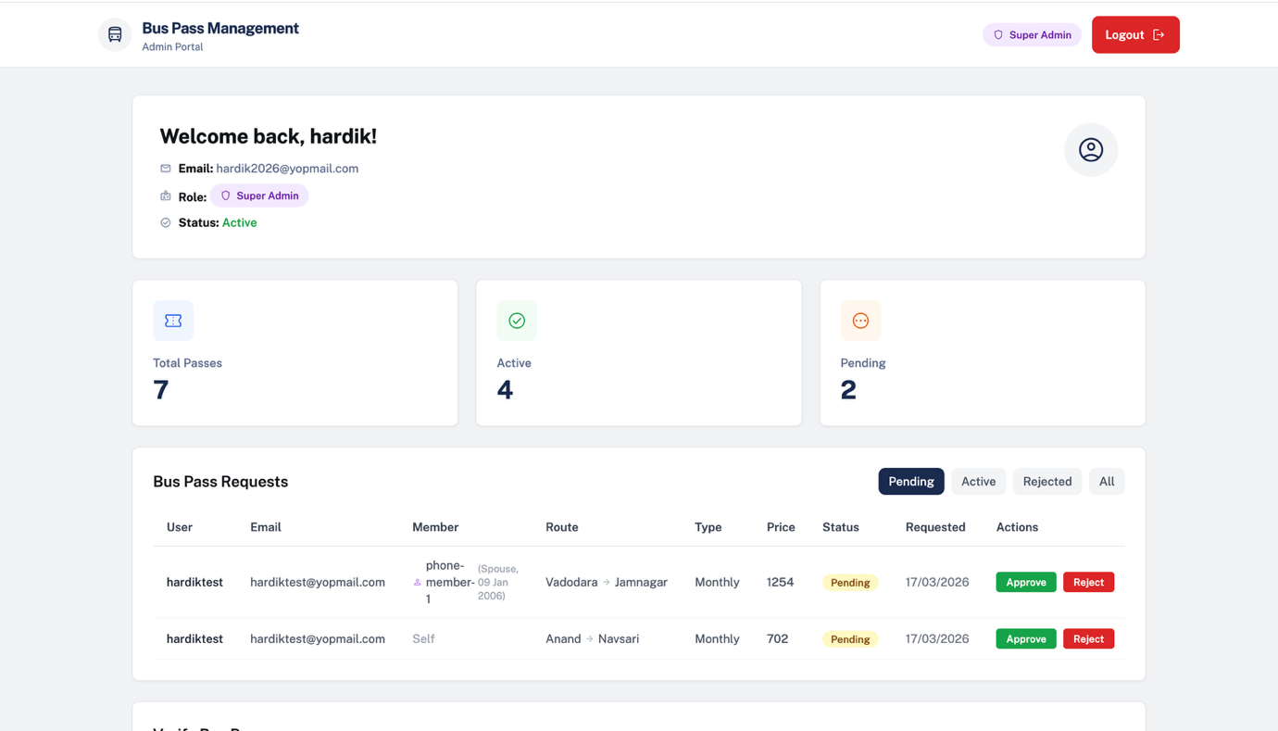
III. Verification Screen

Used by conductors or admins to verify passes using QR codes or manual codes.
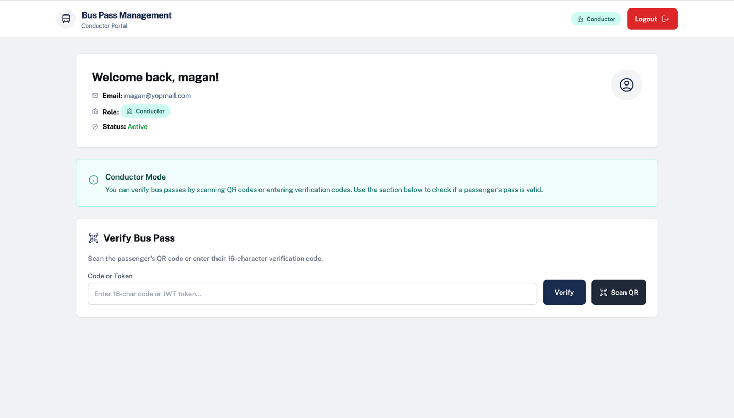

Thank you.

