Construction Content Generator Report

  - Course Name: Generative AI

Institution Name: Medicaps University – Datagami Skill Based Course

Student Name(s) & Enrolment Number(s):
Sr no | Student Name | Enrolment Number
1 | Hardik Baser | EN22CS301380
2 | Hariom Kale | EN22CS301381
3 | Harshita Parmar | EN22CS301408
4 | Hricha Laad | EN22CS301429
5 | Huzefa Burhani | EN22CS301432

Group Name:Group 02D4
Project Number:GAI- 38
Industry Mentor Name: Mr.Suraj
University Mentor Name:Prof. Divya Kumawat
Academic Year:2025-2026

Problem Statement
Construction Content Generator
Build a specialized GenAI content generation tool tailored for Construction professionals. By implementing sophisticated Prompt Engineering techniques, the application enables users to transform basic topics into high-quality professional outputs, such as 'Site Reports'. The system ensures consistency in tone, formatting, and industry-standard terminology, significantly reducing the manual effort required for drafting complex documentation.

Project Objective
1. Develop a Domain-Specific GenAI Tool
To build a specialized content generation system designed specifically for the construction industry.
2. Automate Professional Document Creation
To enable users to convert simple input topics (e.g., “Daily Site Update”) into
structured and professional documents such as:
- Site Reports
- Progress Reports
- Safety Reports
- Material Usage Reports

3. Implement Advanced Prompt Engineering
To design intelligent prompt templates that:
- Maintain professional tone
- Use industry-standard construction terminology
- Follow structured formatting
- Ensure consistency across all generated documents

4. Improve Productivity & Reduce Manual Effort
To significantly reduce the time and effort required by construction
professionals to draft complex documentation.

5. Ensure Standardization & Accuracy
To maintain consistency in:
- Technical language
- Formatting structure
- Report sections (Introduction, Observations, Issues,
Recommendations, Conclusion)

Scope of the Project

1. Content Generation
- Generate structured construction documents based on user input.
- Support multiple report types (site report, safety report, progress
report, etc.).

2. Prompt Engineering Framework
- Predefined prompt templates for different document types.
- Role-based prompts (e.g., “You are a senior construction site
engineer…”).
- Tone control (formal, technical, compliance-oriented).

3. Formatting & Structure
- Standardized headings and subheadings.
- Consistent terminology.
- Organized sections (Date, Project Name, Location, Observations, Risks,
Actions Taken, etc.).

4. User Interface
- Simple input field for topic/details.
- Selection dropdown for report type.
- Output generation in structured format (text, PDF, or DOC format).

- Key features
● Generates professional construction documents from basic text.
● Provides predefined templates (Site Report, Inspection Report, Daily Log, etc.).
● Ensures consistent tone, formatting, and terminology.
● Uses AI to convert raw site notes into structured reports.
● Allows users to review and edit the generated content.
● Supports exporting the final content to PDF or Word.
● Reduces manual writing time for construction professionals.

- Overall Architecture / Workflow
1. User Input
○ The user enters raw site notes or simple text.
○ The user selects a report template.

2. Preprocessing
○ The system processes and cleans the user input.

3. Prompt Building
○ Raw notes + selected template are combined into a structured AI prompt.

4. AI Content Generation
○ The prompt is sent to a GenAI model (e.g., LLM).
○ AI generates a clear, professional construction report.

5. Output Formatting
○ Generated content is formatted for consistency. ○ Layout and structure are applied.

6. User Review & Export
○ User reviews the report.
○ Final content can be exported as PDF/Word.

Architecture Diagrams

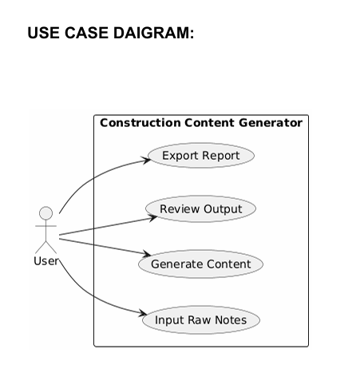
DFD

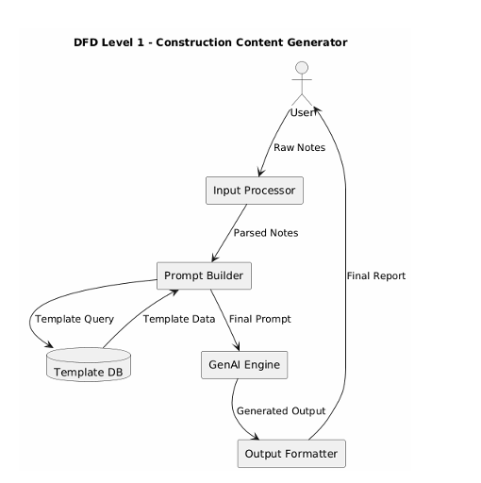

SEQUENCE DIAGRAM:
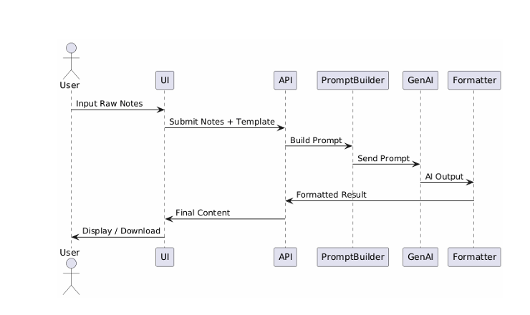

- Tools & Technologies Used
● Frontend: HTML, CSS, JavaScript (or any preferred UI framework)
● Backend: Python / Node.js
● AI Model: Hugging Face Inference API (e.g., Llama, Mistral, SDXL for images)
● Libraries: ○ flask/reportlab/google genai
● Storage: Local file system or cloud storage for saving reports
● Version Control: Git / GitHub

Results & Output

- Screenshots / outputs

USER INTERFACE
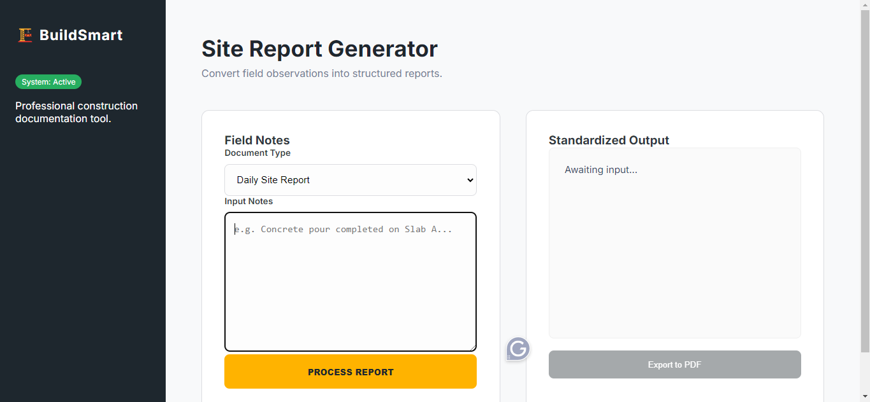

Prompt section for generataing report

z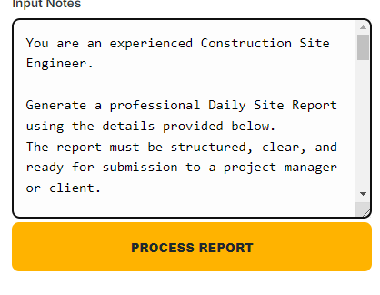

2.Reports

Report generated

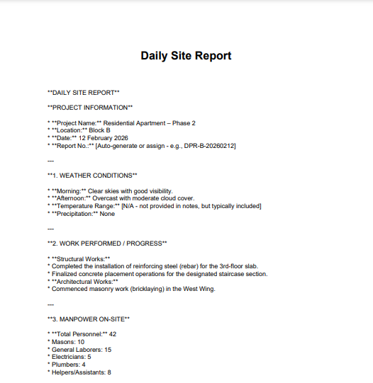

3. Key Outcomes
- Successfully designed and developed an AI-powered Construction Report Generation System.
- Implemented prompt engineering techniques to generate structured Daily Site Reports, Safety Reports, and Project Summaries.
- Integrated LLM APIs for automated content generation.
- Designed modular architecture (Input → Processing → Prompt Engine → AI Model → Output Formatter).
- Improved report preparation efficiency by reducing manual effort and time.
- Implemented structured output formats (Text / JSON / PDF-ready).
- Gained hands-on experience in backend integration (Flask/Python) and API handling.
- Enhanced understanding of real-world construction documentation workflows.

Conclusion
This project successfully demonstrates the practical application of Generative AI in the construction domain. By automating the generation of site reports and project documentation, the system reduces manual workload, improves accuracy, and ensures consistent formatting.
Throughout the development process, I gained strong insights into:
- Prompt engineering strategies
- Large Language Model integration
- Backend API handling and error management
- System design (Low-Level Design & modular architecture)
- Real-world industry problem solving

Future Scope & Enhancements

1. Multi-Report Support
- Weekly and Monthly Progress Reports
- DPR (Detailed Project Report)
- Cost estimation summaries
- Client-facing dashboards

2. AI Enhancements
- Multi-modal support (image-to-report from site photos)
- Voice-based report input
- Auto-progress percentage calculation
- Smart recommendation engine

