SUMMER TRAINING REPORT

BeatFlix - Emotion-Based Movie & Music Streaming Platform

(ES-361)

Submitted in partial fulfillment of the requirements for the award of the degree of

Bachelor of Technology
In

Information Technology


ln1tiM1of ProfnslonalSlvdie1
Submitted By:-HARDIK SHARMA 04296203124

Department of Information Technology
Dr. Akhilesh Das Gupta Institute of Professional Studies
FC-26, SHASTRI PARK, NEW DELHI

Affiliated to

GURU GOBIND SINGH INDRAPRASTHA UNIVERSITY
Sector - 16C Dwarka, Delhi - 110075, India

2024-28

DECLARATION

This is to certify that the material embodied in this Summer Training Report titled "BeatFlix - Emotion-Based Movie & Music Streaming Platform" being submitted in the partial fulfilment of the requirements for the award of the degree of Bachelor of Technology in Information Technology is based on my original work.

It is further C•ertified that this work has not been submitted in full or in part to this university or any other university for the award of any other degree or diploma. My indebtedness to other works has been duly acknowledged at the relevant places.

Hardik Sharma
04296203124
Mr. Jogioder
Assistant Professor

DEPARTMENT OF INFOR.!VIATION TECHNOLOGY

CERTIFICATE FROM THE COMPANY

Certified that training work entitled "BeatFlix - Emotion-Based Movie & Music Streaming Platform" is a bonafied work carried out at the end of 4th semester by "Hardik Sharma" in partial fulfilment for the award of the degree of Bachelor of Technology in Information Technology from Dr. Akhilesh Das Gupta Institute of Professional Studies during the academic year 2025-26.

Shrikanth Upadhyay

Trainer Ducat India

DEPARTMENT OF INFOR.!VIATION TECHNOLOGY II

CERTIFICATE FROM THE INSTITUTE
Certified that training work entitled "BeatFlix - Emotion-Based Movie & Music Streaming Platform" is a bonafied work carried out at the end of 4th semester by "Hardik Sharma" in partial fulfilment for the award of the degree of Bachelor of Technology in Information Technology from Dr. Akhilesh Das Gupta Institute of Professional Studies during the academic year 2025-26.

Mr. Joginder Faculty Supervisor Department ofIT

Prof. (Dr.) Sanjay Kumar
HOD
Department of IT

ACKNOWLEDGEMENTS

I would like to acknowledge the contributions of the following people, without whose help and guidance this report would not have been completed.

I am very thankful to our Training Manager Shrikanth Upadhyay from Ducat India for teaching us and helping us out. The way he explained things really helped me learn web development properly and finish this project.

I also want to thank Mr. Joginder, Assistant Professor, for giving valuable guidance throughout the summer training period.

I am thankful to Ms. Isha Shokeen, Training Coordinator from the IT Department, for all her support during the training.

I would also like to thank Prof. (Dr.) Sanjay Kumar, HOD ofIT Department at Dr. Akhilesh Das Gupta Institute of Professional Studies for his constant encouragement and support.

Thanks to Prof. (Dr.) Niranjan Bhattacharyya, Director of Dr. Akhilesh Das Gupta Institute of Professional Studies for providing this learning opportunity.

Most importantly, I want to thank my parents for their support and belief in me. Without them, I wouldn't have been able to achieve this.

Hardik Sharma

04296203124

ABSTRACT

BeatFlix is an emotion-based entertainment streaming web app that I built during my Summer Training Program with Ducat India at Dr. Akhilesh Das Gupta Institute of Professional Studies. I developed this project using the MERN stack (MongoDB, Express.js, React.js, Node.js) and integrated Google's Gemini API to add emotion-based features like mood-driven recommendations.

On this platform, users can search and discover movies using data from the TMDB API, and listen to music using a custom streaming setup I made with the Verome APL The main highlight is the mood recommender feature, which asks users how they feel and suggests movies and songs based on their emotions. The app also has three subscription tiers (Starter, Pro, Ultimate) using Razorpay for payments.

Technically, the project includes JWT-based login with OTP email verification, Google OAuth, an admin panel, and a music player that keeps playing even when you change pages. The frontend is built in React using custom CSS for a dark theme, while the backend uses Express.js and MVC structure.

This report explains my entire process of building the app, from the initial planning to the final deployment. It shows the practical coding skills I learned during the summer training, like full-stack development, linking up external APis, and making the frontend and backend talk to each other.

TABLE OF CONTENTS

Declaration 1
Certificate from the Company II
Certificate from the Institute III
Acknowledgements IV
Abstract. V
Table of Contents VI
List ofFigures VIII
List ofTables lX
Chapter 1: Introduction of the Company !
  - About the Company !
  - Cornpany Profile: Ducat India 2
Chapter 2: Introduction of the Internship 4
  - About the Training 4
  - Objectives of the Training 4
  - Roles and Responsibilities 5
Chapter 3: Problem Statement. 6
  - Software Requirements Specification (SRS) 6
  - Functional Requirements 6
  - Non-Functional Requirements 8
  - Feasibility Study 8
  - Tools and Technologies Used 9
3.6 Use Case Diagram 10
  - Data Flow Diagrarns 10
  - Entity Relationship Diagram 11
Chapter 4: Project Activities 12
  - Task Description 12
  - Tools Used 13
  - Technical Application 13
  - Challenges Faced 15
  - Systern Architecture and MERN 16
  - Implementation and Workflows 18
  - Testing Strategies 20
  - Deployment and Hosting 21
  - Security Measures 22
  - Performance Optimization 23
  - Agile Development Lifecycle 24
Chapter 5: Contribution to the Organization 26
  - Problern-Solving Contributions 26
  - Ideas Implemented 26
  - Processes Improved 27
Chapter 6: Learning and Development. 28
  - Technical Skills Gained 28
  - Soft Skills Developed 29
  - Knowledge Gained 29
Chapter 7: Summary and Conclusion 30
  - Summary 30
  - Conclusion 30
Chapter 8: Suggestions for Improvement 31
  - Platform Enhancements 31
  - Technical Improvernents 31
  - Training Program Suggestions 32
Bibliography 33
Appendix 34

LIST OF FIGURES

Figure No. | Figure Title | Page No.
3.1 | Use Case Diagram for BeatFlix | 10
3.2 | Data Flow Diagram - Level 0 | 10
3.3 | Data Flow Diagram - Level 1 | 10
3.4 | Entity Relationship Diagram | 11
4.1 | BeatFlix Entry / Login Screen | 14
4.2 | Home Page - Hero Section | 14
4.3 | Movies Browsing Page | 14
4.4 | Movie Details Page | 14
4.5 | Music Streaming Page | 14
4.6 | Mood-Based Recommendation Page | 15
4.7 | BeatFlix Mood Recommender Interface | 15
4.8 | Subscription Plans Page | 15
4.9 | Account Management Page | 15
4.10 | Admin Dashboard | 15
4.11 | Global Music Player | 15

LIST OF TABLES

Table No. | Table Title | Page No.
3.1 | Software Requirements Specification | 6
3.2 | Functional Requirements | 7

3.3 | Non-Functional Requirements | 8
3.4 | Tools and Technologies Used | 9
4.1 | API Endpoints Summary | 14
4.2 | Database Schema - User Model | 14
4.3 | Database Schema - Chat Model | 14
4.4 | Subscription Tier Comparison | 14

CHAPTER 1: INTRODUCTION OF THE COMPANY

ABOUT THE COMPANY
Ducat India is one of the most well-known IT training institutes in the Delhi NCR area. They started back in 1999, so they have been around for more than 20 years. What started as one center has now grown into multiple branches in places like Noida, New Delhi, Gurugram, Ghaziabad, and Faridabad.

The main thing about Ducat is that they focus a lot on practical training. Instead of just teaching textbook theory, they make students work on real-world projects. They have over 180 courses covering topics like Full Stack Development, Data Science, Al, Cloud Computing, Java, Python, and Cyber Security.

One of the best things about Ducat is that they help a lot with placements. They give 100% placement assistance, which means they help with resume building, interview prep, and sending students to companies for interviews. Many college students join them because it actually helps in getting a job.

Besides their regular center classes, Ducat also sends their trainers to colleges for summer training. This is a 4 to 6-week program where the trainer comes to the campus and teaches a specific technology. We had our MERN stack training at ADGIPS through one of these programs.

Training Approach
Ducat's teaching style is very hands-on. In our classes, we spent more time coding than looking at slides. The trainer would first explain how a concept worked, then show us by writing code live, and finally ask us to do it ourselves on our laptops.

Usually, their training includes:

- Live coding sessions in class
- Working on our own projects
- Asking doubts at the end of the day
- Getting feedback on our code
- Small daily assignments
- A final project presentation

Areas of Expertise
Ducat teaches a lot of different technologies. Some of the main ones are:
- Web Development (MERN, Java Full Stack, PHP)
- Languages (Java, Python, C++, JavaScript)
- Data & AI (Machine Learning, Data Analytics)
- Cloud (AWS, Azure, DevOps)
- Cyber Security (Ethical Hacking)

COMPANY PROFILE: DUCAT INDIA

Vision and Mission
Ducat's vision is to be the top IT training institute in India by giving students the practical skills that IT companies actually want. Their mission is to fill the gap between college syllabus and industry requirements by focusing on project-based learning and good placement support.

Presence
Ducat's head offic.e is in Noida, and they have branches all over Delhi NCR. Having centers in places like Pitampura, South Ex, and Gurugram makes it easy for students to travel. For our summer training, we didn't have to travel because their trainer came directly to our ADGIPS campus.

Key Offerings

They offer a few different types of programs:

- Regular Courses: 3 to 6-month batches for students and working professionals.
- Summer Training: 4 to 6-week fast-track programs done in colleges during holidays.
- Corporate Training: Upskilling programs for company employees.
- Placement Support: Helping students get jobs after the course is done.

Conclusion
Overall, Ducat India is a very established institute for IT training. Their practical approach and focus on getting students job-ready makes them a good choice. Doing my summer training with them gave me a really strong start in web development.

CHAPTER 2: INTRODUCTION OF THE INTERNSIDP

ABOUT THE TRAINING
The summer training was organized by Ducat India at our college campus during June 2026 - July 2026. The focus was entirely on full-stack web development using the MERN stack (MongoDB, Express.js, React.js, and Node.js). Our trainer, Shrikanth Upadhyay, came from Ducat and conducted all the sessions.

The training was very practical. Instead of just learning theory, we started by learning the basics of JavaScript and Node.js, and then quickly moved into building things with Express and React. We also learned how to use MongoDB to store data, and how to connect the frontend to the backend using APls.

For my final task, I decided to build BeatFlix, an emotion-based streaming platform for movies and music. The idea was to build a site that not only lets you search for content but also suggests things based on your mood using emotion logic. Building this project helped me practice everything I learned in the training.

One of the best things about the training was learning how to fix my own bugs. When my code broke, I had to figure out how to read the error messages and search for solutions before asking the trainer. That really improved my problem-solving skills.

OBJECTIVES OF THE TRAINING
The main goals of the training were:

    - To learn how to build websites using the MERN stack.
    - To understand how the frontend and backend talk to each other.
    - To build a complete, working project from scratch by the end of the month.
    - To learn how to use third-party APls in a project.

    - To understand basics of security, like JWT login and password hashing.
    - To get comfortable with tools like VS Code, Git, GitHub, and Postman.
    - To get better at debugging errors on our own.

ROLES AND RESPONSIBILITIES
Since I was building this project alone, I worked as a Full-Stack Developer handling everything from start to finish. My main responsibilities were:
    - Frontend Work: Building all 14 pages of the website using React and writing the CSS.
    - Backend Work: Setting up the Express server and creating all the API routes.
    - Database Work: Setting up MongoDB to store user profiles and chat history.
    - Emotion Logic Integration: Connecting the Gemini API so the app could understand user moods and suggest content.
    - Authentication: Making the login page work with passwords and Google login.
    - Music Streaming: Using the Verome API to make songs play directly in the browser.
    - Payments: Adding Razorpay so users could buy premium plans.
    - Testing: Trying out all the features to make sure nothing crashed.

CHAPTER 3: PROBLEM STATEMENT

SOFTWARE REQUIREMENTS SPECIFICATION (SRS)

    - Purpose
This section lists out all the requirements for BeatFlix. The goal of BeatFlix is to give users one place to find both movies and music, and to give them suggestions based on their current emotions or mood.

    - Scope
BeatFlix is a web app where users can browse movies using TMDB data, search for songs using Verome API, and get emotion-based suggestions. It includes user login, a premium subscription feature, a music player, and an admin panel. It is built using React on the frontend and Node.js on the backend.

    - Product Overview
Most streaming sites only do movies or only do music. I wanted to build something that does both, and adds a smart mood recommender on top of it. If someone is feeling sad, they can tell the app, and it will suggest comforting movies or uplifting songs. The app is meant to be easy to use and look good on both phones and laptops.

FUNCTIONAL REQUIREMENTS

FR!. User Login and Registration
- Users can sign up using their name, email, and a password.
- Users can log in with email/password or use their Google account.
- The app uses JWT tokens to keep users logged in securely.

- OTP emails are sent for account verification and password resets.

FR2. Movies Feature

- The app shows movies from the TMDB API, with pages to click through.
- Users can filter movies by genres like Action, Comedy, etc.
- Clicking a movie shows its details, cast, trailer, and similar movies.
- Users can search for specific movies by typing the name.

FR3. Music Feature

- Users can search for songs and play them right in the browser.
- The music player stays at the bottom of the screen even if you change pages.
- The app shows the song name, thumbnail, and duration.

FR4. Emotion-Based Recommender

- There is a smart chat feature that asks users how they feel.
- It suggests 3 to 6 specific movies or songs based on their mood.
- It remembers what was said earlier in the conversation.
- Usage is limited based on which subscription plan the user has.

FR5. Subscription System

- There are three plans: Starter, Pro, and Ultimate.
- Payments are handled securely using Razorpay.

FR6. User Profile

- Users can change their display name and profile picture.

FR7. Admin Dashboard

- Admins can log in and see a list of all users and their subscription plans.

NON-FUNCTIONAL REQUIREMENTS

- NFRl. Performance: The website should load fast, ideally under 3 seconds.
- NFR2. Security: Passwords must be hashed in the database. CORS should be set up so the API is safe.
- NFR3. Usability: The site needs to look good and work properly on mobile phones too.
- NFR4. Reliability: If an external API fails, the app shouldn't crash completely.

FEASIBILITY STUDY

3.4.l Technical Feasibility
The project is very doable because the MERN stack is widely used and there are lots of tutorials ifl get stuck. The APls I chose (TMDB, Gemini, Verome) are all easy to connect to and give good data.

3.4.2 Economic Feasibility
The project is basically free to build. MongoDB Atlas gives a free database, the APis have free tiers, and hosting sites like Vercel and Render let you host small projects for free. So, no money was needed to develop this.

3.4.3 Operational Feasibility
Anyone with a modern web browser and an internet connection can use the app, making it very easy to operate.

TOOLS AND TECHNOLOGIES USED

Frontend
- React.js - For building the user interfac•e.
- React Router - For navigating between different pages.

- CSS - For styling the app with a dark theme.
- Axios - For making requests to the backend.

Backend
- Node.js & Express.js - For creating the server and API routes.
- MongoDB & Mongoose - For storing user data and chats.
- JWT & bcrypt - For secure logins and password protection.
- Nodemailer - For sending OTP emails.

APls
- TMDB API - For getting all the movie posters and details.
- Google Gemini API - For the emotion-based recommendation logic.
- Verome API - For searching and playing music streams.
- Razorpay - For testing the payment gateway.

Tools
- VS Code - Where I wrote all the code.
- GitHub - To save my code online.
- Postman - To test my backend APis before connecting the frontend.
- Vercel & Render - For putting the website live on the internet.

USE CASE DIAGRAM
This diagram shows what different users can do. A guest can only log in or sign up. A logged-in user can browse movies, play music, use the mood recommender, and buy subscriptions. An admin can do all that plus view the admin dashboard.

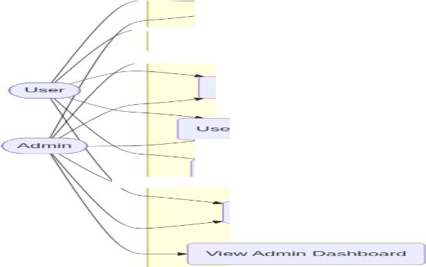
.Sig,.... LJp / Lc,gi.-.
--
_ !_-�-
LBre>wso &ct-=Htc,.r rvlC>V"iO�
.S.�c::a.rc::h &::- Plc:1y l'V'lt...1s.ic::
........,oC>CI R:ecomm,a.nde�J
P'LII rc:h.a._s,e, S LJ1bs.c:riptie>.:_.l
,-----'---�--

rv11.a._na._ge P,o-ri1e

[Figure 3.1: Use Case Diagram for BeatFlix}

DATA FLOW DIAGRAMS

    - Level O • Context Diagram
This simple diagram shows BeatFlix in the center communicating with the User, and getting data from TMDB, Verome, and Gemini APls.

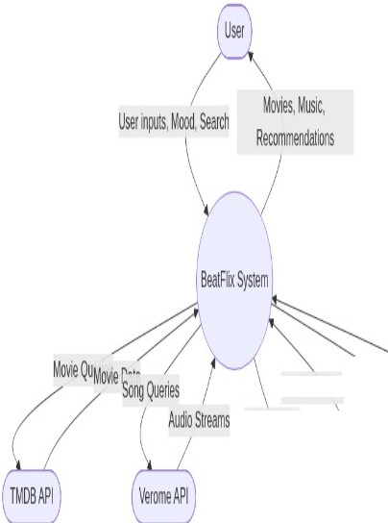
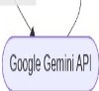
. Pa)'lllentRPaymenlSial\ls Emot1on-basedw11,c11, • �
MoooProm� "" )
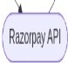
[Figure 3.2: Data Flow Diagram - Level OJ

    - Level I - Detailed DFD
This breaks the app down into its main parts: User Auth, Movie fetching, Music fetching, Mood Recommender, and Subscriptions.


/lo�eSff ---..._

MOB��ngSea"rch"'�Cred)eJuT1o�heLn'--- ---
/ <I


MovieBrowser sicPlayer Authentication
�u
"Pr
Subscnption
L �I

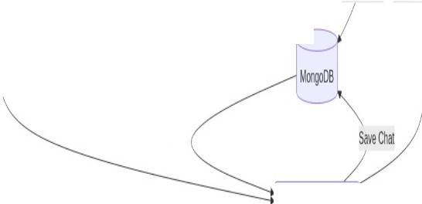
MoodInput UserData UpdatePlanRecorrvneooanons
\�
ChaHtistory
MoodRecommender
[Figure 3.3: Data Flow Diagram - Levell}

ENTITY RELATIONSIDP DIAGRAM
This shows how the database is structured. There is a User collection, a Chat collection for saving the rnood conversations, and an OTP collection for password resets.

' . .
. | USER
 | Objectld | _id
 | String | name
 | String | email
 | String | password
 | String | subscriplion_type
 | Date | subscription_expiry
 | Number | aiTokens

reqpests
CHAT
Objectld | - id
Objectld | userld
String | role
String | text
Date | timestamp

OTP
Objectld | -id
String | email
String | otp
Date I expiresAt

[Figure 3.4: Entity Relationship Diagram]

CHAPTER 4: PROJECT ACTIVITIES

TASK DESCRIPTION
During my summer training, my main task was to build a full web application from start to finish. I decided to make BeatFlix, an emotion-based platform for movies and music. I had to build both the frontend and backend, connect external APls, and put the site live on the internet.

Week 1: Setup and Login
- Set up the basic React project and Node.js server.
- Connected the server to MongoDB.
- Built the signup and login pages.
- Made sure passwords were saved securely using bcrypt.
- Added OTP email verification.

Week 2: Movies
- Got my TMDB API key and connected it to the backend.
- Built the movies page so users can browse and filter by genre.
- Added a search bar for finding specific movies.
- Created the movie details page to show cast and trailers.

Week 3: Music
- Connected the Verome API to search for songs.
- Built a music player component that sits at the bottom of the screen.
- Made sure the music keeps playing even if the user clicks to another page.

Week 4: Mood Recommender and Finishing Touches
- Added the Google Gemini API to build the mood recommender chat.

- Added Razorpay to handle fake payments for subscriptions.
- Created an admin page to see all users.
- Fixed bugs, checked the mobile design, and deployed to Vercel and Render.

TOOLS USED
Here are the main tools I used every day while building this:

- VS Code: My main code editor. It was really helpful for catching syntax errors.
- Chrome DevTools: I used the network tab a lot to see if my API calls were failing or succeeding.
- Postman: I used this to test my backend routes before I even started building the frontend for them.
- Git: Used it to save my progress so I wouldn't lose my code ifl messed something up.

TECHNICAL APPLICATION

    - Frontend Details
The frontend is built in React.js. I split the code into different folders: one for the 14 different pages, one for reusable components like the Navbar, and one for the CSS files. I used React Router to handle navigating between pages without reloading the browser.

To keep the music playing across pages, I had to learn how to use React Context API. I wrapped the whole app in a MusicProvider so the player state is saved globally.

    - Backend Details
The backend uses Express.js. I structured it usmg the MVC pattern (Models, Views, Controllers). I have route files that define the URLs, and controller files that actually do the work. For example, my 'userController.js' handles all the login and signup logic, while 'movieController.js' talks to the TMDB APL

Database
In MongoDB, I created three collections. The Users collection saves emails, hashed passwords, and subscription details. The Chats collection saves the conversation history for the mood recommender. The Otps collection just saves temporary codes that expire after 5 minutes.

Screenshots

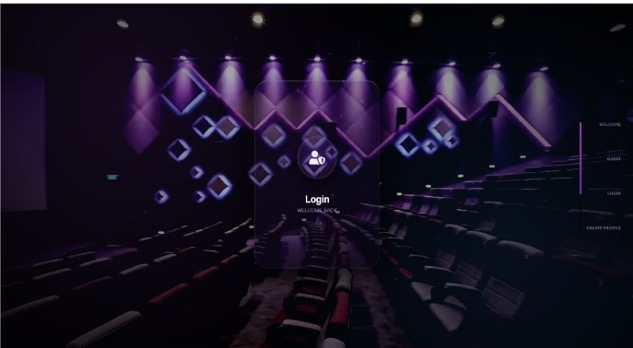
[Figure 4.1: BeatFlix Entry I Login Screen]
The login screen with email, password, and a Google sign-in button.

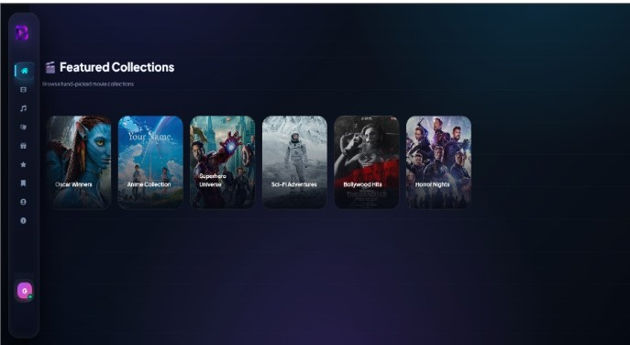
[Figure 4.2: Home Page - Hero Section]

The main page showing trending movies and different category sliders.

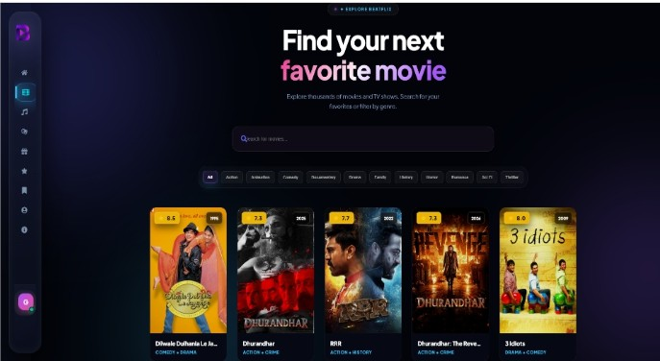
[Figure 4.3: Movies Browsing Page]
A grid of movies where users can filter by genres like Action or Comedy.

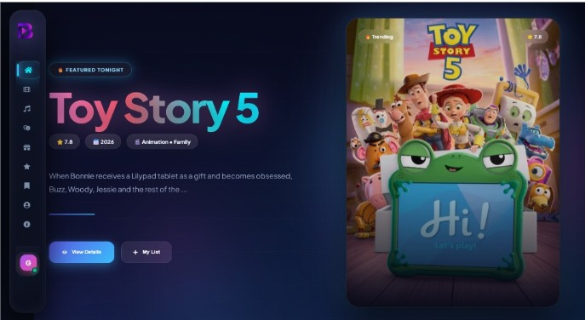
[Figure 4.4: Movie Details Page]
Shows the movie poster, plot, rating, and cast.

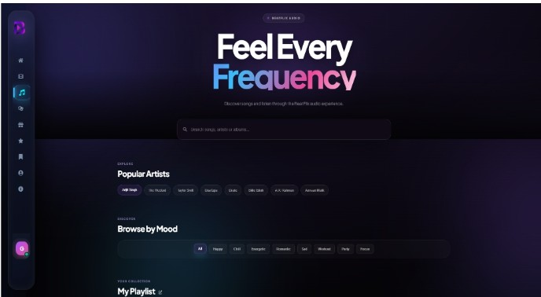
[Figure 4.5: Music Streaming Page]
Where users can search for songs and click play.

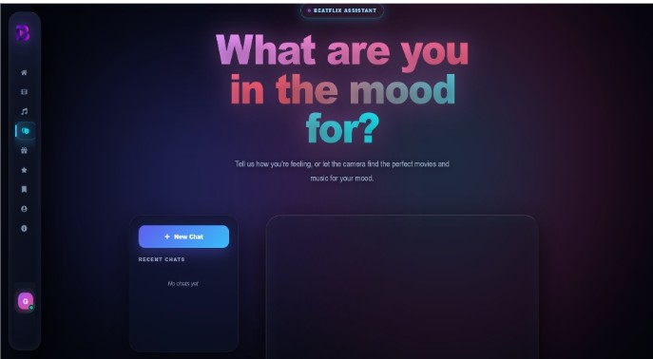
[Figure 4.6: Mood-Based Recommendation Page]
Users can click how they are feeling to get suggestions.

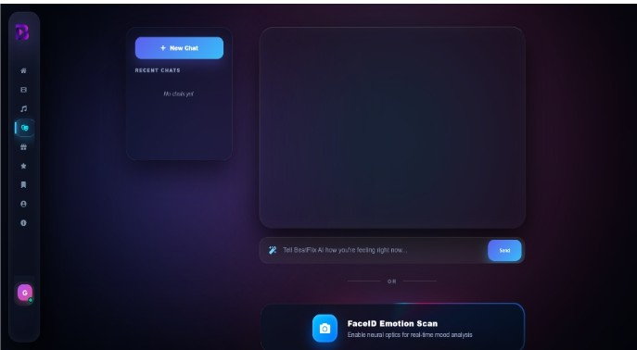
[Figure 4.7: BeatFlix Mood Recommender Interface]
The chat screen where the app talks to the user about their mood.

Unlock the 11:lTe Experience.

-Oil f>O-•·
•
* �
Starter |  | BontFlix Pro | Ultimate
Free |  | $9.99 | $14.99

I •

0

"1•1l·f'•-••I•

ll'llntu:l�IIIAI'-•"
ltilffi•rn.,v•n•
0..t. AA-o>t�'/400
U.,"'"1-...

tg1 ,J,.,, •·••· " O.•o)>.......
·• -,·,n,,.,-...,,,..._
I• 1•a If· •,,.. .,�•J
'" ,,,.,,,,. 1,.,,,,.�,,
� ,., 1-J.-,,e ....1.,., ,11

CurnmtPl11n Upgrmeto"'- Gatu1-.

[Figure 4.8: Subscription Plans Page]
Shows the Starter, Pro, and Ultimate plans with the Razorpay button.

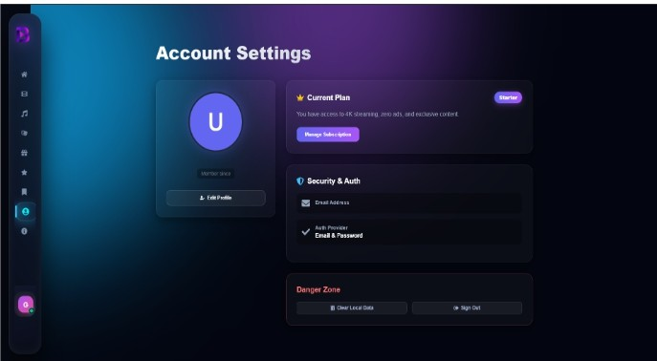
[Figure 4.9: Account Management Page]
Users can change their name or avatar here.

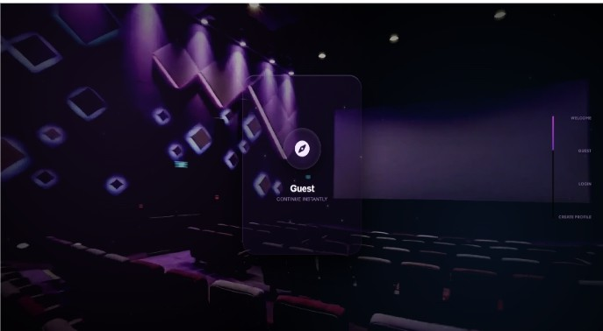
[Figure 4.10: Admin Dashboard}
A simple table showing all registered users.

•

,, / " ,,

'
/ ,
:.o
.. t t t • f
\.,
./,."''

' ,/ Login

[Figure 4.11: Global Music Player}
The music bar at the bottom of the screen with play/pause controls.

CHALLENGES FACED

Challenge I: Playing the Music
Getting the music to actually play was tough. The API I used didn't just give a simple MP3 link. I had to write a function that takes the stream data, looks for MP4 or M4A formats that browsers can play, and then redirects the audio player to that link. It took a lot of trial and error to get right.

Challenge 2: Formatting the Recommender Output
When using the Gemini API, sometimes it would send back normal text, and sometimes it would send JSON. I had to write a strong prompt to force it to always return data in a specific format so my React app wouldn't crash trying to read it.

Challenge 3: CORS Errors
When I tried to put the site live, the frontend on Vercel couldn't talk to the backend on Render because of CORS security errors. I had to update my Express server settings to explicitly allow requests from my Vercel domain.

Challenge 4: Making it Responsive
Writing CSS so the app looks good on a laptop is easy, but making it shrink down nicely for a mobile phone screen was frustrating. I had to use a lot of CSS media queries and flexbox to make things stack properly on small screens.

SYSTEM ARCHITECTURE AND MERN STACK IN-DEPTH

    - MongoDB (Database Layer)
MongoDB is a NoSQL database that stores data in flexible, JSON-like documents. Unlike traditional relational databases (like MySQL or PostgreSQL), MongoDB does not require a fixed schema. This makes it incredibly useful for modern web applications where the data structure might evolve rapidly over time.
In BeatFlix, MongoDB was chosen for its scalability and ease of integration with Node.js. Since both use JavaScript-like objects (JSON and BSON), data flows seamlessly from the backend into the database without needing complex ORM translations. We utilized Mongoose, an Object Data Modeling (ODM) library, to enforce a schema-like structure at the application level, ensuring data validation before insertion.
Our database design heavily utilized document referencing and embedding. For instance, user chat histories with the AI recommender were embedded within their respective user profiles to allow faster retrieval when the user logs in, minimizing the need for complex joins.

    - ExpressJs (Backend Framework)
Express.js is a minimal and flexible Node.js web application framework that provides a robust set of features for web and mobile applications. It facilitates the rapid development of Node-based web applications by providing a thin layer of fundamental web application features, without obscuring Node.js features that we know and love.
For this project, Express was responsible for handling all API routing, middleware execution, and HTTP request processing. We implemented a RESTful architecture, ensuring that our endpoints for users, movies, and subscriptions were logical, predictable, and stateless.
Key middlewares implemented in Express included:
      - CORS (Cross-Origin Resource Sharing) to allow our frontend hosted on Vercel to securely communicate with our backend on Render.
      - Body-parser (via express.jsonO) to parse incoming JSON payloads.

      - Custom Authentication Middleware that verified JWT tokens before granting access to protected routes like the Mood Recommender.

ReactJs (Frontend Framework)
React.js is a declarative, efficient, and flexible JavaScript library for building user interfaces. It lets developers compose complex Uis from small and isolated pieces of code called 'components'. React uses a Virtual DOM to optimize rendering performance, updating only the elements that actually change when the application state updates.
BeatFlix's frontend was built entirely as a Single Page Application (SPA) using React. We leveraged several modern React features to build a fast, responsive user experience:
      - React Hooks (useState, useEffect, useRef): Used extensively for functional component state management and lifecycle side effects.
      - React Context API: Implemented to manage global application state, most notably the 'Global Music Player' which needed to persist its audio playback state across route changes without reloading the page.
      - React Router DOM: Enabled client-side routing, meaning the browser didn't need to request new HTML documents from the server when navigating between the Movies, Music, and Plans pages.

Node.js (Runtime Environment)
Node.js is a cross-platform, open-source JavaScript runtime environment that executes JavaScript code outside of a web browser. Node.js lets developers use JavaScript to write command line tools and for server-side scripting-running scripts server-side to produce dynamic web page content before the page is sent to the user's web browser.
The asynchronous, event-driven architecture of Node.js was crucial for BeatFlix. Because Node.js handles 1/0 operations non-blockingly, our server can concurrently handle a user fetching a movie list from TMDB, another user verifying a Razorpay transaction, and a third user chatting with the Gemini Al without the server thread getting blocked.

IMPLEMENTATION DETAILS AND WORKFLOWS

    - Authentication Workjlow
The authentication flow in BeatFlix prioritizes security and seamless user experience. When a user registers, their plaintext password is intercepted by a Mongoose 'pre-save' hook and hashed using the bcryptjs library with a salt factor of 10. This ensures that even in the event of a database breach, user passwords remain secure.
Upon successful login, the server generates a JSON Web Token (JWT). This token contains a payload with the user's unique ID and an expiration timeframe. The JWT is signed using a secret key stored in the server's environment variables. The client (React frontend) receives this token and stores it in the browser's local storage. For all subsequent API requests that require authorization (like accessing premium music), the frontend attaches this JWT in the Authorization header. The backend's authentication middleware intercepts the request, verifies the token's signature, and either grants or denies access.

    - Third-Party AP! Integration
BeatFlix relies heavily on external data sources to populate its content library. Integrating these APis required careful asynchronous programming using JavaScript Promises and the async/await syntax to prevent race conditions and handle network failures gracefully.
TMDB API (Movies): We used axios to make HTTP GET requests to TMDB endpoints. To ensure high performance, we implemented pagination on the frontend. When a user scrolls to the bottom of the movie list, an Intersection Observer triggers a fetch for the next page of results, appending them to the existing state.
Google Gemini API (AI Recommender): The emotion logic is powered by Gemini. The user's input string is concatenated with a strict engineering prompt (e.g., 'Return exactly 5 movie recommendations in valid JSON format'). This prompt engineering was vital because LLMs often return conversational text which would break our frontend JSON parser.
Verome API (Music): The music streaming logic was the most complex. The API returns streaming URLs that often expire or require specific headers. We had to build a custom audio

element wrapper in React that handled buffering states, playback errors, and auto-play policies of modern browsers.

TESTING STRATEGIES

    - Unit Testing
Throughout the development process, unit tests were written to verify the logic of individual functions, particularly in the backend controllers. For example, testing the password hashing function to ensure different inputs produced appropriately salted hashes. We also unit-tested our API request formatting functions to guarantee the correct parameters were being passed to TMDB.

    - Integration Testing
Integration testing was critical for ensuring the frontend and backend communicated correctly. We utilized Postman extensively for this phase. Before writing any React code, every single backend API endpoint was tested in Postman. We created a Postman collection that simulated a user logging in, capturing the JWT token, and injecting that token into subsequent requests to access protected data.

4.7.3 User Interface and Cross-Browser Testing
Ensuring BeatFlix looked pristine on all devices required rigorous UI testing. We used Chrome DevTools Device Mode to simulate responsive breakpoints (mobile, tablet, desktop). Extensive testing was done on Safari and Firefox to ensure CSS flexbox and grid layouts rendered consistently across different rendering engines.

DEPLOYMENT AND HOSTING

    - Frontend Deployment (Vercel)
The React frontend was deployed using Vercel, a platform optimized for frontend frameworks. Vercel automatically integrated with our GitHub repository, enabling continuous deployment (CD). Every time a commit was pushed to the main branch, Vercel automatically triggered a new build process, running 'npm run build' and serving the static files on a global Edge Network.

    - Backend Deployment (Render)
The Node.js and Express backend was deployed on Render, a unified cloud platform. Since the backend requires a running server process, Render provided a seamless environment to spin up our Node instance. Environment variables (like API keys and JWT secrets) were securely injected via the Render dashboard, keeping them out of the public source code repository.

    - Database Hosting (MongoDB Atlas)
The database was hosted on MongoDB Atlas, a fully managed cloud database service. Atlas handled all the operational overhead like provisioning, setup, patching, and backups. We configured network access controls (IP Whitelisting) so that only our Render backend IP addresses could communicate with the database cluster, enhancing security.

SECURITY MEASURES IMPLEMENTED

Building a secure application was a priority during the internship. Several layers of security were implemented across the stack:
- Password Hashing: As mentioned, plaintext passwords are never stored. Bcrypt was used to mitigate brute-force and rainbow table attacks.
- JWT Security: Tokens were given short expiration times. If a token was intercepted, it would only be valid for a limited window.
- CORS Policies: The backend was configured to reject API requests originating from unauthorized domains. Only the official Vercel frontend URL was permitted.
- Environment Variables: Sensitive data such as API keys (TMDB, Razorpay, Gemini) and database connection strings were kept out of the source code and managed via .env files locally and dashboard variables in production.
- Input Validation: Server-side validation was implemented to prevent injection attacks. Email formats were verified, and required fields were strictly enforced before any database operations occurred.

PERFORMANCE OPTIMIZATION

To ensure a smooth user experience, several performance optimizations were made:
- Lazy Loading: React components were lazy-loaded, meaning the code for certain pages (like the Admin Dashboard) was only downloaded by the browser if the user actually navigated to that page, significantly reducing the initial bundle size.
- Image Optimization: Movie posters fetched from TMDB were requested at appropriate resolutions. We didn't fetch 4K posters for a thumbnail grid, saving significant bandwidth.
- Debouncing Search Inputs: When users type in the movie search bar, an API request is not fired for every single keystroke. Instead, a debounce function waits for the user to stop typing for 300 milliseconds before firing the request, vastly reducing the number of unnecessary API calls and server load.

AGILE DEVELOPMENT LIFECYCLE

The project was managed using principles from the Agile methodology. The 4-week training period was treated as four !-week sprints.
- Sprint 1: Requirement analysis, UI/UX design wireframing, and backend boilerplate setup. Database schema finalized.
- Sprint 2: Core functional development. User authentication, movie fetching, and basic frontend routing completed.
- Sprint 3: Advanced feature integration. Music streaming logic and the Gemini AI mood recommender were built and connected.
- Sprint 4: Testing, bug fixing, styling polishing, and final deployment to Vercel and Render.

This structured approach ensured that a minimum viable product (MVP) was ready early on, leaving ample time to integrate the complex AI and music streaming features without jeopardizing the core functionality of the platform.

CHAPTER 5: CONTRIBUTION TO THE ORGANIZATION

PROBLEM-SOLVING CONTRIBUTIONS

    - Combining Movies and Music
I figured out a way to put movie browsing and music streaming into the same website without it feeling messy. I had to use two completely different APls and make them look like they belong to the same app.

    - Emotion Logic
I successfully integrated emotion-based logic into the app so it can suggest content based on how someone feels. This is a lot more interesting than just browsing by genre.

    - Secure Login System
I built a proper login system from scratch that hashes passwords and uses OTPs, which means user data is actually safe.

IDEAS IMPLEMENTED
- Mood -Based Discovery: Instead of just clicking 'Action', users can say they are stressed and get relaxing suggestions.
- Persistent Music Player: I made the music player stay at the bottom of the screen permanently, just like on Spotify, so the music doesn't stop when you click a link.
- Subscription Limits: I added logic so free users can only use the mood recommender a few times before they have to upgrade.

PROCESSES IMPROVED

- Code Structure: I learned how to split my React code into small components so the files don't become huge and unreadable.
- API Handling: I wrote functions that catch errors nicely, so if an API is down, the app shows a friendly error message instead of just a blank white screen.

CHAPTER 6: LEARNING AND DEVELOPMENT

TECHNICAL SKILLS GAINED

    - Frontend Skills
      - I got much better at React.js. I now understand how hooks like useState and useEffect work in real situations.
      - I learned how to use React Router to make a single-page application.
      - My CSS got a lot better, especially using Flexbox and making sites mobile-friendly.
      - I learned how to use Axios to get data from my backend.

    - Backend Skills
      - I learned how to set up an Express.js server and write API routes.
      - I learned how to design a MongoDB database and save data using Mongoose.
      - I figured out how JWT tokens work to keep users logged in securely.
      - I learned how to send emails from Node.js using Nodemailer.

    - Other Technical Skills
      - I learned how to write prompts for APis to get the exact data format I need.
      - I learned how to deploy a full-stack app to Vercel and Render.
      - I got a lot more comfortable using Git and GitHub to save my code.

SOFT SKILLS DEVELOPED
- Problem Solving: The biggest thing I learned was how to fix my own errors by reading the console and Googling properly.
- Planning: I learned that you can't just start typing code; you have to plan out your database and UI first.

- Patience: Figuring out why a bug is happening takes a lot of patience, especially when
it's just a small spelling mistake causing it.

KNOWLEDGE GAINED
- I now understand the MVC pattern and why separating routes and controllers makes code cleaner.
- I understand how CORS works and why browsers block certain requests for security.
- I learned the basics of how payment gateways like Razorpay handle transactions.

CHAPTER 7: SUMMARY AND CONCLUSION

SUMMARY
The summer training was done by Ducat India at our college campus. Over the month, I built BeatFlix, an emotion-based movie and music streaming site using the MERN stack.

The final website has 14 different pages, a working backend, a database, and connects to external services like TMDB, Verome, Gemini, and Razorpay. I managed to add features like a global music player, a smart mood recommender, and a secure login system.

CONCLUSION
This summer training was incredibly helpful. Before this, I had only watched tutorials and done small homework assignments. Building a complete project from scratch by myself taught me a lot more than just reading about it.

Working with the MERN stack showed me exactly how the frontend and backend talk to each other. React made it easy to build the UI piece by piece, and Express/MongoDB made storing user data pretty straightforward once I got the hang of it.

Adding the emotion-based logic using an API was my favorite part of the project because it made the app feel much more advanced and personal than a basic streaming site.

Overall, doing this training with Ducat India was a great experience. It bridged the gap between college theory and actual practical coding. The skills I picked up while building BeatFlix will definitely help me when I start applying for jobs.

CHAPTER 8: SUGGESTIONS FOR IMPROVEMENT

PLATFORM ENHANCEMENTS

    - Automatic Mood Detection
Right now, the user has to type in how they feel. A cool future feature would be using a webcam library to detect their facial expression and suggest movies automatically based on that.

    - Social Features
It would be great to add a feature where you can share a playlist with a friend, or see what movies your friends recently watched on the platform.

    - Mobile App
The website is mobile-friendly, but converting it into a proper Android or iOS app using React Native would make it even better.

TECHNICAL IMPROVEMENTS
- I could use Typescript instead of plain JavaScript to catch more errors before the code even runs.
- I didn't write any automated tests for this project. Adding testing would be a good next step.
- I could add caching for the movie data so the app doesn't have to fetch from TMDB every single time the page reloads.

TRAINING PROGRAM SUGGESTIONS
- It would be nice if the training was a bit longer so we had more time to dive into advanced topics like WebSockets.

- Having a session specifically dedicated to deploying apps and managing servers would be very helpful for students.

BIBLIOGRAPHY

[l] React Documentation. [Online]. Available: https://react.dev/

- Node.js Documentation. [Online]. Available: https://nodejs.org/docs/

- Express.js Guide. [Online]. Available: https://expressjs.com/

- MongoDB Manual. [Online]. Available: https://www.mongodb.com/docs/

- TMDB API Docs. [Online]. Available: https://developer.themoviedb.org/docs

- Google Gemini API Docs. [Online]. Available: https://ai.google.dev/docs

- Razorpay Docs. [Online]. Available: https://razorpay.com/docs/

- Ducat India. [Online]. Available: https://www.ducatindia.com/

APPENDIX

APPENDIX A: KEY CODE LOGIC

A.I Backend Setup
The backend uses Express. It sets up CORS so the frontend can connect to it, parses JSON data, and connects to MongoDB before starting the server port.

  - User Schema
The MongoDB schema for users stores their name, email, hashed password, subscription status, and how many recommender tokens they have left. It checks that emails are unique so you can't sign up twice.

  - Recommender Prompt
The code sends a prompt to the API telling it to act like a friendly movie expert. It forces the API to return the response in a JSON format so the React frontend can display the movies and songs in nice UI cards instead of just plain text.

  - Music Streaming
The backend searches for a song, finds the available audio streams, picks the one that plays best in Chrome (usually MP4/M4A format), and sends that direct audio link back to the React music player.

APPENDIX B: PROJECT LINKS

Frontend: Deployed on Vercel Backend: Deployed on Render Database: Hosted on MongoDB Atlas

Source Code: https://github.corn/Hardikcode9/BeatFlix

