CareSync Attendance Portal

Project Synopsis & Technical Documentation

Prepared by: Hardik Bhondve

Date: August 2025

# Abstract

Lief Attendance is a web-based attendance management system designed for healthcare organizations. It allows careworkers to clock in and out of shifts with geolocation validation, while managers can configure geofencing perimeters and monitor attendance data through analytics dashboards. The application ensures accurate, location-based attendance logging and role-specific access, improving workforce accountability.

# Problem Statement

Traditional attendance tracking methods in healthcare environments often rely on manual entry or physical logbooks, which are prone to inaccuracies and misuse. There is a need for a digital solution that ensures attendance is recorded only when staff are physically present within an authorized work location.

# Objectives

- Provide an easy-to-use platform for careworkers to clock in/out.  
- Validate attendance through geolocation and geofencing.  
- Enable managers to monitor staff attendance in real-time.  
- Offer analytical insights into workforce attendance trends.

# Proposed System

The system consists of two user roles: Careworkers and Managers. Careworkers can clock in/out, and their location is validated against a geofence perimeter set by the manager. Managers can configure geofencing parameters, view attendance logs, and analyze attendance trends through a dashboard.

# Scope of the Project

The system can be deployed in healthcare organizations, clinics, and hospitals to ensure accurate, location-based attendance tracking. It can be adapted for other industries where physical presence is required for attendance validation.

# System Architecture

# ### Frontend

# frontend/

# │── src/

# │ ├── components/ # Reusable components (Navbar, AuthButtons, Charts)

# │ ├── context/

# │ ├── graphql/ # Queries & mutations for Apollo Client

# │ ├── pages/ # Pages (Careworker, ManagerDashboard)

# │ ├── App.js # Route definitions & Auth0 logic

# │ └── index.js # Entry point

# │── package.json

# ```

# backend/

# │── prisma/

# │ └── schema.prisma # Database schema definition

# │── src/

# │ ├── index.js # Apollo Server initialization

# │── .env # Environment variables

# │── package.json

# Modules & Features

1. Careworker Module:  
 - Clock in/out functionality with geolocation.  
 - View personal shift history.  
  
2. Manager Module:  
 - Configure geofencing perimeters.  
 - View all staff attendance records.  
 - Dashboard analytics for attendance trends.  
  
3. Authentication Module:  
 - Auth0-based login with role-based access control.  
  
4. Analytics Module:  
 - Total hours worked.  
 - Average check-in time.  
 - Attendance compliance rates.  
 - Total Hours clocked in per staff over the last 1 week.

# Technology Stack

Frontend: React.js, Apollo Client, Recharts, CSS, Grommet  
Backend: Node.js, Apollo Server (GraphQL), Prisma ORM  
Database: PostgreSQL  
Other: HTML5 Geolocation API, Haversine formula for geofencing

# Database Design

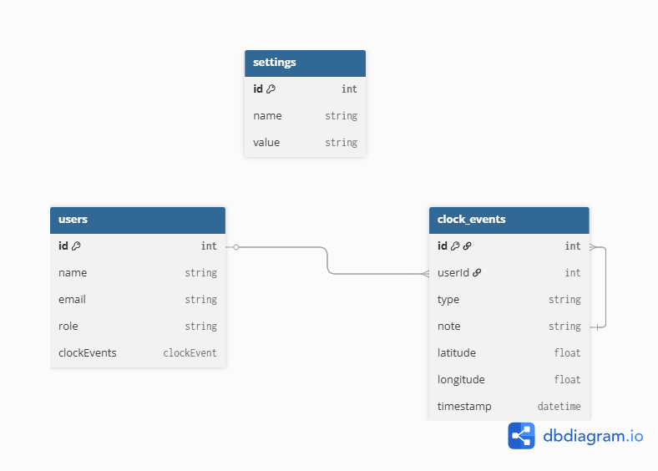

# System Requirements

Hardware:  
- Minimum 4GB RAM  
- Dual-core processor  
  
Software:  
- Node.js  
- PostgreSQL  
- Modern web browser

# Implementation Details

Frontend:  
- Built with React.js using Apollo Client for GraphQL data fetching.  
- Role-based routing and authentication via Auth0.  
- Responsive design with CSS and Grommet library.  
  
Backend:  
- Node.js with Apollo Server for GraphQL APIs.  
- Prisma ORM for database interaction.  
  
Geolocation:  
- HTML5 Geolocation API to fetch user coordinates.  
- Haversine formula for geofence validation.

# Testing & Validation

# Testing was conducted manually by modifying the geofence perimeter value directly in the code and then simulating clock-ins and clock-outs both from locations within the defined radius and from locations outside it. Role-based access control was verified by logging in with both careworker and manager accounts.

# Conclusion & Future Enhancements

The project successfully implements a location-based attendance tracking system suitable for healthcare organizations. Future enhancements include offline clock-in support, automated late arrival reminders, and exportable attendance reports.

# References & Appendix

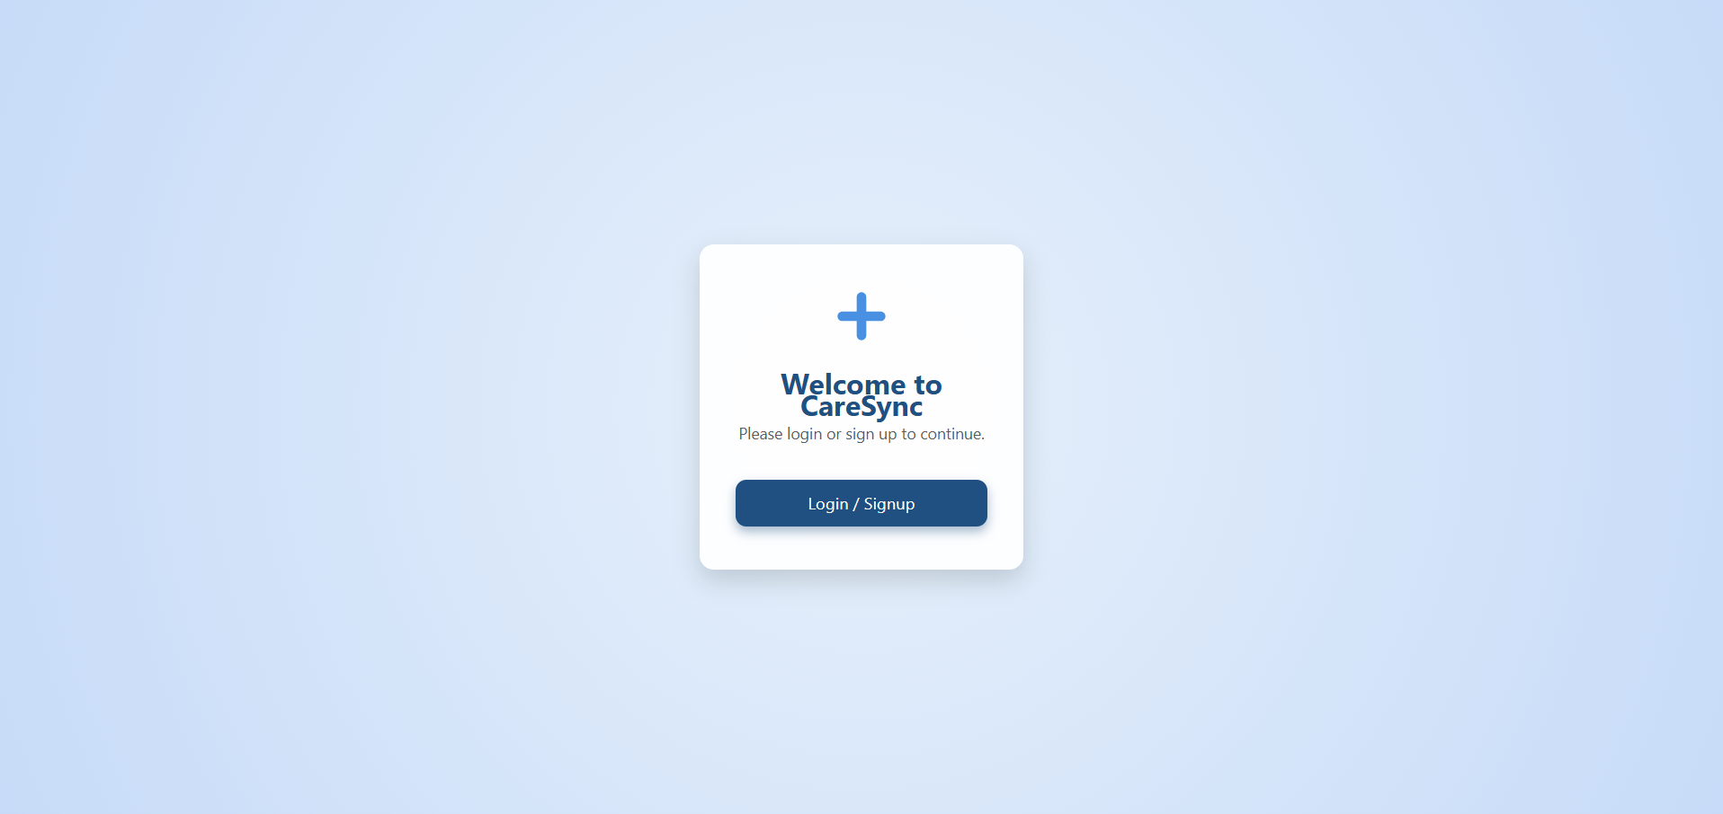

Careworker Dashboard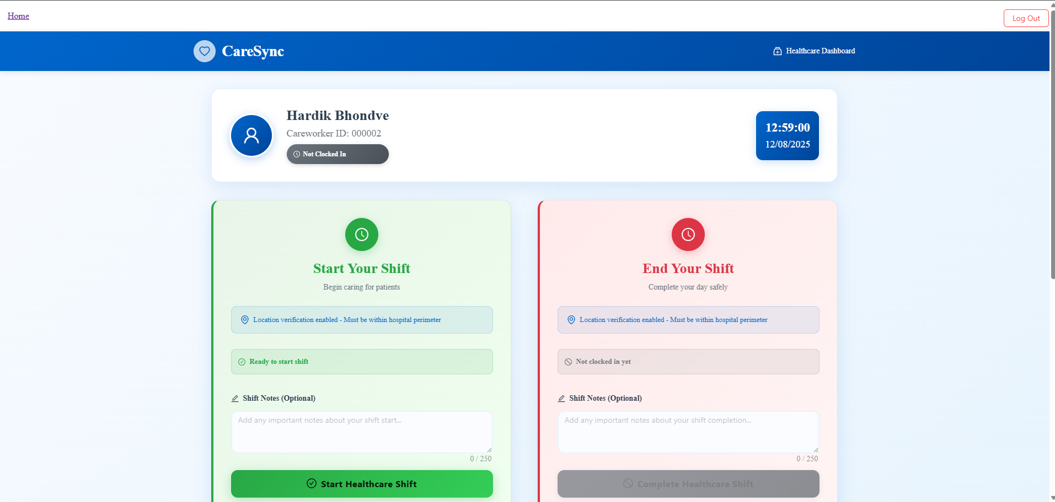

Manager Dashboard



