**PROJECT REPORT ON**

**Statistical Analysis of digital payment on the students of Science Faculty**

**A REPORT SUBMITTED TO**



**DEPARTMENT OF STATISTICS**

**FACULTY OF SCIENCE**

**THE MAHARAJA SAYAJIRAO UNIVERSITY OF BARODA**

**IN PARTIAL FULFILMENT OF THE REQUIREMENTS FOR**

**THE DEGREE OF THE MASTER OF SCIENCE**

**GUIDED BY**: **PROJECT MEMBERS:**

**DR. KHIMYA S. TINANI Dhruvi Sheth**

**Hardik Parmar**

**Mahek Parmar**

**Neelu kanwar**

**Waheedullah stanikzai**

**Year 2021**

**CERTIFICATE**

This is to you certify that Dhruvi sheth , Hardik Parmar , Mahek Parmar ,Neelu Kanwar, Waheedullah stanikzaihave satisfactorily completed the project entitled: “STATISTICAL ANALYSIS OF DIGITAL PAYMENT ON STUDENTS OF SCIENCE FACULTY”.

As a team in the academic year 2020-21, this work is submitted to the Department as a fulfilment for degree of Master of Science in Statistics. Throughout the semester they carried out work with sincerity & has presented on the time and with enthusiasm.

I wish them grand success in future.

Dr. Khimiya Tinani Prof. Vipul Kalamkar (Guide) (Head, Department of Statistics)

**AKNOWLEDGEMENT**

First and fore most we would like to thank our guide, Dr. khimya Tinani who always helped us, welcomed our questions, keep us motivated and gave us a lot of recommendations and suggestions. We would not have reached this phase, if it were not for her permanent support, advice, and guidance.

We also would like to express our gratitude to our Head Dr. Vipul Kalamkar for their support, guidance and helpful feedback.

Thanks to the university to provide us with such great faculties, library, environment -to grow ourselves, and for the platform to explore ourselves and showcase our skills.

Our sincere thanks to our parents for guiding us decently and supporting at every stage in our life also their wishes for successful completion of this project.

Last but not least, we would like to express our eternal gratitude to friends for their support, appreciation and patience. We would like to dedicate this report to them all.

**CONTENTS**

**1. Introduction**

**2. Review of literature**

**3. Objectives**

**4. Sample size determination**

**5. Reliability of Questionnaire**

**6. Data Visualization**

**7. Statistical Analysis**

**7.1. Chi-Square test of Independence of Attributes**

**7.2. Tschuprow’s Test**

**7.3. Multiple Response Analysis**

**8. References**

**9. Appendix**

**9.1 Questionnaire**

**9.2 Coding for questionnaire**

**INTRODUCTION:**

Today, a vast majority of the global population has access to mobile handsets and is becoming familiar with the Internet. Due to the entry of high-tech and low-budget smart phones, the mobile internet services have become kind of basic necessities. The technologies of these gadgets are very helpful in digital payment. Thus, the smartphone is enabling the new payment capabilities.

Now a days, India is moving forward along the path of the most significant digital revolution, and in the coming years, the digital payment system will be an important milestone in a cashless economy. A digital payment system is an electronic environment that allows consumers to make electronic commerce transactions for their purchases, financial transactions, making bill payments like mobile bill, land line service etc. With the rapid development of science, and network technology, “Digital payment” has become a routine part of human life. Digital payments allows users to pay electronically, and therefore indirectly cashless.

In India’s journey towards becoming a cashless economy, two words and their impact played a significant role, ‘demonetization’ and ‘COVID-19’. One laid out the foundation of digital payments and another became the main source to build up the digital payments ecosystem.

The development of digital payments in India is expected to depend on digital payment service providers, an effective banking regulatory mechanism and consumer experience, as well as on factors driving the growth of digital payments in India. The digital payment system is gaining momentum, especially after

demonetization in India. The Government of India has taken various steps to effectively use digital payment platforms to eliminate corruption and black money

in the Indian economic system. Currently, about 60 percent of transactions in India are made through digital platforms. Although digital payments are generally accepted by the public, there are few criticisms regarding the processing of the digital payment system. In order to popularize and accelerate the adoption of digital payments, many digital payment systems have been launched in India. Against this background, it is extremely important to study students perceptions of digital payments in the MSU.

The Digital India programme is a flagship programme of the government of India with a vision to transform India into a digitally empowered society and knowledge economy “Faceless, Paperless, Cashless” is one of professed role of Digital India.

Digital payment is a mode of payment which involves various digital platforms or application to make transaction, using digital means.

**MODES OF DIGITAL PAYMENT:**

**1. Plastic Cards-** These are cards issued by banks to their account holder, by using it they can withdraw money from any ATM by using their password. These cards are used for depositing money in banks to so that there is less wastage of paper. There are two type of cards issued by banks i.e. debit and credit card. Debit cards are issued to all account holders whereas credit cards are issued to the once according to their interests.

**2. UPI**- Unified Payment Interface is a payment mode this is used to make fund transfers through the mobile app. One can transfer funds between two accounts using UPI apps. One should have a registered mobile banking facility to use UPI apps. Currently, this service is only available for android phone users. One can download a UPI app and create a VPA or UPI ID. There are too many good UPI apps available such as BHIM, SBI UPI app, HDFC UPI app, Mobile, Phone Pay app etc. It is not mandatory to use the UPI app from a respective bank to enjoy UPI service. One can download and use any UPI app.

**3. Mobile Wallet**- It’s the other way of storing or keeping digital cash and using it for various transactions. A person can download any mobile wallets namely Paytm, Google Pay, Phone pay, SBI buddy, Jio money, etc. They just need to link there bank account or their plastics cards number to use the amount required and which is further used for making payments, paying bills etc.

**4.Internet banking**- There are various types of internet banking which are NEFT(National Electronic Fund Transfer), RTGS(Real Time Gross Settlement),ECS(Electronic Clearing System), IMPS(Immediate Payment Service).These are e-banking system which allows individual or organization’s to make transfers using the website of their banks.

**5. Mobile banking**- It is provided by all banks to their customers where the customers need to download the application of the bank and they cause it for making transactions. For using such application on should have a smartphone.

**REVIEW OF LITERATURE :**

**Oladejo, Morufu et.al (2012)** in their study examined the improvement of e-payment system in Nigeria. They explored what initiated the people to adopt the e-payment system. A structured questionnaire and some financial statements were collected to analyse the data. The results were such that when bank adopted e-payment system there was a change in the performance level of the banks. With the advent of e-payment system there was a rise in usage of ATMs.

**Nitsure (2014)** in his study highlighted the issues that were being faced or observed in developing country like India in using the e-payment system which was due to the low spread of internet and technology. The paper focused on major issues such as security, rules, etc. IN a country like India there is a high risk where the poor’s are given a chance to be informed about such facilities neither they are given any such information.

**Bezhovski (2016)** has examined how internet and e-commerce has opened the gateway for digital payment system with the increment in technology people are adopting the new means of payment system and how they will be benefited and is there any pitfall of using it. When e-commerce was launched it was a unique way of trading so the digital payment is also a unique way of transaction which will also emerge as the e-commerce and in near future it will become the backbone of e-commerce. The future of these digital wallets will depend on the security and privacy that are provided by the companies as people are highly security concerns any pros and cons will decide the future of digital wallets. It is not only restricted to make transactions but it be used for booking airlines, movie tickets. Many offers are provide for making bill payments or buying any goods using these platforms. As the smart phones has removed many devices from our daily live and have clubbed in one device only so it is expected that digital wallet will also do the same which will become substitute for many other things.

**Baghla . A (2018)** in his study identified the trends for adopting the digital payment system India. Further the paper talks about how after demonetization people started to use the digital platforms for transactions. How the government initiative to make our economy a cashless one and how consumer will be adopting such system are further discussed. A structed questionnaire was used to collect data and find out the future of digital payment system in India.

**Shivathanu B. (2019)** in his study adoption of digital payment system in the era of demonetization emphasised on how the digital payment system was used by the people or accepted by the people during demonetization. It was based on a conceptual framework where the sample size was 766. The data analysed suggested that behavioural intentions and innovation resistance had an impact on the actual usage.

**OBJECTIVE:**

* To study the association between uses of digital payments and demographic variables.
* To study why would you adopt digital payment payments.
* To study biggest concern while using digital-payments.
* To study the choice of application used for digital payment.
* To study the uses of digital payment in different places.
* To study what influenced students to use digital payment payments.
* To study the impact of covid- 19 on digital payment.
* To study the factors which affect to never use digital- payment.

**SAMPLE SIZE DETERMINATION & SAMPLE COLLECTION METHEDOLOGY:**

A population is the total number of students currently study in faculty of science is the main focus of our study. Collecting information from the entire population is not feasible for this study so a sample or subset of the population will be considered instead. It was projected that each individual will be interviewed by calls or asked to fill up the Google form (questionnaire) at their convenient time. We used Power Package in R to determine the sample size. Thus, finding will be extrapolated based on the data received from this sample population. We have determined the sample size for each objective using power package in R.

First, install the power package in R and for each of the objective of our study we have determined the sample size corresponding to the appropriate statistical tool for each of the objective in the study.

Effect size is the simple way of quantifying the difference between two groups that has many advantages over the use of tests of statistical significance alone. Effect size emphasizes the size of the difference rather than confounding this with sample size. Usually, determination of effect size could be achieved either through pilot surveyor from previous related studies on the same research subject. Cohen’s convention can also be used in relation to what can be consider as small, medium or large effect size.

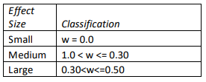

For determining the effective sample size in order to achieve the required accuracy in chi-square tests, we use the following code to get the sample size:

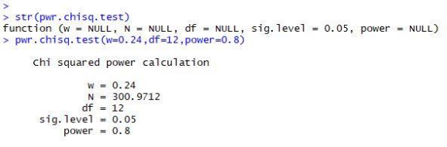

Similarly, we have computed sample size for each of the objective. From all the objectives we have used maximum sample size which is to be 301.

For the collection of samples, we have used two stage sampling. In first stage we have used stratified sampling, we have made strata based on department from faculty of science. Then we use Proportional Allocation Method in every stratum and obtain ni as number of sample points to be collected from each department.

$$n_{i}=\frac{n_{(srswor)}N_{i}}{N}$$

* Where,
* N = Total Students of Science Faculty in current year
* Ni = Total Students of Science Faculty of each department in current year
* n(srswor) = Sample size of the total population
* ni = Sample size of each department based on proportion

Sample size allocated to different strata(department) by using proportional allocation method is shown in the following table:

|  |  |  |  |
| --- | --- | --- | --- |
| **Department name** |  | **Sample Size** |  |
| **Total=Ni** | **ni** | **Round off** |
| Microbiology | 56 | 3.7516 14 | 4 |
| Physics | 516 | 34.56844 | 35 |
| Medical biotechnology | 39 | 2.612731 | 3 |
| Chemistry | 517 | 34.63543 | 35 |
| Botany | 376 | 25.18941 | 25 |
| Biochemistry | 54 | 3.617627 | 4 |
| Statistics | 352 | 23.58157 | 24 |
| Mathematics | 702 | 47.02916 | 47 |
| Zoology | 369 | 24.72045 | 25 |
| Geology | 340 | 22.77765 | 23 |
| Geography | 260 | 17.41821 | 17 |
| Environmental science | 342 | 22.91164 | 23 |
| Information & Technology | 46 | 3.081683 | 3 |
| Biotechnology | 36 | 2.411752 | 2 |
| Cell & molecular | 124 | 8.307144 | 8 |
| Computer application | 364 | 24.38549 | 24 |
| **N** | **4493** |  | **302** |

**Reliability of Questionnaire:**

Reliability in statistics is the overall consistency of a measure. Cronbach’s alpha is a measure of internal consistency, that is, how closely related a set of items are as a group. It is considered to be a measure of scale reliability. The α coefficient for the 30 items is 0.700, suggesting that the items have relatively high internal consistency. The reliability coefficient of .70 or higher is considered “acceptable” in most social science research situations. Thus, for α=0.700, our questionnaire is acceptable, hence valid and reliable for this study.

**Data Visualization:**

**Current Scenario of Digital Payment Usage**

* Here we observe that we have 88% users and 12 % Non-users of Digital payment.

**Gender wise comparison of uses of digital payment**

* Here we observe that 83% of Female use digital Payment and 94% of male use digital payment.

**Income wise Uses of digital payment.**

* From the above graph we observe that digital payment is mostly used by the students whose annual family income lies between 90 thousand – 3 lakhs.

**Reasons for adopting a digital payment system**

* Here we observe that the most important factor determining the usage of digital payment is time saving followed by convenience.

**Online Payment Application Usage Criteria**

* Here it is observed that 77% of students use Google Pay whereas 59% students use Paytm.

**Use digital payments at different places**

* Here we observe that 77% students use digital payment for mobile phone recharge and for paying fees.

**Reasons for Influence towards online payments**

* It can be noticed that 57% influence are through friends and followed by family(54%).

**Concern in digital payment**

* From the above graph we observe that maximum number of students are agree by the fact that Fraud and privacy is the biggest concern while using digital payment.

**Impact of Covid-19**

* From the above graph we observe that after pandemic 8 % of students adopted the mode of digital payment.

**Uses of Digital Payment Based on scaling**

* Here we observe that 72.00% of students believe that digital payment is safe.

**Experience of facing fraud while using digital payment**

* From the above graph we observe that 14% of students facing fraud while using digital payment.

**Reasons for not Using Digital payment**

* Here we observe that 51.0% of students are not using digital payment, due to concern about security and followed by given reason.

**Usages of digital payment in future**

* Here we observe that the students who currently not using digital payment, 97% of them will use in future.

**CHI-SQUARE TEST OF INDEPENDENCE OF ATTRIBUTES:**

The Chi-square test can also be used to test for independence between rows and columns of a contingency table.

We reject null hypothesis when $χ_{cal}^{2}$ > $χ_{tab}^{2}$.

**Test statistic:**

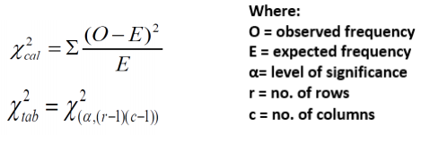

**TSCHUPROW’S T :**

In statistics, Tschuprow's T is a measure association between two nominal variables, given as 0 and 1 (inclusive). It is closely related to Cramer’s V, coinciding with it for square contingency tables. It was published by Alexander Tschuprow (alternative spelling: Chuprov) in 1939. If we have a multinomial sample of size n, the usual way to estimate T from the data is via the formula

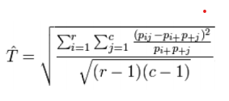

Where is the proportion of the sample in cell. This is the empirical value of T. With the Pearson chi-square statistic, this formula can also be written as

TSCHUPROW’S T

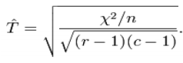

**FINDINGS AND ANALYSIS:**

**1) Objective:** **To check the association between use of digital payment and gender.**

**To test:**

H0: There is no association between gender and usage of digital payments.

H1: There is association between gender and usage of digital payments

|  |  |  |  |  |  |
| --- | --- | --- | --- | --- | --- |
| **Gender vs. Uses of Digital payment Crosstabulation** | | | | | |
|  | | | Do You Use Digital payment methods? | | Total |
| No | Yes |
| Gender | Female | Count | 28 | 132 | 160 |
| Expected Count | 19.6 | 140.4 | 160.0 |
| Male | Count | 9 | 133 | 142 |
| Expected Count | 17.4 | 124.6 | 142.0 |
| Total | | Count | 37 | 265 | 302 |
| Expected Count | 37.0 | 265.0 | 302.0 |

|  |  |  |  |
| --- | --- | --- | --- |
| **Chi-Square Tests** | | | |
|  | Value | df | Asymptotic Significance (2-sided) |
| Pearson Chi-Square | 8.719a | 1 | 0.003 |
| N of Valid Cases | 302 |  |  |
| a. 0 cells (0.0%) have expected count less than 5. The minimum expected count is 17.40. | | | |
| b. Computed only for a 2x2 table | | | |

Here alpha = 0.05

p-value = 0.003

**Conclusion:**

As p-value < alpha, therefore the data provide enough evident to reject H0 at 5% level of significance. Hence we conclude that there is association between gender and usage of digital payments.

As there is association between two attributes, i.e. gender and digital payment.

Then how much?

Hence for we use Tschuprow's test.



|  |  |  |  |
| --- | --- | --- | --- |
| **Symmetric Measures** | | | |
|  | | Value | Approximate Significance |
| Nominal by Nominal | Phi | 0.170 | 0.003 |
| Cramer's V | 0.170 | 0.003 |
| N of Valid Cases | | 302 |  |

T̂ =0.170

Thus there is 17% association between gender and digital payment.

**2) Objective: To check association between income and digital payment.**

**To test:**

H0: There is no association between income and digital payment.

H1: There is association between income and digital payment.

|  |  |  |  |  |  |
| --- | --- | --- | --- | --- | --- |
| **Annual family income vs. Uses of Digital payment Crosstabulation** | | | | | |
|  | | | Do You Use Digital payment methods? | | Total |
| No | Yes |
| Annual family income | Below 90,000 | Count | 9 | 79 | 88 |
| Expected Count | 10.8 | 77.2 | 88.0 |
| Between 90,000 to 3 lakhs | Count | 14 | 101 | 115 |
| Expected Count | 14.1 | 100.9 | 115.0 |
| Between 3 lakhs to 7 lakhs | Count | 10 | 58 | 68 |
| Expected Count | 8.3 | 59.7 | 68.0 |
| Above 7 lakhs | Count | 4 | 27 | 31 |
| Expected Count | 3.8 | 27.2 | 31.0 |
| Total | | Count | 37 | 265 | 302 |
| Expected Count | 37.0 | 265.0 | 302.0 |

|  |  |  |  |
| --- | --- | --- | --- |
| **Chi-Square Tests** | | | |
|  | Value | df | Asymptotic Significance (2-sided) |
| Pearson Chi-Square | .729a | 3 | **0.866** |
| N of Valid Cases | 302 |  |  |
| a. 1 cells (12.5%) have expected count less than 5. The minimum expected count is 3.80. | | | |

Here alpha = 0.05

P-value = 0.866

**Conclusion:**

As p-value > alpha, therefore the data do not provide enough evident to reject H0 at 5% level of significance. Hence we conclude that there is no association between income and digital payment.

**MULTIPLE RESPONSE ANALYSIS:**

Custom Tables and the Chart Builder in SPSS support a special kind of "variable" called a multiple response set. Multiple response sets aren't really "variables" in the normal sense. You can't see them in the Data Editor, and other procedures don't recognize them. Multiple response sets use multiple variables to record responses to questions where the respondent can give more than one answer. Multiple response sets are treated like categorical variables, and the things you can do with categorical variables, you can also do with multiple response sets.

**Multiple Response Analysis in SPSS:**

1. From the menu,

Select Analyze > Multiple Response > Define variable set...

2. Drag and drop required variable sources (this is the descriptive label for

the multiple response set $new variable_name) from the variable list into

‘variable in set’ column. The icon next to the "variable" in the variable list

identifies it as a multiple dichotomy set.

(For a multiple dichotomy set, each "category" is, in fact, a separate

variable, and the category labels are the variable labels (or variable names

for variables without defined variable labels). In this example, the counts

that will be displayed represent the number of cases with a Yes response

for each variable in the set.)

3. Then again select: Analyze > Multiple Response > Frequencies...

4. Drag and drop $new_variable_name into ‘variable in set’ column and then

click OK to create the table.

1. **Reason for using digital payment**

|  |  |  |  |  |
| --- | --- | --- | --- | --- |
| **Adoption of digital payment Frequencies** | | | | |
|  | | Responses | | Percent of Cases |
| N | Percent |
| adoption of digital paymenta | Convenience | 182 | 19.9% | 68.7% |
| Discounts/cashback rewards | 103 | 11.2% | 38.9% |
| Time saving | 196 | 21.4% | 74.0% |
| Safe in this pandemic | 174 | 19.0% | 65.7% |
| Security | 115 | 12.6% | 43.4% |
| Easiness | 146 | 15.9% | 55.1% |
| Total | | 916 | 100.0% | 345.7% |
| a. Dichotomy group tabulated at value 1. | | | | |

**Observation:** From the above table we observe that N column indicates the number of responses for each reason of using digital payment. The most common reason of usage of the digital payment is time saving. The percent of responses column indicates the percentage of responses of each reason to the total number of responses. The percent of cases indicate the percentage of number of respondents responded to the reason to the total number of respondents. Here each respondent can give one reason or more than one reason for using digital payment. Hence the total percentage of the number of respondents responded to each reason exceeds 100%.

1. **Online payment application Preference**

|  |  |  |  |  |
| --- | --- | --- | --- | --- |
| **Application Frequencies** | | | | |
|  | | Responses | | Percent of Cases |
| N | Percent |
| which application you use?a | Google pay | 204 | 32.5% | 77.0% |
| Paytm | 157 | 25.0% | 59.2% |
| phonepay | 107 | 17.1% | 40.4% |
| Amazon pay | 70 | 11.2% | 26.4% |
| Bhim | 77 | 12.3% | 29.1% |
| Other | 12 | 1.9% | 4.5% |
| Total | | 627 | 100.0% | 236.6% |
| a. Dichotomy group tabulated at value 1. | | | | |

**Observation:** From the above table we observe that N column indicates the number of responses for each application of using digital payment. The most common application usage by users is google pay. The percent of responses column indicates the percentage of responses of each application to the total number of responses. The percent of cases indicate the percentage of number of respondents responded to the application to the total number of respondents. Here each respondent can give one application or more than one application for using digital payment. Hence the total percentage of the number of respondents responded to each reason exceeds 100%.

1. **Different place of uses digital payment**

|  |  |  |  |  |
| --- | --- | --- | --- | --- |
| **Places where uses digital payment Frequencies** | | | | |
|  | | Responses | | Percent of Cases |
| N | Percent |
| at which place you use digital payment?a | Ticket booking | 174 | 12.3% | 65.7% |
| Bill payments | 181 | 12.8% | 68.3% |
| Paying fee | 204 | 14.5% | 77.0% |
| Mobile phone recharge | 204 | 14.5% | 77.0% |
| Petrol pump | 110 | 7.8% | 41.5% |
| Grocery store | 130 | 9.2% | 49.1% |
| Online shopping | 192 | 13.6% | 72.5% |
| Food payment | 110 | 7.8% | 41.5% |
| Investment | 58 | 4.1% | 21.9% |
| Insurance | 46 | 3.3% | 17.4% |
| Total | | 1409 | 100.0% | 531.7% |
| a. Dichotomy group tabulated at value 1. | | | | |

**Observation**: From the above table we observe that N column indicates the number of responses for each places of using digital payment. The most common of usage of the digital payment is paying fee and mobile phone recharge. The percent of responses column indicates the percentage of responses of each places to the total number of responses. The percent of cases indicate the percentage of number of respondents responded to the places to the total number of respondents. Here each respondent can give one places or more than one places for using digital payment. Hence the total percentage of the number of respondents responded to each places exceeds 100%.

1. **Digital payment user influence by**

|  |  |  |  |  |
| --- | --- | --- | --- | --- |
| **Influence Frequencies** | | | | |
|  | | Responses | | Percent of Cases |
| N | Percent |
| what influence you ?a | Family | 142 | 23.2% | 53.6% |
| Friends | 150 | 24.5% | 56.6% |
| Demonetization | 94 | 15.4% | 35.5% |
| Advertisement | 112 | 18.3% | 42.3% |
| Pandemic | 114 | 18.6% | 43.0% |
| Total | | 612 | 100.0% | 230.9% |
| a. Dichotomy group tabulated at value 1. | | | | |

**Observation**: From the above table we observe that N column indicates the number of responses for each influence of using digital payment. The most common influence are through friends. The percent of responses column indicates the percentage of responses of each influence to the total number of responses. The percent of cases indicate the percentage of number of respondents responded to the influence to the total number of respondents. Here each respondent can give one influence or more than one influence for using digital payment. Hence the total percentage of the number of respondents responded to each places exceeds 100%.

1. **Reason for not using digital payment**

|  |  |  |  |  |
| --- | --- | --- | --- | --- |
| **Not using digital payment Frequencies** | | | | |
|  | | Responses | | Percent of Cases |
| N | Percent |
| reason for not using digital paymenta | I have no bank account | 10 | 14.7% | 27.0% |
| Lack of knowledge | 8 | 11.8% | 21.6% |
| Concern about security | 19 | 27.9% | 51.4% |
| Family advise not to use | 12 | 17.6% | 32.4% |
| Friends advise not to use | 9 | 13.2% | 24.3% |
| Not required as much | 9 | 13.2% | 24.3% |
| Other | 1 | 1.5% | 2.7% |
| Total | | 68 | 100.0% | 183.8% |
| a. Dichotomy group tabulated at value 1. | | | | |

**Observation:** From the above table we observe that N column indicates the number of responses for each reason of not using digital payment. The most common reason of non-usage of the digital payment is concern about security. The percent of responses column indicates the percentage of responses of each reason to the total number of responses. The percent of cases indicate the percentage of number of respondents responded to the reason to the total number of respondents. Here each respondent can give one reason or more than one reason for not using digital payment. Hence the total percentage of the number of respondents responded to each reason exceeds 100%.

**CHI-SQUARE TEST OF INDEPENDENCE OF ATTRIBUTES FOR MULTIPLE RESPONSES:**

STEPS TO BE FOLLOWED IN SPSS:

A cross tabulation of a categorical variable and a multiple response set that performs a chi-square test of independence on the cross tabulation.

1. Open the table builder (Analyze menu > Tables > Custom Tables).

2. Click “Reset” to clear any previous settings.

3. Drag and drop new sources (this is the descriptive label for the multiple dichotomy set $variable name) from the variable list into the Columns area of the canvas pane.

4. Click the “Test Statistics” tab.

5. Select (check) Tests of independence (chi-square).

6. If it is not already selected, select Include multiple response variables in test.

7. Click OK to run the procedure.

**FINDING AND ANALYSIS:**

1. **Objective: To check dependency of gender on adoption of digital payment**

**To test:**

Ho: There is no association between gender and adoption of digital payment

H1: There is association between gender and adoption of digital payment

|  |  |  |  |  |  |
| --- | --- | --- | --- | --- | --- |
|  | | Gender | | | |
| Female | | Male | |
| Count | Column N % | Count | Column N % |
| why adopt? | Convenience | 81 | 61.4% | 101 | 75.9% |
| Discounts/cashback rewards | 43 | 32.6% | 60 | 45.1% |
| Time saving | 101 | 76.5% | 95 | 71.4% |
| Safe in this pandemic | 92 | 69.7% | 82 | 61.7% |
| Security | 55 | 41.7% | 60 | 45.1% |
| Easiness | 76 | 57.6% | 70 | 52.6% |

|  |  |  |
| --- | --- | --- |
| **Pearson Chi-Square Tests** | | |
|  | | Gender |
| why adopt? | Chi-square | 14.691 |
| df | 6 |
| Sig. | .023* |
| Results are based on nonempty rows and columns in each innermost subtable. | | |
| *. The Chi-square statistic is significant at the .05 level. | | |

Here alpha = 0.05

p-value = 0.023

**Conclusion:**

Since p-value < alpha, therefore the data provides the enough evidence reject Ho at 5% level of significant and 6 degree of freedom. Hence we conclude that there is association between gender and adoption of digital payment.

1. **Objective: To check dependency of gender and which place do you use digital payment.**

**To test:**

Ho: There is no association between gender and which place do you use digital payment.

H1: There is association between gender and which place do you use digital payment.

|  |  |  |  |  |  |
| --- | --- | --- | --- | --- | --- |
|  | | Gender | | | |
| Female | | Male | |
| Count | Column N % | Count | Column N % |
| place at which students use digital payment | Ticket booking | 81 | 61.4% | 93 | 69.9% |
| Bill payments | 93 | 70.5% | 88 | 66.2% |
| Paying fee | 99 | 75.0% | 105 | 78.9% |
| Mobile phone recharge | 98 | 74.2% | 106 | 79.7% |
| Petrol pump | 47 | 35.6% | 63 | 47.4% |
| Grocery store | 60 | 45.5% | 70 | 52.6% |
| Online shopping | 102 | 77.3% | 90 | 67.7% |
| Food payment | 55 | 41.7% | 55 | 41.4% |
| Investment | 14 | 10.6% | 44 | 33.1% |
| Insurance | 20 | 15.2% | 26 | 19.5% |

|  |  |
| --- | --- |
| **Pearson Chi-Square Tests** | |
| place at which students use digital payment | Gender |
| Chi-square | 33.786 |
| df | 10 |
| Sig. | .000* |
| Results are based on nonempty rows and columns in each innermost subtable. | |
| *. The Chi-square statistic is significant at the .05 level. | |
|

Here alpha = 0.05

p-value = 0.000*

**Conclusion:**

Since p-value < alpha, therefore the data provides the enough evidence reject Ho at 5% level of significant and 10 degree of freedom. Hence we conclude that There is association between gender and which place do you use digital payment.

1. **Objective: To check dependency of income on adoption of digital payment**

**To test**

Ho: There is no association between income and adoption of digital payment

H1: There is association between income and adoption of digital payment

|  |  |  |  |  |  |  |  |  |  |
| --- | --- | --- | --- | --- | --- | --- | --- | --- | --- |
|  | | Annual family income | | | | | | | |
| Below 90,000 | | Between 90,000 to 3 lakhs | | Between 3 lakhs to 7 lakhs | | Above 7 lakhs | |
| Count | Column N % | Count | Column N % | Count | Column N % | Count | Column N % |
| why adopt? | Convenience | 44 | 55.7% | 70 | 69.3% | 46 | 79.3% | 22 | 81.5% |
| Discounts/cashback rewards | 37 | 46.8% | 38 | 37.6% | 21 | 36.2% | 7 | 25.9% |
| Time saving | 60 | 75.9% | 78 | 77.2% | 39 | 67.2% | 19 | 70.4% |
| Safe in this pandemic | 55 | 69.6% | 71 | 70.3% | 35 | 60.3% | 13 | 48.1% |
| Security | 30 | 38.0% | 45 | 44.6% | 29 | 50.0% | 11 | 40.7% |
| Easiness | 39 | 49.4% | 60 | 59.4% | 31 | 53.4% | 16 | 59.3% |

|  |  |  |
| --- | --- | --- |
| **Pearson Chi-Square Tests** | | |
|  | | Annual family income |
| why adopt? | Chi-square | 27.907 |
| df | 18 |
| Sig. | 0.063 |
| Results are based on nonempty rows and columns in each innermost subtable. | | |

Here alpha = 0.05

p-value = 0.063

**Conclusion:**

Since p-value > alpha, therefore the data provides the enough evidence to do not reject Ho at 5% level of significant and 18 degree of freedom. Hence we conclude that there is no association between income and adoption of digital payment.

1. **Objective: To check dependency of income on which place do you use digital payment.**

**To test**

Ho: There is no association between income and which place do you use digital payment

H1: There is association between income and which place do you use digital payment

|  |  |  |  |  |  |  |  |  |  |
| --- | --- | --- | --- | --- | --- | --- | --- | --- | --- |
|  | | Annual family income | | | | | | | |
| Below 90,000 | | Between 90,000 to 3 lakhs | | Between 3 lakhs to 7 lakhs | | Above 7 lakhs | |
| Count | Column N % | Count | Column N % | Count | Column N % | Count | Column N % |
| place at which students use digital payment | Ticket booking | 52 | 65.8% | 62 | 61.4% | 39 | 67.2% | 21 | 77.8% |
| Bill payments | 47 | 59.5% | 71 | 70.3% | 44 | 75.9% | 19 | 70.4% |
| Paying fee | 62 | 78.5% | 77 | 76.2% | 45 | 77.6% | 20 | 74.1% |
| Mobile phone recharge | 61 | 77.2% | 77 | 76.2% | 46 | 79.3% | 20 | 74.1% |
| Petrol pump | 34 | 43.0% | 44 | 43.6% | 20 | 34.5% | 12 | 44.4% |
| Grocery store | 33 | 41.8% | 51 | 50.5% | 33 | 56.9% | 13 | 48.1% |
| Online shopping | 55 | 69.6% | 72 | 71.3% | 42 | 72.4% | 23 | 85.2% |
| Food payment | 32 | 40.5% | 31 | 30.7% | 31 | 53.4% | 16 | 59.3% |
| Investment | 16 | 20.3% | 22 | 21.8% | 16 | 27.6% | 4 | 14.8% |
| Insurance | 10 | 12.7% | 17 | 16.8% | 13 | 22.4% | 6 | 22.2% |

|  |  |  |
| --- | --- | --- |
| **Pearson Chi-Square Tests** | | |
|  | | Annual family income |
| place at which students use digital payment | Chi-square | 31.698 |
| df | 30 |
| Sig. | 0.382 |
| Results are based on nonempty rows and columns in each innermost subtable. | | |

Here alpha = 0.05

p-value = 0.382

**Conclusion:**

Since p-value > alpha, therefore the data provides the enough evidence to do not reject Ho at 5% level of significant and 30 degree of freedom. Hence we conclude that there is no association between income and which place you use digital payment.

****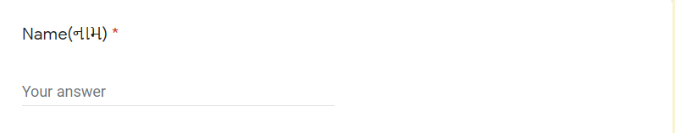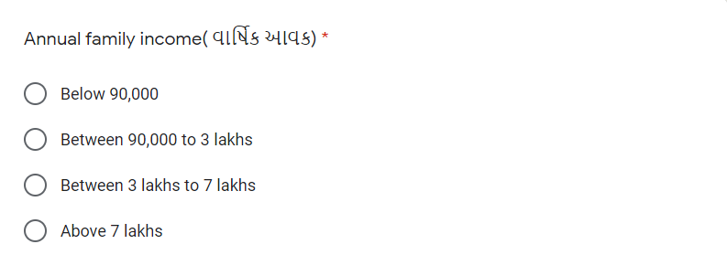QUESTIONNAIRE: 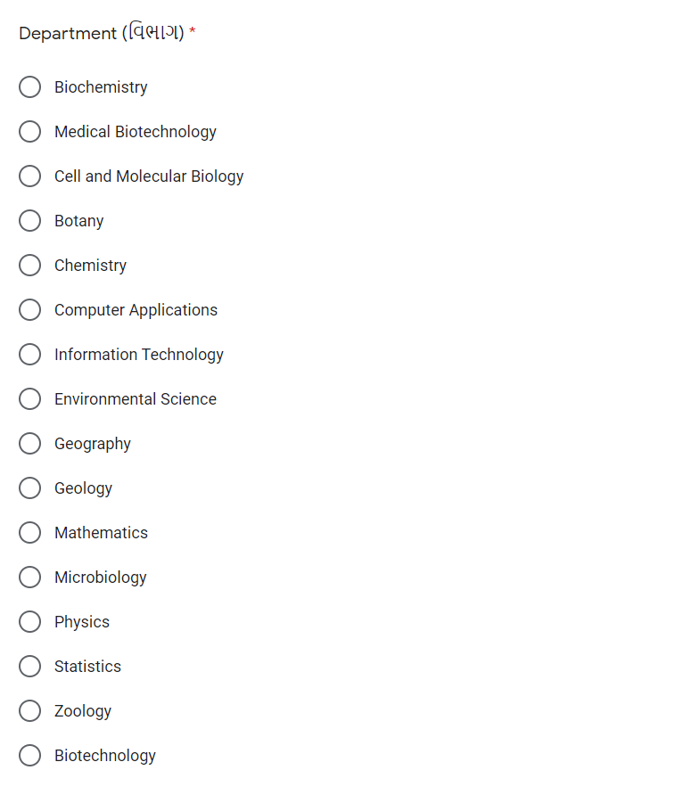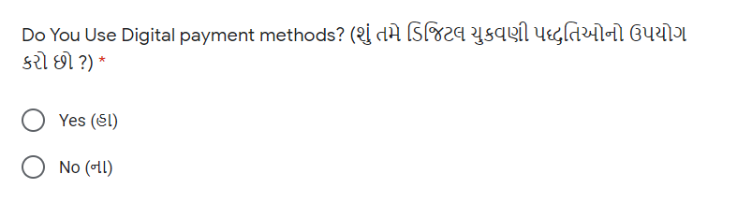

**SECTION 2**

**WHY NOT USING DIGITAL PAYMENT**

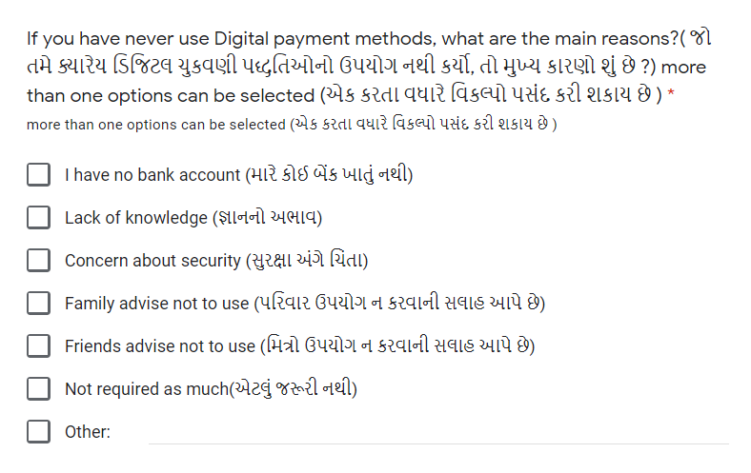

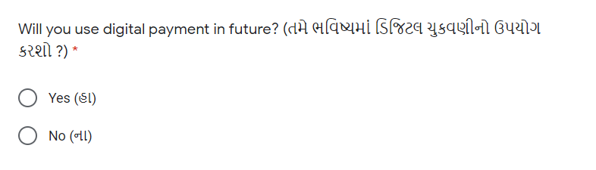

**SECTION 3**

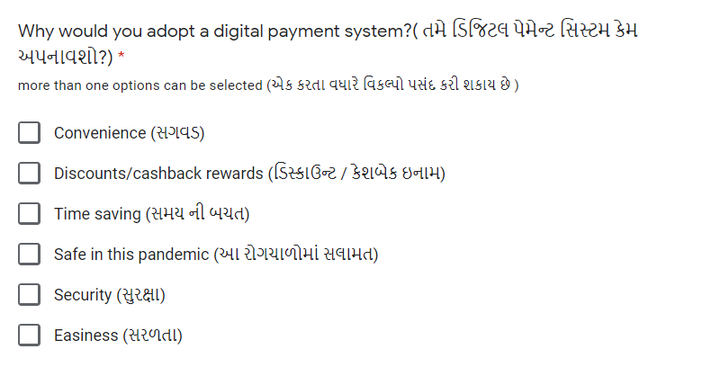**USING DIGITAL PAYMENT**

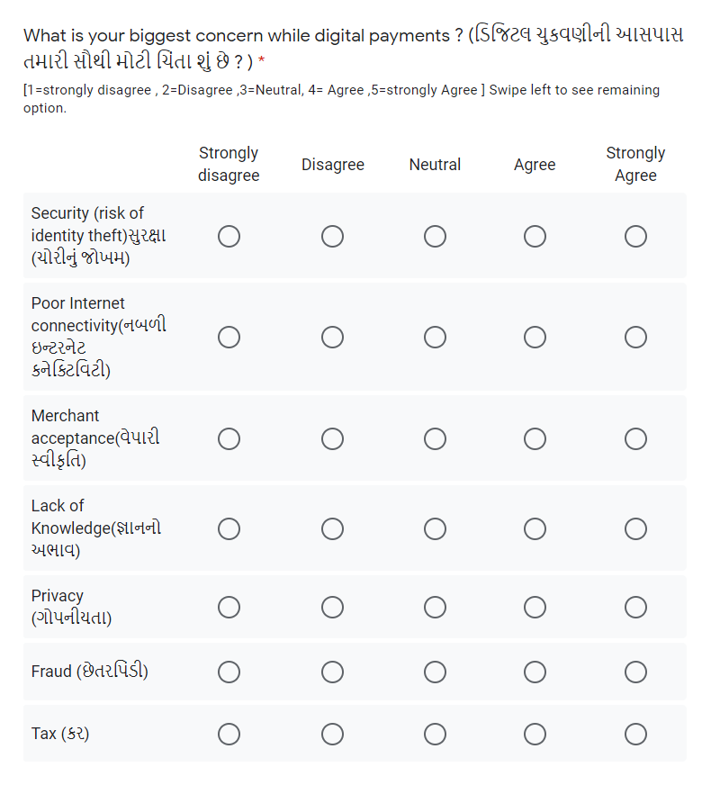

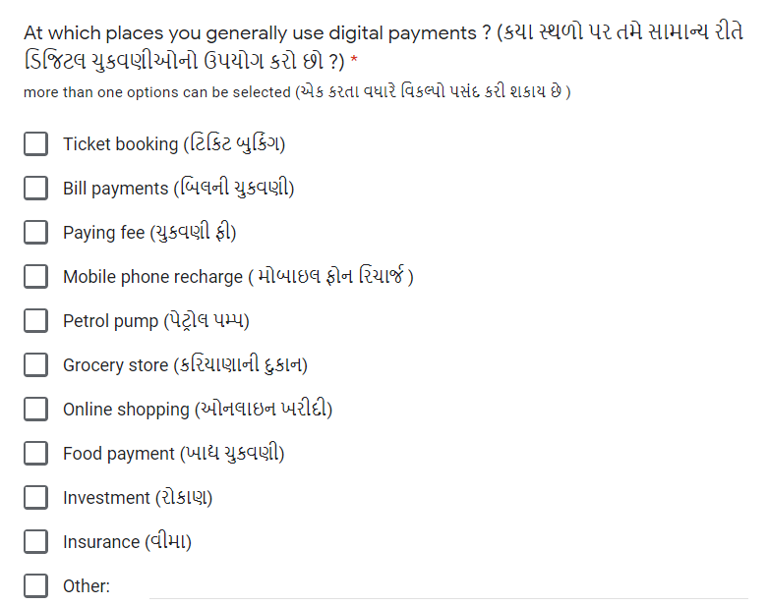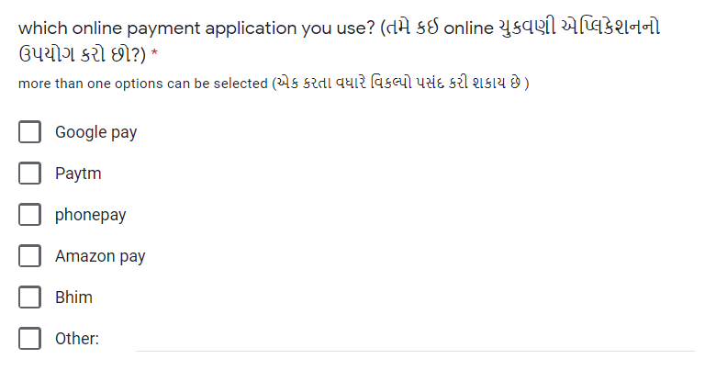

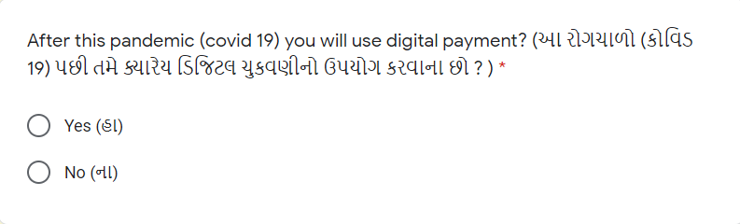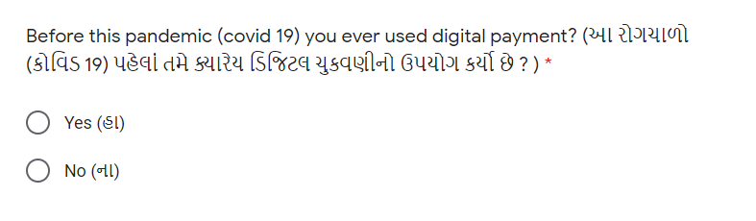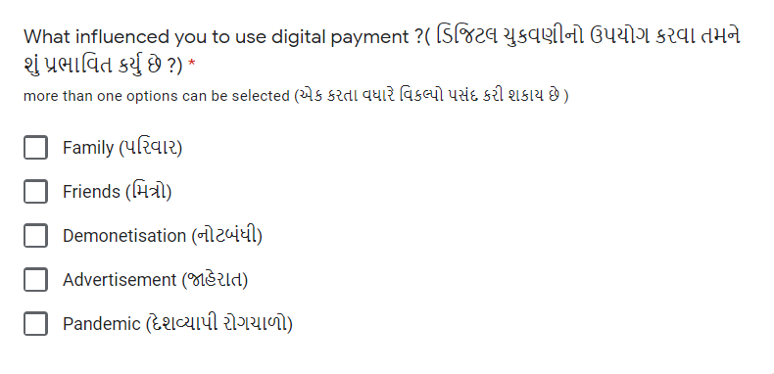

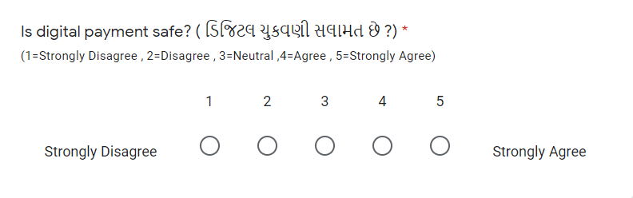**EXPERIENCE OF FACING FRAUD**

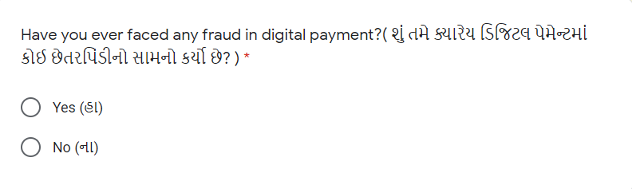

**References:**

* Adeoti, O. & Osotimehin, K. (2012). Adoption of Point of Sale Terminals in Nigeria: Assessment of Consumers' Level of Satisfaction. Research Journal of Finance and Accounting.
* Adeoti, O.,O., Osotimehin, O.,K. and Olajide, (2012) “Consumer Payment Pattern and Motivational Factors using Debit Card in Nigeria”, International Business Management.
* Roy, S., & Sinha, I. (2014). Determinants of Customers’ Acceptance of Electronic Payment System in Indian Banking Sector–A Study. International Journal of Scientific and Engineering Research, 5(1), 177- 187.
* Bezhovski, Z. (2016). “The Future of the Mobile Payment as Electronic Payment System” ,European Journal of Business and Management.
* Singh., S. (2017). “Study on consumer perception of Digital Payment mode”,Journal ofInternet Banking and Commerce”, 22(3), December.
* <https://www.researchgate.net/publication/336835369_An_Overview_On_Digital_Payments>
* <https://www.met.edu/uploadfile/documents/Ms_Shreya_Jain_eMBA_student.pdf>
* <https://www.ijcrt.org/papers/IJCRT2102051.pdf>
* <http://programmer2programmer.net/tips/smu/smu_project_description.aspx?id=472&course=MBA&type=Finance>
* <https://www.researchgate.net/publication/34251733_Electronic_payment_systems_a_user-centered_perspective_and_interaction_design>
* <https://www.researchgate.net/publication/318076004_A_Survey_on_E-Payment_Systems_Elements_Adoption_Architecture_Challenges_and_Security_Concepts>
* <https://www.icommercecentral.com/open-access/study-of-consumer-perception-of-digital-payment-mode.php?aid=86419#:~:text=The%20consumer%20perception%20of%20digital,on%20adoption%20of%20digital%20payment.&text=ANOVA%20indicate%20that%20there%20is,annual%20income%20of%20the%20patients>
* <https://www.jstor.org/stable/2981454?seq=1#metadata_info_tab_contents>
* <https://forms.gle/XrJyERFpsDYECLRT6>
* <https://www.statisticshowto.com/sampling-frame/>
* <https://www.researchgate.net/publication/318484701_Public_Perception_on_Cashless_Transactions_in_India>
* <https://www.ncbi.nlm.nih.gov/pmc/articles/PMC7784624/>