Disha Patel

DPATE157@mail.d2l.depaul.edu

Abstract

***Intent of this document is to show the progression and build out of the content that we will “own” as course develops. Hope is that it provides a framework to help with the homework but this is not the only way to do it.***

ASSET mANAGEMENT sYSTEM

Manage Your Asset Efficiently

Contents

Overview 2

Updates 2

1. High Level Requirements 3

1.1 Use Case Diagram 3

1.2 High Level Analysis 4

2. Persistence 5

2.1 Table layout 5

2.2 Discussion of how your design met the requirements 5

3. User Interface (UI) 6

3.1 Sample UI 6

3.2 Discussion of how your design met the requirements 6

Appendix A. Team Issue Resolution Agreement 7

B. Milestone Contribution Summary 8

B.1 Milestone 1 8

B.2 Milestone 2 8

B.3 Milestone 3 8

B.4 Milestone 4 8

B.5 Final Submission 8

C. Milestone Screen Shots 9

C.1 Milestone 2 9

C.2 Milestone 3 9

C.3 Milestone 4 9

C.4 Final Submission 9

## Overview

The project being developed during 2018-2019 Spring quarter will be the Asset Management System.

Team members working on this project are Disha Patel, Ravi Sharma, Ryan Nielson and Abhinav Kumar.

Team Name - Decepticons

Location of the source code: <https://github.com/rsharm18/AssetManagement_Decepticons/>

## Updates

This shows what was updated when

|  |  |
| --- | --- |
| 04/08 | Created initial draft |
|  |  |
|  |  |

## High Level Requirements

The purpose of asset management system is to ensures a company's assets are used in the most efficient manner, enhancing its profitability. It provides details on asset profiling and documentation, cataloging, provisioning, collection, and depreciation, for assets including hardware, software, furniture and telephony. This system also streamlines the asset request process with approval routing. Monitoring assets will reduce unauthorized use or misappropriation and ensure employees leaving a firm return assets under their control. The major benefit from Asset Management system is it can help companies achieve the greatest benefit at the lowest cost while maximizing an asset's lifespan.

### Use Case Diagram

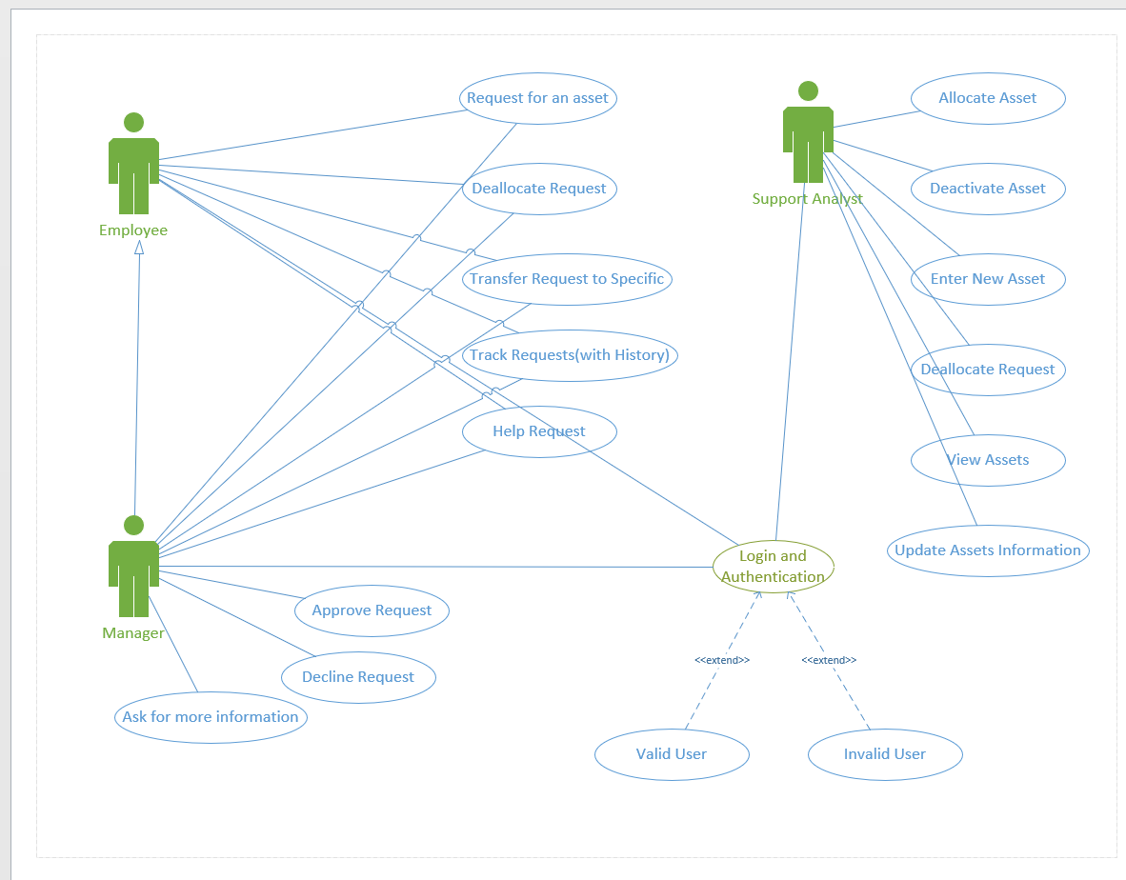

### 1.2 High Level Analysis

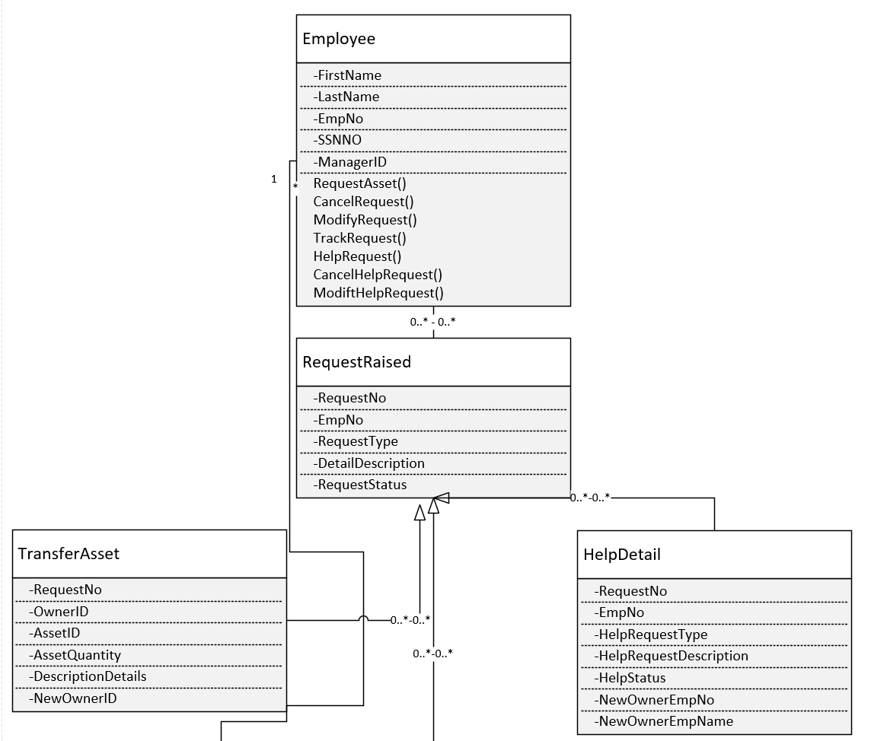

(conti.)

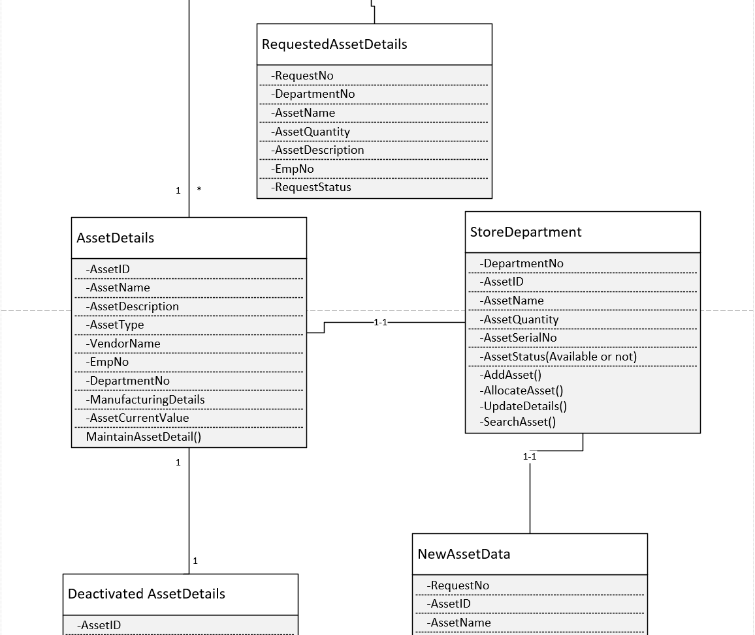 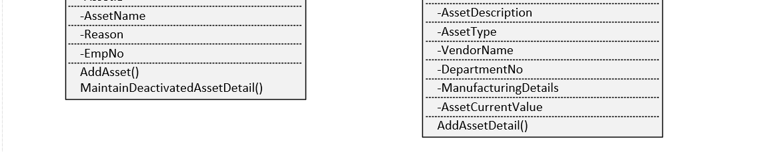

## 2. Persistence

### 2.1 Table layout

### 2.2 Discussion of how your design met the requirements

## 3. User Interface (UI)

### 3.1 Sample UI

### 3.2 Discussion of how your design met the requirements

## Appendix A. Team Issue Resolution Agreement

Issues will be tracked in GitHub and using conference call or Slack, we all (Disha Patel, Sharma, Ravi Kumar, Ryan Nielson and Abhinav Kumar) will resolve any issues that come up during this quarter.

Last but not least, we will consult with Mr. Yu.

Disha Patel

Ravi Sharma

Ryan Nielson

Abhinav Kumar

## Appendix B. Milestone Contribution Summary

### B.1 Milestone 1

|  |  |
| --- | --- |
| **Name** | **What was contributed** |
| Disha Patel | Initial Documentation |
| Ravi Sharma | Created Repository, Discussion on Group Name and Project Ideas |
| Ryan Nielson | Discussion on Group Name and Project Ideas |
| Abhinav Kumar | Discussion on Group Name and Project Ideas |

#### Retrospective (What went well and what did not)

### B.2 Milestone 2

|  |  |
| --- | --- |
| **Name** | **What was contributed** |
| Disha Patel |  |
| Ravi Sharma |  |
| Ryan Nielson |  |
| Abhinav Kumar |  |

#### Retrospective (What went well and what did not)

### B.3 Milestone 3

|  |  |
| --- | --- |
| **Name** | **What was contributed** |
| Disha Patel |  |
| Ravi Sharma |  |
| Ryan Nielson |  |
| Abhinav Kumar |  |

#### Retrospective (What went well and what did not)

### B.4 Milestone 4

|  |  |
| --- | --- |
| **Name** | **What was contributed** |
| Disha Patel |  |
| Ravi Sharma |  |
| Ryan Nielson |  |
| Abhinav Kumar |  |

#### Retrospective (What went well and what did not)

### B.5 Final Submission

|  |  |
| --- | --- |
|  |  |
|  |  |
|  |  |
|  |  |

## Appendix C. Milestone Screen Shots

### C.1 Milestone 2

(a) Screen shot of clean compile

(b) Screen shot of application running

### C.2 Milestone 3

(a) Screen shot of clean compile

(b) Screen shot of application running

### C.3 Milestone 4

(a) Screen shot of clean compile

(b) Screen shot of application running

### C.4 Final Submission

(a) Screen shot of clean compile

(b) Screen shot of application running