Looking a little wider
This won’t be long, but a little text before and after gives best idea how result will work out.

For broader contexts, broader content
So here we have the intent, a picture:
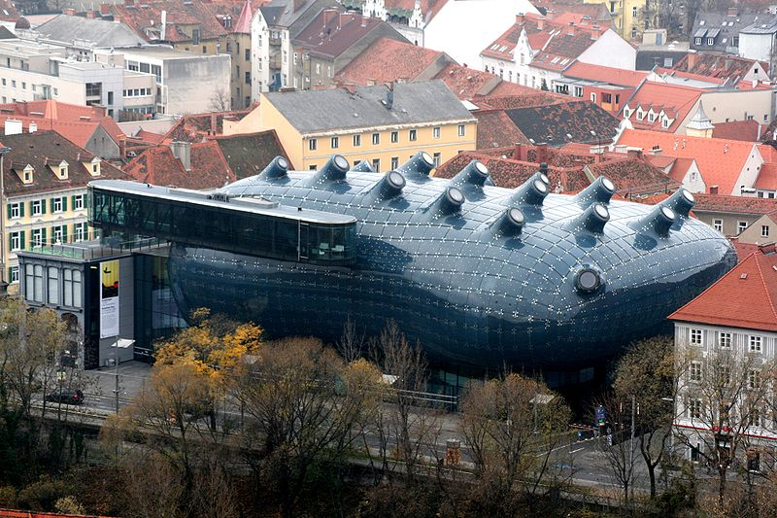
Fig. 1 Graz Kunsthaus
It’s an unusual building among the traditional, in Austria.

What else it can do
Other views showing this ‘whale’ lighting up with moving images at night are pretty entertaining. So let’s see what we’re going to get from pandoc, ‘out of the box.

