Sample 3: image looking a little wider

That is, if you’ve got a wide enough display window…

This won’t be long, but a little text before and after gives best idea how result will work out.

## For broader contexts, broader content

So here we have the intent, a picture:

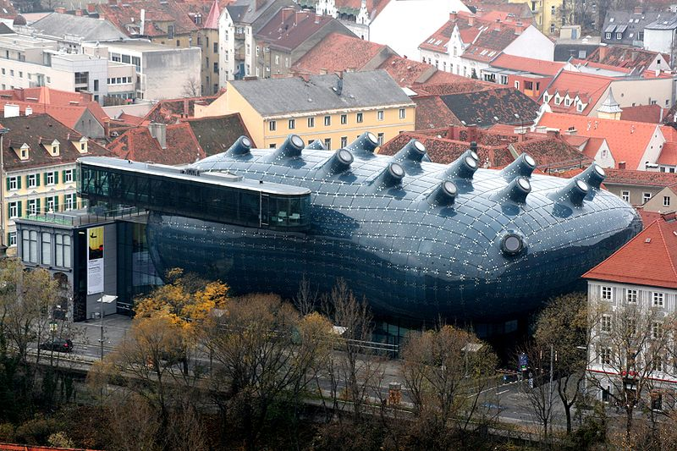

Fig. 1 Graz Kunsthaus

It’s an unusual building among the traditional, in Austria.

## What else it can do

Other views showing this ‘whale’ lighting up with moving images at night are pretty entertaining. So let’s see what we’re going to get from pandoc, ‘out of the box.