**INTRODUCTION**

**EM18** is an RFID reader which is used to read RFID tags of frequency 125 kHz.

After reading tags, it transmits unique ID serially to the PC or microcontroller using UART communication or Wiegand format on respective pins.

EM18 RFID reader reads the data from RFID tags which contains stored ID which is of 12 bytes.

EM18 RFID reader doesn’t require line-of-sight. Also, it has an identification range which is short i.e., in a few centimeters.

The RFID System consist of 2 main parts.

1. **RFID Tag:**

RFID tag includes microchip with radio antenna mounted on substrate which carries 12 Byte unique Identification number.

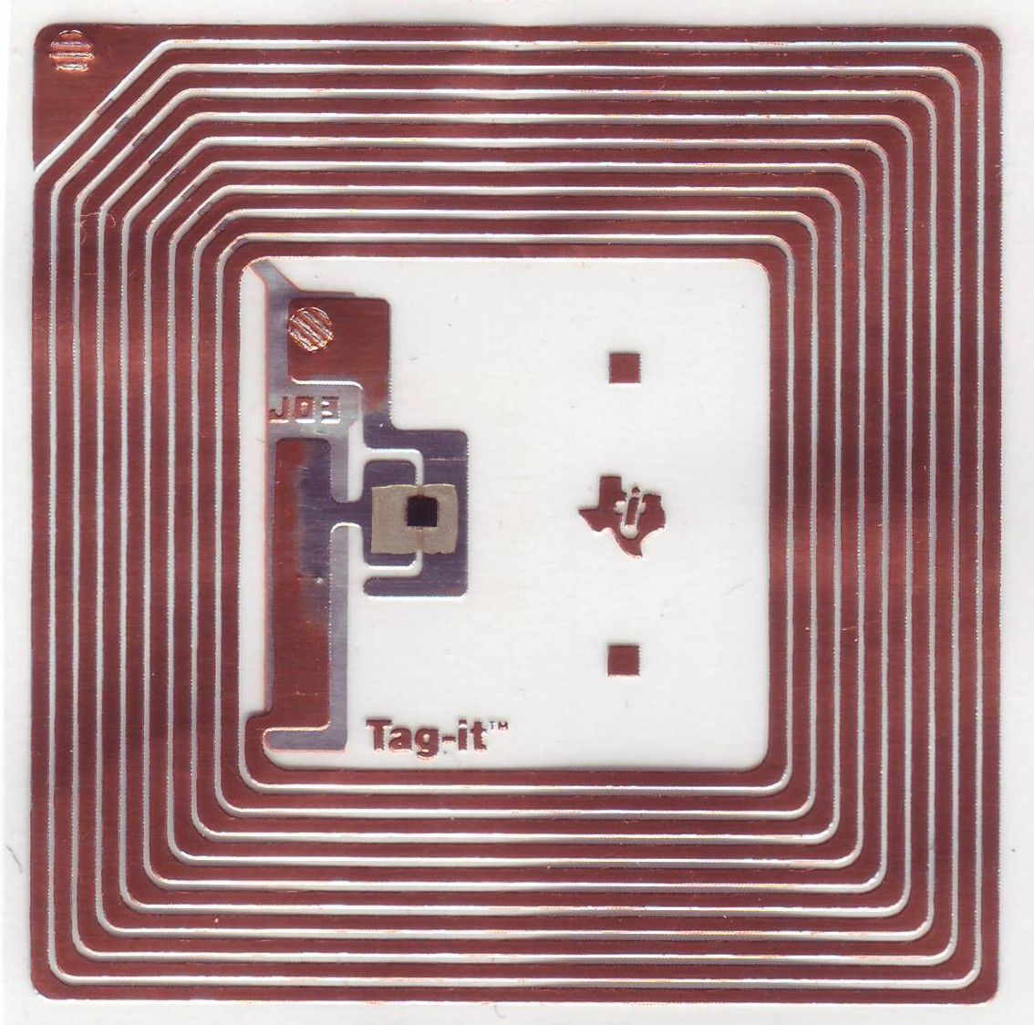

RFID Tag Inside

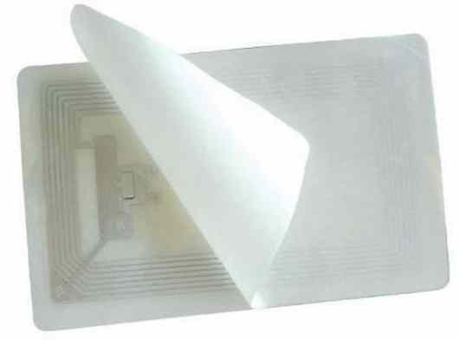

RFID Tag

2.  **RFID Reader:**

It is used to read unique ID from RFID tags. Whenever RFID tags comes in range, RFID reader reads its unique ID and transmits it serially to the microcontroller or PC. RFID reader has a transceiver and an antenna mounted on it. It is mostly fixed in stationary position.

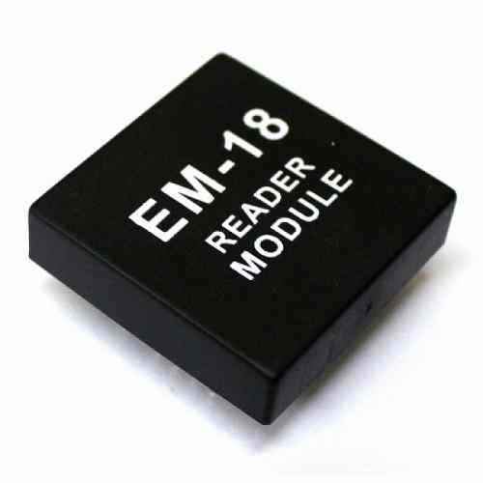

EM18 RFID Chip

Basically, RFID systems are categorized as active and passive based on how they are powered and their range.

**1.      Active RFID system**

Active RFID tags have their own transmitter and power source (Mostly battery operated). They operate at 455 MHz, 2.45 GHz, or 5.8 GHz, and they typically have a read range of 60 feet to 300 feet (20 meters to 100 meters).

**2.      Passive RFID system**

Passive RFID tags do not have a transmitter, they simply reflect energy (radio waves) coming back from the RFID reader antenna. They operate in Low frequency (~125 kHz) as well as High frequency (~13 MHz) band and have limited read range of up to ~1m.

There are two modes of coupling for communication used in RFID as,

**Inductive coupling,** in which RFID reader emits magnetic field and whenever RFID tags enters the magnetic field which creates energy response from RFID tags and is detected by RFID reader. As the magnetic field drops sharply with distance, it is used for short distance applications.

**Capacitive coupling,** where reader emits electromagnetic waves and whenever that wave encounters RFID tags, RFID tag reflects signal containing information of ID.

# **How RFID system works?**

RFID Reader has transceiver which generates a radio signal and transmits it through antenna. This signal itself is in the form of energy which is used to activate and power the tag.

When RFID tag comes in range of signal transmitted by the reader, transponder in the tag is hit by this signal. A tag draws power from the electromagnetic field created by the reader. Then, the transponder converts that radio signal into usable power. After getting power, the transponder sends all the information it has stored in it, such as unique ID to the RFID reader in the form of RF signal. Then, the RFID reader puts this unique ID data in the form of byte on serial Tx (transmit) pin. This data can be used or accessed by PC or microcontroller serially using UART communication.

There are various RFID readers available according to their frequency are shown as follows,

|  |  |  |  |
| --- | --- | --- | --- |
| **Frequency** | **Range** | **Different modules** | **Applications** |
| 120-150 kHz | 5-20 cm | EM-18, ILA-12, etc. | Factory data collection, identifying animals etc. |
| 13.56 MHz | 10 cm – 1m | MFRC522, SM130 | Smart cards |

**How to Use EM-18 RFID Module**

**EM-18** is used like any other sensor module. First, we choose the mode of communication between MODULE and CONTROLLER. Next, we will program the controller to receive data from module to display. Next power the system. When a tag is brought near the MODULE it reads the ID and sends the information to controller. The controller receives the information and performs action programmed by us.

**Step1:** Establishing a mode of communication. EM-18 can provide output through two communication interfaces. One is RS232 and another is WEIGAND. The form of communication is selected by SEL pin. If the SEL pin is selected HIGH, then form of communication is RS232 and if SEL pin is pulled LOW then form of communication is WEIGAND. Usually, the RS232 is selected because it’s popular, so the SEL pin is pulled HIGH.

**Step2:** The output of MODULE bit rate is 9600bps (bit per second). The controller should be programmed to receive information from MODULE at this rate. If bit rate of controller mismatches, then the system will not work correctly.

Now let us consider a **simple EM-18 circuit diagram**,

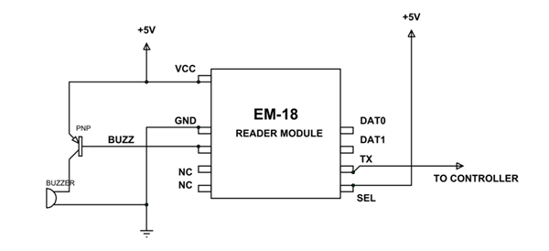

In the circuit BUZZER is not compulsory. When a TAG is read the BUZZER turns ON. As given in circuit, TX is given to CONTROLLER which is to receive DATA.

Consider a TAG is brought near the MODULE. The MODULE reads the ID and sends the information to the controller in 12 ASCII CHARACTERS. In them, 10CHARACTERS represent the TAG ID and 2 CHARACTERS are XOR of previous 10 CHARACTERS.

So, DATA sent = 10ASCII DATA (tag no.) + 2ASCII DATA (XOR result)

Once the Information is sent, the MODULES stop sending DATA. This serial DATA received by the controller though RX pin contains TAG information which is ready for processing. We can program the controller to save the DATA or process it to provide a response immediately.

### 

### EM-18 Pin Configuration

EM-18 is a nine-pin device. Among nine pins, 2 pins are not connected, so we basically must consider seven terminals.

|  |  |
| --- | --- |
| **Pin Number** | **Description** |
| VCC | Should be connected to positive of power source. |
| GND | Should be connected to ground. |
| BUZZ | Should be connected to BUZZER |
| NC | No Connection |
| NC | No Connection |
| SEL | SEL=1 then o/p =RS232  SEL=0then o/p=WEIGAND |
| TX | DATA is given out through TX of RS232 |
| DATA1 | WEIGAND interface DATA HIGH pin |
| DATA0 | WEIGAND interface DATA LOW pin |

# **RFID reader EM-18 features:**

1.      Serial RS232/TTL/UART output

2.      Operating Frequency is 125KHz.

3.      Range is 5-8 cm.

# **Specification of RFID EM-18**

* Operating frequency: 125kHz
* Operating voltage: DC 5V
* Supply current: < 50mA
* Read distance: up to 100mm (depending on the tag used)
* Interface: UART (TTL level)
* Dimensions: 40mm x 40mm x 16mm
* Communication protocol: UART
* Baud rate: 9600, 8, N, 1

Alternate options for RFID EM18

* RFID RC522
* RFID RC531
* RFID RC632
* RFID RDM6300

**RFID Reader to PC/Laptop communication**

We can see RFID reader output on serial terminal of PC/Laptop.

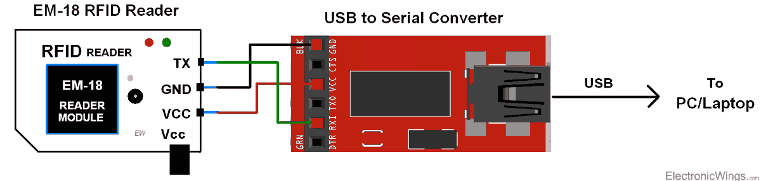

RFID Serial Interface

When we bring RFID tag near to the reader, it reads the data from the tag and immediately transmits 12-byte unique ID on the serial port.

**12 Byte Unique Identification Number**

**RFID**Tags contain 12 Byte unique ID.

|  |  |
| --- | --- |
| **1st 10-Byte Data** | **Last 2-Byte** |
| Tag no. | Checksum |

These checksum bytes will be the XOR result of 1st 10 bytes, i.e., Tag no.