Abstract:
The spike activity propagation in FFN is studied in presence of background activity of excitatory and inhibitory nature. It is found that the spike activity response increases sigmoidaly with incoming spike numbers. The response to variation in spike timings is linear.
FFN was modified to contain inhibitory neurons in all the layers and the ratio of excitation to inhibition was such varied to study the movement of fixed points across the state space. It is found that with decreasing E-I ratio the fixed points disappear similar to the behavior seen by decreasing the number of neurons per layer. The propagation is found to be completely noise driven and the affect on propagation by varying the kind of noise (excitatory/inhibitory ratio) applied was studied. It is found that by increasing the inhibition by noise the spread in spikes increased but for a certain amount of inhibition the spread decreased indicating a suitable window for integrating the incomming spike present. Further on gating of spike propagating activity, two parallel FFNs are made with a layer in common having neurons firing at different timescales to check propagation of two different spiking activities with cross-over.

Introduction:
A feed-forward network (FFN) is a simple network configuration which is used to address the spike activity propagation across layers of brain. Neurons form weak synapses but many with neurons across the group. A propagating pulse (spike activity) needs to attend certain amount of synchrony to elicit an action potential in the receiving neuron. The amount of synchronisation is depending on the firing rates of neuron and the membrane potential of the receiving neurons. The background activity present in the network facilitates in increasing the sensitivity of membrane potential to incomming pulse by lowering the firing threshold for the neuron. In the below figure the membrane potential average is at -62 mV with the firing threshold at -50 mV.
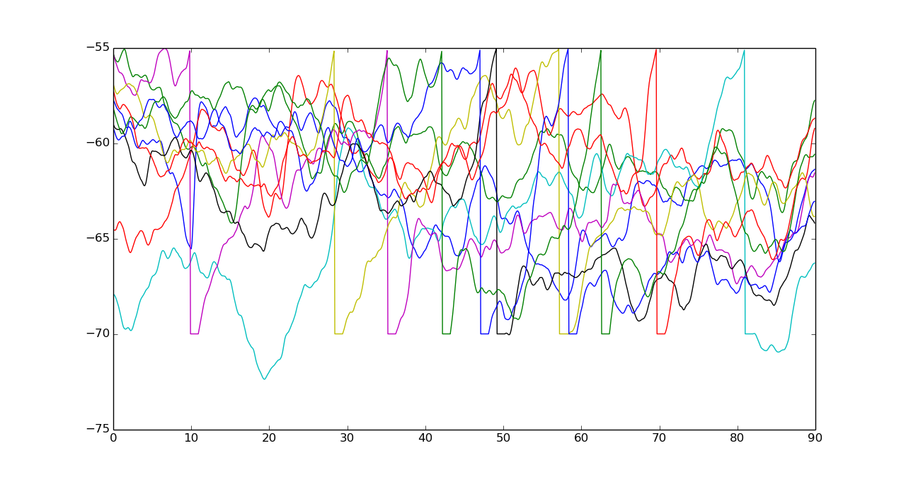
The synchronisation and the number of incomming spikes play an important role in determining the nature of propagation which can be either stable (i.e, synchronously propagating) or unstable (i.e, propagation with decreasing activity and synchrony). The number of neurons present in a layer or the neuron pool also determines the nature. For bigger neuron pool the activity is found to stable and is unstable when small. In the figures below are for w(neuron per group) 90,100 & 110.
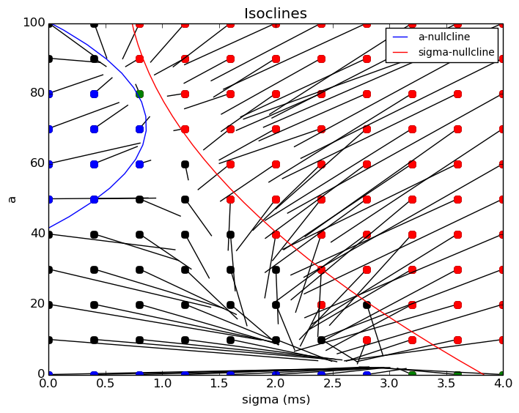
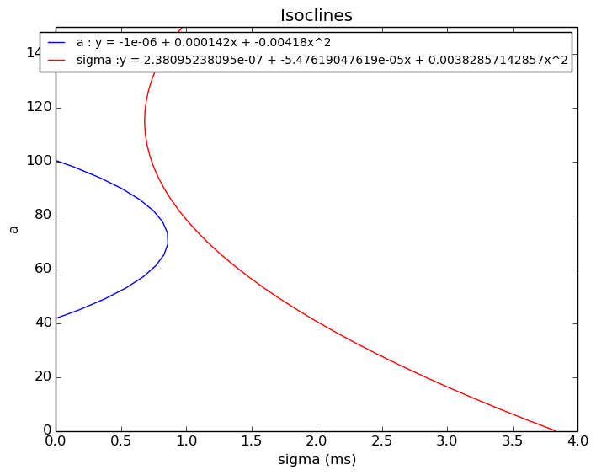

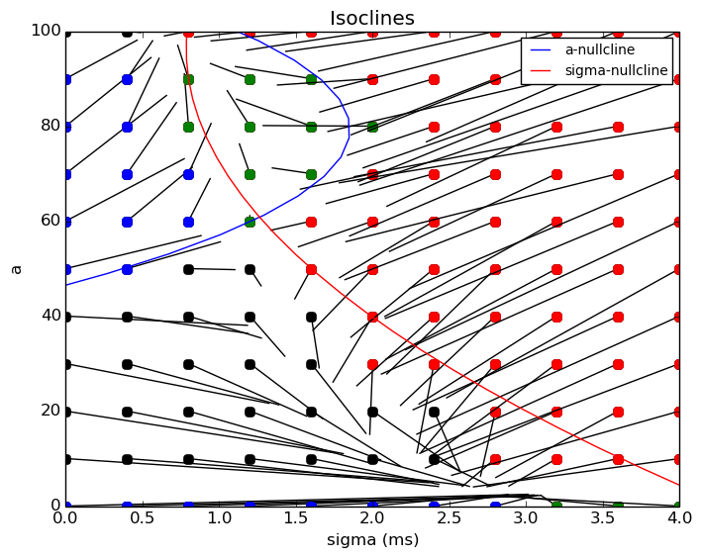
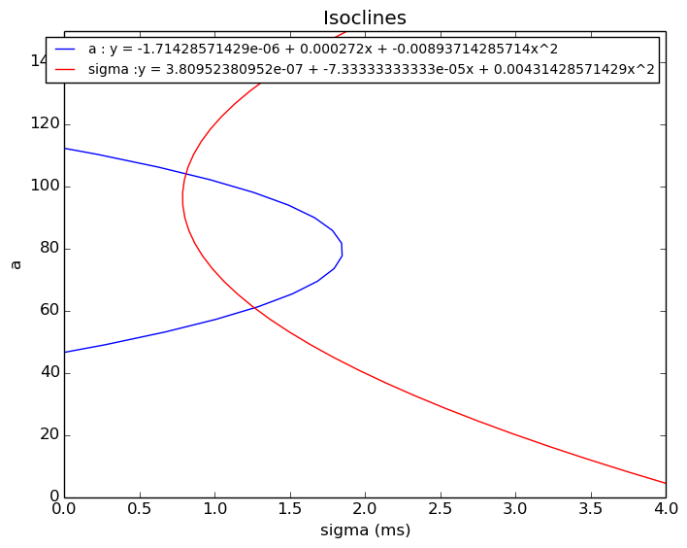

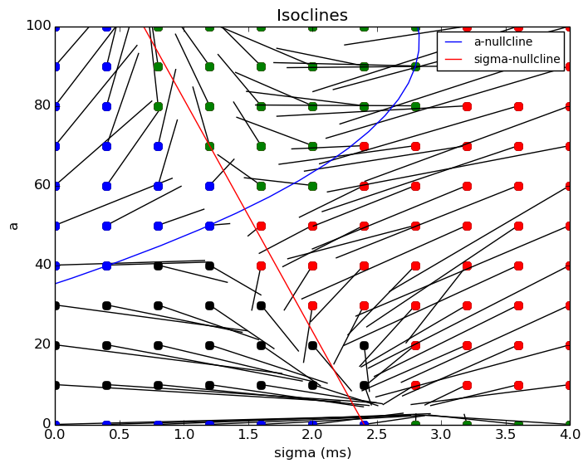
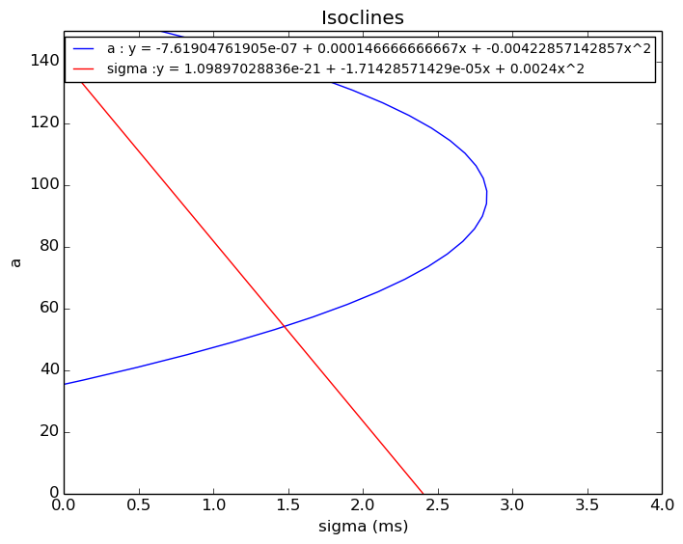

The size of neuron pool affects the spike response probability which is a sigmoid function of number of incomming spikes.
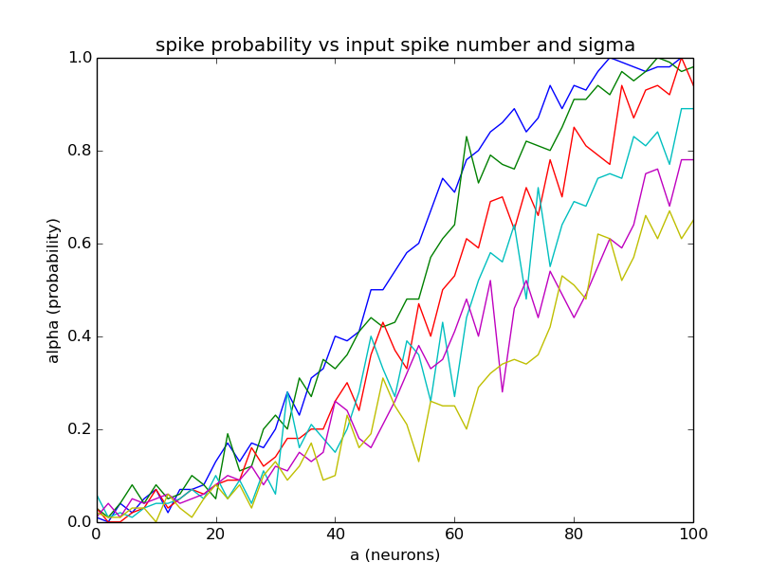

The presence or absence of synchrony in incomming spikes linearly affects the spike response probability as the window for integration of spikes gets affected.
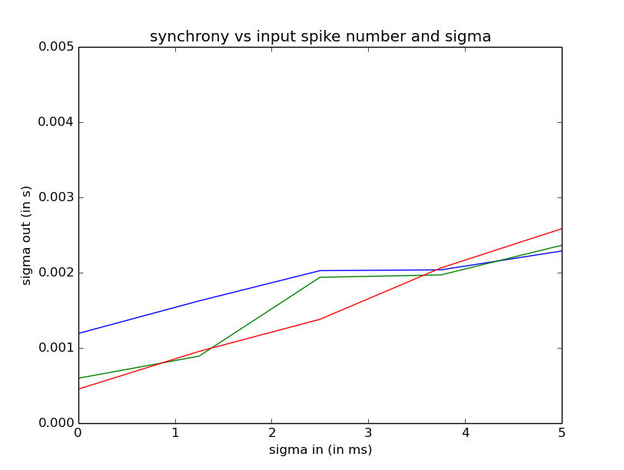

Cortex is found to contain both excitatory and inhibitory neurons roughly in ratio of 88:12. Earlier FFN created was of only excitatory nature and lacked inhibitory connections.

Without inhibition: w = 125, grid 30x30,
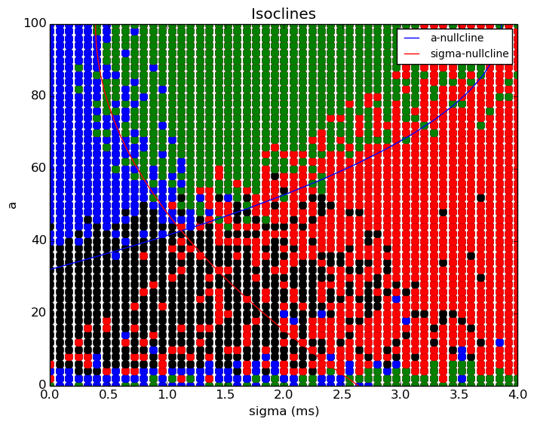
With Inhibition: w = 125, weight of inhibition = -69.4, grid 30x30,
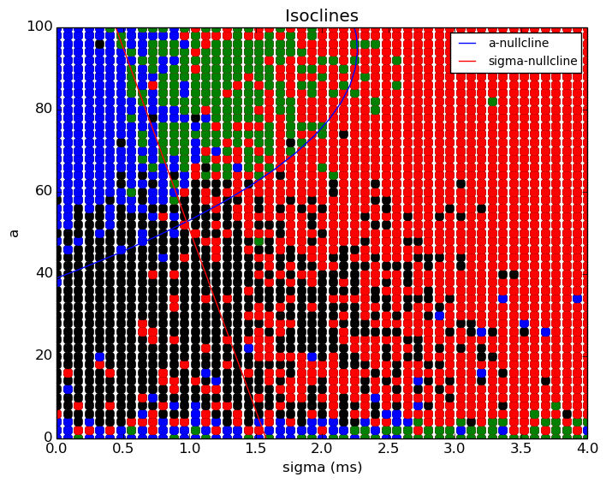

Inhibition in a network is found to determine a window of spike integration and hence is required to attain synchronisation. A new FFN was created containing both inhibitory and excitatory neurons differing only in the nature of synapses they formed. The excitatory and inhibitory neurons synapsed with all the neurons of the subsequent group. Parameters like the weight of inhibition & compostion (E-to-I ratio) were varied. Both the parameters affected the strength of inhibition. It is found that as the strength of inhibition was increased the fixed points started to disappear for a EI-FFN containing 125 neurons ( figures above). The disappearence of ixed point is similar to that observed by varying the number of present per group of an E-FFN.

Figure below is a 3D plot with positive X & Y axis being sigma and neuron number. Z-axis is the weight of inhibition
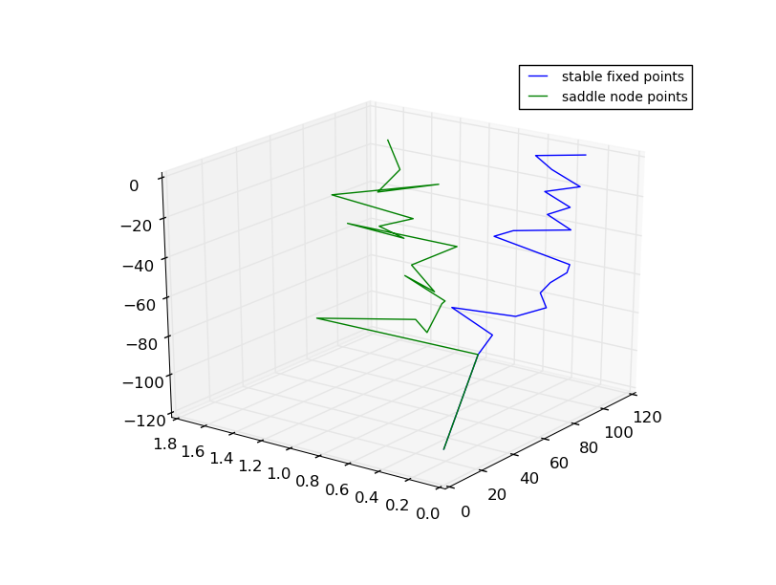

The timescale of inhibition and excitation were same hence the resultant effect was just a decrease in strength of excitation to the subsequent group. The speculation that inhibition in the FFN affected synchrony was ruled out.

The background activity was the key determinant of nature of propagation which affected the membrane potential of the neurons in the groups. Background activity comprised of 20000 synspses feeding to every neuron in the FFN with 88%% being excitatory and 12 inhibitory. The excitation by noise is delivered at 2 Hz and inhibition at 12.5 Hz. The 2 Hz excitation is constantly present due to the large number of excitatory noise neurons firing whereas inhibition comes in short time interval. This short time interval of incomming noisey inhibition in FFN defines the window of integration for spikes. It is found that as the frequency of inhibition was decreased the synchrony in spiking activity decreases.

Figure below are plots with positive Y & X axis being sigma and neuron number,

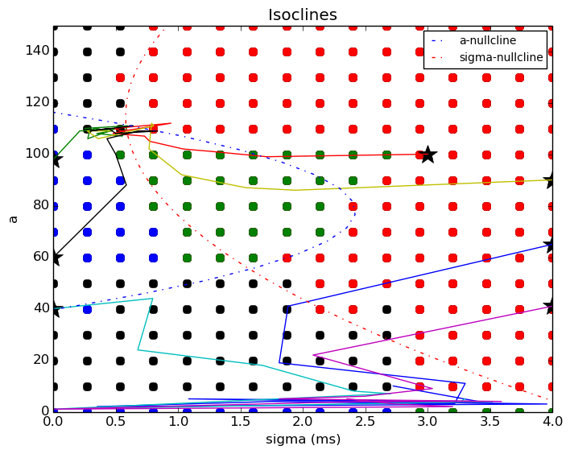
a. Wi = -34, w = 125, Inhibition rate = 2Hz,

b. Wi = -34, w = 125, Inhibition rate = 4.6Hz,
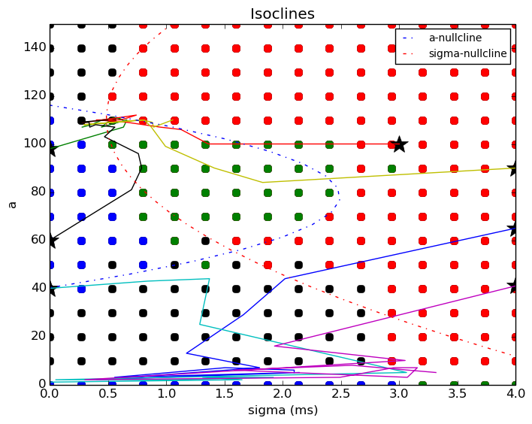

c. Wi = -34, w = 125, Inhibition rate = 19Hz,
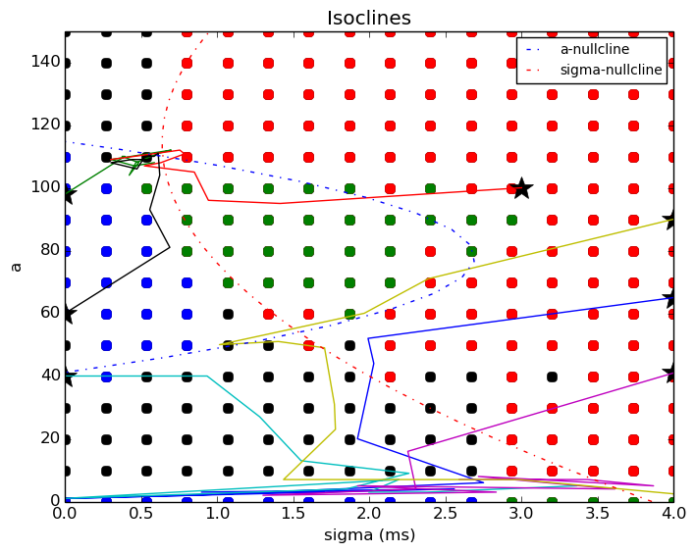

Figure below is a 3D plot with positive X & Y axis being neuron number & sigma. Z-axis is the rate of inhibition,
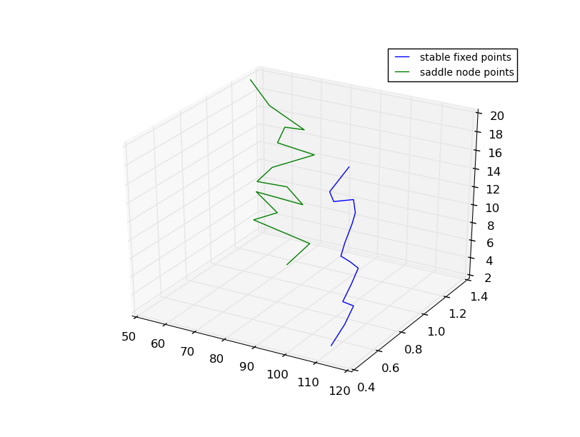

Another interesting discovery was that as the frequency of inhibtion was increased to very high number the synchrony attained in the spiking activity decreased due to the fact that the window of integration of spikes became extremely small.

To make EI-FFN more realistic probabilistic connections were made across subsequent groups.

a. Wi = -34, w = 125, Probability = 0.7,
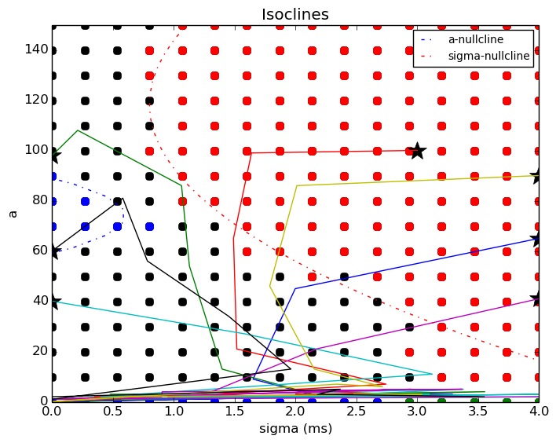

b. Wi = -34, w = 125, Probability = 0.89,
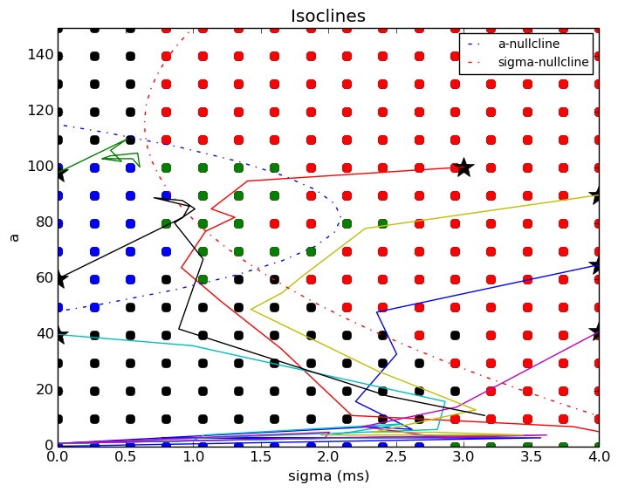

c. Wi = -34, w = 125, Probability = 0.97,
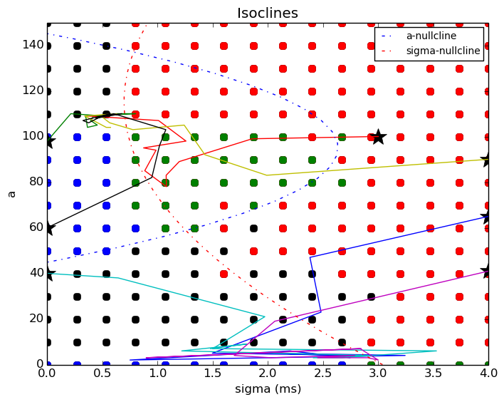

The balance of excitation and inhibition was studied in this network. Balance of excitation and inhibition (BEI) is a necessity for long distance propagation.

Figure below show movement of stable fixed point leftwards indicating a decrease in sigma as the proportion of inhibitory noise neuron is increased.

a. Wi = -34, w = 125, Proportion = 0.17,
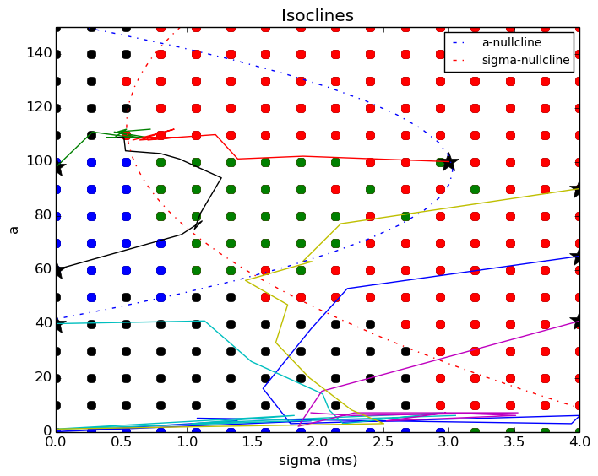

b. Wi = -34, w = 125, Proportion = 0.64,
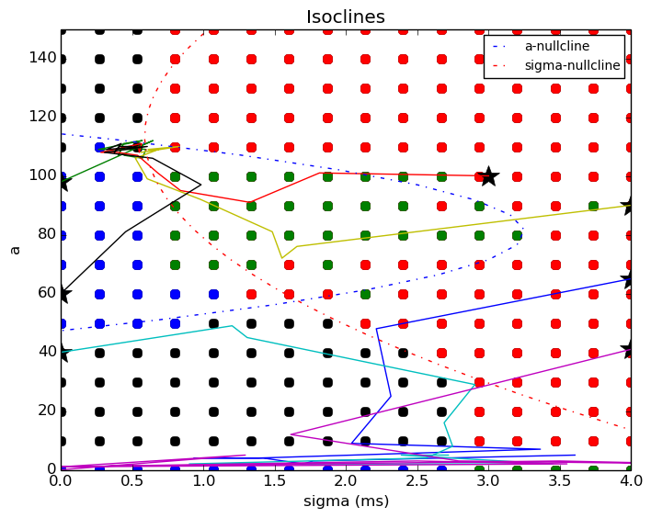

b. Wi = -34, w = 125, Proportion = 0.85,
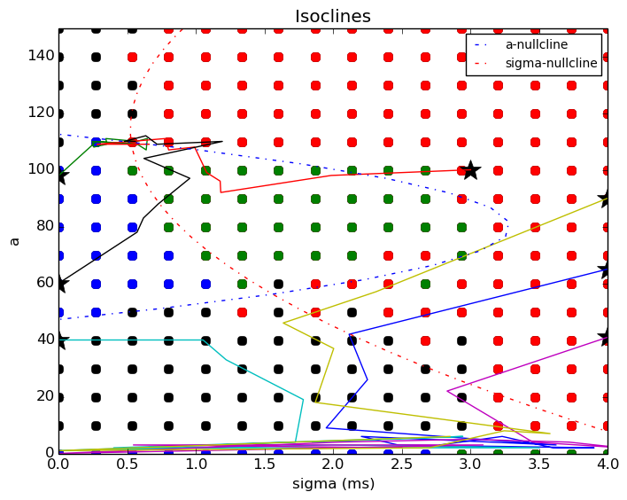

BEI is found to vary across areas of brain and affects the spatio-temporal aspect of spike activity. For E-I ratio in noise of 0.1-0.5 , the fixed points seaparated over temporal scale and became synchronized at 0.5 ms.

Figure below is a 3D plot with positive Y & X axis being neuron number & sigma. Z-axis is the proportion of noise inhibitory neuron to excitatory neuron,
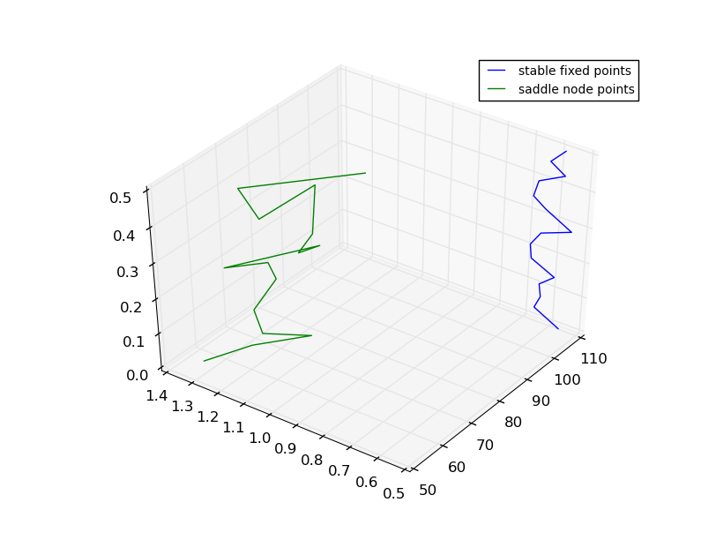

Whereas for higher E-I ratio the fixed points diverged on temporal scale.

Figure below is a 3D plot with positive Y & X axis being neuron number & sigma. Z-axis is the proportion of noise inhibitory neuron to excitatory neuron,

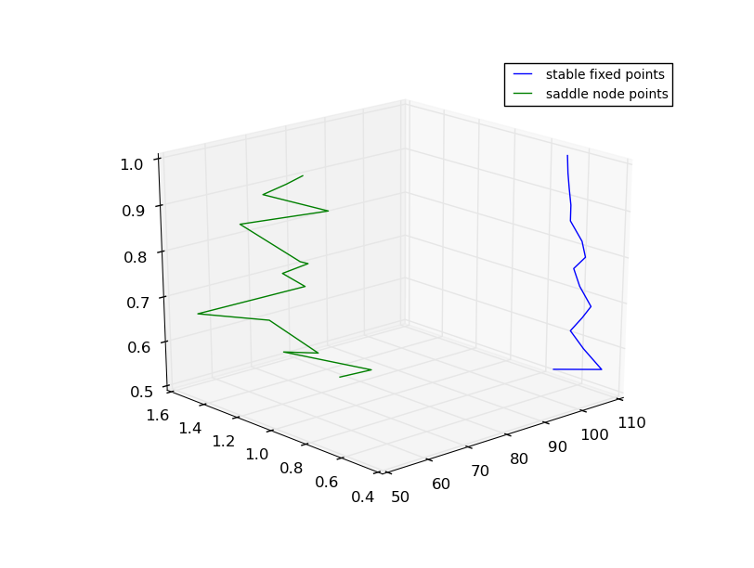
On increasing inhibition due to noise the window for integration becomes shorter which causes less number of spikes to synchronise even though the spike numbers are high.

Methods:
Used Python-brian code taken from Yale model DB with the following changes made:
- Connectivity
- Formulation of nullclines
- Coloring of the regimes of stable and unstable propagation
- Return the fixed points to study their variation with respect to changes in various parameters in a 3D plot

Future direction:
BEI plays a key role in routing of propagating pulses by having different timescales of response across FFNs. This is a key feature as multiple signalling pathways can crossover without affecting the propagation. Further this is being investigated by two EI-FFN with an overlap in use to study the nature of propagation of pulses applied separately to both the EI-FFNs. Each EI-FFN only differs in the respective firing frequencies of their neurons. The signal gets routed based on the fact when the frequency of inhibition matching up with that of the firing frequence of neurons.

