**INNOVATION CONTEST 2019**

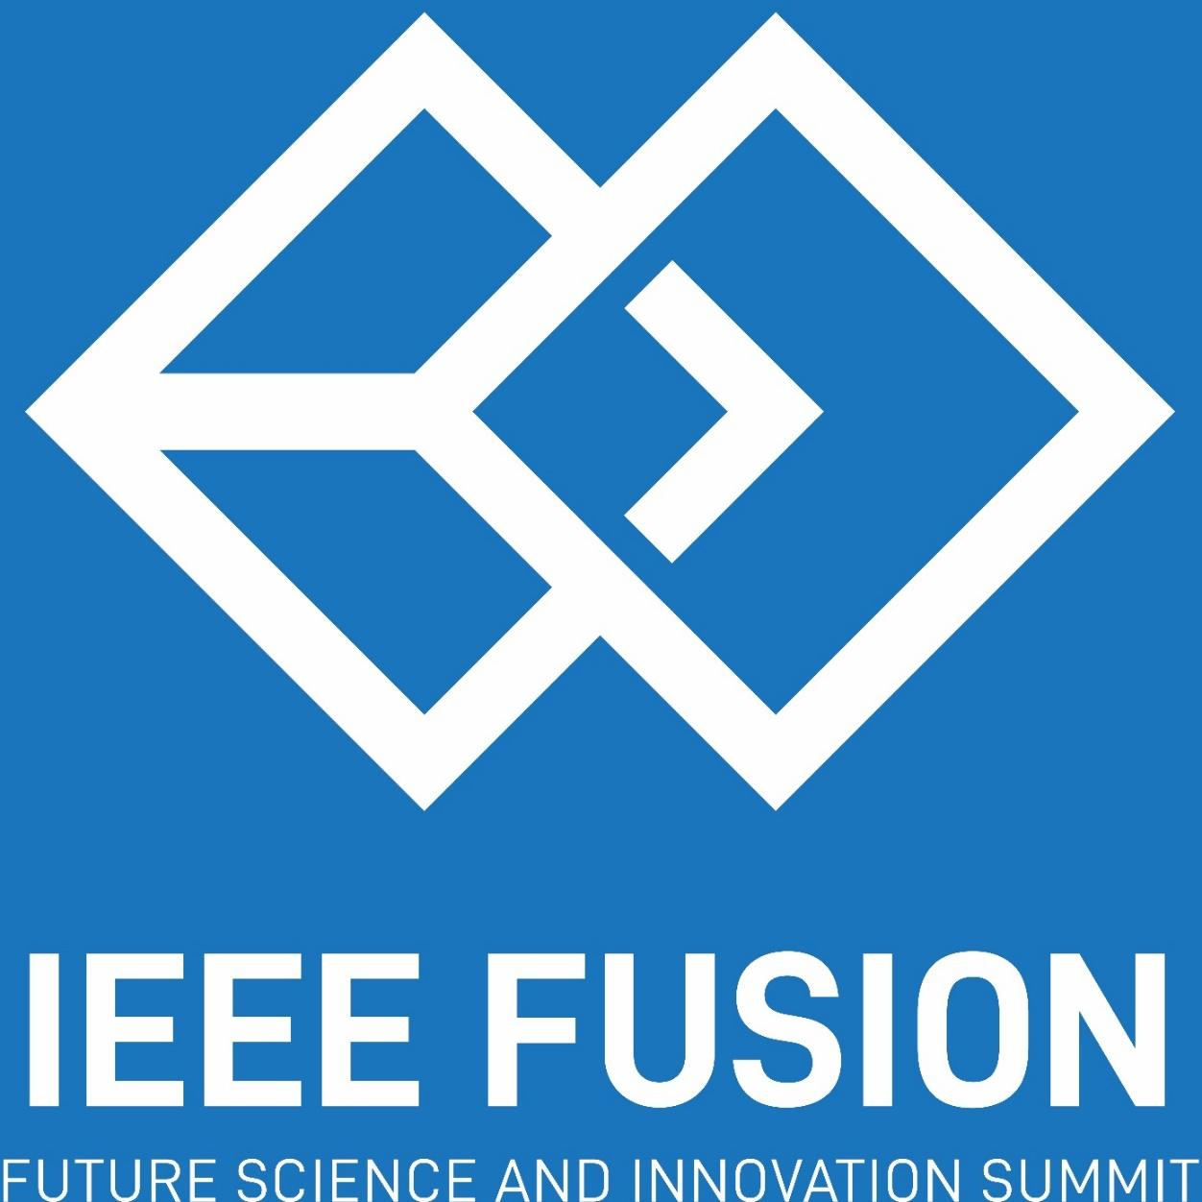

**IEEE ITB SB**

**2019**

**A. Description & Purpose**

Innovation Contest is a competition held by IEEE ITB Student Branch to find the best innovation among participants from all around Asia. Innovation must be a real invention that can be directly implemented in the form of prototypes, systems, products, or platforms. Participants should make their creation according to the themes and subthemes specified.

Any undergraduate from Asia may join IEEE Fusion 2019 Innovation Contest. The purpose of this event is to improve the students’ ability to make an up-to-date innovation. Furthermore, this competition can train students to make scientific paper and to present their work to people.

1. **Theme**

*“Technology for Humanity”*

Technology is developing rapidly and this is almost unstoppable. Technology development is undeniable due to human needs. Human nature that is never satisfied causes the birth of new technology to solve problems that arise. Indirectly the development of true technology for human life.

**Subtheme :**

1. *Renewable Energy*

Innovation is a form of a process, system or prototype in refining renewable resources (sunlight, wind, rain, tides, waves, biomass, plantation, geothermal heat, etc).

1. *Financial Technology*

Develop new technology and innovation that aims to compete with traditional financial methods in the delivery of financial services.

1. *Social Technology*

Build a way using human, intellectual and digital resources in order to influence social processes via social software or social hardware.

1. *Health Technology*

make a health technology application of organized knowledge and skills in the form of devices, procedures and systems developed to solve a health problem and improve the quality of lives.

1. *Eco-Friendly Technology*

build Eco-friendly technology help preserve the environment through energy efficiency and reduction of harmful waste.

1. **Venue and Date**
   1. **Technical Meeting**
2. Venue

Multimedia Room

1. Date
   * + - Thursday, October 11st, 2019
2. Time

07.30 PM until end (GMT + 7)

* 1. **Final**

1. Venue

Bandung Institute Of Technology

1. Date

Friday, October 12nd, 2019

1. Time
   1. AM until end (GMT + 7**)**
2. **General Rules**
3. All participants must still be an undergraduate student of their university until October 2019.
4. Participants are in a team, consists of 3 members that are from the same university, 1 of the members should be the team leader.
5. Every participant is only allowed to be on one team.
6. The team is not participating in another competition in IEEE Fusion 2019.
7. Each campus may send more than 1 representatives.
8. Each team may only send one paper
9. Participants’ work must be based on the given theme.
10. Participants’ work does not contain any elements of plagiarism.
11. All submission of the full paper and final presentation materials should be typed, submitted, and presented in formal English.
12. Top 10 teams will advance to the final round
13. Finalists are required to bring their works to be presented to the judges
14. The committee may share any information related to participants’ work.
15. The decision of the judges and the committee cannot be contested.
16. Every participant who violates the rules will be disqualified.
17. Any information changes will be notified through the IEEE ITB SB website and official account, also participants’ email.

**E. Registration**

1. Participants must create a team account on our website.

Registration will be conducted in IEEE ITB SB 2019 website at

http://www.ieee-itb-sb.com

on May 20th, 2019 until, August 31st, 2019 at 23.59 (GMT + 7).

1. Participants must complete the registration payment and should wait for confirmation from the competition committee.

Registration date from:

* May 20th, 2019 to July 15th, 2019 (First wave) 12 USD per team
* July 15st, 2019 to August 31st, 2019 (Second wave) 16 USD per team

Fees have to be paid to (Via paypal)

Paypal Email : **ieee.sbitb@gmail.com**

**F. Competition Format**

**1. Full Paper Submission**

a. Full paper submission will be held :

* May 20th, 2019 to July 15th, 2019 (First wave)
* July 15st, 2019 to August 31st, 2019 (Second wave)

The submission of Full Paper along with the proof of payment must be uploaded before July 15th, 2019 at 23.59 (GMT + 7) for the **first wave** and before August 31st, 2019 at 23.59 (GMT + 7) for the **second wave** to IEEE ITB SB Website.

1. Participants must submit the paper soft file to the website with format:

**IEEEITBSB2019_InnovationContest_Preliminary_(Team Name).pdf**

then submit to our website using the team account. After submitting your paper, please verify immediately to our contact person.

**2. Final**

1. Final round team announcement will be on September 21st, 2019 and will be shared at IEEE ITB SB 2019 official account and sent directly to your leader’s email.
2. Participants who are entitled to be the finalists are top 10 teams that have passed the Full Paper stage.
3. This stage will be held at ITB within 3 days with time allocation :

* October 11st, 2019 : Technical meeting
* October 12nd, 2019 : Presentation and Exhibition
* October 13rd, 2019 : Grand seminar and winner announcement.

1. At this stage, each team prepared a presentation for the judges.
2. Each team will be given 10 minutes for presentation, 5 minutes for a demo, and 10 minutes for question and answer with the judges.
3. Participants present their work to the judges.
4. **Format**

**Paper Structure**

Paper is written using IEEE writing format. The site can be accessed in our website: *http://ieee-itb-sb.com/*

**Presentation Structure**

Each team presents their work as a presentation with .ppt or .pptx extension.

1. **Judging Criteria**

The assessment will be based on the portion below.

**Preliminary (Paper):**

**Suitability(10%)**

(i). The idea suits the theme of the competition

(ii). The essay suit IEEE format of writing

**Originality(20%)**

(i). The author's originality in terms of ideas and arguments

(ii). How is it better than any other ideas if it is similar

**Argumentation and Feasibility(50%)**

(i). How the idea could solve the problems

(ii).How the idea could be made on a larger scale and its potential to be successful

(iii). How the idea sound realistic

**Value(20%)**

(i). Cost efficiency

(ii). Market value of the idea

**Final (Presentation):**

**Depth of Content(50%)**

(i). Research deals with an important issue in the field of study including goals/motivation questions that provide the audience with a sense of the project’s main idea.

(ii). Information is accurate and questions from the judges can be answered well.

(iii). The ideas are applicable and creative.

**Organization (20%)**

(i). Presentation is clear, logical and organized.

(ii). The material is presented in a logical manner.

(iii). Time management

**Presentation (Oral presentation and delivery) (20%)**

(i). Clarity and directness (tone, pace, pronunciation, and volume)

(ii). Eye contact and manners

(iii). Grammar, fluency and word choices

**Visualization of the material (10%)**

(i). Neat slides

(ii). Visual materials are easy to read. (ex: graphics and charts)

*Please note that the preliminary phase score is accumulated to the Final phase.*

1. **Key Dates**

* **Open Registration: May 20th, 2019**
* **First Wave Registration: May 20th, 2019 until July 15th, 2019 at 23.59 (GMT + 7)**
* **Second Wave Registration: July 15th, 2019 until August 31st, 2019 at 23.59 (GMT + 7)**
* **Close Registration: August 31st, 2019 at 23.59 (GMT + 7)**
* **Finalist Announcement: September 21st, 2019**
* **Technical Meeting: October 11st, 2019**
* **Final Competition: October 12nd, 2019**
* **Grand seminar and the winners announcement: October 13rd, 2019**

1. **Results**
2. The result of full paper submission will be announced at the IEEE ITB SB website.
3. The result of the competition will be announced at the Grand Seminar.
4. Judges’ decisions are final and absolute.
5. **Prizes**
6. 1st Winner : IDR 10,000,000 + certificate
7. 2nd Winner : IDR 7,500,000 + certificate
8. 3rd Winner : IDR 5,000,000 + certificate

**L. Contact Person**

* **RADHIN:**

**line : radhin03**

**WhatsApp : 081322113232**

**email : radhinghaida03@gmail.com**

* **ABEL:**

**line : annisabeliaf**

**WhatsApp : 081910366282**

**email : annisabelia09@gmail.com**

1. **Flowchart**

