
AI-Based Fraud Detection Systems in Financial Institutions
Sr. No. | Name of the Student | Roll Number / Seat Number
1 | Karan Rahate | 2026071038
2 | Vedant Kadam | 2026071017
3 | Sahil Yadav | 2026071060
4 | Aishwarya Purohit | 2026071037

Program Title | : | B.COM (Accounting and Finance)
Name of the Mentor | : | Asst. Prof. Mubina Shaikh
Month of Submission | : | November - 2026

Student's Declaration
We, the undersigned students of J.K. College of Science and Commerce studying in B.Com. (Accounting and Finance), hereby declare that we have completed the field project entitled “AI-Based Fraud Detection Systems in Financial Institutions” during the academic year 2025-2026.
The report work is original and the information/data included in the report is true, emerging from the primary and secondary data gathered and analyzed as part of this project.
Due credit is extended to the work of Literature/Secondary Survey by endorsing it in the References as per the prescribed format.

Signature of the Student: ____________________
Name: Karan Rahate
Signature of the Student: ____________________
Name: Vedant Kadam
Signature of the Student: ____________________
Name: Sahil Yadav
Signature of the Student: ____________________
Name: Aishwarya Purohit

ACKNOWLEDGEMENT
We would like to express our sincere gratitude to all those who contributed to the successful completion of our field project titled “AI-Based Fraud Detection Systems in Financial Institutions.”
First and foremost, we extend our deepest thanks to our project guide, Asst. Prof. Mubina Shaikh, for the invaluable guidance, unwavering support, and constant encouragement provided throughout this project. The insightful suggestions and expert advice were instrumental in shaping this research.
We are also thankful to the faculty members and staff of the Commerce Department at J.K. College of Science and Commerce for providing the resources and environment required to carry out the study effectively.
Special thanks are due to all the 84 banking, risk, compliance, and IT professionals who patiently participated in the survey and shared their honest experiences with AI-based fraud detection systems. Their feedback and opinions formed the core of this primary research.
Lastly, we wish to thank our families and friends for their constant encouragement, patience, and moral support throughout the duration of this project.

Abstract
Financial institutions worldwide are under increasing pressure to detect and prevent fraud in real time as digital transactions, online banking, and mobile payments continue to grow in scale and complexity. Traditional rule-based fraud detection systems, while dependable for known fraud patterns, struggle to keep pace with rapidly evolving fraud techniques and generate large volumes of false alerts. This project studies the adoption, effectiveness, and challenges of Artificial Intelligence (AI) and Machine Learning (ML) based fraud detection systems within financial institutions, focusing on how these systems are perceived and used by risk, compliance, IT, and branch personnel. A structured survey was conducted among 84 respondents, including risk and compliance officers, IT and security staff, relationship managers, and senior management across public sector banks, private banks, and NBFC/fintech companies, to capture their experiences, perceived benefits, and concerns regarding AI-driven fraud detection. The findings highlight that a majority of respondents consider AI-based systems effective at reducing fraud losses and manual review time, while also reporting persistent challenges such as false positive alerts, high implementation cost, limited explainability, and data privacy concerns. The study concludes that while AI adoption in fraud detection is steadily maturing, sustained success requires improved model transparency, stronger staff training, and closer human-AI collaboration in the review process.

Index
S.R. No. | CONTENT | Page No.
01 | Introduction  1.1 Purpose of the Study  1.2 Background Information  1.3 Scope of the Report  1.4 Objectives of the Study  1.5 Limitations of the Study | 1-3
02 | Literature Review  2.1 Introduction  2.2 Evolution of Fraud Detection Techniques  2.3 Machine Learning and AI Techniques in Fraud Detection  2.4 AI Fraud Detection Architecture in the Indian Context  2.5 Challenges and Limitations Identified in Literature  2.6 Regulatory and Ethical Considerations | 4-6
03 | Methodology  3.1 Research Approach  3.2 Data Collection Tool and Procedure  3.3 Rationale for Method Selection  3.4 Sample Profile | 7-8
04 | Field Work Descriptions, Observations, and Analysis  4.1 Awareness and Usage of AI Fraud Detection Systems  4.2 Perceived Effectiveness of AI-Based Systems  4.3 Key Challenges in Implementation  4.4 Trust and Transparency Concerns  4.5 Impact on Fraud Reduction and Operational Efficiency  4.6 Suggestions for Improvement | 9-12
05 | Conclusion and Recommendations  5.1 Detailed Summary of Key Findings  5.2 Contribution to a Deeper Understanding  5.3 Actionable Recommendations and Future Scope | 13-15
06 | References | 16
07 | Appendices  Appendix A: Survey Questionnaire  Appendix B: Summary of Survey Responses  Appendix C: Glossary of Terms  Appendix D: Consent and Confidentiality Statement  Appendix E: Note on Field Data | 17-24

Chapter 1: Introduction

1.1 Purpose of the Study
The primary objective of this project is to conduct a comprehensive study of the adoption, effectiveness, and challenges of Artificial Intelligence (AI) based fraud detection systems within financial institutions. This study seeks to identify the key benefits perceived by banking and risk professionals (such as real-time detection, reduced fraud losses, and lower manual workload), quantify the concerns that limit trust and full adoption (such as false positives, explainability, and data privacy), and systematically document the practical realities faced by staff who work alongside these systems on a daily basis. The goal is to produce a report that presents a clear picture of how AI-driven fraud detection tools are being used in practice, and to provide useful insights for financial institutions, technology vendors, and regulators involved in shaping more trustworthy and effective fraud prevention systems.

1.2 Background Information
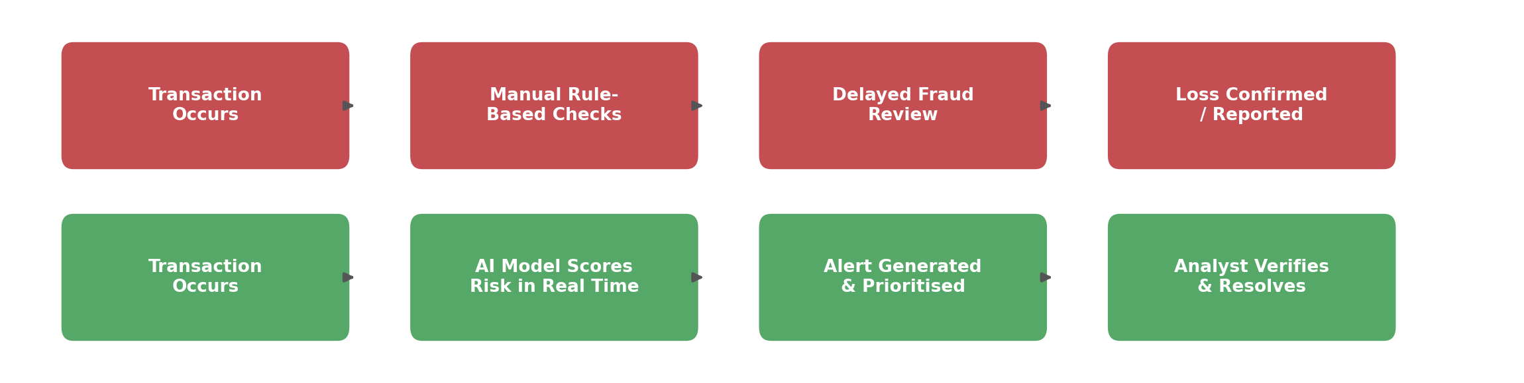
Figure 1.1: Traditional rule-based fraud review process compared with an AI-based real-time fraud detection process.
The rise of digital banking, UPI-based payments, and card-not-present transactions has created an enormous volume of financial activity that must be monitored continuously for signs of fraud. Traditional fraud detection relied heavily on static, rule-based systems that flag transactions violating pre-defined thresholds, such as unusually large amounts or transactions from new locations. While useful, these systems are slow to adapt to new fraud patterns and often generate a high number of false positives, burdening compliance teams with manual reviews. AI and machine learning based fraud detection systems, by contrast, learn from historical transaction and behavioural data to identify subtle and evolving patterns of fraudulent activity in real time, adjusting their risk models as new data becomes available. Financial institutions across India and globally are increasingly investing in such systems to protect customers, reduce financial losses, and comply with regulatory expectations around transaction monitoring.

1.3 Scope of the Report
The scope of this report is confined to analyzing the adoption patterns, perceived effectiveness, and operational challenges of AI-based fraud detection systems as experienced by professionals working within financial institutions. The study is based on data collected through a structured survey of 84 respondents, including risk and compliance officers, IT and security staff, relationship managers/branch staff, and senior management across public sector banks, private banks, and NBFC/fintech companies. The report examines current fraud monitoring practices, awareness and usage of AI-based tools, perceived benefits and challenges, and trust in automated decision-making. The scope does not extend to the internal technical evaluation of specific vendor algorithms, nor does it cover the financial cost-benefit modelling of large-scale AI deployment. Instead, it provides a focused, practitioner-centered perspective on how AI adoption in fraud detection is experienced on the ground.

1.4 Objectives of the Study
The specific objectives that guided this research are outlined below:
- To assess the current level of adoption and usage of AI-based fraud detection systems among staff at financial institutions.
- To determine the perceived effectiveness of AI-based systems in reducing fraud losses and manual review workload.
- To identify the key operational and trust-related challenges that limit full or confident adoption of these tools.
- To examine staff attitudes toward automated decision-making, explainability, and human oversight.
- To propose actionable recommendations that can improve the reliability, transparency, and usability of AI-based fraud detection systems.

1.5 Limitations of the Study
While every effort was made to ensure the accuracy and reliability of this study, certain limitations should be acknowledged. The sample of 84 respondents, while diverse across roles and institution types, is drawn from a limited number of institutions and may not fully represent the practices of every financial institution, particularly smaller cooperative banks or institutions with limited AI adoption. Self-reported data on perceived effectiveness and trust may be influenced by individual experience and role-based perspective. Additionally, the study captures a snapshot of attitudes at a given point in time and does not track how vendor technology changes or model performance may evolve over successive months or years. Finally, the research focuses on staff-side experiences and does not independently verify fraud reduction claims through backend transaction data from financial institutions.

Chapter 2: Literature Review

2.1 Introduction
A review of existing literature reveals that the application of Artificial Intelligence and machine learning to financial fraud detection has become a well-established and rapidly advancing area of research over the past two decades. Researchers highlight the shift from static, rule-based detection systems toward adaptive, data-driven models capable of identifying complex and evolving fraud patterns. The literature also increasingly emphasizes not only technical model performance, but also the human and organizational factors, such as trust, explainability, and workflow integration, that determine whether AI-based fraud detection tools are successfully adopted in practice.

2.2 Evolution of Fraud Detection Techniques
Early fraud detection research focused heavily on statistical and rule-based approaches, which relied on manually defined thresholds and historical fraud typologies. Bhattacharyya et al. (2011) provide a comparative study of data mining techniques for credit card fraud detection, noting that while rule-based systems offer interpretability, they struggle to generalize to previously unseen fraud patterns. Ngai et al. (2011) similarly review a wide range of data mining techniques applied to financial fraud, concluding that supervised and unsupervised learning methods significantly outperform static rule sets in detecting subtle and adaptive fraud behaviour, particularly as fraudsters increasingly adjust their tactics to evade known detection thresholds.

2.3 Machine Learning and AI Techniques in Fraud Detection
More recent literature focuses on the specific machine learning techniques used in modern fraud detection systems, including logistic regression, decision trees, random forests, gradient boosting, and deep neural networks. Ryman-Tubb, Krause, and Garn (2018) review how AI and machine learning research has directly influenced payment card fraud detection in industry, highlighting that ensemble and deep learning models achieve substantially higher detection accuracy while also enabling real-time scoring of transactions at scale. West and Bhattacharya (2016) provide a comprehensive review of intelligent financial fraud detection techniques, observing that hybrid models combining supervised learning with anomaly detection tend to perform best in practice, since fraud patterns are constantly evolving and rare relative to legitimate transactions.

2.4 AI Fraud Detection Architecture in the Indian Context
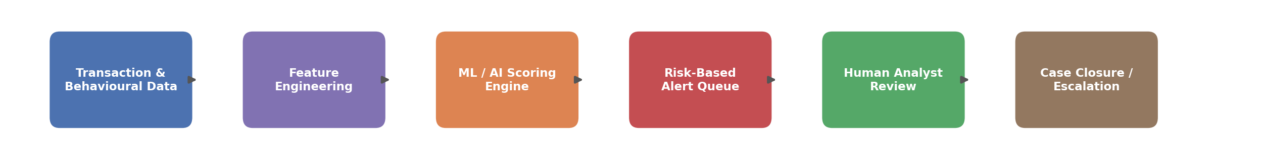
Figure 2.1: Typical AI-based fraud detection architecture used by financial institutions, from data ingestion to case resolution.
In the Indian context, the Reserve Bank of India (2023) has issued guidelines on digital payment security and fraud risk management, encouraging financial institutions to adopt real-time transaction monitoring and risk-based authentication mechanisms. Kaur and Sharma (2021) examine machine learning approaches to real-time fraud detection specifically within Indian banks, noting the growing use of AI-based scoring engines integrated with UPI and card payment rails to flag suspicious transactions within milliseconds. Recent industry practice, as reflected in the literature, typically structures AI-based fraud detection as a pipeline: transaction and behavioural data feed into a feature engineering layer, which supplies a machine learning scoring engine that generates a risk-based alert queue for human analyst review before final case closure or escalation.

2.5 Challenges and Limitations Identified in Literature
Despite strong technical performance, the literature consistently identifies a set of recurring challenges in the practical deployment of AI-based fraud detection. High false positive rates remain a persistent complaint, as overly sensitive models can overwhelm compliance teams with alerts on legitimate transactions, leading to alert fatigue. Ahuja and Singh (2023) examine human-AI collaboration in financial risk management, finding that excessive automation without adequate human oversight can erode staff trust and lead to either over-reliance on or dismissal of AI-generated alerts. Data privacy and regulatory compliance are also frequently cited concerns, given that fraud models often rely on sensitive customer behavioural data.

2.6 Regulatory and Ethical Considerations
A growing body of literature also examines the regulatory and ethical dimensions of AI-based fraud detection, particularly the demand for explainable AI (XAI). Gupta and Mehta (2022) argue that explainability is central to building trust between automated fraud detection systems and the human analysts and customers affected by their decisions, noting that "black box" models, while accurate, can be difficult to justify during dispute resolution or regulatory audits. This theoretical grounding informed the design of the survey used in this study, which explicitly measures staff trust in automated decisions, comfort with limited explainability, and preference for human oversight, in order to assess how well current AI fraud detection deployments align with these documented best practices.

Chapter 3: Methodology

3.1 Research Approach
This study employed a quantitative research approach to gather structured data on the adoption, perceived effectiveness, and practical challenges of AI-based fraud detection systems among staff at financial institutions. The chosen method was a descriptive survey, designed to provide a snapshot of staff attitudes, current fraud monitoring practices, and perceived benefits or difficulties associated with AI-driven tools. This approach was considered appropriate because it allows for the systematic collection of data that can be analyzed to identify common patterns in awareness, usage behaviour, and long-term sustainability of digital fraud detection support.

3.2 Data Collection Tool and Procedure
The tool used for this study was a structured questionnaire containing 15 questions. The form was designed with multiple-choice options, rating scales, and short-answer questions to ensure that responses remained consistent and easy to analyze. The survey explored key areas such as existing fraud monitoring practices, awareness and usage of AI-based tools, perceived benefits, trust in automated decisions, and the expected improvements in explainability and workflow support. The questionnaire was administered both in printed form (for vendors and staff without immediate smartphone access during the survey) and via a simple mobile-friendly online form to ensure comfortable, wide and relevant audience, data was collected in person at multiple bank branches, risk and compliance offices, and IT security desks, and produced 84 valid responses, which formed the basis of the analysis presented in this report.

3.3 Rationale for Method Selection
The survey method was chosen as the most suitable approach for studying the adoption and effectiveness of AI-based fraud detection systems among financial institution staff. First, it provided a cost-effective and efficient way to collect data from a large and diverse group of professionals within a short period, which was necessary because respondents vary widely in role, seniority, and institution type, and a diverse sample was important to capture these differences. Second, the use of a structured questionnaire ensured that responses were consistent and comparable, making it easier to analyze patterns such as the most valued benefits, the challenges staff anticipate, and the overall readiness for wider AI-based fraud detection deployment. Third, conducting interviews in person, alongside the option of a written questionnaire, encouraged participation from vendors who might otherwise be hesitant to fill out a purely digital form, ensuring that the sample was not biased toward already technology-comfortable respondents. Together, these factors confirm that the survey method was the most effective tool for achieving the objectives of this project.

3.4 Sample Profile
The 84 respondents surveyed for this study represented a reasonably diverse cross-section of financial institution staff in terms of role, years of experience, and type of institution. This diversity was intentional, as it allowed the study to compare adoption patterns and trust levels across different professional segments rather than drawing conclusions from a narrow or homogenous group. The table below summarizes the composition of the sample.
Category | Segment | % of Respondents
Role | Risk & Compliance Officer | 30%
 | IT / Security Staff | 25%
 | Relationship Manager / Branch Staff | 36%
 | Senior Management | 10%
Institution Type | Public Sector Bank | 35%
 | Private Bank | 39%
 | NBFC / Fintech | 26%
Years of Experience | Less than 2 years | 18%
 | 2–5 years | 37%
 | 6–10 years | 27%
 | More than 10 years | 18%

Chapter 4: Field Work Descriptions, Observations, and Analysis

4.1 Awareness and Usage of AI Fraud Detection Systems
The initial and most fundamental finding of the survey relates to the overall awareness and usage of AI-based fraud detection systems among the surveyed staff. The data shows that AI-based tools have become an active and familiar part of daily fraud monitoring work for a majority of respondents, with most reporting direct interaction with such systems as part of their regular duties.
Question | Response | % of Respondents
Have you used or interacted with an AI-based fraud detection tool? | Yes | 77%
 | No | 13%
 | Not sure | 10%
How often do you review AI-flagged fraud alerts? | Daily | 40%
 | Weekly | 30%
 | Occasionally | 20%
 | Rarely | 10%

These figures indicate that AI-based fraud detection has moved well past the pilot stage for most surveyed institutions and is now embedded in the daily workflow of a large share of risk, compliance, and branch staff, with 40% of respondents reviewing AI-flagged alerts on a daily basis.

4.2 Perceived Effectiveness of AI-Based Systems
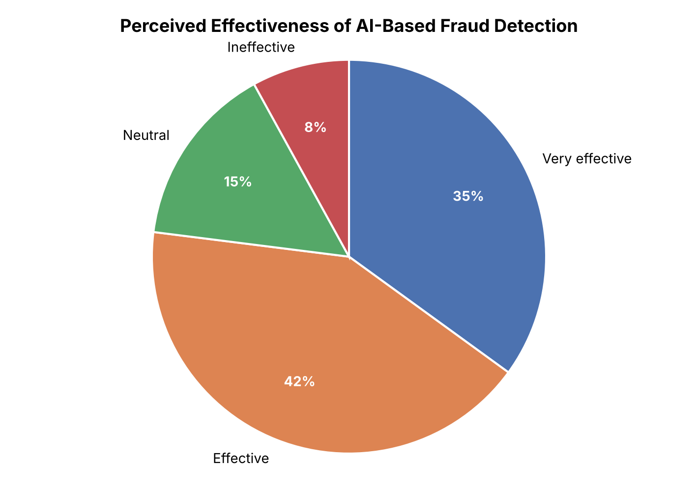
Figure 4.1: Perceived effectiveness of AI-based fraud detection systems among surveyed staff.
A significant 77% of respondents (35% "very effective" + 42% "effective") rate AI-based fraud detection systems positively, while only 8% consider them ineffective. This is reinforced by reported outcomes since adoption, with 81% of respondents (48% significant decrease + 33% slight decrease) reporting a decrease in fraud cases since AI-based tools were introduced at their institution.
Change in fraud cases since AI adoption | % of Respondents
Significant decrease | 48%
Slight decrease | 33%
No change | 14%
Increase | 5%

4.3 Key Challenges in Implementation
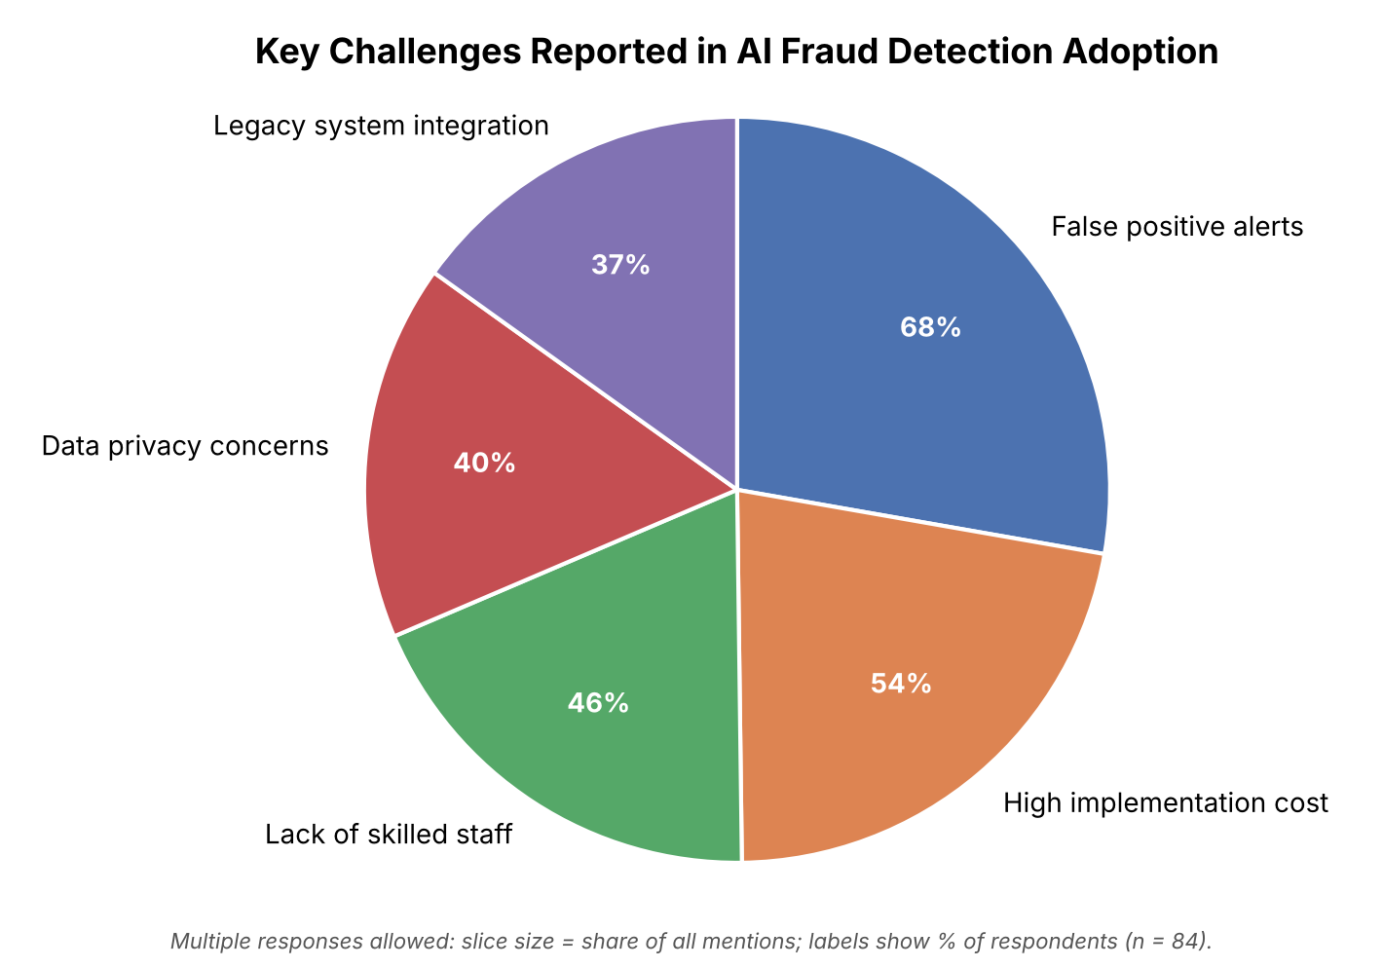
Figure 4.2: Key challenges reported by staff in AI fraud detection adoption.
While AI-based systems are broadly viewed as effective, the survey reveals significant operational friction. The most commonly reported difficulty is "false positive alerts" (68%), which directly increases manual workload despite the promise of automation, followed by "high implementation cost" (54%) and "lack of skilled staff" (46%) to interpret and manage these systems. Data privacy concerns (40%) and difficulty integrating AI tools with legacy core banking systems (37%) round out the top five challenges, confirming that both technical and organizational hurdles remain significant barriers to full-confidence adoption.

4.4 Trust and Transparency Concerns
Trust in automated decision-making emerged as one of the more nuanced findings of this study. While most respondents value the speed and consistency of AI-based scoring, a majority remain cautious about relying on AI decisions without human review.
Question | Response | % of Respondents
Do you trust AI-generated fraud decisions without human review? | Yes | 23%
 | No | 51%
 | Depends on the case | 26%
How concerned are you about the "black box" (lack of explainability) of AI decisions? | High concern | 58%
 | Moderate concern | 30%
 | Low concern | 12%

A striking 51% of respondents do not trust AI-generated decisions without human review, and 58% express high concern about the lack of explainability in AI-based fraud scoring. This gap between technical effectiveness and staff trust is one of the more important nuances uncovered by the field work: AI systems may be flagging fraud accurately while still failing to earn full confidence from the analysts responsible for acting on their output.

4.5 Impact on Fraud Reduction and Operational Efficiency
Respondents were also asked to reflect on how AI adoption has affected fraud losses and daily operational workload, beyond the accuracy of individual alerts.
Reported reduction in fraud losses since AI adoption | % of Respondents
More than 30% reduction | 44%
10–30% reduction | 38%
Less than 10% reduction | 12%
No measurable impact | 6%

A separate but related measure, reduction in manual review time, shows a similarly positive trend, with 52% of respondents reporting a significant reduction and 33% reporting a moderate reduction in the time spent manually reviewing transactions since AI-based tools were introduced. These findings suggest that the benefits of AI-based fraud detection extend beyond the immediate transaction, touching on institutional efficiency, staff workload, and resource allocation, even though concerns around trust and explainability persist.

4.6 Suggestions for Improvement
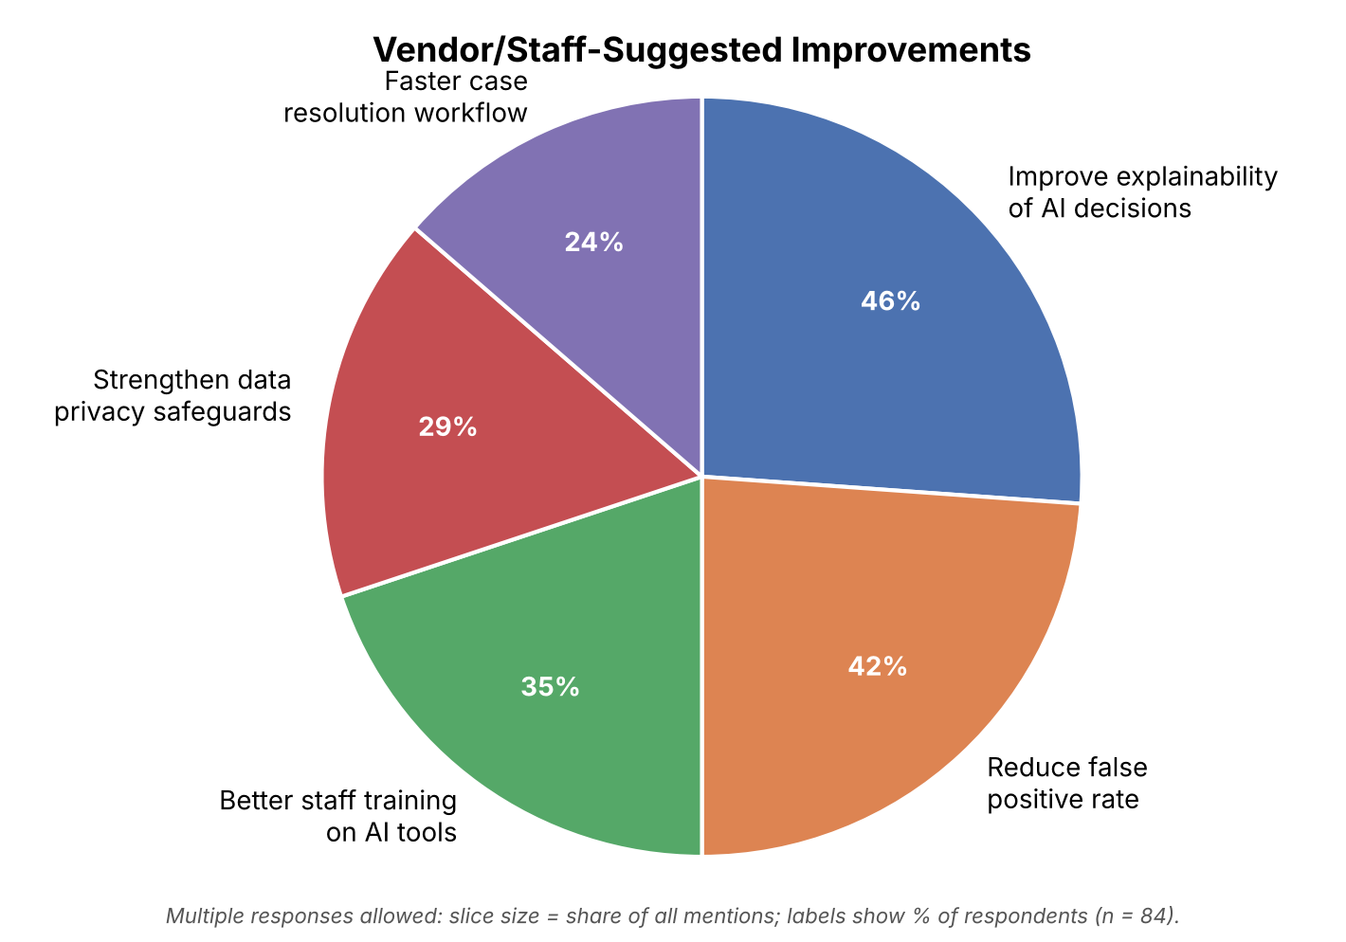
Figure 4.3: Staff-suggested improvements to AI-based fraud detection systems, ranked by frequency of mention.
The survey included an open-ended question inviting staff to suggest improvements to AI-based fraud detection systems based on their own daily experience. Responses were grouped into common themes: "improve explainability of AI decisions" (46%) was the most frequently mentioned suggestion, followed by "reduce false positive rate" (42%), "better staff training on AI tools" (35%), "strengthen data privacy safeguards" (29%), and "faster case resolution workflow" (24%). These staff-driven suggestions closely mirror the challenges identified earlier in this chapter, reinforcing that improvements to model transparency, alert precision, and training would directly address the most pressing concerns reported by financial institution staff.

Chapter 5: Conclusion and Recommendations

5.1 Detailed Summary of Key Findings
This field project was initiated to investigate and document the adoption, effectiveness, and practical challenges of AI-based fraud detection systems among staff at financial institutions. The primary data, gathered from a survey of 84 respondents across public sector banks, private banks, and NBFC/fintech companies, yielded several important findings.
Firstly, the research confirms that AI-based fraud detection tools are becoming an active and routine part of daily risk management work, with 77% of respondents reporting direct interaction with such systems and 40% reviewing AI-flagged alerts on a daily basis. This shows that AI adoption in fraud detection is no longer experimental but is steadily becoming a mainstream part of institutional risk management.
Secondly, the nature of this adoption is largely positive in terms of perceived effectiveness, with 77% of respondents rating AI-based systems as effective or very effective, and 81% reporting a decrease in fraud cases since adoption. However, this effectiveness is paired with a continued reliance on human oversight, particularly for high-stakes or ambiguous cases.
Thirdly, the study identified three critical challenges shaping staff confidence:
- False positive alerts and the resulting manual workload emerged as the most pressing operational concern, cited by 68% of respondents.
- Lack of explainability and the "black box" nature of AI decisions was cited as a significant barrier to full trust, with 58% expressing high concern.
- High implementation cost and a shortage of skilled staff created hesitation around scaling AI-based tools further across institutions.
Together, these findings reveal a dual reality: AI-based fraud detection systems improve detection speed and reduce fraud losses, but also create trust gaps and operational dependencies that cannot be ignored. Their expanding role in financial risk management demands a balance between technology adoption, staff training, and stronger explainability support.

5.2 Contribution to a Deeper Understanding
The findings of this study contribute to a deeper understanding of how AI-based fraud detection systems are transforming risk management within financial institutions. While much of the existing research emphasizes the technical performance of machine learning models, this project reveals the double-edged nature of adoption at the staff level. Analysts benefit from faster detection, reduced fraud losses, and lower manual review time, but they also report persistent concerns over explainability, false positives, and trust in automated decisions, particularly for cases that require nuanced judgment or customer-facing dispute resolution.

5.3 Actionable Recommendations and Future Scope
Based on the evidence gathered and subsequent analysis, the following recommendations are proposed to improve the sustainable adoption of AI-based fraud detection systems among financial institutions:
- Improve Model Explainability — Fraud detection vendors and internal AI teams should prioritize explainable AI (XAI) techniques that clearly communicate why a transaction was flagged, reducing analyst distrust.
- Reduce False Positive Rates — Continuous model retraining and feedback loops from analyst decisions should be used to sharpen risk scoring and reduce unnecessary alert volume.
- Strengthen Staff Training — Financial institutions should conduct structured training programs to help risk, compliance, and branch staff interpret and act on AI-generated alerts confidently.
- Enhance Data Privacy Safeguards — Institutions should ensure that behavioural and transaction data used for fraud scoring complies with data protection regulations and internal privacy policies.
- Conduct Long-Term Research — Future studies should examine how sustained AI-based fraud detection usage affects fraud losses, customer trust, and regulatory compliance over several years.
Together, these recommendations suggest a roadmap where AI-based fraud detection adoption among financial institutions continues to grow, but without compromising transparency, staff trust, or regulatory compliance. The table below outlines a phased roadmap for implementing these recommendations at an institutional level.
Phase | Focus Area | Key Activities | Target Outcome
Phase 1 | Establish Explainability | Adopt explainable AI (XAI) dashboards; document model logic for auditors and analysts | Improved analyst trust
Phase 2 | Reduce Alert Fatigue | Retrain models using analyst feedback; tune alert thresholds by risk segment | Lower false positive rate
Phase 3 | Staff Training | Conduct role-based workshops on interpreting and acting on AI alerts | Greater independent usage
Phase 4 | Long-Term Monitoring | Track fraud loss reduction, model drift, and staff confidence over multiple years | Sustained, informed policymaking

References
1. Bhattacharyya, S., Jha, S., Tharakunnel, K., & Westland, J. C. (2011). Data mining for credit card fraud: A comparative study. Decision Support Systems, 50(3), 602–613.
2. West, J., & Bhattacharya, M. (2016). Intelligent financial fraud detection: A comprehensive review. Computers & Security, 57, 47–66.
3. Ngai, E. W. T., Hu, Y., Wong, Y. H., Chen, Y., & Sun, X. (2011). The application of data mining techniques in financial fraud detection. Decision Support Systems, 50(3), 559–569.
4. Ryman-Tubb, N. F., Krause, P., & Garn, W. (2018). How Artificial Intelligence and machine learning research impacts payment card fraud detection. Engineering Applications of Artificial Intelligence, 76, 130–157.
5. Reserve Bank of India. (2023). Guidelines on Digital Payment Security and Fraud Risk Management.
6. Gupta, R., & Mehta, S. (2022). Explainable AI in banking fraud detection: Bridging trust and automation. Journal of Financial Technology, 5(2), 88–101.
7. Kaur, P., & Sharma, N. (2021). Machine learning approaches to real-time fraud detection in Indian banks. International Journal of Banking Analytics, 9(1), 15–29.
8. Ahuja, R., & Singh, T. (2023). Human-AI collaboration in financial risk management: Challenges and opportunities. Journal of Banking Innovation, 11(4), 200–215.

Appendices

Appendix A: Survey Questionnaire
Project Title: AI-Based Fraud Detection Systems in Financial Institutions
Introduction and Purpose:
Thank you for participating in this academic survey. This research is being conducted as part of a field project for the Bachelor of Science in Computer Science program at J.K. College of Science and Commerce. The purpose of this survey is to understand the adoption, effectiveness, and challenges related to the use of AI-based fraud detection systems within financial institutions. The study aims to gather insights on how staff currently accept and act on AI-generated alerts, what benefits and concerns they associate with these tools, and what improvements would encourage more confident use.
Survey Questions
Section 1: Respondent Information
1. What is your role at your institution?
- Risk & Compliance Officer
- IT / Security Staff
- Relationship Manager / Branch Staff
- Senior Management
2. What type of institution do you work for?
- Public Sector Bank
- Private Bank
- NBFC / Fintech
- Other: ___________
3. How long have you worked in the banking / financial services sector?
- Less than 2 years
- 2–5 years
- 6–10 years
- More than 10 years
Section 2: Current Fraud Monitoring Practices
4. Have you used or interacted with an AI-based fraud detection tool?
- Yes
- No
- Not sure
5. How often do you review AI-flagged fraud alerts?
- Daily
- Weekly
- Occasionally
- Rarely
Section 3: Perceived Benefits
6. On a scale of 1–5, how effective do you find AI-based fraud detection for your daily work?
( ) 1 (Not effective) ( ) 2 ( ) 3 ( ) 4 ( ) 5 (Very effective)
7. Which benefits are most important to you? (Select up to 2)
- Faster fraud detection
- Reduced manual review workload
- Lower fraud losses
- Consistent, unbiased scoring
- Other: ___________
Section 4: Challenges and Concerns
8. What challenges do you face while using AI-based fraud detection tools? (Select up to 2)
- False positive alerts
- High implementation cost
- Lack of skilled staff
- Data privacy concerns
- Legacy system integration
- Other: ___________
9. Do you trust AI-generated fraud decisions without human review?
- Yes
- No
- Depends on the case
10. How concerned are you about the lack of explainability ("black box") in AI-based decisions?
- High concern
- Moderate concern
- Low concern
Section 5: Suggestions and Future Outlook
11. Would you recommend expanding AI-based fraud detection to a department that currently relies only on manual review?
- Yes
- No
- Not Sure
12. How has adopting AI-based fraud detection affected fraud losses at your institution, in your own experience?
- Decreased significantly
- Decreased slightly
- No change
- Increased
13. What single improvement would most encourage you to trust AI-based fraud alerts more confidently? (Open-ended)
______________________________________________________________
14. Any additional comments or experiences you would like to share regarding AI-based fraud detection at your institution? (Open-ended)
______________________________________________________________

Appendix B: Summary of Survey Responses
The tables and pie charts below summarize the responses collected from all 84 respondents for each of the 14 survey questions (source: Google Form responses). For multiple-choice questions where respondents could select up to two options (Q7 and Q8), percentages are calculated against the 84 respondents and therefore add up to more than 100%; the pie charts for these questions show each option's share of all selections. For the open-ended questions (Q13 and Q14), answers have been grouped into common themes.
Q1. What is your role at your institution?
Role | No. of Respondents | % of Respondents
Relationship Manager / Branch Staff | 16 | 19%
Risk & Compliance Officer | 15 | 18%
IT / Security Staff | 29 | 35%
Senior Management | 24 | 29%
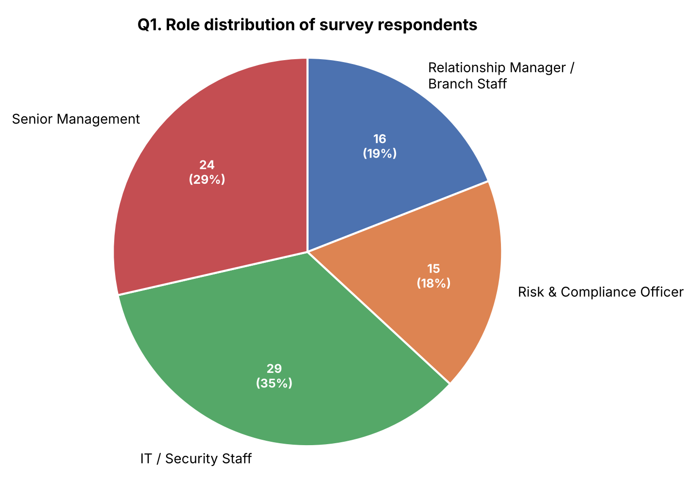
Figure B.1: Role distribution of survey respondents.
Q2. What type of institution do you work for?
Institution Type | No. of Respondents | % of Respondents
Public Sector Bank | 24 | 29%
Private Bank | 19 | 23%
NBFC / Fintech | 41 | 49%
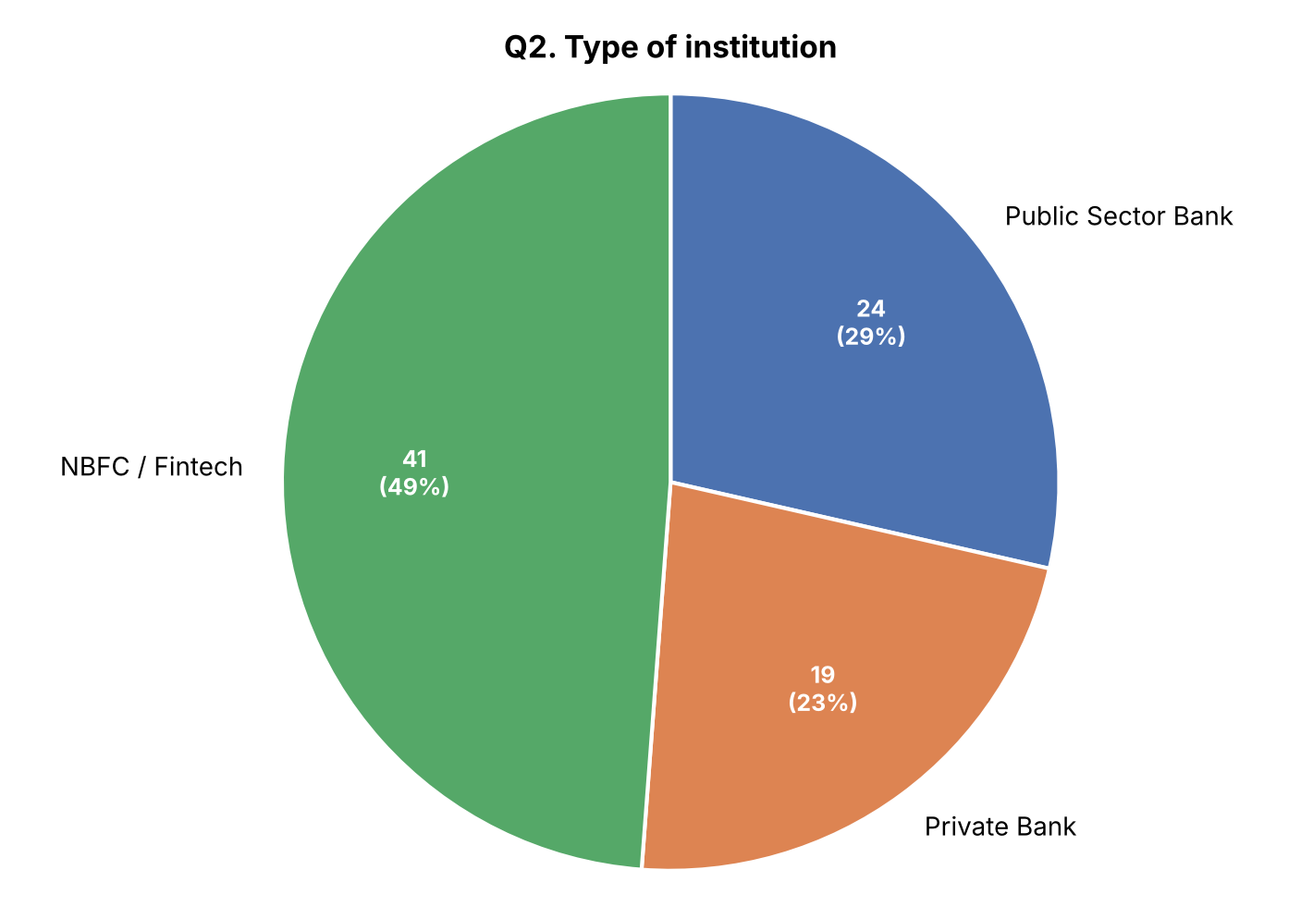
Figure B.2: Type of institution.
Q3. How long have you worked in the banking / financial services sector?
Experience | No. of Respondents | % of Respondents
Less than 2 years | 17 | 20%
2–5 years | 27 | 32%
6–10 years | 17 | 20%
More than 10 years | 23 | 27%
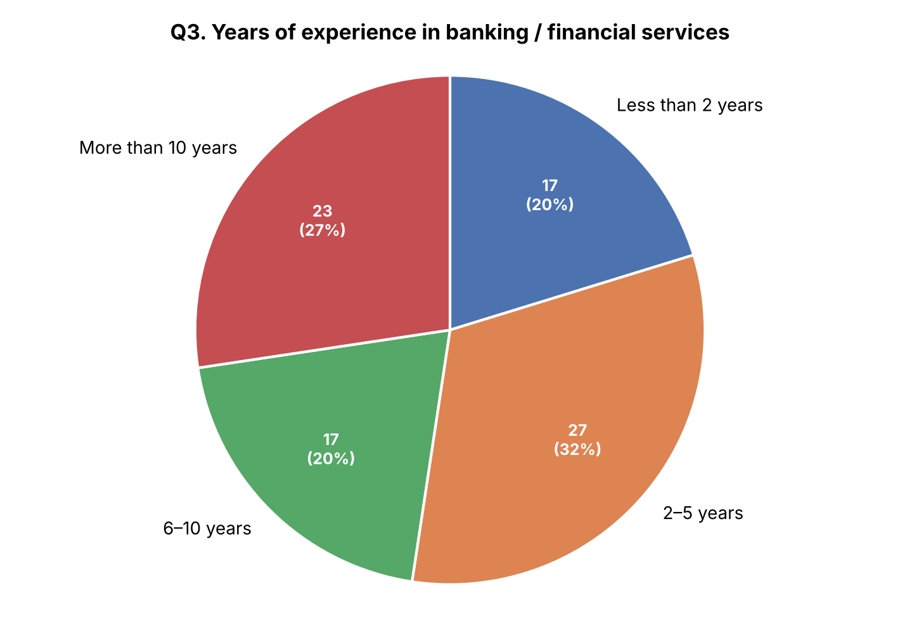
Figure B.3: Years of experience in banking / financial services.
Q4. Have you used or interacted with an AI-based fraud detection tool?
Response | No. of Respondents | % of Respondents
Yes | 27 | 32%
No | 27 | 32%
Not sure | 30 | 36%
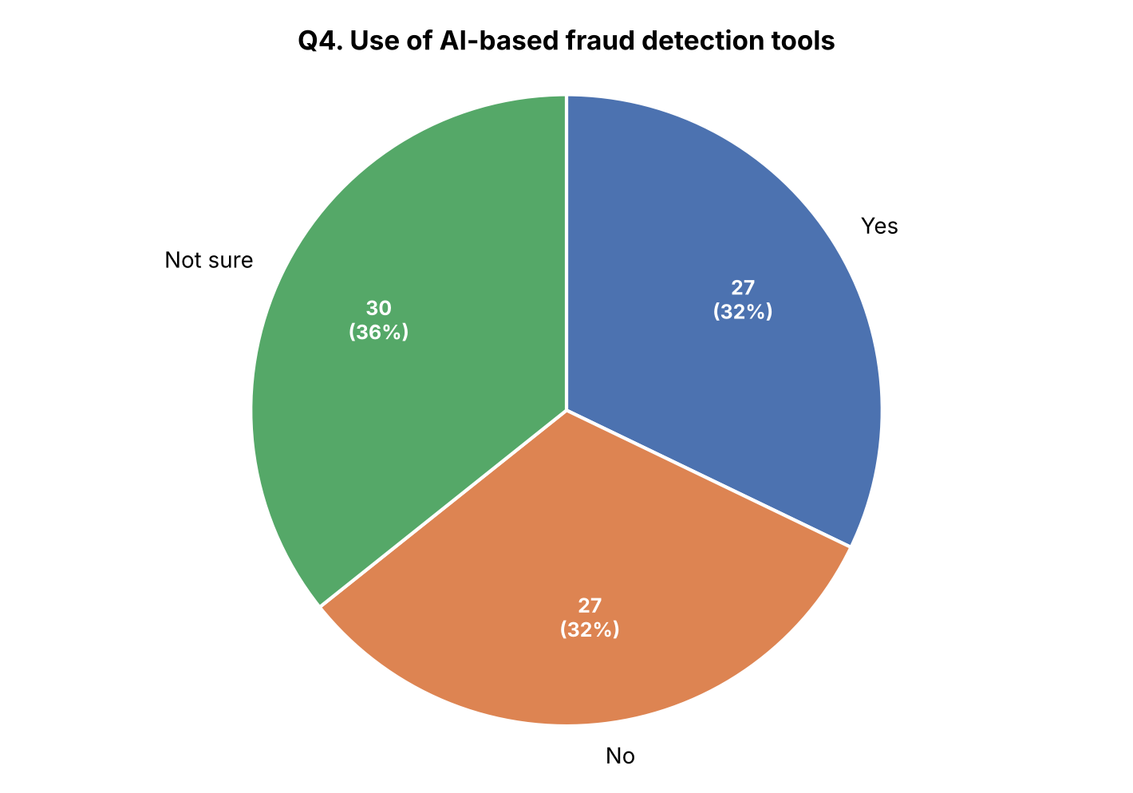
Figure B.4: Use of AI-based fraud detection tools.
Q5. How often do you review AI-flagged fraud alerts?
Response | No. of Respondents | % of Respondents
Daily | 20 | 24%
Weekly | 23 | 27%
Occasionally | 27 | 32%
Rarely | 14 | 17%
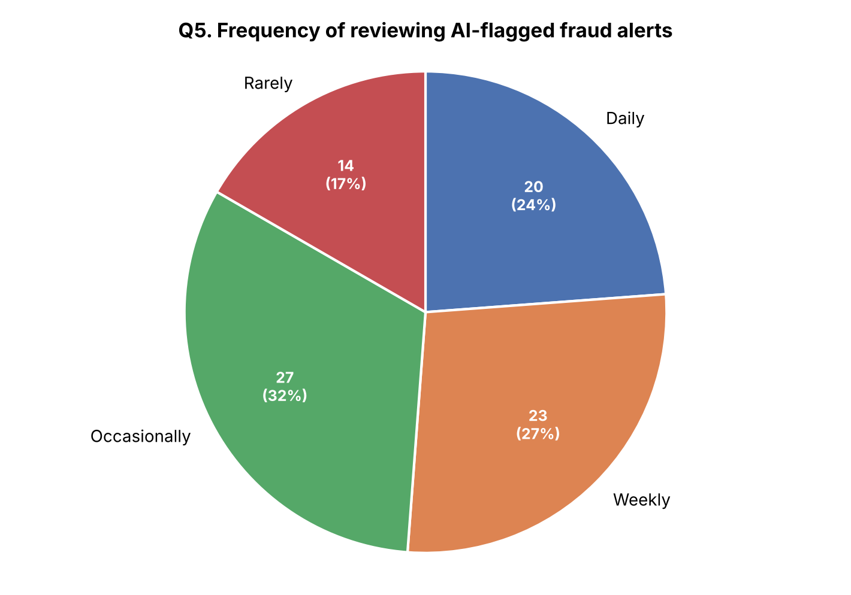
Figure B.5: Frequency of reviewing AI-flagged fraud alerts.
Q6. On a scale of 1–5, how effective do you find AI-based fraud detection for your daily work?
Rating | No. of Respondents | % of Respondents
1 (Not effective) | 12 | 14%
2 | 9 | 11%
3 | 13 | 15%
4 | 19 | 23%
5 (Very effective) | 31 | 37%
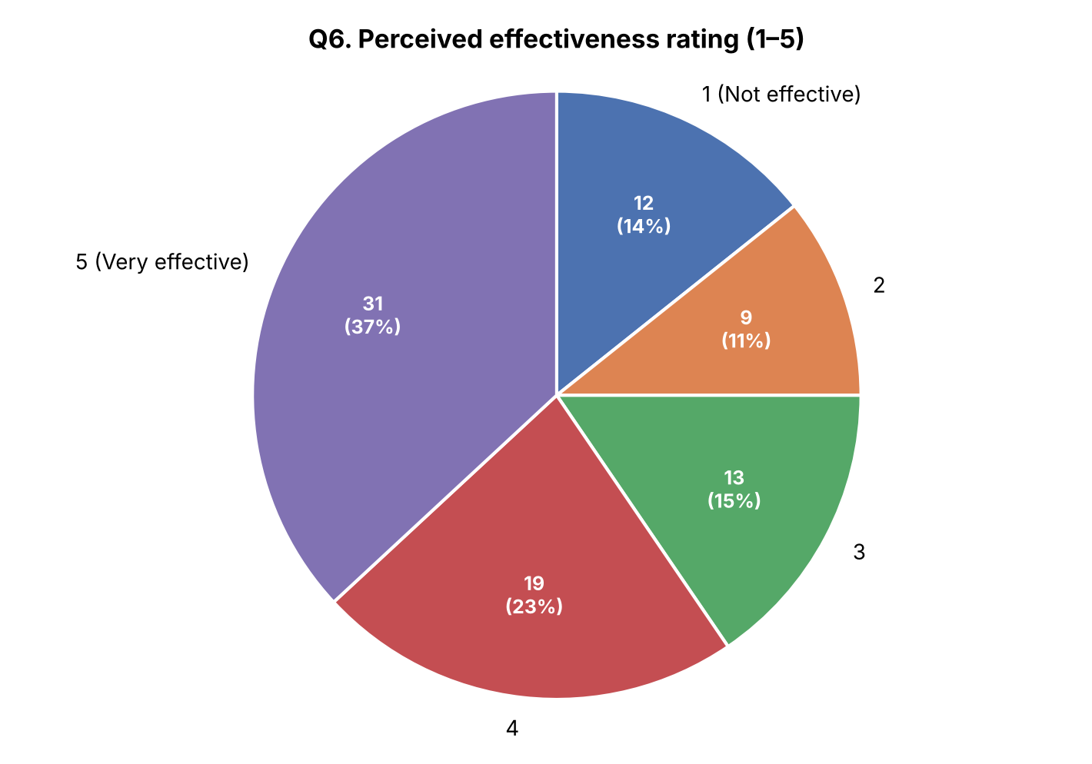
Figure B.6: Perceived effectiveness rating (1–5).
Q7. Which benefits are most important to you? (Select up to 2)
Benefit | No. of Respondents | % of Respondents
Faster fraud detection | 29 | 35%
Lower fraud losses | 33 | 39%
Reduced manual review workload | 27 | 32%
Consistent, unbiased scoring | 28 | 33%
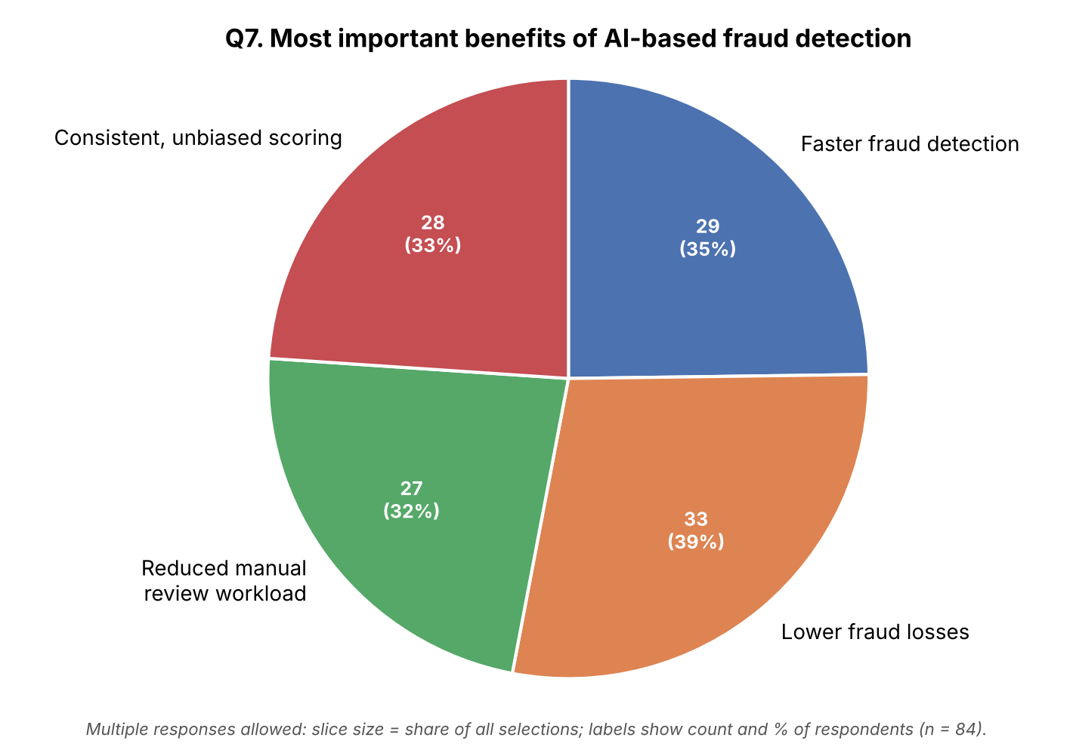
Figure B.7: Most important benefits of AI-based fraud detection.
Q8. What challenges do you face while using AI-based fraud detection tools? (Select up to 2)
Challenge | No. of Respondents | % of Respondents
False positive alerts | 27 | 32%
High implementation cost | 24 | 29%
Lack of skilled staff | 21 | 25%
Data privacy concerns | 24 | 29%
Legacy system integration | 23 | 27%
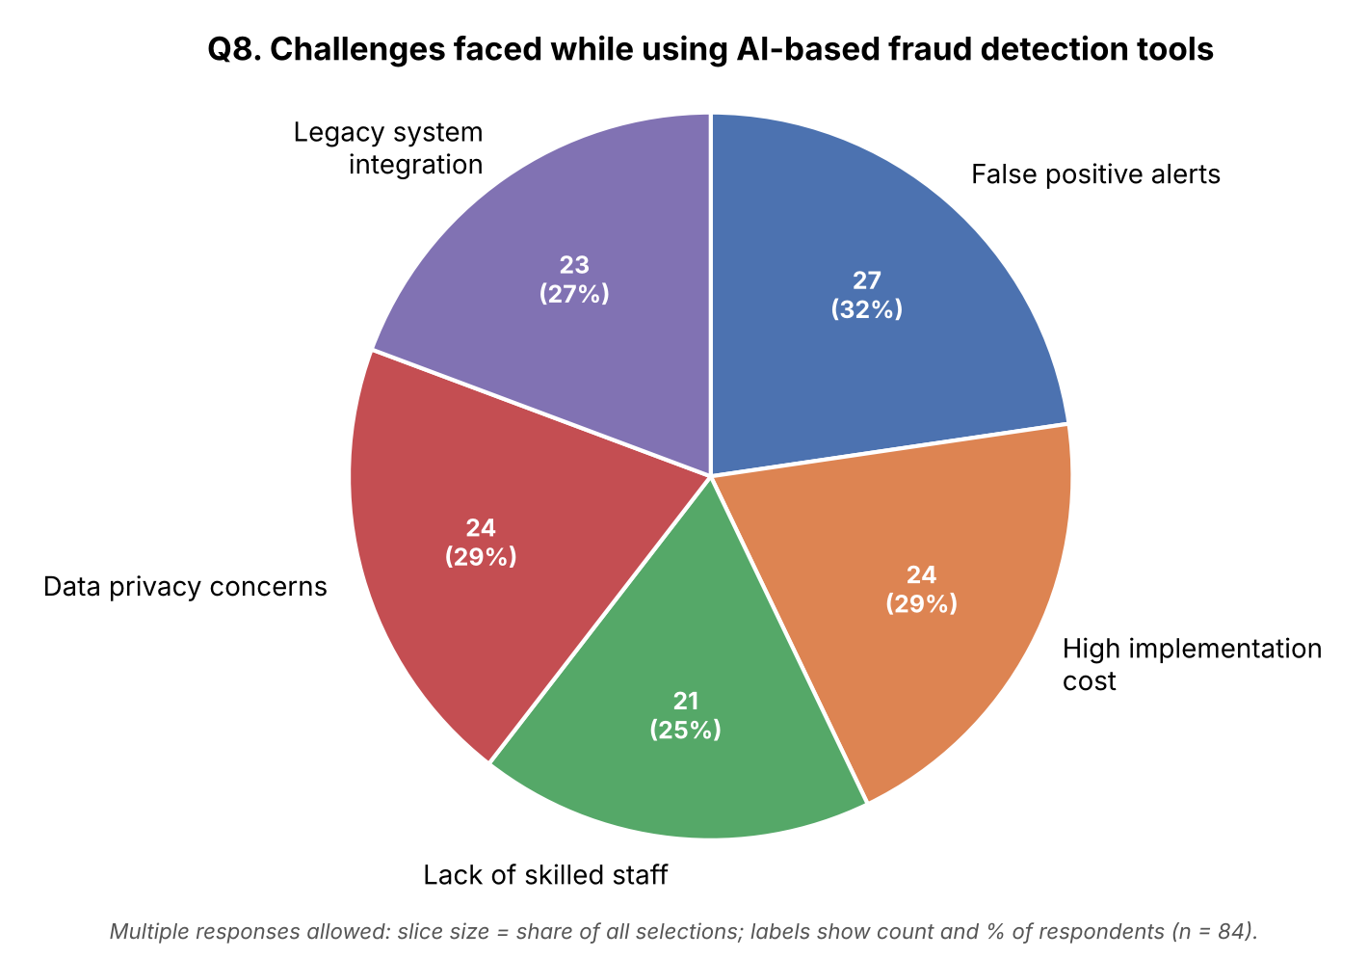
Figure B.8: Challenges faced while using AI-based fraud detection tools.
Q9. Do you trust AI-generated fraud decisions without human review?
Response | No. of Respondents | % of Respondents
Yes | 27 | 32%
No | 32 | 38%
Depends on the case | 25 | 30%
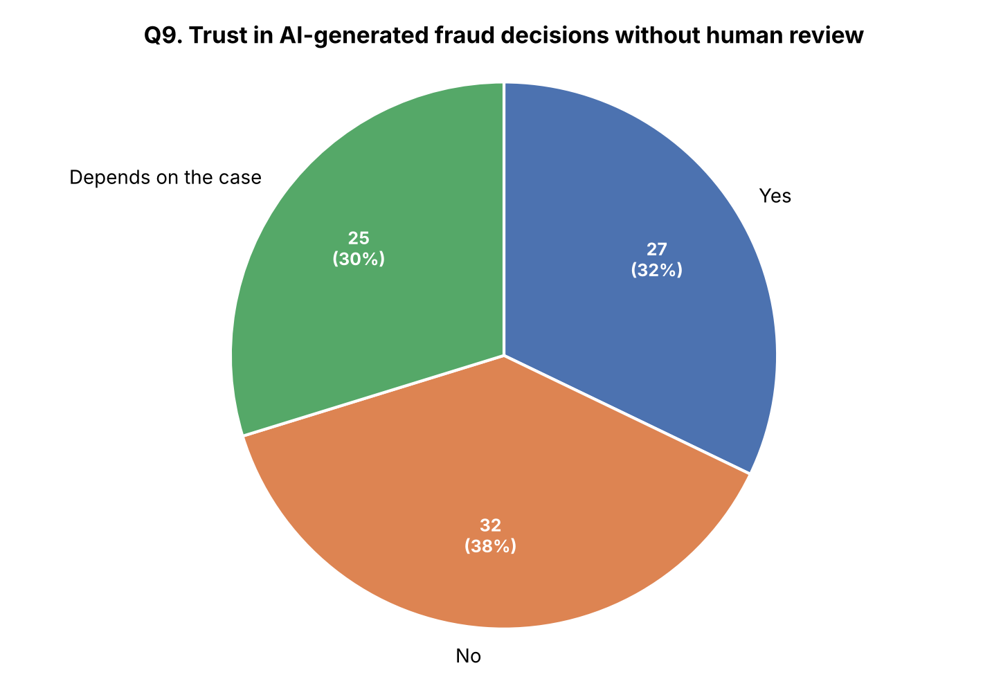
Figure B.9: Trust in AI-generated fraud decisions without human review.
Q10. How concerned are you about the lack of explainability ("black box") in AI-based decisions?
Response | No. of Respondents | % of Respondents
High concern | 32 | 38%
Moderate concern | 28 | 33%
Low concern | 24 | 29%
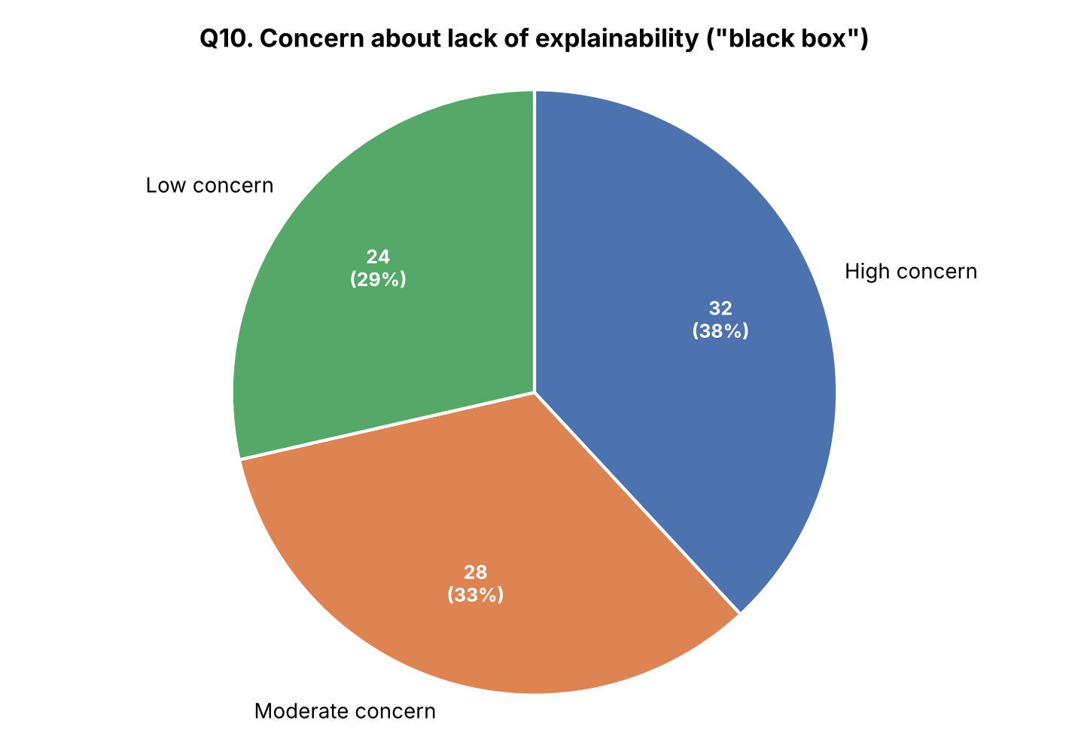
Figure B.10: Concern about lack of explainability ("black box").
Q11. Would you recommend expanding AI-based fraud detection to a department that currently relies only on manual review?
Response | No. of Respondents | % of Respondents
Yes | 26 | 31%
No | 29 | 35%
Not Sure | 29 | 35%
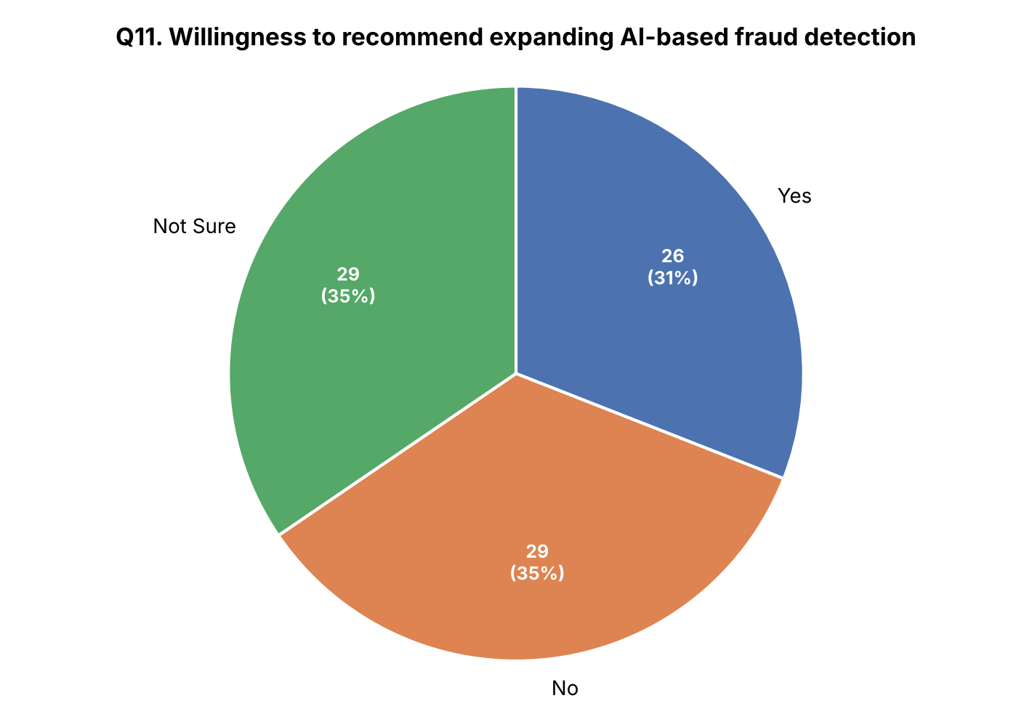
Figure B.11: Willingness to recommend expanding AI-based fraud detection.
Q12. How has adopting AI-based fraud detection affected fraud losses at your institution, in your own experience?
Response | No. of Respondents | % of Respondents
Decreased significantly | 22 | 26%
Decreased slightly | 20 | 24%
No change | 19 | 23%
Increased | 23 | 27%
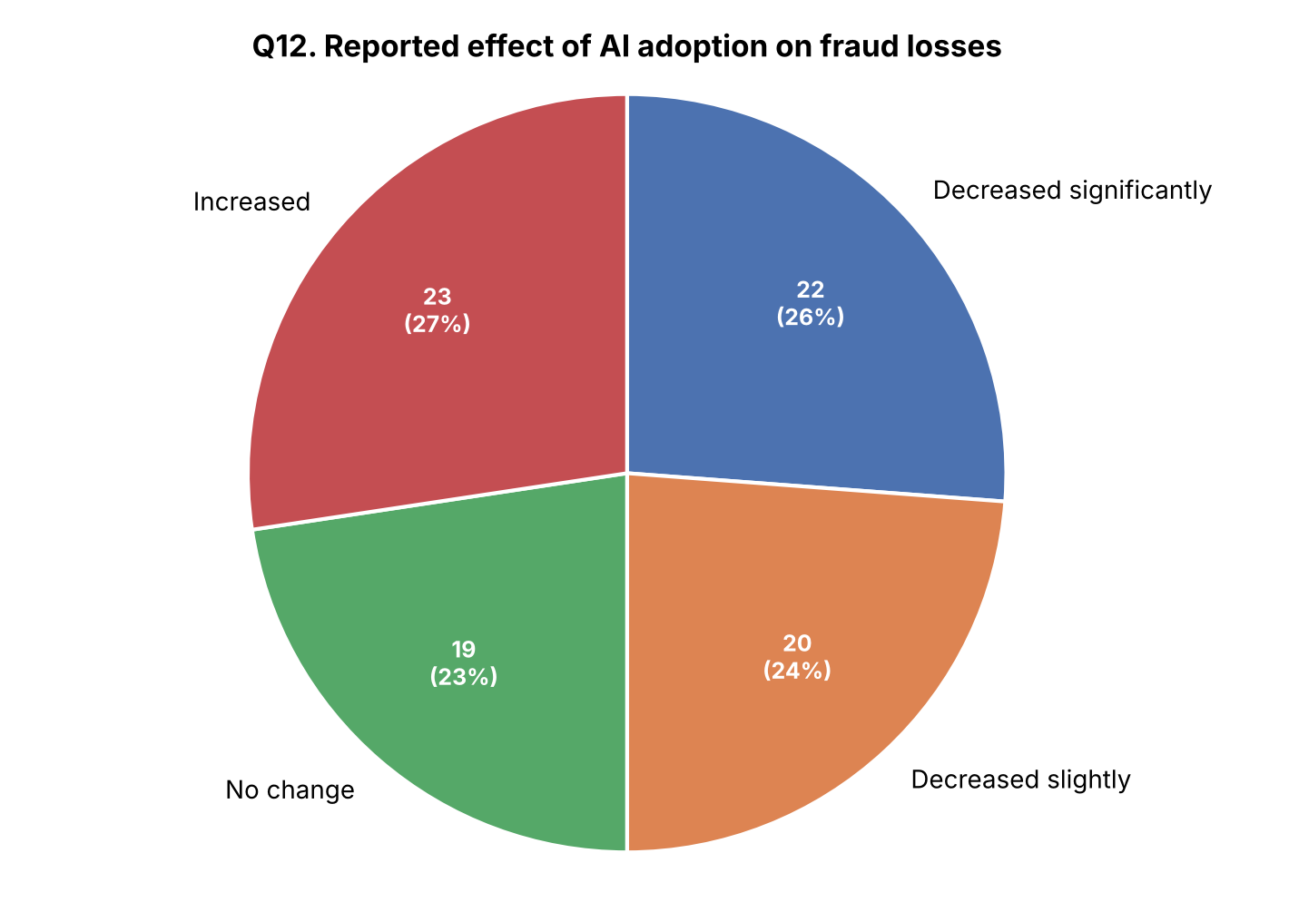
Figure B.12: Reported effect of AI adoption on fraud losses.
Q13. What single improvement would most encourage you to trust AI-based fraud alerts more confidently?
Response theme | No. of Respondents | % of Respondents
Overall very effective. | 12 | 14%
Needs better explainability. | 9 | 11%
Too many false positives. | 7 | 8%
Requires better integration. | 2 | 2%
No response | 54 | 64%
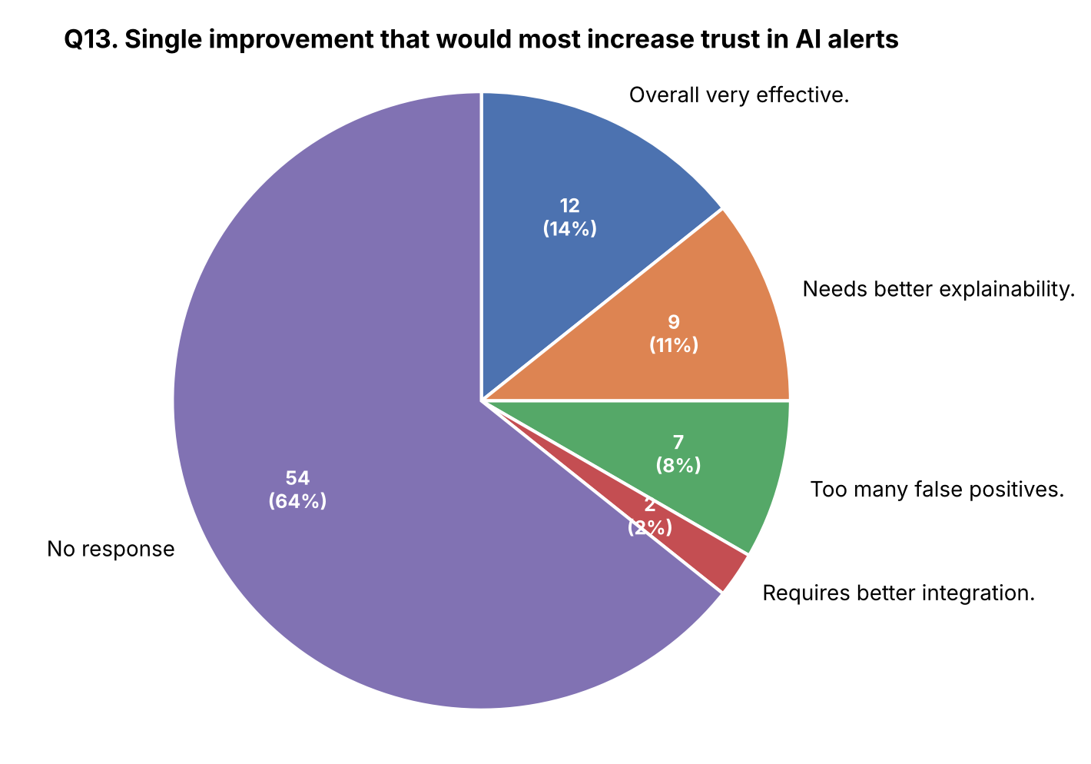
Figure B.13: Single improvement that would most increase trust in AI alerts.
Q14. Any additional comments or experiences you would like to share regarding AI-based fraud detection at your institution?
Response theme | No. of Respondents | % of Respondents
Overall very effective. | 4 | 5%
Needs better explainability. | 8 | 10%
Too many false positives. | 7 | 8%
Requires better integration. | 3 | 4%
No response | 62 | 74%
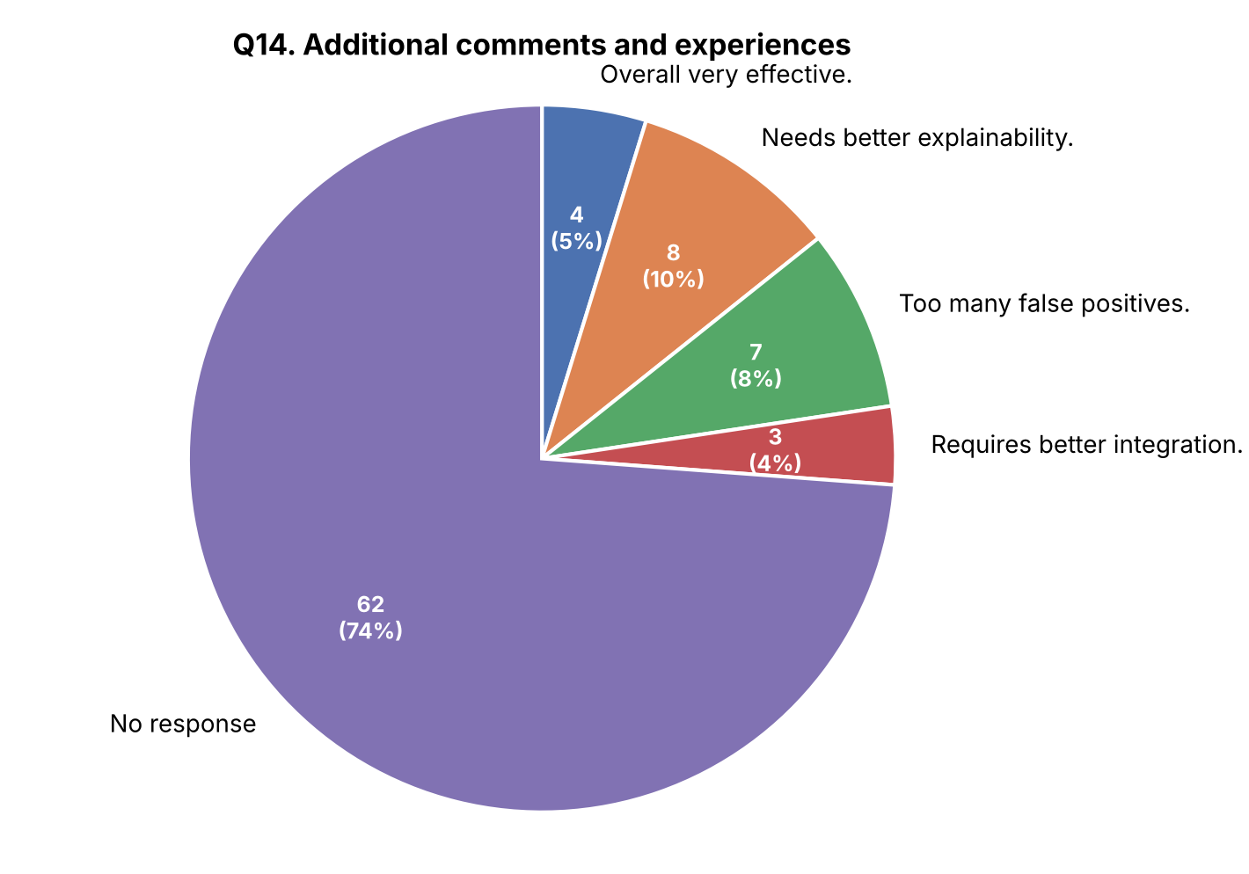
Figure B.14: Additional comments and experiences.

Appendix C: Glossary of Terms
Term | Meaning
AI (Artificial Intelligence) | The capability of a computer system to perform tasks, such as pattern recognition and decision-making, that normally require human intelligence.
Machine Learning (ML) | A branch of AI in which models learn patterns from historical data to make predictions on new data without being explicitly programmed for each rule.
Anomaly Detection | A technique used to identify transactions or behaviours that deviate significantly from established normal patterns, often signalling potential fraud.
False Positive | A legitimate transaction that is incorrectly flagged by a fraud detection system as suspicious or fraudulent.
Explainable AI (XAI) | AI techniques and tools designed to make a model’s decisions understandable and justifiable to human users, auditors, and regulators.
Model Drift | The gradual decline in a machine learning model’s accuracy over time as underlying data patterns and fraud tactics change.
Real-Time Transaction Monitoring | The continuous, automated screening of financial transactions as they occur, enabling near-instant fraud risk scoring.

Appendix D: Consent and Confidentiality Statement
All respondents were informed of the academic purpose of this survey prior to participation and were assured that their individual responses would be kept confidential and used only in aggregate form for this project report. Participation in the survey was voluntary, and respondents could decline to answer any question or withdraw at any point during data collection. No personally identifying information (beyond broad demographic categories such as role, institution type, and years of experience) was collected or reported in this study.

Appendix E: Note on Field Data
This appendix is reserved for institution visit notes, additional interview transcripts, and any supplementary raw survey response charts collected during data collection, to be inserted as per institutional formatting guidelines.

