
Cybersecurity Awareness Survey Among Students
Name of the Student : Anamika Singh
Roll Number : 2026011108
Program Title : Bachelor Of Science In Computer Science (SYCS)
Name of the Mentor : Asst Prof. Shubhangi Shinde
Name of the College: J.K. College of Science and Commerce, Sector-5, Ghansoli, Navi Mumbai
Academic Year - 2026-27
Month of Submission : October - 2026

Student's Declaration
I, Anamika Singh, a student of J.K. College of Science and Commerce studying in S.Y.B.Sc. Computer Science, hereby declare that I have completed the field project entitled “Cybersecurity Awareness Survey Among Students” during the academic year 2026-2027.
The report work is original and the information/data included in the report is true, emerging from the primary and secondary data gathered and analyzed as part of this project.
Due credit is extended to the work of Literature/Secondary Survey by endorsing it in the References as per the prescribed format.

Signature of the Student
Name: Anamika Singh

ACKNOWLEDGEMENT
I would like to express my sincere gratitude to all those who contributed to the successful completion of my field project titled “Cybersecurity Awareness Survey Among Students.”
First and foremost, I extend my deepest thanks to my project guide, Asst Prof. Shubhangi Shinde, for the invaluable guidance, unwavering support, and constant encouragement provided throughout this project. The insightful suggestions and expert advice were instrumental in shaping this research.
I am also thankful to the faculty members and staff of the Computer Science Department at J.K. College of Science and Commerce for providing the resources and environment required to carry out the study effectively.
Special thanks are due to all the 100 students across various years and streams who patiently participated in the survey and shared their honest experiences and habits regarding cybersecurity. Their feedback and opinions formed the core of this primary research.
Lastly, I wish to thank my family and friends for their constant encouragement, patience, and moral support throughout the duration of this project.

Abstract
As students increasingly rely on smartphones, laptops, and online platforms for academics, communication, and social interaction, they have also become a frequent target of cyber threats such as phishing, identity theft, and social media exploitation. This project studies the level of cybersecurity awareness among college students, focusing on their familiarity with common threats, password and account security practices, social media privacy behaviour, and their ability to recognize phishing attempts. A structured survey was conducted among 100 students across different years of study and academic streams to capture their current knowledge, habits, and attitudes toward cybersecurity, as well as their exposure to institutional training and support. The findings reveal that while most students recognize common cybersecurity terms and threats, a significant share continue to engage in risky practices such as reusing passwords across accounts and skipping two-factor authentication. The study also finds strong demand among students for structured cybersecurity education, with the majority expressing interest in workshops, simulated phishing drills, and curriculum-integrated content. The report concludes that closing the gap between awareness and safe practice requires sustained institutional investment in practical, hands-on cybersecurity training rather than one-time awareness campaigns alone.

Index
S.R. No. | CONTENT | Page No.
01 | Introduction  1.1 Purpose of the Study  1.2 Background Information  1.3 Scope of the Report  1.4 Objectives of the Study  1.5 Limitations of the Study | 1-2
02 | Literature Review  2.1 Introduction  2.2 Evolution of Student-Targeted Cyber Threats  2.3 Awareness, Knowledge, and Behavioural Gaps  2.4 Cybersecurity Education and the Indian Context  2.5 Challenges and Limitations Identified in Literature  2.6 Role of Institutions and Digital Literacy Initiatives | 3-4
03 | Methodology  3.1 Research Approach  3.2 Data Collection Tool and Procedure  3.3 Rationale for Method Selection  3.4 Sample Profile | 5
04 | Field Work Descriptions, Observations, and Analysis  4.1 Awareness of Common Cybersecurity Threats  4.2 Password and Account Security Practices  4.3 Social Media and Data Privacy Behaviour  4.4 Phishing Recognition Ability  4.5 Use of Security Tools and Institutional Support  4.6 Suggestions for Improvement | 6-9
05 | Conclusion and Recommendations  5.1 Detailed Summary of Key Findings  5.2 Contribution to a Deeper Understanding  5.3 Actionable Recommendations and Future Scope | 10-11
06 | References | 12
07 | Appendices  Appendix A: Survey Questionnaire  Appendix B: Summary of Survey Responses  Appendix C: Glossary of Terms  Appendix D: Consent and Confidentiality Statement | 12-15

Chapter 1: Introduction

1.1 Purpose of the Study
The primary objective of this project is to conduct a comprehensive study of the level of cybersecurity awareness among college students. This study seeks to identify how familiar students are with common cyber threats (such as phishing, malware, and ransomware), examine their password and account security habits, quantify risky behaviours that leave them vulnerable (such as password reuse and skipping two-factor authentication), and systematically document their exposure to and demand for institutional cybersecurity training. The goal is to produce a report that presents a clear picture of student cybersecurity awareness in practice, and to provide useful insights for college administrations, IT departments, and educators responsible for designing more effective digital safety programs.

1.2 Background Information
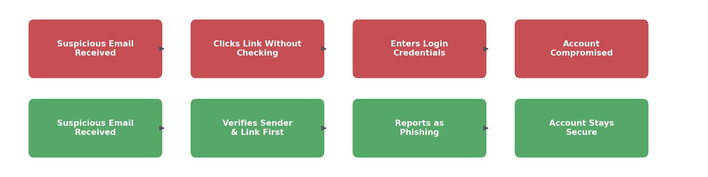
Figure 1.1: Unsafe response to a phishing email compared with a safe, verification-based response.
As students increasingly conduct academics, banking, and social interaction through smartphones and laptops, they have become one of the most frequently targeted groups for cybercrime, including phishing emails, fake job or scholarship offers, social media account takeovers, and public Wi-Fi based attacks. Unlike enterprise employees, who often work within networks protected by dedicated IT security teams, students are largely responsible for their own digital safety, relying on personal judgement, password habits, and whatever awareness they have picked up informally. A single successful phishing attempt or weak password can lead to compromised email accounts, financial loss, identity theft, or exposure of sensitive personal data. Given the rising frequency of cyberattacks targeting young, digitally active populations, understanding what students actually know, and do not know, about cybersecurity has become essential for designing effective campus-level protection strategies.

1.3 Scope of the Report
The scope of this report is confined to analyzing the awareness levels, security practices, and training needs of students regarding cybersecurity. The study is based on data collected through a structured survey of 100 respondents, including students from the First Year, Second Year, Third Year, and postgraduate levels across multiple academic streams. The report examines familiarity with common cybersecurity terms and threats, password and account security behaviour, social media and data privacy practices, ability to recognize phishing attempts, and exposure to institutional cybersecurity training. The scope does not extend to a technical audit of the college’s own network security infrastructure, nor does it cover cybercrime legal proceedings. Instead, it provides a focused, student-centered perspective on awareness gaps and training needs.

1.4 Objectives of the Study
The specific objectives that guided this research are outlined below:
- To assess the current level of awareness of common cybersecurity threats among college students.
- To examine password, account security, and social media privacy practices followed by students.
- To evaluate students’ practical ability to recognize phishing attempts and suspicious online activity.
- To determine the extent of institutional cybersecurity training students have received.
- To propose actionable recommendations that can improve cybersecurity awareness and safe practice among the student community.

1.5 Limitations of the Study
While every effort was made to ensure the accuracy and reliability of this study, certain limitations should be acknowledged. The sample of 100 respondents, while diverse across years of study and streams, is drawn from a single college and may not fully represent cybersecurity awareness levels across all educational institutions, particularly those with different levels of digital infrastructure or existing training programs. Self-reported data on security habits and phishing recognition ability may be influenced by social desirability bias, where students present a more cautious picture of their own behaviour than is actually the case. Additionally, the study captures a snapshot of awareness at a given point in time and does not track how habits may change following exposure to awareness campaigns or real incidents.

Chapter 2: Literature Review

2.1 Introduction
A review of existing literature reveals that cybersecurity awareness among students has become a widely studied area as educational institutions increasingly rely on digital platforms for learning, communication, and administration. Researchers consistently highlight a gap between students’ general familiarity with cybersecurity terminology and their actual day-to-day security behaviour, suggesting that awareness alone does not guarantee safe practice. The literature also emphasizes the growing role of structured, institution-led training in closing this gap.

2.2 Evolution of Student-Targeted Cyber Threats
Early research on cybersecurity in educational settings focused primarily on malware and virus protection on shared computer labs. Zwilling et al. (2020) conducted a comparative study of cybersecurity awareness, knowledge, and behaviour across several countries, finding that while general knowledge of cyber threats has increased over time, translating that knowledge into consistent safe behaviour remains a persistent challenge. As students have shifted toward mobile-first, always-connected digital lifestyles, threats have evolved accordingly, with phishing, social engineering, and social media account compromise now representing some of the most common risks reported in recent studies, rather than traditional virus infections.

2.3 Awareness, Knowledge, and Behavioural Gaps
A recurring theme in the literature is the distinction between cybersecurity knowledge and cybersecurity behaviour. Alharbi and Tassaddiq (2021) assess cybersecurity awareness among university students and find that although most students could correctly define common threats, a majority still engaged in risky practices such as reusing passwords or ignoring software updates. Pattinson, Butavicius, Parsons, McCormac, and Calic (2017) examine how universities manage information security awareness, concluding that repeated, practical training interventions, rather than one-off orientation sessions, are significantly more effective at changing actual student behaviour over time.

2.4 Cybersecurity Education and the Indian Context
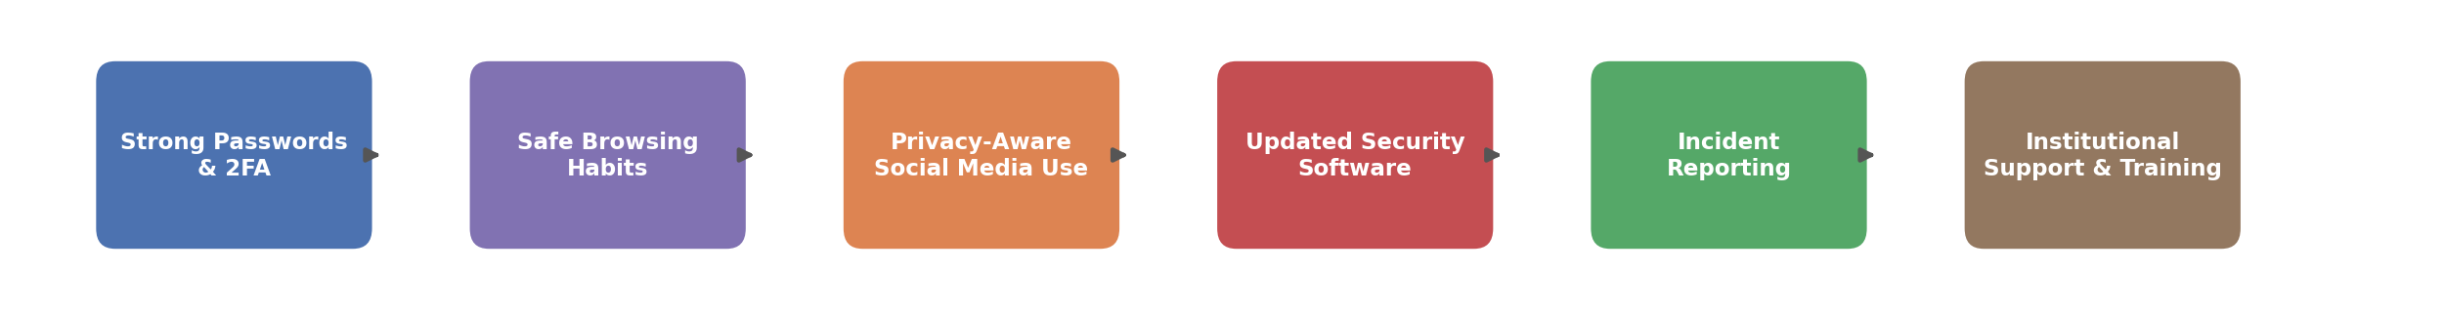
Figure 2.1: Layers of student cyber defense, from individual security habits to institutional support.
In the Indian context, the Ministry of Electronics and Information Technology (2022) runs the Information Security Education and Awareness (ISEA) Programme, aimed at building a culture of cybersecurity awareness among students and educators across the country. Rahman, Sairi, Zizi, and Khalid (2020) highlight the importance of embedding cybersecurity education directly into school and college curricula rather than treating it as an optional add-on, arguing that early, structured exposure builds stronger long-term habits. Recent literature reflects a layered model of student cyber defense, beginning with individual habits such as strong passwords and two-factor authentication, extending through safe browsing and privacy-aware social media use, and ultimately depending on institutional support such as security software provisioning, incident reporting channels, and structured training.

2.5 Challenges and Limitations Identified in Literature
Despite growing attention to the issue, the literature consistently identifies several recurring challenges in improving student cybersecurity awareness. Chowdhury and Gkioulos (2021) review cybersecurity training literature broadly and note that many training programs suffer from low engagement when delivered as generic, one-time sessions rather than as interactive or scenario-based exercises. Kumar and Verma (2020) similarly find that Indian university students often underestimate their personal risk of being targeted, believing cyberattacks are more likely to affect large organizations than individual students, which reduces motivation to adopt safer practices even when awareness of threats exists.

2.6 Role of Institutions and Digital Literacy Initiatives
A significant portion of recent literature also examines the role of institutional initiatives in improving student digital literacy and cybersecurity readiness. Bhattacharya and Ghosh (2022) study digital literacy and cybersecurity awareness among Indian college students, finding that students who had participated in at least one structured cybersecurity workshop demonstrated measurably safer password and social media practices compared to those who had not. This finding directly informed the design of the survey used in this study, which explicitly measures both prior exposure to institutional training and current security behaviour, in order to assess the practical relationship between the two among the surveyed student population.

Chapter 3: Methodology

3.1 Research Approach
This study used a quantitative, descriptive survey to capture a snapshot of students’ cybersecurity knowledge, security habits, and attitudes toward institutional training.

3.2 Data Collection Tool and Procedure
A structured questionnaire of 15 multiple-choice, rating-scale, and short-answer questions covered familiarity with cybersecurity terms, password and account security, social media privacy, phishing recognition, and prior training. It was administered in print and through a mobile-friendly online form across classrooms, the library, and common areas, producing 100 valid responses.

3.3 Rationale for Method Selection
A survey was the most cost-effective way to reach a large, diverse group of students quickly. The structured format kept responses comparable, making risky behaviours and awareness–practice gaps easy to identify, while offering printed and online forms avoided bias toward technology-comfortable respondents.

3.4 Sample Profile
The 100 respondents represented a diverse cross-section of the student community, as summarized below.
Category | Segment | % of Respondents
Year of Study | First Year | 20%
 | Second Year | 35%
 | Third Year | 30%
 | Postgraduate | 15%
Academic Stream | Computer Science / IT | 40%
 | Commerce | 30%
 | Arts | 15%
 | Other Science Streams | 15%
Primary Device Used | Smartphone and Laptop | 65%
 | Smartphone Only | 20%
 | Desktop / Other | 15%

Chapter 4: Field Work Descriptions, Observations, and Analysis

4.1 Awareness of Common Cybersecurity Threats
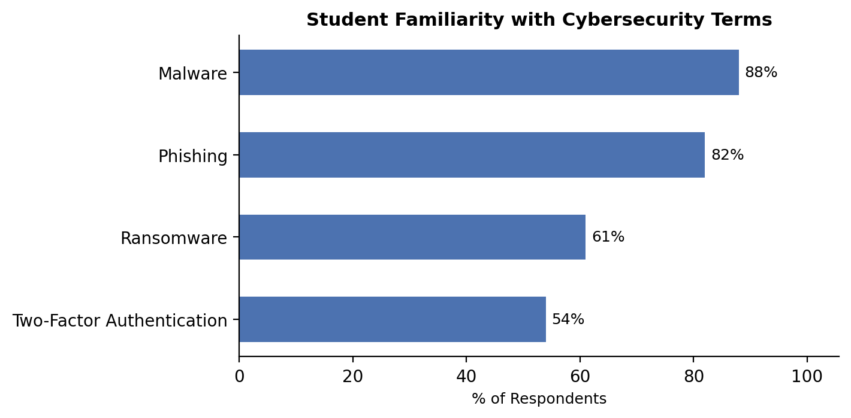
Figure 4.1: Student familiarity with common cybersecurity terms.
The initial and most fundamental finding of the survey relates to students’ general familiarity with common cybersecurity terminology. Familiarity was highest for "malware" (88%) and "phishing" (82%), both widely covered in general digital literacy content, while awareness dropped for more technical terms such as "ransomware" (61%) and especially "two-factor authentication" (54%), indicating that awareness of protective tools lags behind awareness of threats themselves.
Question | Response | % of Respondents
Have you heard of the term "phishing" before? | Yes | 82%
 | No | 18%
Have you received any cybersecurity training from your college? | Yes | 29%
 | No | 71%

4.2 Password and Account Security Practices
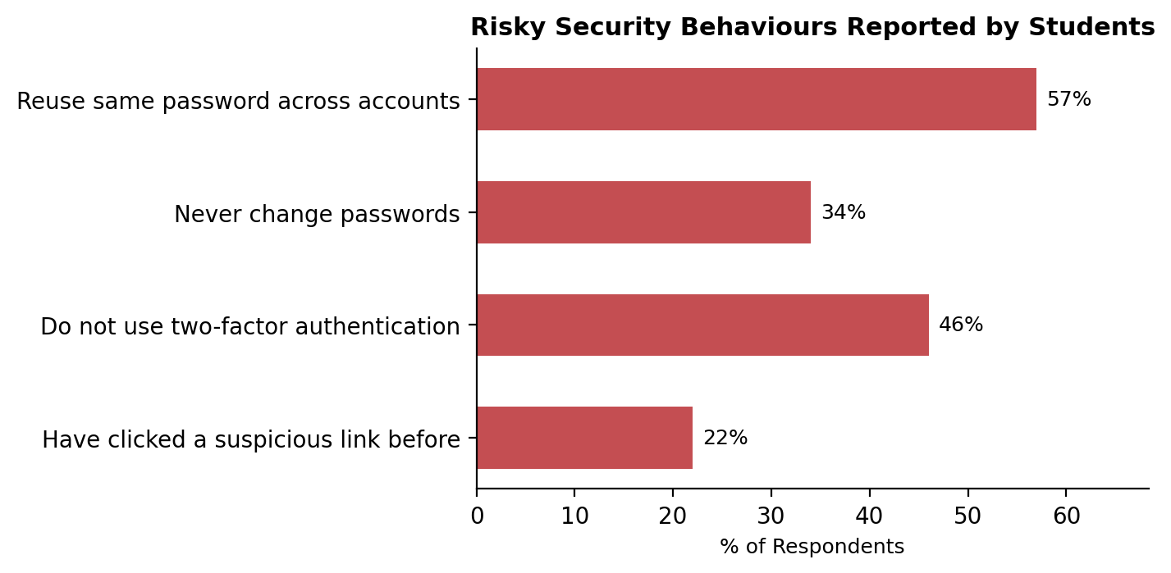
Figure 4.2: Risky security behaviours reported by students.
While awareness of threats is relatively high, the survey reveals a significant gap between knowledge and safe practice. A striking 57% of respondents admit to reusing the same password across multiple accounts, and 34% report never changing their passwords at all. Two-factor authentication, one of the most effective safeguards against account compromise, is not used by 46% of respondents, and 22% admit to having clicked a suspicious link or attachment at some point.
Do you use two-factor authentication (2FA) on your important accounts? | % of Respondents
Yes | 39%
No | 46%
Not sure what this is | 15%

4.3 Social Media and Data Privacy Behaviour
Respondents were also asked about their social media and data privacy habits, which represent one of the most common avenues through which students are exposed to scams and unwanted contact.
Question | Response | % of Respondents
Have you reviewed your social media privacy settings? | Yes | 61%
 | No | 39%
How often do you accept friend/follow requests from strangers? | Often | 18%
 | Sometimes | 35%
 | Rarely | 30%
 | Never | 17%
Do you publicly share personal information (location, phone number)? | Yes | 24%
 | No | 76%

While a majority of students (61%) have taken the basic step of reviewing their privacy settings, more than half (53% combined "often" and "sometimes") accept follow or friend requests from strangers, indicating that privacy awareness has not fully translated into cautious online interaction habits.

4.4 Phishing Recognition Ability
To assess practical readiness rather than just self-reported awareness, the survey included a simple scenario-based question asking students to identify whether a described email was likely to be a phishing attempt.
Could you correctly identify the phishing email in the test scenario? | % of Respondents
Yes | 58%
No | 25%
Not sure | 17%

The finding that only 58% of students could correctly identify a phishing attempt in a simple test scenario, despite 82% claiming familiarity with the term "phishing," reinforces the central gap identified throughout this study: recognizing a term in the abstract is not the same as being able to apply that knowledge in a realistic situation.

4.5 Use of Security Tools and Institutional Support
Respondents were also asked about their use of basic security tools and their exposure to institutional cybersecurity support and training.
Do you have antivirus/security software installed on your primary device? | % of Respondents
Yes | 47%
No | 33%
Not sure | 20%

Only 47% of respondents confirmed having security software installed on their primary device, and as noted earlier, 71% report never having received any cybersecurity training from their college. Despite this, demand for such training is exceptionally high: 89% of respondents said they would like to see more cybersecurity awareness programs offered by their institution, with only 3% opposed.

4.6 Suggestions for Improvement
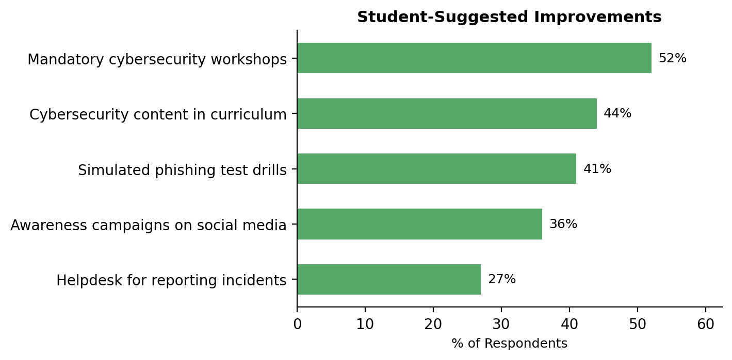
Figure 4.3: Student-suggested improvements to campus cybersecurity awareness, ranked by frequency of mention.
The survey included an open-ended question inviting students to suggest improvements to cybersecurity awareness at their college based on their own experience. Responses were grouped into common themes: "mandatory cybersecurity workshops" (52%) was the most frequently mentioned suggestion, followed by "cybersecurity content in curriculum" (44%), "simulated phishing test drills" (41%), "awareness campaigns on social media" (36%), and a "helpdesk for reporting incidents" (27%). These student-driven suggestions closely mirror the gaps identified earlier in this chapter, reinforcing that structured, hands-on training would directly address the most pressing awareness and practice gaps reported by students.

Chapter 5: Conclusion and Recommendations

5.1 Detailed Summary of Key Findings
This field project was initiated to investigate and document the level of cybersecurity awareness, security practices, and training needs among college students. The primary data, gathered from a survey of 100 respondents across different years of study and academic streams, yielded several important findings.
Firstly, the research confirms that general awareness of cybersecurity terminology is reasonably strong among students, with 88% familiar with "malware" and 82% familiar with "phishing." However, this awareness does not consistently translate into safe practice, with only 58% of students able to correctly identify a phishing attempt in a practical test scenario.
Secondly, the nature of student security behaviour reveals significant risk exposure. A majority of respondents (57%) reuse passwords across multiple accounts, 46% do not use two-factor authentication, and only 47% have security software installed on their primary device. These gaps persist despite generally positive attitudes toward cybersecurity.
Thirdly, the study identified three critical gaps shaping student vulnerability:
- A significant knowledge-to-practice gap, where students recognize threats in theory but struggle to apply that knowledge in realistic scenarios.
- Widespread password and account security shortcuts, including password reuse and low two-factor authentication adoption.
- Minimal institutional training, with 71% of respondents having never received cybersecurity training from their college, despite 89% wanting more of it.
Together, these findings reveal a dual reality: students are broadly aware that cyber threats exist, but lack the structured, practical training needed to translate that awareness into consistently safe behaviour. Closing this gap demands sustained institutional investment in cybersecurity education, not one-time awareness efforts.

5.2 Contribution to a Deeper Understanding
The findings of this study contribute to a deeper understanding of how cybersecurity awareness functions, and fails to function, among college students. While much of the existing research emphasizes general awareness levels, this project reveals the specific gap between recognizing cybersecurity terms and applying that knowledge in practice. Students benefit from a strong foundation of general awareness, but this foundation alone does not protect them from real-world threats such as phishing, weak password practices, or unsafe social media behaviour, particularly in the absence of structured, hands-on institutional training.

5.3 Actionable Recommendations and Future Scope
Based on the evidence gathered and subsequent analysis, the following recommendations are proposed to improve cybersecurity awareness and safe practice among students:
- Introduce Mandatory Workshops — Colleges should conduct structured, hands-on cybersecurity workshops during orientation and at regular intervals throughout the academic year.
- Integrate Cybersecurity into Curriculum — Basic cybersecurity and digital literacy content should be embedded into existing coursework, particularly for non-technical streams.
- Conduct Simulated Phishing Drills — Periodic, low-stakes simulated phishing exercises should be used to build practical recognition skills beyond theoretical awareness.
- Promote Two-Factor Authentication — Institutions should actively encourage and support the setup of two-factor authentication on student email and portal accounts.
- Establish an Incident Reporting Helpdesk — A simple, accessible channel should be created for students to report suspicious emails, messages, or account activity.
Together, these recommendations suggest a roadmap where student cybersecurity awareness continues to mature from theoretical knowledge into consistent safe practice. The table below outlines a phased roadmap for implementing these recommendations at an institutional level.
Phase | Focus Area | Key Activities | Target Outcome
Phase 1 | Awareness Campaign | Orientation sessions, posters, and email advisories on common threats | Baseline awareness across all students
Phase 2 | Curriculum Integration | Embed cybersecurity modules and electives into existing courses | Structured, consistent knowledge base
Phase 3 | Simulated Drills | Run periodic simulated phishing exercises with feedback | Improved practical recognition skills
Phase 4 | Continuous Monitoring | Annual awareness audit surveys and helpdesk incident tracking | Sustained, measurable improvement

References
1. Kumar, A., & Verma, S. (2020). Cybersecurity awareness and behavior among university students in India. Journal of Information Security Education, 8(1), 33–47.
2. Alharbi, T., & Tassaddiq, A. (2021). Assessment of cybersecurity awareness among students of Majmaah University. Big Data and Cognitive Computing, 5(2), 23.
3. Zwilling, M., Klien, G., Lesjak, D., Wiechetek, Ł., Cetin, F., & Basim, H. N. (2020). Cyber security awareness, knowledge and behavior: A comparative study. Journal of Computer Information Systems, 62(1), 82–97.
4. Rahman, N. A. A., Sairi, I. H., Zizi, N. A. M., & Khalid, F. (2020). The importance of cybersecurity education in school. International Journal of Information and Education Technology, 10(5), 378–382.
5. Ministry of Electronics and Information Technology, Government of India. (2022). Information Security Education and Awareness (ISEA) Programme.
6. Pattinson, M., Butavicius, M., Parsons, K., McCormac, A., & Calic, D. (2017). Managing information security awareness at an Australian university. Journal of Information Security and Applications, 32, 1–8.
7. Chowdhury, N., & Gkioulos, V. (2021). Cyber security training for critical infrastructure protection: A literature review. Computer Science Review, 40, 100361.
8. Bhattacharya, D., & Ghosh, K. (2022). Digital literacy and cybersecurity awareness among Indian college students. Journal of Educational Technology Research, 9(3), 112–125.
9. Wilson, M., & Hash, J. (2003). Building an Information Technology Security Awareness and Training Program (NIST Special Publication 800-50). National Institute of Standards and Technology.

Appendices

Appendix A: Survey Questionnaire
Project Title: Cybersecurity Awareness Survey Among Students
Introduction and Purpose:
Thank you for participating in this academic survey. This research is being conducted as part of a field project for the Bachelor of Science in Computer Science program at J.K. College of Science and Commerce. The purpose of this survey is to understand student awareness of common cybersecurity threats, their password and account security habits, and their interest in institutional cybersecurity training.
Survey Questions
Section 1: Respondent Information
1. What is your year of study?
☐ First Year ☐ Second Year ☐ Third Year ☐ Postgraduate
2. What is your academic stream?
☐ Computer Science / IT ☐ Commerce ☐ Arts ☐ Other: ___________
3. Which device do you use most for internet access?
☐ Smartphone only ☐ Smartphone and Laptop ☐ Desktop / Other
Section 2: Awareness of Cybersecurity Threats
4. Which of the following terms are you familiar with? (Select all that apply)
☐ Malware ☐ Phishing ☐ Ransomware ☐ Two-Factor Authentication
5. Have you received any cybersecurity training from your college?
☐ Yes ☐ No
Section 3: Password and Account Security
6. Do you use the same password across multiple accounts?
☐ Yes ☐ No
7. Do you use two-factor authentication (2FA) on your important accounts?
☐ Yes ☐ No ☐ Not sure what this is
Section 4: Social Media and Privacy Behaviour
8. Have you reviewed your social media privacy settings?
☐ Yes ☐ No
9. How often do you accept friend/follow requests from strangers?
☐ Often ☐ Sometimes ☐ Rarely ☐ Never
10. Do you publicly share personal information such as your location or phone number?
☐ Yes ☐ No
Section 5: Phishing Awareness and Security Tools
11. In the scenario described by the surveyor, could you correctly identify the phishing email?
☐ Yes ☐ No ☐ Not sure
12. Have you ever clicked a suspicious link or attachment?
☐ Yes ☐ No
13. Do you have antivirus/security software installed on your primary device?
☐ Yes ☐ No ☐ Not sure
14. Would you like your college to offer more cybersecurity awareness programs?
☐ Yes ☐ No ☐ Maybe
15. What single improvement would most help you feel safer online? (Open-ended)
______________________________________________________________

Appendix B: Summary of Survey Responses
The tables below summarize the distribution of responses collected from the 100 respondents across the key survey questions, supplementing the analysis presented in Chapter 4.
Q1. What is your year of study?
Year of Study | No. of Respondents | % of Respondents
First Year | 20 | 20%
Second Year | 35 | 35%
Third Year | 30 | 30%
Postgraduate | 15 | 15%

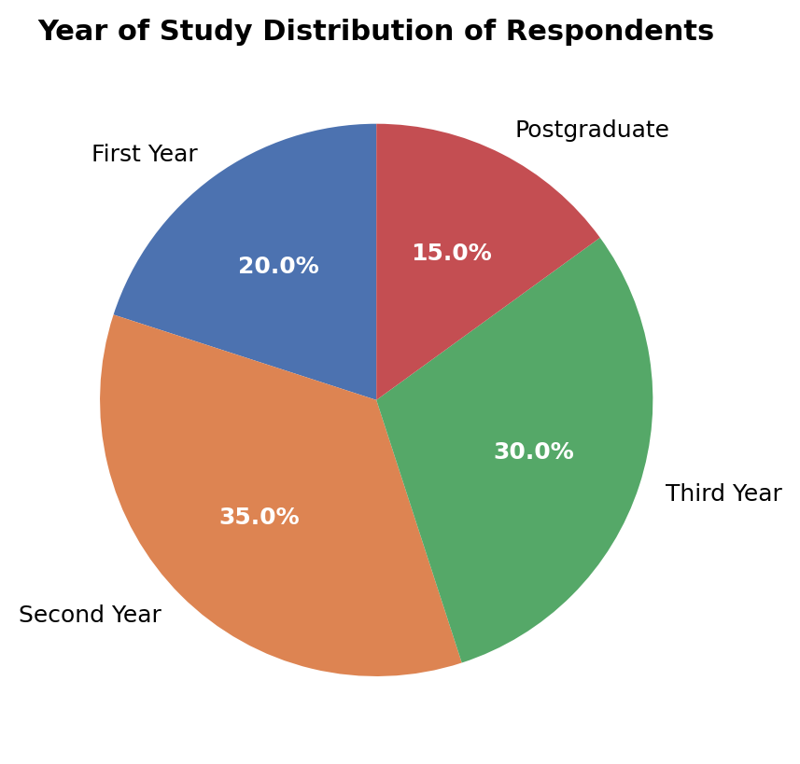
Figure B.1: Year of study distribution of survey respondents.
Q6. Do you use the same password across multiple accounts?
Response | No. of Respondents | % of Respondents
Yes | 57 | 57%
No | 43 | 43%

Q7. Do you use two-factor authentication (2FA) on your important accounts?
Response | No. of Respondents | % of Respondents
Yes | 39 | 39%
No | 46 | 46%
Not sure what this is | 15 | 15%

Q11. Could you correctly identify the phishing email in the test scenario?
Response | No. of Respondents | % of Respondents
Yes | 58 | 58%
No | 25 | 25%
Not sure | 17 | 17%

Q14. Would you like your college to offer more cybersecurity awareness programs?
Response | No. of Respondents | % of Respondents
Yes | 89 | 89%
No | 3 | 3%
Maybe | 8 | 8%

Appendix C: Glossary of Terms
Term | Meaning
Phishing | A deceptive attempt, usually via email or message, to trick a user into revealing sensitive information such as passwords or bank details.
Malware | Malicious software designed to damage, disrupt, or gain unauthorized access to a computer system.
Ransomware | A type of malware that encrypts a victim’s files or system and demands payment in exchange for restoring access.
Two-Factor Authentication (2FA) | A security process requiring two different forms of verification (e.g., password plus a one-time code) before granting account access.
Social Engineering | The psychological manipulation of individuals into performing actions or divulging confidential information.
VPN (Virtual Private Network) | A service that encrypts a user’s internet connection, helping to protect data on public or untrusted networks.
Data Breach | An incident in which sensitive, protected, or confidential data is accessed or disclosed without authorization.

Appendix D: Consent and Confidentiality Statement
All respondents were informed of the academic purpose of the survey and assured that their responses would remain confidential and be reported only in aggregate. Participation was voluntary, respondents could skip any question or withdraw at any time, and no personally identifying information beyond broad demographic categories (year of study, stream, and device used) was collected.

