Sample Question Bank — Source Document
Instructions: Each question is worth the marks shown. Correct answers are included for this assessment exercise.
Q1. (Multiple Choice | Marks: 1 | Difficulty: Easy)
Which Python data type is commonly used to store an ordered, changeable collection?
A. tuple
B. list
C. str
D. int
Correct Answer: B
Q2. (True/False | Marks: 1 | Difficulty: Easy) Python dictionaries store data as key-value pairs. Correct Answer: True
Q3. (Multiple Choice | Marks: 2 | Difficulty: Medium)
Which SQL clause is used to filter grouped results after aggregation?
A. WHERE
B. ORDER BY
C. HAVING
D. LIMIT
Correct Answer: C
Q4. (True/False | Marks: 1 | Difficulty: Easy) XML tags are case-sensitive.
Correct Answer: True
Q5. (Multiple Choice | Marks: 2 | Difficulty: Medium)
Which Python standard-library module can parse XML documents?
A. pathlib

B. xml.etree.ElementTree
C. statistics
D. secrets
Correct Answer: B
Q6. (Multiple Choice | Marks: 2 | Difficulty: Medium)
Which file format is used by Moodle to import questions into a question bank?
A. Moodle XML
B. PNG
C. MP3
D. EXE
Correct Answer: A
Q7. (True/False | Marks: 1 | Difficulty: Easy)
A SQL PRIMARY KEY is intended to uniquely identify each row in a table. Correct Answer: True
Q8. (Multiple Choice | Marks: 2 | Difficulty: Medium)
If a script processes 5 files per minute, how many files can it process in 8 minutes at the same rate?
A. 13
B. 35
C. 40
D. 45
Correct Answer: C
Q9. (Multiple Choice | Marks: 3 | Difficulty: Hard)
For the expression below, what is the value of x when 2x + 6 = 14? Equation: 2x + 6 = 14
A. 2
B. 3

C. 4
D. 5
Correct Answer: C
Q10. (Multiple Choice | Marks: 3 | Difficulty: Hard)
Refer to the diagram below. Which sequence best describes the flow shown?

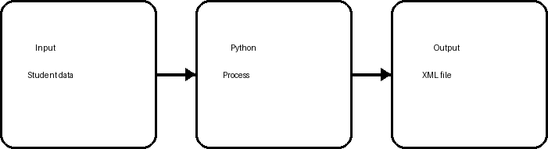

A. Output → Input → Python
B. Input → Python → Output
C. Python → Output → Input
D. Input → Output → Python Correct Answer: B
End of source document.

