Bug Report

Field | Details
Bug ID | BUG-001
Bug Title | Application allows login with an invalid email format
Module | Authentication
Sub Module | Login
Environment | Stage
Browser | Google Chrome 149
Operating System | Windows 11
Severity | Major
Priority | High
Status | Open
Reported By | Gokul V
Reported Date | 06-Jul-2026

Summary
The Login page accepts an invalid email format and allows the user to continue to the password page instead of displaying an email validation error.

Description
The application does not properly validate the email format before processing the login request. An email containing consecutive dots (..) in the local part, such as gokul..v@gmail.com, is accepted as a valid email address. Instead of displaying a validation error, the application allows the user to proceed to the next step of the login process.

Preconditions
• Application is accessible.
• User is on the Login page.
• Stable internet connection is available.
• Supported browser (Google Chrome 149).
• No active user session.

Expected Result
The application should validate the email format before processing the login request. Display 'Please enter a valid email address.' and do not allow the user to proceed until a valid email is entered.

Actual Result
The application accepts the invalid email format and allows the user to continue to the password page without displaying any validation error.

Attachments
• Screenshot 1: Login page with invalid email.
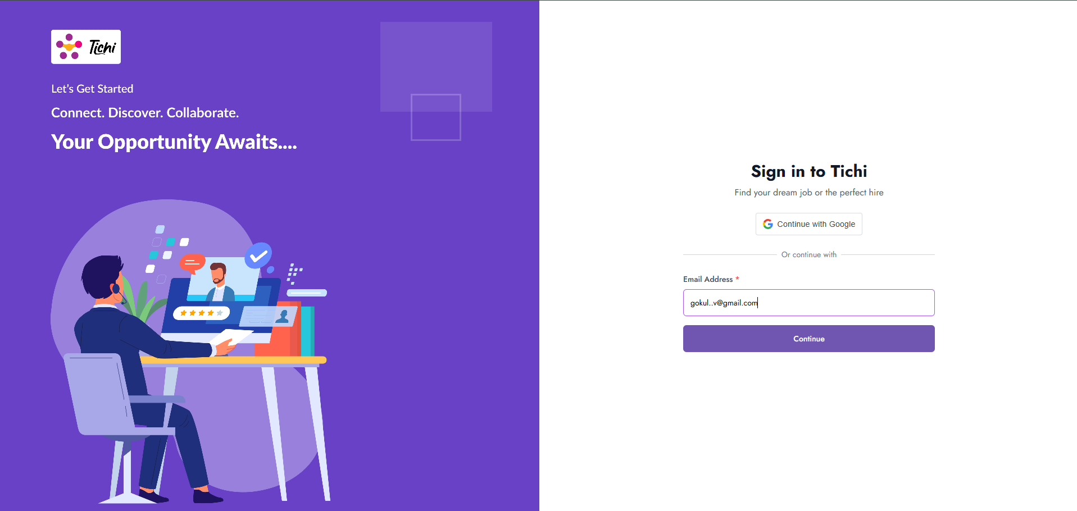
• Screenshot 2: Password page after invalid email is accepted.


Note
Prepared by Gokul V for the Tichi Web Application manual testing assignment.

