Q1：

PCA classification:　()：

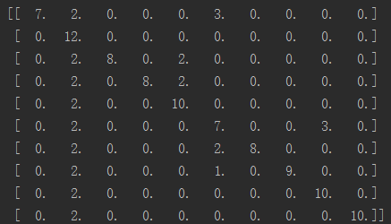



LDA classification:　()：

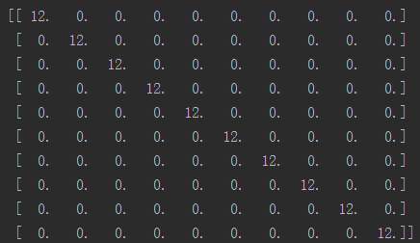



Fused feature： ()

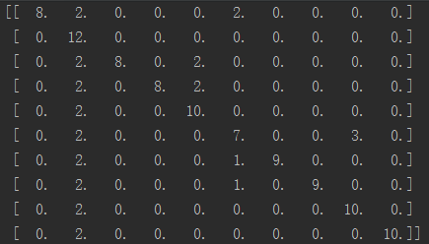



Q2:

LDA is better.

Cause LDA puts the features into another space, which makes the person feature distance faraway from others. But PCA does not use classified information, and makes it worse to recognize faces.

LDA has only 9 vectors, however, better than PCA (30 vectors).

Q3:

When rfa is： 0.0 The ratio is: 1.0

When rfa is： 0.1 The ratio is: 0.9833333333333333

When rfa is： 0.2 The ratio is: 0.8666666666666667

When rfa is： 0.3 The ratio is: 0.8416666666666667

When rfa is： 0.4 The ratio is: 0.7916666666666666

When rfa is： 0.5 The ratio is: 0.7583333333333333

When rfa is： 0.6 The ratio is: 0.7583333333333333

When rfa is： 0.7 The ratio is: 0.75

When rfa is： 0.8 The ratio is: 0.75

When rfa is： 0.9 The ratio is: 0.75

When rfa is： 1.0 The ratio is: 0.7416666666666667

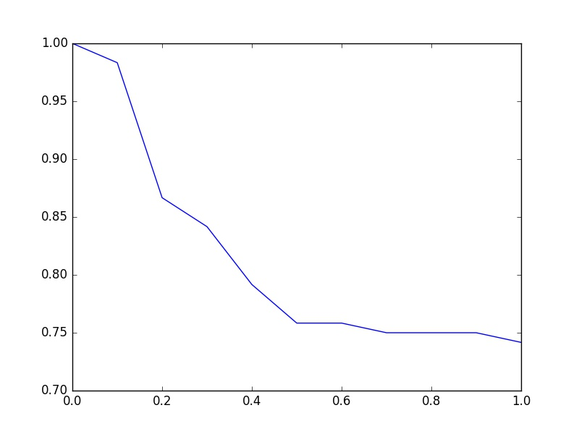

Q4：

Fused feature shows better than PCA, but worse than LDA.

It uses different  to change the weight of the PCA and LDA. But the y of PCA (30) is longer than y of LDA (9), using fused feature makes the result depends on PCA more. Because LDA has a good recognition rate, so fused feature makes PCA outperform. On the contrary, makes LDA worse perform.