**SUBMITTED BY- GROUP 283**

**Members-**

20BCE10876- Harsh Nayak

# 20BCY10051- Aman Kumar

# 20BCE11077- Hare Krishana Mishra

20BCE10839- Suraj Jha

# INTRODUCTION

* 1. Overview

This project focuses on visualizing suicides in India using Tableau, a powerful data visualization tool. It aims to analyze and present data related to suicide cases in India to gain insights and raise awareness about this critical issue.

* 1. Purpose

The purpose of this project is to provide a comprehensive visual representation of suicide data in India. By using Tableau's interactive features, the project aims to enable users to explore and understand the patterns, trends, and factors associated with suicides in different regions of the country. This visualization can help researchers, policymakers, and organizations working in mental health to make data-driven decisions and formulate effective strategies to address this problem.

# LITERATURE SURVEY

* 1. Existing problem

Suicides in India have been a significant concern for several years. The country has witnessed a high number of suicides, with various factors contributing to this issue. Lack of awareness, societal pressures, mental health stigma, unemployment, and poverty are some of the factors associated with suicides in India.

Several studies have been conducted to analyze suicide data in India. Researchers have used statistical analysis, data mining techniques, and visualization tools to identify patterns and factors related to suicides. However, there is a need for more effective and accessible visualization methods to present this data and facilitate better understanding and decision-making.

* 1. Proposed solution

The proposed solution is to utilize Tableau, a powerful data visualization tool, to create interactive and visually appealing dashboards and reports that showcase suicide data in India. By utilizing Tableau's features such as maps, charts, and filters, the project aims to provide a user-friendly platform for exploring and analyzing the data. This solution will help users gain insights into the demographic distribution, time trends, causes, and other relevant aspects of suicides in India.

# THEORETICAL ANALYSIS

* 1. Hardware / Software designing

**Hardware requirements:**

* Computer system capable of running Tableau software
* Sufficient storage capacity to store the dataset

**Software requirements:**

* Tableau Desktop
* Dataset containing suicide data in India
* SQL Workbench
* Tableau Public

# EXPERIMENTAL INVESTIGATIONS

During the course of the project, various investigations were conducted to analyze the suicide data in India. These investigations involved data preprocessing, exploratory data analysis, and the creation of visualizations using Tableau. The dataset was cleaned, outliers were identified and handled appropriately, and relevant features were selected for visualization. Different visualizations were created to represent suicide rates, trends, and demographic information

# RESULT

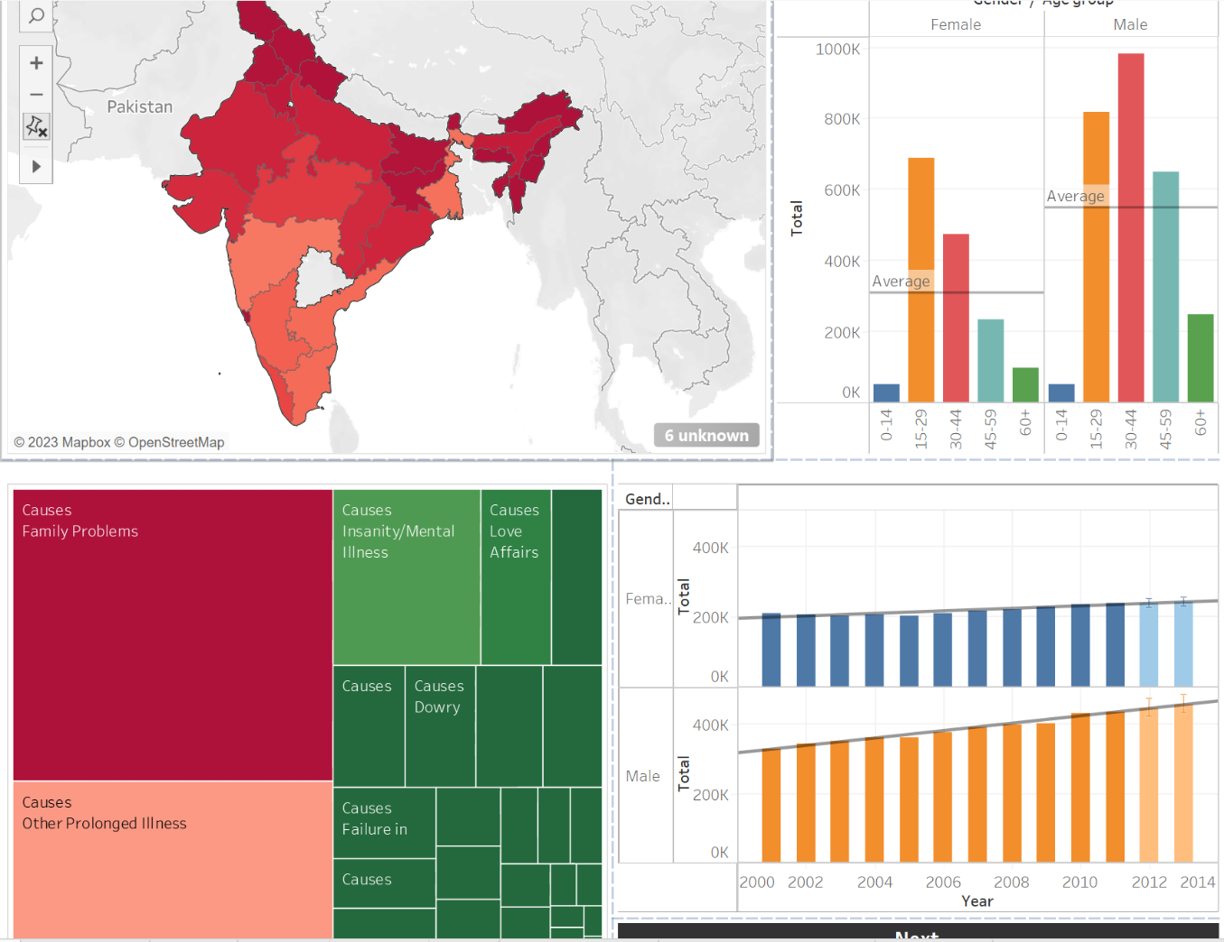

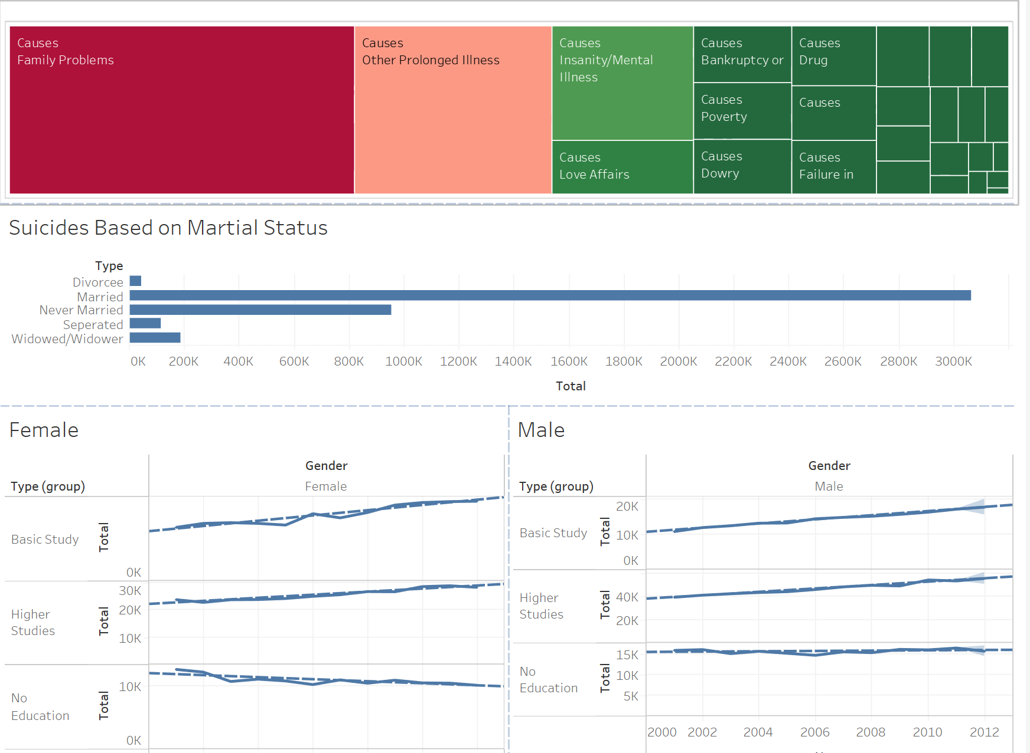

# ADVANTAGES & DISADVANTAGES

**Advantages:**

* Interactive visualizations provide a better understanding of suicide data in India.
* Enables exploration of patterns, trends, and factors associated with suicides.
* Supports data-driven decision-making for researchers, policymakers, and organizations.
* Raises awareness about the critical issue of suicides in India.

**Disadvantages:**

* The accuracy of the findings depends on the quality and completeness of the dataset.
* Visualizations may require interpretation and context to draw meaningful conclusions.
* The project does not address the underlying causes of suicides but aims to provide insights based on available data.

# APPLICATIONS

The solution can be applied in the following areas:

* Research: Researchers can utilize the visualizations to identify patterns and trends in suicide data and conduct further analysis.
* Policy-making: Policymakers can use the insights gained from visualizations to formulate targeted strategies to prevent suicides and promote mental health.
* Public awareness campaigns: Visualizations can be used in public awareness campaigns to inform and educate the general public about suicide rates, risk factors, and available resources.

# CONCLUSION

In conclusion, this project utilized Tableau to visualize suicides in India, aiming to provide a comprehensive and interactive platform to explore and understand the patterns and factors associated with this critical issue. The visualizations created through this project can facilitate data-driven decision-making, raise awareness, and contribute to efforts to address suicides in India.

# FUTURE SCOPE

Future enhancements that can be made to the project include:

* Integration of additional data sources to provide a more comprehensive analysis.
* Real-time updates of the suicide data to ensure the visualizations reflect the most recent information.
* Incorporation of predictive analytics to forecast future suicide rates and identify potential hotspots.
* Collaboration with mental health organizations and experts to provide additional context and resources within the visualizations.

# BIBLIOGRAPHY

* **Datasets-**

[*https://www.kaggle.com/datasets/rajanand/suicides-in-india*](https://www.kaggle.com/datasets/rajanand/suicides-in-india)

* **Inspiration-**

(i)[Brief Theory about Suicides by Kristine Brown](https://etd.ohiolink.edu/apexprod/rws_etd/send_file/send?accession=toledo1301765761&disposition=inline)

(ii)[Aggarwal, S., 2015. Suicide in India. *British medical bulletin*, *114*(1)](https://citeseerx.ist.psu.edu/document?repid=rep1&type=pdf&doi=39cb5c5c465cf0a0aa6db4963346f9b19a7e4fe6)

# APPENDIX

GitHub link: -

**https://github.com/HareKrishanaMishra787/20BCE11077_Hare_Krishana_Mishra_Team283_Data_Analytics**