Task-3
Open-VAS Vulnerability Scanner

Step 1: Install OpenVAS in any linux Distributions.

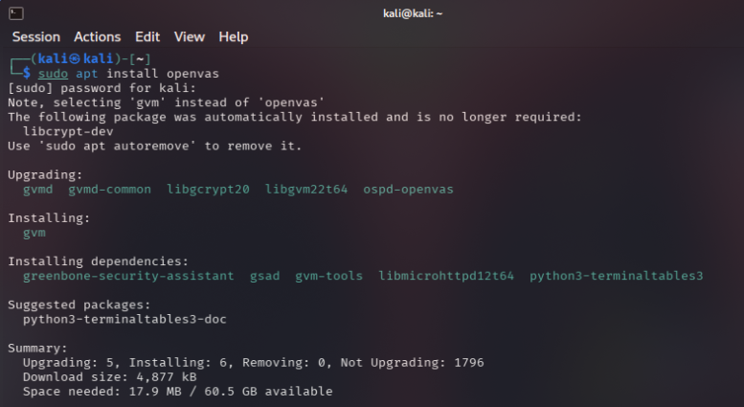
Step 2: Run the configuration command to obtain the credentials for username and password, in order to use the utility.
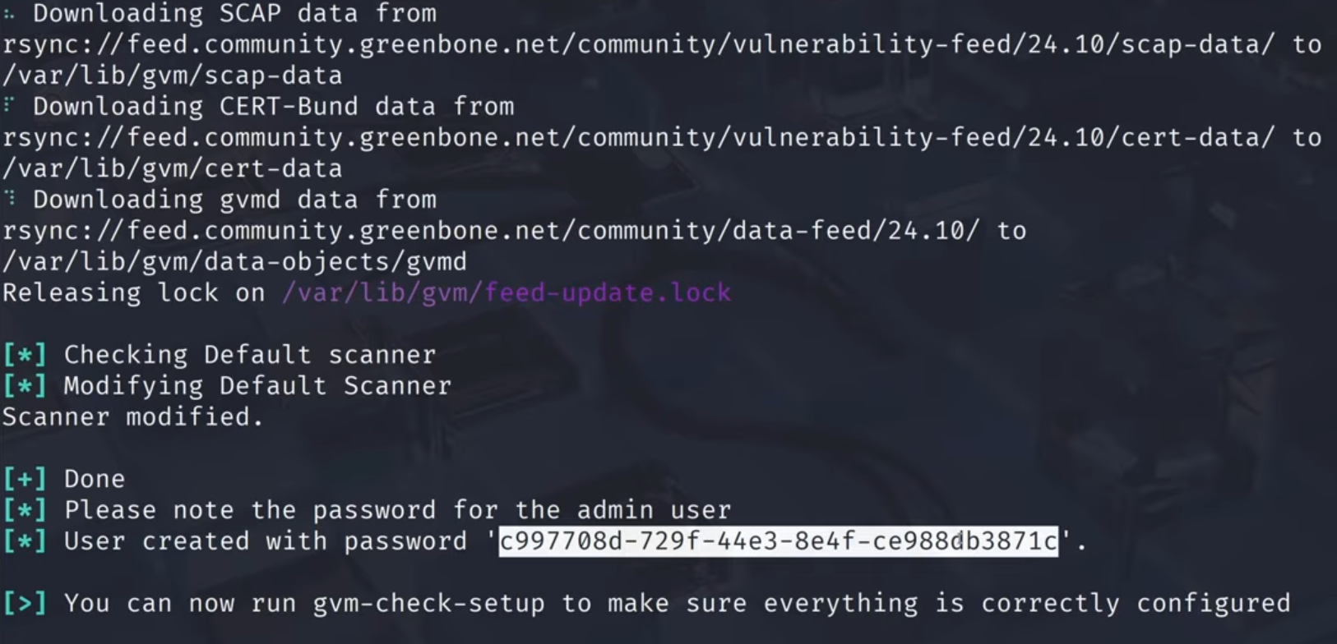

Step 3: Use the credentials to get into the Website which is hosted in the localhost.

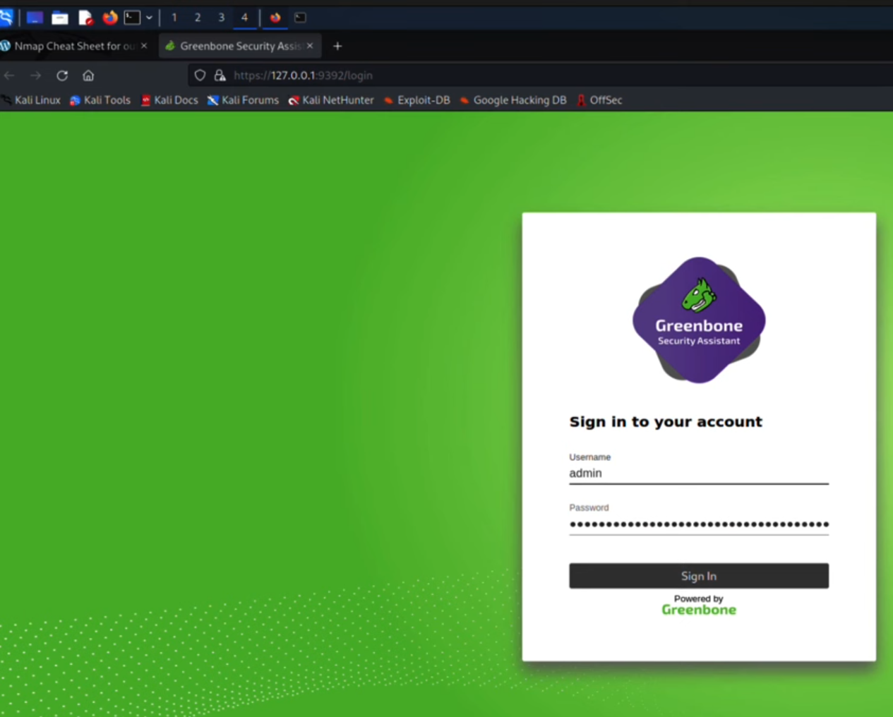
Step 4: Feed the updates, using the command [gvm-feed-update] and reload the website.
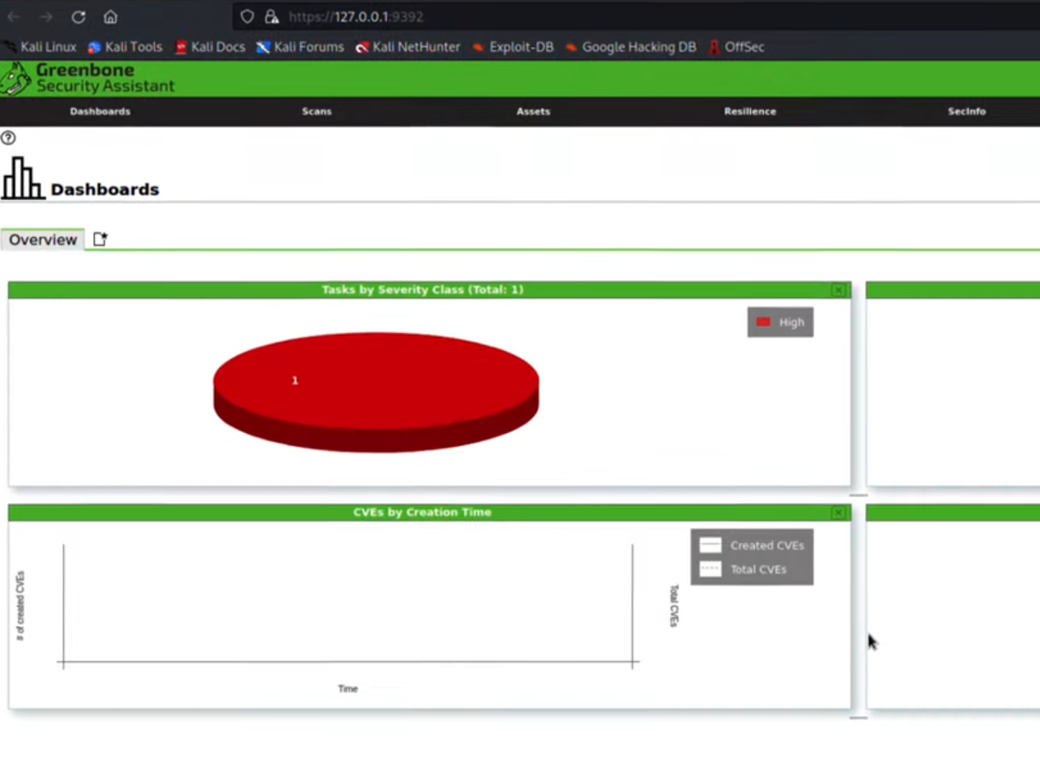
- Hareekshith AS

