Task – 4
Configuring a firewall (Linux)

Step 1: Install ufw using any suitable package manager like dnf, pacman, apt, etc… I will be using apt.
Step 2: Check whether ufw is properly installed by typing ufw in the terminal:
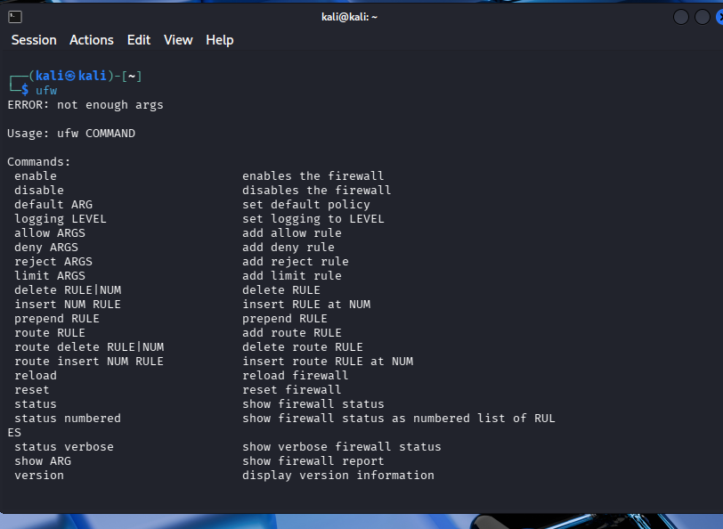

Step 3: Exploring different configurations such as allow certain ports, change default ports, allowing services, deny/allow incoming/outgoing requests.
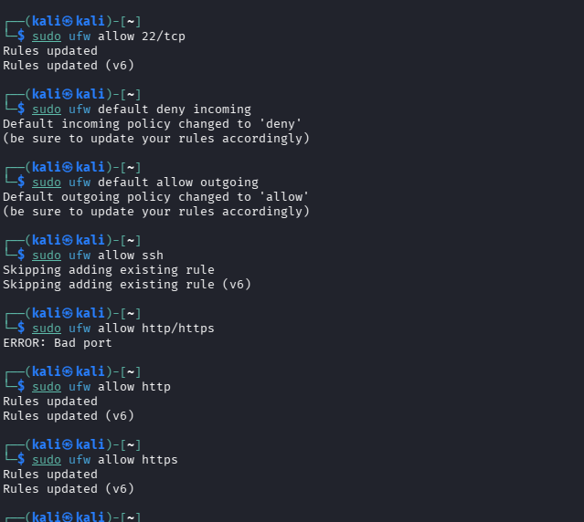
Step 4: Get the firewall working
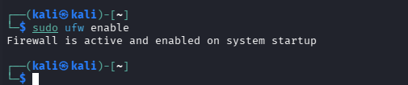
Now, the specified ports will be receiving incoming and outgoing requests, all the others will only be used for outgoing requests. Hence, this system will be under your control as in, no port scan will detect any other ports to perform attack except the ones that are allowed by you, specifically.

- Hareekshith AS

