Task – 5
Wireshark (Packet capturing and filtering)

Install the wireshark and start the capture.

Step 1:
Keep the capturing turned on for a minute atleast, meanwhile, in order to create network traffic, open a few websites or ping any known domains.

Step 2:
Stop the capture, and start filtering the packets based on the protocols.

Step 3:
Filtering what is specified in the task sheet,
HTTP
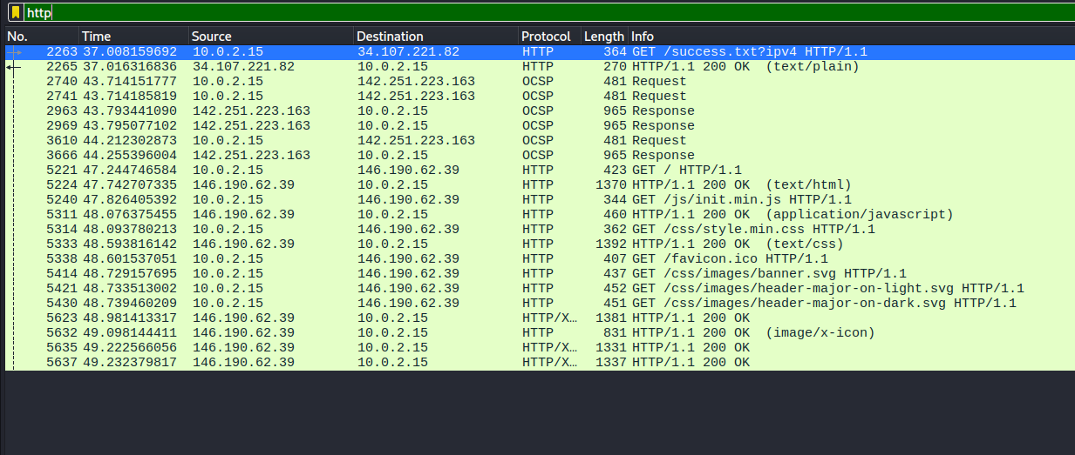
DNS
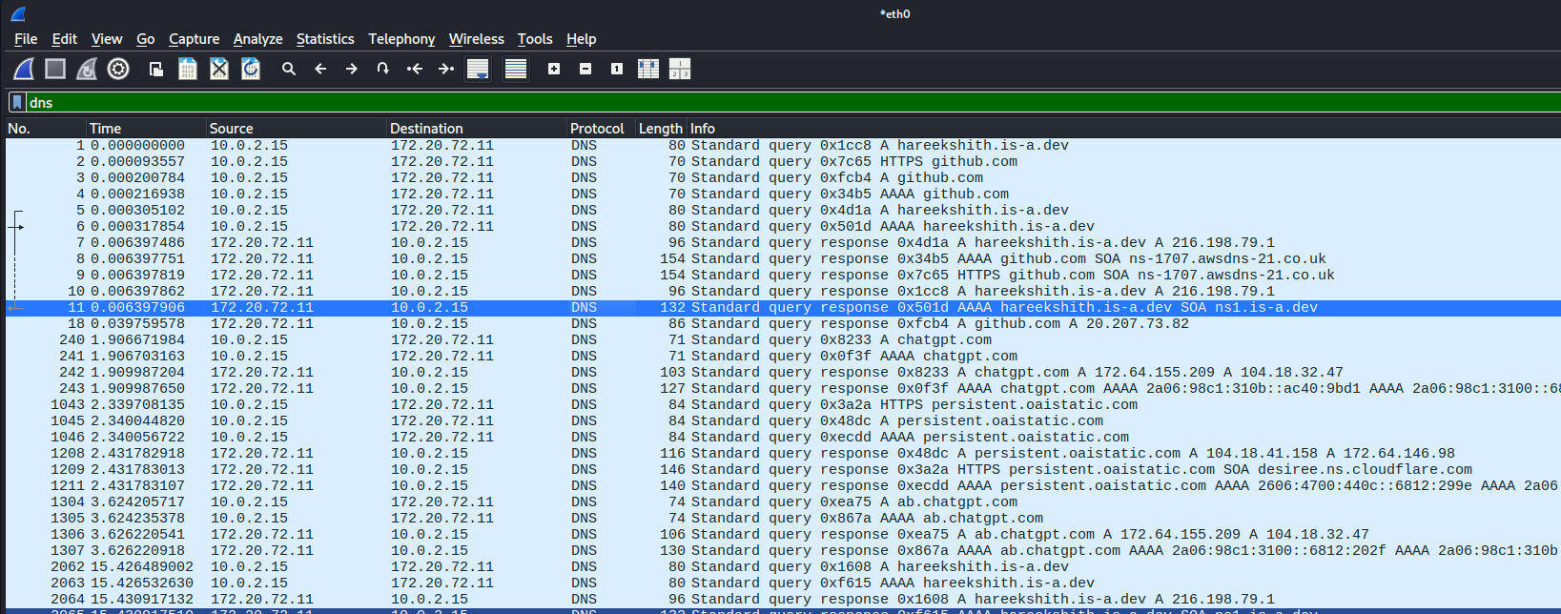

TCP
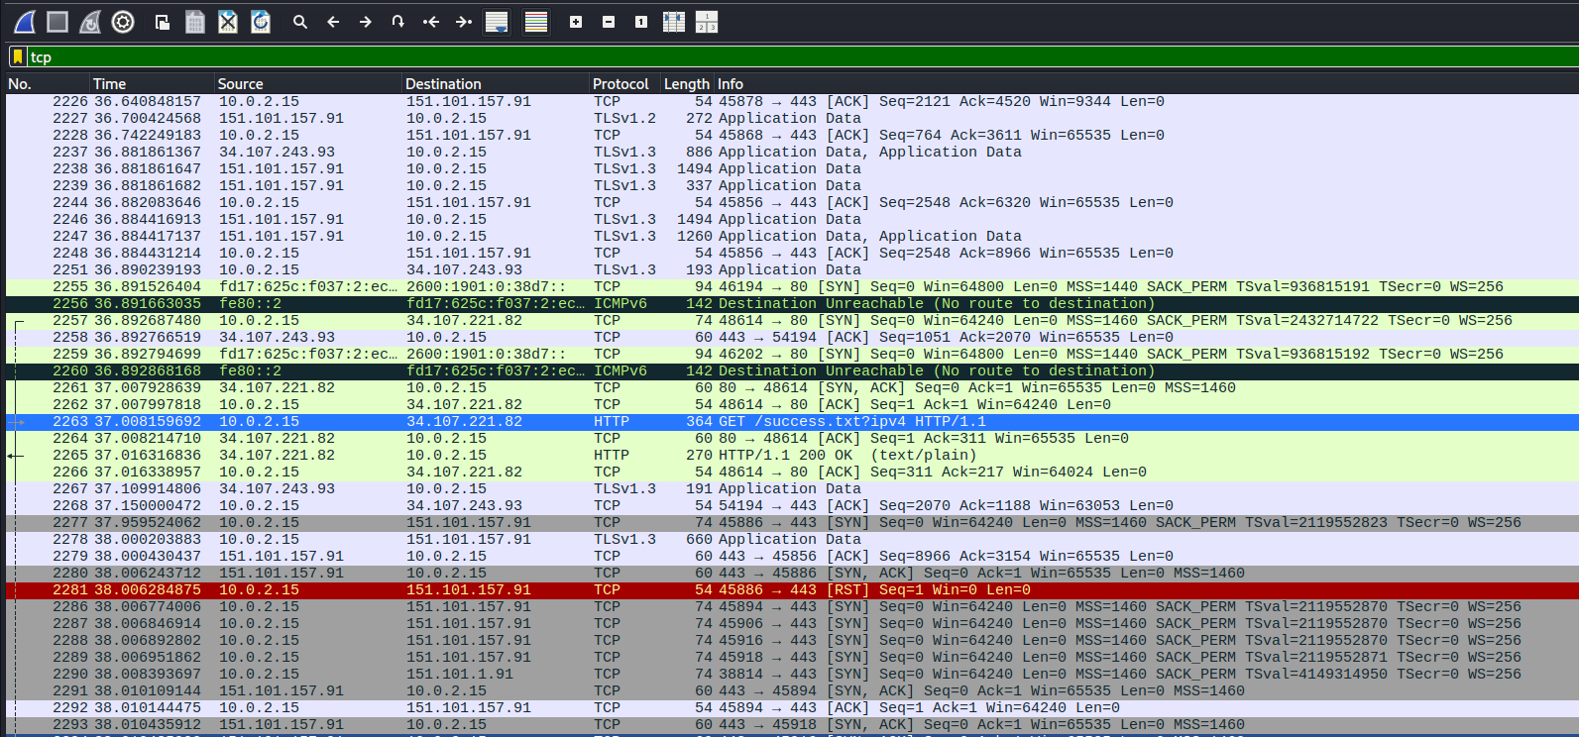
Note: There are also 3 other protocols such as QUIC (Quick UDP internet Connections), TLSv1.3 (Transport Layer Security), ICMP(Internet Control Message Protocol) and OSCP (Online Security Certification Protocol).

Export the whole capture into a .pcap file for future references.

Step 4:

- Hareekshith AS

