Task – 6
Password Evaluation

For this task, I myself have created a python program using regex(re module) that check whether all the upper case, lowercase, numbers and special characters occur and the overall length of the password is more than 8 and less than 20. Below is the screenshot of the outputs received:
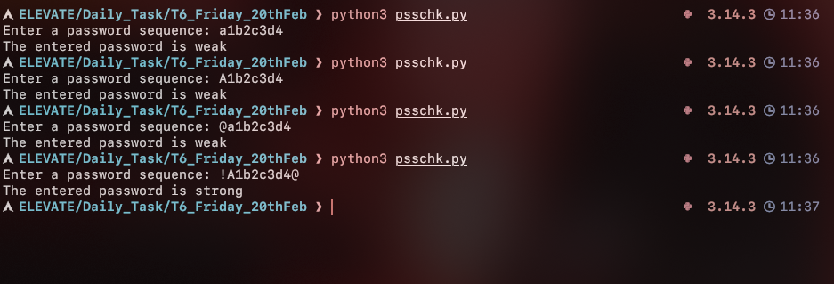
Now, we prefer a robust password to prevent bruteforce attacks using existing heavy dictionaries such as rockyou.txt, etc…. These store a huge amount of leaked, common, easy to crack passwords. In order for your belongings to be safe, we prefer a robust password with lowercase, uppercase, digits and special characters, with their combined length of more than 8 characters so that, even through permutation it takes around 2285 years minimum. Hence, it is an important step to be initiated to have our passwords with all the necessary conditions.

- Hareekshith AS

