Task-8
Setting up a VPN Service

: Install Proton-VPN in any linux Distributions by creating an account.

Step 1

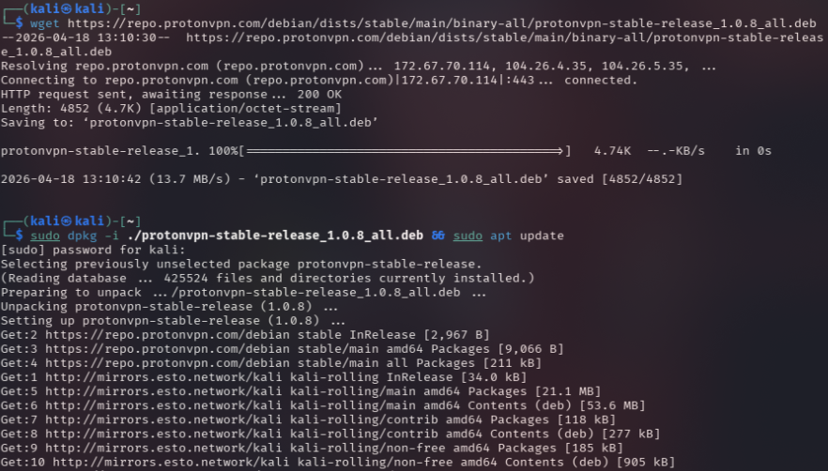
Step 2: Use the account credentials to login to the desktop utility.
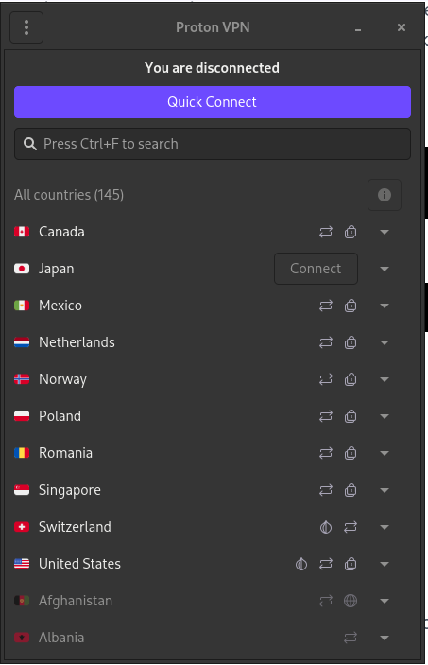

Step 3: Press Quick Connect, and get connected to a free VPN provider.
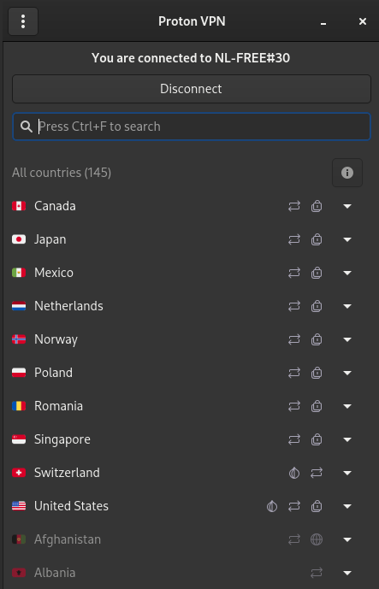
Now we can access all the applications that are made for citizens of Netherlands, as the connected server belongs to Netherlands.
- Hareekshith AS

