**COMMANDS**

Npm create vite@latest

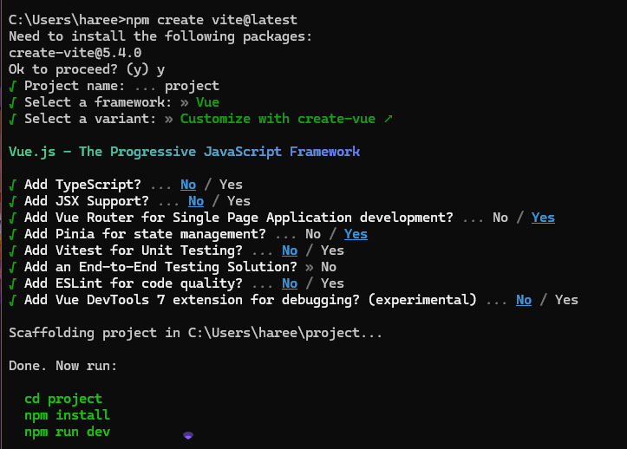

Cd project

Npm install

Code .

Npm I pinia

npm install vee-validate@next yup

npm run dev (run)

npm init -y

npm I express

nodemon server.js