Enhancing Object Removal in Images using Text Prompts

Problem Statement
Image editing has come a long way, but one major hurdle still remains: object removal. Most existing tools rely heavily on manual mask creation, where users must painstakingly outline every object they want to remove. This approach is not only tedious and time-consuming, but it also becomes impractical when dealing with multiple or intricately shaped objects.
While some automated solutions exist, they often fall short in accessibility—they lack the ability to understand natural language commands, making them hard to use for non-experts.
Motivation
Whether it's removing photo bombers from a vacation picture, eliminating watermarks from a presentation slide, or cleaning up timestamps from old scanned images, object removal is a common editing task. Yet, the process is still largely manual.
In scenes with many overlapping or complex objects, creating accurate masks for each one becomes inefficient and error-prone. Imagine having to manually mask every person in a crowded street photo—frustrating and slow.
Now imagine simply typing a prompt like “remove people from the background” and letting the tool do the rest.
Goal
Our goal is to develop an automated, intuitive object removal tool that can understand and act upon natural language instructions. The tool should:
- Accurately detect and isolate objects based on user text prompts.
- Seamlessly restore the background where the objects once were.
- Significantly improve efficiency, precision, and user accessibility compared to traditional manual methods.
By blending computer vision and natural language understanding, this tool aims to democratize advanced image editing, making it faster and easier for everyone—from casual users to professionals.

Model Architecture:
To make object removal both accurate and user-friendly, we combine powerful vision-language models into a streamlined pipeline. The architecture consists of four core components working together:
1. Grounding DINO
A cutting-edge zero-shot object detection model that bridges vision and language. Given an input image and a text prompt (e.g., “car”), Grounding DINO precisely detects and localizes the object of interest—no prior training on specific classes required.
2. Segment Anything Model (SAM)
Once the object is localized, SAM takes over to generate a fine-grained segmentation mask. This model can segment any object in the image with high precision, producing clean boundaries even in cluttered scenes.
3. Stable Diffusion (Inpainting Mode)
With the object mask in hand, Stable Diffusion is used for inpainting—filling in the removed region in a way that looks natural and seamless. It leverages deep generative learning to maintain texture, color, and structural consistency across the image.
4. Fine-Tuning via LoRA (Low-Rank Adaptation)
To improve prompt alignment and output quality, we fine-tune Stable Diffusion using LoRA. This method allows efficient adaptation to specific tasks without needing to retrain the full model, making our solution both scalable and lightweight.
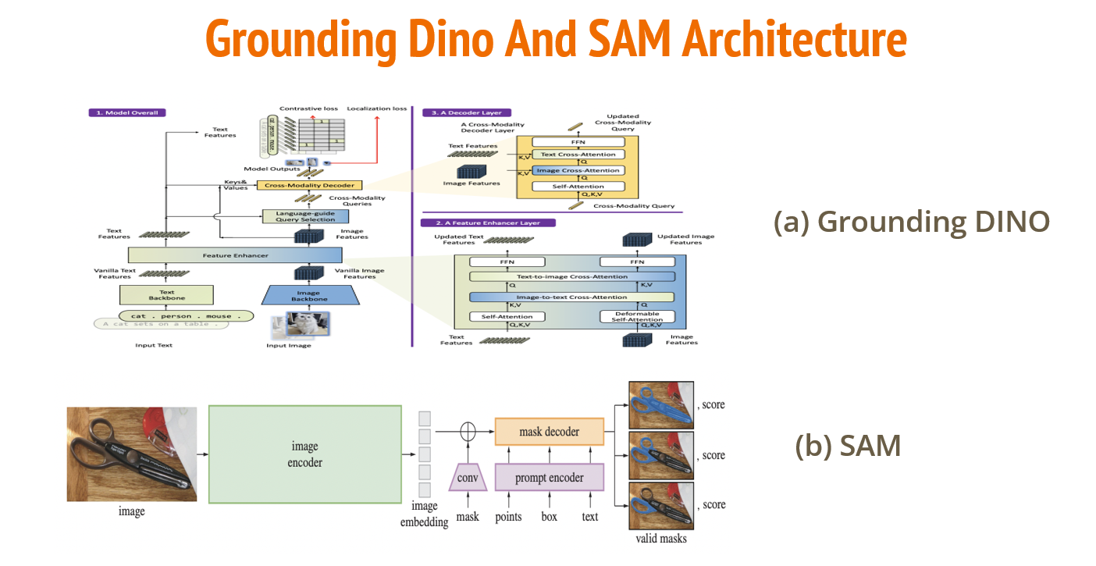
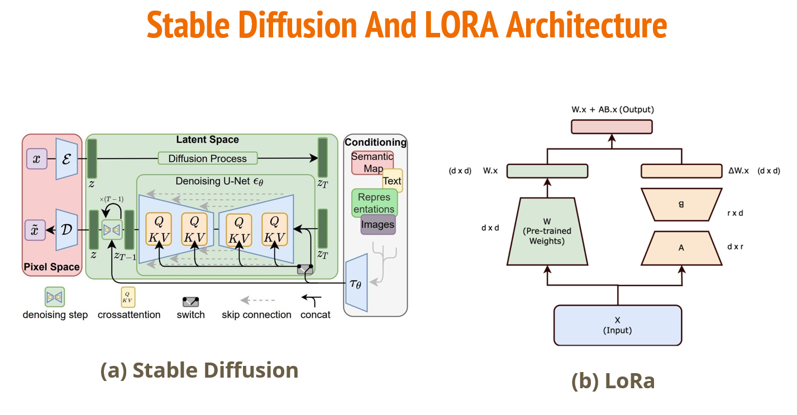

How It Works (Visual Overview)
- Input: An image and a natural language prompt, e.g., “car”.
- Detection: Grounding DINO identifies the car in the scene.
- Segmentation: SAM segments the car, creating a precise mask.
- Prompted Inpainting: With the command “remove car”, the masked region is passed to Stable Diffusion for inpainting.
- Output: A clean, realistic image where the car is seamlessly removed.
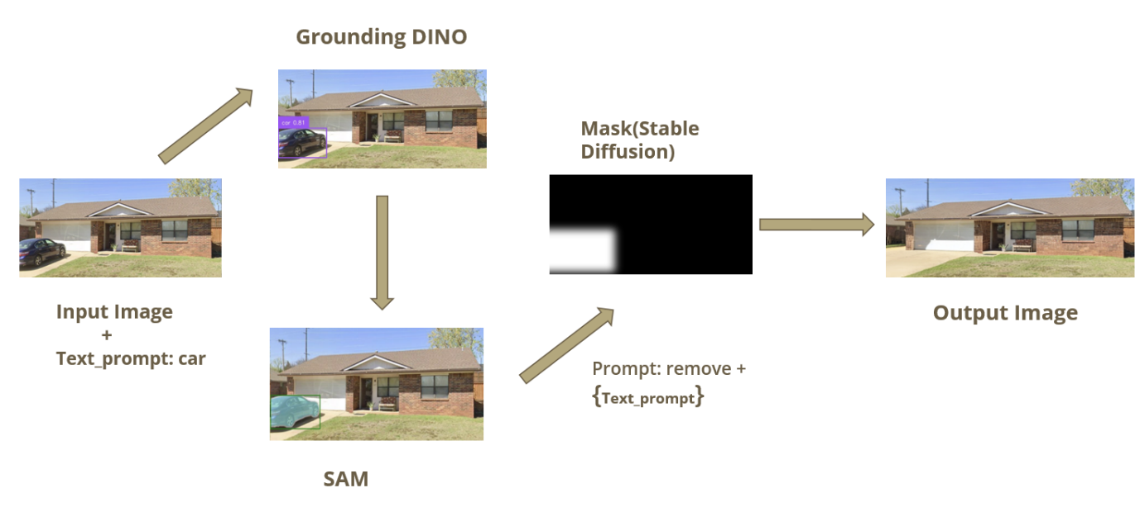

Evaluation Metrics: Measuring Object Removal Quality
To objectively assess the performance of our text-guided object removal pipeline, we rely on a set of well-established image quality and segmentation metrics. These ensure we not only remove the correct object but also restore the image in a way that looks natural to the human eye.
Structural Similarity Index (SSIM)
SSIM evaluates the visual similarity between the original and inpainted image by comparing luminance, contrast, and structural information.
- Higher SSIM values (closer to 1) indicate that the edited image retains the original image’s structure and quality.
- Useful for ensuring coherence in restored regions.

Intersection over Union (IoU)
IoU is a standard metric in object detection and segmentation that measures the overlap between the predicted mask and the ground truth mask.
- Higher IoU means more accurate localization and segmentation of the object to be removed.
- It ensures the masking step is precise, which is critical for clean inpainting.

LPIPS (Learned Perceptual Image Patch Similarity)
LPIPS leverages deep neural network features to measure perceptual similarity, aligning closely with how humans perceive image quality.
- Lower LPIPS scores suggest the inpainted image is perceptually closer to the original.
- Our model consistently achieves low LPIPS values, showing it maintains fine details and perceptual fidelity.

Results
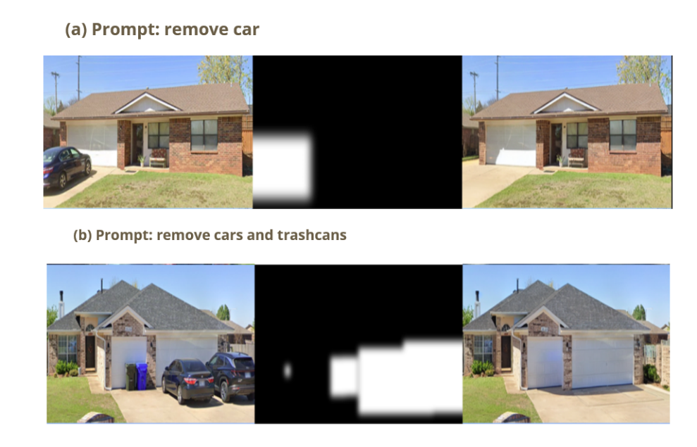

Limitations:
While our model achieves impressive results across a wide range of scenarios, several limitations remain that highlight opportunities for future improvement:

1. Texture and Structure Reconstruction
Reconstructing highly detailed textures or complex structural backgrounds—like brick walls, patterned fabrics, or architectural elements—can still be challenging.
- This sometimes leads to blurry or unrealistic regions in the inpainted output.

2. Reflective, Transparent, or Occluded Objects
Objects that are reflective (e.g., mirrors, glass), transparent (e.g., windows), or partially occluded often leave behind visual inconsistencies.
- These may appear as shadows, ghosting effects, or lighting mismatches, impacting the realism of the edited image.

3. Processing Time and Scalability
Processing high-resolution images or scenes with many objects can significantly increase inference time.
- This limits the model’s effectiveness in real-time applications without additional optimization or hardware acceleration.
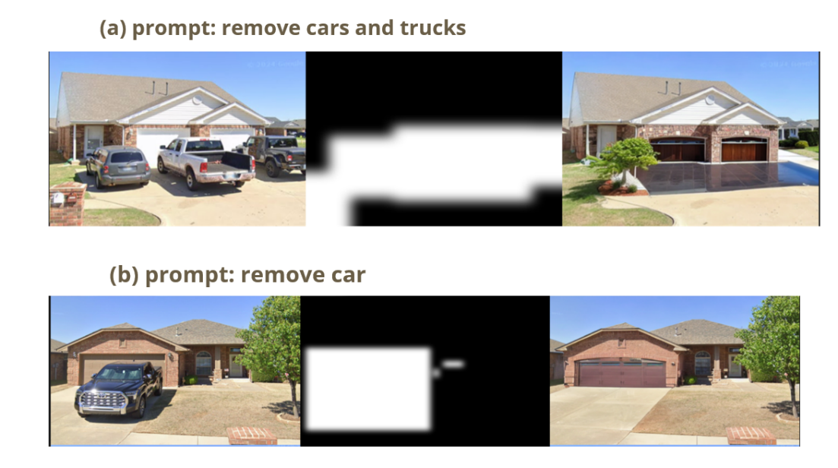

Conclusion
We successfully developed a robust and intuitive system for automated object removal from images using natural-language text commands, transforming a traditionally manual and time-consuming editing process into a streamlined, user-friendly workflow.
By integrating Grounded SAM for precise segmentation with Stable Diffusion-based inpainting, and further enhancing results through LoRA fine-tuning, our system delivers seamless, context-aware image restoration with minimal user input.
The approach not only improves accuracy and visual realism, but also significantly boosts efficiency and accessibility for non-expert users. Our performance, validated through standard metrics like SSIM, IoU, and LPIPS, as well as user feedback, clearly demonstrates superior usability and effectiveness over traditional manual methods.

Future Work
Building on the promising results of our current system, we identify several directions for future enhancement:

1. Multi-Object Removal
Expand the model's capability to handle multiple object types in a single prompt (e.g., “remove all cars and people”), improving flexibility for more complex use cases.

2. Robustness in Challenging Conditions
Improve performance in complex scenes, particularly those involving occlusions, reflections, shadows, or low lighting, where current models may struggle with consistency and realism.

3. Video-Based Object Removal
Extend the system to support temporal consistency in video editing, enabling smooth and accurate object removal in dynamic content across frames—opening doors to real-time video retouching and cinematic post-production.

References:
- Brooks, T., Holynski, A., Efros, A. A. (2023). InstructPix2Pix: Learning to Follow Image Editing Instructions. Proceedings of the IEEE/CVF Conference on Computer Vision and Pattern Recognition (CVPR), 18372–18382.
- Kirillov, A., Mintun, E., Ravi, N., Mao, H., Rolland, C., Gustafson, L., Xiao, T., Whitehead, S., Berg, A. C., Lo, W. Y., & Dollár, P. (2023). Segment Anything. Meta AI Research. arXiv preprint arXiv:2304.02643.
- Liu, S., Zeng, Z., Ren, T., Li, F., Zhang, H., Yang, J., Li, C., Yang, J., Su, H., & Zhu, J. (2023). Grounding DINO: Marrying DINO with Grounded Pre-Training for Open-Set Object Detection. arXiv preprint arXiv:2303.05499. https://arxiv.org/abs/2303.05499.
- Rombach, R., Blattmann, A., Lorenz, D., Esser, P., & Ommer, B. (2022). High-Resolution Image Synthesis with Latent Diffusion Models. Proceedings of the IEEE/CVF Conference on Computer Vision and Pattern Recognition (CVPR), 10684–10695.

