HistoGeneAlign: Multimodal Alignment of H&E Histopathology and Spatial Transcriptomics for Spot-Level Image-Gene Retrieval
ABSTRACT:
HistoGeneAlign is a biomedical multimodal learning project designed to align visual morphology from H&E-stained histopathology images with molecular signals from spatial transcriptomics. The core hypothesis is that local tissue morphology contains recoverable information about spatially localized gene-expression patterns, and that a contrastive learning framework can learn this relationship by pairing H&E patches with transcriptomic profiles from the same tissue locations.
The project has now completed the full first-pass MVP workflow through dataset acquisition and validation, spatial transcriptomics exploration, H&E patch verification and mapping, frozen image embedding extraction, contrastive model training, and bidirectional retrieval evaluation. Using the TENX95 sample from HEST, the project validated 11,845 spatial transcriptomics spots and 541 genes, resolved the patch-to-spot bridge using the H5 barcode field for 7,592 usable H&E patches, generated frozen ResNet-50 image embeddings, trained a CLIP-style image-gene contrastive baseline, and evaluated spot-level retrieval on a held-out test set of 1,130 paired spots.
The first random-split baseline produced clear above-random retrieval: Image-to-Gene Recall@10 reached approximately 41.5%, Gene-to-Image Recall@10 reached approximately 38.4%, and both directions achieved a median rank of 17 out of 1,130 candidates. These results are promising as a first biomedical multimodal representation-learning result, while the next immediate scientific step is a spatial block split experiment to test whether performance remains above random when entire tissue regions are held out.
1. INTRODUCTION
1.1. Project Motivation
Histopathology and spatial transcriptomics provide two complementary views of tissue biology.
H&E histology captures morphology: nuclei, glands, stromal organization, tissue boundaries, cellular density, extracellular matrix patterns, and local architecture. Spatial transcriptomics captures molecular state: gene-expression profiles measured at spatially localized tissue spots, including epithelial, stromal, immune, metabolic, and microenvironment programs.
The central motivation of HistoGeneAlign is to connect these two modalities:
What the tissue looks like
↓
What genes are active in that tissue region
This project is not a conventional image-classification pipeline. It is a multimodal representation-learning problem: the objective is to learn a shared latent space where an H&E patch and its matched gene-expression profile are close together, while mismatched patches and expression profiles are pushed apart.
This makes the project useful as a data-science-to-biotech bridge because it combines pathology image representation learning, spatial transcriptomics preprocessing, contrastive learning, retrieval evaluation, and biological interpretation.
1.2. Research Question
The main research question is:
Can local H&E morphology retrieve or predict the molecular gene-expression profile from the same spatial tissue region?
In modeling terms, the question is whether an image encoder and a gene encoder can learn a shared embedding space in which matched image-gene pairs are closer than unmatched pairs.
In biological terms, the question is whether morphology contains enough recoverable molecular information to retrieve the corresponding local transcriptomic profile.
The current MVP focuses on spot-level image-gene retrieval. A later advanced extension can add cell-type composition or marker-gene supervision, but the central scientific checkpoint remains whether morphology and gene-expression profiles align at the spatial spot level.
1.3. Current Contribution
The current contribution is no longer only dataset preparation. The project now demonstrates an end-to-end working baseline:
Layer | Completed contribution
Data layer | Loaded TENX95 AnnData, H5 patch file, WSI metadata, thumbnails, and safe visualization assets.
Alignment layer | Resolved patch-to-spot mapping using H5 barcode values rather than fragile row-wise assumptions.
Image branch | Extracted frozen ResNet-50 image embeddings with shape 7,592 x 2,048 and QC-filtered embeddings with shape 7,530 x 2,048.
Gene branch | Built log-normalized, train-scaled gene features from 541 TENX95 genes.
Modeling layer | Trained a symmetric CLIP-style contrastive model with 256-dimensional shared latents.
Evaluation layer | Measured bidirectional retrieval using Recall@K, median rank, mean rank, MRR, similarity matrix diagnostics, PCA overlap, and qualitative retrieval examples.

2. PROJECT ARCHITECTURE
2.1. High-Level Architecture
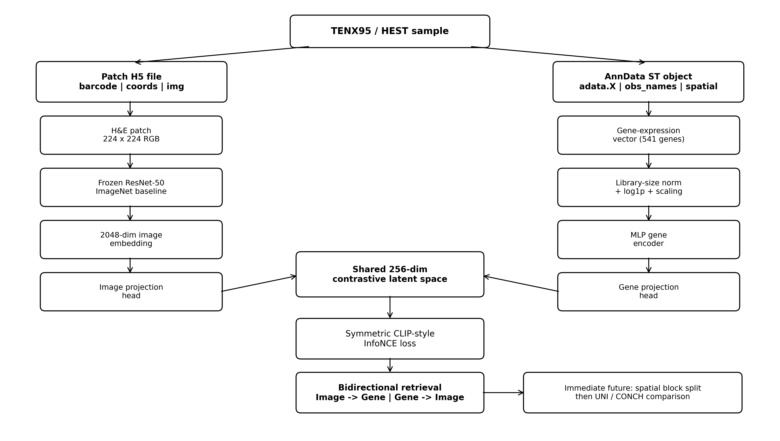
Figure 1. Current HistoGeneAlign MVP architecture
The current architecture has two branches that meet in a shared latent space. The image branch starts with H&E patches and produces 2,048-dimensional frozen ResNet-50 embeddings. The gene branch starts with AnnData gene-expression vectors and produces learned transcriptomic representations. Trainable projection heads map both modalities to a 256-dimensional shared latent space. The contrastive objective makes matched image-gene pairs similar and unmatched pairs dissimilar.
2.2. Image Branch
The image branch takes an H&E patch and converts it into a dense numerical representation.
H&E patch
→ uint8 RGB image
→ 224 x 224 tensor
→ ImageNet normalization
→ frozen ResNet-50
→ 2048-dimensional image embedding
The current baseline uses frozen ResNet-50 ImageNet embeddings. This is not the final pathology-specific encoder, but it is an appropriate first implementation because it is stable, fast, GPU-efficient, and easy to validate. Later work should compare ResNet-50 against pathology foundation encoders such as UNI or CONCH.
2.3. Gene Branch
The gene branch takes the spatial transcriptomics vector from the same spot and converts it into a learned gene representation.
Raw counts
→ per-spot library-size normalization to 10,000
→ log1p transformation
→ StandardScaler fitted on train split only
→ MLP gene encoder
→ gene projection head
→ 256-dimensional shared latent
Because the TENX95 matrix contains 541 genes, the first baseline uses all available genes rather than applying a 2,000-HVG selection rule. This is a dataset-specific constraint: the general plan can still use HVG selection for larger transcriptomics matrices.
2.4. Contrastive Objective
The model uses a symmetric CLIP-style InfoNCE objective. For each mini-batch, the model receives matched image and gene examples in the same order.
image_z: B x D
gene_z: B x D
similarity = image_z @ gene_z.T / temperature
positive pairs: diagonal entries
negative pairs: off-diagonal entries
loss = 0.5 * CE(image_to_gene_logits, labels)
+ 0.5 * CE(gene_to_image_logits, labels)
This objective directly matches the research question: paired H&E morphology and gene-expression profiles should move closer together in the latent space, while unrelated pairs should be pushed apart.
2.5. Retrieval Evaluation Branch
After training, the model is evaluated as a retrieval system. The evaluation is bidirectional:
Direction | Query | Candidate database | Correct answer
Image → Gene | H&E patch latent | All gene latents in the split | Gene profile from the same spot
Gene → Image | Gene-expression latent | All image latents in the split | H&E patch from the same spot

This evaluation is stricter and more informative than only plotting loss, because retrieval asks whether the model can identify the correct paired item among many candidates.

3. DATASET & DATA SOURCES
3.1. Dataset
The current workflow uses the TENX95 sample from the HEST dataset. The exact files used for the MVP are:
metadata/TENX95.json
st/TENX95.h5ad
patches/TENX95.h5
wsis/TENX95.tif
thumbnails/TENX95_downscaled_fullres.jpeg
spatial_plots/TENX95_spatial_plots.png
patches_vis/TENX95_patch_vis.jpg
pixel_size_vis/TENX95_pixel_size_vis.png
3.2. Key Dataset Discovery
A major technical discovery was that coordinate and expression data are not stored as separate CSV files. They are stored inside the AnnData file:
st/TENX95.h5ad
AnnData field | Meaning
adata.X | Spot-by-gene expression matrix
adata.obs_names | Spot IDs
adata.var_names | Gene names
adata.obsm["spatial"] | Spatial coordinates
adata.obs | Per-spot metadata
adata.var | Per-gene metadata
adata.uns["spatial"] | Spatial metadata
This changed the correct data-loading strategy. Instead of searching for external coordinate or expression tables, the correct approach is to load TENX95.h5ad using Scanpy and then extract expression, spot IDs, gene names, and spatial coordinates from the AnnData object.
3.3. TENX95 Data Statistics
Quantity | Value | Interpretation
Spatial spots | 11,845 | Total spot-level transcriptomic observations in AnnData.
Genes | 541 | Available gene features in the TENX95 object.
Expression matrix shape | 11,845 x 541 | Each row is a spatial spot and each column is a gene.
Nonzero values | 2,292,200 | Detected expression entries.
Total values | 6,408,145 | All spot-gene entries.
Sparsity | ~64.23% | Expected sparse structure for spatial transcriptomics.
Maximum expression | 1,254 | Shows skewed count distribution.
Mean expression | ~1.49 | Raw counts are low and sparse, motivating normalization.

3.4. Patch H5 Structure and Mapping Discovery
Notebook 03 identified that the existing TENX95 H5 patch file already contains usable image patches and the mapping information required for alignment.
H5 field | Shape | Meaning
barcode | (7,592, 1) | Patch-associated spot IDs.
coords | (7,592, 2) | Patch-associated coordinate metadata.
img | (7,592, 224, 224, 3) | Real RGB H&E patches.

This solved the most important alignment bottleneck. The project does not need to assume row-wise correspondence between AnnData rows and H5 patch rows. The correct mapping is:
H5 barcode → spot_id → AnnData obs_names row → gene-expression vector
Mapping check | Result
Number of H5 patches | 7,592
Unique H5 spot IDs | 7,592
Duplicate H5 spot IDs | 0
Patch spot IDs found in AnnData metadata | 7,592
Patch IDs missing from metadata | 0
Metadata IDs without patches | 4,253
Overlap fraction relative to patches | 1.0

A coordinate sanity check showed a systematic offset of roughly 263 pixels in x and y, with a mean coordinate distance of approximately 372.67. This likely reflects patch-origin coordinates versus spot-center coordinates. It does not invalidate the mapping because barcode matching is exact and should be treated as the primary alignment route.

4. COMPLETED WORKFLOW
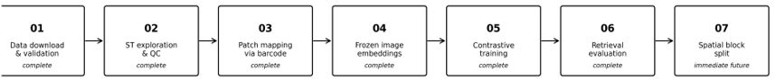
The completed notebook workflow is now:

Figure 2. Completed workflow through Notebook 06, with Notebook 07 kept as the immediate future step.
Notebook | Status | Core output
01_data_download_check.ipynb | Complete | Validated TENX95 file availability and safe loading.
02_data_exploration.ipynb | Complete | Explored AnnData, expression QC, spatial coordinates, top genes, and thumbnail overlay.
03_patch_extraction.ipynb | Complete | Validated H5 patch structure and barcode-based patch-to-spot mapping.
04_embedding_extraction.ipynb | Complete | Generated frozen ResNet-50 image embeddings and QC-filtered metadata.
05_contrastive_training.ipynb | Complete | Trained the first image-gene contrastive baseline.
06_evaluation.ipynb | Complete | Evaluated bidirectional image-gene retrieval and qualitative alignment diagnostics.
07_spatial_block_split_experiment.ipynb | Immediate future | Will test generalization to held-out spatial regions.

5. NOTEBOOK 01: DATA DOWNLOAD & VALIDATION
5.1. What We Did
Notebook 01 verified that the project could access, download, and load the required TENX95 data files. It confirmed that metadata, AnnData, patch H5, WSI, and safe preview files exist and are accessible.
Validation target | Result
metadata/TENX95.json | Available
st/TENX95.h5ad | Available and loadable
patches/TENX95.h5 | Available
wsis/TENX95.tif | Available
safe preview images | Available
spatial coordinates | Available in adata.obsm["spatial"]
expression matrix | Available in adata.X

5.2. Why We Did It
Before building a multimodal model, the project needed to prove that the dataset contains molecular expression, spatial coordinates, and histology image data. Without this validation, later model failures could come from data absence rather than modeling weakness.
5.3. Important Technical Decisions
The notebook avoided fragile project-root assumptions. Using Path.cwd() can fail when a notebook is launched from inside the notebooks directory, so robust root detection was preferred.
The notebook also avoided broad Hugging Face download patterns. Exact file selection was used to prevent accidentally downloading unrelated files from the larger dataset.
The full-resolution WSI was not opened directly with PIL. Instead, the workflow used thumbnails and safe preview images, because the WSI is too large for naive image preview.
6. NOTEBOOK 02: SPATIAL TRANSCRIPTOMICS EXPLORATION
6.1. AnnData Interpretation
Notebook 02 established the transcriptomics branch of the project. The key unit is a spatial spot:
one spatial spot = one AnnData row = one coordinate pair = one gene-expression vector
This is the central molecular object that later gets aligned with one H&E patch.
6.2. Spot Metadata Table
Notebook 02 created a clean spot metadata table with spot IDs, x/y coordinates, availability flags, library size, and detected gene counts. This table is the central indexing layer for the project.
spot_id → gene-expression row → patch index → image embedding row
Without this table, the project would risk silently mismatching image and gene rows during training.
6.3. Expression QC
The expression matrix is sparse, which is expected for spatial transcriptomics. The key diagnostic quantities were library size and detected genes per spot.
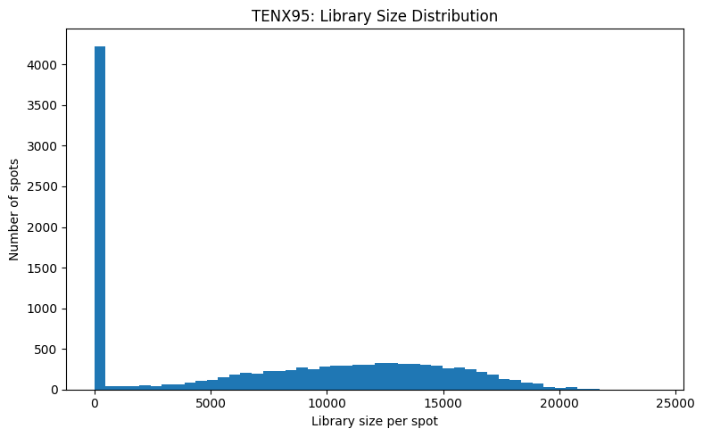
Figure 3. TENX95 library-size distribution.
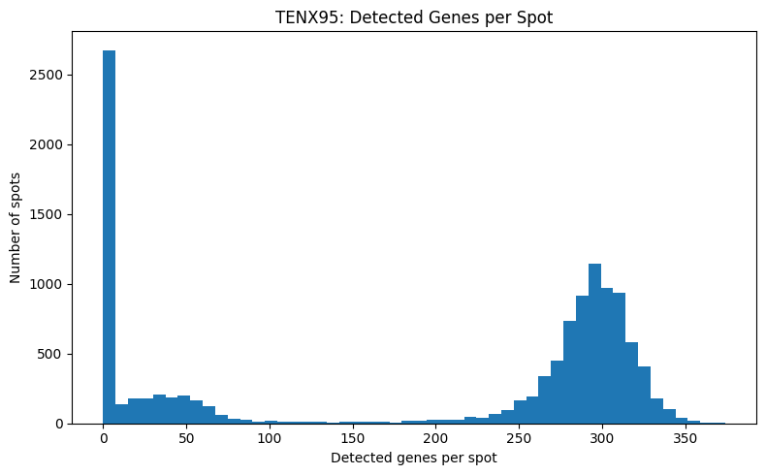
Figure 4. TENX95 detected-genes distribution.
The distributions showed low-signal or near-zero spots as well as higher-quality tissue-containing spots. This motivated the first MVP QC rule: library_size >= 1000 and detected_genes >= 100.
6.4. Biological Gene Sanity Check
The top expressed genes showed coherent tissue biology rather than random noise.
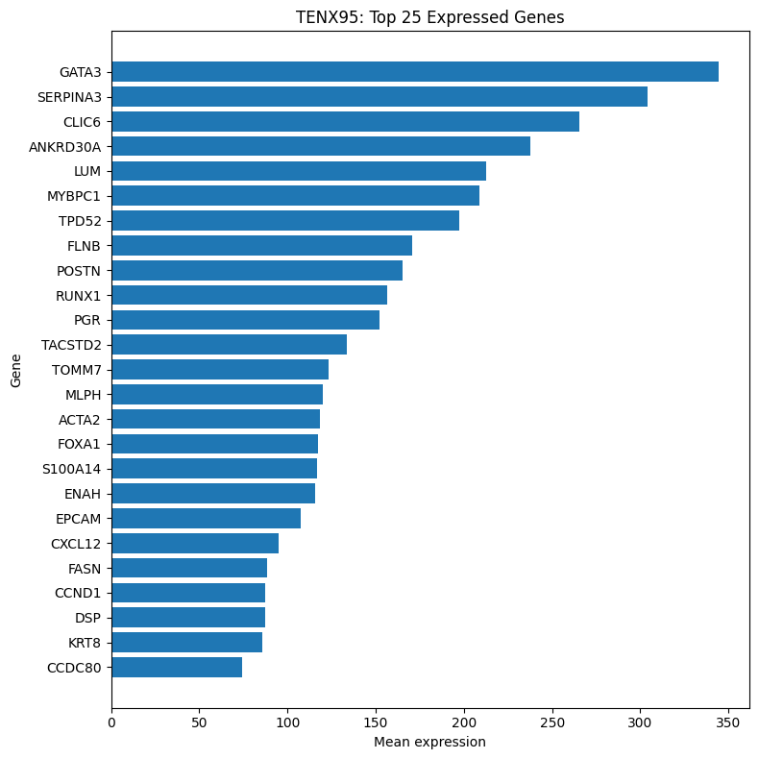
Figure 5. TENX95 top expressed genes.
Biological program | Example genes | Interpretation
Epithelial / luminal identity | GATA3, FOXA1, EPCAM, KRT8, PGR, TACSTD2 | Epithelial or glandular tissue signal.
Stromal / extracellular matrix | LUM, POSTN, CXCL12 | Connective tissue, extracellular matrix, and stromal organization.
Smooth-muscle / myofibroblast-like signal | ACTA2, MYBPC1 | Contractile or stromal activation signal.
Inflammatory / microenvironment signal | SERPINA3, CXCL12, RUNX1 | Immune, stress, or microenvironment variation.
Growth / metabolism | CCND1, FASN | Growth and metabolic activity.

This checkpoint matters because contrastive alignment is only meaningful if the gene branch has interpretable biological structure. These markers give biological plausibility to the image-gene retrieval task.
6.5. Highly Variable Gene Exploration
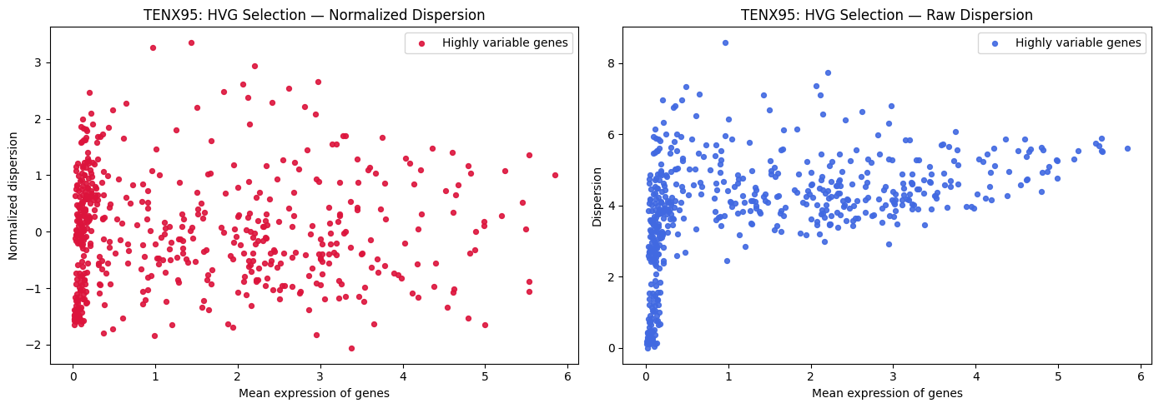
Figure 6. Highly variable gene exploration.
Highly variable genes were explored to understand spatially informative expression variation. For the current ResNet-50 contrastive baseline, all 541 genes were used because TENX95 has a small gene set. In larger HEST samples, HVG selection can be revisited as a gene-branch ablation.
6.6. Spatial Coordinates and Thumbnail Overlay
The spatial coordinates form a regular grid with x ranging from roughly 0 to 50,000 and y ranging from roughly 0 to 55,000.
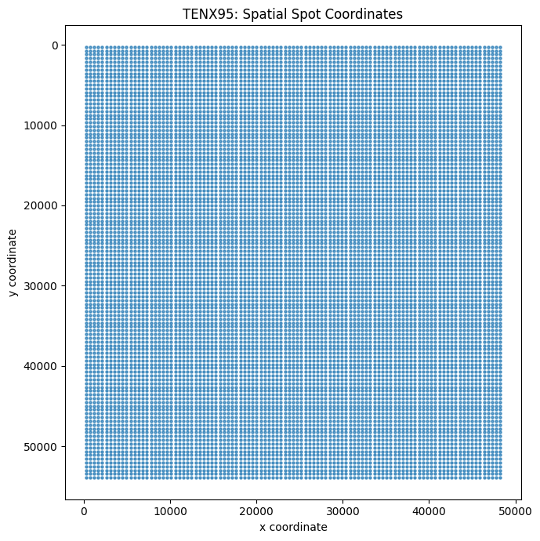
Figure 7. TENX95 spatial spot coordinate grid.
Overlaying scaled coordinates on the H&E thumbnail confirmed that the molecular coordinate system and histology image are compatible.
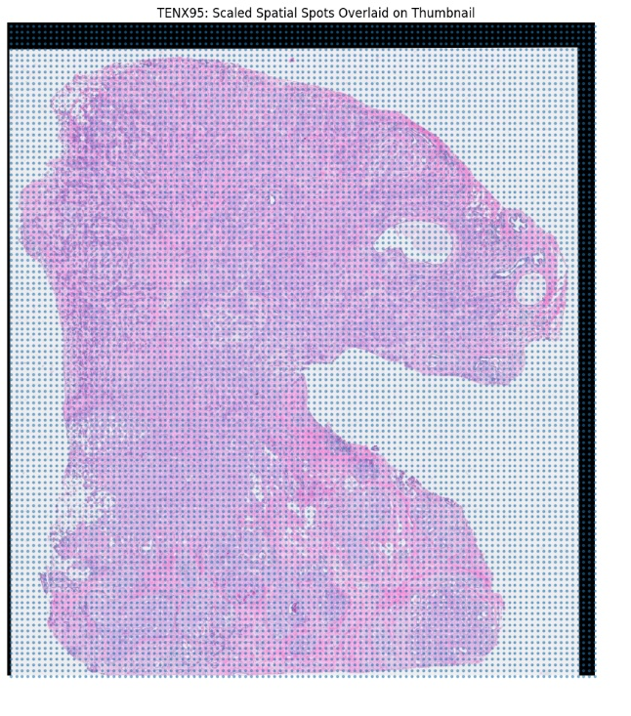
Figure 8. Scaled spatial spots overlaid on the H&E thumbnail.
The overlay also explained low-signal expression populations: some spots lie over tissue, while others fall near white or background regions. This supports QC filtering before training.
7. NOTEBOOK 03: PATCH INSPECTION & PATCH MAPPING
7.1. What We Did
Notebook 03 inspected the existing H5 patch file instead of immediately extracting patches from the WSI. This was the correct first step because the file already contains patch images, barcodes, and coordinates.
The preview confirmed that the patches contain meaningful H&E morphology, including cellular epithelial-like regions, stromal or fibrous regions, elongated-nuclei regions, and some background/tissue-edge patches.
7.2. Patch Count Versus Spot Count
Object | Count
AnnData spatial spots | 11,845
Available H&E patches | 7,592
Difference | 4,253 fewer patches than transcriptomic spots

This count mismatch means row-wise matching is invalid. The project cannot assume patch index 0 corresponds to AnnData row 0. The H5 barcode field solved this by providing direct patch-associated spot IDs.
7.3. Aligned Image-Gene Table
Notebook 03 created the aligned image-gene table:
data/processed/TENX95_aligned_image_gene_table.csv
Aligned table property | Value
Rows | 7,592
Missing values | 0
Valid patch rows | 7,592
Valid expression rows | 7,592
Rows passing MVP QC | ~7,530

This table is now the source of truth for bridging image patches and gene-expression rows.
image_embeddings[embedding_row] ↔ patch_index ↔ spot_id ↔ adata.X[ann_data_row]

8. NOTEBOOK 04: FROZEN IMAGE EMBEDDING EXTRACTION

8.1. What We Did
Notebook 04 extracted frozen image embeddings from the validated H&E patch table. The pipeline was:
H&E patch
→ uint8 RGB image
→ float tensor
→ ImageNet normalization
→ frozen ResNet-50
→ 2048-dimensional embedding
The important implementation fix was to ensure that embedding_row represents the saved image embedding matrix row order. If the aligned table already contained an embedding_row column, it was dropped and reinserted to avoid duplicate-column errors.
8.2. Embedding Outputs
Output file | Shape / role
data/embeddings/TENX95_resnet50_image_embeddings.npy | (7,592, 2,048) full image embedding matrix.
data/embeddings/TENX95_resnet50_image_embedding_metadata_full.csv | Full embedding metadata.
data/embeddings/TENX95_resnet50_image_embeddings_qc.npy | (7,530, 2,048) QC-filtered image embedding matrix.
data/embeddings/TENX95_resnet50_image_embedding_metadata_qc.csv | QC-filtered embedding metadata.

AnnData validation passed: all 7,530 QC metadata rows pointed to the same spot ID through adata.obs_names and ann_data_row.
8.3. Embedding Norm QC
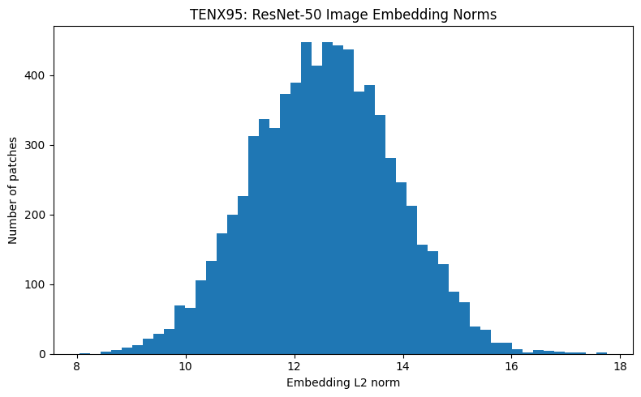
Figure 9. ResNet-50 image embedding norm distribution.
The embedding norm distribution was smooth and stable, indicating that the frozen encoder and preprocessing pipeline produced usable numerical features. There was no evidence of collapsed embeddings or obvious preprocessing corruption.

9. NOTEBOOK 05: CONTRASTIVE TRAINING
9.1. Training Objective
Notebook 05 trained the first HistoGeneAlign contrastive baseline using frozen ResNet-50 image embeddings and processed gene-expression vectors. The image encoder itself was not trained. Only the image projection head, gene encoder, and gene projection head were trained.
9.2. Training Data Construction
The training pair was:
image_vector = image_embeddings_qc[embedding_row]
gene_vector = adata.X[ann_data_row]
The gene vector was normalized per spot to 10,000 counts, log1p transformed, and scaled using a StandardScaler fitted only on the training split.
9.3. Random Split Setup
Split | Approximate rows | Fraction
Train | 5,271 | 70%
Validation | 1,129 | 15%
Test | 1,130 | 15%
The random split was appropriate as a first sanity-check baseline. It tests whether the model can learn the image-gene pairing signal at all. However, because nearby spots can share morphology and expression, random split performance should not be treated as proof of cross-region or cross-slide generalization.
9.4. Model Configuration
Hyperparameter / component | Value
Image input dimension | 2,048
Gene input dimension | 541
Shared latent dimension | 256
Hidden dimension | 512
Dropout | 0.10
Batch size | 64
Epochs | 20
Learning rate | 1e-4
Optimizer | AdamW
Temperature | 0.07
Seed | 42

9.5. Notebook 05 Outputs
Output file | Role
data/processed/TENX95_gene_features_qc_lognorm_scaled.npy | Processed gene feature matrix.
data/splits/TENX95_random_split_indices.npz | Random train/validation/test indices.
outputs/checkpoints/TENX95_resnet50_contrastive_baseline.pt | Trained baseline checkpoint.
outputs/metrics/TENX95_contrastive_training_history.csv | Training and validation history.
outputs/metrics/TENX95_contrastive_final_test_metrics.json | Final test metrics.
data/embeddings/TENX95_resnet50_contrastive_image_latents_qc.npy | QC image latents with shape 7,530 x 256.
data/embeddings/TENX95_resnet50_contrastive_gene_latents_qc.npy | QC gene latents with shape 7,530 x 256.
data/embeddings/TENX95_contrastive_qc_metadata_with_splits.csv | Metadata with random split labels.

10. NOTEBOOK 06: RETRIEVAL EVALUATION
10.1. Evaluation Purpose
Notebook 06 evaluated whether the trained contrastive latent space can recover matched image-gene pairs. This is the first true quantitative test of the HistoGeneAlign idea.
The test set contained 1,130 paired image-gene examples. Random retrieval would have Recall@1 of approximately 1/1,130 = 0.000885, Recall@5 of approximately 0.004425, and Recall@10 of approximately 0.008850.
10.2. Main Test Retrieval Metrics
Direction | Recall@1 | Recall@5 | Recall@10 | Recall@50 | Median rank | MRR
Image → Gene | 0.08584 | 0.29292 | 0.41504 | noted in outputs | 17 / 1130 | ~0.1901
Gene → Image | 0.08584 | 0.27434 | 0.38407 | noted in outputs | 17 / 1130 | ~0.1860
Random expectation | ~0.000885 | ~0.004425 | ~0.008850 | ~0.04425 | ~565 / 1130 | low
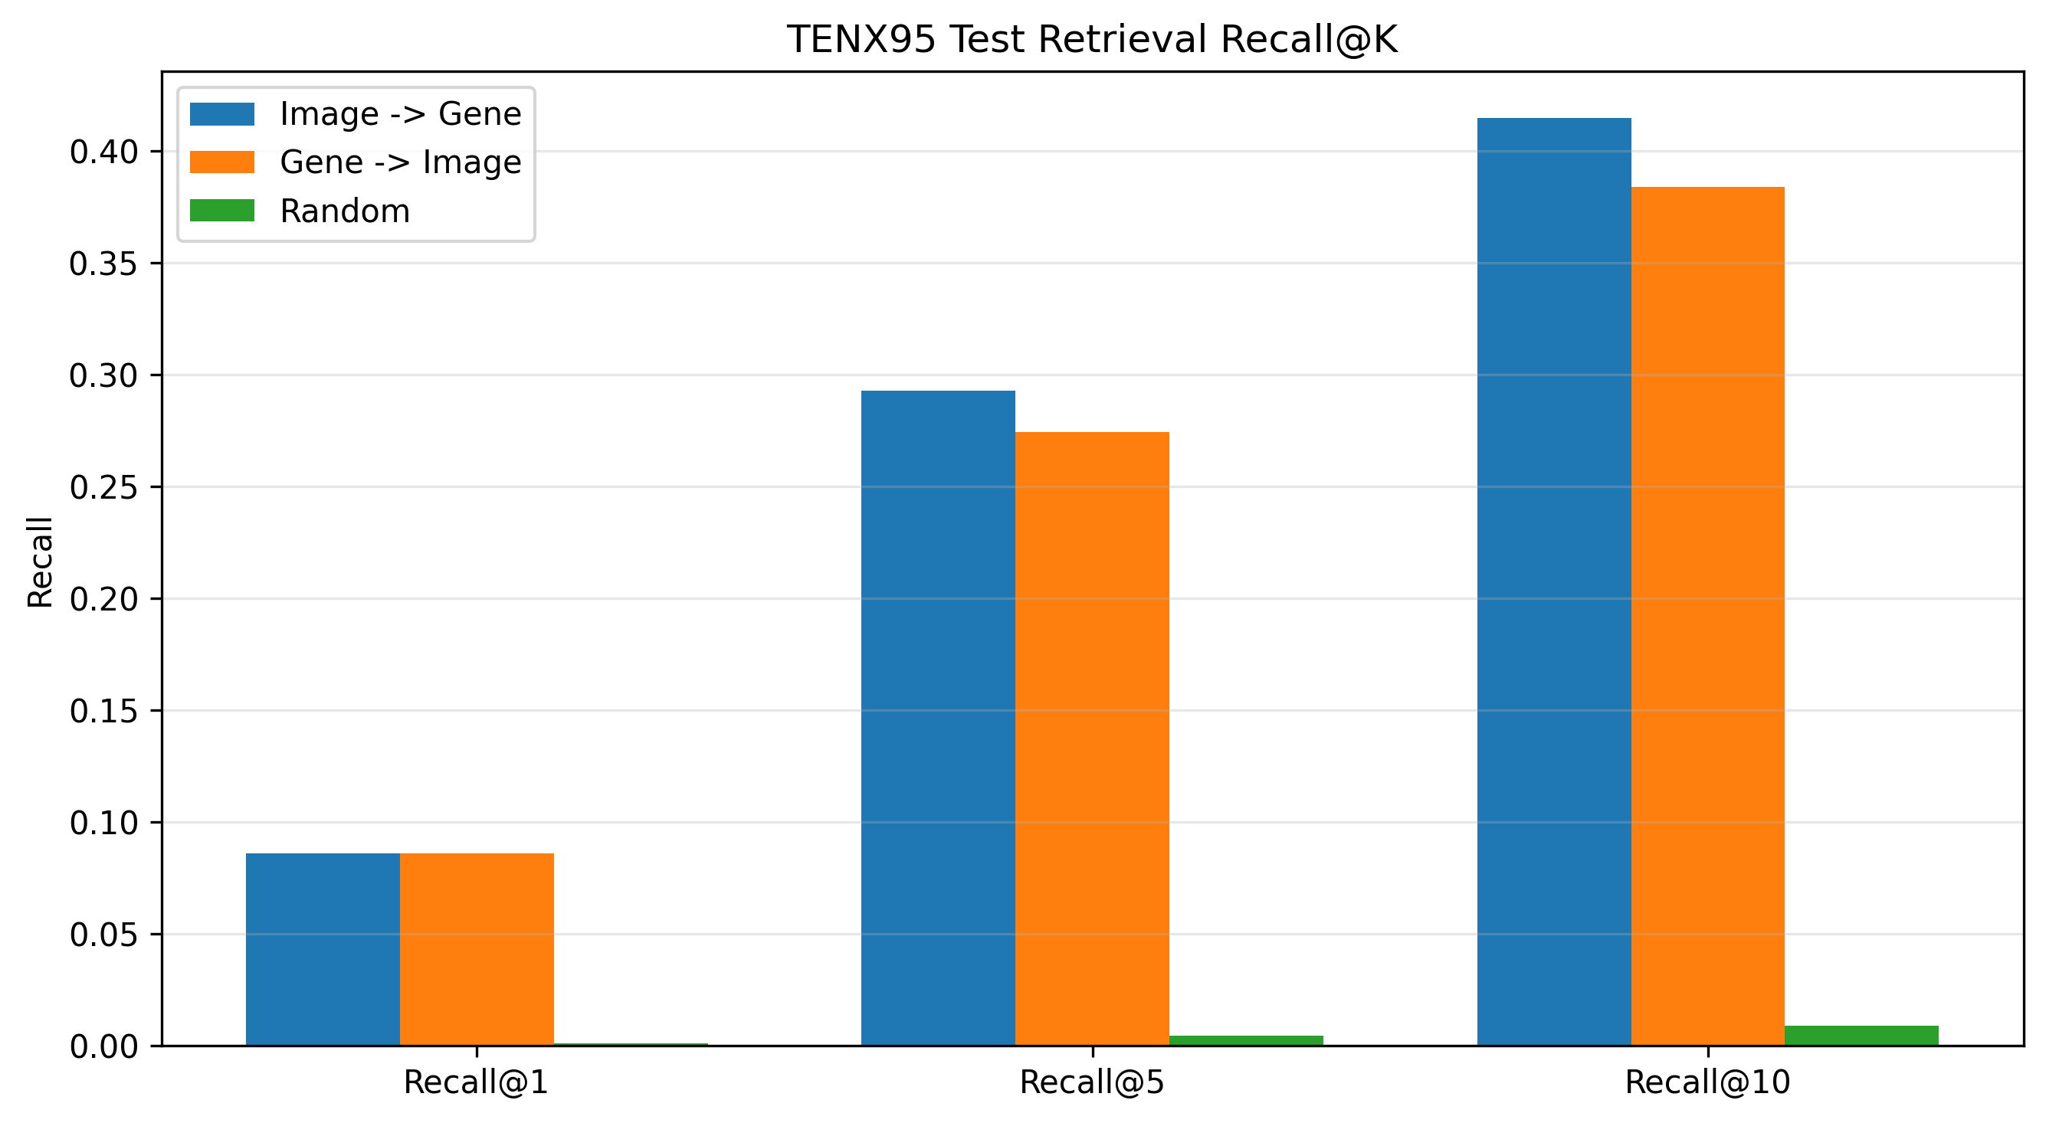
Figure 10. Test retrieval Recall@K compared with random expectation.
The result is far above random. Image-to-Gene Recall@1 is about 97 times random, and Image-to-Gene Recall@10 is about 47 times random. The model retrieves the correct gene-expression profile within the top 10 candidates for about 41.5% of test H&E patches and retrieves the correct H&E patch within the top 10 candidates for about 38.4% of test gene-expression profiles.
10.3. Rank Distribution Interpretation
Rank summary | Image → Gene | Gene → Image
Count | 1,130 | 1,130
Mean rank | 61.45 | 60.04
Standard deviation | 111.17 | 109.25
Minimum rank | 1 | 1
25th percentile | 4 | 5
Median rank | 17 | 17
75th percentile | 62 | 61
Maximum rank | 1,025 | 1,022
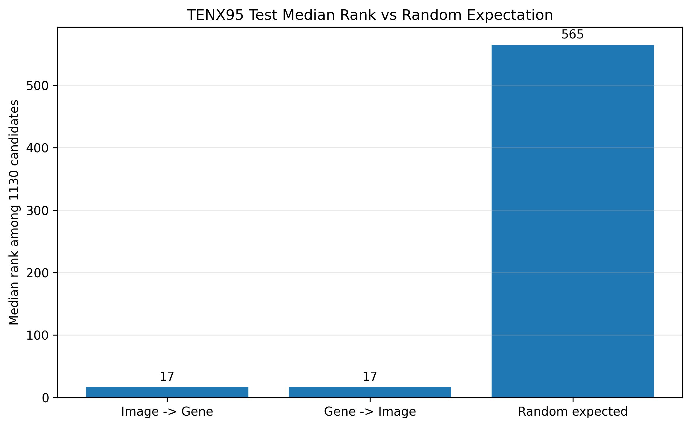
Figure 11. Median rank of true matches compared with random expectation.
A random system over 1,130 candidates would have an expected median rank around 565. The trained model achieves median rank 17 in both directions, meaning the true match is usually placed near the top of the candidate list. Ranking the true match within the top 17 out of 1,130 candidates places it in approximately the top 1.5% of the retrieval set.
10.4. Similarity Matrix Interpretation
Quantity | Value
Diagonal mean similarity | 0.3639
Off-diagonal mean similarity | 0.0566
Diagonal advantage | 0.3073

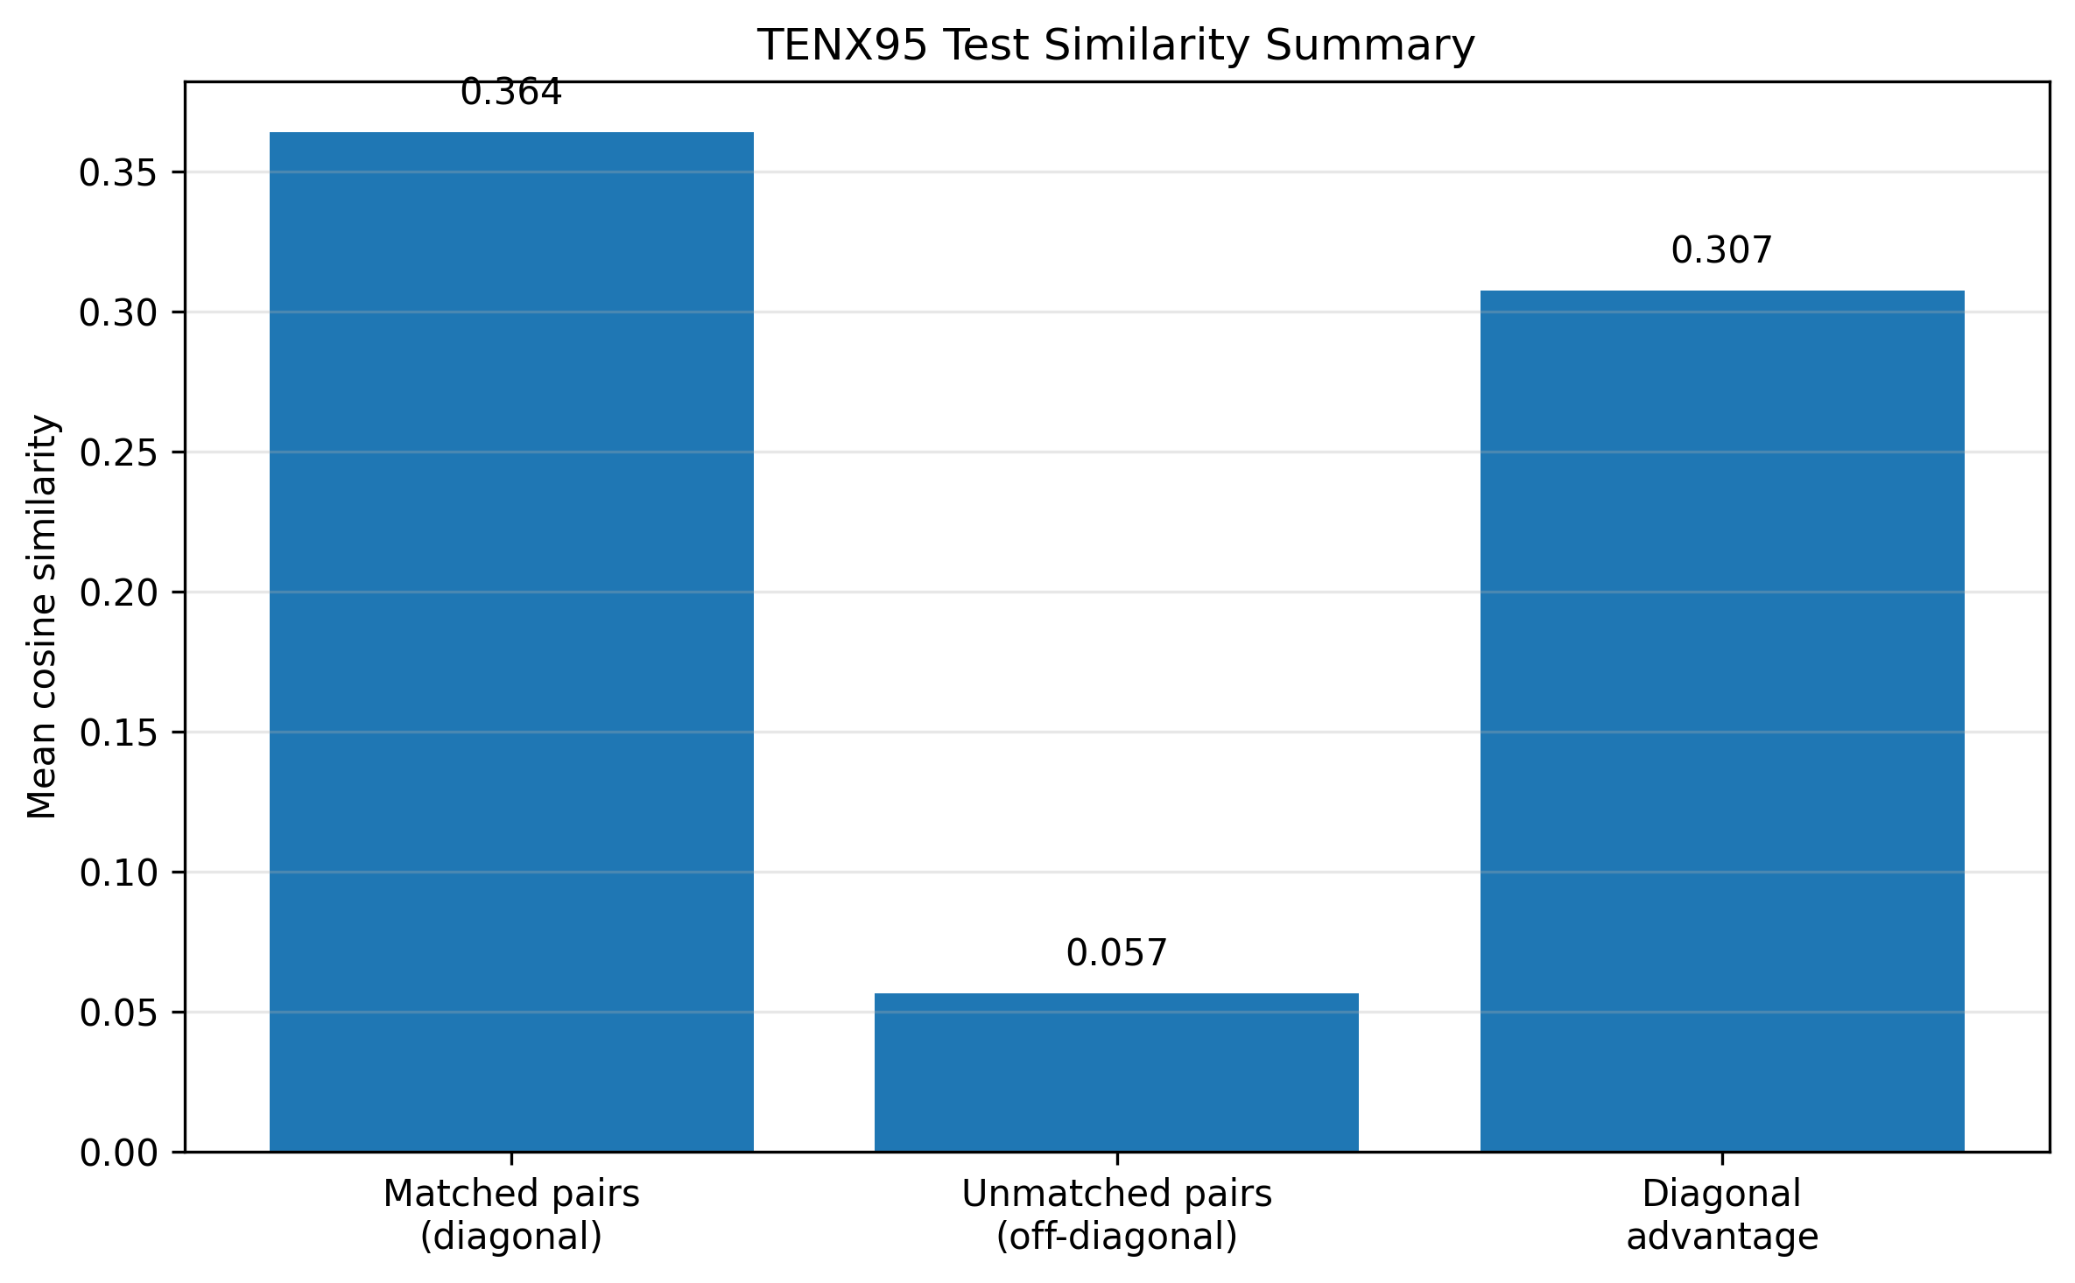
Figure 12. Mean similarity summary for matched and unmatched pairs.
The diagonal entries of the similarity matrix represent true matched image-gene pairs, while off-diagonal entries represent mismatches. The diagonal mean is substantially higher than the off-diagonal mean, indicating that the model learned to place matched H&E morphology and gene-expression profiles closer together.
A strong off-diagonal structure is not automatically bad in spatial biology. Neighboring or biologically related tissue regions may share morphology and expression, so some non-matched pairs can still be genuinely similar.
10.5. Spatial Top-1 Success Map
Quantity | Value
Top-1 success rate | 0.08584
Median top-1 spatial distance, all test queries | ~9,191
Median top-1 spatial distance, failures only | ~10,834

Top-1 retrieval is a strict criterion because the model must retrieve the exact paired spot as the first result among 1,130 candidates. The top-1 success rate of 8.58% is far above the random expectation of approximately 0.09%. The success map showed that correct top-1 retrievals were distributed across multiple tissue regions rather than confined to one small local area.
Failures are still informative. In several failed examples, the retrieved patch appeared broadly morphologically similar to the query, suggesting that the model may capture tissue-level visual similarity even when it misses exact spot-level identity.

10.6. PCA of Contrastive Latent Space
PCA component | Explained variance ratio
PC1 | ~0.0668
PC2 | ~0.0620
Total PC1 + PC2 | ~0.1288

The PCA visualization showed substantial overlap between image latents and gene latents in the same two-dimensional region. This supports the retrieval metrics by showing that the model reduced the modality gap between H&E morphology and transcriptomic profiles.
The PCA plot should be interpreted as supporting evidence rather than the main result, because the first two PCs explain only about 12.9% of the full latent variance. Retrieval metrics remain the primary evidence.
10.7. Train/Test Gap and Overfitting Observation
Metric | Value
Train mean Recall@1 | ~0.9445
Validation mean Recall@1 | ~0.0939
Test mean Recall@1 | ~0.0858

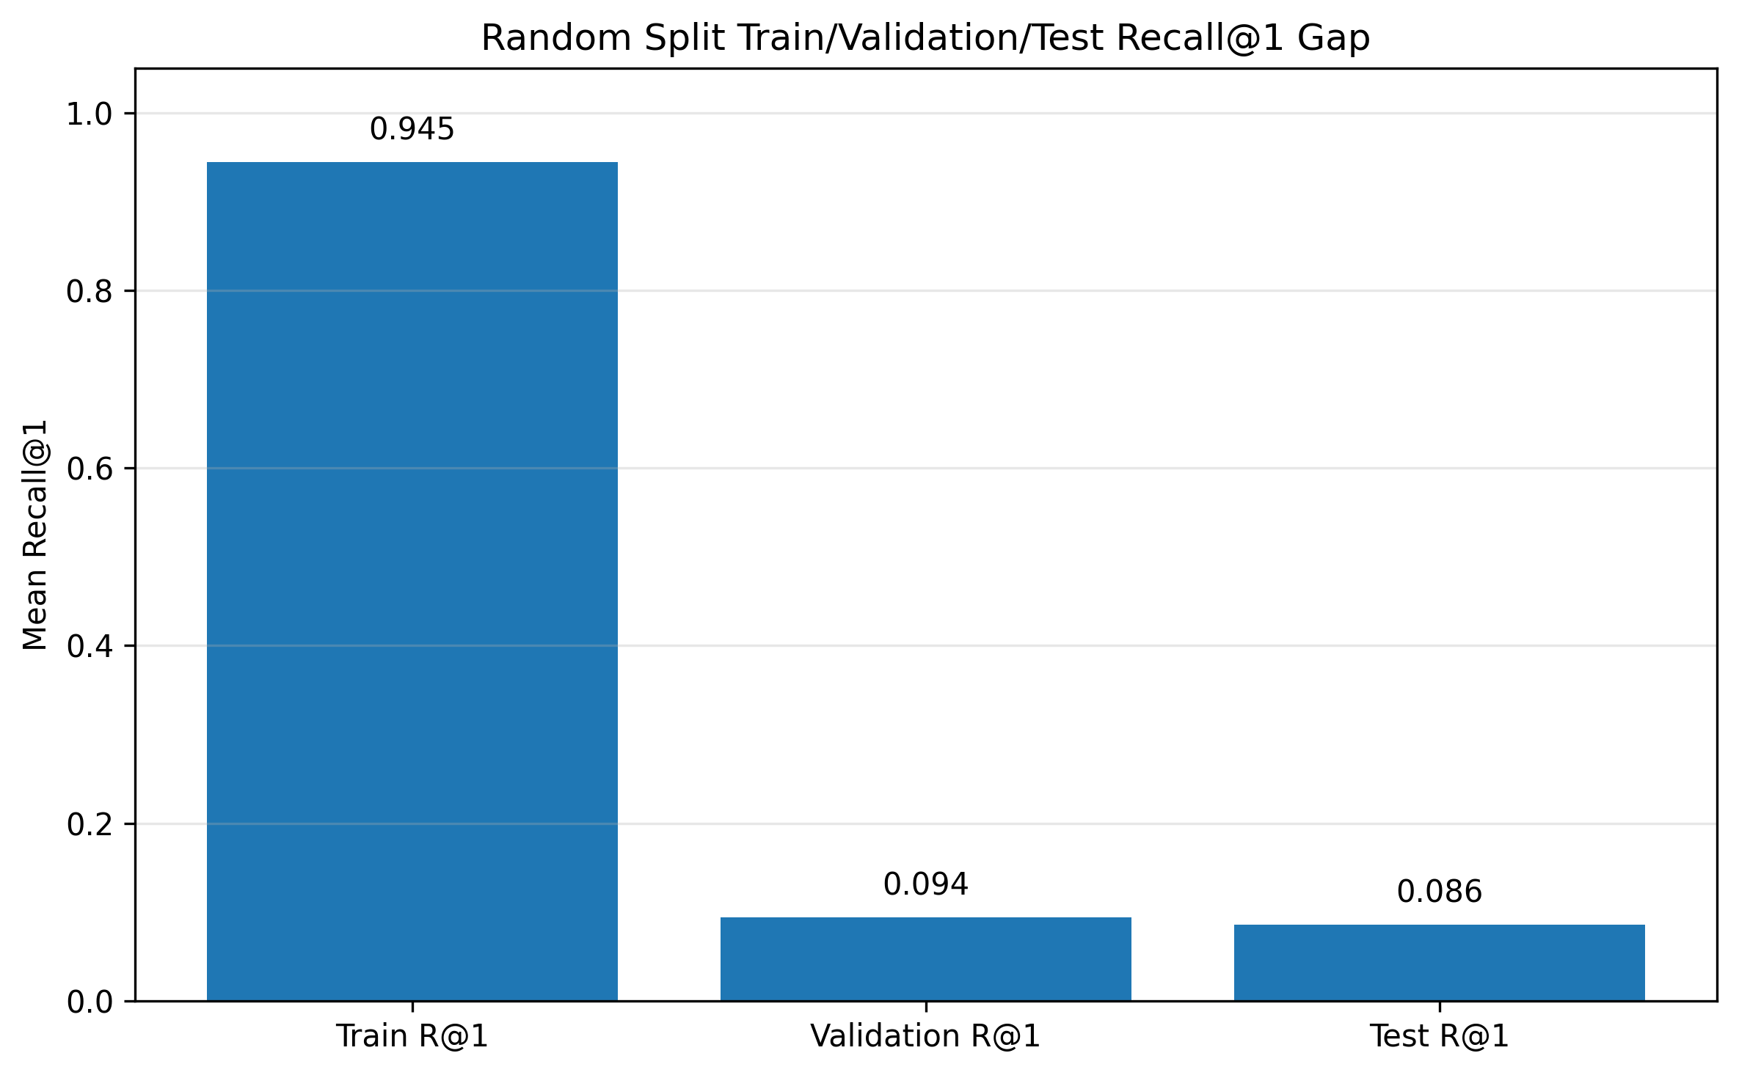
Figure 13. Random split train/validation/test Recall@1 gap.
The model fits the training pairs very strongly and generalizes above random to validation and test. The large train/test gap indicates overfitting or memorization pressure, which is expected for a one-slide random-spot contrastive baseline. Therefore, test metrics should be presented as the main result, not train metrics.
11. CURRENT PROJECT STATE
Component | Status | Evidence
Dataset download | Complete | TENX95 files available.
AnnData loading | Complete | 11,845 x 541 expression matrix loaded.
Spatial coordinates | Complete | adata.obsm["spatial"] validated.
Spot metadata table | Complete | Central spot indexing layer created.
Expression diagnostics | Complete | Sparsity, library size, detected genes, and top genes computed.
Biological gene sanity check | Complete | Coherent epithelial, stromal, immune, and metabolic markers observed.
Patch H5 inspection | Complete | barcode, coords, and img fields found.
Patch-to-spot mapping | Solved | 7,592 / 7,592 H5 barcodes matched AnnData metadata.
Aligned table | Complete | 7,592 aligned rows; approximately 7,530 QC rows.
Image embeddings | Complete | ResNet-50 embeddings generated and QC-filtered.
Contrastive training | Complete | ResNet-50 + MLP gene encoder baseline trained.
Retrieval evaluation | Complete | Image-to-Gene and Gene-to-Image retrieval evaluated on test split.
Spatial block split | Immediate future | Next stricter generalization test.

12. SCIENTIFIC STORYLINE SO FAR
The project began with a multimodal biomedical question: can H&E morphology recover spatial molecular biology?
Notebook 01 established that the required TENX95 files exist and can be loaded.
Notebook 02 showed that the molecular branch is valid: TENX95 contains 11,845 spatial spots, 541 genes, coherent spatial coordinates, interpretable biological markers, and a coordinate system that aligns with the H&E thumbnail after scaling.
Notebook 03 solved the core multimodal alignment problem by using H5 barcodes to map H&E patches to AnnData spot IDs.
Notebook 04 converted H&E patches into stable frozen ResNet-50 embeddings.
Notebook 05 trained the first CLIP-style contrastive alignment model.
Notebook 06 demonstrated that the learned latent space retrieves matched image-gene pairs far above random on the held-out random test split.
At this point, HistoGeneAlign has moved from a data-preparation project to a working biomedical multimodal retrieval baseline.
13. RESULT JUDGMENT
Area | Judgment | Reason
Data alignment | Excellent | Patch-to-spot mapping is barcode-resolved and validated.
Notebook pipeline | Good | The workflow runs end-to-end through retrieval evaluation.
Baseline model result | Good | Retrieval is far above random in both directions.
Scientific strength | Promising but early | Current result is within one sample using random spot split.
Portfolio value | Strong | End-to-end biomedical multimodal learning pipeline with real results.
Publication strength | Not yet | Needs spatial split, stronger encoders, and multi-sample evaluation.

The fair current claim is that the first ResNet-50 contrastive baseline demonstrates clear above-random spot-level retrieval between H&E morphology and spatial transcriptomics profiles on TENX95.
The stronger but still accurate claim is that HistoGeneAlign learns a meaningful morphology-transcriptomics alignment at the spot level on TENX95, achieving Image-to-Gene Recall@10 of approximately 41.5%, Gene-to-Image Recall@10 of approximately 38.4%, and median retrieval rank of 17 out of 1,130 test candidates.
14. WHAT CAN AND CANNOT BE CLAIMED
14.1. Claims Supported Now
The current results support the following statements:
Supported claim | Why it is supported
The dataset is usable for image-gene alignment. | AnnData expression, spatial coordinates, H5 patch images, and barcode mapping were validated.
The model learns non-random alignment. | Test Recall@K and median rank are far above random expectation.
The shared latent space reduces modality gap. | Image and gene latents overlap in PCA and matched pairs have higher similarity than mismatches.
The baseline is strong enough to continue. | Retrieval performance is meaningful despite using generic ResNet-50 features.

14.2. Claims Not Supported Yet
The current results do not yet support claims that the model generalizes across patients, slides, tissue types, or institutions. The current model should not be described as biologically validated, universally predictive, or capable of replacing spatial transcriptomics.
The reason is that the current result uses one HEST sample, one random spot split, a generic ImageNet image encoder, and within-sample retrieval. These are appropriate MVP choices, but they define the boundary of the claim.
15. CURRENT LIMITATIONS
Limitation | Meaning | Next response
Random spot split | Nearby tissue regions can appear across train and test, potentially inflating performance through spatial autocorrelation. | Run Notebook 07 spatial block split.
Single-sample MVP | TENX95 alone does not prove cross-slide or cross-patient generalization. | Scale to additional HEST samples after spatial split.
Generic image encoder | ResNet-50 is not pathology-specific. | Compare UNI and CONCH.
Train/test gap | The model strongly fits training pairs and generalizes less strongly to test. | Use harder splits, regularization, and stronger encoders.
No biological target branch yet | The current model retrieves gene profiles but does not directly predict cell-type composition. | Add marker-gene scores or composition branch later.
No expression similarity analysis of wrong hits yet | Some wrong top-1 retrievals may still be biologically plausible. | Evaluate expression correlation and spatial distance for retrieval failures.

16. IMMEDIATE FUTURE STEP: NOTEBOOK 07 SPATIAL BLOCK SPLIT
Notebook 07 is intentionally kept as the immediate future step rather than included as completed work. The purpose is to test whether the model still performs above random when the test examples come from spatial regions excluded during training.
The key motivation is that random spot splitting can overestimate performance because nearby tissue regions often share both morphology and gene-expression structure. A spatial block split assigns entire tissue neighborhoods to train, validation, or test.
Comparison | Random split | Spatial block split
Difficulty | Easier | Harder
Leakage risk | Nearby spots may cross split boundaries | Entire spatial blocks are held out
Question answered | Can the model learn paired signal at all? | Can the model generalize to unseen tissue regions?
Expected result | Higher performance | Lower performance but more scientifically meaningful

The key comparison for Notebook 07 will be against the Notebook 06 random-split baseline: Image-to-Gene Recall@10 approximately 41.5%, Gene-to-Image Recall@10 approximately 38.4%, and median rank 17 out of 1,130.
If spatial block split performance remains clearly above random, the scientific claim becomes much stronger. If it drops close to random, the project still gains useful information: the current model may be relying heavily on local spatial autocorrelation, and stronger encoders or modeling changes will be needed.
17. NEXT MODELING IMPROVEMENTS AFTER SPATIAL SPLIT
Improvement | Reason
UNI encoder comparison | Pathology foundation embeddings should capture tissue morphology better than ImageNet ResNet-50.
CONCH encoder comparison | Pathology vision-language features may improve biologically relevant alignment.
Gene preprocessing ablations | Compare all genes, HVGs, PCA + MLP, and pathway/gene-set features.
Expression similarity of wrong retrievals | A wrong exact spot may still be biologically similar.
Spatial retrieval distance analysis | Quantify whether wrong retrieved spots are nearby or biologically similar.
Marker-gene or cell-composition branch | Add interpretability by predicting biological programs or cell-type composition.

18. FILES AND OUTPUTS CREATED SO FAR
18.1. Important Figures
TENX95_detected_genes_distribution.png
TENX95_library_size_distribution.png
TENX95_top_expressed_genes.png
TENX95_hvg_selection.png
TENX95_spatial_coordinates.png
TENX95_spot_overlay_thumbnail_scaled.png
TENX95_resnet50_embedding_norms_qc.png
TENX95_contrastive_training_loss.png
TENX95_contrastive_validation_recall.png
TENX95_retrieval_recall_bar.png
TENX95_test_rank_distribution.png
TENX95_test_similarity_heatmap.png
TENX95_test_spatial_top1_success.png
TENX95_contrastive_latent_pca.png
TENX95_retrieval_patch_examples.png

18.2. Important Metrics and Embeddings
outputs/metrics/TENX95_contrastive_training_history.csv
outputs/metrics/TENX95_contrastive_final_test_metrics.json
outputs/metrics/TENX95_retrieval_metrics_by_split.csv
outputs/metrics/TENX95_retrieval_metrics_by_split.json
outputs/metrics/TENX95_test_image_to_gene_retrieval_examples.csv
outputs/metrics/TENX95_test_gene_to_image_retrieval_examples.csv
outputs/metrics/TENX95_retrieval_summary.json
data/embeddings/TENX95_resnet50_image_embeddings.npy
data/embeddings/TENX95_resnet50_image_embedding_metadata_full.csv
data/embeddings/TENX95_resnet50_image_embeddings_qc.npy
data/embeddings/TENX95_resnet50_image_embedding_metadata_qc.csv
data/embeddings/TENX95_resnet50_contrastive_image_latents_qc.npy
data/embeddings/TENX95_resnet50_contrastive_gene_latents_qc.npy
data/embeddings/TENX95_contrastive_qc_metadata_with_splits.csv
outputs/checkpoints/TENX95_resnet50_contrastive_baseline.pt
19. PORTFOLIO AND RESEARCH FRAMING
The project can be described as an end-to-end biomedical multimodal learning pipeline aligning H&E histology patches with spatial transcriptomics gene-expression profiles using frozen image embeddings, gene-expression preprocessing, CLIP-style contrastive learning, and bidirectional retrieval evaluation.
A concise portfolio framing is:
Built HistoGeneAlign, a multimodal contrastive learning pipeline for spot-level image-to-gene retrieval between H&E histology and spatial transcriptomics.
The strongest current technical framing is that the project demonstrates above-random morphology-transcriptomics retrieval on TENX95, while explicitly acknowledging that spatial block splitting and multi-sample validation are the next steps required for stronger scientific evidence.
20. CONCLUSION
HistoGeneAlign has now reached a meaningful MVP milestone. The project has moved beyond file loading and image embedding extraction into actual contrastive multimodal learning and retrieval evaluation.
The key technical achievement is that the image-gene alignment bridge is solved through H5 barcode mapping, allowing H&E patches to be paired with the correct AnnData gene-expression rows. The key modeling achievement is that a frozen ResNet-50 image branch and trainable gene branch learn a shared latent space that retrieves matched image-gene pairs far above random on the TENX95 test split.
The result is promising but early. The random-split baseline is strong enough to justify continuing, but not strong enough to claim broad biological generalization. The immediate future step is Notebook 07: spatial block split evaluation. If the model remains above random under spatially held-out evaluation, the project becomes substantially stronger as a scientific and portfolio-level biomedical ML system.

