HistoGeneAlign: Multimodal Alignment of H&E Histopathology and Spatial Transcriptomics for Spot-Level Image–Gene Retrieval
ABSTRACT:
HistoGeneAlign is a biomedical multimodal learning project designed to align visual morphology from H&E-stained histopathology images with molecular signals from spatial transcriptomics. The core hypothesis is that tissue morphology contains recoverable information about local gene-expression patterns, and that a contrastive learning framework can learn this relationship by pairing H&E image patches with spatial transcriptomics profiles from the same tissue locations.
So far, the project has completed four major stages: dataset acquisition and validation, spatial transcriptomics exploration, H&E patch verification, and frozen image embedding extraction. Using the TENX95 sample from the HEST dataset, we confirmed that molecular expressions, spatial coordinates, tissue thumbnails, whole-slide image data, and pre-extracted image patches are all available. The processed spatial transcriptomics object contains 11,845 spatial spots and 541 genes, while the patch file contains 7,592 usable H&E patches. A frozen ResNet-50 encoder was then used to convert these patches into stable 2,048-dimensional image embeddings. Better models can also be explored like UNI or CONCH in the future once a proper iteration of this project is done
This documentation explains the project motivation, system architecture, completed workflow, technical decisions, biological implications, and how each step prepares the project for contrastive image-gene alignment.

- INTRODUCTION
  - Project Motivation
Histopathology and spatial transcriptomics provide two complementary views of tissue biology.
H&E histology captures morphology: nuclei, glands, stromal structure, tissue boundaries, cellular density, and extracellular matrix patterns. Spatial transcriptomics captures molecular state: gene-expression profiles measured at spatially localized tissue spots.

The central motivation of HistoGeneAlign is to connect these two modalities:
What the tissue looks like
↓
What genes are active in that tissue region
This project is not simply image classification. It is a representation learning problem: we want to learn a shared latent space where an H&E patch and its matched gene-expression profile are close together, while mismatched patches and expression profiles are pushed apart.
The project plan frames this as “a multiscale multimodal learning framework that aligns H&E histopathology morphology with spatial transcriptomics at the spot level,” with a possible extension to cell-level biological composition prediction.
  - Research Question
The main research question is:
Can visual morphology from H&E image patches be aligned with spatial transcriptomics profiles at the spot level?
In modeling terms:
Can an image encoder and a gene encoder learn a shared embedding space
where matched image–gene pairs are close and unmatched pairs are far?
In biological terms:
Can the morphology of a local tissue region predict or retrieve
its corresponding molecular expression profile?
The project plan separates this into two levels: a core spot-level branch where H&E patches are aligned with gene-expression profiles, and a cell-level branch where morphology is aligned with inferred cell-type composition. The spot-level branch is the MVP; the cell-composition branch is the advanced extension.

- PROJECT ARCHITECTURE
  - High-level Architecture
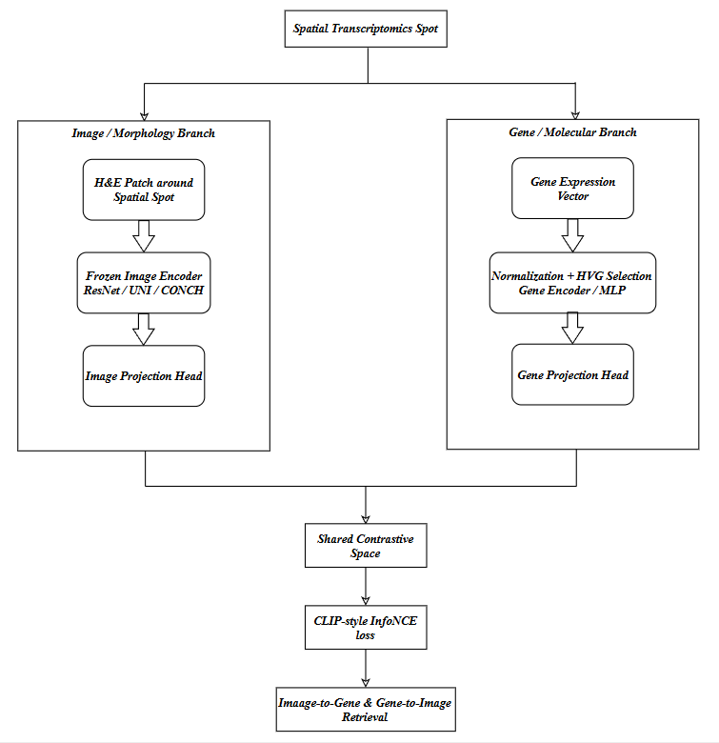
  - Image Branch
The image branch takes an H&E patch and converts it into a dense numerical representation.
Current implementation:
H&E patch → resize to 224 x 224 → normalize image channels → frozen ResNet-50 encoder → 2048-dimensional image embedding

The project plan defines the image pathway as:
spot coordinate → H&E patch → frozen pathology image encoder → image embedding → projection head → shared latent space
The project also recommends starting with ReNet-50 if UNI or CONCH setup is slower.
  - Gene Branch
The gene branch takes the spatial transcriptomics vector for the same spot and converts it into a learned gene embedding.
The planned implementation is:
Gene-expression vector → library-size normalization → log1p transformation → highly variable gene selection → MLP gene encoder → projection head → shared latent space
The project plan defines the gene pathway as expression vector → normalization → highly variable gene selection → MLP encoder → projection head → shared latent space. The project also recommends starting with 2,000 highly variable genes in general, although the current TENX95 matrix contains 541 genes, so feature selection is constrained by available gene count.
  - Contrastive Objective
The planned training objective is symmetric CLIP-style InfoNCE loss.
For a batch of matched image and gene embeddings:
image_z: B × D
gene_z: B × D
Both are L2-normalized, and the similarity matrix is computed as:
similarity = image_z @ gene_z.T / temperature
The diagonal entries represent true matched pairs:
image_i ↔ gene_i where i = j
The off-diagonal entries represent negatives:
image_i ↔ gene_j where i ≠ j
The loss is:
L = 0.5 × CE(image_to_gene_logits, labels) + 0.5 × CE(gene_to_image_logits, labels)
The project plan specifies this symmetric contrastive loss with normalized embeddings, temperature scaling, diagonal positive pairs, and cross-entropy in both retrieval directions.

- DATASET & DATA SOURCES
  - Dataset
The current workflow uses the TENX95 sample from the HEST dataset.
The relevant downloaded files are:
metadata/TENX95.json
st/TENX95.h5ad
patches/TENX95.h5
wsis/TENX95.tif
thumbnails/TENX95_downscaled_fullres.jpeg
spatial_plots/TENX95_spatial_plots.png
patches_vis/TENX95_patch_vis.jpg
pixel_size_vis/TENX95_pixel_size_vis.png
The project plan explicitly identifies TENX95 as the current starting sample and lists these files as the exact relevant subset.
  - Key Dataset Discovery
A major technical discovery was that the coordinate and expression data are not stored as separate CSV files.
Instead, they are stored inside:
st/TENX95.h5ad
The important AnnData fields are:

expression matrix = adata.X
spot IDs = adata.obs_names
gene IDs = adata.var_names
spatial coordinates = adata.obsm["spatial"]

This was a critical correction because earlier coordinate-search logic was looking for external table files. The project plan confirms that the correct Branch A data source is scanpy.read_h5ad("data/raw/hest/st/TENX95.h5ad"), with expression in adata.X and coordinates in adata.obsm["spatial"].

- WORKFLOW COMPLETED SO FAR
The completed workflow is:
01_data_download_check.ipynb → 02_data_exploration.ipynb → 03_patch_extraction.ipynb → 04_embedding_extraction.ipynb
Each notebook had a distinct purpose and created a bridge to the next stage.

- NOTEBOOK 01: DATA DOWNLOAD & VALIDATION
  - What We Did
In 01_data_download_check.ipynb, we verified that the project could access, download, and load the required TENX95 data files.
The notebook confirmed:
HEST/TENX95 files are accessible
metadata/TENX95.json exists
st/TENX95.h5ad exists
patches/TENX95.h5 exists
wsis/TENX95.tif exists
safe preview images exist
AnnData object can be loaded
coordinates are available
expression matrix is available
The plan defines Notebook 01 as the step that confirms data exists, metadata loads, AnnData loads, coordinates are extracted, expression matrix is identified, image files are found, and a first linked record can be created.
  - Why We Did It
Before modeling, we needed to prove that the dataset has all three required components:
- Molecular expression
- Spatial coordinates
- Histology image source
Without this validation, later failures would be hard to diagnose. For example, if the expression matrix was loaded but coordinates were missing, we could not link genes to image patches. If patches existed but spot IDs could not be mapped, contrastive training would be invalid.
  - Important Debugging Decisions
Path Handling:
We avoided fragile path logic such as:
PROJECT_ROOT = Path.cwd()
Because notebooks may be launched from inside the notebooks/ directory. That would incorrectly resolve the paths as:
HistoGeneAlign/notebooks/data/raw/hest/
Instead of:
HistoGeneAlign/data/raw/hest/
So we moved toward robust project-root detection.
Safe Downloading:
We avoided broad patterns such as:
**/*.csv
**/*.h5ad
**/*.h5
because they can download unrelated files from the full dataset. The project plan explicitly states that exact target files should be used instead of broad patterns.
Safe Image Preview:
We did not preview the full-resolution WSI directly with PIL.
The WSI file:
wsis/TENX95.tif
is too large and can trigger decompression-bomb warnings or memory issues. The project plan states that thumbnail or visualization files should be used for preview instead of directly opening the full WSI with PIL.
  - Implication for the Rest of the Project
Notebook 01 established that the dataset is structurally usable.
After this step, the project the project could move from:
Can we access the data?
To:
What does the data contain, and is it biologically/modeling useful?
This led directly into Notebook 02.

- NOTEBOOK 02: SPATIAL TRANSCRIPTOMICS DATA EXPLORATION
  - What We Did
In o2_data_exploration.ipynb, we explored the TENX95 AnnData object and created the first clean processed metadata structure.
We confirmed:
AnnData shape: 11,845 spots × 541 genes
obs metadata available
var metadata available
obsm["spatial"] available
uns["spatial"] available
The main data structure was:
spot_id → x coordinate → y coordinate → gene-expression vector
  - AnnData Interpretation
The AnnData object contained:
n_obs = 11,845 spatial spots
n_vars = 541 genes
This means each row is a spatial location and each column is a gene feature.
Important fields:
Field | Meaning
adata.X | spot-by-gene expression matrix
adata.obs_names | spot IDs
adata.var_names | gene names
adata.obsm["spatial"] | spatial coordinates
adata.obs | per-spot metadata
adata.var | per-gene metadata

  - Why We Did It
This step was necessary because the model cannot be built directly from raw files. We needed to establish a clean, reproducible representation of the molecular branch.
The first modeling-ready unit is not an image and not a gene by itself. It is a spatial spot:
one spatial spot = one row in AnnData
= one coordinate pair
= one gene-expression vector
= candidate for one H&E patch
The project plan calls this the MVP data representation and describes the first clean processed table as containing spot ID, x/y coordinates, expression availability, image availability, sample ID, and tissue-related fields.
  - Spot Metadata Table
What We Did:
We created a clean spot metadata table with:
11,845 rows * 8 columns
The table included:
sample_id
spot_id
x
y
expression_available
coordinate_available
wsi_available
patch_h5_available
Why We Did It
This table becomes the central indexing layer of the project.
The model will eventually need to align:
spot_id → gene-expression row → patch index → image embedding row
Without a clean metadata table, every downstream step risks silently misaligning image and gene pairs.
Implication:
The spot metadata table is the project’s first true bridge between spatial transcriptomics and histology. It provides the basis for patch mapping, filtering, and training-set construction.
  - Expression Matrix Diagnostics
What We Did:
We inspected the expression matrix and found:
Expression matrix type: numpy.ndarray
Expression matrix shape: 11,845 × 541
Nonzero values: 2,292,200
Total values: 6,408,145
Sparsity: 0.6423
Minimum expression: 0.0000
Maximum expression: 1254.0000
Mean expression: 1.4918
Why We Did It:
Spatial transcriptomics matrices are typically sparse. Many genes are not detected at many spatial spots. We needed to quantify this sparsity to understand whether the expression matrix contained useful signal or was dominated by zeros.
Interpretation:
A sparsity of 0.6423 means approximately 64.23% of all spot-gene entries are zero. This is expected for spatial transcriptomics but has modeling implications.
The expression distribution is also skewed:
many values are zero or low
a small number of values are high
This means raw counts should not be fed directly into the gene encoder. The gene branch needs:
normalization
log transformation
feature selection
optional scaling
Implication:
This confirmed that the gene matrix is valid but requires preprocessing before contrastive learning.
  - Library Size & Detected Genes
What We Did:
We computed:
library_size = total expression per spot
detected_genes = number of genes with nonzero expression per spot
The plot shows two major groups:
- low-signal or near-zero spots
- high-quality tissue spots
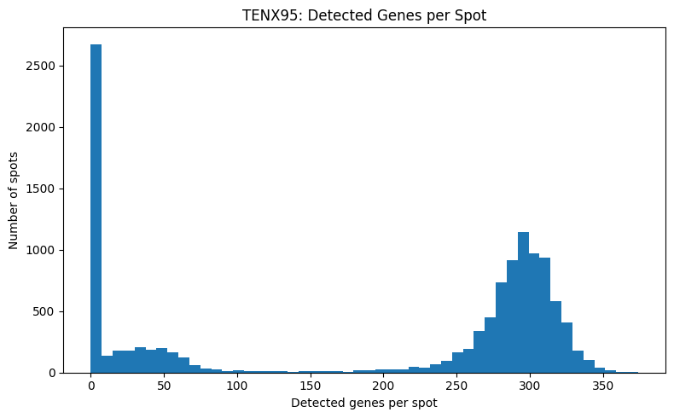
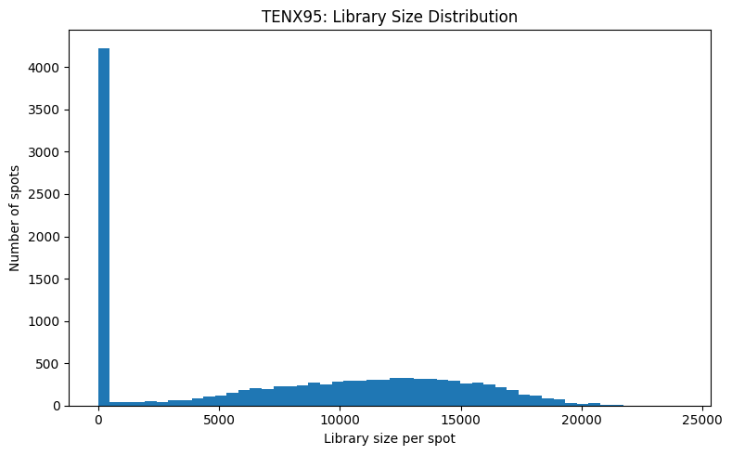
The library-size distribution had a large spike near zero, while the detected-gene distribution had a strong group around roughly 270–320 detected genes.
Why We Did It:
This identifies which spots are biologically informative. A spatial spot with near-zero expression likely corresponds to background, tissue edge, or weak capture. Such spots are poor training examples because their gene vector may not represent meaningful local biology.

Interpretation:
The dataset includes both:
valid tissue-containing spots + background / low-signal spots
This matched what we later observed visually in the thumbnail overlay and patch previews.
Implication:
Before model training, we should filter to spots with adequate molecular quality.
A reasonable initial rule is:
library_size >= 1000
detected_genes >= 100
This is not final biological truth; it is a practical MVP filtering rule to keep the training set focused on informative spots.
  - Top Expressed Genes
What We Did:
We plotted the top 25 genes by mean expression.
The leading genes included:
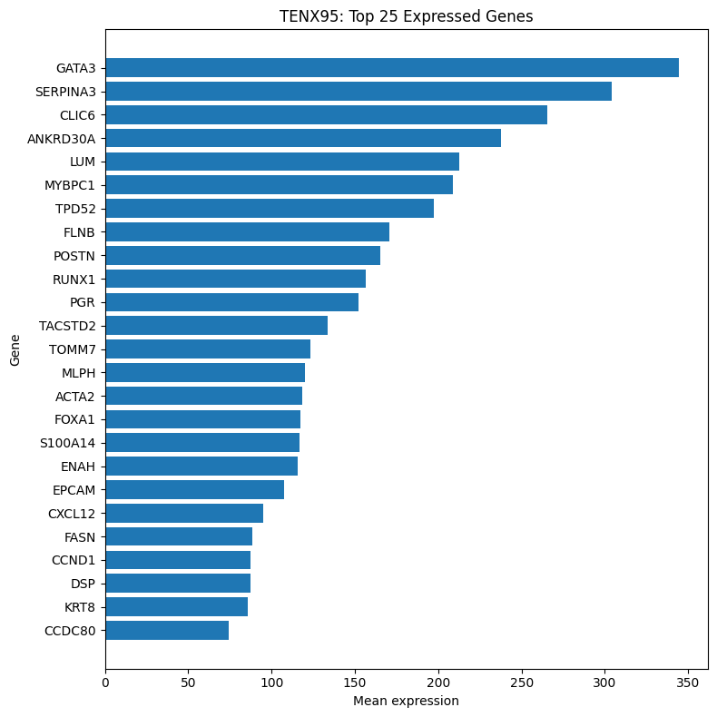
GATA3, SERPINA3, CLIC6, ANKRD30A, LUM, MYBPC1, TPD52, FLNB, POSTN, RUNX1, PGR, TACSTD2, ACTA2, FOXA1, EPCAM, CXCL12, FASN, CCND1, DSP, KRT8
Why We Did It:
Top expressed genes act as a biological sanity check. If the expression matrix were random, corrupted, or poorly loaded, the top genes would not form coherent tissue programs.
Biological Interpretation:
The top genes suggested several interpretable biological programs:
Program | Example genes | Interpretation
Epithelial / luminal identity | GATA3, FOXA1, EPCAM, KRT8, PGR, TACSTD2 | epithelial or glandular tissue signal
Stromal / extracellular matrix | LUM, POSTN, CCDC80, CXCL12 | connective tissue and matrix organization
Smooth-muscle / myofibroblast-like signal | ACTA2, MYBPC1 | contractile or stromal activation signal
Inflammatory / microenvironment signal | SERPINA3, CXCL12, RUNX1 | immune/stress/microenvironment variation
Proliferation / metabolism | CCND1, FASN, TOMM7 | growth and metabolic activity
Implication:
This was an important biological checkpoint. It showed that the expression matrix contains interpretable tissue biology, not just technical noise.
For the future contrastive model, these programs provide a basis for expecting morphology–gene alignment:
epithelial gene signal ↔ epithelial morphology
stromal gene signal ↔ fibrous morphology
ACTA2/stromal signal ↔ smooth muscle or myofibroblast-rich areas
inflammatory signal ↔ tissue microenvironment variation
  - Highly Variable Gene Selection
What We Did:
We normalized/log-transformed the expression matrix and selected highly variable genes.
We visualized:
mean expression vs normalized dispersion
mean expression vs raw dispersion
The high-contrast plot separated highly variable genes from background genes.
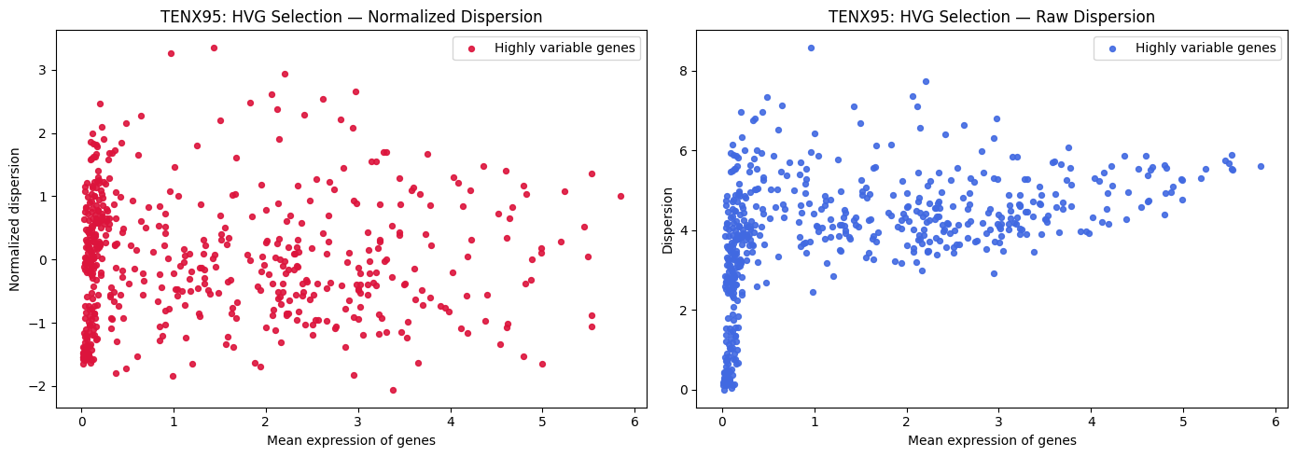
Why We Did It:
Highly expressed genes are not always the best modeling features. Some genes are highly expressed everywhere and therefore do not distinguish spatial regions.
Highly variable genes are more useful because they capture differences across tissue locations.
The goal is:
not genes that are simply abundant
but genes that separate biological regions
Interpretation:
The selected variable genes likely capture spatial heterogeneity, including epithelial, stromal, immune, metabolic, and contractile programs.
Implication:
This prepares the gene branch for modeling.
Instead of:
raw expression vector → model
we move toward:
normalized expression → log1p → highly variable features → gene encoder
This improves the contrastive objective because the gene embedding is built from spatially informative variation rather than raw count magnitude.
  - Spatial Coordinate Plot
What We Did:
We plotted the spatial coordinates from adata.obsm["spatial"].
The result was a regular rectangular grid covering approximately:
x: 0 to ~50,000
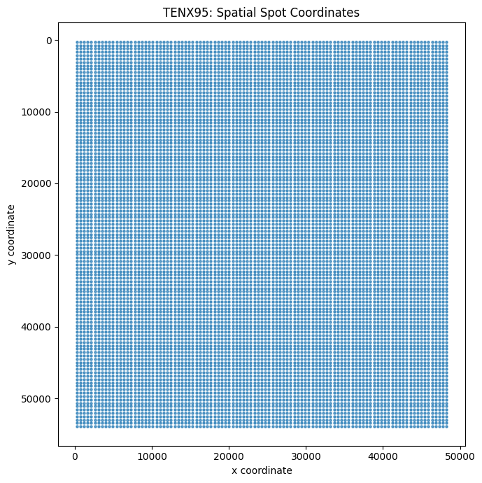
y: 0 to ~55,000

Why We Did It:
This verified that the coordinate system was coherent and grid-like. Spatial transcriptomics platforms use regular capture arrays, so the rectangular grid is expected.
Interpretation:
The coordinate values are large, meaning they are likely full-resolution image coordinates rather than thumbnail coordinates.
Implication:
This matters for visualization and patch extraction:
For patch extraction from WSI:
use full-resolution x/y coordinates
For thumbnail visualization:
scale coordinates into thumbnail coordinate space
  - Scaled Thumbnail Overlay
What We Did:
We overlaid the scaled spatial spot coordinates on the H&E thumbnail.
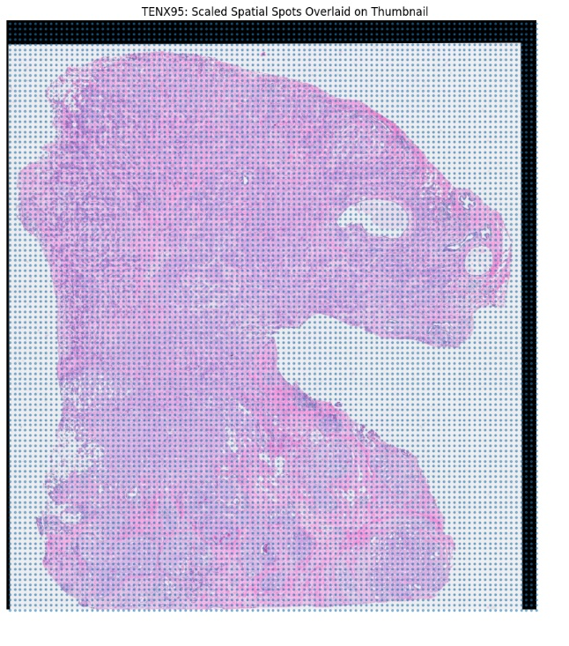
The overlay showed that the rectangular capture grid aligns with the tissue image after scaling.
Why We Did It:
This was the first visual confirmation that the molecular spatial coordinates and histology image are compatible.
Interpretation:
The overlay showed:
spots over tissue regions
spots over white/background regions
This explained the earlier low-library-size and low-detected-gene populations.
Implication:
This validates the multimodal link:
spot_id → spatial coordinate → tissue location on H&E image
It also supports filtering. Spots over white background are unlikely to be useful for image–gene alignment.

- NOTEBOOK 03: PATCH INSPECTION & PATCH EXTRACTION LOGIC
  - What We Did:
In 03_patch_inspection.ipynb, we inspected:
data/raw/hest/patches/TENX95.h5
We previewed patches from the H5 file and confirmed that the file contains real H&E image patches.
The patch preview showed:
cellular epithelial-like patches
stromal/fibrous patches
smooth-muscle-like or elongated-nuclei regions
background or tissue-edge patches
The plan is to inspect patches/TENX95.h5 before extracting from the WSI, because it may already contain patch data.
  - Why We Did It:
Direct extraction from the full-resolution WSI can be expensive and fragile. The WSI is large and opening it incorrectly can cause memory issues.
So, the preferred logic was:
first inspect existing patch H5
if usable patches exist, use them
only extract from WSI if necessary
This is more efficient and less error prone.
  - Patch Preview Interpretation:
The preview confirmed that the H5 patches are visually meaningful.
Observed morphology included:
Visual type | Meaning
Dense purple nuclei | cellular or epithelial-rich regions
Pink fibrous matrix | stromal / extracellular matrix regions
Elongated nuclei | stromal or smooth-muscle-like morphology
Mostly white patches | background or tissue-edge patches
This is important because the image branch is not operating on blank or corrupted images. The patches contain recognizable histopathological signals.
  - Patch Count v/s Spot Count:
What We Found:
Number of patches: 7,592
Number of spots in metadata: 11,845
Difference: -4,253
Interpretation:
The patch file does not contain one patch for every spot in the full AnnData object.
This likely means the patch file contains only a subset of spots, possibly tissue-containing or patch-extractable regions.
Why This Matters:
We cannot assume:
patch index 0 ↔ spot metadata row 0
patch index 1 ↔ spot metadata row 1
...
Because the counts do not match.
Implication:
Before contrastive training, we must build an aligned image–gene table:
spot_id | patch_index | gene_expression_row | image_embedding_row
The project can proceed with image embedding extraction, but training must wait until patch-to-spot mapping is resolved.

- NOTEBOOK 04: FROZEN IMAGE EMBEDDING EXTRACTION
  - What We Did:
In 04_embedding_extraction.ipynb, we used a frozen ResNet-50 encoder to convert each available H&E patch into a numerical feature vector. The pipeline was:
H&E patch → resize to 224 × 224 → convert to RGB → normalize with ImageNet statistics → frozen ResNet-50 → 2,048-dimensional image embedding
The plan is to define Notebook 04 as the stage that extracts frozen image embeddings from patch images and saves them as a reusable feature table or array.
  - Why We Did It:
Contrastive learning does not train directly on raw image pixels in the MVP. Instead, we use a frozen image encoder to produce stable representations:
patch image → image embedding
This has several advantages:
faster training
lower GPU memory usage
simpler debugging
clear separation between image feature extraction and contrastive alignment
ResNet-50 is not the final pathology-specific model, but it is a strong baseline for proving the pipeline.
  - Embedding Output:
The expected image embedding matrix is:
7,592 patches * 2,048 features
Each row corresponds to one patch, and each column corresponds to a learned visual feature from ResNet-50.
  - Embedding Norm QC:
What We Did:
We plotted the L2 norm distribution of the ResNet-50 embeddings.
The histogram showed a smooth, approximately bell-shaped distribution centered around:
~12 to 13
Most embeddings fell between:
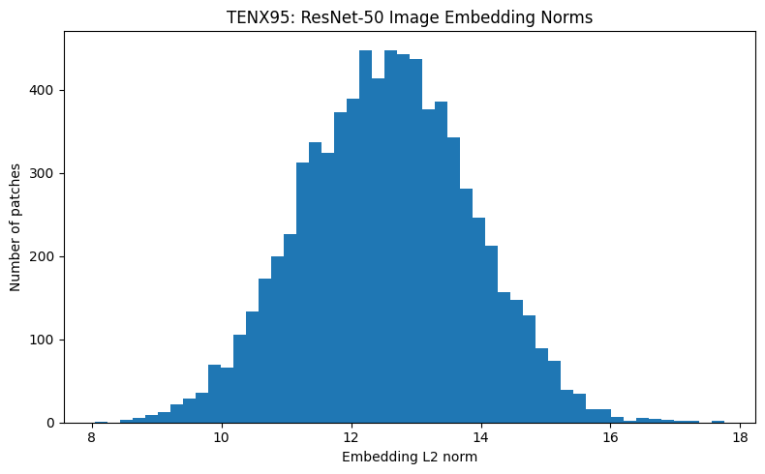
~10 and ~15
Why We Did It:
Embedding norms are a fast numerical quality-control check. If they collapsed, we might see:
Huge spike near zero
If preprocessing was unstable, we might see:
Extreme values or irregular norm distribution
Interpretation:
The smooth distribution suggests:
the encoder is producing stable outputs
image preprocessing is consistent
patches are not numerically corrupted
embeddings are suitable for downstream projection
Implication:
The image branch is now functional. We have:
patch_index → 2,048-dimensional image embedding
The next step is not more image extraction. The next step is alignment:
patch_index → spot_id → gene-expression vector

- CURRENT PROJECT STATE
  - Completed Components:
Component | Status | Evidence
Dataset download | Complete | TENX95 files available
AnnData loading | Complete | 11,845 × 541 AnnData matrix
Spatial coordinates | Complete | adata.obsm["spatial"] loaded
Spot metadata table | Complete | 11,845 × 8 table created
Expression diagnostics | Complete | sparsity and count summaries computed
Biological gene sanity check | Complete | coherent epithelial/stromal/immune markers found
HVG selection | Complete | high-contrast HVG plot generated
Thumbnail overlay | Complete | scaled spots align with tissue thumbnail
Patch H5 inspection | Complete | real H&E patches confirmed
Patch count check | Complete | 7,592 patches vs 11,845 spots
Image embedding extraction | Complete | ResNet-50 embeddings generated
Embedding QC | Complete | stable L2 norm distribution
  - Main Technical Bottleneck:
The current bottleneck is:
patch-to-spot mapping
We know:
11,845 transcriptomic spots exist
7,592 H&E patches exist
But we still need to confirm exactly which patch belongs to which spot.
This must be solved before contrastive training.

- SCIENTIFIC STORYLINE SO FAR
The project began with a general multimodal question:
Can H&E morphology recover spatial molecular biology?
To answer this, we first needed to prove that the dataset contains matched spatial molecular and image information.
Notebook 01 established that the required TENX95 files exist and can be loaded.
Notebook 02 showed that the molecular branch is valid: TENX95 contains 11,845 spatial spots, 541 genes, coherent spatial coordinates, interpretable biological markers, and a coordinate system that aligns with the H&E thumbnail after scaling.
Notebook 03 showed that the histology branch is valid: the H5 patch file contains real H&E patches with meaningful morphological heterogeneity.
Notebook 04 converted those patches into stable numerical embeddings using a frozen ResNet-50 encoder.
At this point, the project has both modalities independently processed:
Molecular branch:
spot_id → gene-expression vector
Image branch:
patch_index → ResNet-50 image embedding

The remaining bridge is:
spot_id ↔ patch_index
Once that is resolved, the project can train the first contrastive alignment model.

- ARCHITECTURE STATUS: CURRENT v/s PLANNED
  - Current Implemented Architecture:
TENX95.h5ad
↓
Spot metadata + Expression matrix
↓
QC + HVG Exploration
↓
TENX95.h5 patch file
↓
H&E patch preview
↓
Frozen ResNet-50
↓
Image Embeddings
  - Next Implemented Architecture:
Spot metadata + Expression Matrix + Patch Index + Image Embeddings
↓
Aligned image-gene dataset
↓
Gene Encoder
↓
Image Projection Head
↓
Gene Projection Head
↓
Contrastive Loss
↓
Retrieval Evaluation

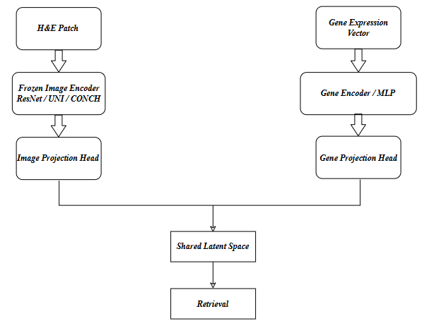
  - Final Target Architecture:

- PLANNED EVALUATION
The first formal experiment will be spot-level retrieval.
  - Image-to-Gene Retrieval
Given an H&E patch, retrieve the correct gene-expression profile:
query: image embeddings
target database: gene embeddings
correct result: gene profile from same spot
  - Gene-to-Image Retrieval
Given a gene-expression profile, retrieve the correct H&E patch:
query: gene embedding
target database: image embeddings
correct result: image patch from same spot
  - Metrics
The planned metrics are:
Metric | Meaning
Recall@1 | True match is ranked first
Recall@5 | True match appears in top 5
Recall@10 | True match appears in top 10
Median Rank | median position of the true match
MRR | average reciprocal rank of the true match
The project plan identifies Recall@1, Recall@5, Recall@10, Median Rank, and MRR as the core retrieval metrics for image-to-gene and gene-to-image evaluation.
- IMPLICATIONS OF EACH STEP
  - Dataset Validation:
What it gave us: confidence that the correct files exist.
Why it matters: prevents wasting effort on code before verifying data integrity.
Downstream implication: enabled AnnData loading, metadata extraction, and patch inspection.
  - AnnData Loading:
What it gave us: the molecular structure of TENX95.
Why it matters: expression and coordinates are the foundation of spot-level alignment.
Downstream implication: enabled spot metadata creation and expression preprocessing.
  - Spot Metadata Table:
What it gave us: a clean spot-level index.
Why it matters: every downstream multimodal join depends on this table.
Downstream implication: this becomes the backbone of the aligned training dataset.
  - Expression QC:
What it gave us: knowledge of sparsity, library size, and detected genes.
Why it matters: low-signal spots can damage contrastive learning.
Downstream implication: motivates the QC filtering before training.
  - Biological Gene Interpretation:
What it gave us: evidence that the gene matrix has meaningful tissue biology.
Why it matters: contrastive alignment is only meaningful if the transcriptomic branch has interpretable biological structure.
Downstream implication: helps interpret retrieval successes and failures later.
  - HVG Selection:
What it gave us: a more informative gene feature space.
Why it matters: variable genes better capture spatial heterogeneity than uniformly expressed genes.
Downstream implication: prepares the input for the gene encoder.
  - Spatial Overlay:
What it gave us: visual confirmation that spatial coordinates align with H&E tissue after scaling.
Why it matters: validates the spatial link between gene expression and morphology.
Downstream implication: supports patch-level image-gene alignment.
  - Patch H5 Inspection:
What it gave us: confirmation that H&E patches already exist.
Why it matters: avoids costly full WSI patch extraction.
Downstream implication: allows direct embedding extraction from H5 patches.
  - Patch Count Check:
What it gave us: identified the mismatch between spots and patches.
Why it matters: prevents incorrect row-wise pairing.
Downstream implication: patch-to-spot mapping must be resolved before training.
  - Image Embedding Extraction:
What it gave us: numerical representations of H&E patches.
Why it matters: contrastive training needs image vectors, not raw image files.
Downstream implication: enables image projection head and shared latent-space training.

- CURRENT LIMITATIONS
The project is in strong shape, but several limitations remain before training.
- Patch-to-Spot Mapping is not yet resolved: The key limitation is that the H5 file contains 7,592 patches, while AnnData contains 11,845 spots. The patch subset must be mapped to the correct gene-expression rows.
- RestrNet-50 is a Baseline Encoder: ResNet-50 is useful for MVP validation, but it is not pathology-specific. Later experiments should compare it with UNI or CONCH, as the project plan suggests.
- Background Patches exist: Patch previews showed some mostly blank or tissue-edge patches. These may need filtering before training.
- Single-Sample MVP: So far, the workflow uses TENX95 only. This is appropriate for the MVP but does not yet test cross-slide or cross-tissue generalization.

