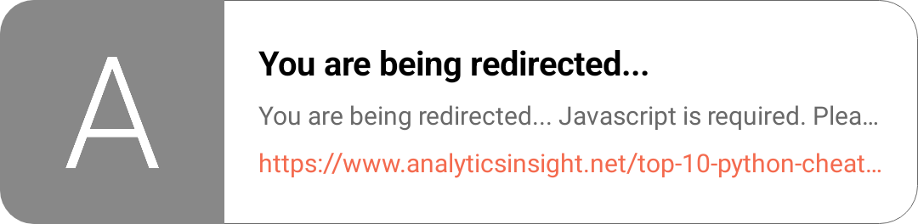
MERN
PHP

Devops frameworks:
Docker
Kotlin
Zenkits
Micro services

AWS free registration for learning

Ieron (dsa)

