NAME: GURRALA HAREESH REDDY ID NO:2400090155 SEC NO : 06
FULL STACK DEVLOPMENT
Skill-12: Full Stack CRUD Application (React + Spring Boot)

Purpose:
Build a full-stack CRUD app for student management using React frontend and Spring Boot backend.
Tech stack:
Java 17, Spring Boot, Maven, Spring Data JPA, H2 Database, React 18, Axios

Project files (full contents)
Backend:
pom.xml
(see pom.xml for full Maven config)
StudentAppApplication.java
package com.example.studentapp;

import org.springframework.boot.SpringApplication;
import org.springframework.boot.autoconfigure.SpringBootApplication;

@SpringBootApplication
public class StudentAppApplication {
public static void main(String[] args) {
SpringApplication.run(StudentAppApplication.class, args);
}
}
Student.java
package com.example.studentapp.model;

import jakarta.persistence.*;

@Entity
public class Student {
@Id
@GeneratedValue(strategy = GenerationType.IDENTITY)
private Long id;
private String name;
private String email;
private String course;

// Constructors, getters, setters
}
StudentRepository.java
package com.example.studentapp.repository;

import com.example.studentapp.model.Student;
import org.springframework.data.jpa.repository.JpaRepository;

public interface StudentRepository extends JpaRepository<Student, Long> {}
StudentService.java
package com.example.studentapp.service;

import com.example.studentapp.model.Student;
import com.example.studentapp.repository.StudentRepository;
import org.springframework.stereotype.Service;
import java.util.List;
import java.util.Optional;

@Service
public class StudentService {
private final StudentRepository repository;

public StudentService(StudentRepository repository) {
this.repository = repository;
}

public Student addStudent(Student student) { return repository.save(student); }
public List<Student> getAllStudents() { return repository.findAll(); }
public Optional<Student> updateStudent(Long id, Student student) {
return repository.findById(id).map(existing -> {
existing.setName(student.getName());
existing.setEmail(student.getEmail());
existing.setCourse(student.getCourse());
return repository.save(existing);
});
}
public void deleteStudent(Long id) { repository.deleteById(id); }
}
StudentController.java
package com.example.studentapp.controller;

import com.example.studentapp.model.Student;
import com.example.studentapp.service.StudentService;
import org.springframework.http.ResponseEntity;
import org.springframework.web.bind.annotation.*;
import java.util.List;

@RestController
@RequestMapping("/students")
@CrossOrigin(origins = "http://localhost:3000")
public class StudentController {
private final StudentService service;

public StudentController(StudentService service) { this.service = service; }

@PostMapping
public ResponseEntity<Student> addStudent(@RequestBody Student student) {
Student created = service.addStudent(student);
return ResponseEntity.status(201).body(created);
}

@GetMapping
public ResponseEntity<List<Student>> getAllStudents() {
return ResponseEntity.ok(service.getAllStudents());
}

@PutMapping("/{id}")
public ResponseEntity<Student> updateStudent(@PathVariable Long id, @RequestBody Student student) {
return service.updateStudent(id, student)
.map(ResponseEntity::ok)
.orElse(ResponseEntity.notFound().build());
}

@DeleteMapping("/{id}")
public ResponseEntity<Void> deleteStudent(@PathVariable Long id) {
service.deleteStudent(id);
return ResponseEntity.noContent().build();
}
}
application.properties
server.port=8085
spring.datasource.url=jdbc:h2:mem:studentsdb
spring.datasource.driverClassName=org.h2.Driver
spring.jpa.database-platform=org.hibernate.dialect.H2Dialect
spring.jpa.hibernate.ddl-auto=create
spring.h2.console.enabled=true

Frontend:
package.json
(see package.json for full config)
index.html
(see index.html)
index.js
import React from "react";
import ReactDOM from "react-dom/client";
import App from "./App";

const root = ReactDOM.createRoot(document.getElementById("root"));
root.render(<App />);
App.jsx
import React, { useState } from "react";
import AddStudent from "./components/AddStudent";
import StudentList from "./components/StudentList";
import "./App.css";

function App() {
const [editingStudent, setEditingStudent] = useState(null);
const [refresh, setRefresh] = useState(false);

const handleEdit = student => setEditingStudent(student);
const handleSuccess = () => {
setEditingStudent(null);
setRefresh(r => !r);
};

return (
<div className="container">
<h2>Skill-12: Full Stack Student CRUD App</h2>
<AddStudent editingStudent={editingStudent} onSuccess={handleSuccess} />
<StudentList key={refresh} onEdit={handleEdit} />
</div>
);
}

export default App;
App.css
(see App.css for full styling)
AddStudent.jsx
import React, { useState, useEffect } from "react";
import axios from "axios";

function AddStudent({ editingStudent, onSuccess }) {
const [form, setForm] = useState({ name: "", email: "", course: "" });
const [editId, setEditId] = useState(null);

useEffect(() => {
if (editingStudent) {
setForm({
name: editingStudent.name,
email: editingStudent.email,
course: editingStudent.course
});
setEditId(editingStudent.id);
} else {
setForm({ name: "", email: "", course: "" });
setEditId(null);
}
}, [editingStudent]);

const handleChange = e => setForm({ ...form, [e.target.name]: e.target.value });

const handleSubmit = e => {
e.preventDefault();
if (editId) {
axios.put(`http://localhost:8085/students/${editId}`, form)
.then(() => {
setForm({ name: "", email: "", course: "" });
setEditId(null);
onSuccess();
});
} else {
axios.post("http://localhost:8085/students", form)
.then(() => {
setForm({ name: "", email: "", course: "" });
onSuccess();
});
}
};

return (
<div>
<h3>{editId ? "Update Student" : "Add Student"}</h3>
<form className="student-form" onSubmit={handleSubmit}>
<input name="name" value={form.name} onChange={handleChange} placeholder="Name" required />
<input name="email" value={form.email} onChange={handleChange} placeholder="Email" required />
<input name="course" value={form.course} onChange={handleChange} placeholder="Course" required />
<button type="submit">{editId ? "Update" : "Add"}</button>
{editId && <button type="button" onClick={() => {
setForm({ name: "", email: "", course: "" });
setEditId(null);
onSuccess();
}}>Cancel</button>}
</form>
</div>
);
}

export default AddStudent;
StudentList.jsx
import React, { useEffect, useState } from "react";
import axios from "axios";

function StudentList({ onEdit }) {
const [students, setStudents] = useState([]);

const fetchStudents = () => {
axios.get("http://localhost:8085/students")
.then(res => setStudents(res.data))
.catch(() => setStudents([]));
};

useEffect(() => {
fetchStudents();
}, []);

const handleDelete = (id) => {
axios.delete(`http://localhost:8085/students/${id}`)
.then(() => setStudents(students.filter(s => s.id !== id)));
};

return (
<div>
<h3>Student List</h3>
<table className="student-table">
<thead>
<tr>
<th>ID</th><th>Name</th><th>Email</th><th>Course</th><th>Actions</th>
</tr>
</thead>
<tbody>
{students.map(student => (
<tr key={student.id}>
<td>{student.id}</td>
<td>{student.name}</td>
<td>{student.email}</td>
<td>{student.course}</td>
<td>
<button onClick={() => onEdit(student)}>Update</button>
<button onClick={() => handleDelete(student.id)}>Delete</button>
</td>
</tr>
))}
</tbody>
</table>
</div>
);
}

export default StudentList;

Build & Run
Backend:
- mvn spring-boot:run (runs at http://localhost:8085)
Frontend:
- npm install
- npm start (runs at http://localhost:3000)

Expected console flow
- Add, view, update, delete students
- UI updates instantly after each operation

What was done
- Spring Boot backend with REST API and H2 DB
- React frontend with Axios for API calls
- Full CRUD operations with instant UI updates

Outputs:
(Add screenshots of backend, frontend, and CRUD operations) 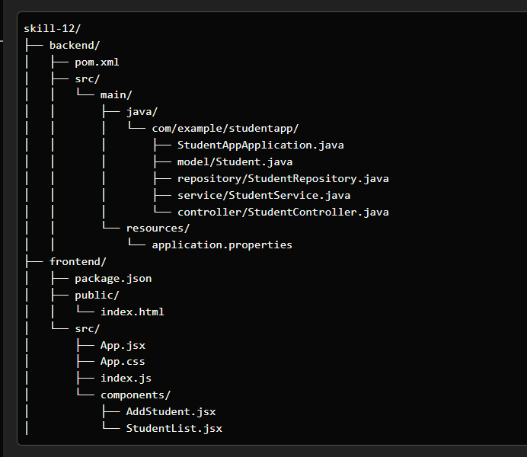
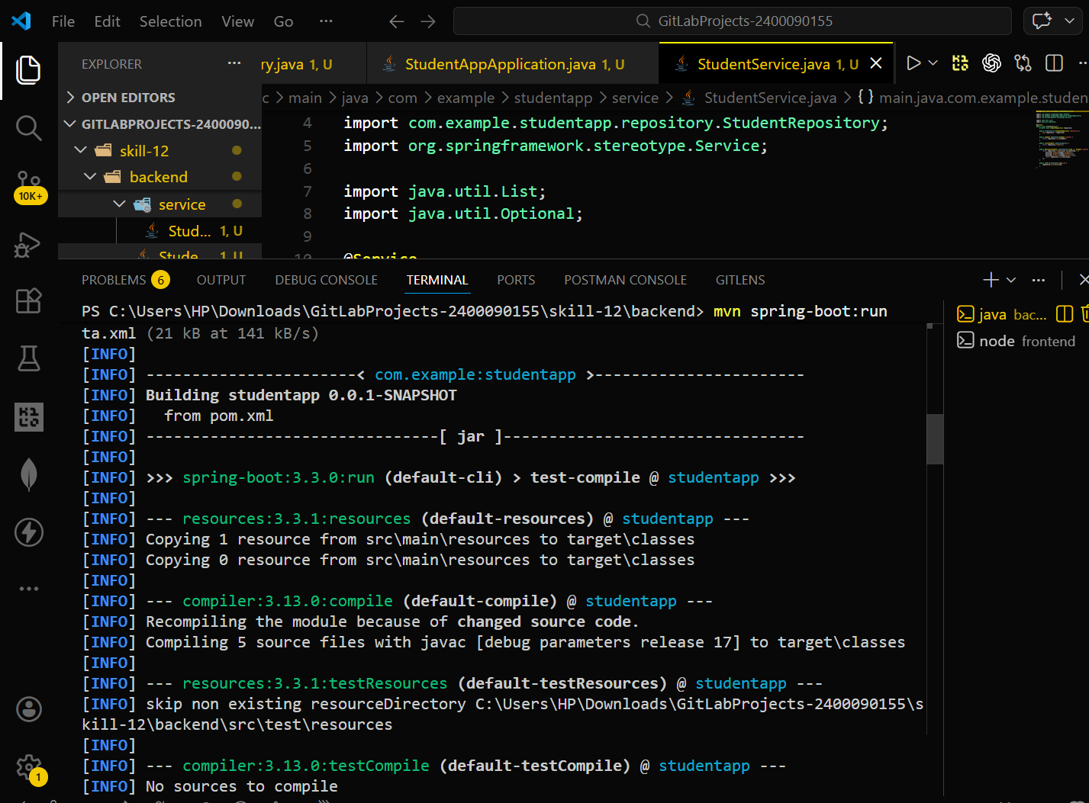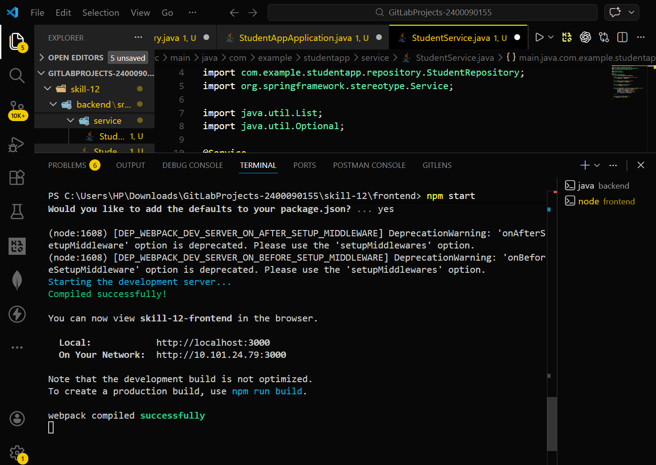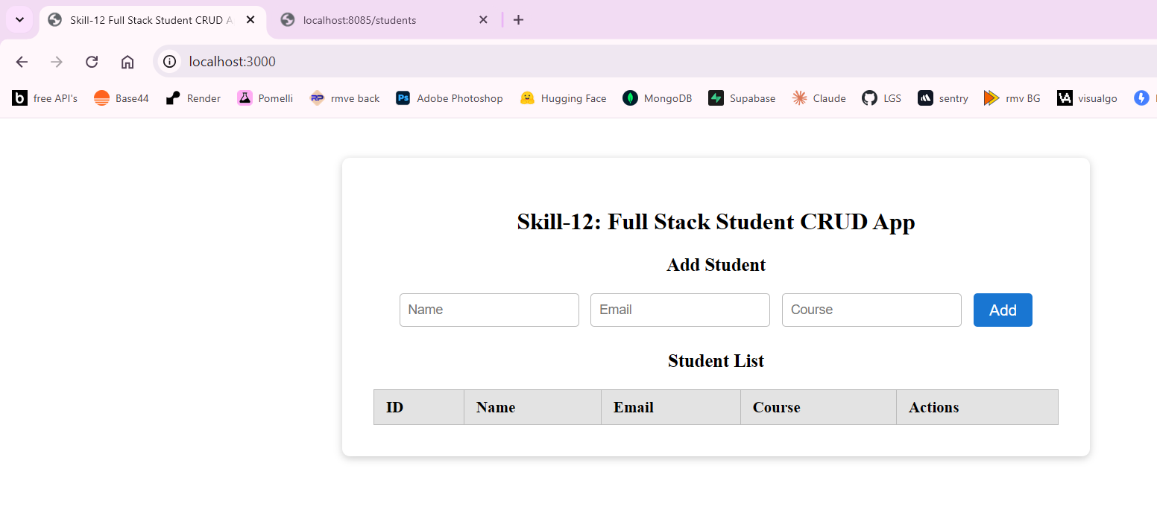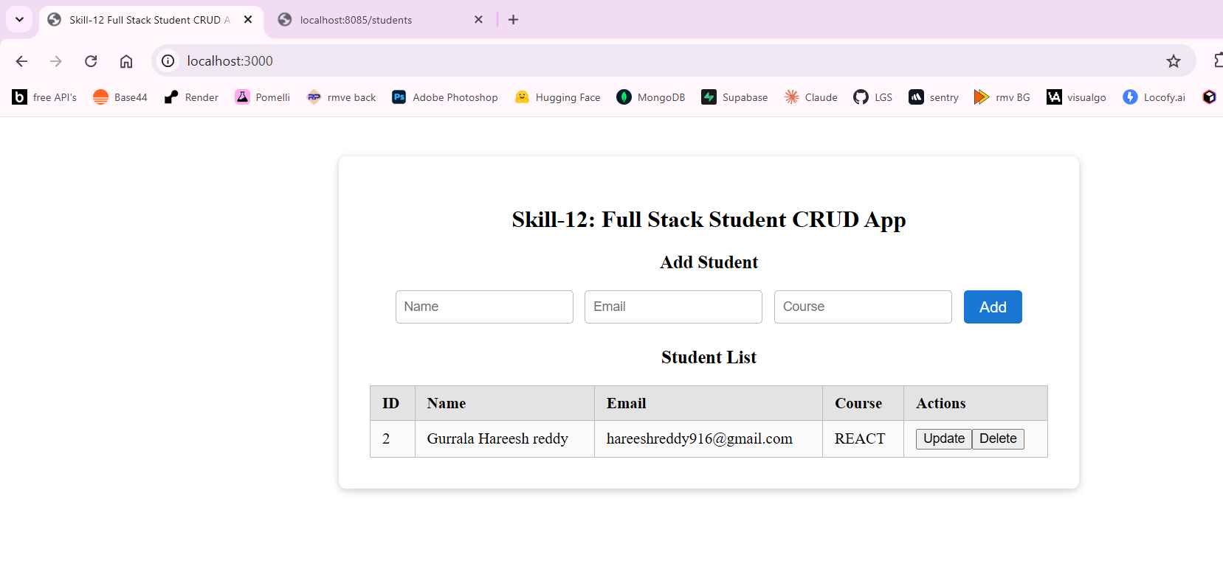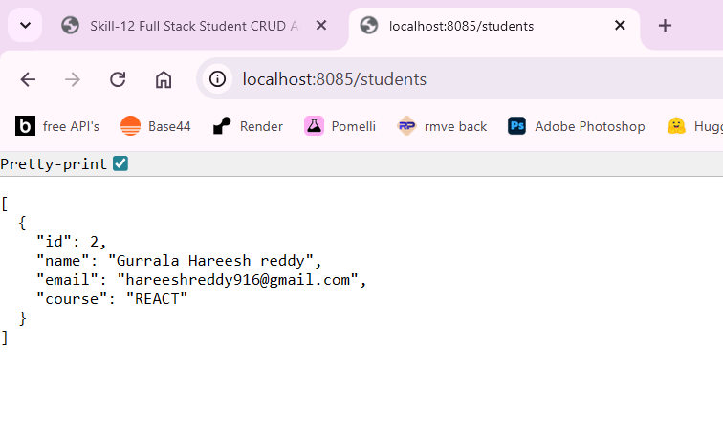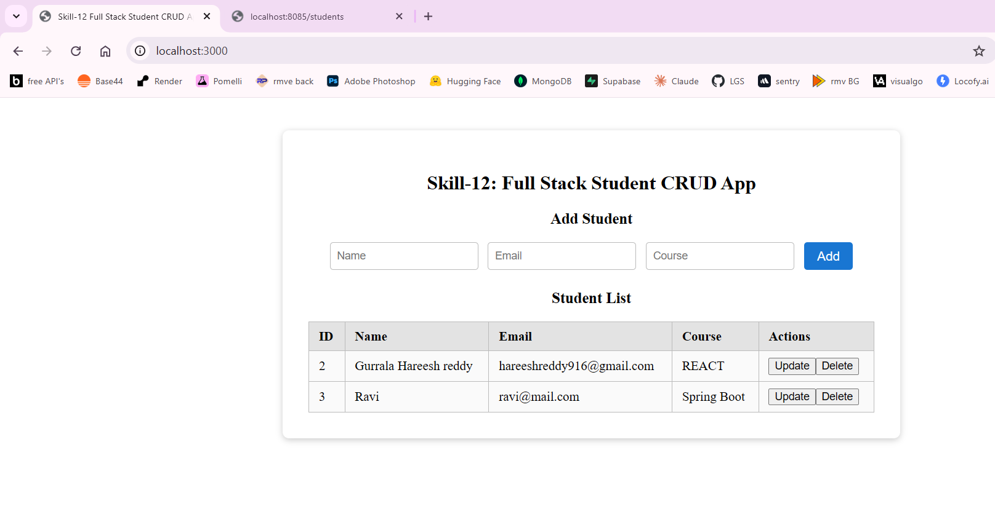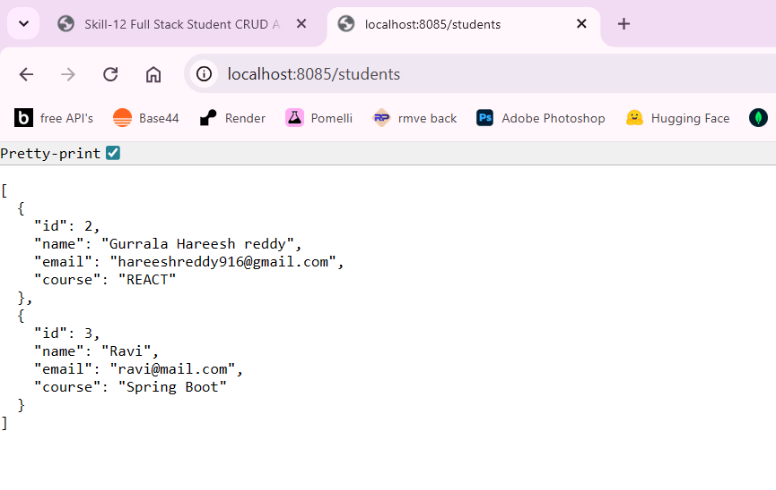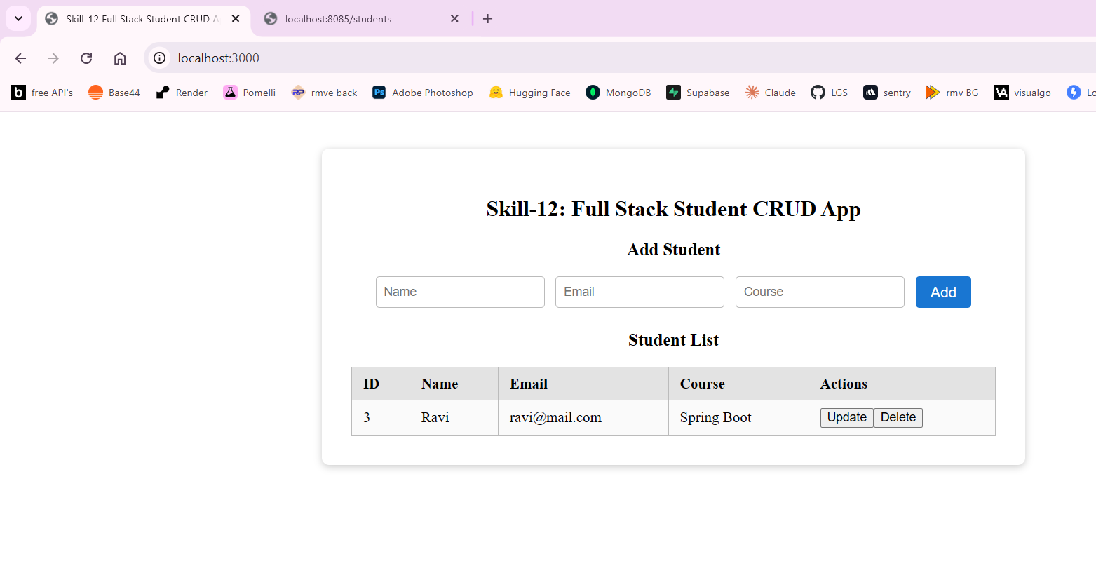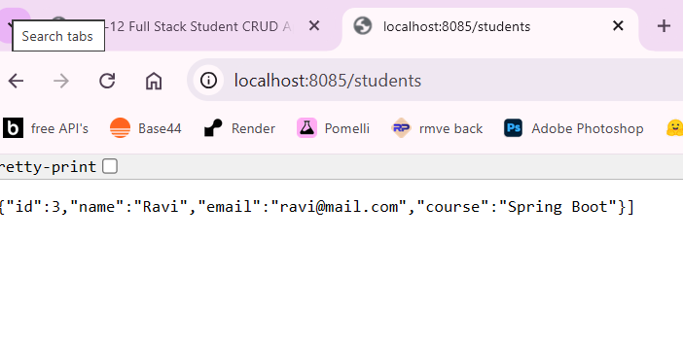
GitHub Repository Link
The complete source code for this experiment is available in the following GitHub repository:
Repository:
https://github.com/Hareesh-Reddy-9126/2400090155_FSAD_SKILL_11.git

