NAME: GURRALA HAREESH REDDY ID NO:2400090155 SEC NO : 06
FULL STACK DEVLOPMENT
Skill-13: Deployment of Full-Stack Application (Spring Boot + React)

Purpose:
Deploy a production-ready full-stack application where a React frontend is integrated with a Spring Boot backend.
The application is prepared for deployment by generating a React production build, packaging the Spring Boot backend as a JAR file, and serving the React build through Spring Boot.

Tech stack:
Java 17, Spring Boot 3.x, Maven, Spring Data JPA, H2 Database, React 18, Axios, Node.js

Project files (deployment configuration)
Backend:
pom.xml
(see pom.xml for full Maven configuration)

StudentAppApplication.java
package com.skill13;
import org.springframework.boot.SpringApplication;
import org.springframework.boot.autoconfigure.SpringBootApplication;
@SpringBootApplication
public class StudentAppApplication {
public static void main(String[] args) {
SpringApplication.run(StudentAppApplication.class, args);
}
}

Student.java
package com.skill13.model;
import jakarta.persistence.*;
@Entity
public class Student {
@Id
@GeneratedValue(strategy = GenerationType.IDENTITY)
private Long id;
private String name;
private String email;
private String course;
// Constructors
public Student() {}
public Student(String name, String email, String course) {
this.name = name;
this.email = email;
this.course = course;
}
// Getters and setters
}

StudentRepository.java
package com.skill13.repository;
import com.skill13.model.Student;
import org.springframework.data.jpa.repository.JpaRepository;
public interface StudentRepository extends JpaRepository<Student, Long> {
}

StudentService.java
package com.skill13.service;
import com.skill13.model.Student;
import com.skill13.repository.StudentRepository;
import org.springframework.stereotype.Service;
import java.util.List;
import java.util.Optional;
@Service
public class StudentService {
private final StudentRepository repository;
public StudentService(StudentRepository repository) {
this.repository = repository;
}
public Student addStudent(Student student) {
return repository.save(student);
}
public List<Student> getAllStudents() {
return repository.findAll();
}
public Optional<Student> updateStudent(Long id, Student student) {
return repository.findById(id).map(existing -> {
existing.setName(student.getName());
existing.setEmail(student.getEmail());
existing.setCourse(student.getCourse());
return repository.save(existing);
});
}
public void deleteStudent(Long id) {
repository.deleteById(id);
}
}

StudentController.java
package com.skill13.controller;
import com.skill13.model.Student;
import com.skill13.service.StudentService;
import org.springframework.http.ResponseEntity;
import org.springframework.web.bind.annotation.*;
import java.util.List;
@RestController
@RequestMapping("/students")
@CrossOrigin(origins = "http://localhost:3000")
public class StudentController {
private final StudentService service;
public StudentController(StudentService service) {
this.service = service;
}
@PostMapping
public ResponseEntity<Student> addStudent(@RequestBody Student student) {
return ResponseEntity.status(201).body(service.addStudent(student));
}
@GetMapping
public ResponseEntity<List<Student>> getAllStudents() {
return ResponseEntity.ok(service.getAllStudents());
}
@PutMapping("/{id}")
public ResponseEntity<Student> updateStudent(@PathVariable Long id, @RequestBody Student student) {
return service.updateStudent(id, student)
.map(ResponseEntity::ok)
.orElse(ResponseEntity.notFound().build());
}
@DeleteMapping("/{id}")
public ResponseEntity<Void> deleteStudent(@PathVariable Long id) {
service.deleteStudent(id);
return ResponseEntity.noContent().build();
}
}

application.properties
server.port=8080
spring.datasource.url=jdbc:h2:mem:testdb
spring.datasource.driverClassName=org.h2.Driver
spring.jpa.database-platform=org.hibernate.dialect.H2Dialect
spring.jpa.hibernate.ddl-auto=create
spring.h2.console.enabled=true

Frontend Deployment
The React frontend is prepared for production using the React build process.
React build command:
npm run build
This generates optimized static files inside:
frontend/build
These files are copied into the Spring Boot static folder:
backend/src/main/resources/static
Spring Boot automatically serves these static files when the backend application runs.

Build & Run
Build React Production Version
cd frontend
npm install
npm run build

Package Spring Boot Backend
cd backend
mvn clean package
This creates the deployable file:
target/student-manager-1.0.0.jar

Run the Backend JAR
java -jar target/student-manager-1.0.0.jar
Application runs at:
http://localhost:8080

Expected console flow
• React production build generated successfully
• Spring Boot packaged as JAR
• Spring Boot server starts with embedded Tomcat
• React UI served through Spring Boot static folder
• CRUD operations function normally after deployment

What was done
• Generated React production build using npm run build
• Packaged Spring Boot backend using mvn clean package
• Copied React build files into Spring Boot static folder
• Ran backend as executable JAR file
• Verified frontend–backend integration in browser
• Tested CRUD operations in deployed application

Outputs:
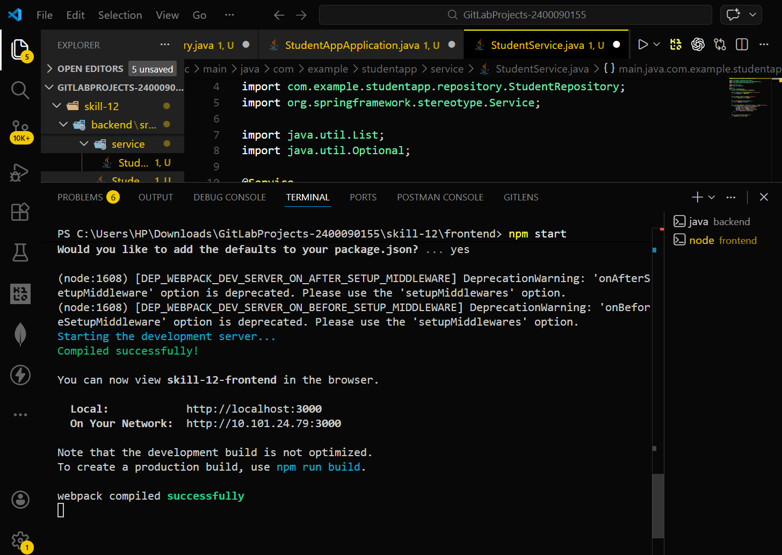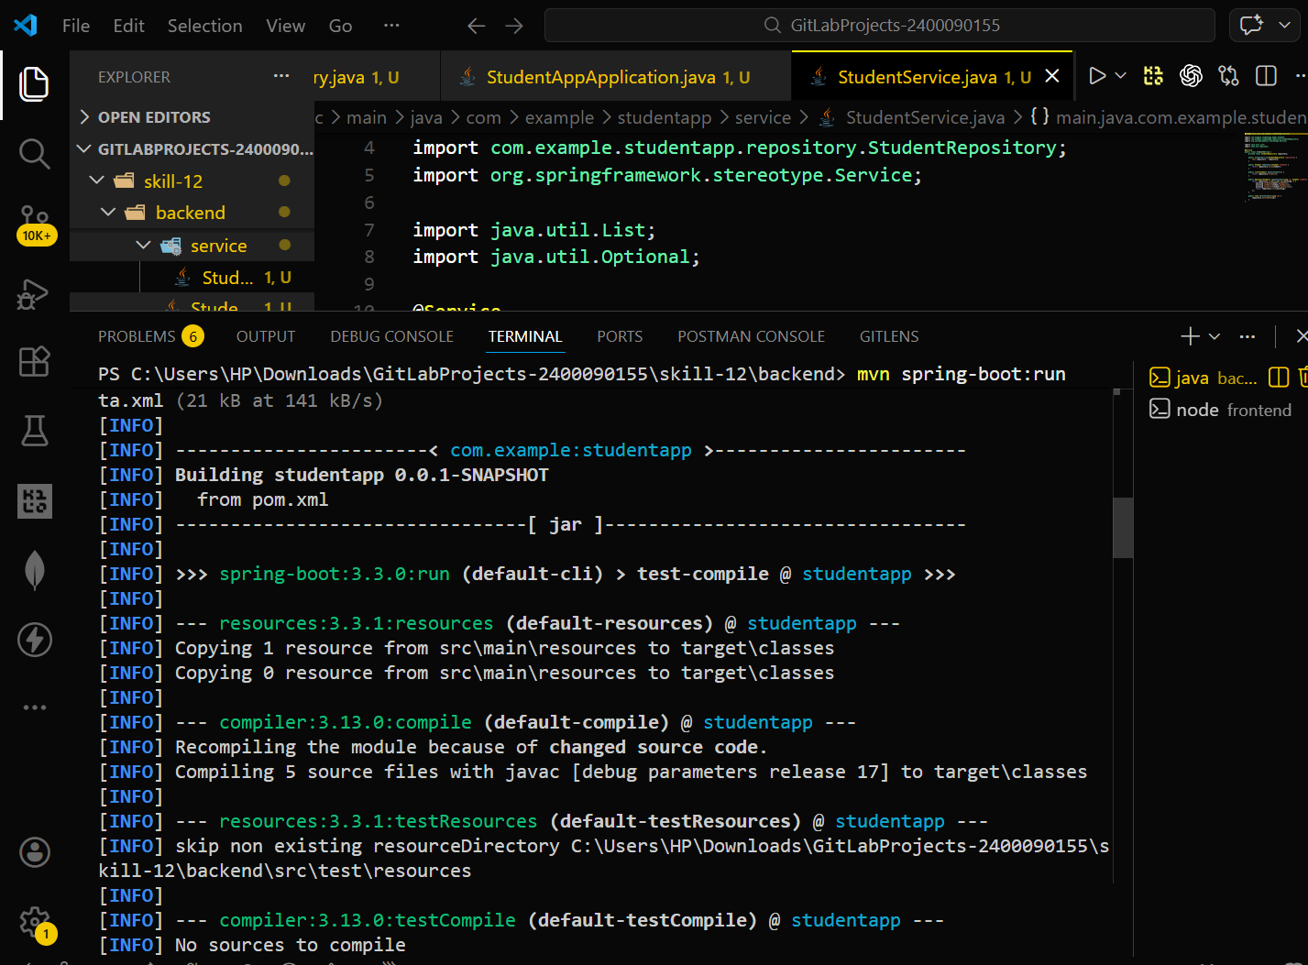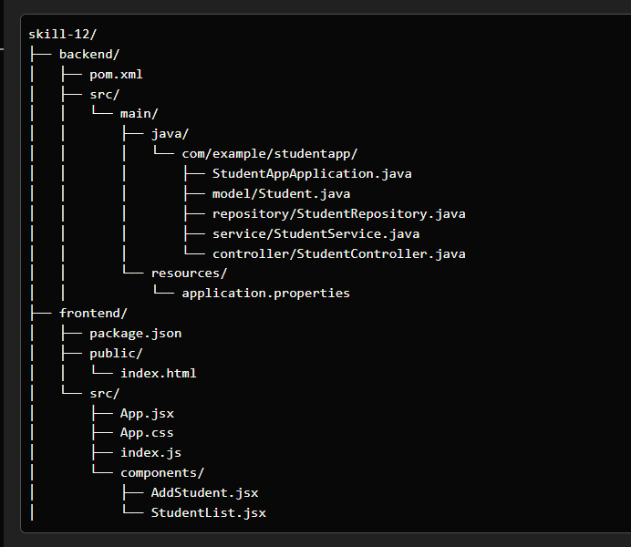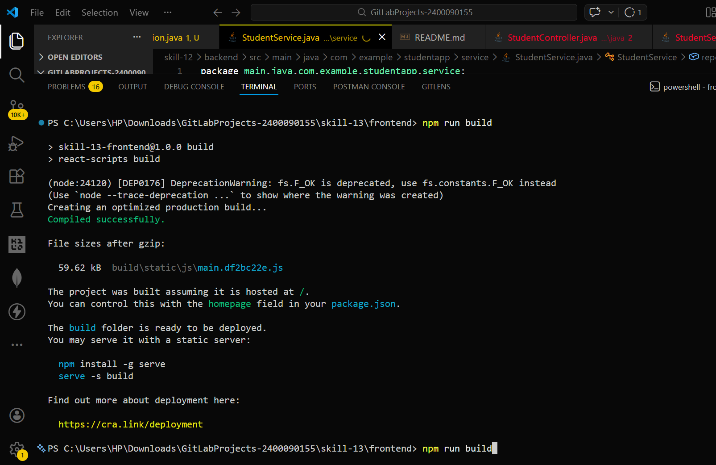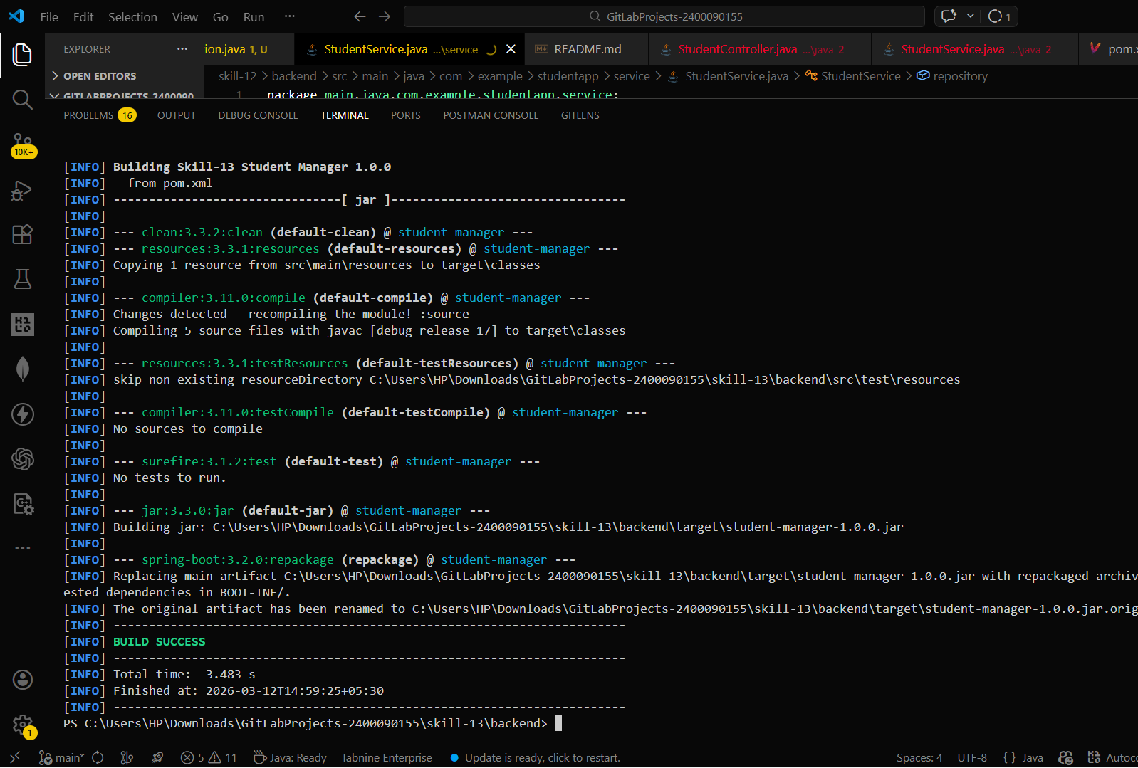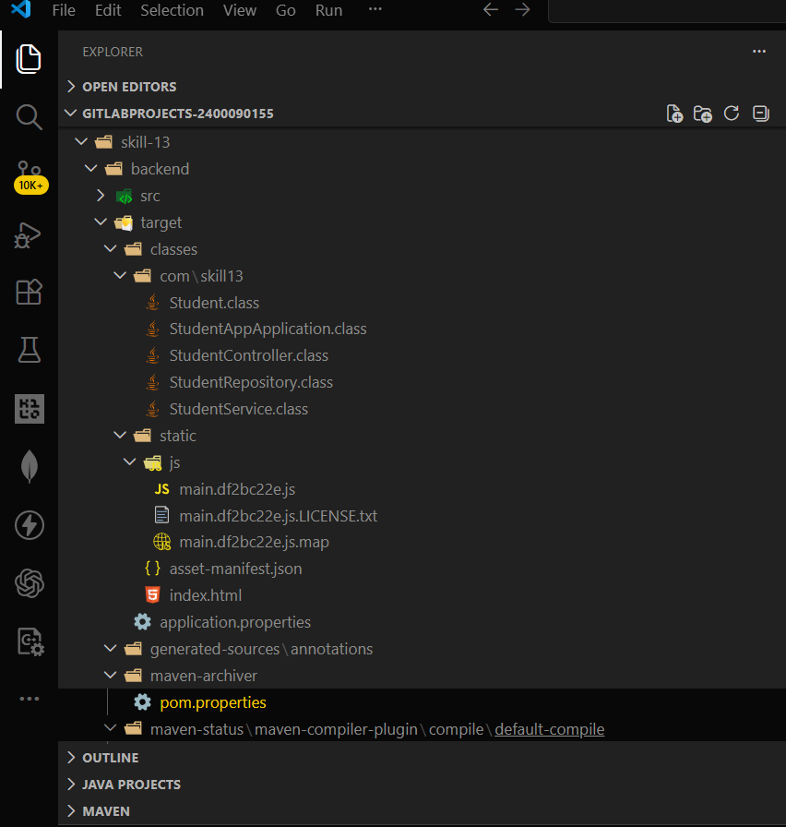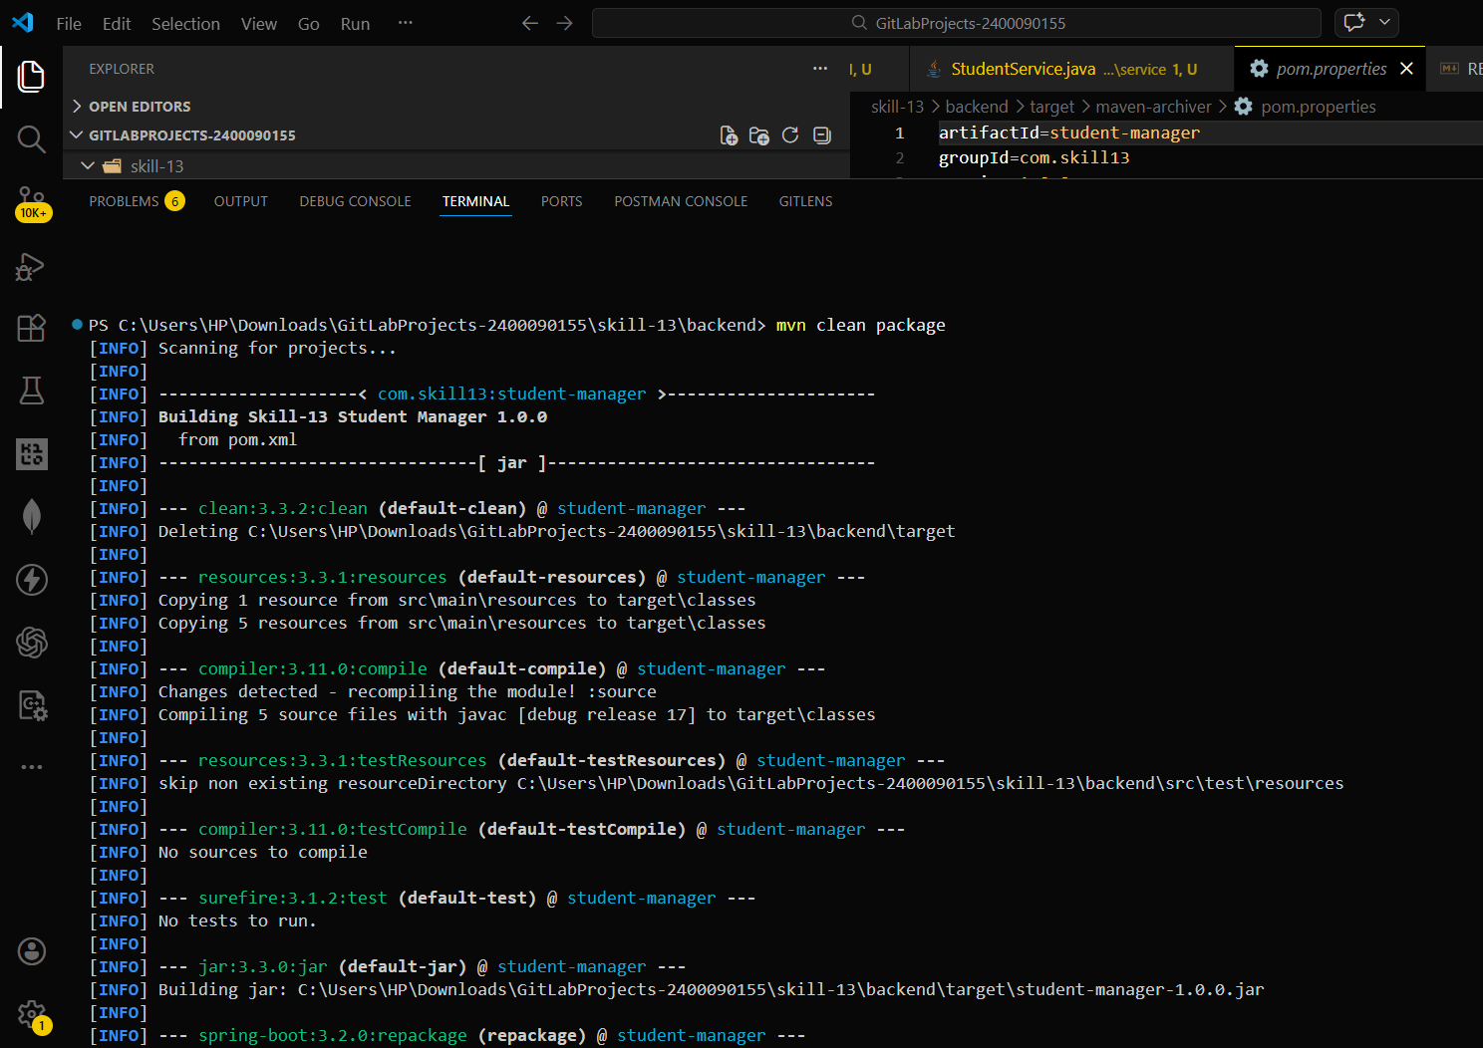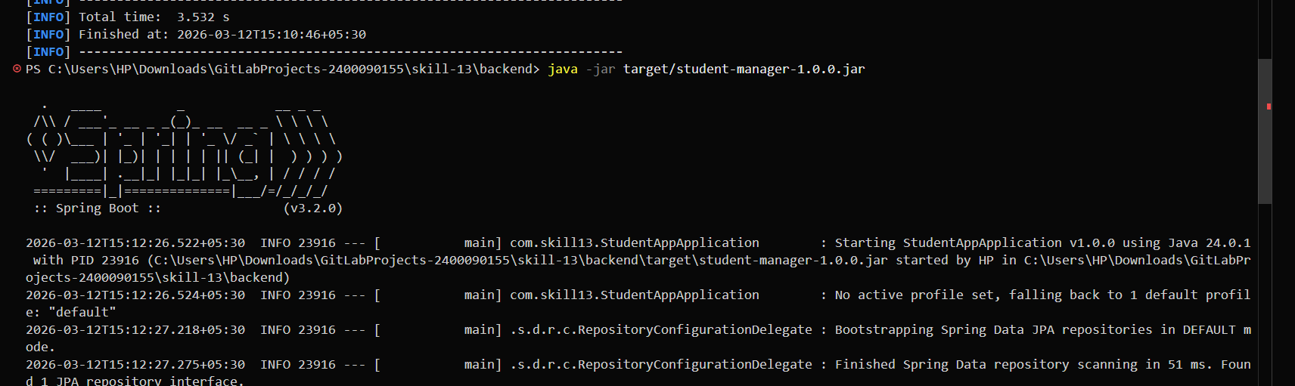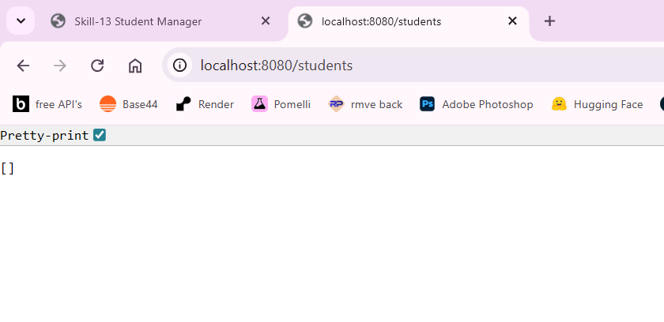
• React production build
• Maven packaging success
• Running Spring Boot JAR
• Deployed React UI in browser
• CRUD operations working after deployment

GitHub Repository Link
The complete source code for this experiment is available in the following GitHub repository:
Repository:
https://github.com/Hareesh-Reddy-9126/2400090155_FSAD_SKILL_11.git

