NAME: GURRALA HAREESH REDDY ID NO:2400090155 SEC NO : 06
FULL STACK DEVLOPMENT
Skill-4: Spring Dependency Injection – Constructor & Setter Injection
Purpose
To demonstrate Dependency Injection (DI) in the Spring Framework using both Constructor Injection and Setter Injection through XML-based configuration and Annotation-based configuration. This experiment shows how Spring’s IoC container injects object dependencies without manual object creation.

Tech Stack
- Java 17
- Maven
- Spring Core (spring-context)
- Spring Tools Suite (STS)
- VS Code (for Maven execution)

Project Structure
skill-4/
├── pom.xml
├── src/main/java/com/example
│ ├── Student.java
│ ├── XmlConfigMain.java
│ ├── AnnotationConfigMain.java
│ └── JavaConfig.java
└── src/main/resources
└── applicationContext.xml

Project Files

pom.xml
<project xmlns="http://maven.apache.org/POM/4.0.0"
xmlns:xsi="http://www.w3.org/2001/XMLSchema-instance"
xsi:schemaLocation="http://maven.apache.org/POM/4.0.0
https://maven.apache.org/xsd/maven-4.0.0.xsd">

<modelVersion>4.0.0</modelVersion>

<groupId>com.example</groupId>
<artifactId>skill-4-spring-di</artifactId>
<version>1.0-SNAPSHOT</version>

<properties>
<maven.compiler.release>17</maven.compiler.release>
</properties>

<dependencies>
<dependency>
<groupId>org.springframework</groupId>
<artifactId>spring-context</artifactId>
<version>6.1.5</version>
</dependency>
</dependencies>

</project>

Student.java
package com.example;

public class Student {

private int studentId;
private String name;
private String course;
private String year;

// Constructor Injection
public Student(int studentId, String name, String course, String year) {
this.studentId = studentId;
this.name = name;
this.course = course;
this.year = year;
}

// Setter Injection
public void setCourse(String course) {
this.course = course;
}

public void setYear(String year) {
this.year = year;
}

@Override
public String toString() {
return "Student{" +
"studentId=" + studentId +
", name='" + name + '\'' +
", course='" + course + '\'' +
", year='" + year + '\'' +
'}';
}
}

applicationContext.xml
<beans xmlns="http://www.springframework.org/schema/beans"
xmlns:xsi="http://www.w3.org/2001/XMLSchema-instance"
xsi:schemaLocation="
http://www.springframework.org/schema/beans
https://www.springframework.org/schema/beans/spring-beans.xsd">

<!-- Constructor Injection -->
<bean id="student1" class="com.example.Student">
<constructor-arg value="101"/>
<constructor-arg value="Alice"/>
<constructor-arg value="Spring Framework"/>
<constructor-arg value="2026"/>
</bean>

<!-- Setter Injection -->
<bean id="student2" class="com.example.Student">
<constructor-arg value="102"/>
<constructor-arg value="Bob"/>
<constructor-arg value="Java"/>
<constructor-arg value="2027"/>
</bean>

</beans>

XmlConfigMain.java
package com.example;

import org.springframework.context.ApplicationContext;
import org.springframework.context.support.ClassPathXmlApplicationContext;

public class XmlConfigMain {

public static void main(String[] args) {

ApplicationContext context =
new ClassPathXmlApplicationContext("applicationContext.xml");

Student s1 = (Student) context.getBean("student1");
Student s2 = (Student) context.getBean("student2");

System.out.println("XML Constructor Injection -> " + s1);
System.out.println("XML Setter Injection -> " + s2);
}
}

JavaConfig.java (Annotation Configuration)
package com.example;

import org.springframework.context.annotation.Bean;
import org.springframework.context.annotation.Configuration;

@Configuration
public class JavaConfig {

@Bean
public Student student() {
return new Student(201, "Ravi", "Spring Boot", "2025");
}
}

AnnotationConfigMain.java
package com.example;

import org.springframework.context.ApplicationContext;
import org.springframework.context.annotation.AnnotationConfigApplicationContext;

public class AnnotationConfigMain {

public static void main(String[] args) {

ApplicationContext context =
new AnnotationConfigApplicationContext(JavaConfig.class);

Student student = context.getBean(Student.class);
System.out.println(student);
}
}

Build & Run
From skill-4 directory:
mvn clean compile
mvn exec:java

Output
XML Constructor Injection -> Student{studentId=101, name='Alice', course='Spring Framework', year='2026'}
XML Setter Injection -> Student{studentId=102, name='Bob', course='Java', year='2027'}

📌 (Paste the screenshot of STS console output here)

What Was Done
- Created a Spring Core Maven project
- Implemented Student POJO with constructor and setters
- Configured Spring beans using XML
- Demonstrated Constructor Injection and Setter Injection
- Implemented Annotation-based configuration using JavaConfig
- Loaded Spring IoC container and retrieved beans
- Verified output in STS and VS Code using Maven

Result
The Spring Dependency Injection experiment was successfully implemented using both XML-based and Annotation-based configurations. Constructor Injection and Setter Injection were demonstrated, and student details were injected by the Spring IoC container without manual object creation.

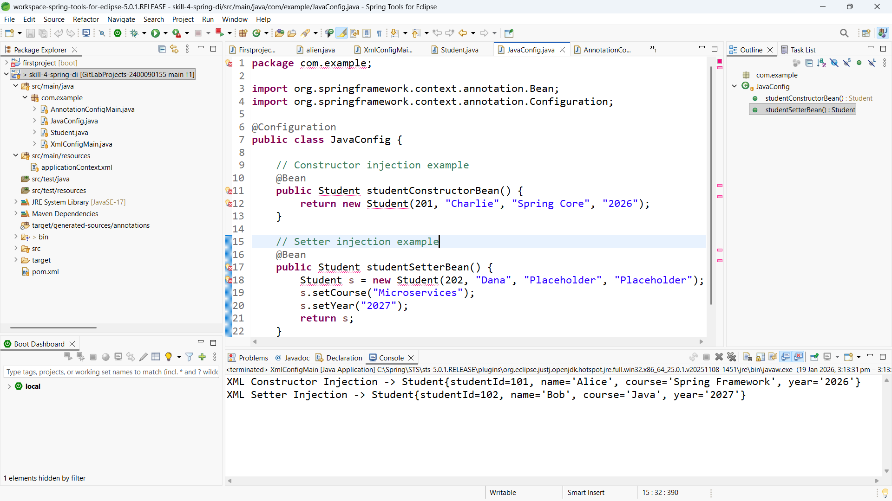
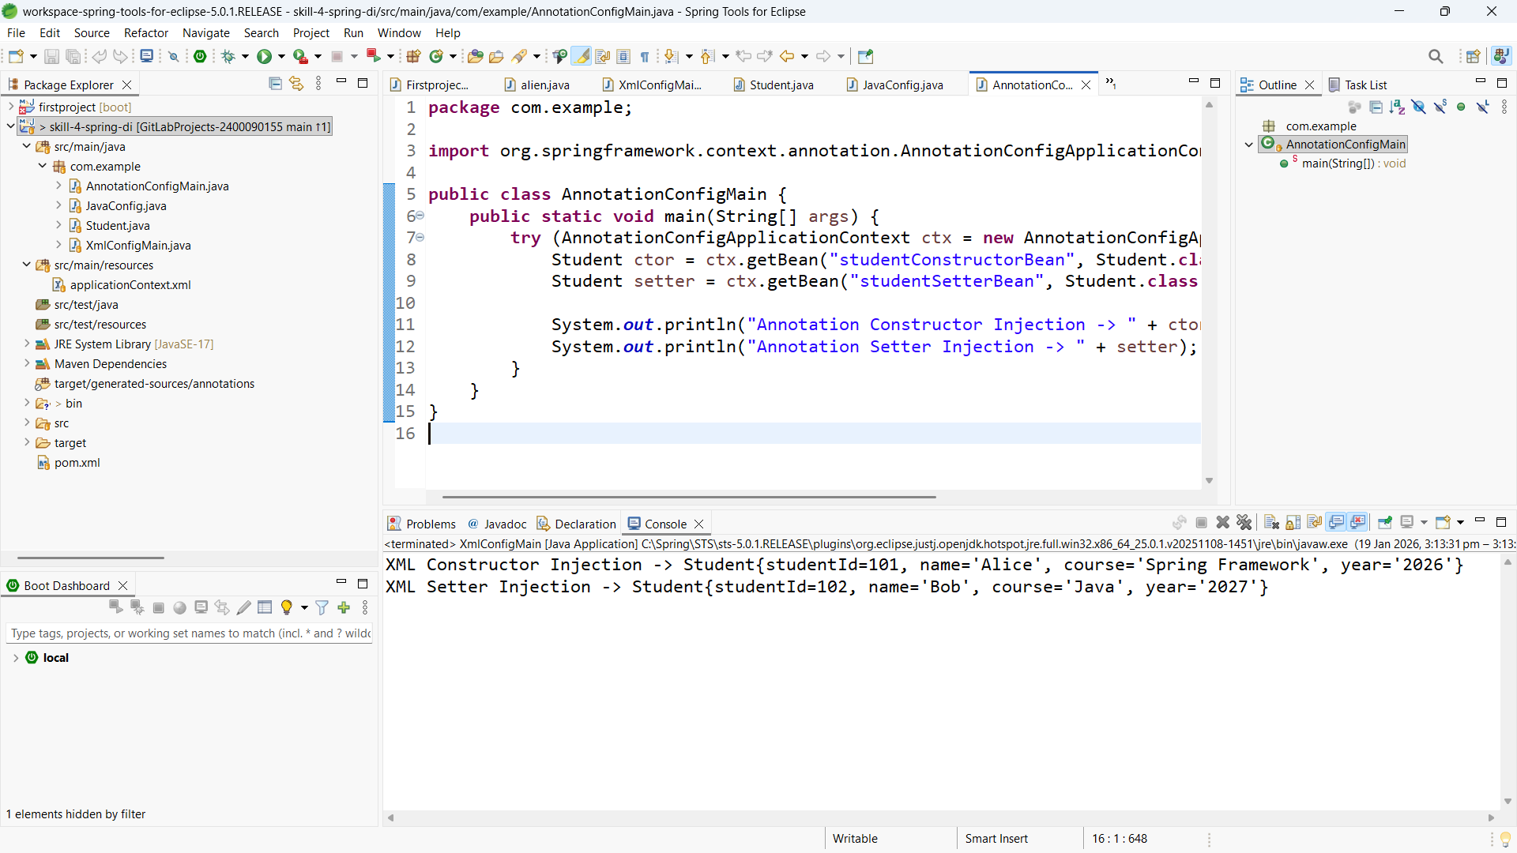

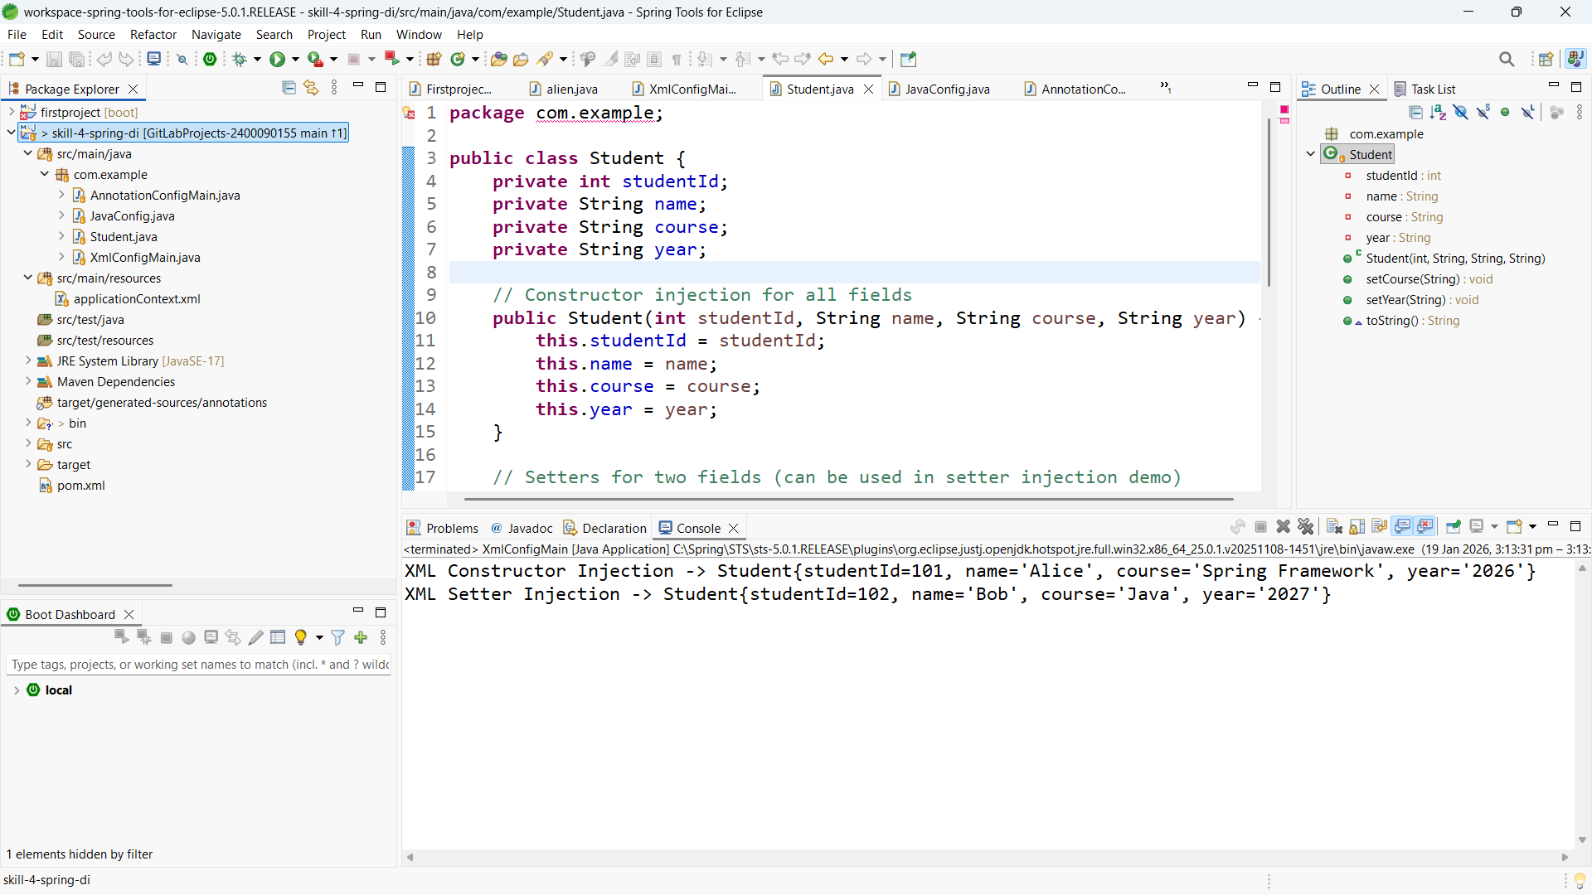

GitHub Repository Link
The complete source code for this experiment is available in the following GitHub repository:
Repository:
https://github.com/Hareesh-Reddy-9126/2400090155_FSAD_SKILL_11.git

