NAME: GURRALA HAREESH REDDY ID NO:2400090155 SEC NO : 06
FULL STACK DEVLOPMENT
Skill-5: Spring Autowiring (Annotation-Based) – Student & Certification
Purpose
Demonstrate Spring Core DI using annotations (@Component, @Autowired) with XML component scanning.
Tech stack
Java 17, Maven 3.x, Spring Context 6.1.5.
Project files (full contents)
pom.xml
<project xmlns="http://maven.apache.org/POM/4.0.0"
xmlns:xsi="http://www.w3.org/2001/XMLSchema-instance"
xsi:schemaLocation="http://maven.apache.org/POM/4.0.0
https://maven.apache.org/xsd/maven-4.0.0.xsd">

<modelVersion>4.0.0</modelVersion>

<groupId>com.example</groupId>
<artifactId>skill-5-spring-autowire</artifactId>
<version>1.0-SNAPSHOT</version>

<properties>
<maven.compiler.release>17</maven.compiler.release>
</properties>

<dependencies>
<dependency>
<groupId>org.springframework</groupId>
<artifactId>spring-context</artifactId>
<version>6.1.5</version>
</dependency>
</dependencies>

</project>

Certification.java
package com.example;

import org.springframework.stereotype.Component;

@Component
public class Certification {

private int id = 501;
private String name = "Spring Professional";
private String dateOfCompletion = "10-01-2026";

@Override
public String toString() {
return "Certification{" +
"id=" + id +
", name='" + name + '\'' +
", dateOfCompletion='" + dateOfCompletion + '\'' +
'}';
}
}

Student.java
package com.example;

import org.springframework.beans.factory.annotation.Autowired;
import org.springframework.stereotype.Component;

@Component
public class Student {

private int id = 101;
private String name = "Hareesh";
private String gender = "Male";

@Autowired
private Certification certification;

@Override
public String toString() {
return "Student{" +
"id=" + id +
", name='" + name + '\'' +
", gender='" + gender + '\'' +
", certification=" + certification +
'}';
}
}

MainApp.java
package com.example;

import org.springframework.context.ApplicationContext;
import org.springframework.context.support.ClassPathXmlApplicationContext;

public class MainApp {

public static void main(String[] args) {

ApplicationContext context =
new ClassPathXmlApplicationContext("applicationContext.xml");

Student student = context.getBean(Student.class);
System.out.println(student);
}
}

Build
From skill-5 folder:
mvn -DskipTests package
Run (with Maven [INFO] logs) (PowerShell)
From skill-5 folder:
mvn --% exec:java -Dexec.mainClass=com.example.MainApp -Dstyle.color=always
Note:
--% is PowerShell “stop parsing”, so -Dexec.mainClass passes correctly to Maven.
Expected console flow
• Spring loads applicationContext.xml
• Component scan finds @Component beans (Student, Certification)
• Spring autowires Certification into Student using @Autowired
• Prints Student object with injected Certification details
• Ends with [INFO] BUILD SUCCESS
Expected Output
Student{id=101, name='Hareesh', gender='Male', certification=Certification{id=501, name='Spring Professional', dateOfCompletion='10-01-2026'}}
What was done
• Created a Spring Maven project with spring-context dependency.
• Enabled context:component-scan in applicationContext.xml to auto-detect beans.
• Implemented Certification and Student as @Component beans.
• Used @Autowired in Student to inject Certification automatically.
• Loaded Spring container in MainApp and printed the Student bean.
OUTPUTS:
SPRING TOOL (STS) output:
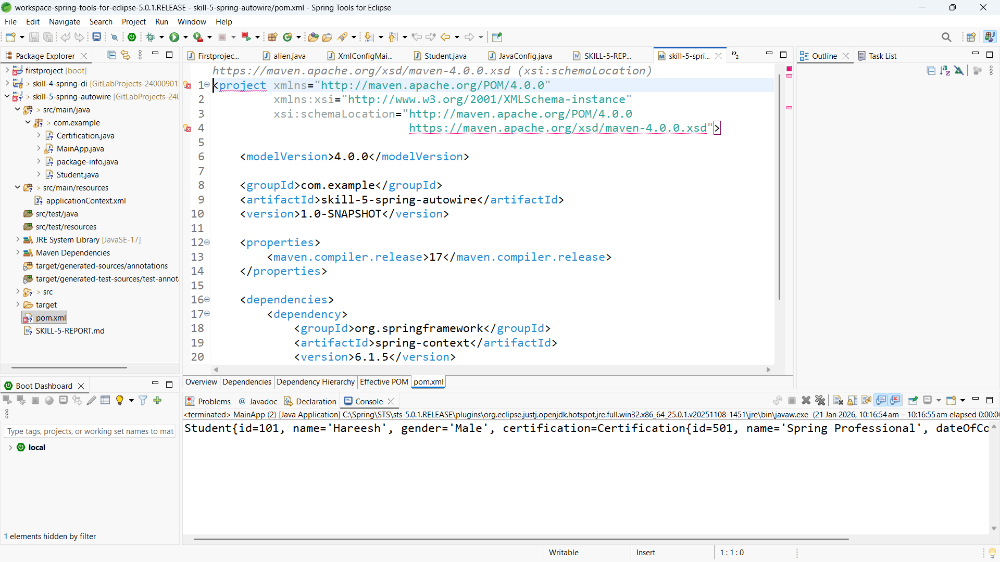

Vs code outputs:
