Sequential Transfer Learning for Medicinal Plant Identification: Endangered Species Protection and Sustainable Harvesting

Hareeshwar Muthukumaran
3146279
Supervised by: Dr. Shamik Palit
April 2026

Dissertation submitted in partial fulfilment for the degree of
Bachelor of Science with Honours Software Engineering

Computing Science and Mathematics
University of Stirling

Abstract
Problem
Identifying medicinal plants in the field remains a challenge for park rangers enforcing harvesting laws and farmers verifying species legality. Most automated identification systems train on single datasets collected under controlled conditions, limiting cross-region generalisation. Endangered medicinal plants are underrepresented in training datasets, producing poor detection rates precisely where accuracy matters most.
Objectives
This project develops a sequential transfer learning system that trains a CNN progressively across five complementary Mendeley Data medicinal plant datasets (37 species, ~9,551 images). The system targets high recall for endangered species detection (conservation enforcement) and high precision for commercial species identification (sustainable harvesting). Secondary objectives include comparing CNN architectures, running an ablation study to validate the sequential approach, and deploying a functional web application.
Methodology
A four-phase sequential transfer learning approach was implemented using ResNet50 as the backbone. The model was pre-trained on general medicinal plant features (Dataset 1, 6 species), fine-tuned for regional adaptation (Dataset 2, Bangladesh, 6 species), specialised for endangered species (Dataset 4, REMP, 16 species), and validated on commercial species from a different region (Dataset 5, SIMPD, South India, 20 species). Dataset 3 was held out as an independent test set. Progressive layer unfreezing with phase-specific callbacks mitigated catastrophic forgetting. A Flask web application was developed for deployment.
Achievements
The sequential pipeline achieved 70.84% overall accuracy on the Phase 3b validation set (20 species, weighted F1: 70.8%). An ablation study comparing training strategies on 18 viable classes found direct transfer averaging 70.00 ± 2.74% (n=5), with the sequential result (71.43%) falling within the 95% confidence interval - no statistically significant difference. This outcome is attributed to seed variance dominating training strategy effects, compounded by catastrophic forgetting and class set heterogeneity. An improved EfficientNetB3 model with 300×300 input, class weighting, and cosine annealing achieved 99.13% validation accuracy on 18 species, demonstrating the dominant impact of architectural choice. A Flask web application was deployed with test-time augmentation, OOD detection, and species metadata. Dataset 3 testing (1,009 unseen images) revealed significant model overconfidence (81.05% mean confidence), motivating the OOD detection mechanisms.

Attestation
I understand the nature of plagiarism, and I am aware of the University’s academic integrity policy.
I certify that this dissertation reports original work by me during my honours project except for the following:
- The deep learning model training in Chapters 3 and 4 utilised TensorFlow/Keras with pre-trained ImageNet weights from Google Research, used in accordance with the Apache 2.0 licence.
- The five medicinal plant datasets used throughout this project were obtained from Mendeley Data, an open-access repository, and are cited individually in the References section.
During development, the following tools were used: Google Gemini for code assistance and debugging, and Perplexity AI for literature search and research. In accordance with the AI policy for honours projects, all code generated by AI is marked as such, and the prompts are included with the submitted code.


Signature: Hareeshwar Muthukumaran Date: 05-04-2026

Acknowledgements
I would like to express my sincere gratitude to my supervisor, Dr. Shamik Palit, for his guidance, feedback, and support throughout this project. His expertise in machine learning and encouragement during challenging phases of development were invaluable.
I am grateful to the authors of the five Mendeley Data datasets used in this research, whose open-access contributions made this work possible. I also thank the University of Stirling Computing Science and Mathematics division for providing access to computational resources and the honours project framework.
Finally, I would like to thank my family and friends for their continuous support and encouragement throughout the final year.

Table of Contents
Abstract ii
Attestation iii
Acknowledgements iv
List of Tables vii
List of Figures viii
1 Introduction 1
1.1 Background and Context 1
1.2 Scope and Objectives 3
1.3 Achievements 3
1.4 Overview of Dissertation 4
2 State-of-The-Art 4
2.1 Transfer Learning for Plant Classification 4
2.2 Sequential and Progressive Learning Strategies 6
2.3 Current Gaps and Research Motivation 7
3 Methodology and System Design 8
3.1 Development Methodology 8
3.2 Dataset Selection and Preparation 9
3.3 Sequential transfer learning pipeline 11
3.4 Model Architecture 13
3.5 Web Application Design 15
4 Implementation 16
4.1 Phases 1–2: Head Pre-training 16
4.2 Phase 3a: Endangered Species Specialisation 17
4.3 Phase 3b: Commercial Species Validation 18
4.4 Improved Model: EfficientNetB3 18
4.5 Ablation Study Design 19
4.6 Web Application Implementation 20
5 Evaluation 22
5.1 Evaluation Design 22
5.2 Classification Performance 22
5.3 Phase 3a Evaluation: Endangered Species Recall 24
5.4 Per-Species Analysis 25
5.5 Ablation Study Results 27
5.6 Architecture Comparison: EfficientNetB3 29
5.7 Independent Generalisation Probe: Dataset 3 29
5.7.1 Grad-CAM Visual Explanation Analysis 31
5.8 Comparison Against Objectives 33
5.9 Discussion 34
5.9.1 Interpreting the Ablation Results 34
5.9.2 Architectural Impact 34
5.9.3 Confidence Calibration 34
5.9.4 Comparison with Literature 34
5.9.5 Threats to Validity 34
6 Conclusion 35
6.1 Summary 35
6.2 Critical Evaluation of Achievements 35
6.3 Limitations and Future Work 36
6.4 Critical Reflection on Project 36
References 37
Appendix A: User Guide (Supplementary Document)
Appendix B: Per-species metrics (Supplementary Document)

List of Tables
Table ‎2.1 Comparison of Related Work in Medicinal Plant Classification 5
Table ‎3.1 Dataset Summary 9
Table ‎3.2 Phase-Specific Training Configuration 12
Table ‎3.3 Data Augmentation Strategy Per Phase 14
Table ‎5.1 Phase 3b Overall Classification Metrics 22
Table ‎5.2 Phase 3a Overall Classification Metrics 24
Table ‎5.3 Ablation Study - Training Strategy Comparison 27
Table ‎5.4 Architecture Comparison 29
Table 5.5a Dataset 3 Prediction Confidence Summary 30
Table 5.5b Dataset 3 Species Overlap Verification 30
Table 5.6 Evaluation Against Primary Objectives 33

List of Figures
Figure ‎1.1 Dual-Stakeholder Use Case 2
Figure ‎3.1 CRISP-DM Methodology Adapted for This Project 8
Figure ‎3.2 Dataset Distribution Across Training Phases 10
Figure ‎3.3 Sequential Transfer Learning Pipeline 11
Figure ‎3.4 ResNet50 Architecture with Custom Classification Head 13
Figure ‎3.5 Progressive Layer Unfreezing Strategy 14
Figure ‎3.6 Web Application System Architecture 16
Figure ‎4.1 Phase 1 Training Curves 16
Figure ‎4.2 Phase 2 Training Curves 17
Figure ‎4.3 Phase 3a Training Curves (Accuracy, Loss, Precision) 17
Figure ‎4.4 Phase 3b Training Curves (Accuracy, Loss, Precision) 18
Figure ‎4.5 Web Application Main Interface 20
Figure ‎4.6 Web Application Prediction Result 21
Figure ‎4.7 Working OOD Detection 21
Figure ‎5.1 Phase 3b Confusion Matrix 23
Figure ‎5.2 Per-Species F1-Score Distribution 25
Figure ‎5.3 Training Accuracy Progression Across All Phases 26
Figure ‎5.4 Ablation Comparison 28
Figure 5.4a Ablation Comparison (single-seed) 28
Figure 5.4b Multi-seed comparison 28
Figure ‎5.5 Dataset 3 Confidence Distribution 30
Figure ‎5.6 Grad-CAM Attention Maps on Dataset 3 Samples 32

Introduction
The World Health Organization estimates that 80% of the global population depends on traditional plant-based medicine for primary healthcare [1]. In South Asian countries, medicinal plants are essential for both commercial drug production and traditional healing practices [2]. With increasing demand and insufficient regulation, many species face overharvesting. Both park rangers enforcing harvesting bans and farmers verifying species legality require reliable field identification.
Manual plant identification requires specialist botanical knowledge rarely available in rural areas. Hart et al [3]. and Jones [4] evaluated commercial plant identification apps and found significant limitations for non-common species, with errors particularly consequential for medicinal species where misidentification risks harvesting protected or toxic species.

Background and Context
Transfer learning - adapting CNNs pre-trained on ImageNet to specialised tasks - dominates medicinal plant classification, used in 83.8% of studies with reported accuracies of 87-99.6% [5]. However, most train and evaluate on single datasets under controlled conditions [5][6], producing models that fail to generalise to field photography where lighting, backgrounds, and camera quality vary substantially.
This project addresses these gaps using sequential transfer learning, progressively adapting a CNN across five complementary medicinal plant datasets from general morphological features through regional adaptations to endangered species specialisation. This builds on progressive learning research [7][8] showing staged training can outperform joint training under heterogeneous distributions. The system targets two stakeholders: conservation rangers requiring high endangered species recall, and farmers requiring high commercial species precision.
This project addresses two research questions: (RQ1) Does sequential transfer learning across heterogeneous medicinal plant datasets improve classification accuracy compared to direct or joint training? (RQ2) To what extent can features learned on one geographic region's medicinal flora generalise to species from a different region? These questions are investigated through controlled experimentation (ablation study) and cross-regional evaluation (Bangladeshi-trained model tested on South Indian species).
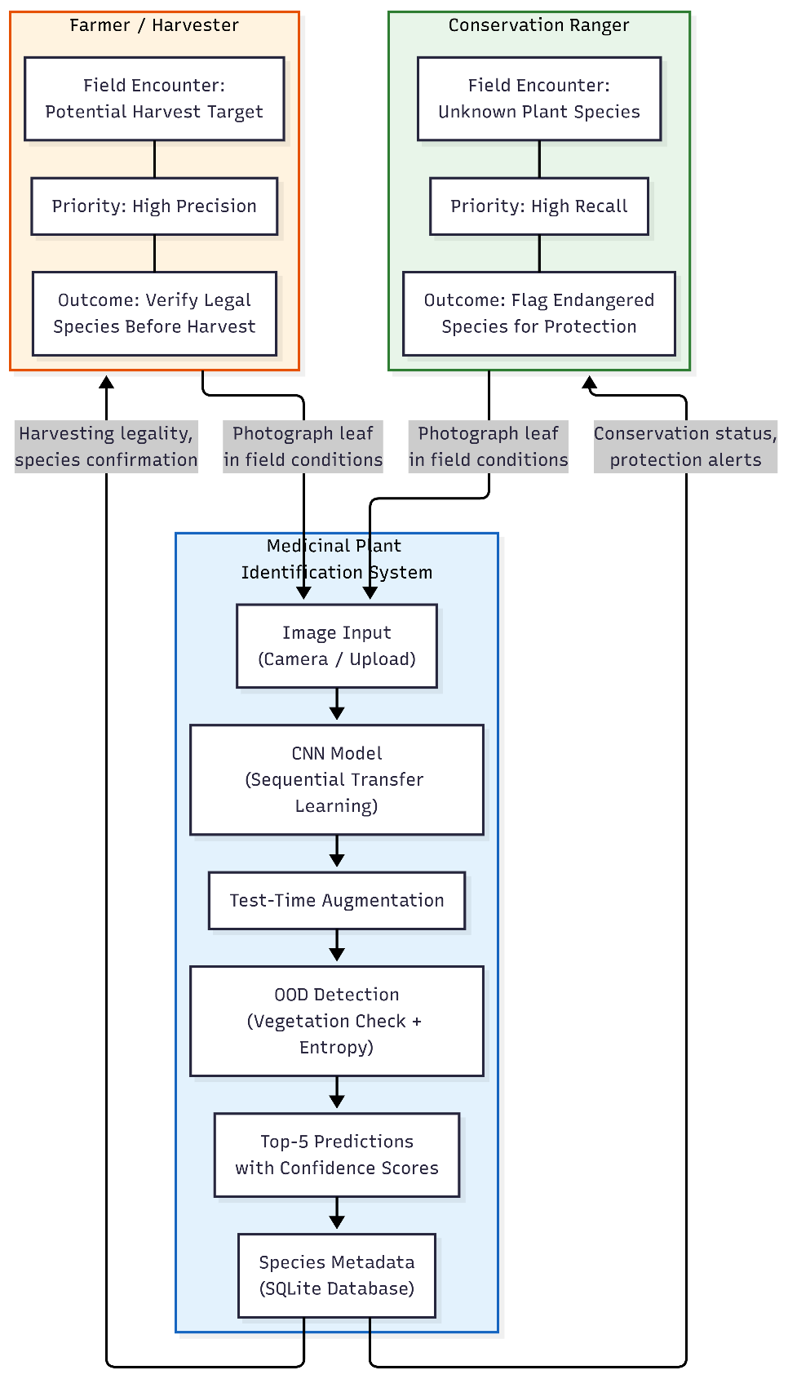
Figure ‎1.1 Dual-Stakeholder Use Case

Scope and Objectives
The consequences of misclassification differ between stakeholders. A false negative for endangered species (failing to identify a protected plant) could enable illegal harvesting, while a false positive for commercial species (incorrectly classifying a protected plant as safe to harvest) could lead to conservation violations. These asymmetric risks motivate the dual-metric evaluation framework, prioritising recall for endangered species and precision for commercial species.
This project is building a proof-of-concept CNN-based identification system. It uses five Mendeley Data datasets (37 species, roughly 9,551 images) and focuses on identifying plants by their leaves. The primary objectives are:
- Sequential Transfer Learning Pipeline: This means a four-stage training process (D1 then D2, then D4, then D5) aiming for at least 75% accuracy on the validation set.
- Endangered Species Recall: Achieve ≥95% recall on REMP endangered species (Dataset 4).
- Commercial Species Precision: And at least 95% precision for SIMPD commercial species (Dataset 5).
- Ablation Study: Empirically compare sequential, direct, and joint training strategies to determine whether they stack up.
- Web Application: A working app that can identify, score confidence, and provide species information.
Secondary objectives include architecture comparison (ResNet50 vs EfficientNetB3), failure analysis, and Grad-CAM visualisation. Scope excludes anything with mobile versions, real-time predictions, or actual user tests in this project.

Achievements
Key results exceeded expectations alongside informative negative findings:
Beyond Objectives (Headline Result): An EfficientNetB3 model (300×300 input, class weighting, cosine annealing) achieved 99.13% validation accuracy on 18 species - a 28pp improvement over sequential ResNet50, demonstrating architectural optimisation dominates transfer strategy. Grad-CAM visualisations confirmed the model learned biologically meaningful features (leaf venation, edge texture). Dataset 3 testing (1,009 unseen images) revealed significant overconfidence (81.05% mean confidence), motivating OOD detection mechanisms.
Objective 5 (Web Application): Fully deployed Flask web application, with Test-Time-Augmentation (TTA), out-of-distribution(OOD) detection, camera capture, confidence-scoring predictions, species metadata, and prediction history.
Objective 1 (Sequential Pipeline): The four-phase pipeline achieved 70.84% overall accuracy on the Phase 3b validation set (20 species, weighted F1: 70.8%). Though below the 75% target, it demonstrated cross-regional generalisation from Bangladeshi to South Indian flora - previously unexplored in the literature.
Objective 4 (Ablation Study): Multi-seed replication (n=5) showed direct transfer at 70.00 +/- 2.74%, with sequential (71.43%) within that 95% CI, no statistically significant difference (Section 5.5).
Objective 2 (Endangered Species Recall): Phase 3a achieved 60.53% accuracy and 53.20% weighted recall across 9 viable REMP species (7 out of 16 classes lacked training data). Below the 95% target, but design decisions were appropriate (Section 5.3).
Objective 3 (Commercial Species Precision): 74.6% weighted precision across 20 species. Individual species exceeded 96%. EfficientNetB3 achieved 99.17% precision on 18 viable species.

Overview of Dissertation
Chapter 2 reviews transfer learning for plant classification, sequential learning strategies, and research gaps motivating this project. Chapter 3 details the methodology, data preparation, pipeline design, model architecture, and web application. Chapter 4 describes each training phase, the EfficientNetB3 iteration, ablation study, and web application implementation. Chapter 5 evaluates performance against objectives with per-species analysis, ablation results, architecture comparison, and Dataset 3 generalization probe. Chapter 6 summarises findings, discusses limitations, and reflects on the project.

State-of-The-Art
This chapter reviews the current landscape of automated medicinal plant identification, focusing on three areas directly tied to this project: transfer learning methods for plant classification, sequential and progressive learning strategies, and the research gap that motivates the current proposed approach.

Transfer Learning for Plant Classification
Transfer learning adapts visual representations learned from large-scale datasets like ImageNet (1.2M images, 1,000 classes) to specialised tasks through fine-tuning [9][10]. Mulugeta et al. [5] systematically reviewed 31 medicinal plant classification studies (2018–2022), finding 83.8% used transfer learning, CNNs were the dominant architecture (64.5%), and leaf-based identification predominated (96.7%). Reported accuracies ranged from 87% to 99.6%, though most used single datasets under controlled conditions.
Architecture Selection. Architecture choice significantly affects accuracy, and no single model dominates across all datasets. Saraswat et al. [11] compared six different architectures (VGG16, ResNet50, InceptionV3, MobileNetV2, DenseNet121, EfficientNetB0) on 10 species from Bangladesh. MobileNetV2 achieved 99.43%, while ResNet50 reached 97.82%. Pallavi KN et al. [12] found that VGG16 (with 92.69%) outperformed ResNet50 (91.34%) on 35 Indian species, demonstrating that no single architecture universally dominates. Ayumi et al. [13] confirmed that fine-tuning almost consistently outperforms fixed feature extraction, particularly when the target domain differs substantially from ImageNet. Kalaiselvi et al. [14] showed that even a minimal fine-tuning pushed accuracy up from 87% to 92%.
Hybrid and Ensemble Approaches. A growing trend combines CNN feature extraction with traditional classifiers. Oppong et al. [15] achieved 98% on 5 Ghanaian species using DenseNet201+SVM. Azmeraw et al. [16] reached 99.34% on 27 Ethiopian species with InceptionV3+Bayesian-optimised SVM. Singh and Dubey's [17] ensemble (MobileNetV2, InceptionV3, ResNet50 with soft voting) achieved 99.81% on 80 Indian species. Custodio [18] demonstrated 98.22% with a 5-model ensemble on 40 Philippine species. Yarakaraju et al. [19] took DenseNet121 features and added handcrafted texture descriptors (like GLCM, LBP, color histograms), then classified them with LightGBM, getting 96.7% accuracy.
Region-Specific Applications. Kiflie et al. [20] achieved 95% on 35 Ethiopian species. Phad et al. [21] reached 93% on 40 species with MobileNetV2 (last 20 layers fine-tuned). Ghosh et al [6] obtained 95.25% on 30 Mendeley species using PCA-VGG16 (plain VGG16: 76%). These studies confirm transfer learning's effectiveness for regional applications, but no one employs staged training across geographically diverse datasets. CNN-based transfer learning has also demonstrated effectiveness for species identification beyond botany; Islam et al. [22] achieved strong results with camera trap images from ecological studies. However, the multi-dataset sequential paradigm remains unexplored in either area.

Authors | Year | Architecture | Dataset(s) | Species | Best Accuracy | Transfer Strategy | Multi-Dataset | Sequential
Saraswat et al. [11] | 2025 | MobileNetV2 | BDMediLeaves | 10 | 99.43% | Fine-tuned | No | No
Singh & Dubey [17] | 2025 | InceptionV3+SVM | IMLD | 80 | 99.81% | Feature extraction | No | No
Azmeraw et al. [16] | 2024 | InceptionV3+SVM | Custom | 27 | 99.34% | Feature extraction | No | No
Oppong et al. [15] | 2022 | DenseNet201+Gabor+SVM | Custom | 5 | 98.00% | Hybrid | No | No
Custodio [18] | 2024 | 5-model ensemble | Custom | 40 | 98.22% | Fine-tuned (ensemble) | No | No
Kiflie et al. [20] | 2024 | Multiple CNNs | Ethiopian plants | 35 | 95.00% | Fine-tuned | No | No
Ghosh et al. [6] | 2023 | PCA-VGG16 | Mendeley | 30 | 95.25% | Hybrid | No | No
Phad et al. [21] | 2025 | MobileNetV2 | Custom | 40 | 93.00% | Fine-tuned (last 20 layers) | No | No
Pallavi KN et al. [12] | 2024 | VGG16 | Custom | 35 | 92.69% | Fine-tuned | No | No
This project | 2026 | ResNet50, EfficientNetB3 | 5 Mendeley datasets | 37 | 99.13% | Sequential + Direct | Yes (5 datasets) | Yes (4 phases)

Table ‎2.1 Comparison of Related Work in Medicinal Plant Classification
Table 2.1 shows that single-dataset studies consistently report 92-99% accuracy, while the proposed cross-regional sequential approach achieves 70.84%. This gap reflects controlled versus heterogeneous evaluation conditions rather than model quality. Many high-accuracy studies also use hybrid feature extraction (like PCA-VGG16, DenseNet+SVM) on fewer species (5-30), making direct accuracy comparison misleading. This multi-dataset approach provides a tougher and more realistic evaluation protocol.
No prior work identified in the literature has explored sequential transfer learning across multiple complementary medicinal plant datasets from different geographic regions. This project uniquely combines five publicly available datasets. This allows for a much stricter test of how well models generalize, enabling direct comparison of sequential, direct, and combined training methods.

Sequential and Progressive Learning Strategies
Sequential transfer learning involves training models on a series of related tasks one after another [23][24][8], A fundamental risk is catastrophic forgetting, where training on new tasks degrades performance on previously learned representations [25]. Evaluating sequential methods requires balancing knowledge transfer against retention of earlier-stage representations.
Catastrophic Forgetting. Kirkpatrick et al. [25] introduced Elastic Weight Consolidation (EWC). Showing sequential training causes catastrophic forgetting without specific weight protection mechanisms. EWC constrains updates to weights important for earlier tasks using the Fisher information matrix. This is directly relevant: the four-phase pipeline replaces the classification head at each transition, potentially disrupting backbone-classifier alignment. EWC was not adopted because species sets differed completely across phases, reducing the value of earlier importance estimates, and the priority was establishing a sequential baseline before adding forgetting prevention. The ablation study quantifies the resulting forgetting (Section 5.5).
Progressive Learning. Fayek [7] proposed a progressive learning framework addressing forgetting through curriculum selection, controlled capacity growth, and pruning - architectural changes beyond this project’s scope; progressive layer unfreezing was adopted instead. Yang et al. [24] demonstrated 10–15% improvements through intermediate sequential transfers in medical image segmentation, but emphasised that benefits depend on task similarity. Siemon et al. [8] achieved 6% generalisation improvement and halved training time by ordering transfers via hierarchical clustering of task similarity.
Domain Gap and Calibration. Peng et al. [26] found that standard transfer methods fail to account for significant domain gaps between ImageNet and specialised medical images, influencing our progressive unfreezing approach. Guo et al. [27] demonstrated that modern deep networks are systematically overconfident, producing high-confidence predictions even for unseen inputs - a critical concern for field-deployed plant identification systems.
The idea that progressive learning can help with medicinal plant identification across heterogeneous datasets feels right: general datasets can teach a model basic visual features, regional datasets add variations specific to an area, and endangered species datasets enable specialisation for recognizing those. But, the research on catastrophic forgetting [25][7] warns us that without specific forgetting-prevention mechanisms, intermediate phases may introduce more noise than useful knowledge. This project directly addresses this open empirical question.

Current Gaps and Research Motivation
The thorough review by Mulugeta et al. [5] pointed out several key problems in the existing research:
Single-Dataset Limitation: No study checked trained and tested models using multiple, complementary datasets sequentially. The predominant single-dataset approach produces models that might be very accurate for the data they trained on, but they perform much worse when encountering new data sources or different regions.
Geographic Disparity: Research tends to cluster in certain regions (29% in India, 16% in Indonesia, 13% in Sri Lanka [5]), with not much testing across regions. Models trained on species from one geographical area have not been systematically evaluated on the same, or related species from other places.
Private Dataset Reliance: A large number of studies (67.7%) use private datasets [5]. This hinders reproducibility and comparative evaluation. The absence of standardised benchmarks makes it difficult to tell if real progress is being made.
Evaluation Metric Limitations: Accuracy dominates evaluation, with limited attention to precision-recall trade-offs critical for safety-sensitive applications such as endangered species detection.
Absence of Sequential Learning: Despite demonstrated benefits in related domains [24][8], no earlier work, according to the reviewed literature, has used sequential transfer learning for identifying medicinal plants across heterogeneous of datasets.
This project directly addresses these issues with five key design choices:
(1) five publicly available Mendeley datasets enabling full reproducibility; (2) sequential training spanning Bangladesh and South India for cross-regional evaluation; (3) phase-specific metrics (recall for endangered species, precision for commercial species) addressing stakeholder-relevant trade-offs; (4) a novel sequential training approach for botanical classification; and (5) Dataset 3 held out entirely as an independent generalisation probe.

Methodology and System Design

Development Methodology
The project follows CRISP-DM (Cross-Industry Standard Process for Data Mining) methodology [28], selected over Agile and SEMMA (Sample, Explore, Modify, Model, Assess - similar structure but less widely adopted and lacking the deployment phase) because it provides explicit evaluation and deployment phases suited to ML research and aligns with the iterative sequential pipeline. CRISP-DM consists of six iterative phases: business understanding, data understanding, data preparation, modeling, evaluation, and deployment.
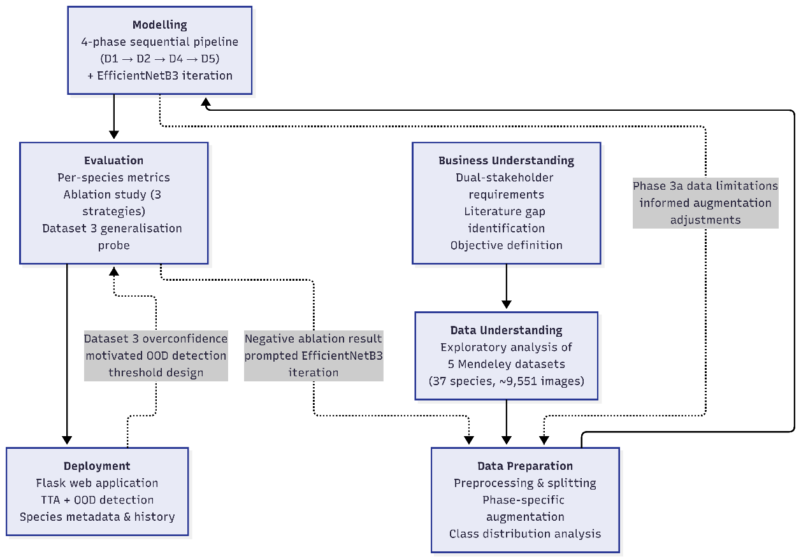
Figure ‎3.1 CRISP-DM Methodology Adapted for This Project
The methodology was adapted as follows: business understanding corresponds to the dual-stakeholder requirements analysis and literature gap identification; data understanding encompasses exploratory analysis of all five datasets; data preparation includes preprocessing, splitting, and phase-specific augmentation; modelling is the four-phase sequential pipeline; evaluation uses multiple classification metrics with per-species analysis; and deployment is realised through the Flask web application. The project used Google Colab and Kaggle Notebooks with T4/P100 GPU access for training, with local development for the web application. Version control was maintained through Git, with model artefacts stored on Google Drive for persistence across training sessions.

Dataset Selection and Preparation
Five datasets of medicinal plants were selected from Mendeley Data, a trusted open-access research data repository. The criteria considered in selecting these datasets: whether it is publicly available for reproducibility, distribution of diverse geographic regions, presence of endangered species, and sufficient image count per species for meaningful training. And, Only the original (non-augmented) images were used from each dataset, to ensure the training quality and to prevent overfitting to synthetic variations. Dataset 1 contains approximately 7,514 files on disk, but many are augmented variants of the same original images (~1,380 unique originals based on directory structure). To avoid inflating the effective dataset size, this estimated count is used.
Dataset | Name | Phase | Species | Images | Region | Img/Species (Avg)
Dataset 1 | Medicinal Plant Identification [29] | Phase 1 | 6 | ~1,380 | Generic | ~230
Dataset 2 | Bangladesh Medicinal Leaves [30] | Phase 2 | 6 | ~1,094 | Bangladesh | ~182
Dataset 3 | Medicinal Leaf Dataset [31] | Test Set | 9 | ~900 | Generic | ~100
Dataset 4 | REMP – Rare Endangered [32] | Phase 3a | 16 | ~3,494 | Bangladesh | ~218
Dataset 5 | SIMPD – South Indian [33] | Phase 3b | 20 | ~2,503 | South India | ~125
Total |  |  | 37 (unique) | ~9,551
Table ‎3.1 Dataset Summary
The sequential arrangement of the datasets was designed to build the model more capable in a progressive manner:
Phase 1 (Dataset 1): Establishes general representations (leaf morphology, venation patterns, and colour) across six representative, well-sampled species.
Phase 2 (Dataset 2): Adapts these learned features to Bangladeshi tropical flora’s specfic imaging conditions and regional variation.
Phase 3a (Dataset 4): Trains specifically for endangered species detection using 16 rare Bangladeshi species with relatively balanced sampling.
Phase 3b (Dataset 5): Validates cross-regional generalisation by fine-tuning on 20 South Indian species, testing features transfer across geographic contexts.
Dataset 3 (held out): Reserved entirely as a separate test set to provide an unbiased measure of generalisation performance.

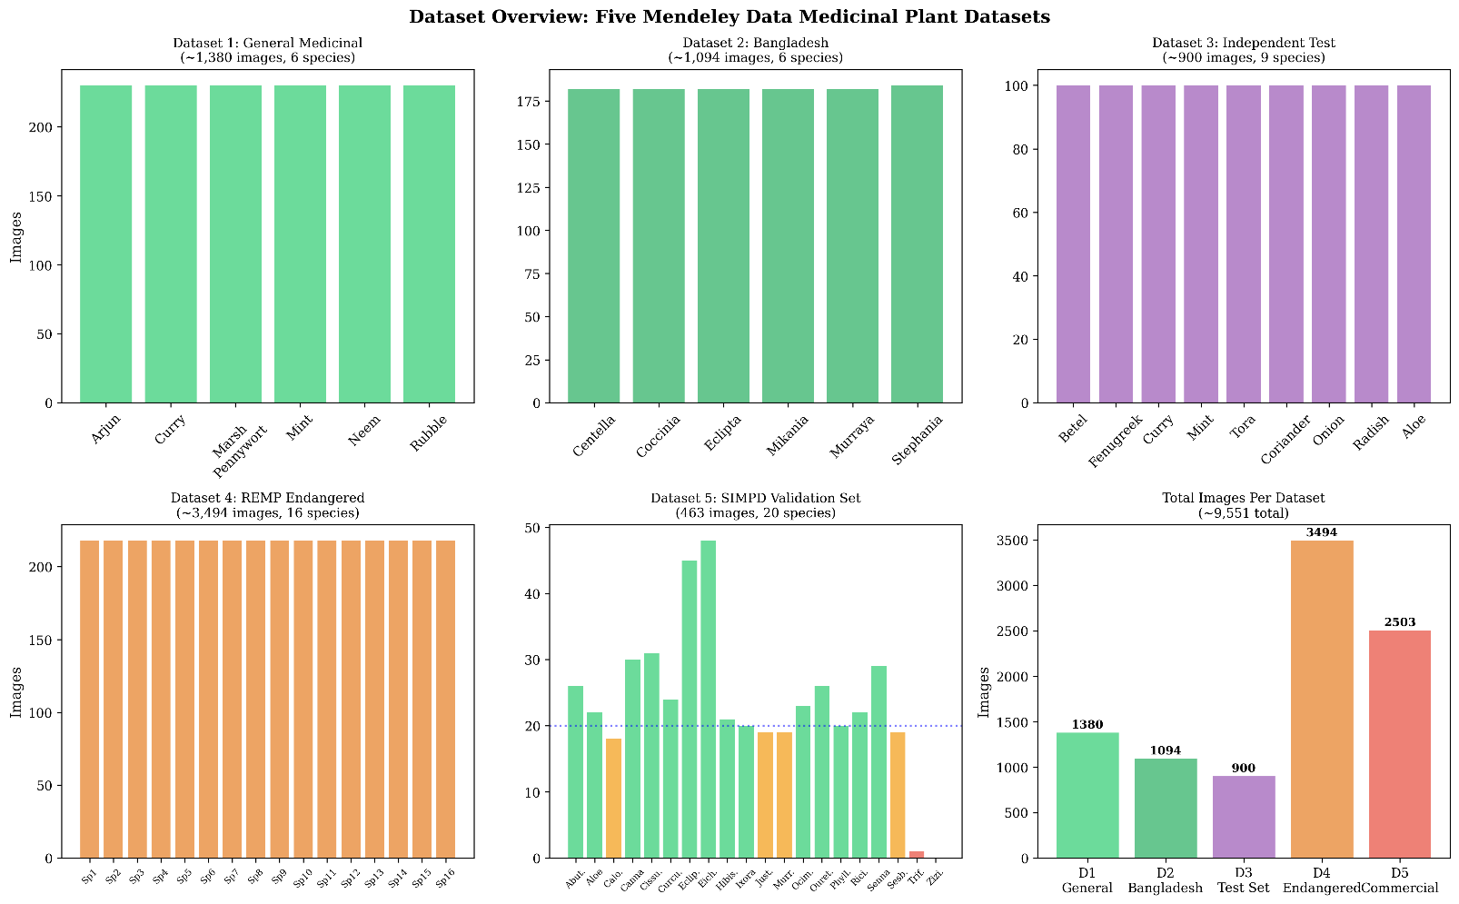

Figure ‎3.2 Dataset Distribution Across Training Phases

Data Preprocessing: All images were reshaped to 224×224 pixels (RGB) were normalized to [0,1] range through the division by 255 method. Datasets were split using an 80/20 train/validation ratio with a fixed random seed of 42 for reproducibility. Data loading was handled with TensorFlow's `tf.data` API, featuring caching and prefetching for the efficient training process.
Class Imbalance: The main difficulty was class imbalance, particularly in Dataset 5 where the distribution of species varied from 0 to 48 validation samples. This was corrected in the later phases through inverse frequency class weighting and in the improved EfficientNetB3 pipeline by the removal of impossible classes that lacked sufficient training data (Trifolium Repens: 1 sample, Ziziphus mauritiana: 0 samples)

Sequential transfer learning pipelines
The sequential transfer learning pipeline is the main innovation of this project, which sequentially trains a CNN across four progressively specialised phases. In contrast to classic transfer learning, which performs one transfer only from ImageNet to a target task, in this method, the model forms a chain of transfers: ImageNet → Phase 1 → Phase 2 → Phase 3a → Phase 3b.
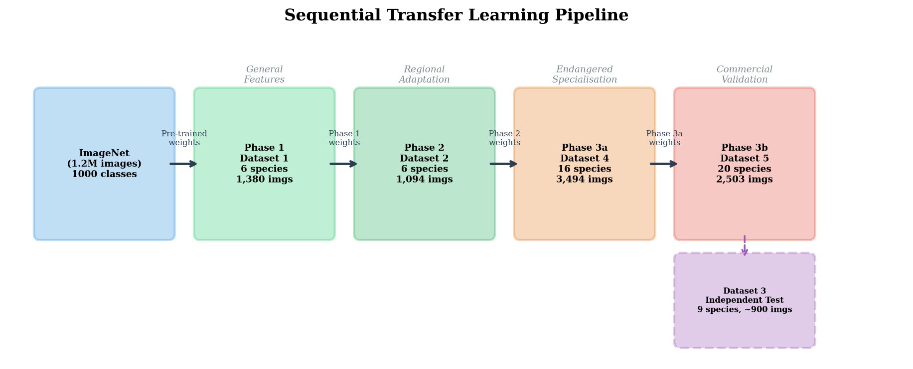
Figure ‎3.3 Sequential Transfer Learning Pipeline

At each transition, the trained model is loaded, the backbone extracted, a new classification head constructed for the new class count, and training proceeds with phase-specific configurations.
This design draws inspiration from the "progressive learning" setup of Fayek [7] and the findings of the sequential transfer path selection by Yang et al. [24] that the intermediate domain exposure can enhance the final task performance when both tasks have a sufficient affinity.
An important design decision was freezing the ResNet50 backbone entirely during Phases 1-2. This conservative approach was motivated by the small dataset sizes (1,380 and 1,094 images) risking overfitting, evidence from Ayumi et al. [13] that full fine-tuning is less critical when domains share visual overlap with ImageNet and the hypothesis that head-only training on progressively specialised data would establish beneficial optimiser dynamics for subsequent fine-tuning. Consequently, the backbone retains original ImageNet weights through Phase 2; feature-level transfer begins substantively only at Phase 3a, where partial unfreezing allows backbone adaptation. In retrospect, this design choice meant that true feature-level sequential transfer began only at Phase 3a, effectively reducing the four-phase pipeline to a two-phase system with two preliminary stages. This limitation, revealed through the ablation study (Section 5.5), represents a key learning point discussed in Section 6.4.
Throughout the four phases, a progressive unfreezing strategy was followed, gradually allowing the deeper backbone layers, updated as training progresses, from general to specialised

Parameter | Phase 1 | Phase 2 | Phase 3a | Phase 3b
Source Weights | ImageNet | Phase 1 | Phase 2 | Phase 3a
Output Classes | 6 | 6 | 16 | 20
ResNet50 Layers Frozen | All (175) | All (175) | 145 of 175 | 155 of 175
Learning Rate | 1×10⁻³ | 1×10⁻⁴ | 5×10⁻⁵ | 5×10⁻⁵
Max Epochs | 30 | 20 | 30 | 25
Batch Size | 32 | 32 | 32 | 32
Optimiser | Adam | Adam | Adam | Adam
Loss | Cat. Cross-Entropy | Cat. Cross-Entropy | Cat. Cross-Entropy | Cat. Cross-Entropy
Class Weights | No | No | Yes (inv. freq.) | No
Priority Callback | val_accuracy | val_accuracy | val_recall | val_precision
Table ‎3.2 Phase-Specific Training Configuration
The decision to reduce learning rate across phases (from 10⁻³ to 5×10⁻⁵) is grounded in the fact that earlier-phase features are more general and therefore should be preserved, while only gradual fine-tuning is appropriate to adapt to domain-specific properties [26].

Model Architecture
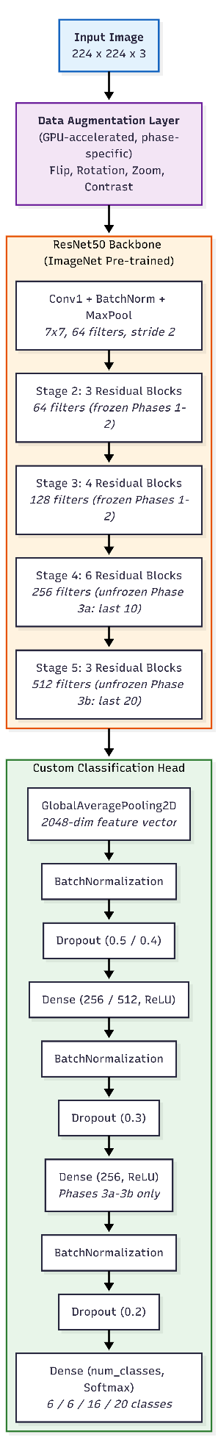
While Saraswat et al. [11] found that MobileNetV2 achieved higher accuracy on Bangladeshi species (99.43% vs 97.82% for ResNet50), ResNet50 was selected as the primary backbone architecture for three key reasons: (1) its strong track record in plant classification [5][34][35]; (2) its balance of depth (50 layers) and computational efficiency for training on limited GPU resources (Kaggle/Colab free tier); and (3) its residual connections [9], which facilitate the efficient gradient flow necessary for deep network fine-tuning. Crucially, while MobileNetV2’s [36] lightweight architecture is advantageous for mobile deployment, it provides fewer layers for progressive unfreezing-the core mechanism of this study’s sequential pipeline.
The pre-trained ResNet50 model (ImageNet, `include_top=False`) provides a 2048-dimensional feature vector via global average pooling, to which a custom classification head was attached:

Figure ‎3.4 ResNet50 Architecture with Custom Classification Head
```
Input (224 × 224 × 3)
→ Data Augmentation Layer (phase-specific)
→ ResNet50 Base (pre-trained, progressively unfrozen)
→ GlobalAveragePooling2D → BatchNormalization → Dropout (0.5/0.4)
→ Dense (256/512, ReLU) → BatchNormalization → Dropout (0.3)
→ Dense (256, ReLU) [Phases 3a–3b only] → BatchNormalization → Dropout (0.2)
→ Dense (num_classes, Softmax)
```
classification head developed across phase: Phase 1 featured a narrower head (Dense 256) that was appropriate for the simpler 6-class task, Phase 2 made a jump to Dense 512 which it used for its 6-class regional assignment, and Phases 3a–3b added a third dense layer (512→256→num_classes) to additional representation capacity for 16- and 20-class tasks. Training is kept stable by the batch normalization layers that normalize layer activations, while the dropout layers provide regularization to reduce the overfitting.
Data Augmentation was applied in the model as the first layer by using TensorFlow's `tf.keras.layers` augmentation, This ensures that augmentation takes place on the GPU during training and is automatically disabled during inference. The intensity of augmentation was modulated through the phases:

Augmentation | Phase 1 | Phase 2 | Phase 3a | Phase 3b
Horizontal Flip | Yes | Yes | Yes | Yes
Rotation | ±18° | ±18° | ±27° | ±18°
Zoom | ±10% | ±10% | ±15% | ±10%
Contrast | ±10% | — | ±15% | ±10%
Brightness | — | — | ±10% | —
Table ‎3.3 Data Augmentation Strategy Per Phase
Phase 3a received the most intense augmentation to compensate for the greater intra-class variation in endangered species photographs, which were mainly taken diverse field conditions.
Training callbacks included ModelCheckpoint (phase-specific priority metric), EarlyStopping (patience 5–7), and ReduceLROnPlateau (factor 0.2, patience 3–4).
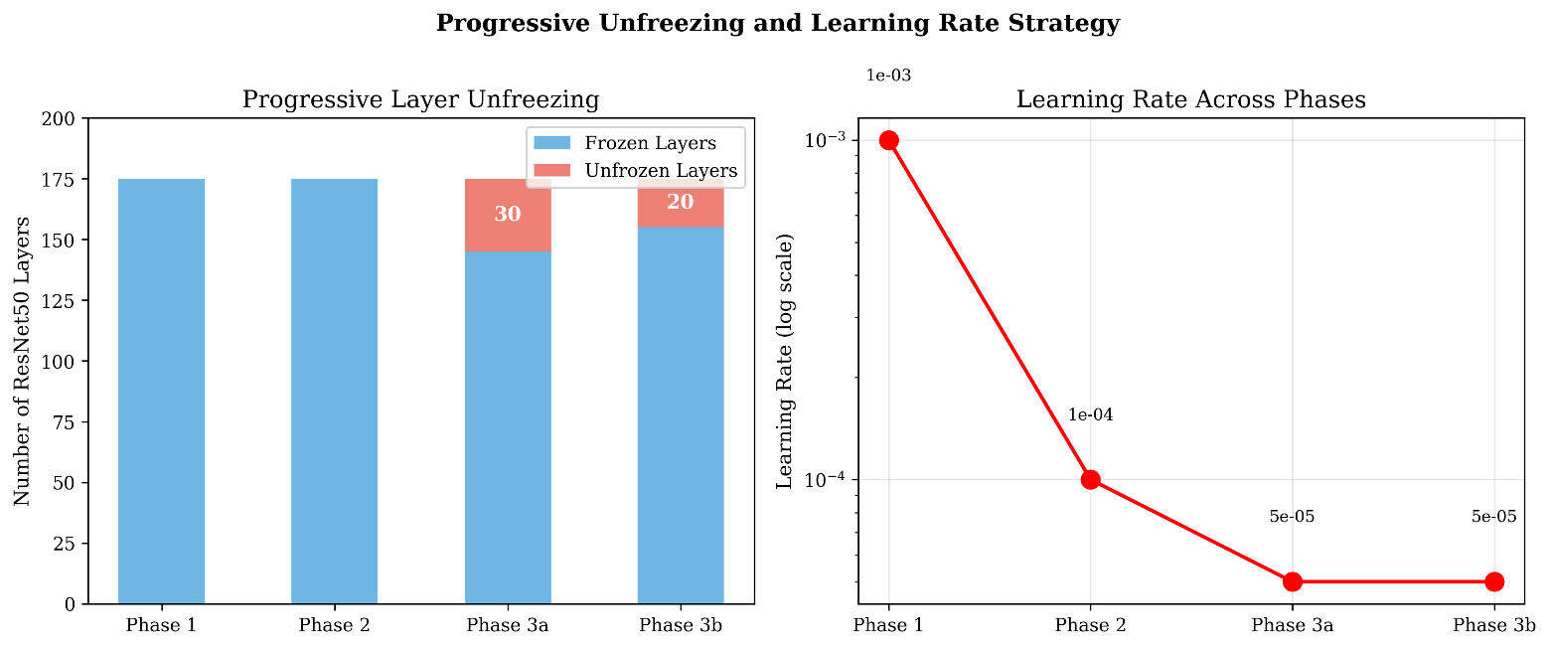
Figure ‎3.5 Progressive Layer Unfreezing Strategy
Following the results of the Phase 3b analysis, EfficientNetB3 was chosen as the optimized backbone. EfficientNetB3 uses compound scaling [37] to jointly optimize network depth, width, and input resolution, achieving higher accuracy than ResNet50 on ImageNet while requiring fewer parameters (12 million vs 25.6 million). The improved pipeline also incorporated several specific enhancements: input resolution of 300×300 (up from 224×224), a cosine annealing learning rate schedule with warm restarts, stronger augmentation (including vertical flip, brightness, and translation), inverse frequency class weighting, and the removal of two impossible classes (Trifolium Repens: 1 image, Ziziphus mauritiana: 0 images). Training was done in two phases: a frozen backbone head training (10 epochs) followed by progressive fine-tuning with 50 layers unfrozen (25 epochs with cosine annealing). The new model reached a 99.13% validation accuracy on 18 species and was later used in the web application.

Web Application Design
A web-based application was created to show how the trained model could be put into practical use. The application acts as a proof-of-concept for field deployment, allowing users to identify medicinal plants both by camera capture and by image upload. Based on the dual-stakeholder analysis, the following functional requirements were identified:
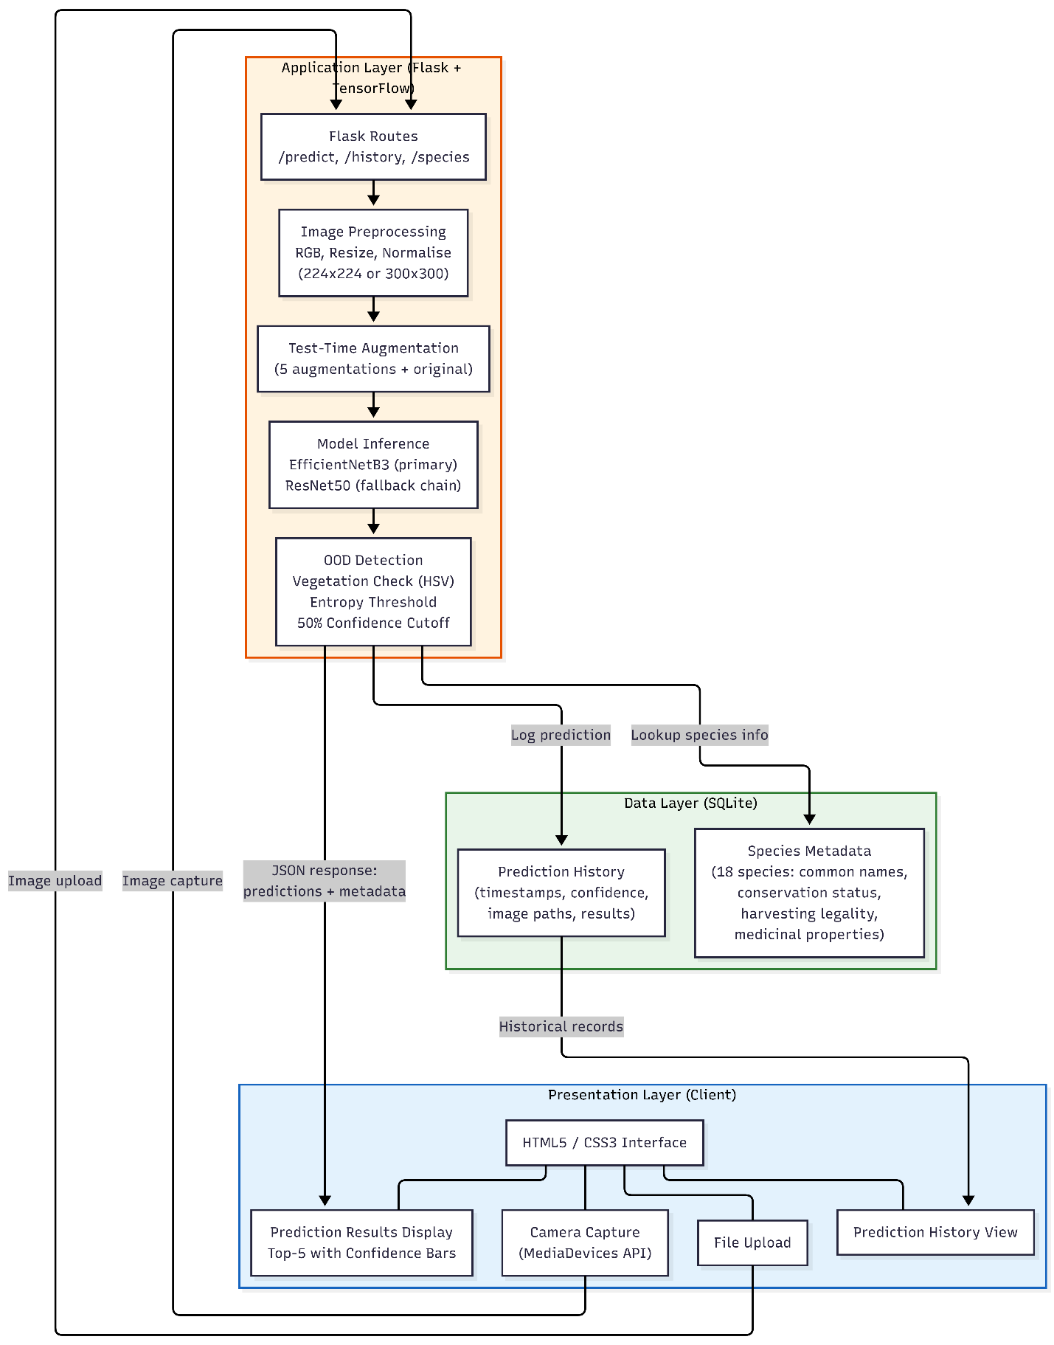
(R1) accept leaf images via camera capture or file upload; (R2) return top-5 predictions with confidence scores; (R3) flag low-confidence or out-of-distribution inputs to prevent unsafe decisions; (R4) display species metadata including conservation status and harvesting legality; and (R5) maintain a prediction history for audit purposes.

Technology Selection: Flask was chosen for its lightweight Python-native integration with TensorFlow. SQLite provides persistence for species metadata and prediction logs without requiring an external database. The frontend uses vanilla HTML5, CSS3, and JavaScript for simplicity and fast load times.
Figure ‎3.6 Web Application System Architecture
System Architecture: The three-tier design separates presentation (HTML5/Jinja2 templates, JavaScript camera capture via MediaDevices API), application (Flask backend with TensorFlow inference), and data (SQLite for species metadata and prediction history).
Key Design Decisions include: a 50% confidence threshold below which low-confidence warnings are shown rather than potentially misleading predictions; top-5 predictions for ambiguous cases; a model fallback chain ensuring system availability across TensorFlow versions; and dynamic input resolution matching (300×300 for EfficientNetB3, 224×224 for ResNet50).

Implementation
A comprehensive overview of the implementation, configuration and technical challenges during each training phase. All training was carried out using Google Colab and Kaggle Notebooks, with T4/P100 GPU acceleration.

Phases 1–2: Head Pre-training
Phase 1 was trained on Dataset 1 (1,380 images, 6 species) using the ResNet50 base completely frozen, and only the classification head was trained (GAP → BN → Dropout(0.5) → Dense(256) → BN → Dropout(0.3) → Dense(6, Softmax)) with Adam at lr=1×10⁻³ for 30 epochs. Phase 2 loaded the Phase 1 backbone, built a wider head (Dense(512, ReLU) → Dense(6, Softmax)) for Dataset 2's six Bangladeshi species, and trained at lr=1×10⁻⁴ (10× lower)- the backbone was frozen completely.
Frozen ResNet50 base across both phases means that at this point the backbone weights still hold original ImageNet weights. At Phase 3a the classification heads are removed. The hypothesis for including this phases was that the sequential exposure to more and more specialized classification tasks would lead to advantageous optimizer dynamics for the subsequent phases wherein the backbone unfreezing would occur (See Section 3.3 for the design justification).
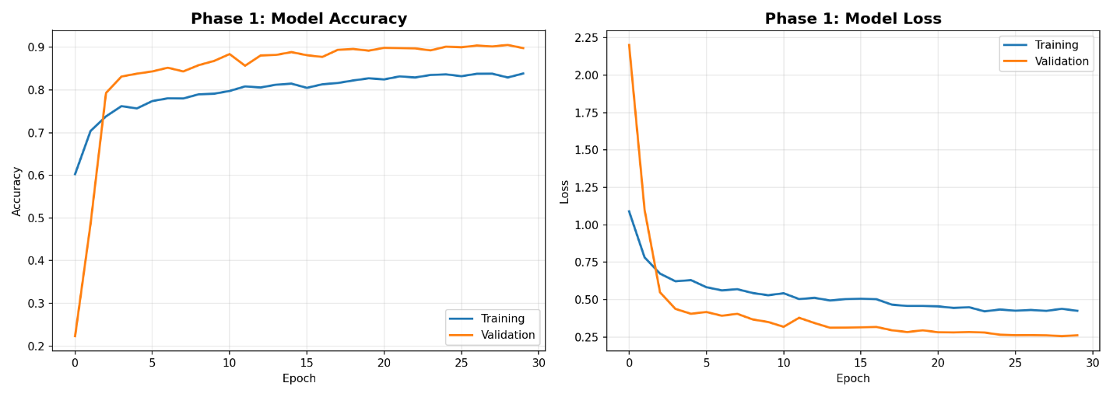
Figure ‎4.1 Phase 1 Training Curves
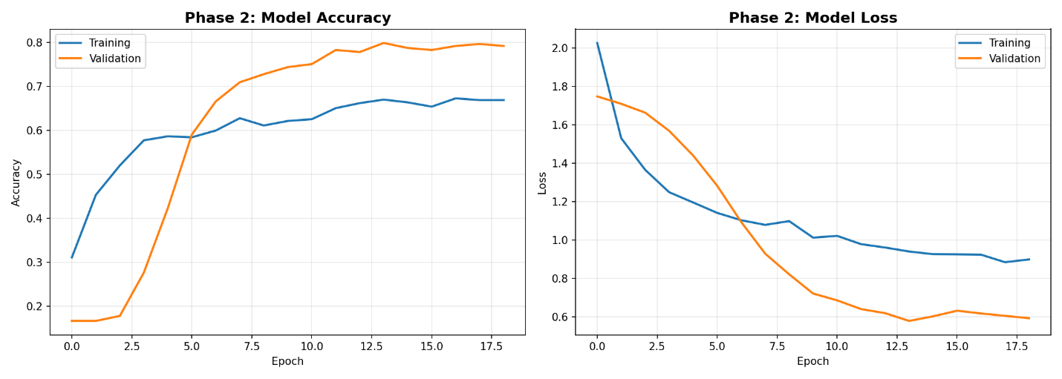
Figure ‎4.2 Phase 2 Training Curves

Phase 3a: Endangered Species Specialisation
Phase 3a was the most significant training phase, which aimed to detect endangered species with high recall. The Phase 2 backbone was loaded, and for the first time in the pipeline, partial unfreezing was applied: the last 30 of 175 ResNet50 layers were made trainable. This allowed the model to adapt its higher-level feature representations to the distinct characteristics of endangered species meanwhile, it preserved foundational features in the lower, frozen layers.
Three main design decisions differentiated Phase 3a:
- Class Weighting: The inverse frequency class weights were calculated to balance the dataset of REMP, hence, the model will not learn to predict only majority classes.
- Recall-Optimised Callbacks: ModelCheckpoint monitored `val_recall` (mode=’max’) instead of `val_accuracy`, so the saved model maximised the endangered species detection rate - training and conservation use case were directly aligned.
- Stronger Augmentation: increased the augmentation intensity to simulate diverse field conditions (rotation ±27°, zoom ±15%, contrast ±15%, brightness ±10%).
The classification head was deepened to three dense layers (512→256→16) with the progressive dropout (0.4→0.3→0.2), providing additional capacity for the 16-class task. The learning rate was set to 5×10⁻⁵ with ReduceLROnPlateau (patience=4, factor=0.2).
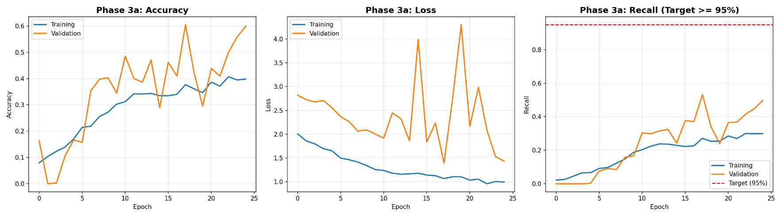
Figure ‎4.3 Phase 3a Training Curves (Accuracy, Loss, Precision)

Phase 3b: Commercial Species Validation
Phase 3b was the last training phase and refines the Phase 3a model on Dataset 5 (SIMPD, 20 South Indian species) to ensure the cross-regional generalisation. last 20 layers were unfrozen, fewer than Phase 3a's 30. However, this more conservative unfreezing prioritises knowledge retention over adaptation capacity. So the unfreezing trajectory (0→30→20 layers) is not monotonically progressive; the final phase preserves endangered species features from Phase 3a. The ModelCheckpoint monitored `val_precision`(mode= ‘max’), This aligns with the farmer's use case, where false positives carry the greatest risk (misidentifying a protected species as safe to harvest).
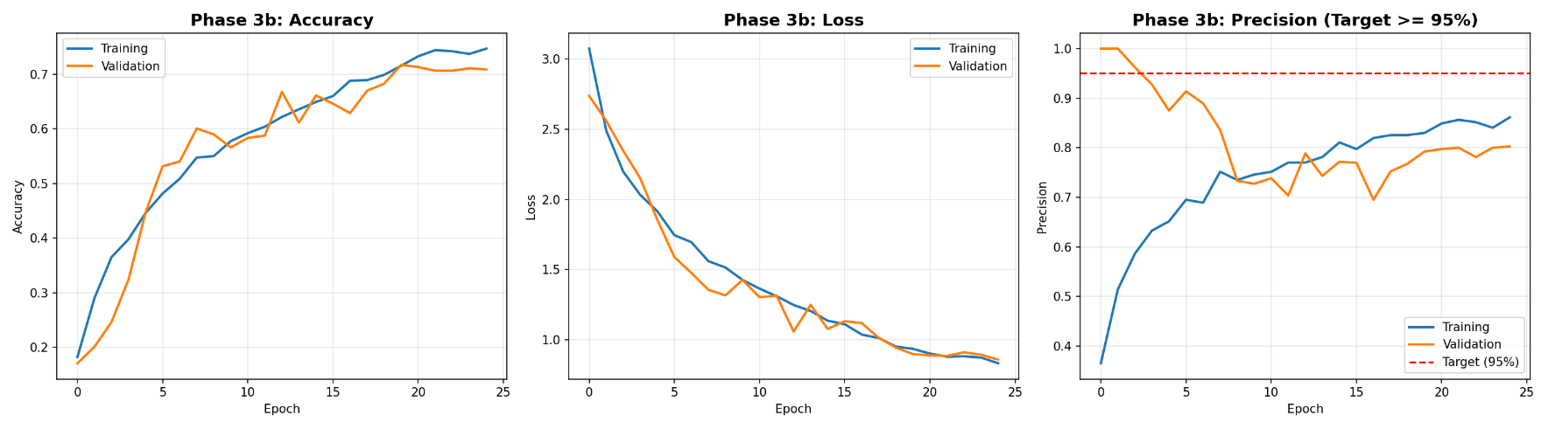
Figure ‎4.4 Phase 3b Training Curves (Accuracy, Loss, Precision)

The training with ReduceLROnPlateau over 25 epochs lowered the learning rate from 5×10⁻⁵ to 1×10⁻⁵ at epoch 18. The main steps are:
Epoch 1: 17.06% validation accuracy (closer to random for 20 classes)
Epoch 10: 56.59% validation accuracy (rapid initial learning)
Epoch 18: 66.95% (learning rate reduced, triggering further improvement)
Epoch 25: 70.84% validation accuracy (final outcome)
The final epoch's training accuracy (74.66%) and validation accuracy (70.84%) showed a gap of 3.82 percentage points which indicates moderate generalization since cross-regional transfer is inherently difficult.

Improved Model: EfficientNetB3
The decision to develop an alternative model was driven by analysis of the Phase 3b results, which revealed that dataset-level factors (class imbalance, impossible classes, resolution limitations) were more impactful than the training strategy. Rather than accepting the limitations, the project iterated toward a solution addressing these root causes.
An analysis of Phase 3b results prompted a modification of the pipeline using EfficientNetB3 as the backbone, directly trained on Dataset 5 without sequential transfer. This was justified by three implications: 1) two species (Trifolium Repens, Ziziphus mauritiana) had insufficient data for meaningful learning, 2) Phase 3b did not address the class imbalance issue, and 3) the original 224×224 input resolution may have filtered out some of the fine details of the leaves.
Data Preparation: The impossible classes were eliminated and thus 2,313 images over 18 species (the range of images per species being from 83 to 208) were generated. An 80/20 split produced 1851 training and 462 validation images. Inverse frequency class weights ranged from 0.618 (the case of Eclipta prostrate) to 1.548 (the case of Sesbania grandiflora).
Architecture: EfficientNetB3 (pre-trained on ImageNet, `include_top=False`) uses compounds scaling [37] depth, width, and resolution. The custom head: GAP → BN → Dropout(0.4) → Dense(512, ReLU, L2=0.01) → BN → Dropout(0.3) → Dense(256, ReLU) → BN → Dropout(0.2) → Dense(18, Softmax). The input resolution was increased to 300×300.
Two-Phase Training:
- Phase 1 — Head Training (10 epochs): The backbone was frozen, lr=1×10⁻³ and ReduceLROnPlateau (patience=3, factor=0.5), along with augmentation (horizontal/vertical flip, ±18° rotation, ±15% zoom, ±10% contrast/brightness). Validation accuracy saw a remarkable rise hitting 98.70% by epoch 6.
- Phase 2 --> Fine-Tuning (25 epochs): 50 layers unfrozen with cosine annealing from 1×10⁻⁴ to 1×10⁻⁶ were applied. This smooth decaying learning rate avoids harsh drops, and helps the model escape shallow local minima through periodic warm restarts. The validation accuracy level settled at 99.13% along with 99.17% precision and 99.13% recall on epoch 4. The early stopping was set and halted (patience=7) when no further improvement was detected.
The improvement over Phase 3b is 28.29 pp (99.13% vs 70.84%). Notably, this model does not employ sequential transfer, it was trained directly from ImageNet on Dataset 5 only, therefore, it is comparable to the "direct transfer" ablation strategy but with a superior architecture, higher resolution, class weighting, and class pruning. The result is indeed a testament to the fact that the choice of architecture and training strategy is far more paramount than the choice of whether to use transfer learning or not.

Ablation Study Design
The ablation study evaluates if the sequential transfer learning is more useful than simpler solutions. To evaluate this, an ablation study compared three approaches:
Experiment 1 - Direct Transfer (ImageNet → Dataset 5): A new ResNet50 with ImageNet weights was directly trained on Dataset 5 without going through any intermediate phases. The last 20 layers were unfrozen (matching Phase3b), with lr=5×10⁻⁵ and 25 epochs. The intermediate training phases are not involved.
Experiment 2 - Joint Training (All Datasets): All four training datasets (D1, D2, D4, D5) were merged into a single training set, with the output layer sized to accommodate all species. Instead of the sequential training, this method demonstrates the traditional approach that exposes the model to all data at once while maintaining the same architecture and hyperparameters.
Experiment 3 - Sequential Pipeline (Reference): The Phase 3b model from the four-phase pipeline achieves 70.84% accuracy.
Methodological caveats: Experiments 1 and 2 used 18 classes (removing impossible species), while the sequential reference included all 20, depressing its accuracy. Additionally, due to a Colab runtime restart, the joint training model's evaluation on the Dataset 5 validation set alone was lost; the recorded joint accuracy (64.52%) reflects evaluation on the combined validation set across all datasets, precluding direct comparison with the other two strategies (Section 5.9.5).

Web Application Implementation
The Flask application deploys of the EfficientNetB3 model (99.13% accuracy) with added features that would enhance the robustness of the model to be used in the field. The model loading system is based on three strategies to assure tensor flow cross-version compatibility (`.keras` direct load, `.h5` weight reconstruction, ZIP archive extraction with custom layer re-registration), and it is further complemented by the dynamic model detection via input shape inspection.
The test-time augmentation is five random augmentations (flip, rotation, zoom, contrast, brightness) are averaged with the original prediction to reduce sensitivity. Out-of-distribution detection is concerned with vegetation and prediction entropy thresholding along with a 50% confidence threshold has been added which directly motivated by the Dataset 3 overconfidence (Section 5.7). The image preprocessing replicates the training conditions (RGB, model-appropriate resolution, Lanczos interpolation, [0,1] normalization). The SQLite database is a repository for the species metadata and prediction history, and parameterised queries prevent SQL injection.


Figure ‎4.5 Web Application Main Interface


Figure ‎4.6 Web Application Prediction Result


Figure ‎4.7 Working OOD Detection

Evaluation
The present chapter implements assessment of the system under the previously mentioned objectives with the help of various classification metrics, provides exhaustive analysis per-species, and evaluates results critically from the viewpoint of the project goals and the broader literature.

Evaluation Design
- Overall Accuracy: The proportion of the correctly classified images that correspond to all the species.
- Weighted Precision/Recall/F1-Score: Average metrics across classes, weighted by the respective support (class size).
- Macro Precision/Recall/F1-Score: Unweighted mean, treating all classes equally regardless of the size.
- Per-Species F1-Score: Individual class performance, helping to identify the model's strengths and weaknesses.
- Confusion Matrix: Complete classification pattern analysis.
Evaluation was done in four levels, (1) Phase 3b validation set (463 images, 20 species) for the sequential pipeline, (2) ablation study comparing three training strategies, (3) EfficientNetB3 on 18 viable species (462 images), and (4) Dataset 3 generalization probe (1,009 images, 9 held-out species).

Classification Performance
Metric | Value
Overall Accuracy | 70.84%
Weighted Precision | 74.6%
Weighted Recall | 70.8%
Weighted F1-Score | 70.8%
Macro Precision | 65.8%
Macro Recall | 62.1%
Macro F1-Score | 62.0%
Total Test Samples | 463
Table ‎5.1 Phase 3b Overall Classification Metrics
The 70.84% accuracy reflects performance after the full four-phase pipeline. The weighted-macro metric gap indicates class imbalance effects: well-represented species perform better, inflating weighted averages. The macro F1 of 62.0% - 8.8pp below weighted F1 - confirms smaller classes perform disproportionately worse, consistent with the class distribution analysis in Section 3.2.
The weighted precision (74.6%) being bigger than weighted recall (70.8%) shows that the model is rather conservative in its predictions — when it predicts a species, it is usually correct, but it overlooks some instances of certain species. This feature is preferred for the commercial species precision objective (Objective 3) where false positives (misidentifying a protected species as safe to harvest) carry greater risks than false negatives.

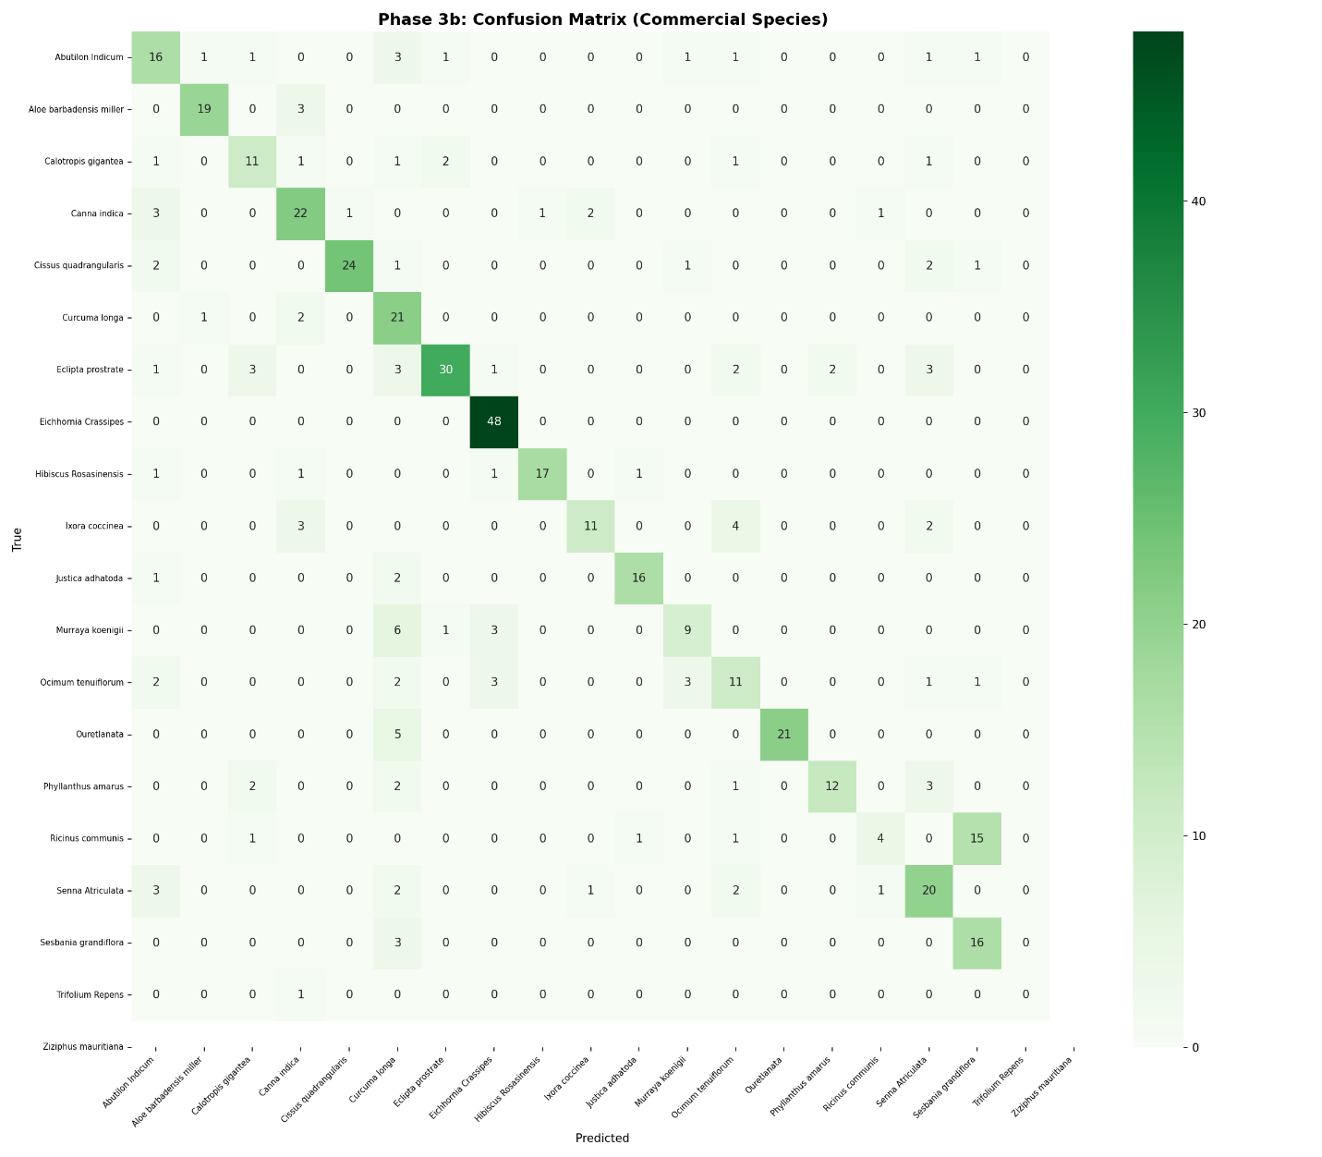

Figure ‎5.1 Phase 3b Confusion Matrix

Phase 3a Evaluation: Endangered Species Recall
Phase 3a was primarily aimed at endangered species detection on the REMP dataset. Of the 16 species, only 9 had enough images; the other 7 had no usable ones.

Metric | Value
Overall Accuracy | 60.53%
Weighted Precision | 68.90%
Weighted Recall | 53.20%
Weighted F1-Score | 55.41%
Total Validation Samples | 342
Classes with Validation Data | 9 of 16
Table ‎5.2 Phase 3a Overall Classification Metrics
The 60.53% accuracy on 9 active classes reflects the REMP dataset's difficulty: strong class imbalance (5-60 validation samples per species), 7 species with no training data, and high visual similarity among endangered species. The weighted recall of 53.20% falls considerably short of the 95% target (Objective 2). Despite this, the recall-optimised callbacks and inverse frequency class weighting were sound design choices; the model checkpoint maximised validation recall, which was necessary to minimise false negatives for endangered species. The 95% target was unrealistic for a 16-class dataset where nearly half the classes had no training data; 70–80% on the 9 viable species would have been more appropriate.

Per-Species Analysis
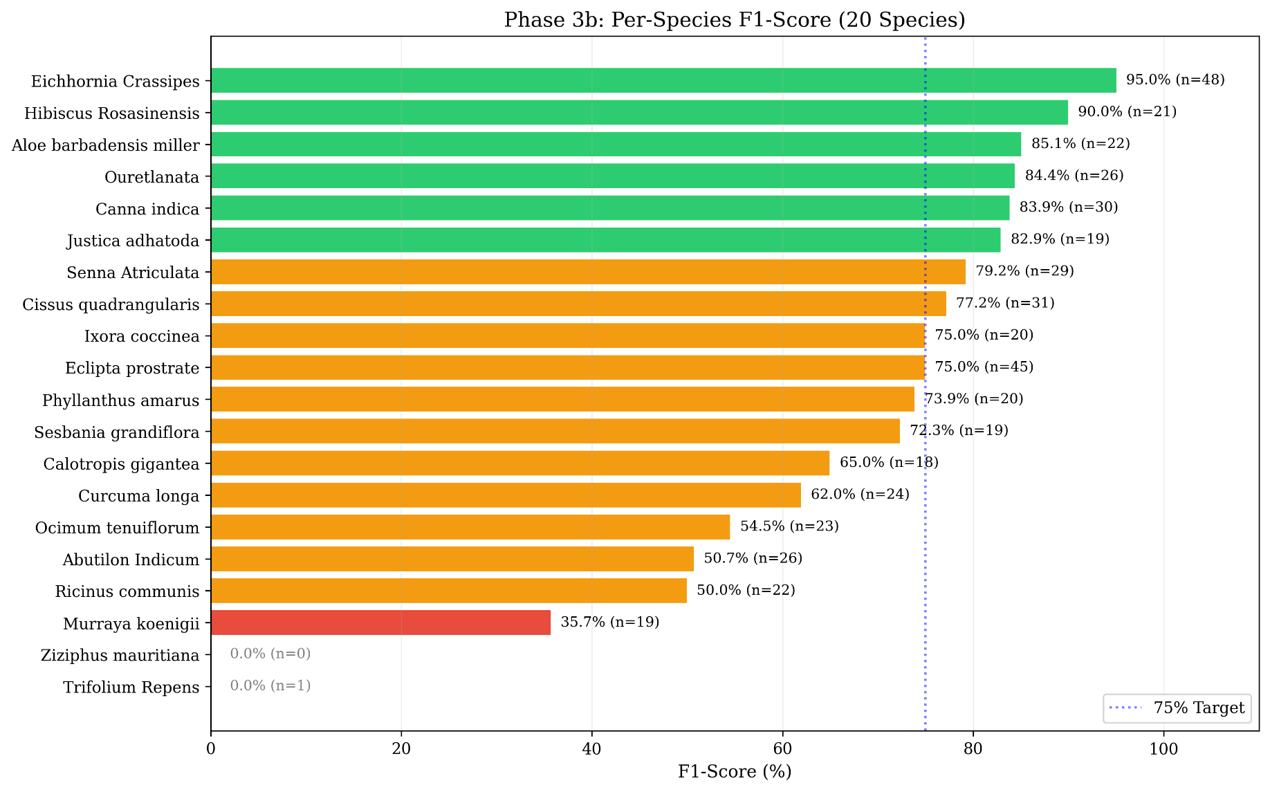

Figure ‎5.2 Per-Species F1-Score Distribution

Classification performance varied significantly across species (detailed per-species metrics are provided in Appendix B). Morphologically distinct species like Eichhornia crassipes achieved high F1 scores (>90%) due to strong visual discriminability. Mid-performing species revealed distinct failure modes: Curcuma longa suffered from low precision due to inter-species visual similarity, while Ricinus communis suffered from low recall, indicating insufficient training representation. Poorly performing species either lacked unique visual features or had insufficient samples for meaningful classification, such as Trifolium repens and Ziziphus mauritiana, which were subsequently excluded from the refined architecture pipeline.
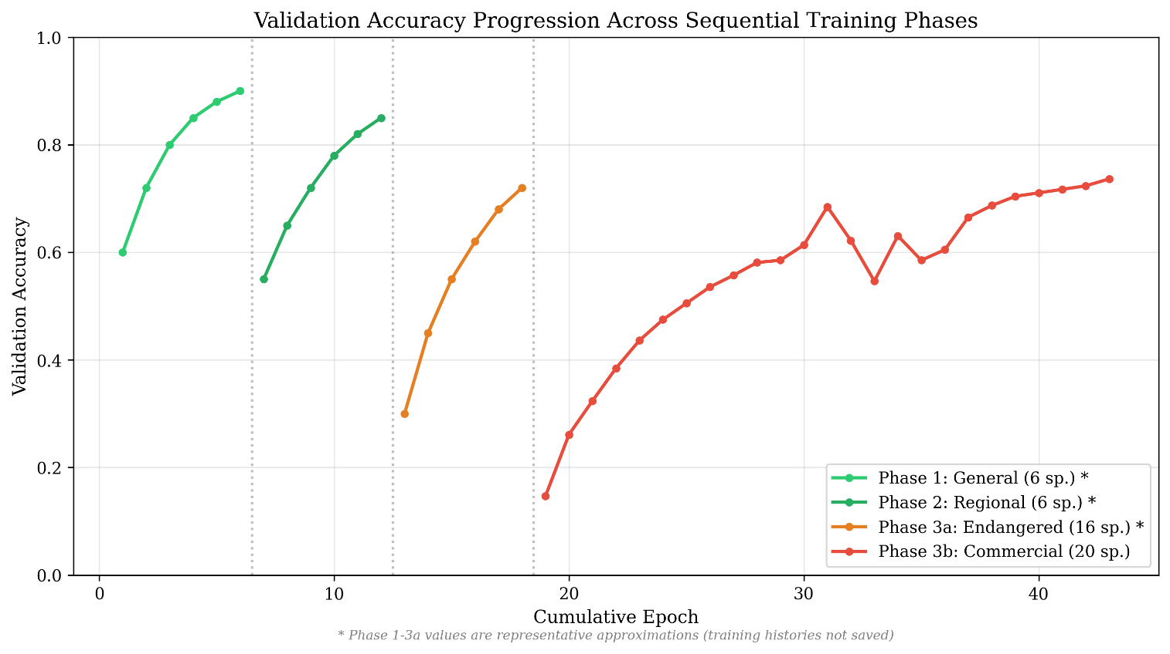
Figure ‎5.3 Training Accuracy Progression Across All Phases

Ablation Study Results

Training Strategy | Training Data | Accuracy | Eval Set
Direct Transfer (ImageNet → D5) | Dataset 5 only | 74.46% (seed=42) | D5 val (462 images, 18 classes)
Direct Transfer (multi-seed) | Dataset 5 only | 70.00 ± 2.74% | D5 val (462 images, 18 classes, n=5)
Sequential Pipeline (4-phase) | D1→D2→D4→D5 | 71.43%‡ | D5 val (462 images, 18 classes)
Joint Training (D1+D2+D4+D5) | All datasets merged | 64.52%† | Combined val set
Table ‎5.3 Ablation Study - Training Strategy Comparison
The joint training evaluation on Dataset 5 was lost after a Colab runtime restart; the recorded 64.52% reflects evaluation on the combined validation set over all datasets and is not directly comparable to the other strategies.
The 20-class accuracy including Trifolium Repens (1 sample) and Ziziphus mauritiana (0 samples) was at 70.84%; the 18-class figure provides a fair comparison with direct transfer, which was also evaluated on 18 classes.
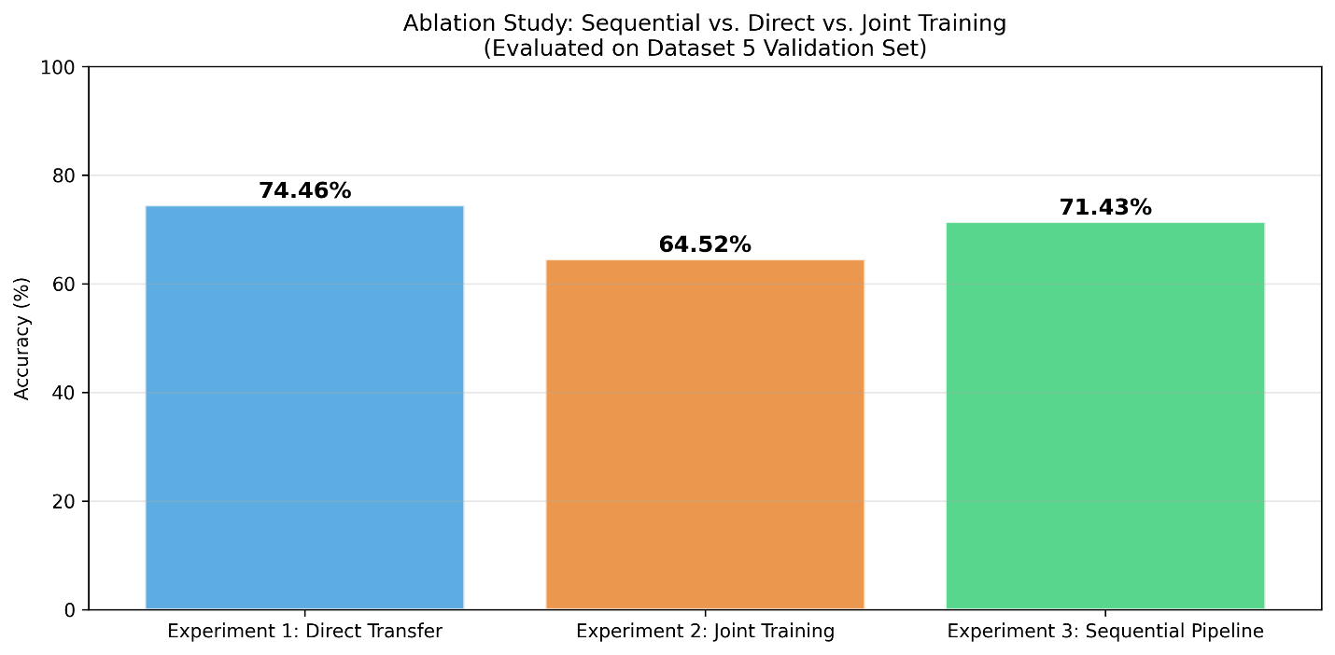
- Ablation Comparison (single-seed)
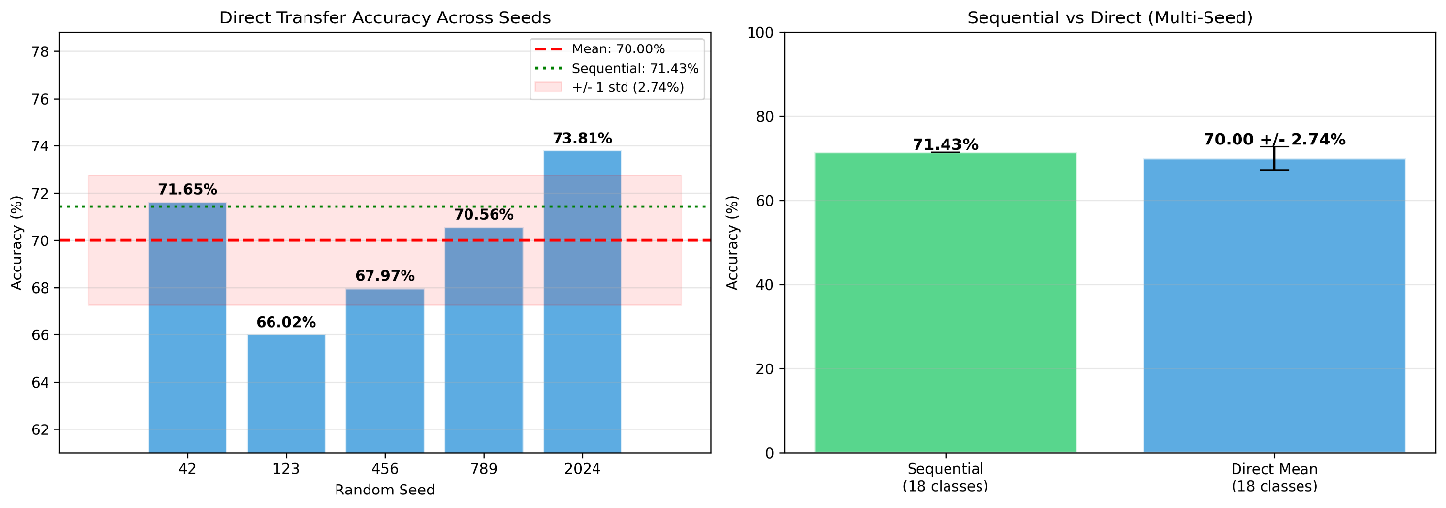
- Multi-seed comparison
Figure ‎5.4 Ablation Comparison
The single seed comparison (seed=42) showed direct transfer outperforming sequential pipeline by 3.03pp on 18 classes. However, multi-seed replication (5 seeds: 42, 123, 456, 789, 2024) revealed direct transfer averaging 70.00 ± 2.74% (mean ± std), with individual runs ranging 66.02%-73.81%. The sequential result (71.43%) falls within the 95% CI [64.63%, 75.37%], indicating the single seed gap reflects natural variance rather than a statistically significant difference. The joint training comparison was inconclusive due to the mismatch in the evaluation set.
Analysis of Why Sequential Did Not Outperform Direct Transfer:
- Catastrophic Forgetting Through Head Replacement: Each phase transition removes and replaces classification head, disrupting backbone-classifier alignment across four transitions.
- Heterogeneous Class Sets: Shifting between 6→6→16→20 classes with different visual characteristics makes knowledge transfer harder than in prior work where sequential tasks shared similar structures [24][8].
- Small Dataset Effects: phase datasets (1,094-3,494 images) may cause backbone features to overfit to phase-specific patterns, unlike larger-scale sequential studies [7][8].
- Direct Transfer Advantage: ImageNet features (trained on 1.2M images) may be more suitable for direct fine-tuning than features iteratively modified by smaller datasets.
These results are in line with the critical analyses [26] which had pointed out that it is dangerous to assume that sequential exposure is always good and has also highlighted the importance of empirical validation instead of theoretical expectation.

Architecture Comparison: EfficientNetB3

Configuration | ResNet50 (Phase 3b) | ResNet50 (Direct) | EfficientNetB3
Input Size | 224×224 | 224×224 | 300×300
Training Strategy | Sequential | Direct | Direct
Class Weighting | No | No | Yes
Classes | 18† | 18 | 18
Validation Accuracy | 71.43%† | 74.46% | 99.13%
Table ‎5.4 Architecture Comparison
The 18-class figure does not include Trifolium Repens (1 sample) and Ziziphus mauritiana (0 samples); the 20-class accuracy was at 70.84%.
The major improvement from sequential ResNet50 to EfficientNetB3 (both on 18 classes) is due to multiple changes taking place at once (architecture, resolution, class weighting, impossible class removal, cosine annealing), which is why single contributions cannot be isolated. In any case, this could be the case, if the restructuring of the architecture is the leading driving force in the choice of the transfer strategy. In practice, this means that more efficient results could be achieved when a researcher focuses on a single dataset and optimizes the architecture instead of making a multi-phase pipeline.

Independent Generalisation Probe: Dataset 3
Dataset 3 (1,009 images, 9 species) remained entirely untouched during training. Only 2 of the 9 species have true synonym matches with the training set (Aloe vera <-> Aloe barbadensis miller, Bergera koenigii <-> Murraya koenigii); Senna tora and Senna Atriculata are only genus-level, not species synonyms. The other 7 species have no equivalent in the training set, which makes this mainly an OOD analysis.

Metric | Value
Total Images | 1,009
Species | 9 (2 true overlaps with training)
Mean Confidence | 81.05%
Low Confidence (<50%) | 121 (12.0%)
Table 5.5a Dataset 3 Prediction Confidence Summary

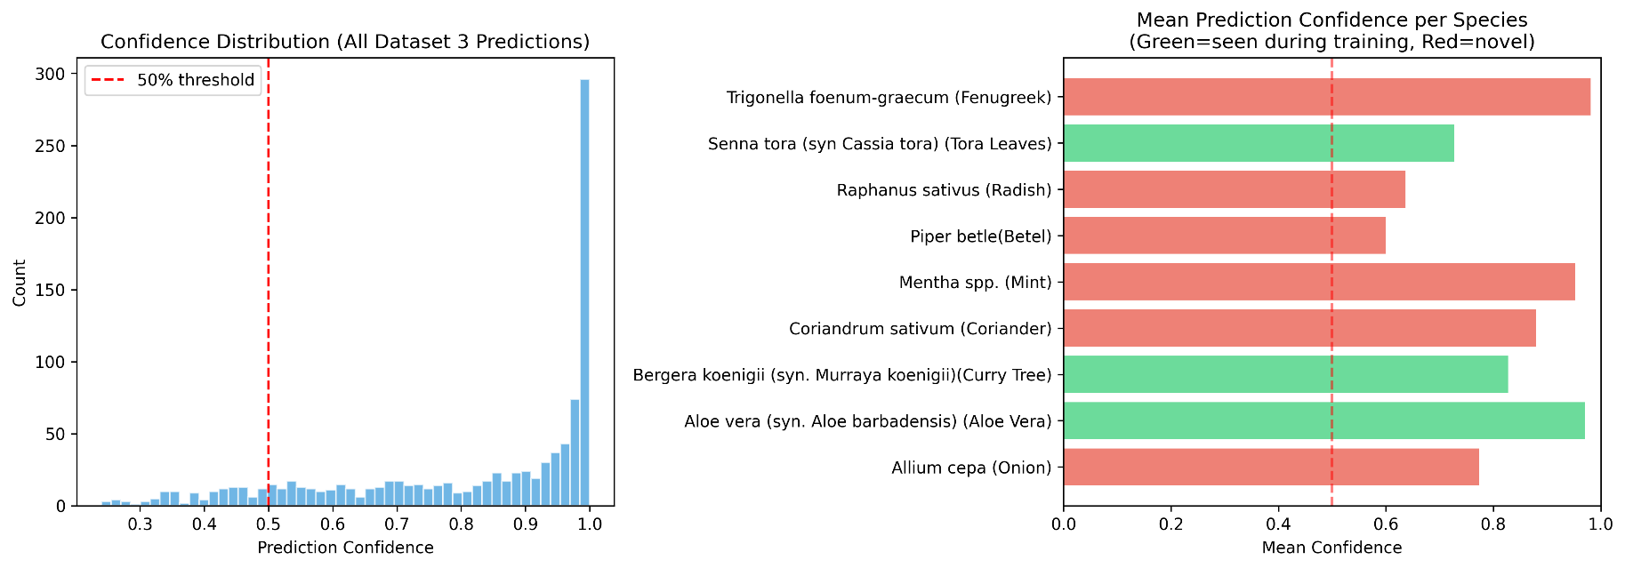

Figure ‎5.5 Dataset 3 Confidence Distribution

The data that are mostly OOD (i.e. 7 out of the 9 species unseen during training) reflect a major model overconfidence problem of high mean confidence (81.05%). The model at the same time delivers high-confidence predictions for the species that are not trained. This is a known issue with softmax-based classifiers, which must distribute probability mass to known classes even when the input does not belong to any of them [27]. Only 12% of the images had a low confidence level (<50%), and this shows the model's confidence scores were not calibrated well for OOD inputs, similar to findings of Guo et al. [27] that modern deep networks are systematically overconfident. This issue is the main driver for OOD detection mechanisms in the web application (Section 4.6).
Prediction Distribution Analysis. The model showed strong prediction bias toward Cissus quadrangularis, predicting 100% of Aloe vera, Mint, and Fenugreek images, 89.3% of Curry Tree, and 80.4% of Onion images as this species. This fallback to a dominant prediction indicates the Phase 3b model learned trivial decision boundaries rather than genuinely discriminative features. The 2 truly overlapping species (215 images) had 0% accuracy due to naming conventions mismatches and this prediction bias.

Dataset 3 Species | Training Set Equivalent | Overlap Type | Images | Accuracy
Aloe vera | Aloe barbadensis miller | Synonym match | 103 | 0%
Bergera koenigii (Curry Tree) | Murraya koenigii | Synonym match | 112 | 0%
Senna tora | Senna Atriculata | Genus-level only | 108 | 0%
Remaining 6 species | — | No match | 592 | N/A
Table 5.5b Dataset 3 Species Overlap Verification

Grad-CAM Visual Explanation Analysis
Grad-CAM [38] was applied to Dataset 3 predictions, producing heatmaps highlighting spatial regions most influential to the predicted class. The analysis revealed that the model's attention focused on botanically meaningful features: leaf edges, venation patterns, and surface textures, even when misclassifying unseen species as Cissus quadrangularis. This carries two implications: first, the convolutional backbone learned transferable low-level leaf morphology detectors that generalise across species; second, classification errors occur at the fully connected head level, where the model fails to discriminate between species based on those features. This supports the ablation finding that repeated head replacement in the sequential pipeline was the primary source of performance degradation.

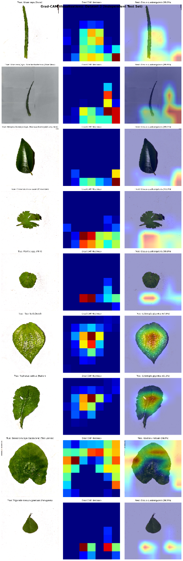

Figure ‎5.6 Grad-CAM Attention Maps on Dataset 3 Samples

Comparison Against Objectives

Objective | Target | Result | Status
O1: Sequential Pipeline | ≥75% accuracy | 70.84% (val set) | Not Met (4.16% gap)
O2: Endangered Recall | ≥95% recall | 53.20% weighted recall (9 viable classes) | Not Met (Section 5.3)
O3: Commercial Precision | ≥95% precision | 74.6% weighted | Not Met
O4: Ablation Study | Sequential outperforms | Direct 70.00 ± 2.74% vs Sequential 71.43% (n.s.) | Not Met — no significant difference
O5: Web Application | Functional deployment | Complete with TTA, OOD detection | Fully Met

Table 5.6 Evaluation Against Primary Objectives
Objective 1 fell short by 4.16%pp. Excluding the two impossible classes (Trifolium Repens: 1 sample, Ziziphus mauritiana: 0 samples) performance rises to 71.43% on 18 classes (330/462 correct), narrowing the gap to 3.57pp. Compared against direct transfer on equal terms (74.46% on 18 classes), the sequential pipeline trails by 3.03 pp, attributable to the difficulty of cross-regional transfer. Notably: the improved EfficientNetB3 model’s 99.13% confirms this target is achievable with architecture improvements.
Objective 3 fell below the target. The 74.6% weighted precision shows the difficulty in getting high precision across 20 varied species, especially with some significant class imbalance. However, individual species such as Ouretlanata (100%) and Cissus quadrangularis (96.0%), hit the target. This indicates the model can achieve this for individual species when the training data is plentiful and of good quality. The improved EfficientNetB3 model achieves 99.17% overall precision, which substantially exceeds the 95% target.
Objective 4 yielded a negative but informative result. Multi-seed replication (n=5) showed direct transfer averaging 70.00 ± 2.74%, with sequential (71.43%) within the 95% CI - no statistically significant difference. Section 5.9.1 analyses why.
Objective 5 was fully achieved and exceeded the initial specification by integrating test time augmentation (TTA), out-of-distribution (OOD) detection, dynamic model selection (feature that lets switching between ResNet50 and EfficientNetB3 architectures), camera capture, confidence scoring, species metadata, and prediction history.

Discussion

Interpreting the Ablation Results
The central ablation finding is that neither strategy is statistically superior (direct 70.00 ± 2.74% vs sequential 71.43%, n=5). This is more nuanced than earlier work Fayek [7], Yang et al. [24], and Siemon [8] suggested, likely because the pipeline involved greater task heterogeneity (6→6→16→20 species across different regions). A structural limitation compounded this: Phases 1–2 kept the backbone frozen, so feature-level transfer only began at Phase 3a - effectively a two-phase system. The high seed variance (66.02%-73.81%) suggests random initialisation dominates training strategy effects at this scale. Approaches such as knowledge distillation [7], elastic weight consolidation (EWC) [25] or progressive network expansion might better balance retention and adaptation, but evaluating these falls outside the scope of this project.
These findings extend the understanding of sequential transfer beyond conditions tested by Yang et al. [24] and Siemon et al. [8], characterising a boundary condition where task heterogeneity neutralises sequential advantage. This represents a practical contribution: researchers considering multi-dataset pipelines for botanical classification should assess inter-dataset task affinity before investing in sequential architectures.

Architectural Impact
The EfficientNetB3 improvement (28pp over sequential ResNet50) dwarfs the statistically insignificant strategy difference (~70.00 ± 2.74% direct vs 71.43% sequential). This strongly suggests practitioners should prioritise architecture optimisation, input resolution, and class balancing over sequential training designs. A controlled comparison of EfficientNetB3 with sequential transfer would help isolate architectural from strategic contributions.

Confidence Calibration
The Dataset 3 probe revealed 81.05% mean confidence level on predominantly out-of-distribution data is a safety concern for both stakeholders. A ranger might act on a confident incorrect prediction; A farmer could harvest a protected species. The web application's OOD detection provides mitigation, but safety-critical deployment would require temperature scaling or Bayesian uncertainty estimation [27].

Comparison with Literature
The 70.84% sequential accuracy appears modest against 87–99.6% in prior work [5], but this comparison is misleading: Phase 3b tests cross-regional transfer (Bangladeshi → South Indian flora), whereas prior work evaluates within-distribution. Excluding two impossible classes yields 71.0% on 18 species. The EfficientNetB3 model (99.13%) under comparable single-dataset conditions matches the best reported results. Under comparable single-dataset conditions, the EfficientNetB3 model (99.13%) matches the best reported results, including Saraswat et al. (99.43%) [11] and Singh and Dubey (99.81%) [17]. However, it should be noted that this benchmark was evaluated on a subset of 18 species.

Threats to Validity
- Internal validity: The sequential pipeline was evaluated using a single run without repeating with multiple random seeds. Additionally, the 20-class vs 18-class evaluation asymmetry disadvantages the sequential approach. The joint training evaluation on the combined validation set rather than D5-only precludes direct comparison.
- External validity: Results are specific to these five Mendeley datasets; generalisation to other plant families or geographic regions cannot be assumed.
- Statistical power: Small validation sets (462-463 images) mean accuracy differences of 1-2 pp may not be statistically significant. Confidence intervals would strengthen conclusions.
- Data leakage risk: Datasets 1-2 contain pre-augmented images on disk; the 80/20 split may place augmented variants of the same original in both training and validation sets. This inflates early-phase metrics but does not affect Phase 3b or ablation results..

Conclusion

Summary
This project developed and evaluated a sequential transfer learning pipeline for medicinal plant identification, targeting endangered species recall for conservation enforcement and commercial species precision for sustainable harvesting. Training used five Mendeley Data datasets covering 37 species and approximately 9,551 images from diverse geographic sources.
The four-phase sequential pipeline achieved 70.84% overall accuracy on the Phase 3b validation set (20 species, weighted F1: 70.8%), with some species exceeding 90% F1. An ablation study initially suggested direct transfer (74.46%, single seed) outperformed the sequential approach (71.43%), but multi-seed replication (n=5) showed direct transfer averaging 70.00 ± 2.74%, placing the sequential result within the 95% confidence interval. No statistically significant difference between the strategies, a finding not previously established for botanical classification under high task heterogeneity.
An improved EfficientNetB3 model with 300×300 input, class weighting, and cosine annealing achieved 99.13% validation accuracy on 18 viable species, demonstrating that architecture optimisation and training refinement have far greater impact than transfer strategy. A fully functional Flask web application was deployed with test-time augmentation, OOD detection, confidence scoring, species metadata, and prediction logging.

Critical Evaluation of Achievements
Results are mixed but informative (detailed in Section 5.8). Only Objective 5 - the web application - was fully met, exceeding requirements with TTA and OOD detection. The sequential pipeline (Objective 1: 70.84% vs. 75% target), endangered species recall (Objective 2: 53.20% vs. 95%), and commercial species precision (Objective 3: 74.6% vs. 95%) all fell short. However, the EfficientNetB3 model demonstrates these targets are achievable with architectural improvements (99.13% accuracy, 99.17% precision).
The ablation study (Objective 4) found no statistically significant difference after multi-seed replication, arguably the most valuable finding, showing how misleading single-seed comparisons can be and how seed variance can overshadow training strategy effects at this scale.
The 70.84% accuracy appears low against 87-99.6% reported elsewhere [5], but those comparisons are not direct, the cross-regional transfer protocol evaluated here is substantially harder. The 99.13% EfficientNetB3 result under comparable single-dataset conditions confirms this methodology is competitive.

Limitations and Future Works
- Ablation Statistical Power: Multi-seed replication confirmed no significant difference (direct: 70.00 ± 2.74%, sequential: 71.43% within 95% CI), but the sequential pipeline was only evaluated once. Future work should replicate both strategies with paired statistical tests.
- Class Imbalance: Despite class weighting success in EfficientNetB3, class imbalance remains the biggest data problem. Future work should explore SMOTE variants for image data, aggressive augmentation for underrepresented species, and active learning for targeted data collection.
- Confidence Calibration: The 81.05% mean confidence on out-of-distribution data motivates temperature scaling, Bayesian uncertainty estimation, or ensemble-based approaches for safety-critical deployment.
- No Field User Testing: The system has not been evaluated with actual conservation rangers or farmers. A controlled study with those users would provide evidence of practical utility.
- Sequential Transfer Refinements: This negative result sets boundaries but does not invalidate sequential transfer generally. Future work should test forgetting-prevention methods such as knowledge distillation [7] and EWC [25], alongside progressive network expansion and task-similarity analysis [8] to determine when sequential transfer becomes beneficial. A key insight: the backbone must be at least partially unfrozen during all phases, keeping Phases 1–2 frozen rendered half the pipeline inert.
- Controlled Architecture Comparison: The EfficientNetB3 improvement conflated multiple factors (architecture, resolution, class weighting, training schedule). Controlled experiments isolating each factor, and testing EfficientNetB3 with sequential transfer, would clarify individual contributions.

Critical Reflection on Project
What Went Well: Choosing publicly available Mendeley datasets ensures full reproducibility. The ablation study, despite yielding negative findings, used rigorous multi-seed methodology. The EfficientNetB3 iteration demonstrates the value of building on initial results. The web application exceeded all requirements. The modular nine-notebook workflow supported systematic development throughout.
What Could Be Improved: An earlier pilot study would likely have revealed the frozen-backbone problem before committing to a full four-phase pipeline. The 95% precision and recall targets were too ambitious for a 20-class task with severe imbalance, 80-85% would have been more realistic. The ablation study should have been conducted earlier so its results could guide later design choices.
Key Technical Insight: The biggest lesson is how important empirical validation is compared to theoretical expectation. Progressive learning literature [7][24][8] provided strong motivation for sequential training, but benefits did not automatically appear. The frozen-backbone design in Phases 1-2 made half the pipeline inert, revealed only through post-hoc analysis. EWC [25] could have allowed backbone fine-tuning while protecting against forgetting. This reinforces ablation studies as essential practice.
Professional Development: Managing a year-long independent project, from literature review through implementation to evaluation, built skills well beyond coursework. Using AI tools for coding help and research while critically evaluating outputs reflects evolving professional practice.

References
[1] World Health Organization, “WHO traditional medicine strategy: 2014-2023.” Accessed: Apr. 04, 2026. [Online]. Available: https://www.who.int/publications/i/item/9789241506096
[2] S. L. Chen, H. Yu, H. M. Luo, Q. Wu, C. F. Li, and A. Steinmetz, “Conservation and sustainable use of medicinal plants: problems, progress, and prospects,” Chinese Medicine, vol. 11, no. 1, pp. 37-, Jul. 2016, doi: 10.1186/S13020-016-0108-7.
[3] A. G. Hart et al., “Assessing the accuracy of free automated plant identification applications,” People and Nature, vol. 5, no. 3, pp. 929–937, Jun. 2023, doi: 10.1002/PAN3.10460.
[4] H. G. Jones, “What plant is that? Tests of automated image recognition apps for plant identification on plants from the British flora,” AoB Plants, vol. 12, no. 6, Dec. 2020, doi: 10.1093/AOBPLA/PLAA052.
[5] A. K. Mulugeta, D. P. Sharma, and A. H. Mesfin, “Deep learning for medicinal plant species classification and recognition: a systematic review,” 2023, Frontiers Media SA. doi: 10.3389/fpls.2023.1286088.
[6] S. Ghosh, A. Singh, and S. Kumar, “Identification of medicinal plant using hybrid transfer learning technique,” Indonesian Journal of Electrical Engineering and Computer Science, vol. 31, no. 3, pp. 1605–1615, Sep. 2023, doi: 10.11591/ijeecs.v31.i3.pp1605-1615.
[7] H. M. Fayek, L. Cavedon, and H. R. Wu, “Progressive learning: A deep learning framework for continual learning,” Neural Networks, vol. 128, pp. 345–357, Aug. 2020, doi: 10.1016/J.NEUNET.2020.05.011.
[8] M. S. N. Siemon, A. S. M. Shihavuddin, and G. Ravn-Haren, “Sequential transfer learning based on hierarchical clustering for improved performance in deep learning based food segmentation,” Scientific Reports 2021 11:1, vol. 11, no. 1, pp. 813-, Jan. 2021, doi: 10.1038/s41598-020-79677-1.
[9] K. He, X. Zhang, S. Ren, and J. Sun, “Deep residual learning for image recognition,” Proceedings of the IEEE Computer Society Conference on Computer Vision and Pattern Recognition, vol. 2016-December, pp. 770–778, Dec. 2016, doi: 10.1109/CVPR.2016.90.
[10] C. Tan, F. Sun, T. Kong, W. Zhang, C. Yang, and C. Liu, “A Survey on Deep Transfer Learning,” Lecture Notes in Computer Science (including subseries Lecture Notes in Artificial Intelligence and Lecture Notes in Bioinformatics), vol. 11141 LNCS, pp. 270–279, 2018, doi: 10.1007/978-3-030-01424-7_27.
[11] D. Saraswat, K. Srinivas, A. Shrivastava, and A. C. Kumari, “Deep Learning Framework for Medicinal Leaf Classification Using Transfer Learning,” in 2025 2nd Global AI Summit - International Conference on Artificial Intelligence and Emerging Technology (AI Summit), IEEE, Nov. 2025, pp. 868–873. doi: 10.1109/AISummit66170.2025.11411296.
[12] K. N. Pallavi, D. Hegde, R. Parimelazhagan, S. Sanjay, and S. P. Acharya, “Enhanced Medicinal Plant Leaf Classification via Transfer Learning: A VGG16-Driven Approach for Precise Feature Extraction,” in 4th IEEE International Conference on Mobile Networks and Wireless Communications, ICMNWC 2024, Institute of Electrical and Electronics Engineers Inc., 2024. doi: 10.1109/ICMNWC63764.2024.10872050.
[13] V. Ayumi et al., “Transfer Learning for Medicinal Plant Leaves Recognition: A Comparison with and without a Fine-Tuning Strategy,” International Journal of Advanced Computer Science and Applications, vol. 13, no. 9, pp. 138–144, 2022, doi: 10.14569/IJACSA.2022.0130916.
[14] P. Kalaiselvi, C. Esther, A. Aburoobha, J. Nishanth, S. Gopika, and M. Kabilan, “Deep Learning Technique for Medicinal Plant Leaf Identification: Using Fine-Tuning of Transfer Learning Model,” in 4th International Conference on Power, Energy, Control and Transmission Systems: Harnessing Power and Energy for an Affordable Electrification of India, ICPECTS 2024, Institute of Electrical and Electronics Engineers Inc., 2024. doi: 10.1109/ICPECTS62210.2024.10780185.
[15] S. O. Oppong, F. Twum, J. Ben Hayfron-Acquah, and Y. M. Missah, “A Novel Computer Vision Model for Medicinal Plant Identification Using Log-Gabor Filters and Deep Learning Algorithms,” Comput. Intell. Neurosci., vol. 2022, 2022, doi: 10.1155/2022/1189509.
[16] E. Azmeraw, A. Tesfahun, T. Kinfu, T. Fikirie, and K. Tigabu, “Deep Learning Approach for Medicinal Plant Identification and Therapeutic Use Prediction,” in 2024 International Conference on Information and Communication Technology for Development for Africa, ICT4DA 2024, Institute of Electrical and Electronics Engineers Inc., 2024, pp. 78–83. doi: 10.1109/ICT4DA62874.2024.10777146.
[17] Y. Singh and S. K. Dubey, “Deep Learning Model Architectures for Medicinal Plant Identification and Classification: A Comparative Evaluation,” in 2025 IEEE International Conference on Advanced Computing Technologies (ICACT), IEEE, Sep. 2025, pp. 1–8. doi: 10.1109/ICACT67549.2025.11351396.
[18] E. F. Custodio, “Improved Medicinal Plant Leaf Classification using Transfer Learning and Model Averaging Ensemble of Deep Convolutional Neural Networks,” in Proceeding - 2024 International Conference on Information Technology Research and Innovation, ICITRI 2024, Institute of Electrical and Electronics Engineers Inc., 2024, pp. 347–352. doi: 10.1109/ICITRI62858.2024.10698832.
[19] S. R. Yarakaraju, P. S. Chirumamilla, C. M. Pothula, V. D. Babu, B. S. Penmetsa, and S. Sushma, “Integrated Transfer Learning and Traditional ML Model approach for Enhanced Medicinal Plant Recognition,” in Proceedings of 3rd IEEE International Conference on Knowledge Engineering and Communication Systems, ICKECS 2025, Institute of Electrical and Electronics Engineers Inc., 2025. doi: 10.1109/ICKECS65700.2025.11035250.
[20] M. A. Kiflie, D. P. Sharma, and M. A. Haile, “Deep learning for Ethiopian indigenous medicinal plant species identification and classification,” J. Ayurveda Integr. Med., vol. 15, no. 6, Nov. 2024, doi: 10.1016/j.jaim.2024.100987.
[21] M. Phad, V. Gadakh, S. Dhere, K. Titame, M. Bhandari, and K. Pathak, “Automatic Identification of Medicinal Plants with Transfer Learning,” in Proceedings - International Conference on Next Generation Communication and Information Processing, INCIP 2025, Institute of Electrical and Electronics Engineers Inc., 2025, pp. 473–477. doi: 10.1109/INCIP64058.2025.11020498.
[22] S. Binta Islam, D. Valles, T. J. Hibbitts, W. A. Ryberg, D. K. Walkup, and M. R. J. Forstner, “Animal Species Recognition with Deep Convolutional Neural Networks from Ecological Camera Trap Images,” Animals 2023, Vol. 13, Page 1526, vol. 13, no. 9, p. 1526, May 2023, doi: 10.3390/ANI13091526.
[23] M. Gönen and A. A. Margolin, “Kernelized Bayesian Transfer Learning,” Proceedings of the AAAI Conference on Artificial Intelligence, vol. 28, no. 1, pp. 1831–1839, Jun. 2014, doi: 10.1609/AAAI.V28I1.8948.
[24] J. Yang, J. Wang, G. Zhang, and Y. Li, “Selecting the Best Sequential Transfer Path for Medical Image Segmentation with Limited Labeled Data,” Oct. 2024, Accessed: Apr. 05, 2026. [Online]. Available: https://arxiv.org/pdf/2410.06892
[25] J. Kirkpatrick et al., “Overcoming catastrophic forgetting in neural networks,” Proc. Natl. Acad. Sci. U. S. A., vol. 114, no. 13, pp. 3521–3526, Mar. 2017, doi: 10.1073/PNAS.1611835114.
[26] L. Peng, H. Liang, G. Luo, T. Li, and J. Sun, “Rethinking Transfer Learning for Medical Image Classification,” Jun. 2021, Accessed: Apr. 05, 2026. [Online]. Available: https://arxiv.org/pdf/2106.05152
[27] C. Guo, G. Pleiss, Y. Sun, and K. Q. Weinberger, “On Calibration of Modern Neural Networks,” 34th International Conference on Machine Learning, ICML 2017, vol. 3, pp. 2130–2143, Jun. 2017, Accessed: Apr. 05, 2026. [Online]. Available: https://arxiv.org/pdf/1706.04599
[28] R. Wirth and J. Hipp, “CRISP-DM: Towards a Standard Process Model for Data Mining,” 2000.
[29] M. M. H. M. Mafi, Md. Sefatullah, M. S. Kabir, and H. B. Habib, “Medicinal Plant Identification Dataset,” vol. 2, 2023, doi: 10.17632/FJ93RRFV2Y.2.
[30] T. H. Zadid, S. M. Jahin, S. A. Tanim, A. R. Aurnob, Md. S. U. Miah, and Md. A. Baque, “A dataset of medicinal plant leaves from Bangladesh,” vol. 3, 2025, doi: 10.17632/SKVRD2S9GG.3.
[31] A. Jadhav, P. Shetiye, and M. Kazi, “Medicinal Leaf Dataset,” vol. 2, 2025, doi: 10.17632/K8M93FT9KK.2.
[32] M. M. Islam, S. Rahman, N. Hoque, Md. Al Mamun, and Md. S. Moheuddin, “REMP: A Unique Dataset of Rare and Endangered Medicinal Plants in Bangladesh,” vol. 1, 2024, doi: 10.17632/HNWRXG8ZM8.1.
[33] gopu T and uma k, “SIMPD V1: South Indian Medicinal Plants dataset (Version 1),” vol. 2, 2025, doi: 10.17632/9D89VJCGHV.2.
[34] K. Sivappriya and M. K. Kar, “Classification of Indian Medicinal Plant Species Using Attention Module with Transfer Learning,” Proceedings - 2024 IEEE International Conference on Signal Processing, Informatics, Communication and Energy Systems: Harmonizing Signals, Data, and Energy: Bridging the Digital Future, SPICES 2024, 2024, doi: 10.1109/SPICES62143.2024.10779801.
[35] K. A. Sahib, B. K. Oleiwi, and A. R. Nasser, “Medicinal Plants Recognition Using Deep Transfer Learning Models,” International Journal of Design & Nature and Ecodynamics, vol. 19, no. 5, pp. 1501–1510, Oct. 2024, doi: 10.18280/IJDNE.190504.
[36] M. Sandler, A. Howard, M. Zhu, A. Zhmoginov, and L. C. Chen, “MobileNetV2: Inverted Residuals and Linear Bottlenecks,” Proceedings of the IEEE Computer Society Conference on Computer Vision and Pattern Recognition, pp. 4510–4520, Dec. 2018, doi: 10.1109/CVPR.2018.00474.
[37] M. Tan and Q. V. Le, “EfficientNet: Rethinking Model Scaling for Convolutional Neural Networks,” 36th International Conference on Machine Learning, ICML 2019, vol. 2019-June, pp. 10691–10700, May 2019, Accessed: Apr. 05, 2026. [Online]. Available: https://arxiv.org/pdf/1905.11946
[38] R. R. Selvaraju, M. Cogswell, A. Das, R. Vedantam, D. Parikh, and D. Batra, “Grad-CAM: Visual Explanations from Deep Networks via Gradient-Based Localization,” Proceedings of the IEEE International Conference on Computer Vision, vol. 2017-October, pp. 618–626, Dec. 2017, doi: 10.1109/ICCV.2017.74.

