Question 1. [2+2+1= 5 Marks]
Given the following simplified transition and emission probabilities for an HMM-based Part-of-Speech (POS) tagger:
| Tag Transition Probabilities | Noun | Verb | Adj |
| Noun | | 0.4 | | 0.3 | | 0.3 |
| Verb | | 0.1 | | 0.8 | | 0.1 |
| Adj | | 0.6 | | 0.3 | | 0.1 |

| Emission Probabilities | Noun | Verb | Adj |
| "run" | 0.8 | 0.2 | - |
| "fast" | 0.6 | - | 0.4|
| "dog" | 0.7 | 0.3 | - |
Question:
Find the most likely sequence of POS tags for the sentence “run fast” using the Viterbi algorithm.

Question 2. How is a knowledge graph used to support RAG? How is a knowledge graph different from entity-relationship model on tabular data?

Question 3.
Consider the statement: “The flying fish jumped out of the water”
Using CKY Down Parsing method, work out the steps only till the noun-phrase “The flying fish” is successfully parsed. Provide one line explanation for each step.
The grammar rules to be applied and the lexicon are given below.

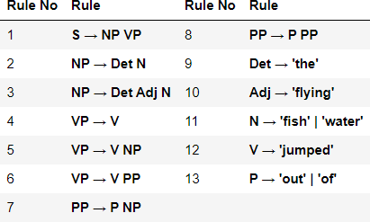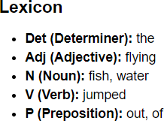

Question 4.
- Highlight the differences between Constituency Parsing and Dependency Parsing based on the following aspects: i) Basic structure ii) Applications iii) Parsing methods
- What will be the Constituency Parse Tree and the Dependency Parse Tree for the statement “The man shouted loudly”? (Only show the final tree, derivation steps are not expected).

Question 5.
- Show how you would disambiguate the following sentence using the Simple Lesk approach. Describe the algorithm and show how it would apply in this instance. [4 marks]
The room was dark and there was no light though it was summer morning.
Sense 1
- (noun) The natural agent that stimulates sight and makes things visible.
The morning light filtered softly through the curtains.

Sense 2
- (verb) To ignite something, causing it to start burning.
He used a match to light the candle.

Sense 3
- (adjective) Having a considerable or sufficient amount of natural light; the opposite of dark.
The room was light and airy, perfect for a summer’s day.

Sense 4
- (adjective) Of low weight; not heavy.
The suitcase was surprisingly light, making it easy to carry.

Question 6.

- Explain the Vanishing Gradients problem and how does it impact the RNNs and the Encoder- Decoder architecture? Support your answer with relevant diagrams. (1+1 marks)
- Given the sentence: “Dream Big” and information below, demonstrate the mathematical application of a single attention head to derive Self Attention. Support your answer with diagrams and relevant mathematical equations, detailing all steps. Apply score normalization, masking and softmax.
Embeddings:

 | Token
Dream | [1 1]
Big | [1 0]

Weight Matrix for Query W^{q} [0 1
1 0]

Weight Matrix for Keys W^{k} [1 0
0 1]

Weight Matrix for Values Wv [1 2
2 1]

Question 7. Text Summarization
For the generic text summarization, given below 5 documents in the collection as per the chronological order of mentions, answer the following questions sequentially. Here are the documents:
Document 1 (d1): “There lived a shepherd boy.” Document 2 (d2): “He cried out loudly, Wolf Wolf " Document 3 (d3): "Once lived a shepherd boy.” Document 4 (d4): “Shepherd cried wolf”
Document 5 (d5): "Shepherd cried loudly”
    - Preprocess the training document to remove the below set of tokens. Note: Ignore word cases but retain all the words. Stop words & punctuations: {the, a, he, there, was, for, is, '.', ','}

    - Compute the saliency score of every sentence using the sum of weights (normalized by size of pre- processed sentence) of all the words in the above preprocessed sentences. Use only the new simplified formula to compute word’s weightage.
Weight (word Wi) = TF(i,j) * N/DF(i)

    - Extract summary in reverse chronological order with the top 2 most informative documents from part b)’s result.

