Task

Write a query to pull back the most recent redemption count, by redemption date, for the date

range 2023-10-30 to 2023-11-05, for retailer "ABC Store". Your result should have 2 columns

and 7 rows (one row per day in the date range). Provide the query and then using your query

result, provide answers to the following questions.

Questions

Using the data set you produced from your query, answer the following questions:

1. Which date had the least number of redemptions and what was the redemption count?

2. Which date had the most number of redemptions and what was the redemption count?

3. What was the createDateTime for each redemptionCount in questions 1 and 2?

4. Is there another method you can use to pull back the most recent redemption count, by

redemption date, for the date range 2023-10-30 to 2023-11-05, for retailer "ABC Store"?

In words, describe how you would do this (no need to write a query, unless you’d like to).

Query :

I do have access to create tables in BigQuery, hence created in SQL editor and performed queries.

**Note 1 -** The query would not return 7 rows, it will return 6 rows because there are only 6 rows meeting the date filter and retailer name filter , I have provided screenshot below for reference.

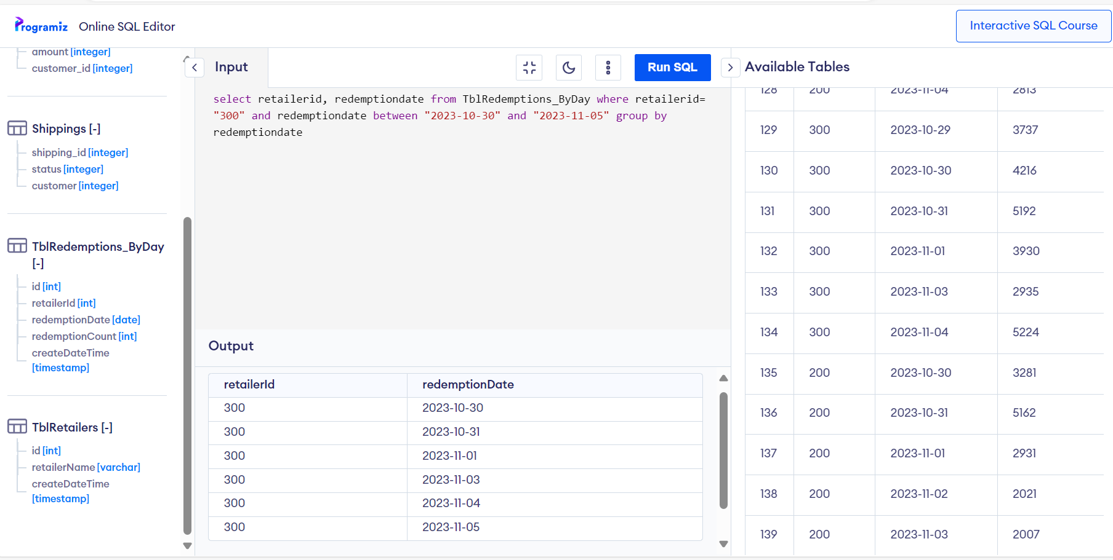

**Query Answer:**

select redemptionCount,redemptionDate from (select redemptionCount, max(T2.createDateTime), retailerId, redemptionDate from

TblRedemptions_ByDay T2 join TblRetailers T1 on T2.retailerid = T1.id where retailerName = "ABC Store" and redemptionDate

between "2023-10-30" and "2023-11-05" group by retailerId, redemptionDate)

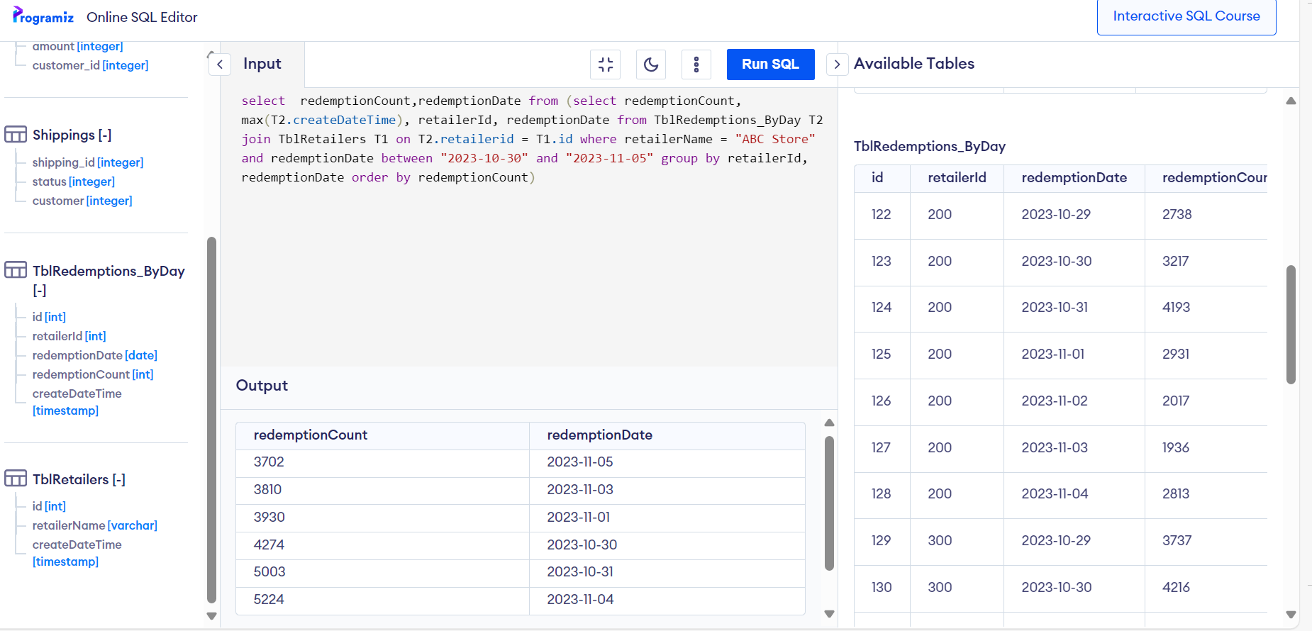

Questions

Using the data set you produced from your query, answer the following questions:

1. Which date had the least number of redemptions and what was the redemption count?

Answer – 2023-11-05 had least number of redemptions of count 3702

2. Which date had the most number of redemptions and what was the redemption count?

Answer - 2023-11-04 had most number of redemptions of count 5224

3. What was the createDateTime for each redemptionCount in questions 1 and 2?

For 3702 , createDateTime is 2023-11-0611:00:00UTC

For 5224, createDateTime is 2023-11-0511:00:00UTC

4. Is there another method you can use to pull back the most recent redemption count, by

redemption date, for the date range 2023-10-30 to 2023-11-05, for retailer "ABC Store"?

In words, describe how you would do this (no need to write a query, unless you’d like to).

~Could not think of any other methods right now.